Soil bacterial and fungal community response differently to Bombax ceiba (Malvaceae) in a traditional agroforestry system

Wen-Juan Wang^{1,2}, Jing Wen^{1,2}, Pastor L. Malabrigo³, Ming-Xun Ren^{1,2,*}

¹Ministry of Education Key Laboratory for Genetics and Germplasm Innovation of Tropical Special Forest Trees and Ornamental Plants, Hainan University, Haikou 570228, China
²Center for Terrestrial Biodiversity of the South China Sea, Hainan University, Haikou 570228, China
³College of Forestry and Natural Resources, University of Philippines Los Baños, Laguna 4031, Philippine

* Correspondence:
Ming-Xun Ren: renmx@hainanu.edu.cn

Table S1. Pearson’s correlation analysis between bacterial and fungal alpha diversity and soil nutrient properties
Alpha diversity index | AN | AP | AK | SOM | TN | TP | TK
Bacterial richness | -0.07 | -0.45* | -0.41* | -0.05 | -0.28 | -0.17 | 0.44*
Bacterial Shannon index | 0.27 | -0.62** | -0.32 | -0.09 | -0.39* | -0.24 | 0.42*
Fungal richness | -0.12 | -0.25 | -0.03 | -0.27 | -0.37 | -0.30 | 0.37
Fungal Shannon index | -0.29 | -0.14 | 0.01 | -0.22 | -0.32 | -0.10 | 0.23
Values in the table are F value, and “*” represent P < 0.05 while “**” represent P < 0.01
Table S2. Relative abundance (%) of dominant bacterial and fungal taxonomic groups at the phylum level in three distances in three reproductive stages of rice
 | phylum | BS-D0 | BS-D1 | BS-D5 | HS-D0 | HS-D1 | HS-D5 | MS-D0 | MS-D1 | MS-D5
Bacteria | Proteobacteria | 24.46±1.79 | 22.47±0.52 | 25.06±2.09 | 16.52±1.72 ab | 16.49±0.28 a | 14.68±0.28 b | 24.23±1.97 a | 17.80±1.84 b | 17.50±1.11 b
 | Acidobacteria | 20.92±2.55 | 19.84±0.79 | 17.72±1.26 | 14.03±2.55 | 14.15±0.77 | 13.49±1.06 | 14.25±1.00 b | 16.53±0.49 a | 14.10±0.16 b
 | Firmicutes | 1.31±0.27 b | 2.39±0.16 a | 2.22±0.16 a | 29.80±2.81 | 25.44±0.98 | 31.42±0.78 | 19.71±3.57 | 13.79±1.08 | 17.40±1.34
 | Chloroflexi | 6.90±0.51 b | 16.07±0.86 a | 13.8±1.31 a | 7.42±0.22 b | 11.19±0.13 a | 10.33±0.69 a | 6.81±1.42 b | 13.26±0.25 a | 12.88±0.42 a
 | Actinobacteria | 18.34±4.56 a | 7.74±0.71 b | 8.65±0.32 b | 10.27±1.66 | 8.65±1.13 | 7.77±0.57 | 12.22±0.74 a | 9.02±0.81 b | 10.22±0.53 ab
 | Myxococcota | 4.79±0.26 b | 6.85±0.26 a | 7.76±0.67 a | 3.35±0.25 b | 4.96±0.22 a | 4.28±0.27 a | 4.21±0.87 | 5.78±0.47 | 5.34±0.65
 | Verrucomicrobia | 4.1±0.22 | 3.56±0.17 | 3.70±0.16 | 2.85±0.56 b | 3.11±0.14 ab | 4.07±0.18 a | 1.91±0.40 | 4.00±1.16 | 4.38±1.15
 | Desulfobacteria | 0.83±0.23 b | 5.08±1.17 a | 4.92±0.61 a | 1.71±0.04 b | 3.54±0.19 a | 3.92±0.49 a | 1.66±0.45 b | 4.33±0.78 a | 4.58±0.20 a
 | Gemmatimonadetes | 5.01±0.11 a | 3.41±0.43 b | 3.88±0.41 ab | 1.95±0.07 b | 2.64±0.23 a | 1.74±0.09 b | 2.35±0.53 | 2.78±0.12 | 2.29±0.05
 | Bacteroidetes | 2.03±0.28 | 1.95±0.19 | 1.94±0.09 | 1.35±0.49 | 1.41±0.09 | 1.18±0.27 | 3.45±1.15 | 1.89±0.39 | 1.84±0.72
 | Planctomycetes | 3.42±0.34 a | 1.24±0.17 b | 1.11±0.08 b | 1.95±0.56 | 0.99±0.15 | 1.28±0.50 | 1.85±0.67 | 1.47±0.47 | 1.28±0.18
 | Nitrospira | 1.03±0.24 b | 1.88±0.16 a | 2.14±0.05 a | 1.06±0.30 | 1.15±0.14 | 1.23±0.28 | 1.43±0.55 | 2.02±0.44 | 1.92±0.58
 | Methylomirabilota | 1.81±0.47 | 1.76±0.31 | 2.07±0.18 | 1.34±0.20 | 1.11±0.02 | 0.97±0.13 | 1.40±0.24 | 1.43±0.27 | 0.92±0.10
Fungi | Ascomycota | 51.34±5.02 | 65.39±5.28 | 65.19±2.26 | 50.94±5.60 b | 55.55±1.51 b | 71.85±3.81 a | 55.09±1.60 b | 63.60±0.95 a | 67.08±0.65 a
 | unidentified | 26.93±7.46 a | 12.01±3.45 ab | 10.02±1.26 a | 17.94±3.01 | 15.15±2.44 | 11.69±1.95 | 19.81±3.12 | 10.29±0.96 | 10.98±3.66
 | Basidiomycota | 10.37±2.92 | 11.28±1.85 | 11.85±0.36 | 15.06±9.85 | 8.92±0.67 | 7.71±1.28 | 6.87±1.41 | 12.91±2.28 | 10.54±2.69
 | Mortierellomycota | 9.01±1.07 a | 3.03±0.60 b | 1.60±0.96 b | 8.11±3.19 a | 6.46±3.57 a | 1.55±0.55 b | 9.78±4.01 | 3.36±0.79 | 2.95±1.07
 | Rozellomycota | 0.70±0.45 b | 5.30±2.04 ab | 7.86±2.01 a | 5.46±3.73 | 5.52±1.50 | 4.02±0.94 | 4.91±3.75 | 3.06±0.40 | 3.44±0.66
 | Chytridiomycota | 0.64±0.34 | 1.61±0.96 | 0.94±0.34 | 0.71±0.30 | 5.35±4.39 | 1.52±0.92 | 1.78±0.53 | 1.38±0.43 | 3.14±1.11
 | Glomeromycota | 0.32±0.18 | 0.66±0.23 | 0.97±0.26 | 1.51±1.30 | 1.77±1.23 | 0.69±0.08 | 1.29±1.18 | 1.71±1.11 | 0.83±0.17

Table S3. Results of Mantel test evaluating relationships of soil nutrient properties with bacterial and fungal community composition
 | Bacteria |  | Fungi
 | r | p | r | p
AN | 0.265 | <0.05 | 0.223 | <0.05
AP | 0.347 | <0.01 | 0.316 | <0.05
AK | 0.517 | <0.001 | 0.375 | <0.01
SOC | 0.325 | <0.05 | 0.392 | <0.01
TN | 0.291 | <0.05 | 0.398 | <0.01
TP | -0.007 | =0.482 | 0.004 | =0.421
TK | 0.034 | =0.234 | 0.025 | =0.286

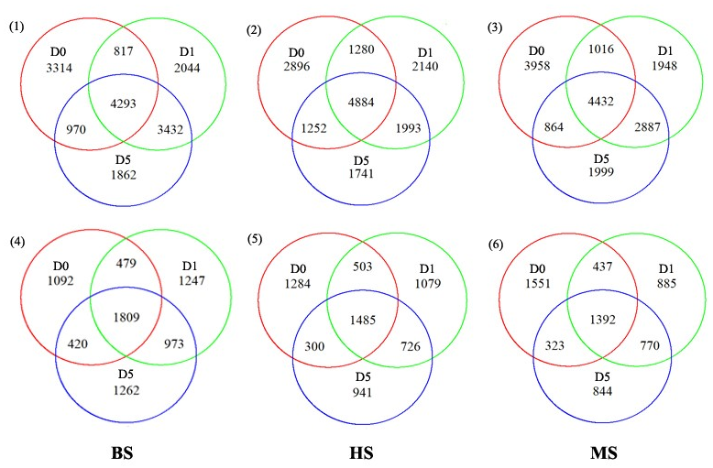
Fig. S1 Veen diagram of bacterial OTUs in different distance to B. ceiba during rice booting stage (1), heading stage (2) and mature stage (3) and fungal OTUs in different distance to B. ceiba during rice booting stage (4), heading stage (5) and mature stage (6).

