SUPPLEMENTARY INFORMATION

The Large Extracellular Loop of CD63 Interacts with gp41 of HIV-1 and is Essential for Establishing the Virological Synapse

Daniel Ivanusic,¹ Kazimierz Madela,² Norbert Bannert,¹ Joachim Denner^{3, 4}
¹HIV and Other Retroviruses, Robert Koch Institute, Nordufer 20, 13353 Berlin, Germany
²Special Light and Electron Microscopy, Robert Koch Institute, Nordufer 20, 13353 Berlin, Germany
³Robert Koch Fellow, Robert Koch Institute, Nordufer 20, 13353 Berlin, Germany
⁴present address: Institute of Virology, Department of Veterinary Medicine, Free University Berlin, 14163 Berlin, Germany
Corresponding author: Joachim.Denner@fu-berlin.de

Supplementary Table S1: Used primers for vector construction containing CD63 sequences, deduced amino acid (AA) sequence of the full-length CD63 protein refers to Genbank accession no. KF998086.
Vector | AA | Primer forward (for) reverse (rev)
pPR3-N-TM1-2 | 1-84 | TM1-2_CD63_for TM1-2_CD63_rev
pPR3-N-TM3-4 | 74-238 | TM3-4_LEL_CD63_for TM3-4_LEL_CD63_rev
pPR3-SUC-TM2 | 50-84 | TM2_CD63_for TM2_SEL_SIL_CD63_rev
pPR3-SUC-TM2SEL | 36-84 | TM2_SEL_SIL_CD63_for TM2_SEL_SIL_CD63_rev
pPR3-SUC-TM4 | 207-238 | TM4_CD63_for  TM2_SEL_SIL_CD63_rev
pPR3-SUC-TM4LEL | 108-238 | TM4_LEL_SIR_CD63_for  TM4_LEL_SIR_CD63_rev

Supplementary Table S2: Sequences of primers used for molecular cloning steps.
Primer | Sequence 5´ 3´
TM1-2_CD63_for | TTAATTAAGGCCATTACGGCCATGGCGGTGGAAGGAGGAAT
TM1-2_CD63_rev | TTAATTAAGGCCGAGGCGGCCAGATCATAAGACAATAGTTC
TM3-4_LEL_CD63_for | TTAATTAAGGCCATTACGGCCGGGGCCTGCAAGGAGAACTA
TM3-4_LEL_CD63_rev | TTAATTAAGGCCGAGGCGGCCACATCACCTCGTAGCCACTT
TM2_CD63_for | TTTTTTTGGCCATTACGGCCGGCTCTCTGTTGCCAG
TM2_SEL_SIL_CD63_for | TTTTTTTGGCCATTACGGCCCAGCTTGTCCTGAGTCAGACCA
TM2_SEL_SIL_CD63_rev | TTTTTTTGGCCGAGGCGGCCTTGATCATAAGACAATAGTTCT
TM4_CD63_for | TTTTTTTGGCCATTACGGCCGCTGCAGCAGCCCTTGGAA
TM4_LEL_SIR_CD63_for | TTTTTTTGGCCATTACGGCCAGAGATAAGGTGATGTCAGAGT
TM4_LEL_SIR_CD63_rev | TTTTTTTGGCCGAGGCGGCCTTCATCACCTCGTAGCCACTTC
C145A,C146A_CD63_LEL_for | GCAGGCAGATTTTAAGGCTGCTGGGGCTGCTAACTACACAGATTG
C145A,C146A _CD63_LEL_rev | CAATCTGTGTAGTTAGCAGCCCCAGCAGCCTTAAAATCTGCCTGC
C169A, C170A _CD63_LEL_for | GAACCGAGTCCCCGACTCCGCTGCTATTGATGTTACTGTGGG
C169A, C170A _CD63_LEL_rev | CCCACAGTAACATCAATAGCAGCGGAGTCGGGGACTCGGTTC
C177A _CD63_LEL_for | GCATTGATGTTACTGTGGGCGCTGGGATTAATTTCAACG
C177A _CD63_LEL_rev | CGTTGAAATTAATCCCAGCGCCCACAGTAACATCAATGC
C191A _CD63_LEL_for | GGCGATCCATAAGGAGGGCGCTGTGGAGAAGATTGGGGG
C191A _CD63_LEL_rev | CCCCCAATCTTCTCCACAGCGCCCTCCTTATGGATCGCC
mCherry_for | TTTTTCTCGAGATGGTGAGCAAGGGCGAGG
mCherry_rev | TTTTTGGGCCCATCTTGTACAGCTCGTCCATG
CD63_TM1-3_for | TTTTTTGGATCCATGGCGGTGGAAGGAGGAATG
CD63_TM1-3_rev | TTTTTCTGCAGCTTATCTCTAAACACA
CD63_TM4_for | TTTTTGATATCGGAGGAGGAGGAAAAAATGTGCTGG
CD63_TM4_rev | TTTTTTAAGCTTCATCACCTCGTAGCCACTTCT

Supplementary Fig. S1: Western Blot images in full-length used for figure 4D.

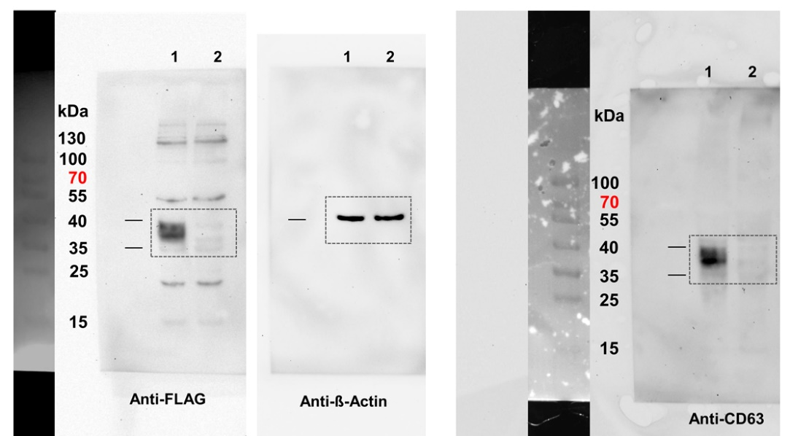

Lysates of HEK 293T cells co-transfected with the vectors lane 1: pCMV-CD63-FLAG/pcDNA-SP1-gp41-V5, lane 2: pCMV-Tag 2B/pcDNA4B

Supplementary Fig. S2: Western Blot images in full-length used for figure 6B.

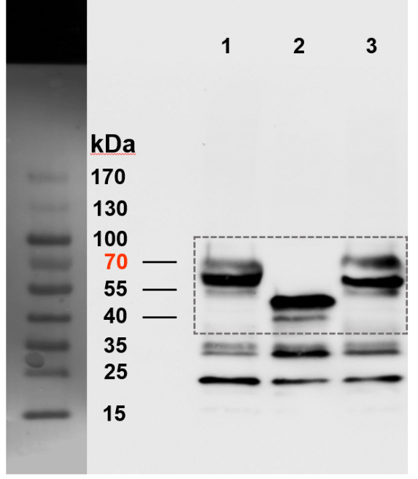

Lysates of HEK 293T cells transfected with the vectors lane1: pCMV-CD63-mCherry, lane 2: pCMV-CD63ΔLEL-mCherry, lane 3: pCMV-CD63_{C145A,C146A}-mCherry.

