Supplementary Information for
Aging threatens sustainability of smallholder farming in China

Chenchen Ren ^{a,b}, Xinyue Zhou ^{c}, Chen Wang ^{b,d}, Yaolin Guo ^{d}, Yu Diao ^{d}, Sisi Shen ^{d}, Stefan Reis ^{e,f}, Wanyue Li ^{c}, Jianming Xu ^{d}, Baojing Gu ^{d,g,*}

This file includes:

Supplementary Methods
Reference
Tables S1 to S7
Figures S1 to S9
Supplementary Methods
Variables from the CRHPS 2015 to 2017
Aging
Aging labor ratio refers to the proportion of people over 65 years old in rural households.

Adult farmer’s ratio
Adult farmers ratio refers to adult farmer’s ratio (age over 15 but less than 64) in rural household.

Education
Education refers to average years of education of family members aged 15 and over. Education year of each household individual are reported by surveyed farmers directly.

Farm size
Farm size (ha) refers to the household’s gross cultivated land areas covering all crops in the four seasons immediately preceding the survey.

Transfer-out
It is the ratio of transferred-out area of cropland trough land circulation to the current total cropland area of rural household. The current total cropland area is the area after considering cropland circulation and abandonment.

Abandoned
Abandoned (ha) indicates the area of abandoned cropland by farmers.

Output
Output ($ per ha) is total market value of all crop yields directly reported by farmers including all grains and crash crops.

Input
Input is the total immediate input ($) per ha during farming. It includes all purchase of agricultural products such as seed and fertilizer, land transferred-in cost, machinery rental fee, depreciation of own machinery and labor input.

Profit-cost ratio
Profit-cost ratio means the ratio of profit to the input. Agricultural profit ($ per ha) equals to the difference between total agricultural output and input.

Labor Productivity
Labor Productivity is the household agricultural gross output ($) divided by total labor working hours. Labor working hours were calculated according to labors’ working time during busy and non-busy seasons concerning family labors (person), employed long-term labors (person) and short-term labors (working days). We hypothesize that each labor works 8 hours per day, and long-term labor and family members engaged in agriculture work an average of 5 days per week. While assuming seven-fifths of the 365 days for long-term and family labors fully engaged in agriculture, we also weighted their working time with 80% considering non-busy seasons, part-time jobs and other situations. Accordingly, total working hours of all labors are calculated.

Fertilization
Fertilization refers to chemical fertilizer purchases ($) divided by farm size.

Fertilizer use efficiency
Fertilizer use efficiency is the ratio of agricultural output to fertilizer input, measuring fertilizer contribution and reflecting its loss.

Fertilizer loss
Fertilizer loss is calculated taking nitrogen (N) surplus as an indicator of environmental pollution, which only consider three grain crops (wheat, rice and corn) due to data limitation. It is the difference between the amounts of nitrogen applied during crop planting and the amounts of nitrogen subsequently found in the harvested yields. The application rate of grain crops was imputed by assuming that the average nitrogen application rate in the sample equals those in Chen et al. 2014 ¹. By comparing the province average expenditure of fertilizer to the overall average, application rates on each province were calculated. Using crop yield data from the CRHPS and the absorption rate from the literature, the levels of nitrogen contained in harvested crops ($N_{har}$) were estimated ²⁻⁴. After that, the fertilizer loss was estimated as follows:
$${Fertilizer}_{loss}=\frac{\sum_{i}{(N_{app}^{i}-N_{app}^{i})}∙100\%}{N_{app}^{i}}$$
where subscript i stands for different crops.

Abandon rate (%)
It is the ratio of abandoned cropland to total cropland area. Abandon rate on province or country-level is the household-level abandon rate weighted by the total provincial or national cropland area, respectively.

Machine input
Machine input ($ per ha) is summed by depreciation cost of owned machinery and machinery rental cost. The machinery depreciation cost is calculated by 10% of their original value as we consider the service life of owned machinery as 10 years.

Machine owned
Machine owned ($ per ha) is calculated by the original value of owned machinery ($) divided by farm size.

Pesticide
It refers to pesticide purchases ($) divided by farm size.

Pesticide use efficiency
Pesticide use efficiency (PUE) means the ratio of agricultural output to pesticide input, measuring pesticide contribution and reflecting its loss.

Manure
Manure refers to expenditures on manure ($) divided by farm size.

Technology adoption
Technology adoption is a binary variable indicating whether there is any technology adoption and knowledge exchange of each household. It is a binary variable, equaling to 1 or 0 when there are or no technology adoption and knowledge exchange, respectively.

Income ratio
It is derived by dividing the non-agricultural income by the total income. Income from non-agricultural sectors is directly reported by farmers.

Crop type
Crop type is a categorical variable denoting the type of crops that each household grows. We mainly focus on ten categories of crops based on data availability in our regression analysis, including rice, wheat, maize, soybeans, tubers, vegetables, fruits and other crops. And the crop type of each household is determined by which crop’s sowing area exceeds all other crops’ sowing area. For example, if the sowing area of rice exceeds that of any other crop, the main crop type of this household is rice.

Plot numbers
Plot numbers also is a categorical variable denoting the number of pieces of cropland of each household.
References:
1. Chen, X., et al. Producing more grain with lower environmental costs. Nature 514, 486-489 (2014).
2. Gu, B., Ju, X., Chang, J., Ge, Y. & Vitousek, P.M. Integrated reactive nitrogen budgets and future trends in China. Proc. Natl. Acad. Sci. U. S. A. 112, 8792-8797 (2015).
3. Cui, Z., et al. Pursuing sustainable productivity with millions of smallholder farmers. Nature 555, 363-366 (2018).
4. Apipoonyanon, C., et al. Socio-economic and environmental barriers to increased agricultural production: New evidence from central Thailand. Outlook Agric., 1800480096 (2020).

Table S1 Aging lower agricultural vitality
 | Ln Pesticide ($ ha⁻¹) | Ln Pesticide ($ ha⁻¹) | Ln PUE | Ln PUE | Manure ($ ha⁻¹) | Manure ($ ha⁻¹) | Tech | Tech
Aging | -0.25*** |  | -0.07 |  | -93.2*** |  | 0.12
Ln Age |  | -0.21*** |  | -0.05 |  | -77.9*** |  | 14.8***
Ln Age² |  |  |  |  |  |  |  | -1.87***
Ln Farm size (ha) | -0.34*** | -0.34*** | 0.18*** | 0.18*** | 19.8*** | 20.6*** | 0.31*** | 0.31***
Education (yr) | -0.01 | -0.001 | 0.04*** | 0.02*** | 10.5*** | 6.27*** | 0.11*** | 0.08***
County | Yes | Yes | Yes | Yes
City |  |  |  |  | Yes | Yes | Yes | Yes
N | 14869 | 14836 | 14716 | 14710 | 12263 | 12257 | 16363 | 16357
Adjust R² | 0.33 | 0.32 | 0.19 | 0.19
Model | FEP | FEP | FEP | FEP | Tobit | Tobit | Logit | Logit
*p < 0.05, **p < 0.01, and ***p< 0.005. PUE, pesticide use efficiency. Tech, technology adoption. FEP, Fixed effect panel. Pesticide use efficiency (PUE) means the ratio of agricultural output to pesticide input, measuring pesticide contribution and reflecting its loss. Technology adoption (Tech) is a binary variable indicating whether there is any technology adoption and knowledge exchange of each household. Aging refers to the proportion of people over 65 years old in rural households. Age refers to the age of the head of the investigated household. Farm size is the total cultivated area covering all crops. Education refers to average years of education of family members aged 15 and over in equations with the indicator of aging. For equations with the variable of age, education means education years of the head of the investigated household. Adult farmer’s ratio has been controlled in regression equations with the variable of aging ratio. County and city mean county-level or city-level regional effect is controlled, respectively. Income ratio from non-agricultural sectors, crop type, plot numbers and year effect have been controlled in all regression equations.
Table S2 Summary of the structural equation model shown in Fig. 2
 | Yield |  |  | Labor productivity |  |  | Fertilization |  |  | Fertilizer use efficiency
 | Effect | Ratio |  | Effect | Ratio |  | Effect | Ratio |  | Effect | Ratio
Direct effect | -0.05 | 71% |  | -0.05 | 33% |  | -0.08 | 67% |  | -0.02 | 33%
Indirect effect from Farm size | 0.01 | 14% |  | -0.08 | 53% |  | 0.03 | 25% |  | -0.01 | 17%
Indirect effect from Education | -0.01 | 14% |  | -0.02 | 13% |  | 0.01 | 8% |  | -0.03 | 50%
Net effect | -0.05 |  |  | -0.15 |  |  | -0.04 |  |  | -0.06
Direct effects are derived from the standardized path coefficient from aging to explained variables based on Fig. 2. Indirect effects were calculated as the product of all effects in a single path. Net effects are the sum of all direct and indirect effects. Ratio is the absolute value of direct or indirect effects divided by the sum of the absolute values of all effects.
Table S3 Abandoned cropland across China’s provinces in 2019
Province | Abandoned (10³ ha) | Abandoned without aging (10³ ha) | Total cropland area (10³ ha) | Abandon rate (%) | Abandon rate without aging (%) | Relative change (%)
BEJ | 1.3 | 1.1 | 213.7 | 0.6 | 0.5 | 13.3
TAJ | 0.4 | 0.1 | 436.8 | 0.1 | 0.0 | 78.1
HEB | 74.7 | 43.7 | 6518.9 | 1.1 | 0.7 | 41.5
SHX | 309.6 | 283.1 | 4056.3 | 7.6 | 7.0 | 8.6
NEG | 304.1 | 277.5 | 9270.8 | 3.3 | 3.0 | 8.8
LIA | 10.9 | 0.0 | 4971.6 | 0.2 | 0.0 | 100.0
JIL | 0.0 | 0.0 | 6986.7 | 0.0 | 0.0
HLJ | 23.0 | 18.8 | 15845.7 | 0.1 | 0.1 | 18.3
JSU | 5.6 | 0.0 | 4573.3 | 0.1 | 0.0 | 100.0
ZHJ | 103.8 | 74.8 | 1977.0 | 5.3 | 3.8 | 27.9
ANH | 88.0 | 59.0 | 5866.8 | 1.5 | 1.0 | 32.9
FUJ | 118.2 | 97.0 | 1336.9 | 8.8 | 7.3 | 17.9
JXI | 192.7 | 170.7 | 3086.0 | 6.2 | 5.5 | 11.4
SHD | 28.3 | 0.0 | 7589.8 | 0.4 | 0.0 | 100.0
HEN | 137.2 | 93.0 | 8112.3 | 1.7 | 1.1 | 32.2
HUB | 269.8 | 235.0 | 5235.9 | 5.2 | 4.5 | 12.9
HUN | 657.3 | 537.6 | 4151.0 | 15.8 | 13.0 | 18.2
GUD | 335.0 | 308.9 | 2599.7 | 12.9 | 11.9 | 7.8
GUX | 975.7 | 919.1 | 4387.5 | 22.2 | 20.9 | 5.8
HAN | 91.6 | 87.1 | 722.4 | 12.7 | 12.1 | 4.9
CHQ | 293.0 | 202.9 | 2369.8 | 12.4 | 8.6 | 30.8
SCH | 631.2 | 443.5 | 6725.2 | 9.4 | 6.6 | 29.7
GUI | 913.4 | 842.1 | 4518.8 | 20.2 | 18.6 | 7.8
YUN | 676.4 | 652.2 | 6213.3 | 10.9 | 10.5 | 3.6
SHA | 161.3 | 139.4 | 3982.9 | 4.0 | 3.5 | 13.5
GAS | 319.8 | 297.8 | 5377.0 | 5.9 | 5.5 | 6.9
QIH | 41.9 | 40.0 | 590.1 | 7.1 | 6.8 | 4.5
NXA | 19.1 | 16.4 | 1289.9 | 1.5 | 1.3 | 14.2
National | 6783.4 | 5841.0 | 129006.1 | 5.3 | 4.5 | 13.9
Acronyms for 31 provinces, autonomous regions, and municipalities directly under the Central Government are listed in Table S6. Shanghai, Tibet and Xinjiang aren’t depicted due to data limitation. The last line shows the situation of the whole country.

Table S4 New farming mitigates aging and its impacts on agriculture
 | Aging and Farm size |  |  |  |  | Cost and Benefit |  |  |  |  | Fertilizer and Machinery
 | Ln Age | Aging | Education (yr) | Ln Farm size (ha) |  | Ln Output ($ ha⁻¹) | Ln Input ($ ha⁻¹) | Profit-cost ratio | Ln LP ($ hr⁻¹) |  | Ln Fertilization ($ ha⁻¹) | Ln FUE | Machine input ($ ha⁻¹) | Machine owned ($ ha⁻¹)
New farm | -0.06** | -0.05 | 1.02*** | 0.27** |  | 0.17* | 0.19* | -0.13 | 0.42* |  | 0.04 | 0.22* | 110* | -120
Aging |  |  |  | -0.31** |  | -0.27*** | -0.17*** | -0.11 | -0.38*** |  | -0.22*** | -0.11*** | -38.8 | -697***
Ln Farm size (ha) |  |  |  |  |  | -0.14*** | -0.12*** | -0.01 | 0.60*** |  | -0.20*** | 0.04*** | -12.8* | 445***
Education (yr) |  |  |  | -0.004 |  | 0.03*** | 0.01** | 0.03*** | 0.03*** |  | -0.01 | 0.04*** | 13.0*** | 58.4***
County | Yes | Yes | Yes | Yes |  | Yes | Yes | Yes | Yes |  | Yes | Yes
City |  |  |  |  |  |  |  |  |  |  |  |  | Yes | Yes
N | 7448 | 7450 | 7450 | 6371 |  | 5924 | 5617 | 5564 | 5608 |  | 5487 | 5425 | 5789 | 5831
Adjust R² | 0.13 | 0.06 | 0.12 | 0.54 |  | 0.26 | 0.18 | 0.08 | 0.38 |  | 0.17 | 0.15
Model | FEP | FEP | FEP | FEP |  | FEP | FEP | FEP | FEP |  | FEP | FEP | Tobit | Tobit
*p < 0.05, **p < 0.01, and ***p< 0.005. LP, Labor productivity. FUE, fertilizer use efficiency. FEP, Fixed effect panel. Age refers to the age of the head of the investigated household. Aging refers to the proportion of people over 65 years old in rural households. Education refers to average years of education of family members aged 15 and over. Farm size is the total cultivated area covering all crops. Profit-cost ratio means the ratio of difference between agricultural income and input to the input. Labor productivity (LP) indicates agricultural output per working hour of labor. Fertilizer use efficiency (FUE) is the ratio of agricultural output to fertilizer input, measuring fertilizer contribution and reflecting its loss. Machine input is total machine cost including machinery rent and depreciation to total cultivated area. Machine owned means original value of agricultural machinery the household owned per area. New farm is binary variable indicating whether there is a new farming model. County and city mean county-level or city-level regional effect is controlled, respectively. Adult farmer’s ratio, income ratio from non-agricultural sectors, crop type, plot numbers and year effect have been controlled in all regression equations. For all models in this table, we only use data in 2019 due to data limitation.
Table S5 Robust check of aging impacts on agricultural sustainability
 | Farm size and Education |  |  |  |  | Cost and Benefit |  |  |  |  | Fertilizer and Machinery
 | Ln Farm size (ha) | Education (yr) | Transfer-out | Abandoned (ha) |  | Ln Output ($ ha⁻¹) | Ln Input ($ ha⁻¹) | Profit-cost ratio | Ln LP ($ hr⁻¹) |  | Ln Fertilization ($ ha⁻¹) | Ln FUE | Machine input ($ ha⁻¹) | Machine owned ($ ha⁻¹)
Ln Age | -0.18*** | -3.90*** | 1.02*** | 0.04 |  | -0.23*** | -0.23*** | -0.01 | -0.36*** |  | -0.08* | -0.18*** | -90.3*** | -931***
Ln Farm size (ha) |  |  |  |  |  | -0.14*** | -0.19*** | 0.13*** | 0.62*** |  | -0.26*** | 0.10*** | -24.1*** | 470***
Education (yr) | 0.01*** |  | 0.02* | -0.01 |  | 0.02*** | 0.01*** | 0.02*** | 0.02*** |  | -0.001 | 0.02*** | 7.44*** | 34.1***
County | Yes | Yes |  |  |  | Yes | Yes | Yes | Yes |  | Yes | Yes
City |  |  | Yes | Yes |  |  |  |  |  |  |  |  | Yes | Yes
N | 16761 | 16761 | 16132 | 12298 |  | 16761 | 15596 | 15454 | 16241 |  | 15441 | 15286 | 16536 | 16587
Adjust R² | 0.51 | 0.17 |  |  |  | 0.25 | 0.20 | 0.08 | 0.40 |  | 0.21 | 0.13
Model | FEP | FEP | Tobit | Tobit |  | FEP | FEP | FEP | FEP |  | FEP | FEP | Tobit | Tobit
*p < 0.05, **p < 0.01, and ***p< 0.005. LP, Labor productivity. FUE, fertilizer use efficiency. FEP, Fixed effect panel. Farm size is the total cultivated area covering all crops. Education refers to education years of the head of the investigated household. Transfer-out are the ratio of transferred-out cropland area to the current total cropland area. Abandoned indicates the area of abandoned cropland by farmers. Profit-cost ratio means the ratio of difference between agricultural income and input to the input. Labor productivity (LP) indicates agricultural output per working hour of labor. Fertilizer use efficiency (FUE) is the ratio of agricultural output to fertilizer input, measuring fertilizer contribution and reflecting its loss. Machine input is total machine cost including machinery rent and depreciation to total cultivated area. Machine owned means original value of agricultural machinery the household owned per area. Age refers to the age of the head of the investigated household. County and city mean county-level or city-level regional effect is controlled, respectively. Income ratio from non-agricultural sectors, crop type, plot numbers and year effect have been controlled in all regression equations.

Table S6 Acronyms for 31 provinces, autonomous regions, and municipalities directly under the Central Government.
Abbreviation | Full name | Abbreviation | Full name
BEJ | Beijing | HUB | Hubei
TAJ | Tianjin | HUN | Hunan
HEB | Hebei | GUD | Guangdong
SHX | Shanxi | GUX | Guangxi
NEG | Inner Mongolia | HAN | Hainan
LIA | Liaoning | CHQ | Chongqing
JIL | Jilin | SCH | Sichuan
HLJ | Heilongjiang | GUI | Guizhou
SHH | Shanghai | YUN | Yunnan
JSU | Jiangsu | TIB | Tibet
ZHJ | Zhejiang | SHA | Shaanxi
ANH | Anhui | GAS | Gansu
FUJ | Fujian | QIH | Qinghai
JXI | Jiangxi | NXA | Ningxia
SHD | Shandong | XIN | Xinjiang
HEN | Henan
Table S7 Summary statistics for main variables used in regression analysis
 | Obs | Mean | SD | Min | Max
Aging ratio | 33,058 | 0.18 | 0.30 | 0 | 1
Adult farmer’s ratio | 33,058 | 0.68 | 0.30 | 0 | 1
Average education (yr) | 33,058 | 7.31 | 2.90 | 0 | 18
Ln Farm size (ha) | 27,895 | -1.08 | 1.16 | -7.60 | 5.58
Transfer-out | 28,509 | 0.06 | 0.31 | 0 | 5
Abandoned (ha) | 17,772 | 0.01 | 0.11 | 0 | 6.67
Ln Output ($ ha⁻¹) | 26,164 | 7.56 | 0.86 | -2.52 | 10.53
Ln Labor Productivity ($ hr⁻¹) | 25,435 | -1.04 | 1.42 | -10.27 | 6.28
Ln Cost ($ ha⁻¹) | 25,844 | 6.95 | 0.86 | -2.20 | 12.54
Profit-cost ratio | 24,779 | 1.48 | 2.21 | -1 | 24
Ln Fertilization ($ ha⁻¹) | 17,675 | 5.70 | 0.87 | -6.48 | 7.67
Ln Fertilizer use efficiency | 16,788 | 1.70 | 0.89 | -8.13 | 4.12
Machine input ($ ha⁻¹) | 27,489 | 195.2 | 327.1 | 0 | 3,857
Machine owned ($ ha⁻¹) | 27,548 | 484.9 | 1,318 | 0 | 14,732
Manure ($ ha⁻¹) | 14,742 | 37.24 | 122.6 | 0 | 1,469
Ln Pesticide ($ ha⁻¹) | 17,024 | 4.63 | 1.07 | -5.52 | 7.07
Ln Pesticide use efficiency | 16,149 | 2.79 | 1.07 | -6.55 | 5.39
Technology adoption | 23,477 | 0.10 | 0.30 | 0 | 1
New farming | 14,406 | 0.02 | 0.14 | 0 | 1
Income ratio | 26,107 | 0.54 | 0.41 | 0 | 1.00
Plot numbers (Categorical variable) | 20,418 | 3.07 | 1.97 | 1 | 6
Plant type (Categorical variable) | 23,477 | 5.30 | 3.81 | 1 | 10
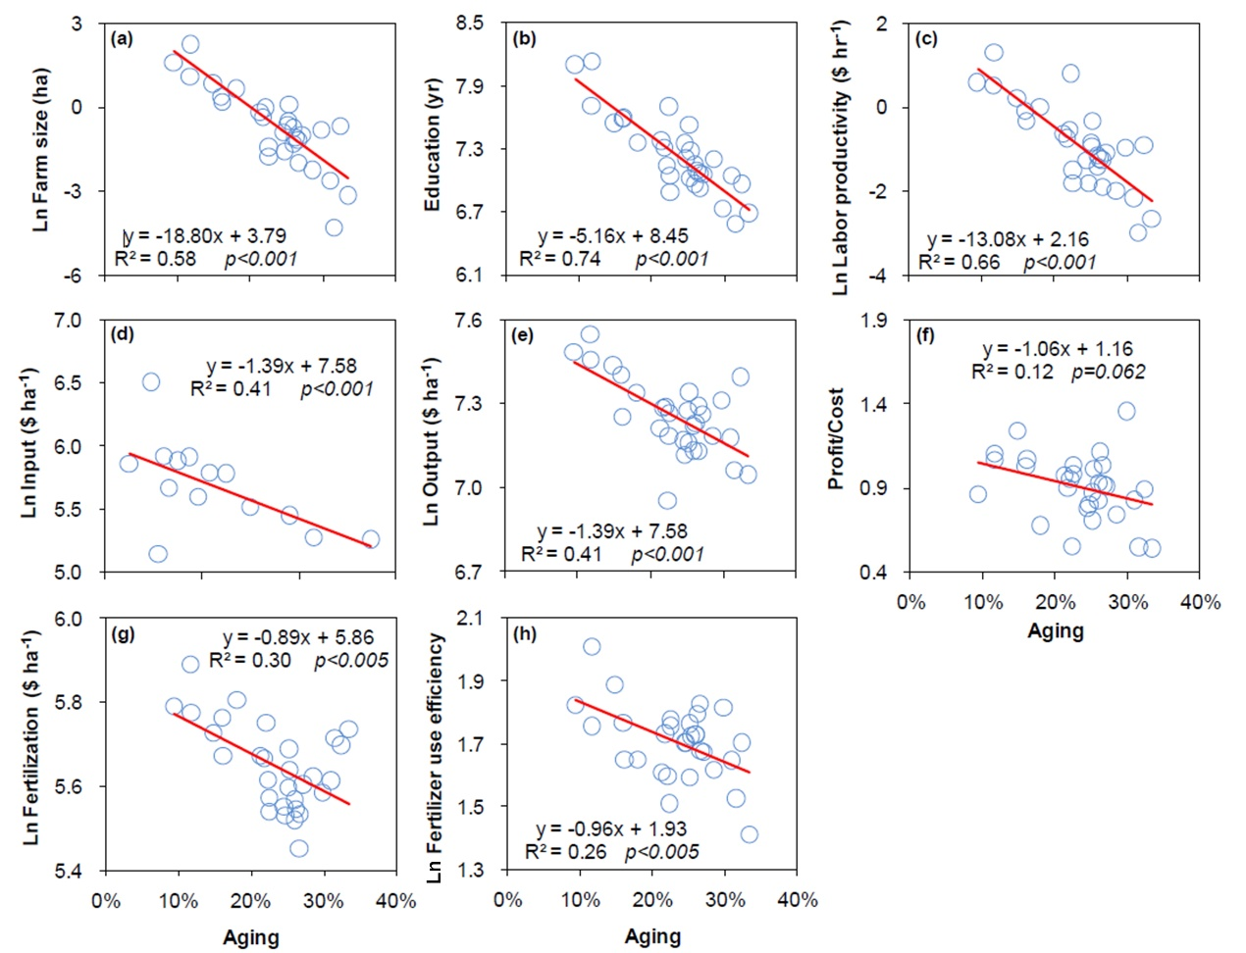
Fig. S1 Relationships between aging and agricultural sustainability. (a) Farm size; (b) Education; (c) Labor productivity; (d) Total agricultural input; (e) Agricultural output; (f) Profit-cost ratio; (g) Fertilization; (h) Fertilizer use efficiency. Machine input changes was not presented due to its non-linear relationship with aging.
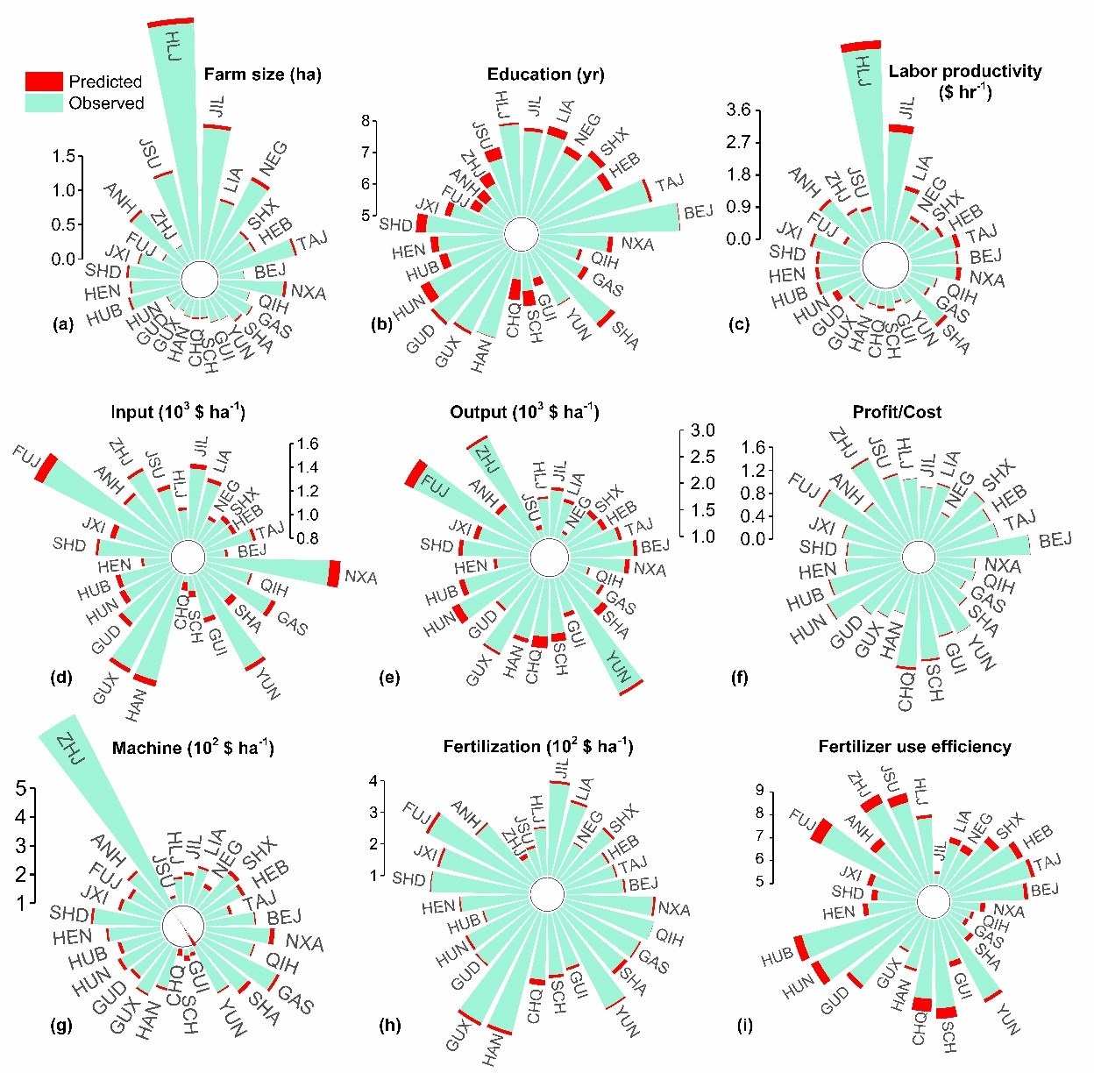
Fig. S2 Changes of agricultural sustainability with aging in 2019. (a) Farm size; (b) Education; (c) Labor productivity; (d) Total agricultural input; (e) Agricultural output; (f) Profit-cost ratio; (g) Machine input; (h) Fertilization; (i) Fertilizer use efficiency. The predicted means the value without aging. The observed means the observed value in 2019. The input, output, machine and fertilization are all weighted with the total cultivated area on province-level. Acronyms for 31 provinces, autonomous regions, and municipalities directly under the Central Government are listed in Table S6. Shanghai, Tibet and Xinjiang aren’t depicted due to data limitation.
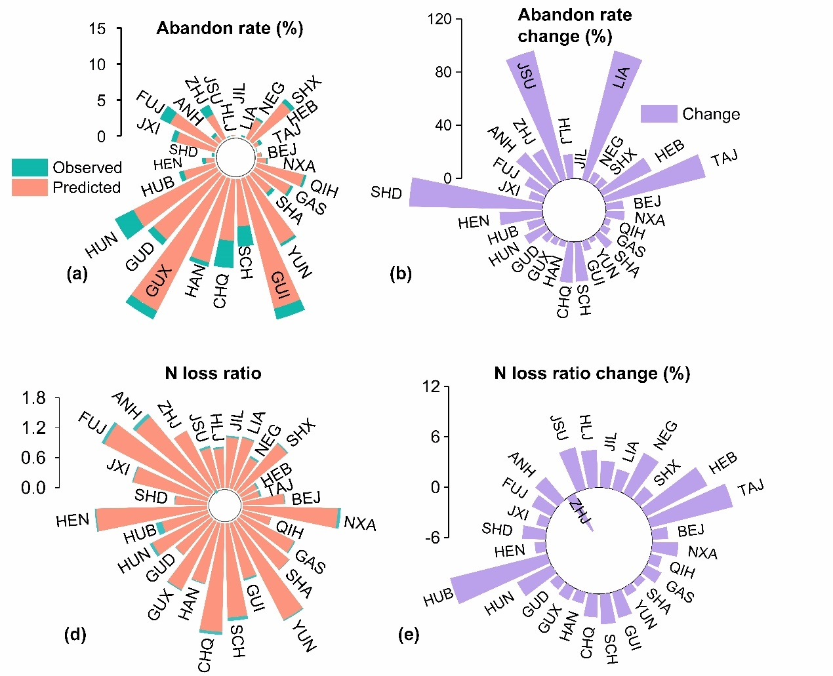
Fig. S3 Impact of aging on abandoned cropland and nitrogen (N) fertilizer loss in 2019. (a) Changes on abandoned cropland ratio; (b) Impact on abandoned cropland ratio under aging; (c) Changes on N fertilizer loss ratio; (d) Impact on N fertilizer loss ratio under aging. Abandoned cropland ratio is abandoned cropland area to the total cropland area on province-level. The predicted in panel (a) and (c) means the value without aging. The observed means the observed value in 2019. Relative change in panel (b) and (d) is calculated by determining the difference between the predicted values without aging and the observed values with aging divided by the observed values on province-level, and the result is carried out in percentage terms. Acronyms for 31 provinces, autonomous regions, and municipalities directly under the Central Government are listed in Table S6. Shanghai, Tibet and Xinjiang aren’t depicted due to data limitation.
Fig. S4 Socioeconomic changes under different scenarios by 2100. (a) Aging ratio; (b) Total population; (c) Urban population ratio; (d) Gross domestic product per capita (PGDP). SSP1-4 refers to Shared Socioeconomic Pathways (SSPs) scenarios. Data are from SSP Database.
Fig. S5 Relative changes of agricultural sustainability due to aging under SSP scenarios by 2100. (a) Farm size; (b) Education; (c) Labor productivity; (d) Total agricultural input; (e) Agricultural output; (f) Profit-cost ratio; (g) Machine input; (h) Fertilization; (i) Fertilizer use efficiency. NF, New farming. SSP1-4 refers to Shared Socioeconomic Pathways (SSPs) scenarios. The Baseline assumed no changes in the future. Relative change means value changes compared to 2020, and the result is carried out in percentage terms.
Fig. S6 Abandoned cropland and Nitrogen (N) fertilizer loss changes due to aging under SSP scenarios by 2100. (a) Abandoned cropland ratio change; (b) N fertilizer loss ratio change; (c) Relative change of abandoned cropland ratio compared to 2020; (d) Relative change of N fertilizer loss ratio compared to 2020. Abandoned cropland ratio is abandoned cropland area to the total cropland area on country-level. Relative change in panel (c) and (d) is carried out in percentage terms. NF, New farming. SSP1-4 refers to Shared Socioeconomic Pathways (SSPs) scenarios. The Baseline assumed no changes in the future.
Fig. S7 Employment and income in rural China. (a) Employed rate in rural and urban areas and in primary industry; (b) Income ratio from primary industry of rural people. Data are from China Rural Statistical Yearbook (available at https://data.cnki.net/trade/Yearbook/Single/N2020120306?z=Z009).
Fig. S8 Mortality of people aged over 65 in rural and urban areas. (a) Mortality due to accident; (b) Mortality due to mental illness; (c) Mortality due to suicide; (d) Total mortality of people aged over 65. Mortality, death number per 10⁴ people. Data are from China Population & Employment Statistics Yearbook (available at https://data.cnki.net/yearbook/Single/N2021020056).
Fig. S9 Mortality of people aged less 14 in rural and urban areas. (a) Mortality due to accident; (b) Mortality due to mental illness; (c) Mortality due to suicide; (d) Total mortality of people aged less 14. Mortality, death number per 10⁴ people. Data are from China Population & Employment Statistics Yearbook (available at https://data.cnki.net/yearbook/Single/N2021020056).

