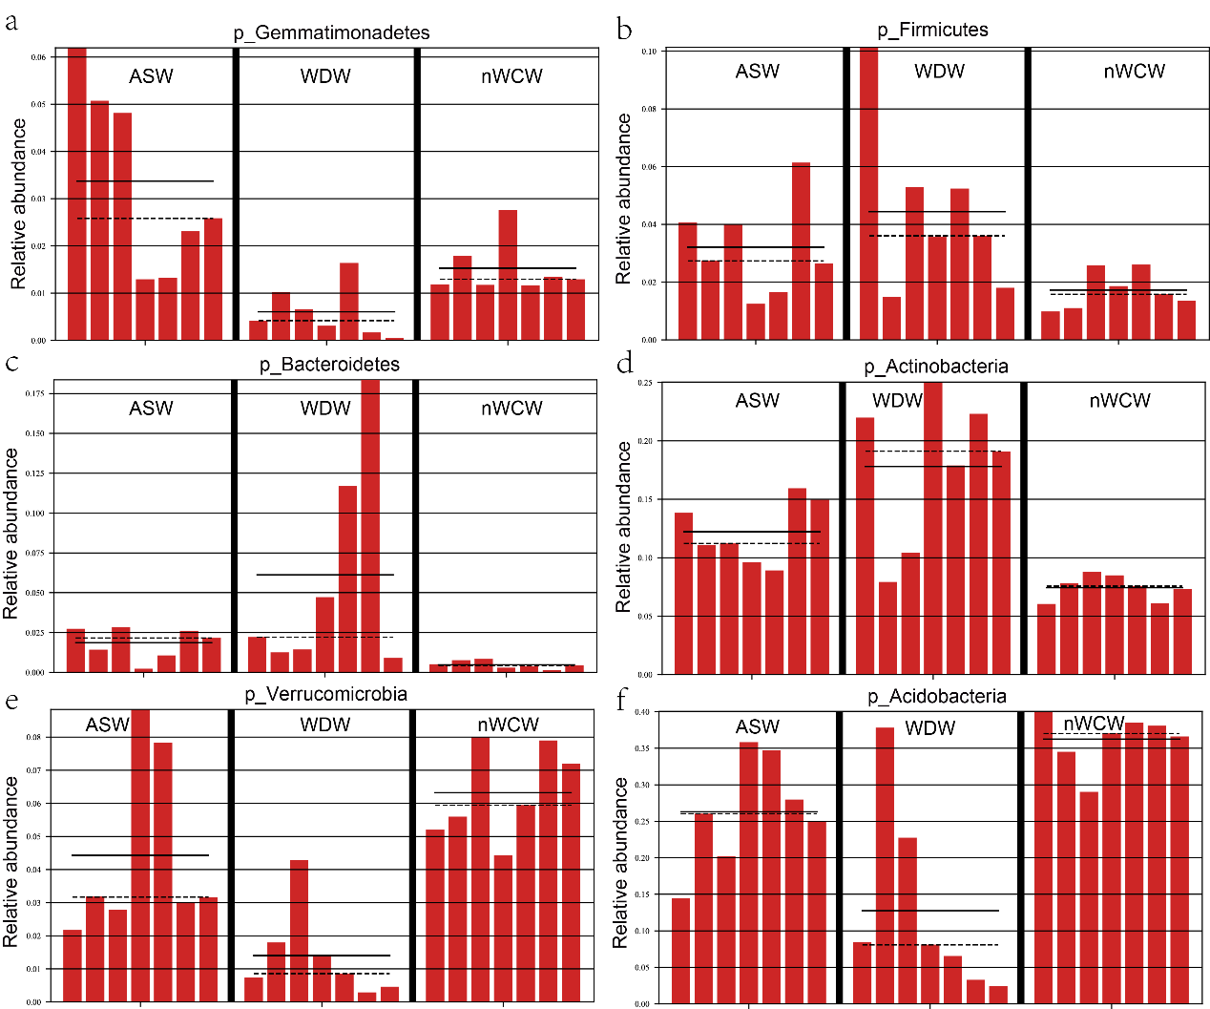
Fig. S1 Relative abundance of soil bacteria at genus level (Candidatus Solibacter, Ktedonobacter, Mucilaginibacter, and Leifsonia) in the three treatment groups

Table S1 Correlation coefficients (Spearman's ρ) among the predominant bacterial alpha diversity, soil properties, and nutrient contents of new leaves of Chinese fir seedlings
 | DOC | pH | SM | NH4 | NO3 | TN | AP | TP | Sugar | GLU | TG | TCH | FFA
OTU | -0.278 | 0.332 | 0.427 | -0.489 | 0.051 | -0.554 | 0.255 | -0.321 | 0.128 | 0.211 | 0.304 | 0.127 | 0.635
ACE | -0.216 | 0.481 | 0.341 | -0.572 | -0.335 | -0.529 | 0.419 | -0.210 | 0.063 | 0.024 | 0.373 | 0.127 | 0.544
Chao1 | -0.249 | 0.376 | 0.401 | -0.579 | -0.263 | -0.490 | 0.387 | -0.221 | 0.122 | 0.121 | 0.286 | 0.035 | 0.612
Simpson | -0.535 | 0.170 | 0.622 | -0.374 | -0.002 | -0.293 | 0.308 | -0.337 | 0.304 | 0.30 | 0.029 | -0.138 | 0.750
Shannon | -0.561 | 0.322 | 0.648 | -0.5539 | -0.249 | -0.498 | 0.454 | -0.253 | 0.295 | 0.318 | 0.285 | 0.068 | 0.743
DOC |  |  |  |  |  |  |  |  | -0.034 | -0.099 | -0.026 | -0.013 | -0.470
pH |  |  |  |  |  |  |  |  | -0.237 | -0.269 | 0.171 | -0.024 | 0.138
SM |  |  |  |  |  |  |  |  | 0.555 | 0.548 | 0.056 | -0.063 | 0.746
NH₄⁺-N |  |  |  |  |  |  |  |  | 0.187 | 0.162 | -0.255 | -0.027 | -0.348
NO₃⁻-N |  |  |  |  |  |  |  |  | -0.066 | 0.007 | -0.265 | -0.061 | 0.184
TN |  |  |  |  |  |  |  |  | 0.038 | 0.044 | -0.464 | -0.195 | -0.483
AP |  |  |  |  |  |  |  |  | -0.235 | -0.236 | 0.181 | 0.048 | 0.217
TP |  |  |  |  |  |  |  |  | 0.072 | 0.065 | 0.002 | 0.165 | -0.314
Significant values (p < 0.05) are in bold. DOC: Dissolved organic carbon; SM: soil moisture; TN: total nitrogen; TP: total phosphorus; AP: available phosphorus; Sugar: sugar content; GLU: glucose; TG: triglycerides; TCH: total cholesterol; FFA: free fatty acids

