A novel nanobody-heavy chain antibody against Angiopoietin-like protein 3 reduces plasma lipids and relieves nonalcoholic fatty liver disease
Xiaozhi Hu^{1,#}, Jiajun Fan^{1,#}, Qianqian Ma^{1,2,#}, Lei Han^{1,#}, Zhonglian Cao¹, Caili Xu¹, Jingyun Luan^{1,3}, Yanyang Nan¹, Tao Wu¹, Yuting Zhang¹, Hanqi Wang¹, Dianwe Ju^{1,*}

#These authors contributed equally to this work.
*Correspondence to: Prof. Dianwen Ju, E-mail: dianwenju@fudan.edu.cn
School of Pharmacy & Minhang Hospital, Shanghai Engineering Research Center of Immunotherapeutics, Fudan University, Shanghai, 201203, China
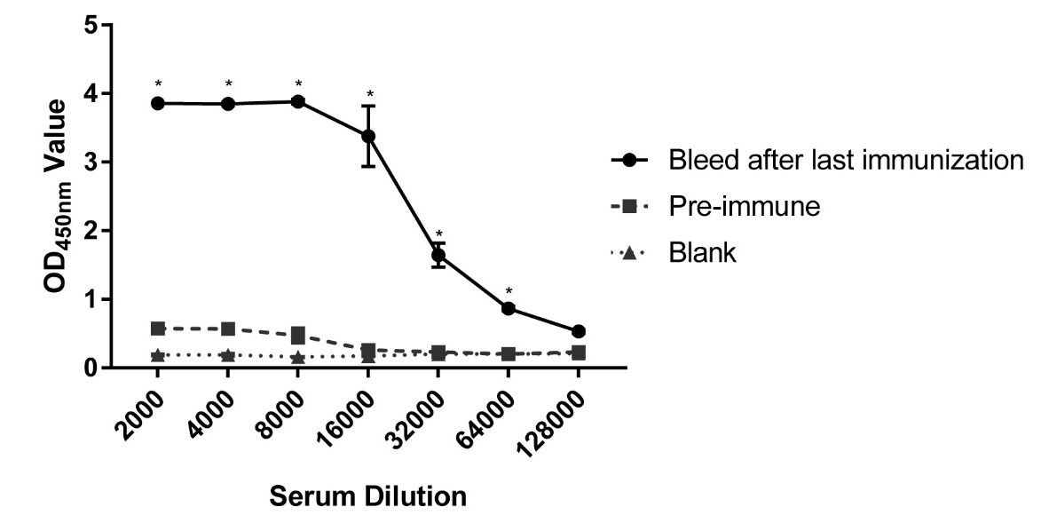
Figure S1 ELISA assay of plasmatic antibody titer from pre-immune and immunized alpaca (n = 3). The value ratio of post / pre-immune plasmatic ELISA ≥ 2.1 is recorded as positive (*)
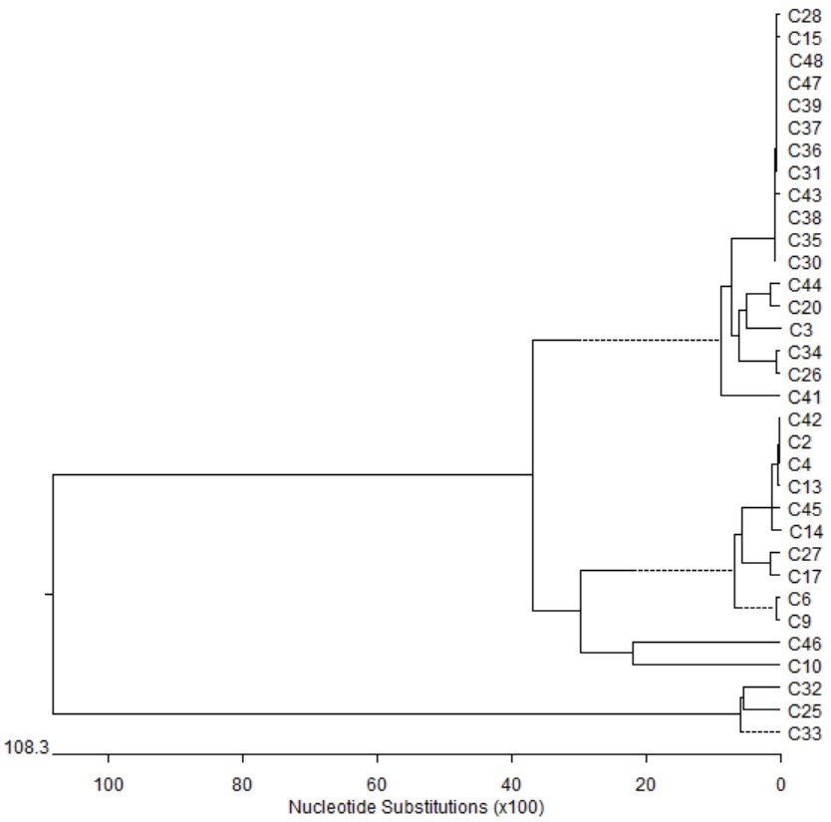
Figure S2 The phylogenetic tree analysis of hANGPTL3-specific VHHs. The hANGPTL3-specific VHHs sequences were analyzed by DNASTAR software.

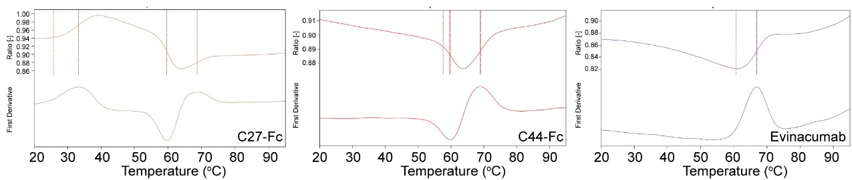
Figure S3 The thermal-stability curves of C27-Fc, C44-Fc and evinacumab tested by NanoTemper PR.48.
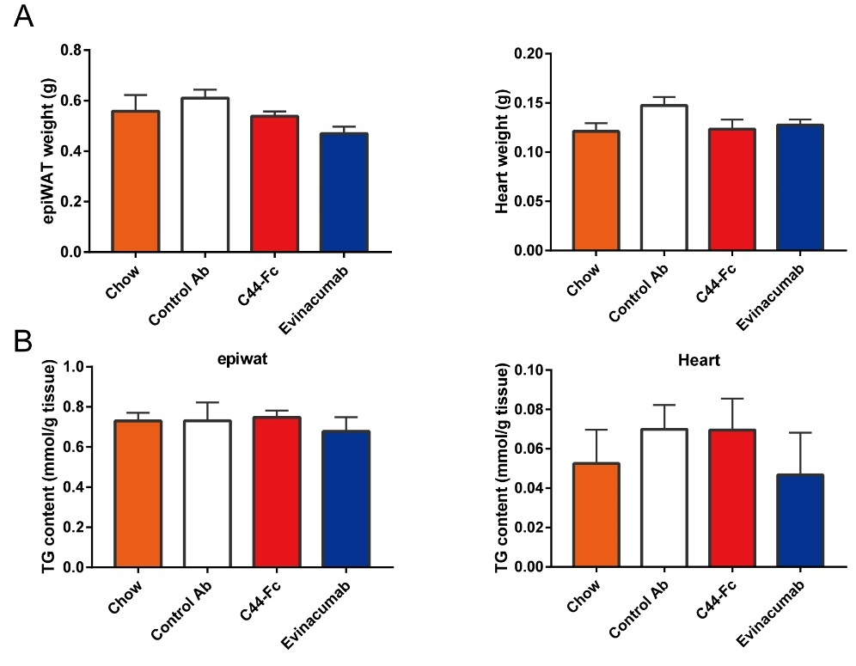
Figure S4 The weight (A) and TG content (B) of white adipose tissue (epiWAT) and hearts (n = 5). All tissue were acquired at the end of multiple lipids-lowering treatments.
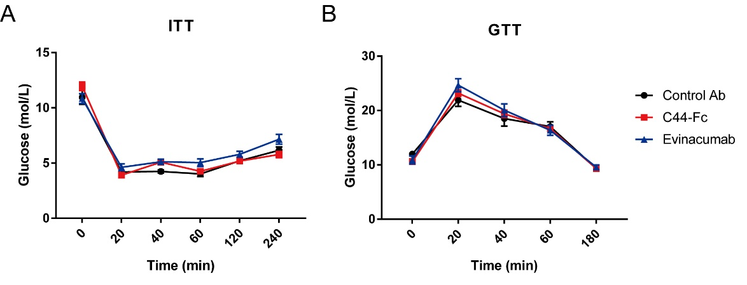
Figure S5 Insulin tolerance test (ITT, A) and glucose tolerance test (GTT, B) were performed at the sixth week of multiple lipids-lowering treatments (n = 5).

