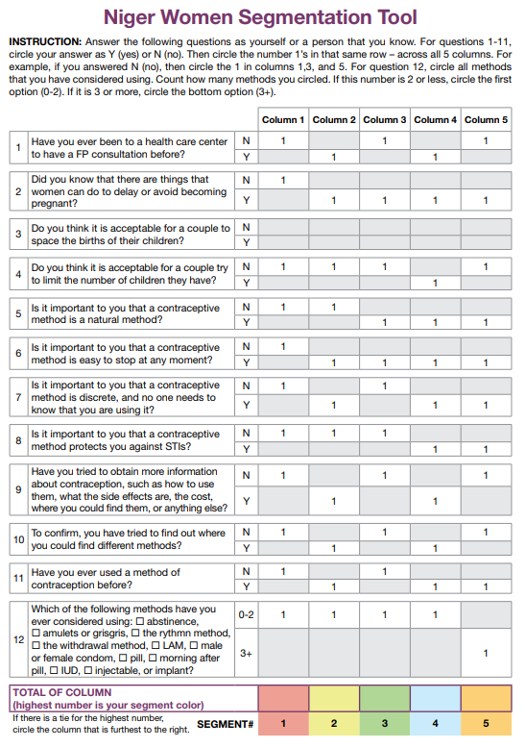
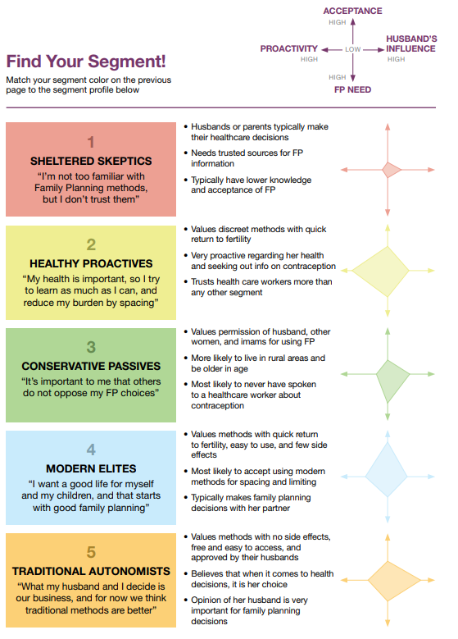
Figure 1: Segmentation counseling tool developed by (removed for anonymity) for use in Niger

