Anomalous Thermo-osmotic Conversion Performance of Ionic Covalent-Organic-Framework Membranes in Response to Charge Variations

Weipeng Xian,¹ Xiuhui Zuo,¹ Changjia Zhu,² Qing Guo,¹ Qing-Wei Meng,¹ Xincheng Zhu,¹ Sai Wang,¹ Shengqian Ma,² Qi Sun^{1,}*

¹Zhejiang Provincial Key Laboratory of Advanced Chemical Engineering Manufacture Technology, College of Chemical and Biological Engineering, Zhejiang University, Hangzhou, 310027, China.
²Department of Chemistry, University of North Texas, 1508 W Mulberry St Denton, TX 76201, United States.

*Email: sunqichs@zju.edu.cn (QS)

Experimental Details

Fabrication of COF-EB_{x}BD_{y}/PAN
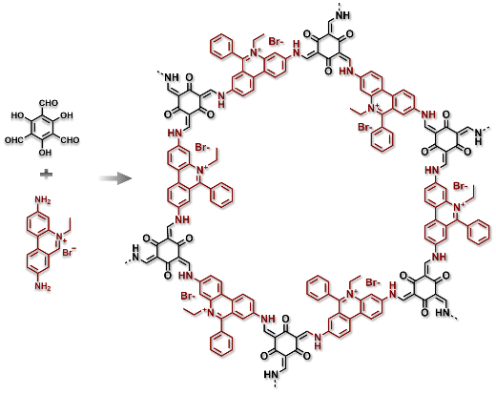
COF-EB/PAN. The COF active layers were formed via interface polymerization on the surface of asymmetric polyacrylonitrile (PAN) ultrafiltration membrane. The PAN support was vertically placed in the middle of a homemade diffusion cell, resulting in each volume of 7 cm³. A p-toluenesulfonic acid (TsOH, 31.5 mg, 0.165 mmol) aqueous solution (7 mL) of ethidium bromide (EB, 32.7 mg, 0.083 mmol), and the dichloromethane (7 mL) of Tp (11.6 mg, 0.055 mmol) were separately introduced into the two sides of the diffusion cell. The reaction mixture was kept at 35 °C for 4 d.
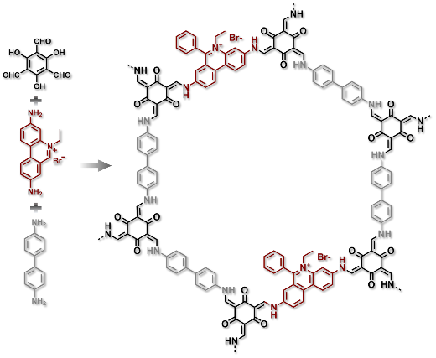
COF-EB₁BD₂/PAN. A TsOH (31.5 mg, 0.165 mmol) aqueous solution (7 mL) of the mixture of benzidine (BD, 10.1 mg, 0.055 mmol) and EB (11.0 mg, 0.028 mmol), and the dichloromethane (7 mL) of Tp (11.6 mg, 0.055 mmol) were separately introduced into the two sides of the diffusion cell. The reaction mixture was kept at 35 °C for 4 d.

COF-EB₁BD₃/PAN. A TsOH (31.5 mg, 0.165 mmol) aqueous solution (7 mL) of the mixture of benzidine (BD, 11.4 mg, 0.062 mmol) and EB (8.3 mg, 0.021 mmol), and the dichloromethane (7 mL) of Tp (11.6 mg, 0.055 mmol) were separately introduced into the two sides of the diffusion cell. The reaction mixture was kept at 35 °C for 4 d.
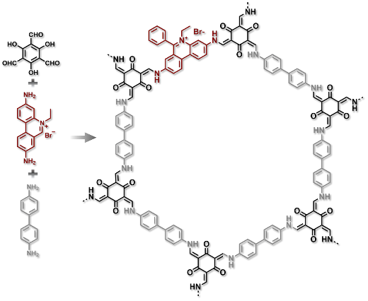
COF-EB₁BD₅/PAN. A TsOH (31.5 mg, 0.165 mmol) aqueous solution (7 mL) of the mixture of benzidine (BD, 12.7 mg, 0.069 mmol) and EB (5.5 mg, 0.014 mmol), and the dichloromethane (7 mL) of Tp (11.6 mg, 0.055 mmol) were separately introduced into the two sides of the diffusion cell. The reaction mixture was kept at 35 °C for 4 d.
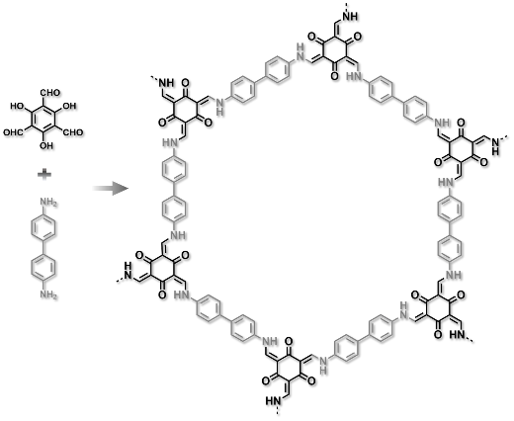
COF-BD/PAN. A TsOH (31.5 mg, 0.165 mmol) aqueous solution (7 mL) of benzidine (BD, 15.3 mg, 0.083 mmol), and the dichloromethane (7 mL) of Tp (11.6 mg, 0.055 mmol) were separately introduced into the two sides of the diffusion cell. The reaction mixture was kept at 35 °C for 4 d.

The resulting membranes were rinsed with methanol to remove any residual monomers and the catalyst. Finally, the membrane was rinsed with HCl aqueous solution (0.01 M) and H₂O for 24 h in sequence before testing or air-dried for physicochemical characterization.

Transmembrane conductance measurement
The ionic current was recorded by a CHI660E (CH Instruments). A pair of Ag/AgCl electrodes was used to apply a transmembrane potential. The membrane was mounted between the two chambers (4 cm³) of a homemade conductivity cell with a pore diameter of 1 mm. Both chambers were filled with an equal mole of KCl solution with the concentration ranging from 0.001 mM to 3 M. A scanning triangle voltage signal from -1 V to 1 V with a step voltage of 0.01 V and a period of 1 s was applied to record the I–V curves. The conductance values were derived from the slops of the resulting I–V curves.

Evaluation of transference number
For investigating the ion transport property of COF-EB_{x}BD_{y}/PAN, the ion current was recorded by CHI660E. To ignore the contribution of the redox potential of Ag/AgCl electrodes as a result of the inequable potential drop at the electrode-electrolyte interface, the conductivity cell with the pierced membrane separating three chambers was used (4 cm³), where the low concentration solution reservoirs were separated from a high concentration solution reservoir by the COF membrane and PAN, respectively (the effective testing area is 0.008 mm²). The voltage was scanned with a step of 0.01 V s⁻¹. The ion transference number $t_{-}$ of COF-EB_{x}BD_{y}/PAN was evaluated by determining the transmembrane diffusion potential ($ф_{diff}$). Herein, given that the redox potential of Ag/AgCl electrodes was eliminated during testing, $ф_{diff}$ is equal to $V_{oc}$.
$$V_{oc}=ф_{diff}=({2t}_{-}-1)\frac{RT}{F}ln\frac{a_{high}}{a_{low}} (1)$$
The ion transference number $t_{-}$ can be calculated with the following equation:
$${ t}_{-}=\frac{1}{2}\left(\frac{V_{oc}F}{RTln\frac{a_{high}}{a_{low}}}+1\right) (2)$$
where $a_{high},a_{low}, V_{oc}, F, R, and T$ are the activities of ions in high concentration solution and low concentration solution, open circuit potential, Faraday constant, gas constant, and absolute temperature, respectively.
Evaluation of thermoelectric response of COF-EB_{x}BD_{y}/PAN
The thermoelectric response was recorded by a homemade setup (Figure 5b, inset, main text). A micro-ceramic heater (Zhuhai Huiyou Electronics, China) was employed to regulate the temperature of solutions. A direct current power (HSPY-60-5, Hanshengpuyuan, China) was connected to the heating rod to control the heating rate and temperature range. A pair of temperature microsensors (PT100, Tenghui Wenkong Instruments, China) was immersed in two solutions to measure the real-time temperature, which was recorded by a temperature sensor (THMA temperature recorder, Tenghui Wenkong Instruments, China). The measurement accuracy and working range of the temperature sensor are ± 0.1 K and −173.15−473.15 K, respectively. The transmembrane potential was synchronously collected by the CHI660E electrochemical workstation using two Ag/AgCl electrodes. The time resolutions of temperature recorder and transmembrane potential are both 1 s. For investigating the thermoelectric response property of the COF-EB_{x}BD_{y}/PAN membrane, a conductivity cell with the pierced membrane separating two chambers was used and both of the chambers were filled with 1 mM KCl solutions. A temperature gradient was induced by a brief heating of the chamber facing the COF active layer. The voltage variation relative to the initial state can be expressed as:
$${∆V_{oc}(T)=-2t}_{-}\frac{R}{F}∆Tlnα (3)$$
$$∆T=T_{low}-T_{high} (4)$$

Osmotic energy harvesting
A pair of cation-selective membrane (Nafion®212) and anion-selective membrane (COF-EB_{x}BD_{y}/PAN) is mounted in a three-compartment conductive cell to harvest osmotic energy. The volume of each chamber is 4 cm³ with a pore diameter of 0.1 mm. The high salinity solution (0.5 M NaCl) is placed in the middle chamber and the low salinity solution (0.01 M NaCl) is set at the side chambers. Ag/AgCl electrodes were used to apply a transmembrane potential and measure the resulting current. The X-intercepts of the I–V plots represent the open-circuit voltage ($V_{oc}$) and the Y-intercepts of I–V plots present the short-circuit current ($I_{sc}$). The maximum output power can be calculated using
$${ P}_{max}= \frac{I_{sc}V_{oc}}{4} (5) \\ { PD}_{max}= \frac{P_{max}}{S} (6)$$
where $P_{max}$, ${PD}_{max}$, and $S$ are the maximum power, maximum power density, and the effective working area of the COF membrane, respectively.

Evaluation of the thermo-osmotic power production
The thermo-osmotic power production of COF-EB_{x}BD_{y}/PAN was evaluated using a homemade setup. A micro-ceramic heater (Zhuhai Huiyou Electronics, China) was employed to regulate the temperature of solutions. A direct current power (HSPY-60-5, Hanshengpuyuan, China) was connected to the heating rod to control the heating rate and temperature range. A pair of temperature microsensors (PT100, Tenghui Wenkong Instruments, China) was immersed in two solutions to measure the real-time temperature, which was recorded by a temperature sensor (THMA temperature recorder, Tenghui Wenkong Instruments, China). The transmembrane potential was synchronously collected by the CHI660E electrochemical workstation using a pair of Ag/AgCl electrodes. A conductivity cell with the pierced membrane separating three fluidic chambers was used, where the chambers filled with 0.01 M NaCl solution were separated from the chamber filled with 0.5 M NaCl solution by the COF membrane and Nafion®212, respectively, with the COF active layer facing the low concentration side. The volume of each chamber is 4 cm³ with a pore diameter of 0.1 mm. A temperature gradient was induced by a brief heating of the 0.01 M NaCl solution. The voltage variation relative to the initial state is dependent on both temperature and activity gradient, which can be calculated using the following equation:
$$V_{oc}= -2t_{-}\frac{R}{F}(T_{low}lna_{low}-T_{high}lna_{high}) (7)$$
where $T_{high}, and T_{low}$ are the temperatures of high concentration and low concentration solutions. When the temperature of low concentration solution was changed (the temperature of solution in high concentration solution remained unchanged), the voltage variation relative to the initial state can be expressed as:
$${∆V_{oc}(T)=-2t}_{-}\frac{R}{F}∆Tlna_{low} (8)$$
The maximum output power density can be calculated using equations 5 and 6.

Stability evaluation
A pair of a cation-selective membrane (Nafion®212) and anion-selective membrane (COF-EB₁BD₂/PAN) is mounted in a three-compartment conductive cell to harvest osmotic energy. The high salinity solution (0.5 M NaCl) is placed on the middle reservoir, and the low salinity solution (0.01 M NaCl) is set at the side reservoirs, with the COF active layer facing the low concentration side using the setup for the evaluation of thermo-osmotic power production. The electrolyte solutions were replenished with fresh solutions at each cycle. The temperature gradient of 40 K was induced by a brief heating of the 0.01 M NaCl solution. I–V plots of the RED device were recorded every 24 h. The initial $V_{oc}, I_{sc},$and power density are 167.7 mV, 35.7 μA, and 191 W m⁻², which are maintained at 163.7 mV, 34.8 μA, and 181 W m⁻² after 14 d, respectively.

Numerical simulations
The numerical simulation was performed based on coupled Poisson and Nernst-Planck equations by setting appropriate boundary parameters using a commercial finite-element software package COMSOL (version 5.2). The Nernst-Planck equation (9) defines the flux of each ion species, which describes the transport character of charged nanochannels. The ion concentration induced electrical potential can be described by Poisson equation (10). When the system reaches a stationary regime, the ion flux should conform to the steady-state continuity equation (11).
$${ j}_{i}=D_{i}\left(∇c_{i}+\frac{z_{i}F c_{i} }{RT}∇ф\right) (9)$$
$${ ∇}^{2}ф=-\frac{F}{ɛ}∑{z_{i}c}_{i} (10)$$
$$∇·j_{i}=0 (11)$$
Where $j_{i}$, $c_{i}$, $z_{i}$, and $D_{i}$ are the ionic flux, ion concentration, charge number of each ionic species, and diﬀusion coeﬃcient. $ф$and $ɛ$ represent the electrical potential and the dielectric constant of medium. $T$, $F$, and $R$ are the absolute temperature, Faraday constant, and universal gas constant, respectively. The diﬀusion coeﬃcients for cations and anions are 1.334×10⁻⁵ and 2.032×10⁻⁵ cm² s⁻¹ (NaCl was used as the electrolyte).
For simplification, a 1.5-nm-width and 200-nm-length rectangle nanochannel was used to simulate the channels inside the COF-EB_{x}BD_{y}/PAN. To decrease the effect of entrance/exit mass transfer resistances on the overall ionic transport, two electrolyte reservoirs are introduced. The external potential is applied on the boundary $w_{1}$, and $w_{2}$ offered the reference potential. The boundary conditions for the electrical potential and ion flux are shown as below:
$$\vec{n}·∇ф=-\frac{σ}{ε} (12)$$
$$\vec{n}·j=0 (13)$$
The physical quantity σ represents the surface charge density of the channel walls. The ionic current can be calculated by
$$I=\iint{j_{i}}ds=-\iint{D_{i}\left(∇c_{i}+z_{i}c_{i}\frac{F}{RT}∇ф\right)ds} (14)$$
Temperature gradient, as an external driving force, drives the motion of solute. To describe the cause for thermal potential inside a nanochannel, the numerical model has to consider both mass and heat transfers. To facilitate the calculation, the diffusion coefficients of Na⁺ and Cl⁻ were fixed during heating. Therefore, we introduce the Nernst-Plank equation into the model to describe ion transport and concentration profiles under a temperature gradient,
$$I=\iint{j_{i}}ds=-\iint{D_{i}\left(∇c_{i}+z_{i}c_{i}\frac{F}{RT}∇ф-c_{i}u\right)ds} (15)$$
where $u$ is the velocity induced by thermo-osmosis and thermoelectric effect, which can be formulated as follow,
$$u=-\frac{εζ^{2}}{3η}-\frac{εζψ_{0}}{η}\frac{∇T}{T} (16)$$
where $ζ$ is the zeta potential; $η$ is the viscosity of solvent; $ψ_{0}$is the bulk electric potential.
For the power generation calculations, a concentration gradient ($c_{high}$/$c_{low}$ = 0.5 M/0.01 M) is employed and no external potential is applied. The corresponding diffusion current can be attained by:
${ I}_{diff}=\left|\left|I_{+}\right|-\left|I_{-}\right|\right| (17)$
$${{ ф}_{diff}=ф}_{high}-ф_{low} (18)$$

Supplementary Table 1 | Zeta potentials for the COF-EB_{x}BD_{y}/PAN membranes collected at pH=6.5.
Membrane | Zeta potential (mV)^{[a]}
COF-BD/PAN | 10.9
COF-EB₁BD₅/PAN | 13.0
COF-EB₁BD₃/PAN | 18.2
COF-EB₁BD₂/PAN | 20.7
COF-EB/PAN | 25.8
^{[a]}The zeta potentials for these membranes were calculated using Z(COF-EB_{x}BD_{y}/PAN)$-$Z(PAN), whereby Z(COF-EB_{x}BD_{y}/PAN) is the zeta potential of the composite COF-EB_{x}BD_{y}/PAN membranes, and Z(PAN) is the zeta potential of PAN (-51.1 mV), respectively.

Supplementary Table 2 | The content of bromine species in the free-standing COF-EB_{x}BD_{y}/PAN membranes.
Membrane | Theoretical values (mmol g⁻¹) | Elemental analysis (mmol g⁻¹)
COF-BD | -- | --
COF-EB₁BD₅ | 0.026 | 0.017
COF-EB₁BD₃ | 0.049 | 0.031
COF-EB₁BD₂ | 0.066 | 0.042
COF-EB | 0.250 | 0.250

Supplementary Table 3 | The charge density in the COF-EB_{x}BD_{y}/PAN membranes calculated according to the results of elemental analysis.
Membrane | Charge density (C m⁻²)
COF-BD | 0
COF-EB₁BD₅ | 0.02
COF-EB₁BD₃ | 0.03
COF-EB₁BD₂ | 0.04
COF-EB | 0.12

Supplementary Table 4 | Osmotic/thermo-osmotic energy harvesting performance of representative RED systems in the literature.
Materials | Charge density  (C m⁻²) | System | Power density  (W m⁻²) | Testing area  (mm²) | Resistance (kΩ) | ΔT (K)
2D materials
Ti₃C₂T_{x} MXene membranes^{[1]} |  | 0.5 M/0.01 M NaCl | 4.6 | 0.2 | 5
MXene/Kevlar nanofiber composite^{[2]} | 0.02 | 0.5 M/0.01 M NaCl | 4.1 | 0.03 | 30
Ti₃C₂T_{x} MXene^{[3]} |  | 1 M/0.001 M KC | 20.85 | 0.0163 | 14
Ti₃C₂T_{x} MXene/BN (MXBN) membrane^{[4]} |  | 0.5 M/0.01 M | 0.8(6.2^{[a]}) | 7.07 cm² | 60 | 60
Graphene oxide membrane^{[5]} | 0.15 | 0.5 M/0.01 M NaCl | 0.77 | 0.2 | 10
Vertically transported graphene oxide^{[6]} |  | 0.5 M/0.01 M NaCl | 10.6 | 0.00355 | 100
Graphene reverse electrodialysis device^{[7]} | 0.02 | 1 M/0.001 M NaCl | 8 | 1.5 μm² | 130000
GO/Silk nanofiber membrane^{[8]} |  | 0.5 M/0.01 M NaCl | 5.07 (9^{[a]}) | 0.03 | 35 | 40
2D/3D-GO/polymer^{[9]} |  | 0.5 M/0.01 M NaCl | 0.76 |  | 300
Polymeric-C₃N₄^{[10]} |  | 0.1 M/0.1 mM KCl | 0.21 | 1.5 | 8.9
Nanocomposite membranes (BN)^{[11]} |  | 0.5 M/0.01 M NaCl | 5.9 | 0.03
BN nanopore membrane^{[12]} | 0.0323 | 1000 mM/1 mM KCl | 0.17 | 0.1
Single transmembrane BN nanotube^{[13]} | 0.1 | 1 M/0.1 mM KCl | 4000 | 10000 nm² | 54348
Inorganic materials
Silk-based AAO hybrid membranes^{[14]} |  | 0.5 M/0.01 M NaCl | 2.86 | 0.03 | 23
AAO ionic diode membrane^{[15]} | 0.06 | 0.5 M/0.01 M NaCl | 3.46 | 0.03 | 10
Heterogeneous BCP/AAO^{[16]} |  | 0.5 M/0.01 M NaCl | 2.94 | 0.03 | 46
CMWs/AAO membrane^{[17]} |  | 0.5 M/0.01 M NaCl | 2.78 | 0.03 | 10
Silica/AAO heterostructure membranes^{[18]} |  | 0.5 M/0.01 M NaCl | 4.5 | 0.03 | 10
AAO nanochannels^{[19]} |  | 0.1 mM/0.1 mM KCl^{[a]} | 25.5 |  | 50 | 30
Solar thermoelectric nanofluidic^{[20]} | -0.0052 |  | 4.5×10-5^{[a]} |  |  | 35
Ultrasmall silica nanochannels^{[21]} |  | 0.5 M/0.01 M NaCl | 1.0 (1.404^{[a]}) | 0.0327 | 20 | 10
Silica nanochannels^{[22]} | 0.002 | 1 M/0.1 mM KCl | 7.7
Ultrathin silica isoporous membrane^{[23]} | 0.015 | 0.5 M/0.01 M NaCl | 0.024 | 0.25 | 220
Nanofluidic crystal silicon^{[24]} |  | 0.1 M/0.1 mM KCl | 2.82 | 0.00532 | 1300
Silica^{[25]} |  | 300 mM/0.1 mM KCl | 3.9 | 55.7 μm² | 14000
Black phosphorus membranes^{[26]} | 0.002 | 0.6 M/0.004 M NaCl | 4.7 | 0.03 | 40
2D metallic MoS₂^{[27]} |  | 0.5 M/0.01 M NaCl | 6.7 | 0.03 | 23
Single-layer MoS₂^{[28]} | 0.0469 | 1 M/1 mM KCl | 1000000 | 100 nm² | 9400
Montmoril-modification lamellae^{[29]} |  | 1 M/1 mM KCl | 0.15 (0.34^{[a]}) | 0.785 | 10 | 30
Nanokaolinite membranes^{[30]} |  | 0.1 M/0.001 M KCl | 0.18 | 0.2 | 250
Polymers
Janus 3D porous membrane^{[31]} | 0.05 | 0.5 M/0.01 M NaCl | 2. 66 |  | 10
PVA gel electrolytes^{[32]} | 0.005 | 100 mM/0.1 mM KCl | 0.624 | 0.03 | 100
Three-dimensional hydrogel interface^{[33]} |  | 0.5 M/0.01 M NaCl | 5.06 | 0.03 | 40
TOCNs/PET^{[34]} | -0.012 | 0.5 M/0.01 M NaCl | 0.96 | 9 | 100
Janus membranes (PSS)^{[35]} |  | 0.5 M/0.01 M NaCl | 2.04 | 0.03 | 20
Single-ion-selectivenanopores (PET)^{[36]} |  | 1 M/1 mM KCl | 20-2600 | 225 nm² | 16000
Paper channel ^{[37]} |  | 0.3 M/0.0001 M KCl | 0.00275 | 20 | 10
Heterogeneous membrane (PET)^{[38]} |  | 0.5 M/0.01 M NaCl | 0.35 |  | 150
Hydrogel-based nanofluidics^{[39]} |  | 0.5 M/0.01 M NaCl | 4.08 | 0.03 | 25
Cyto-compatible asymmetric polypyrrole^{[40]} |  | 0.5 M/0.01 M NaCl | 0.087 |  | 5
Poly(ether sulfone) bipolar membrane^{[41]} |  | 0.5 M/0.01 M NaCl | 6.2 | 0.03 | 10
PES/SPES nanochannel^{[42]} |  | 0.5 M/0.001 M NaCl | 2.48 |  | 30
Polyelectrolyte-filled mesopores^{[43]} |  | 500 mM/1 mM KCl | 945 | 0.123 μm² | 54000
SPEEK^{[44]} | 0.0423 | 0.5 M/0.01 M NaCl | 5.8 | 0.03 | 20
Nanochannel array membrane (PEI)^{[45]} |  | 0.5 M/0.01 M NaCl | 13.2 | 0.008 | 10
PCTE membrane^{[46]} | -0.0065 | 10 mM/1 mM KCl | 74.8 nW (177.5^{[a]}) |  |  | 25
PET membrane^{[47]} | -0.06 | 1 M/1 mM KCl | 56.22% enhanced^{[a]} |  |  | 30
SPEEK/PES blend membrane^{[48]} |  | 0.5 M/0.01 M LiBr | 9.26 (16.50^{[a]}) | 0.2 | 30(7^{[a]}) | 30
Alternating cells^{[49]} |  | 35.4 g L⁻¹/0.56 g L⁻¹ NaCl | 0.46 | 4 cm² | 0.005
Ion exchange membrane pairs^{[50]} |  | 0.5 M/0.01 M NaCl | 0.26 |  | 0.082
Ion exchange membrane^{[51]} |  | 30 g/1 g NaCl | 1.2
Ion exchange membranes^{[52]} |  | 0.6 M/1.5 mM | 3.5
RED-MED system^{[53]} |  | 4.5 M/0.05 M NaCl | 4 (14^{[a]}) | 8.8×10⁴ | 132 | 80
Framework materials
Polymer/MOF^{[54]} | 0.01 | 0.5 M/0.01 M NaCl | 2.87 | 0.03 | 6.5
COF-TpPa-SO₃H^{[55]} |  | 0.5 M/0.01 M NaCl | 5.9 | 0.03 | 23
MOFs membrane^{[56]} |  | 0.5 M/0.01 M NaCl | 2.96 | 0.03 | 50
PyPa-SO₃H/SANF membranes^{[57]} |  | 0.5 M/0.01 M NaCl | 8.3 | 20.74 | 5
Biomaterials
Silk fibroin membrane^{[58]} | 0.008 | 5 M/0.01 M NaCl | 21.66 | 0.03 | 4
Bacterial cellulose membranes^{[59]} | 0.0031 | 0.5 M/0.01 M NaCl | 0.23 | 1.8 | 7
Ionized wood membrane^{[60]} | 0.0031 | 0.6 M/0.01 M NaCl | 0.00514 | 100
This work
COF-BD/PAN | 0 | 0.5 M/0.01 M NaCl | 32 (57^{[a]}) | 0.008 | 12 | 40
COF-EB₁BD₅/PAN | 0.02 | 0.5 M/0.01 M NaCl | 77 (134^{[a]}) | 0.008 | 8 | 40
COF-EB₁BD₃/PAN | 0.03 | 0.5 M/0.01 M NaCl | 99 (183^{[a]}) | 0.008 | 7 | 40
COF-EB₁BD₂/PAN | 0.04 | 0.5 M/0.01 M NaCl | 113 (215^{[a]}) | 0.008 | 7 | 40
COF-EB/PAN | 0.12 | 0.5 M/0.01 M NaCl | 110 (218^{[a]}) | 0.008 | 7 | 40
^{[a]} The values in parentheses refer to the output power density in the presence of a temperature difference.
- Ding, L., Xiao, D., Lu, Z., Deng, J., Wei, Y., Caro, J. & Wang, H. Oppositely charged Ti₃C₂T_{x} MXene membranes with 2D nanofluidic channels for osmotic energy harvesting. Angew. Chem. Int. Ed. 59, 8720–8726 (2020).
- Zhang, Z., Yang, S., Zhang, P., Zhang, J., Chen, G. & Feng, X. Mechanically strong MXene/Kevlar nanofiber composite membranes as high-performance nanofluidic osmotic power generators. Nat. Commun. 10, 2920 (2019).
- Hong, S., Ming, F., Shi, Y., Li, R., Kim, I. S., Tang, C. Y., Alshareef, H. N. & Wang, P. Two-dimensional Ti₃C₂T_{x} MXene membranes as nanofluidic osmotic power generators. ACS Nano 13, 8917 (2019).
- Yang, G., Liu, D., Chen, C., Qian, Y., Su, Y., Qin, S., Zhang, L., Wang, X., Sun, L. & Lei, W. Stable Ti₃C₂T_{x} MXene-boron nitride membranes with low internal resistance for enhanced salinity gradient energy harvesting. ACS Nano 15, 6594–6603 (2021).
- Ji, J., Kang, Q., Zhou, Y., Feng, Y., Chen, X., Yuan, J., Guo, W., Wei, Y. & Jiang, L. Osmotic power generation with positively and negatively charged 2D nanofluidic membrane pairs. Adv. Funct. Mater. 27, 1603623 (2017).
- Zhang, Z., Shen, W., Lin, L., Wang, M., Li, N., Zheng, Z., Liu, F. & Cao, L. Vertically transported graphene oxide for high-performance osmotic energy conversion. Adv. Sci. 7, 2000286 (2020).
- Fu, Y., Guo, X., Wang, Y., Wang, X. & Xue, J. An atomically-thin graphene reverse electrodialysis system for efficient energy harvesting from salinity gradient. Nano Energy 57, 783–790 (2019).
- Xin, W., Xiao, H., Kong, X.-Y., Chen, J., Yang, L., Niu, B., Qian, Y., Teng, Y., Jiang, L. & Wen, L. Biomimetic nacre-like silk-crosslinked membranes for osmotic energy harvesting. ACS Nano 14, 9701–9710 (2020).
- Zhu, X., Zhou, Y., Hao, J., Bao, B., Bian, X., Jiang, X., Pang, J., Zhang, H., Jiang, Z. & Jiang, L., A charge-density-tunable three/two-dimensional polymer/graphene oxide heterogeneous nanoporous membrane for ion transport. ACS Nano 11, 10816–10824 (2017).
- Xiao, K., Giusto, P., Wen, L., Jiang, L. & Antonietti, M. Nanofluidic ion transport and energy conversion through ultrathin free‐standing polymeric carbon nitride membranes. Angew. Chem. Int. Ed. 57, 10123–10126 (2018).
- Chen, C., Liu, D., He, L., Qin, S., Wang, J., Razal, J. M., Kotov, N. A. & Lei, W. Bio-inspired nanocomposite membranes for osmotic energy harvesting. Joule 4, 247–261 (2020).
- Pendse, A., Cetindag, S., Rehak, P., Behura, S., Gao, H., Nguyen, N. H. L., Wang, T., Berry, V., Král, P., Shan, J. & Kim, S., Highly efficient osmotic energy harvesting in charged boron-nitride-nanopore membranes. Adv. Funct. Mater. 31, 2009586 (2021).
- Siria, A., Poncharal, P., Biance, A.-L., Fulcrand, R., Blasé, X., Purcell, S. T. & Bocquet, L. Giant osmotic energy conversion measured in a single transmembrane boron nitride nanotube. Nature 494, 455–458 (2013).
- Xin, W., Zhang, Z., Huang, X., Hu, Y., Zhou, T., Zhu, C., Kong, X.-Y., Jiang, L. & Wen, L. High-performance silk-based hybrid membranes employed for osmotic energy conversion. Nat. Commun. 10, 3876 (2019).
- Gao, J., Guo, W., Feng, D., Wang, H., Zhao, D. & Jiang, L. High-performance ionic diode membrane for salinity gradient power generation. J. Am. Chem. Soc. 136, 12265–12272 (2014).
- Sui, X., Zhang, Z., Li, C., Gao, L., Zhao, Y., Yang, L., Wen, L. & Jiang, L. Engineered nanochannel membranes with diode-like behavior for energy conversion over a wide pH range. ACS Appl. Mater. Interfaces. 11, 23815–23821 (2019).
- Xie, L., Zhou, S., Liu, J., Qiu, B., Liu, T., Liang, Q., Zheng, X., Li, B., Zeng, J., Yan, M., He, Y., Zhang, X., Zeng, H., Ma, D., Chen, P., Liang, K., Jiang, L., Wang, Y., Zhao, D. & Kong, B. Sequential superassembly of nanofiber arrays to carbonaceous ordered mesoporous nanowires and their heterostructure membranes for osmotic energy conversion. J. Am. Chem. Soc. 143, 6922–6932 (2021).
- Zhou, S., Xie, L., Zhang, L., Wen, L., Tang, J., Zeng, J., Liu, T., Peng, D., Yan, M., Qiu, B., Liang, Q., Liang, K., Jiang, L. & Kong, B. Interfacial super-assembly of ordered mesoporous silica-alumina heterostructure membranes with pH-sensitive properties for osmotic energy harvesting. ACS Appl. Mater. Interfaces 13, 8782–8793 (2021).
- Van Toan, N., Hasnan, M. M. I. M., Udagawa, D., Inomata, N., Toda, M., Said, S. M., Sabri, M. F. M. & Ono, T. Thermoelectric power battery using al₂o₃ nanochannels of 10 nm diameter for energy harvesting of low-grade waste heat. Energy Convers. Manag. 199, 111979 (2019).
- Li, Z.-Q., Wu, Z.-Q., Ding, X.-L., Wu, M.-Y. & Xia, X.-H. A solar thermoelectric nanofluidic device for solar thermal energy harvesting. CCS Chem. 2, 2174–2182 (2020).
- Chen, K., Yao, L., Yan, F., Liu, S., Yang, R. & Su, B. Thermo-osmotic energy conversion and storage by nanochannels. J. Mater. Chem. A 7, 25258–25261 (2019).
- Kim, D.-K., Duan, C., Chen, Y.-F. & Majumdar, A. Power generation from concentration gradient by reverse electrodialysis in ion-selective nanochannels. Microfluid. Nanofluid. 9, 1215–1224 (2010).
- Yan, F., Yao, L., Chen, K., Yang, Q. & Su, B. An untrathin and highly porous silica nanochannel membrane: toward highly efficient salinity energy conversion. J. Mater. Chem. A. 7, 2385–2391 (2019).
- Ouyang, W., Wang, W., Zhang, H., Wu, W. & Li, Z. Nanofluidic crystal: a facile, high-efficiency and high-power-density scaling up scheme for energy harvesting based on nanofluidic reverse electrodialysis. Nanotechnology 24, 345401 (2013).
- Hwang, J., Kataoka, S., Endo, A. & Daiguji, H. Enhanced energy harvesting by concentration gradient-driven ion transport in SBA-15 mesoporous silica thin films. Lab Chip. 16, 3824–3832 (2016).
- Zhang, Z., Zhang, P., Yang, S., Zhang, T., Löffler, M., Shi, H., Lohe, M. R. & Feng, X. Oxidation promoted osmotic energy conversion in black phosphorus membranes. Proc. Natl Acad. Sci. USA 117, 13959–13966 (2020).
- Zhu, C., Liu, P., Niu, B., Liu, Y., Xin, W., Chen, W., Kong, X.-Y., Zhang, Z., Jiang, L. & Wen, L. Metallic two-dimensional MoS₂ composites as high-performance osmotic energy conversion membranes. J. Am. Chem. Soc. 143, 1932–1940 (2021).
- Feng, J., Graf, M., Liu, K., Ovchinnikov, D., Dumcenco, D., Heiranian, M., Nandigana, V., Aluru, N. R., Kis, A. & Radenovic, A. Single-layer MoS₂ nanopores as nanopower generators. Nature 536, 197–200 (2016).
- Wu, C., Xiao, T., Tang, J., Zhang, Q., Liu, Z., Liu, J. & Wang, H. Biomimetic temperature-gated 2D cationic nanochannels for controllable osmotic power harvesting. Nano Energy 76, 105113 (2020).
- Cheng, H., Zhou, Y., Feng, Y., Geng, W., Liu, Q., Guo, W. & Jiang, L. Electrokinetic energy conversion in self‐assembled 2D nanofluidic channels with janus nanobuilding blocks. Adv. Mater. 29, 1700177 (2017).
- Zhu, X., Hao, J., Bao, B., Zhou, Y., Zhang, H., Pang, J., Jiang, Z. & Jiang, L. Unique ion rectification in hypersaline environment: a high-performance and sustainable power generator system. Sci. Adv. 4, eaau1665 (2018).
- Yeh, L.-H., Huang, Z.-Y., Liu, Y.-C., Deng, M.-J., Chou, T.-H., OuYang, H.-C., Ahamad, T., Alshehrif, S. M. & Wu, K. C.-W. A nanofluidic osmotic power generator demonstrated in polymer gel electrolytes with substantially enhanced performance. J. Mater. Chem. A. 7, 26791–26796 (2019).
- Zhang, Z., He, L., Zhu, C., Qian, Y., Wen, L. & Jiang, L. Improved osmotic energy conversion in heterogeneous membrane boosted by three-dimensional hydrogel interface. Nat. Commun. 11, 875 (2020).
- Xu, Y., Song, Y. & Xu, F. TEMPO oxidized cellulose nanofibers-based heterogenous membrane employed for concentration-gradient-driven energy harvesting. Nano Energy 79, 105468 (2021).
- Zhang, Z., Sui, X., Li, P., Xie, G., Kong, X.-Y., Xiao, K., Gao, L., Wen, L. & Jiang, L. Ultrathin and ion-selective Janus membranes for high-performance osmotic energy conversion. J. Am. Chem. Soc. 139, 8905–8914 (2017).
- Guo, B. W., Cao, L., Xia, J., Nie, F.-Q., Ma, Wen., Xue, J., Song, Y., Zhu, D., Wang, Y. & Jiang, L. Energy harvesting with single-ion-selective nanopores: a concentration-gradient-driven nanofluidic power source. Adv. Funct. Mater. 20, 1339–1344 (2010).
- Chang, H.-K., Choi, E. & Park, J. Paper-based energy harvesting from salinity gradients. Lab Chip. 16, 700–708 (2016).
- Zhang, Z., Kong, X.-Y., Xiao, K., Liu, Q., Xie, G., Li, P., Ma, J., Tian, Y., Wen, L. & Jiang, L. Engineered asymmetric heterogeneous membrane: a concentration-gradient-driven energy harvesting device. J. Am. Chem. Soc. 137, 144765–14772 (2015).
- Chen, W., Zhang, Q., Qian, Y., Xin, W., Hao, D., Zhao, X., Zhu, C., Kong, X.-Y., Lu, B., Jiang, L. & Wen, L. Improved ion transport in hydrogel-based nanofluidics for osmotic energy conversion. ACS Cent. Sci. 6, 2097–2104 (2020).
- Yu, C., Zhu, X., Wang, C., Zhou, Y., Jia, X., Jiang, L., Liu, X. & Wallace, G. G. A smart cyto-compatible asymmetric polypyrrole membrane for salinity power generation. Nano Energy 53, 475–482 (2018).
- Sun, Y., Dong, T., Lu, C., Xin, W., Yang, L., Liu, P., Qian, Y., Zhao, Y., Kong, X.-Y., Wen, L. & Jiang, L. Tailoring a poly (ether sulfone) bipolar membrane: osmotic-energy generator with high power density. Angew. Chem. Int. Ed. 59, 17423–17428 (2020).
- Huang, X., Zhang, Z., Kong, X.-Y., Sun, Y., Zhu, C., Liu, P., Pang, J., Jiang, L. & Wen, L. Engineered PES/SPES nanochannel membrane for salinity gradient power generation. Nano Energy 59, 354–362 (2019).
- Lin, C.-Y., Combs, C., Su, Y.-S., Yeh, L.-H. & Siwy, Z. S. Rectification of concentration polarization in mesopores leads to high conductance ionic diodes and high performance osmotic power. J. Am. Chem. Soc. 141, 3691–3698 (2019).
- Zhao, Y., Wang, J., Kong, X.-Y., Xin, W., Zhou, T., Qian, Y., Yang, L., Pang, J., Jiang, L. & Wen, L. Robust sulfonated poly (ether ether ketone) nanochannels for high-performance osmotic energy conversion. Natl. Sci. Rev. 7, 1349–1359 (2020).
- Li, C., Wen, L., Sui, X., Cheng, Y., Gao, L. & Jiang, L. Large-scale, robust mushroom-shaped nanochannel array membrane for ultrahigh osmotic energy conversion. Sci. Adv. 7, eabg2183 (2021).
- Mai, V.-P. & Yang, R.-J. Boosting power generation from salinity gradient on high-density nanoporous membrane using thermal effect. Applied Energy 274, 115294 (2020).
- Long, R., Luo, Z., Kuang, Z., Liu, Z. & Liu, W. Effects of heat transfer and the membrane thermal conductivity on the thermally nanofluidic salinity gradient energy conversion. Nano Energy 67, 104284 (2020).
- Sun, Y., Wu, Y., Hu, Y., Zhu, C., Guo, H., Kong, X.-Y., Luo, E., Jiang, L. & Wen, L. Thermoenhanced osmotic power generator via lithium bromide and asymmetric sulfonated poly(ether ether ketone)/poly(ether sulfone) nanofluidic membrane. NPG Asia Mater. 13, 50 (2021).
- Turek, M. & Bandura, B. Renewable energy by reverse electrodialysis. Desalination 205, 67–74 (2007).
- Suda, F., Matsuo, T. & Ushioda, D. Transient changes in the power output from the concentration different cell (dialytic battery) between seawater and river water. Energy 32, 165–173 (2007).
- Veerman, J., de Jong, R. M., Saakes, M., Metz, S. J. & Harmsen, G. J. Reverse electrodialysis: comparison of six commerical membrane pairs on the thermodynamic efficiency and power density. J. Membr. Sci. 343, 7–15 (2009).
- Yip, N. Y., Vermaas, D. A., Nijmeijer, K. & Elimelech, M. Thermodynamic, energy efficiency, and power density analysis of reverse electrodialysis power generation with natural salinity gradients. Environ. Sci. Technol. 48, 4925–4936 (2014).
- Palenzuela, P., Micari, M., Ortega-Delgado, B., Giacalone, F., Zaragoza, G., Alarcón-Padilla, D., Cipollina, A., Tamburini, A. & Micale, G., Performance analysis of a red-med salinity gradient heat engine. Energies 11, 3385 (2018).
- Li, R., Jiang, J., Liu, Q., Xie, Z. & Zhai, J. Hybrid nanochannel membrane based on polymer/MOF for high-performance salinity gradient power generation. Nano Energy 53, 643–649 (2018).
- Hou, S., Ji, W., Chen, J., Teng, Y., Wen, L. & Jiang, L. Free-standing covalent organic framework membrane for high-efficiency salinity gradient energy conversion. Angew. Chem. Int. Ed. 60, 9925–9930 (2021).
- Liu, Y. C., Yeh, L. H., Zheng, M. J. & Wu, K. C. W. Highly selective and high-performance osmotic power generators in subnanochannel membranes enabled by metal-organic frameworks. Sci. Adv. 7, eabe9924 (2021).
- Man, Z., Safaei, J., Zhang, Z., Wang, Y., Zhou, D., Li, P., Zhang, X., Jiang, L. & Wang, G. Serosa-mimetic nanoarchitecture membranes for highly efficient osmotic energy generation. J. Am. Chem. Soc. 143, 16206–16216 (2021).
- Chen, J., Xin, W., Kong, X.-Y., Qian, Y., Zhao, X., Chen, W., Sun, Y., Wu, Y., Jiang, L. & Wen, L. Ultrathin and robust silk fibroin membrane for high-performance osmotic energy conversion. ACS Energy Lett. 5, 742–748 (2020).
- Wu, Z., Ji, P., Wang, B., Sheng, N., Zhang, M., Chen, S. & Wang, H. Oppositely charged aligned bacterial cellulose biofilm with nanofluidic channels for osmotic energy harvesting. Nano Energy 80, 105554 (2021).
- Wu, Q.-Y., Wang, C., Wang, R., Chen, C., Gao, J., Dai, J., Liu, D., Lin, Z. & Hu, L. Salinity-gradient power generation with ionized wood membranes. Adv. Energy Mater. 10, 1902590 (2020).

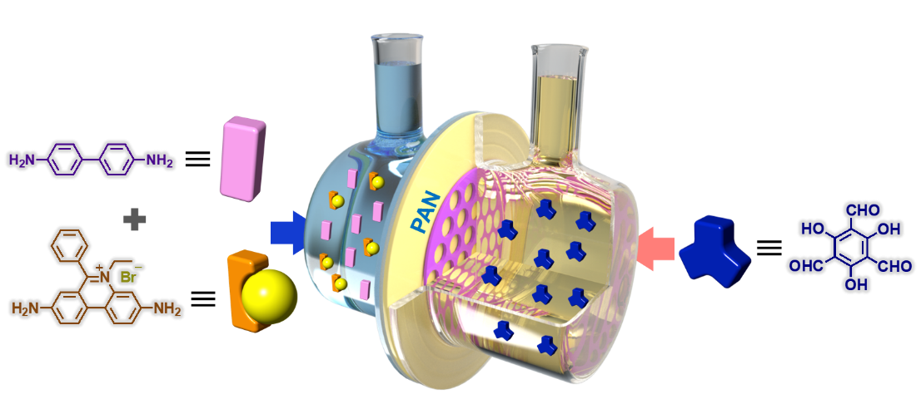
Supplementary Figure 1 | Schematic illustration of the set-up used for the fabrication of COF-EB_{x}BD_{y}/PAN via interfacial polymerization. BD and EB were dissolved in TsOH aqueous solution, and Tp was dissolved in dichloromethane.

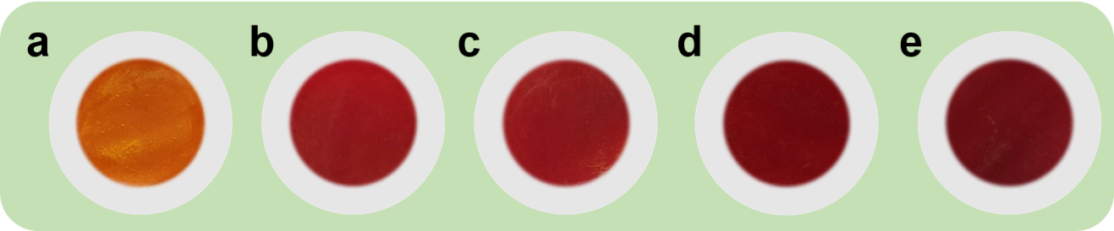
Supplementary Figure 2 | Digital photos. (a) COF-BD/PAN, (b) COF-EB₁BD₅/PAN, (c) COF-EB₁BD₃/PAN, (d) COF-EB₁BD₂/PAN, and (e) COF-EB/PAN.

Supplementary Figure 3 | Top-view SEM image of the PAN membrane.

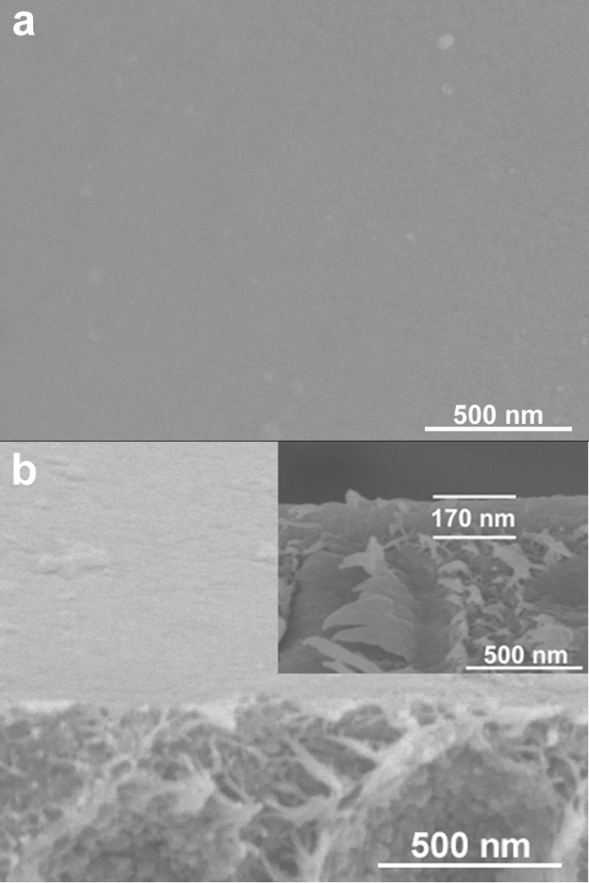
Supplementary Figure 4 | SEM images. (a) top view and (b) cross section-view SEM images of COF-BD/PAN (inset: the thickness of the membrane).

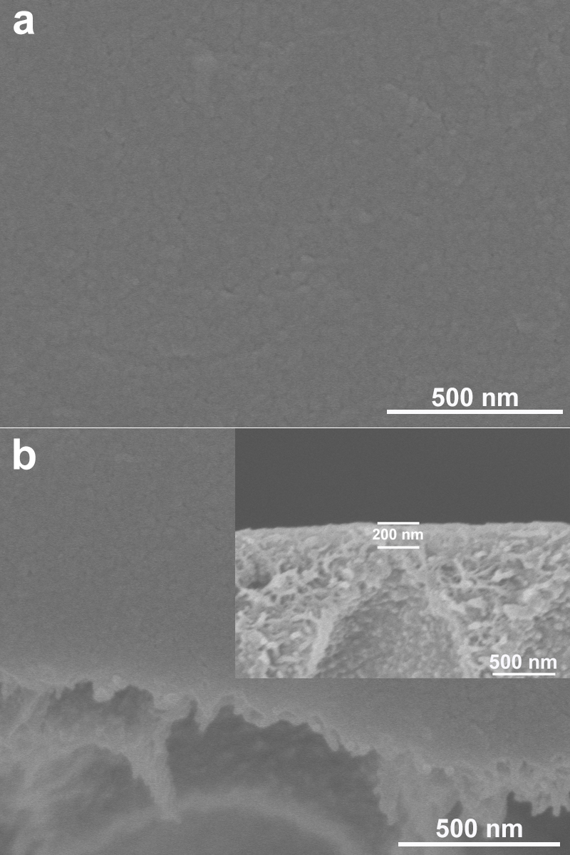
Supplementary Figure 5 | SEM images. (a) top view and (b) cross section-view SEM images of COF-EB₁BD₅/PAN (inset: the thickness of the membrane).

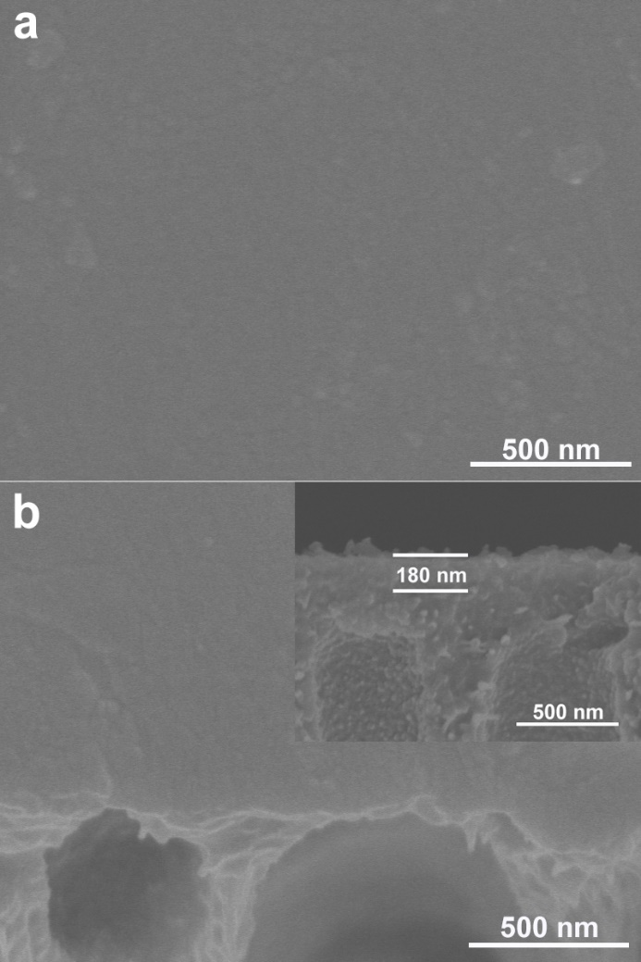
Supplementary Figure 6 | SEM images. (a) top view and (b) cross section-view SEM images of COF-EB₁BD₃/PAN (inset: the thickness of the membrane).

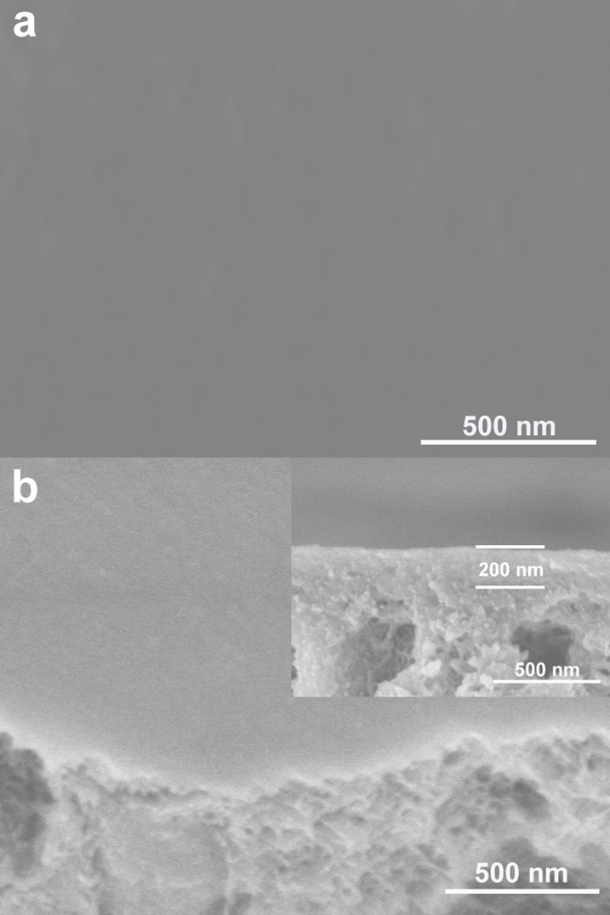
Supplementary Figure 7 | SEM images. (a) top view and (b) cross section-view SEM images of COF-EB₁BD₂/PAN (inset: the thickness of the membrane).

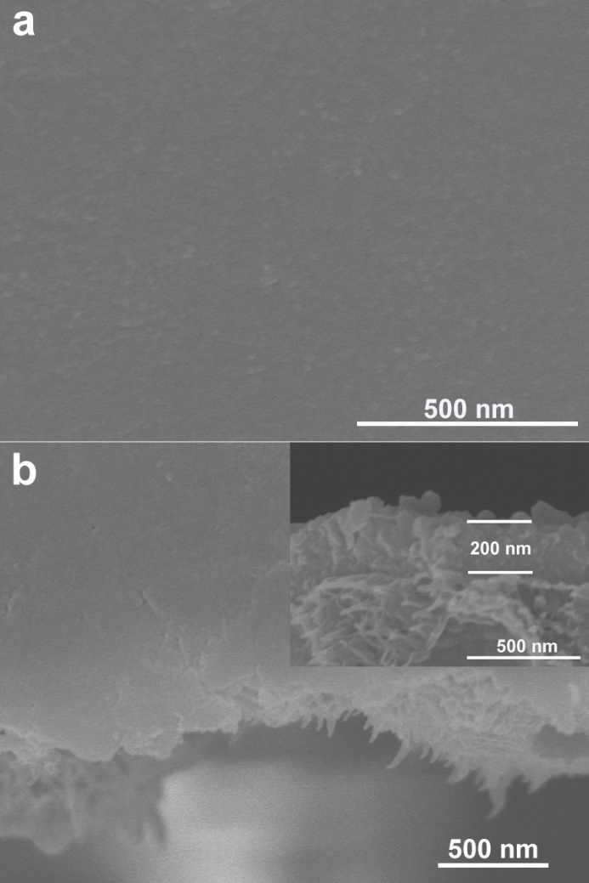
Supplementary Figure 8 | SEM images. (a) top view and (b) cross section-view SEM images of COF-EB/PAN (inset: the thickness of the membrane).

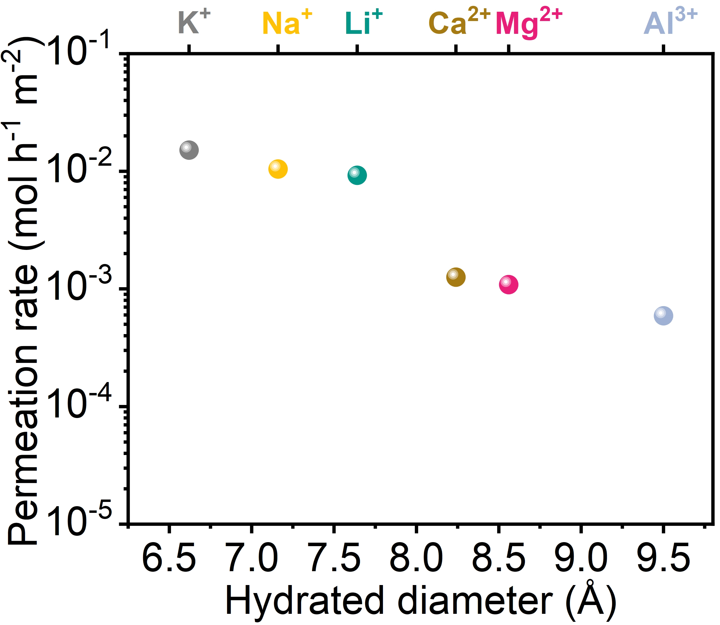
Supplementary Figure 9 | The permeation rates of various salts (0.1 M) through the COF-EB₁BD₂/PAN membrane.

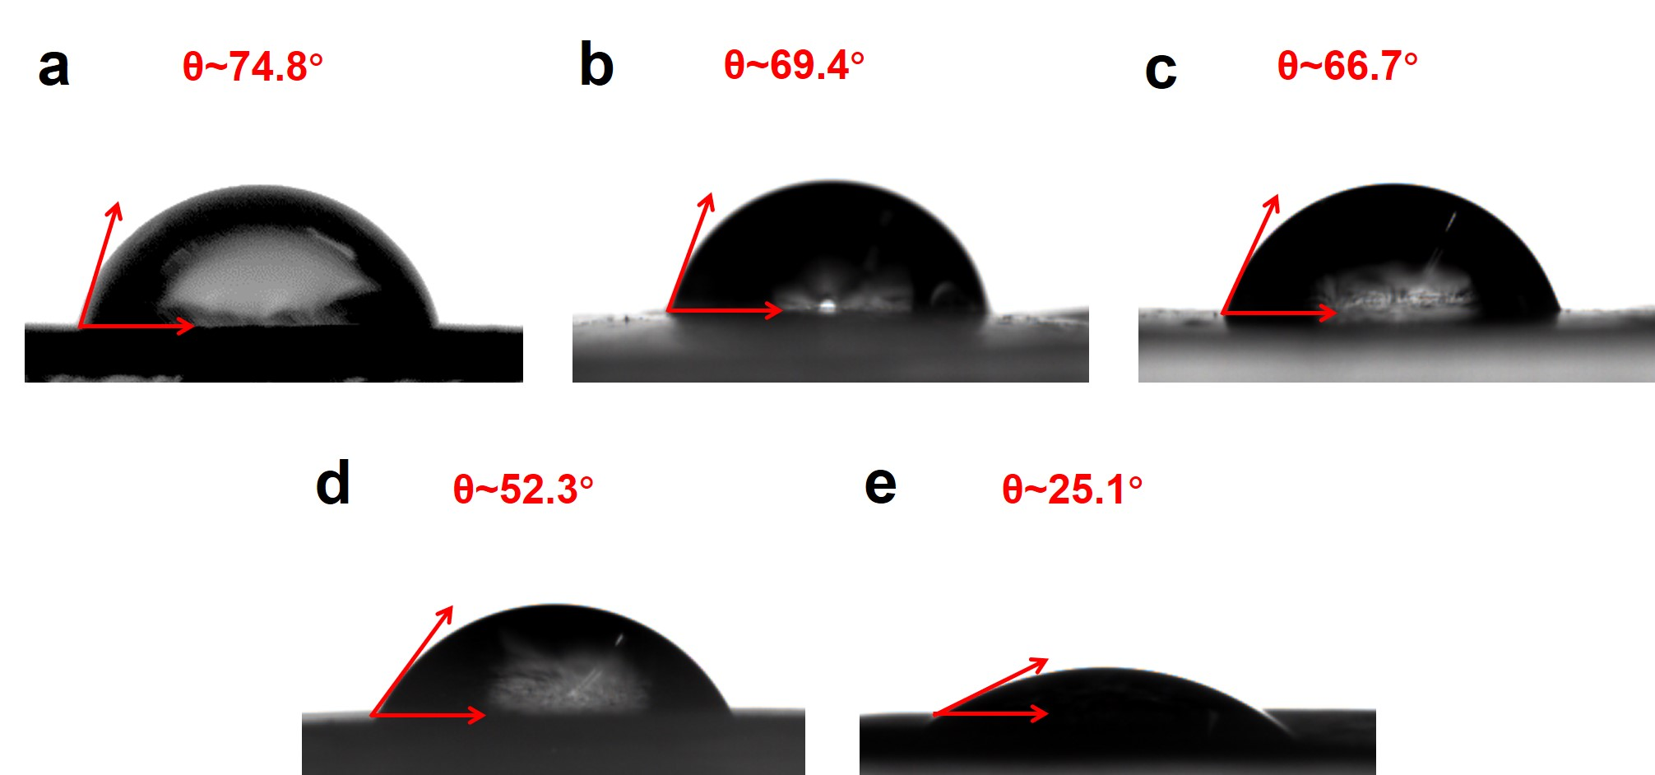
Supplementary Figure 10 | Photographs of water droplets on the COF-EB_{x}BD_{y}/PAN membranes. (a) COF-BD/PAN, (b) COF-EB₁BD₅/PAN, (c) COF-EB₁BD₃/PAN, (d) COF-EB₁BD₂/PAN, and (e) COF-EB/PAN.

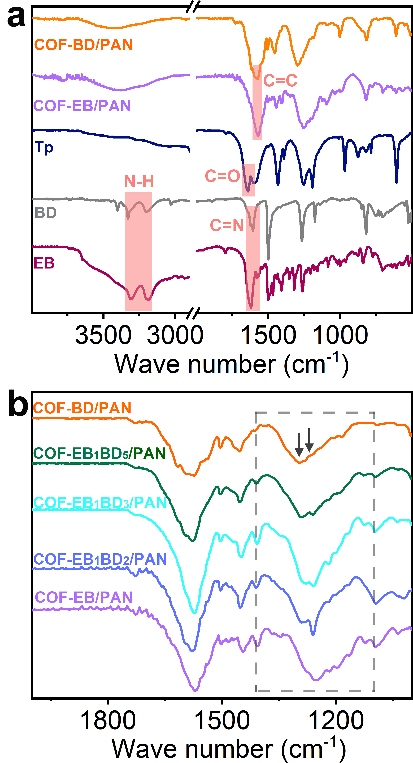
Supplementary Figure 11 | IR spectra.

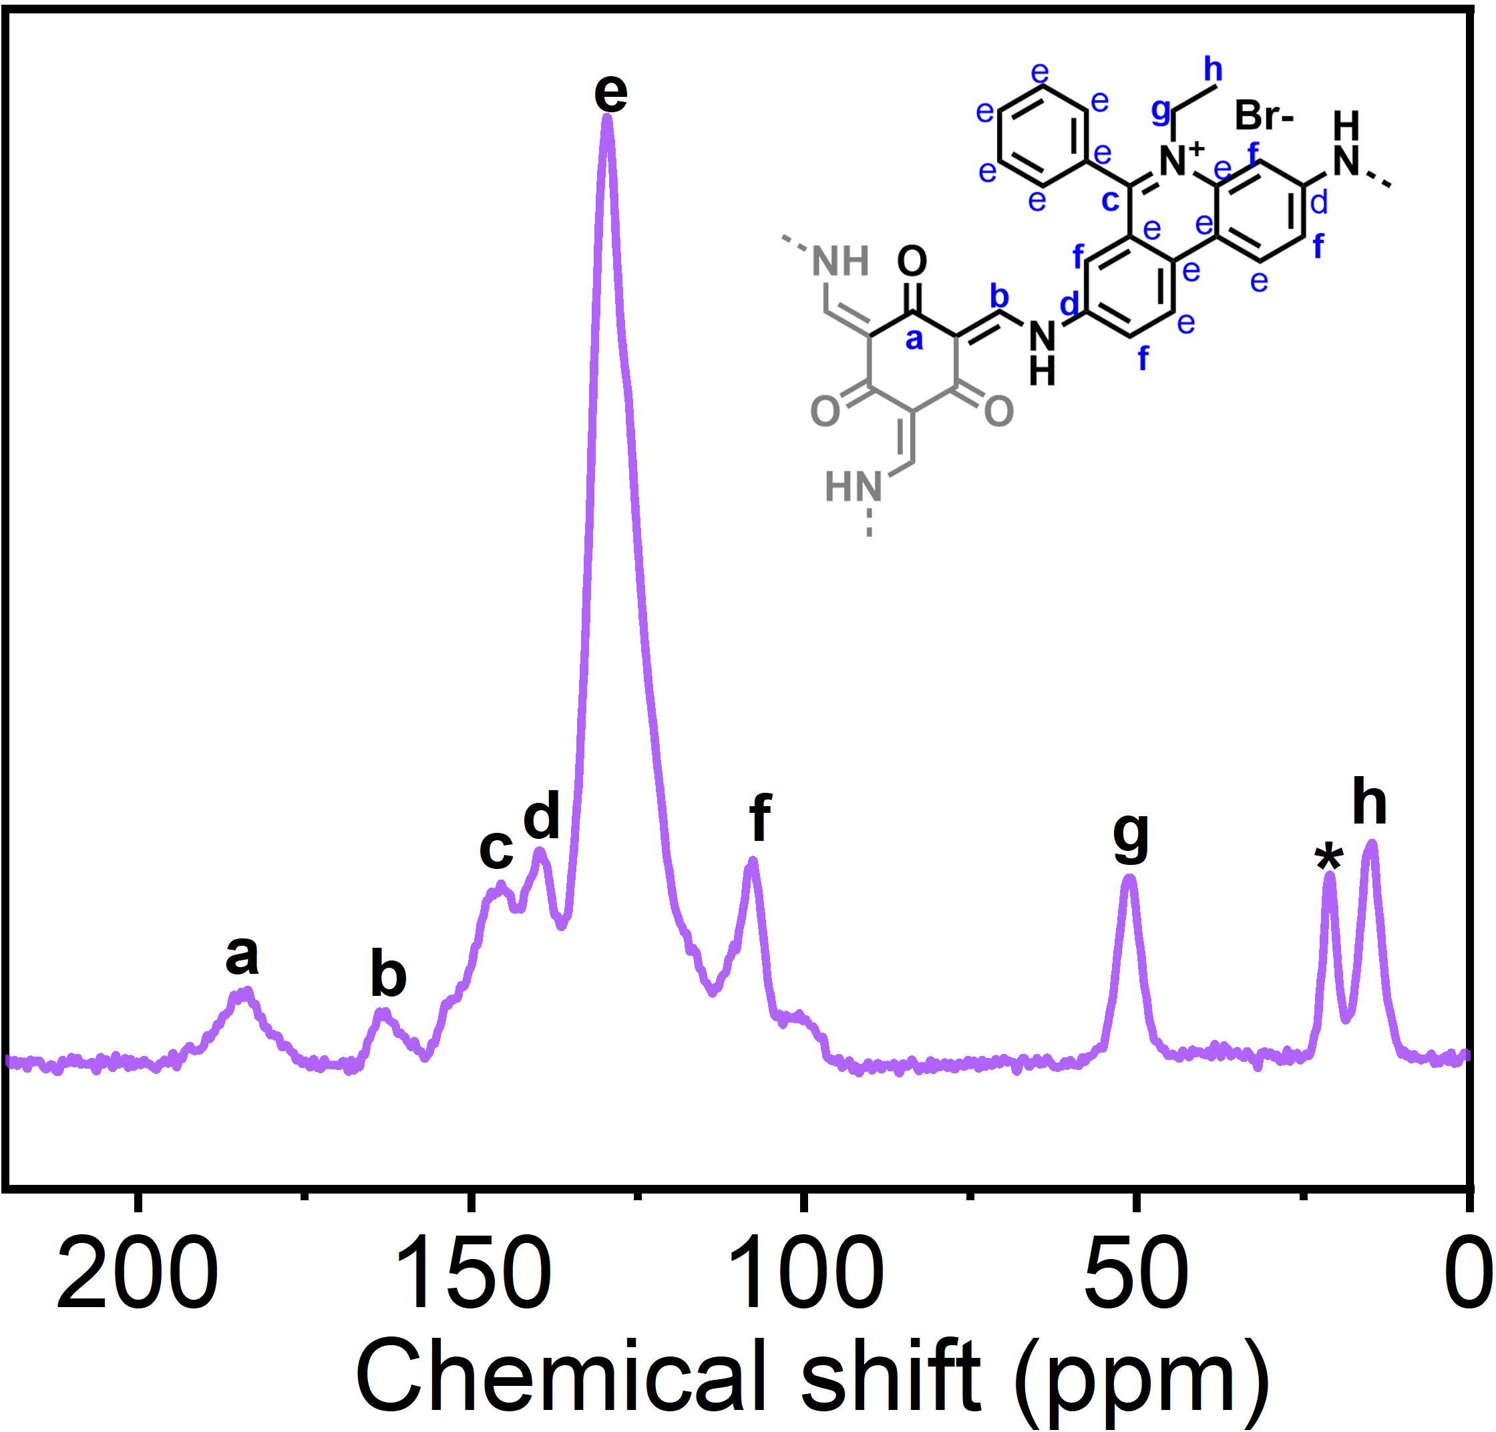
Supplementary Figure 12 | Solid-state ¹³C NMR spectra for the free-standing COF-EB membrane (* the carbon atom from methanol).

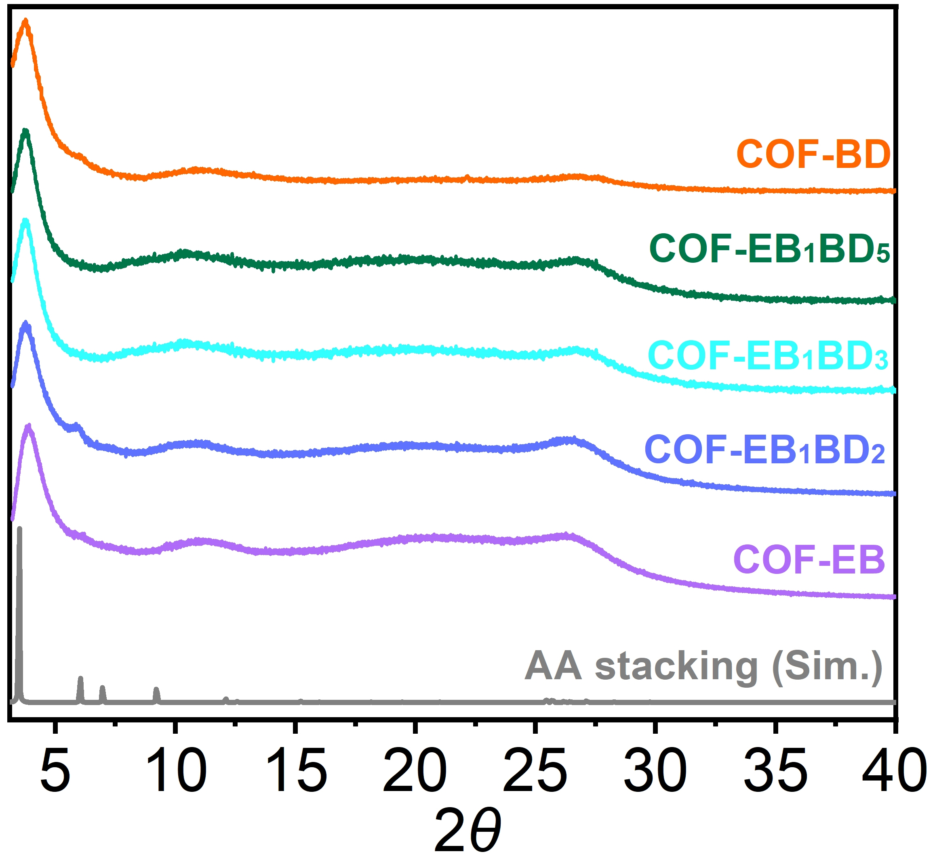
Supplementary Figure 13 | Calculated and experimental PXRD patterns of the free-standing COF-EB_{x}BD_{y} membranes.

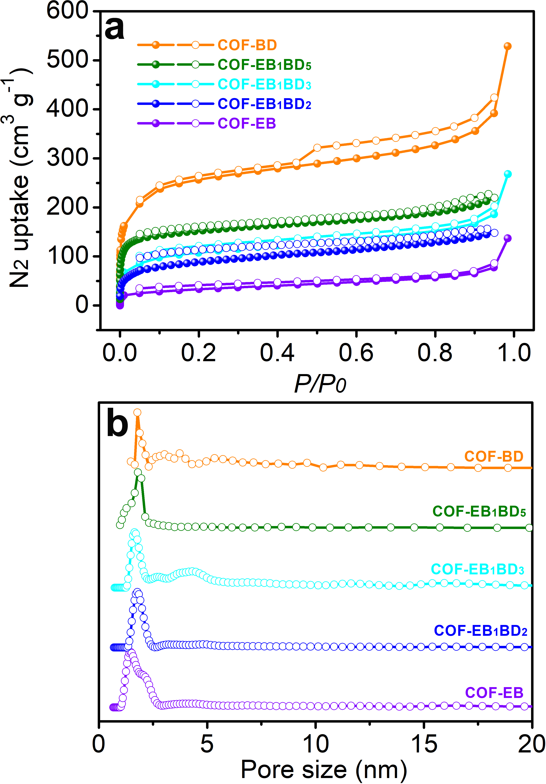
Supplementary Figure 14 |Porosity evaluation. (a) N₂ sorption isotherms collected at 77 K of the free-standing COF-EB_{x}BD_{y} membrane and (b) the corresponding pore size distribution based on the NLDFT method. The BET surface area of the free-standing COF-EB_{x}BD_{y} membrane was calculated to be 764, 370, 340, 286, and 124 m² g⁻¹ for COF-BD, COF-EB₁BD₅, COF-EB₁BD₃, COF-EB₁BD₂, and COF-EB, respectively. The pore size distributions for COF-BD, COF-EB₁BD₅, COF-EB₁BD₃, COF-EB₁BD₂, and COF-EB were centered at 1.8, 1.7, 1.6, 1.6, and 1.4 nm respectively.

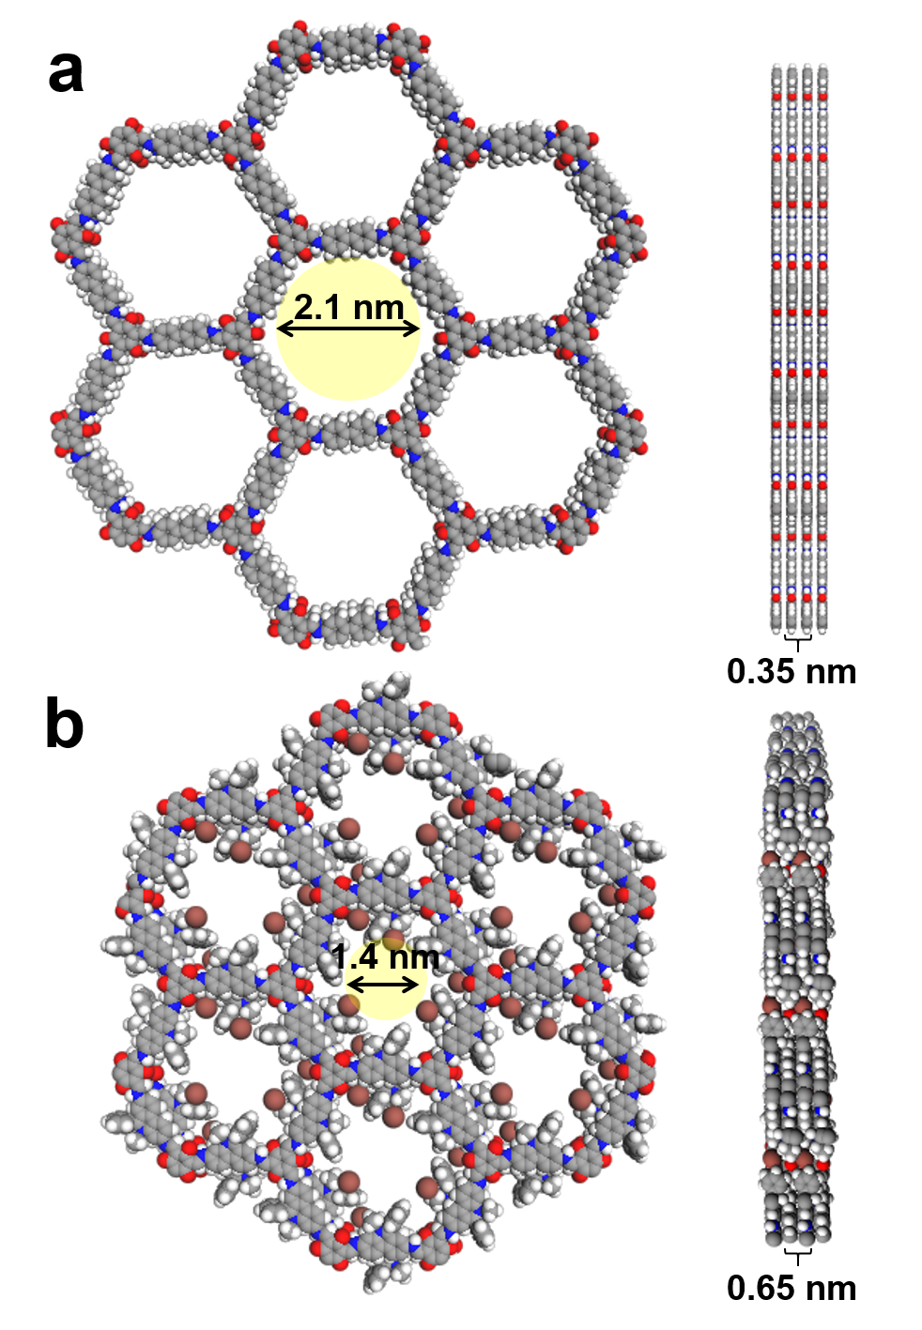
Supplementary Figure 15 | Simulated structures. Graphic view of AA-stacking mode of (a) COF-BD and (b) COF-EB (gray, C; blue, N; red, O; white, H, brown, Br).

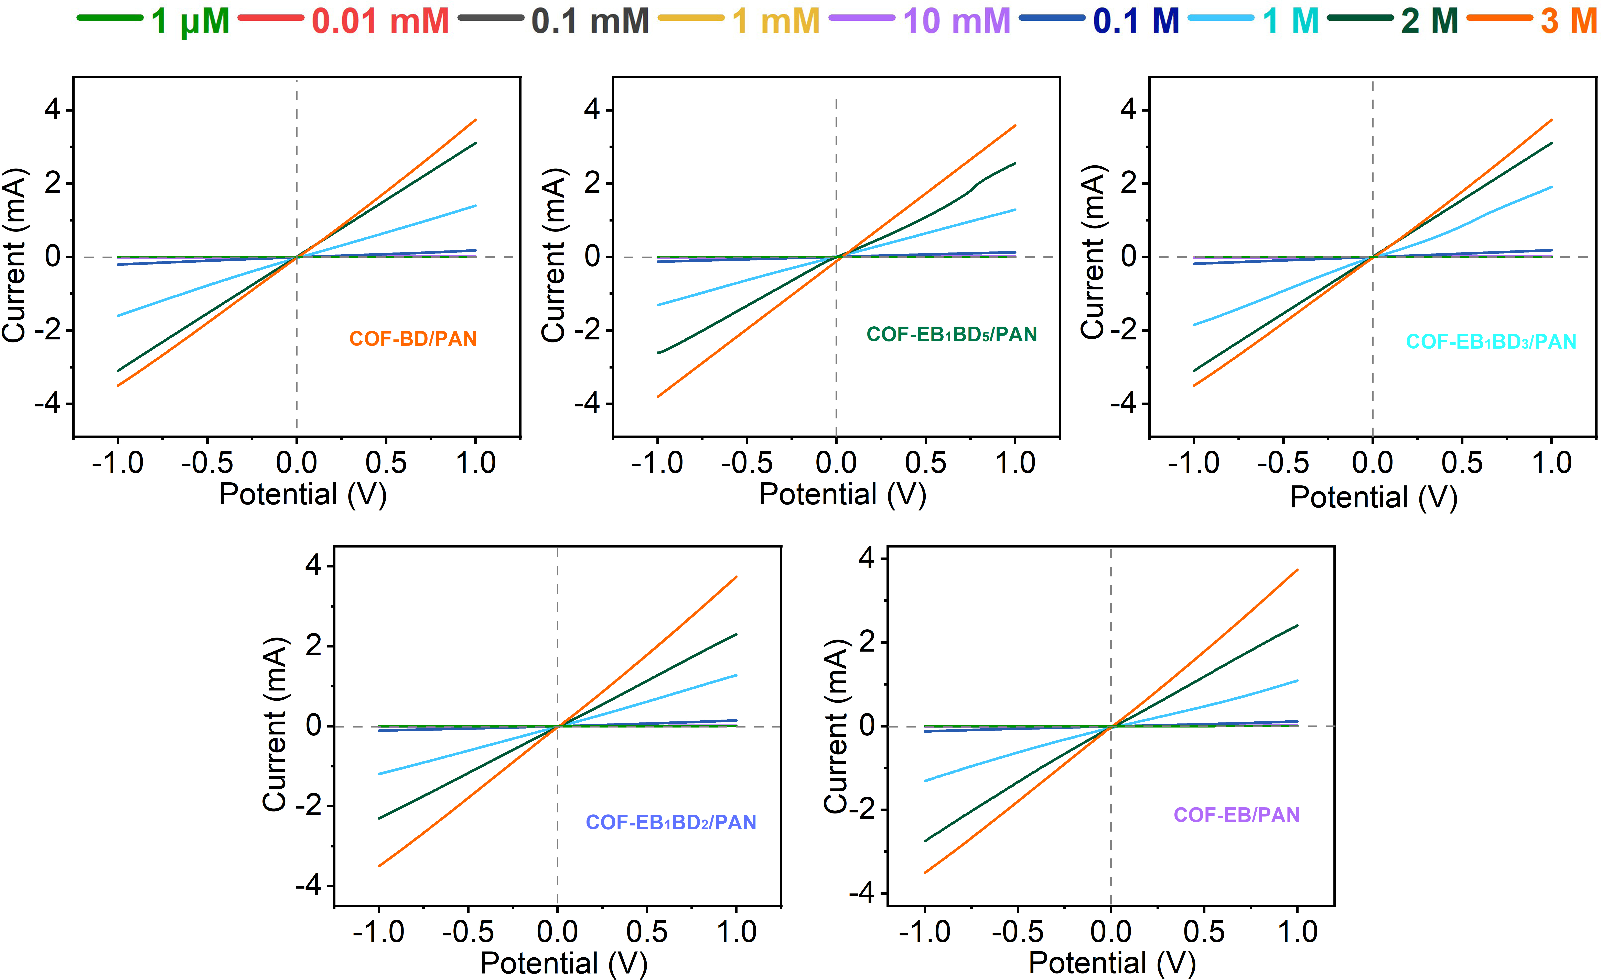
Supplementary Figure 16 | I–V plots for COF-EB_{x}BD_{y}/PAN recorded in KCl solution with concentrations ranging from 1 μM to 3 M.

Supplementary Figure 17 | Plots of the recorded $V_{oc}$ and$I_{sc}$ versus KCl concentration difference. (a) COF-BD/PAN, (b) COF-EB₁BD₅/PAN, (c) COF-EB₁BD₃/PAN, (d) COF-EB₁BD₂/PAN, and (e) COF-EB/PAN.

Supplementary Figure 18 | The diffusion currents and output power densities as a function of load resistances for the COF active layer facing 0.5 M NaCl. (a) COF-BD/PAN, (b) COF-EB₁BD₅/PAN, (c) COF-EB₁BD₃/PAN, (d) COF-EB₁BD₂/PAN, and (e) COF-EB/PAN.

Supplementary Figure 19 | The diffusion currents and output power densities as a function of load resistances for the COF active layer facing 0.01 M NaCl. (a) COF-BD/PAN, (b) COF-EB₁BD₅/PAN, (c) COF-EB₁BD₃/PAN, (d) COF-EB₁BD₂/PAN, and (e) COF-EB/PAN.
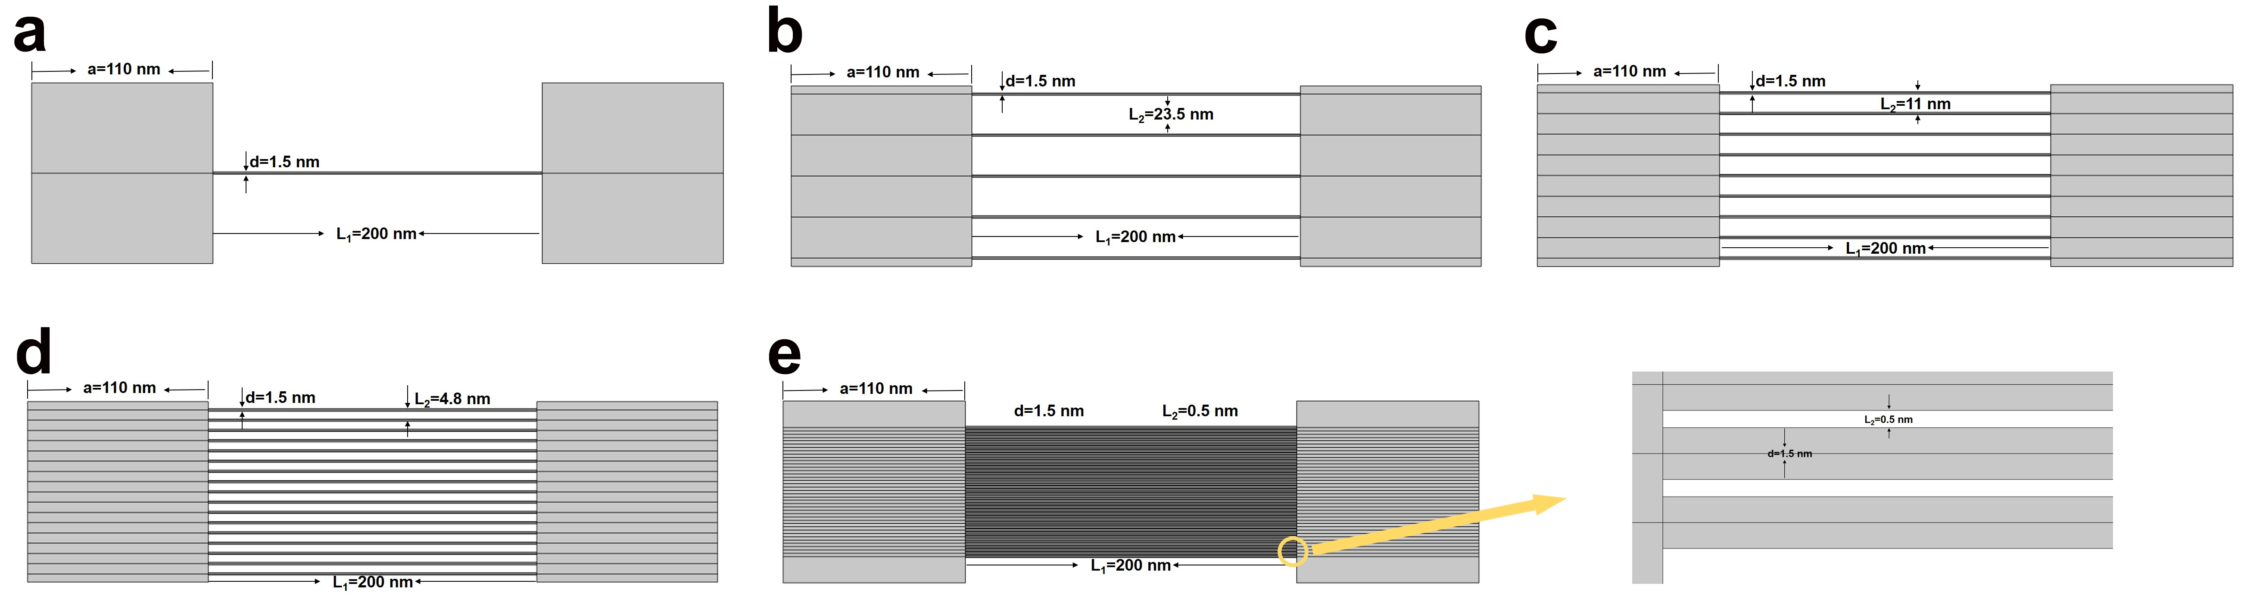
Supplementary Figure 20 | Schematic illustration of 2D model with various channel densities used for calculation under the concentration difference of 0.5 M/0.01 M. (a) 1 channel, (b) 5 channels, (c) 9 channels, (d) 17 channels, and (e) 40 channels.

Supplementary Figure 21 | Numerical simulation of the impact of charge and channel densities on the Na⁺ (dashed line) and Cl⁻ (solid line) distribution in the nanochannels. (a) 1 channel, (b) 5 channels, (c) 9 channels, (d) 17 channels, and (e) 40 channels.

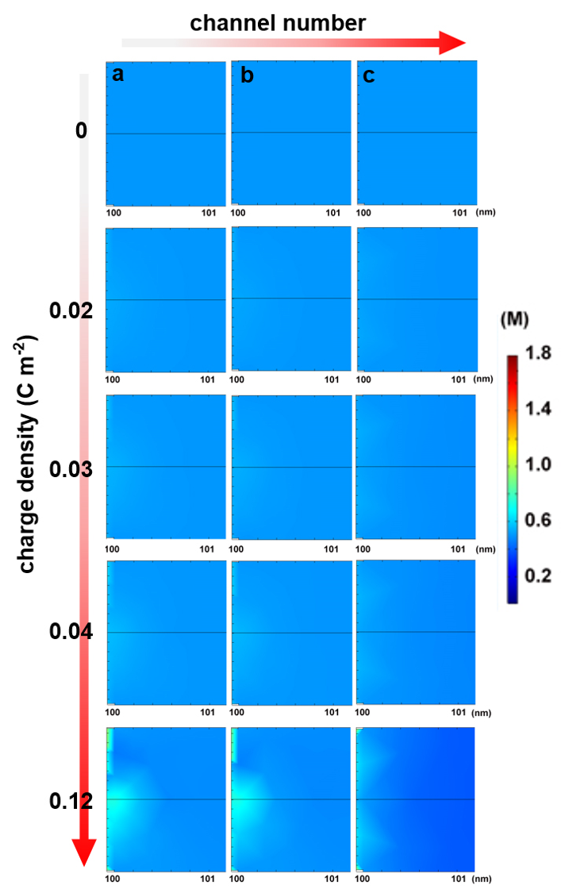
Supplementary Figure 22 | Numerical simulation of the impact of charge and channel densities on the distribution of Cl⁻ ions at the entrance of pore channels facing 0.5 M NaCl. (a) 1 channel, (b) 9 channels, and (c) 40 channels.

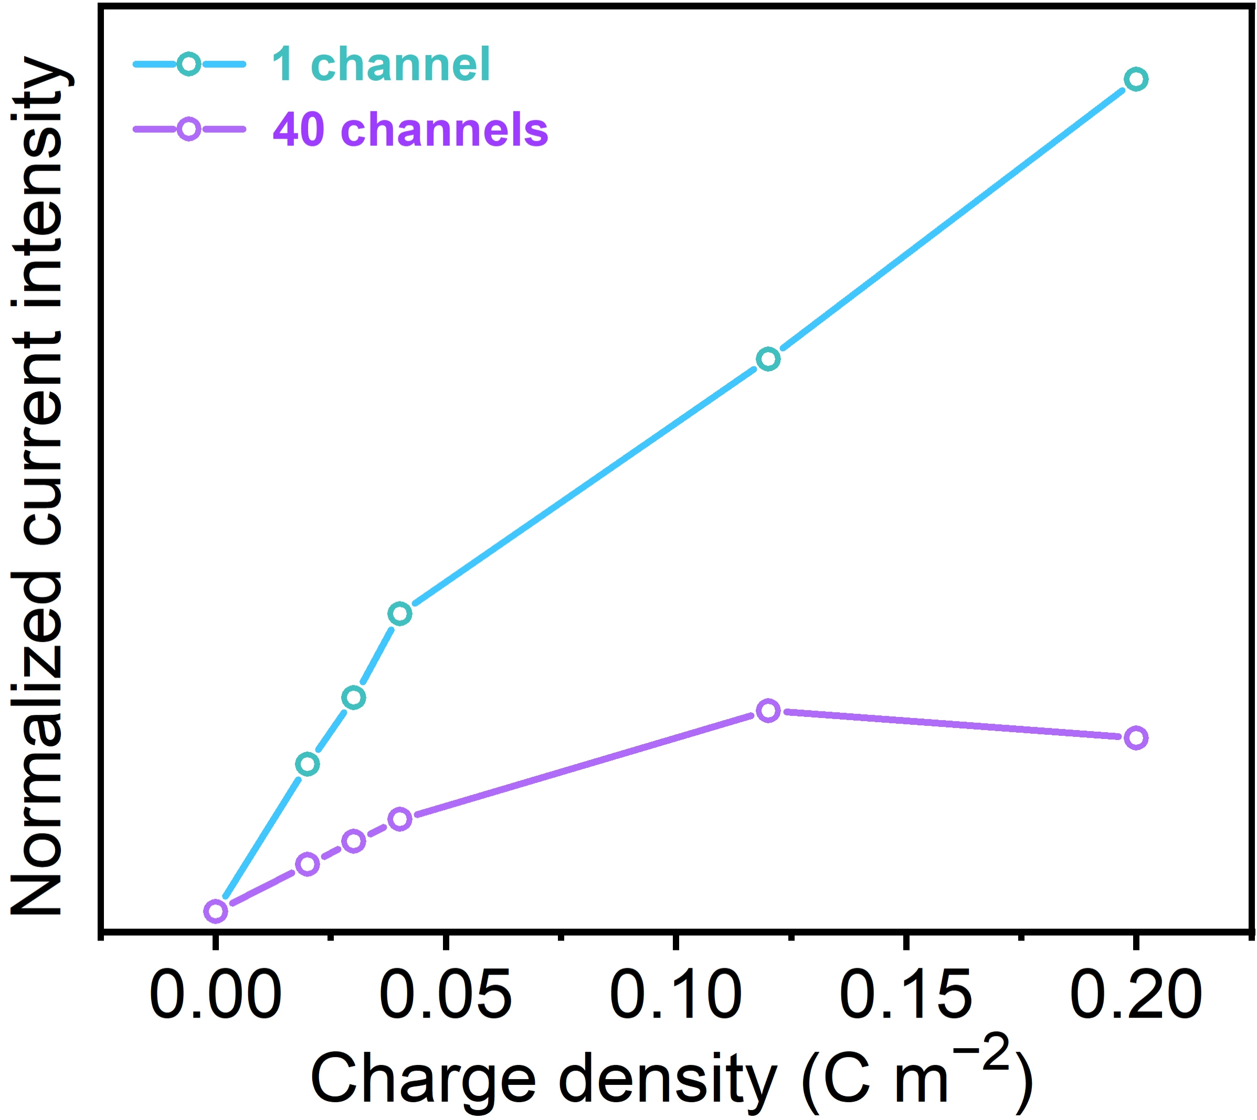
Supplementary Figure 23 | Numerical simulation of the impact of charge and channel densities on the ion current. Ion flux of multipore membranes obviously deviate from the behavior of single-pore counterparts, unveiling the fact that the high power density estimated from the single nanopores could not be simply achieved with multipore membranes as the pore–pore interactions cannot be ignored at high porosity.

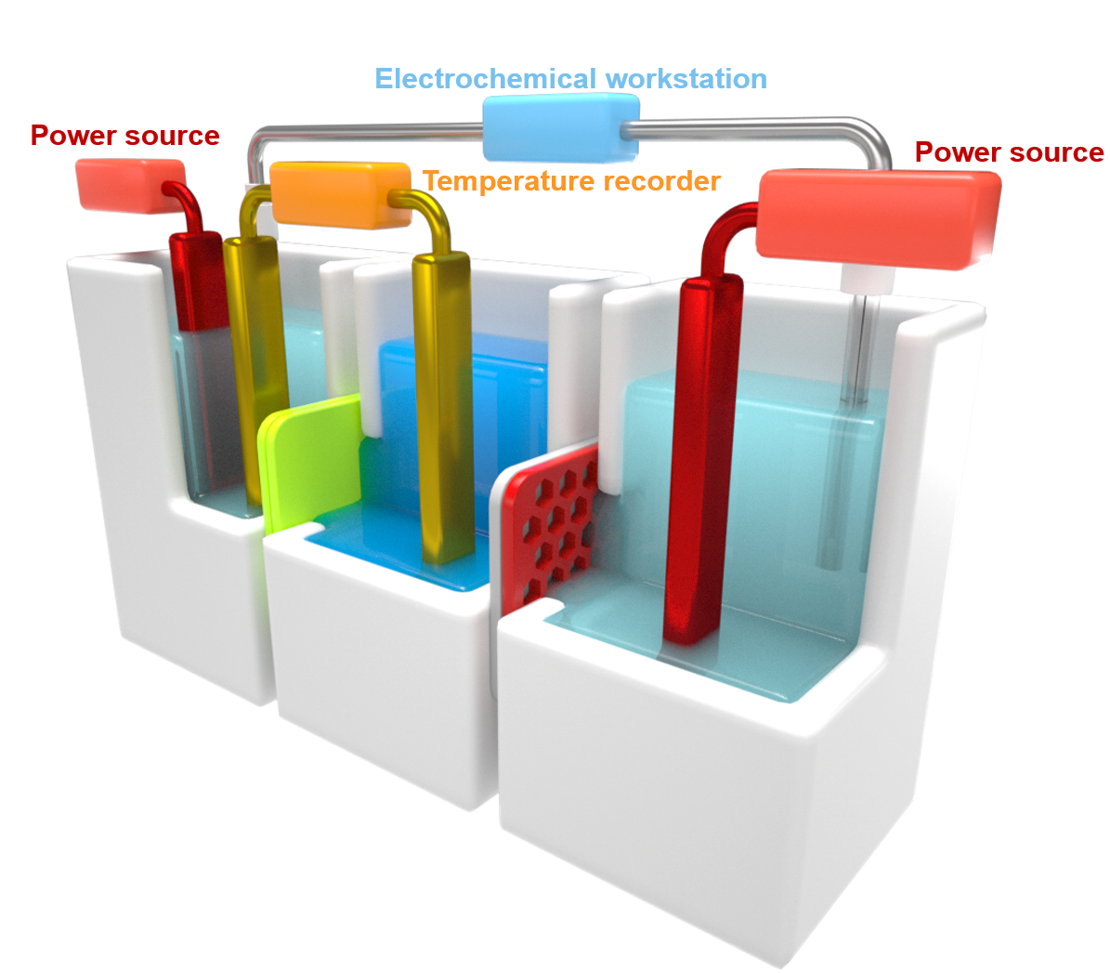
Supplementary Figure 24 | Schematic illustration of the experimental setup used for investigating the thermo-osmotic conversion of COF-EB_{x}BD_{y}/PAN.

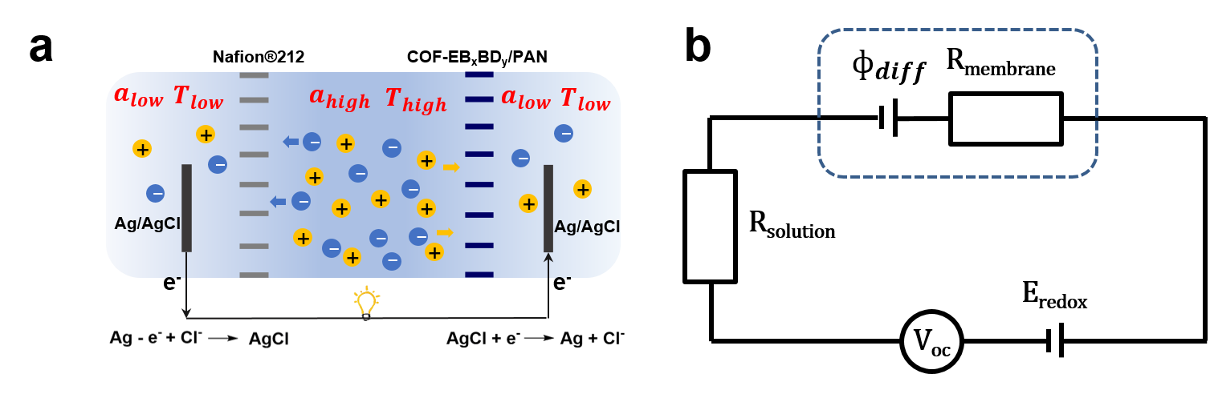
Supplementary Figure 25 | Equivalent circuit. Simplified model of ion transport across COF-EB_{x}BD_{y}/PAN and Nafion®212 in the presence of temperature and concentration gradient (left) and equivalent circuit of experimental measurement of thermoelectric response under the open-circuit condition (right).

Supplementary Figure 26 | Evaluation of thermo-osmotic conversion performance of COF-EB_{x}BD_{y}/PAN. Repersentive I–V curves of the thermo-osmotic conversion device coupled with COF-EB_{x}BD_{y}/PAN and Nafion®212 in the presence of asymmetric NaCl (0.5 M/0.01 M) before and after imposing various temperature gradients for (a) COF-BD/PAN, (b) COF-EB₁BD₅/PAN, (c) COF-EB₁BD₃/PAN, (d) COF-EB₁BD₂/PAN, and (e) COF-EB/PAN, respectively.

Supplementary Figure 27 | The power was output to an external circuit to supply an electronic load before and after imposing temperature gradients of 20 K and 40 K. (a) COF-BD/PAN, (b) COF-EB₁BD₅/PAN, (c) COF-EB₁BD₃/PAN, (d) COF-EB₁BD₂/PAN, and (e) COF-EB/PAN.

Supplementary Figure 28 | Numerical simulation results. The impact of temperature gardient and charge density on the Cl⁻/Na⁺ ratio at the mouth of the low-concentration side.

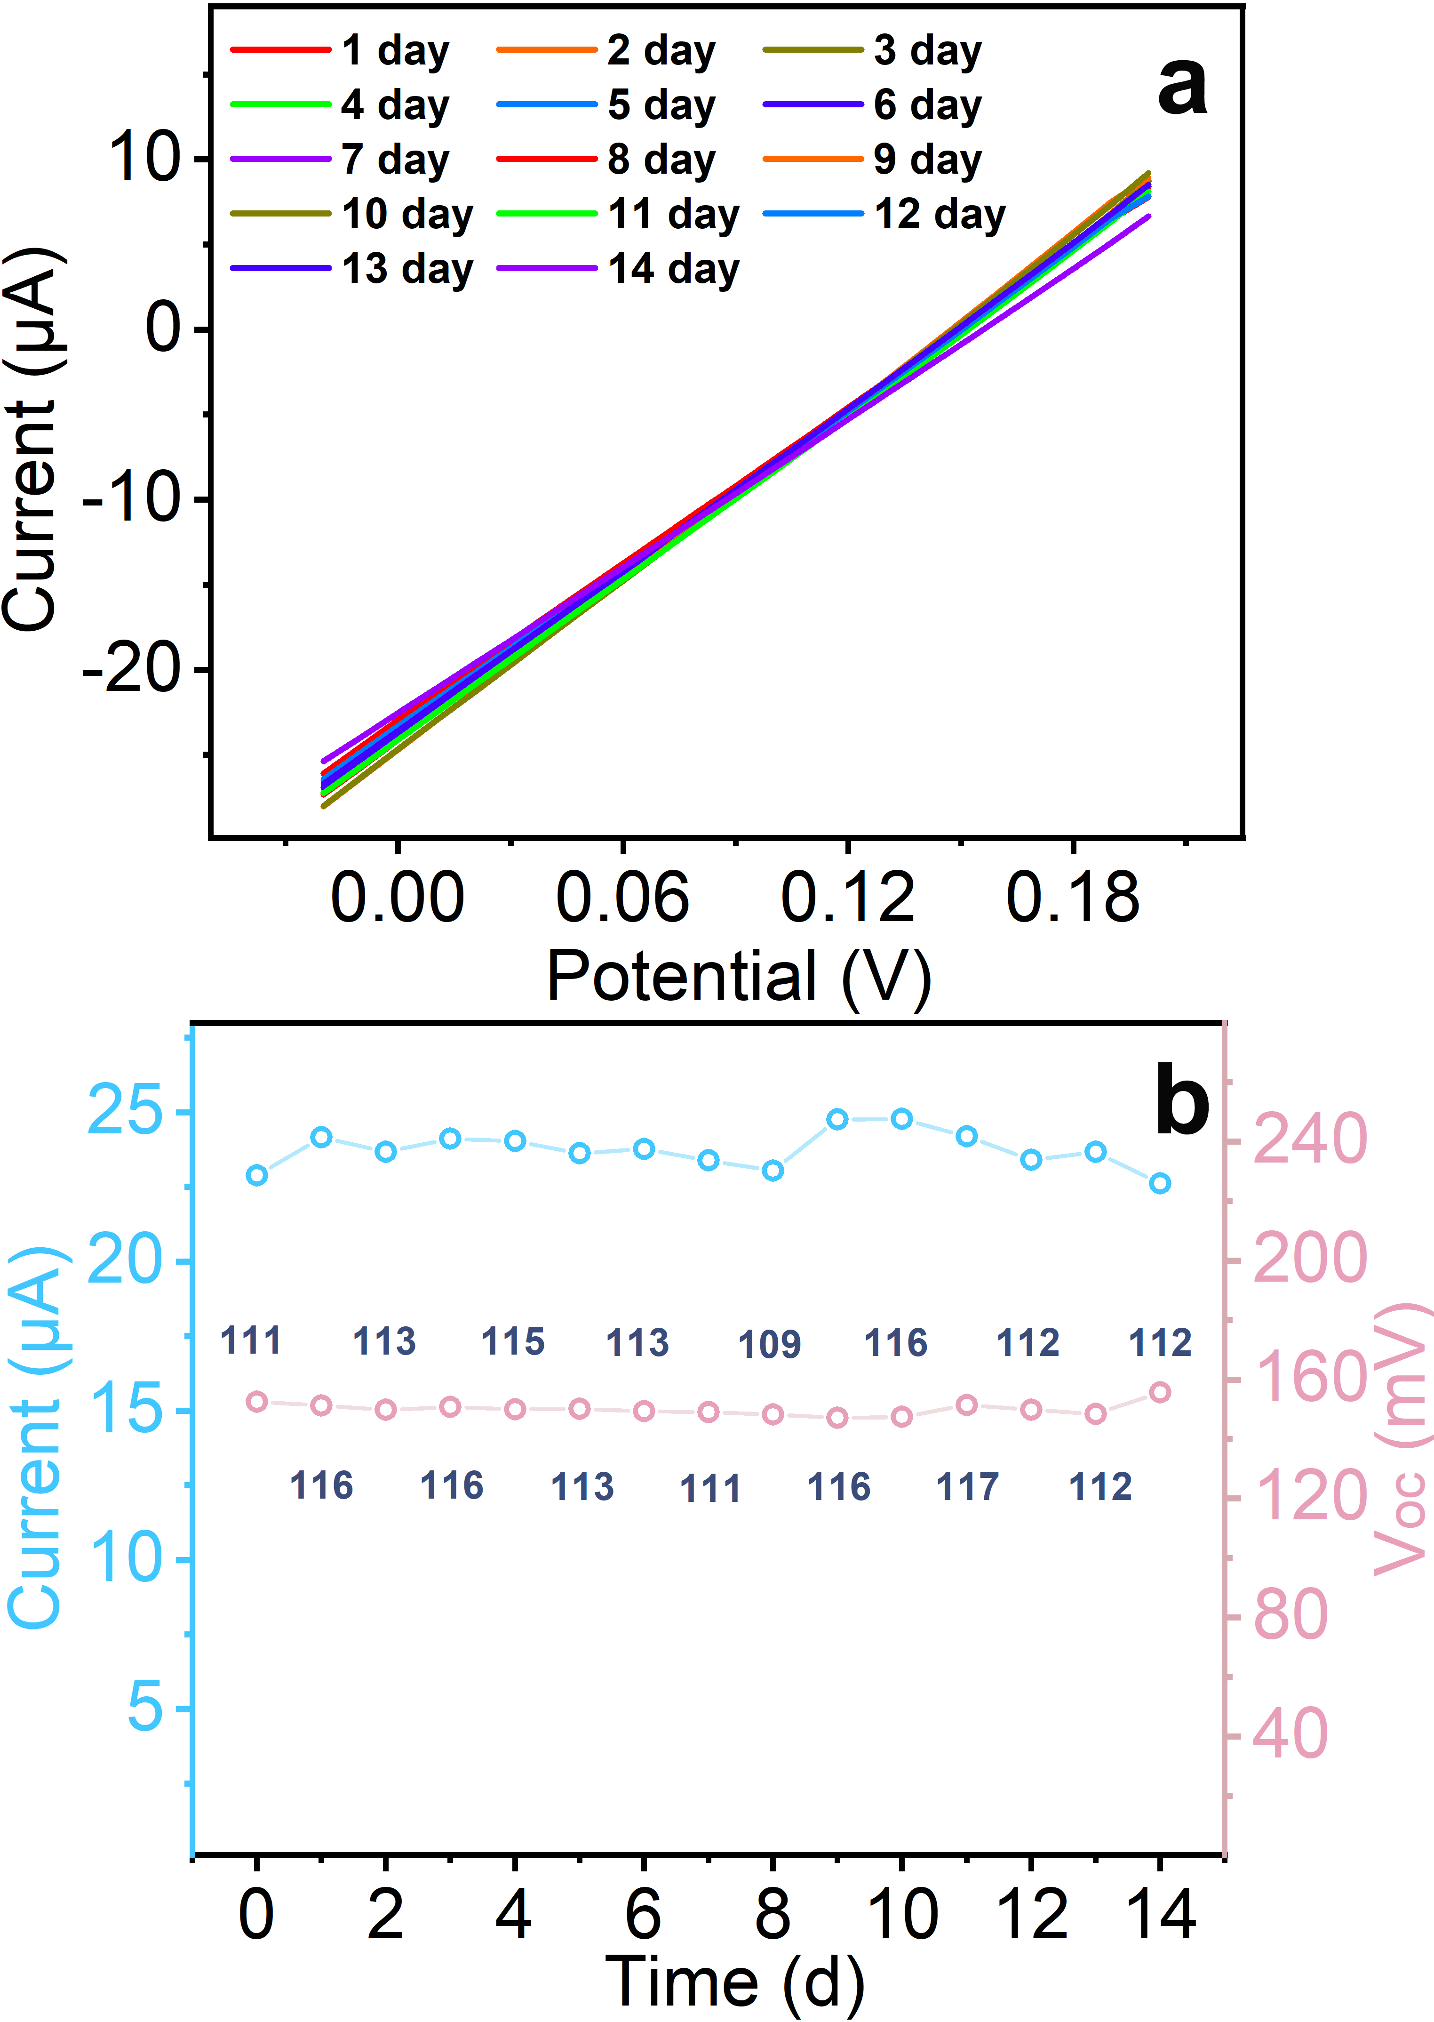
Supplementary Figure 29 | Stability evaluation. (a) Time series of the I−V curves of the thermo-osmotic conversion device constructed by COF-EB₁BD₂/PAN by mixing 0.01 M and 0.5 M NaCl, and (b) plots of $V_{oc}$, $I_{sc}$, and output power density of the osmotic conversion device over time.
.

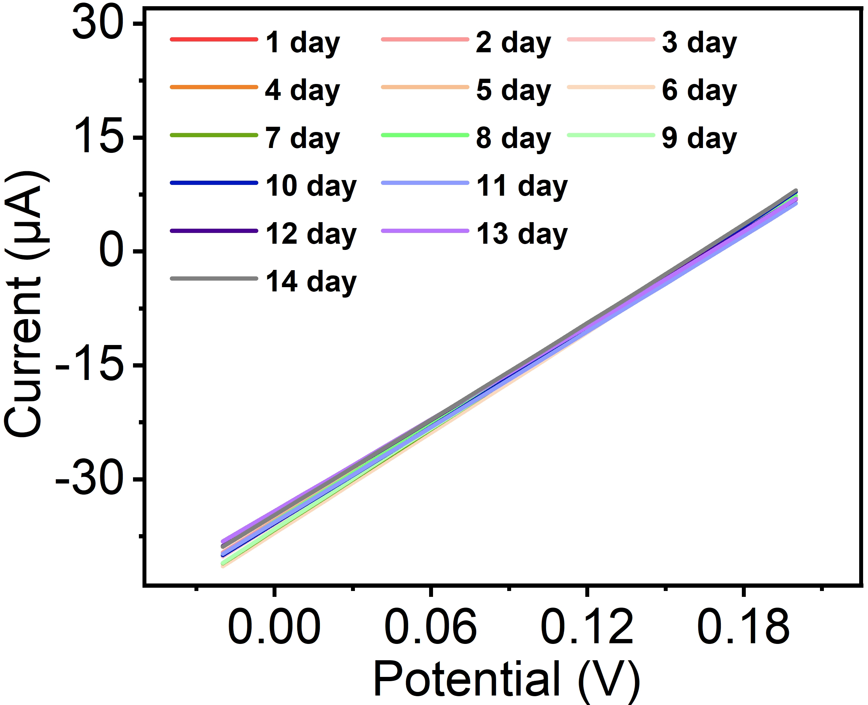
Supplementary Figure 30 | Stability evaluation. Time series of the I−V curves of the thermo-osmotic conversion device constructed by a pair of RED stack coupled by COF-EB₁BD₂/PAN and Nafion®212 by mixing 0.01 M and 0.5 M NaCl with a temperature difference of 40 K.

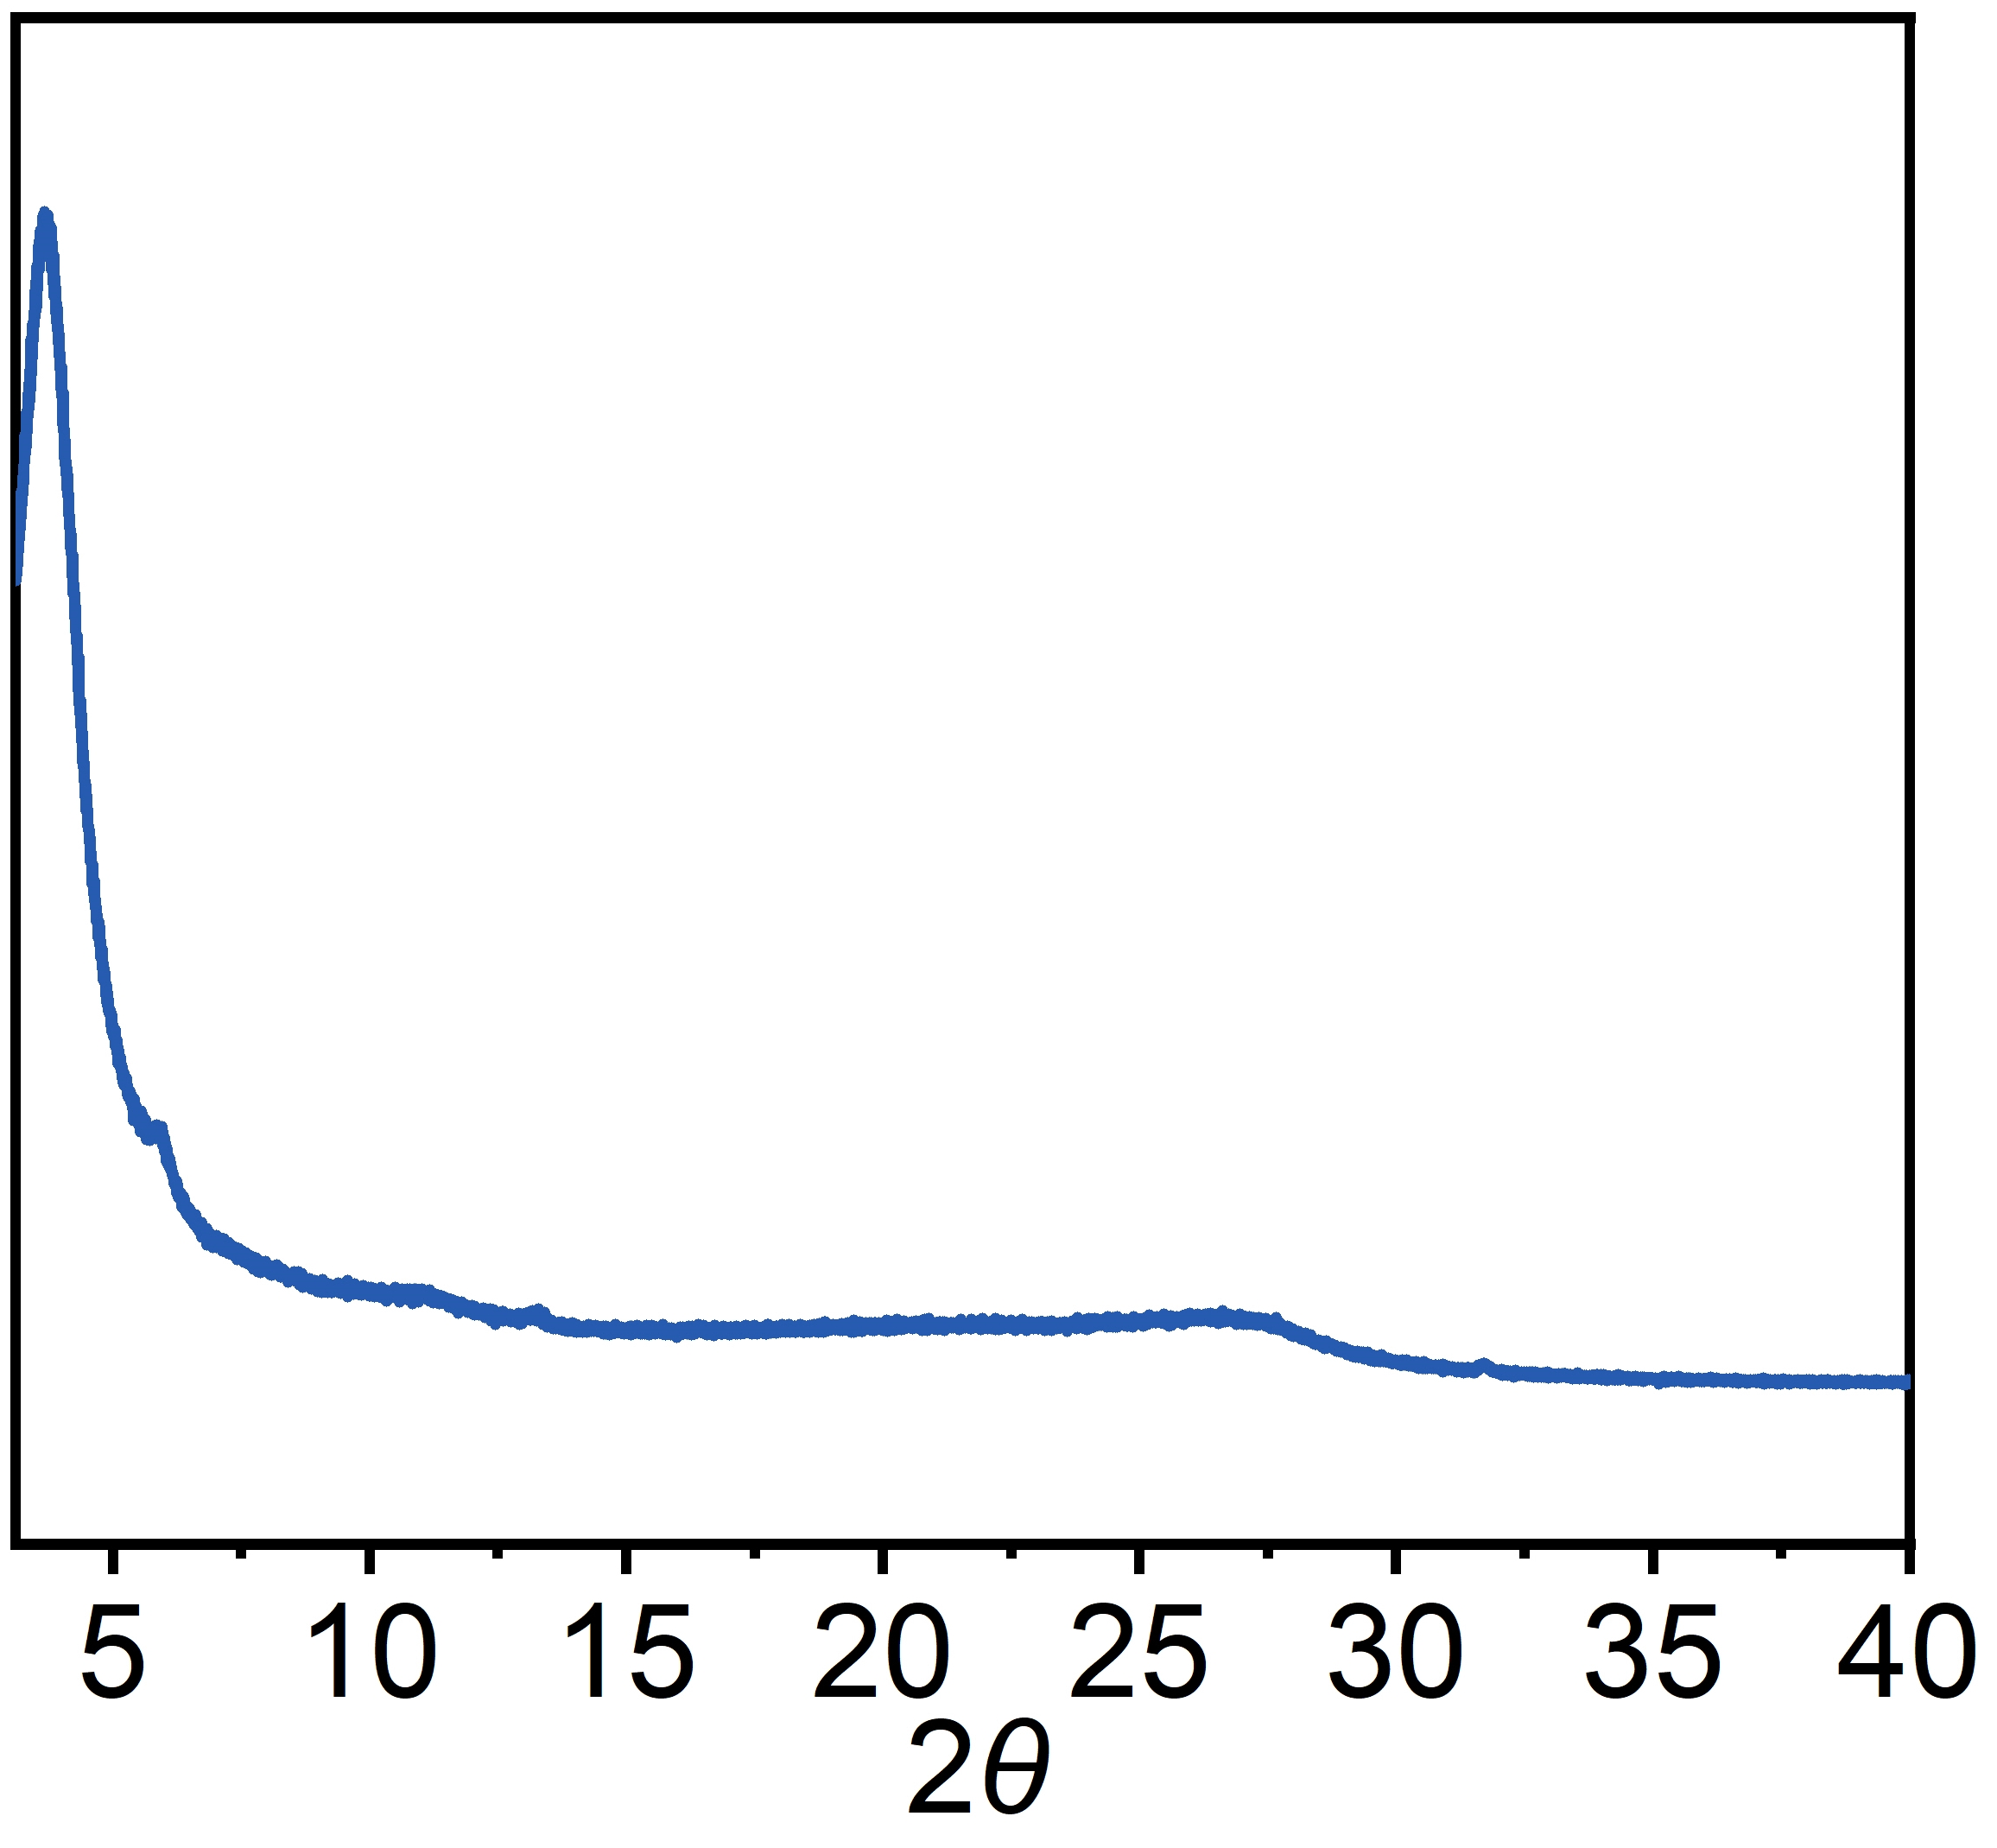
Supplementary Figure 31 | XRD pattern of the free-standing COF-EB₁BD₂ membrane after being soaked in 0.5 M NaCl for 15 d.

