Supplementary Materials
for
Three-body Photodissociation of Water Molecule: An Important Prebiotic Oxygen Source

Yao Chang^{1#}, Yong Yu^{1#}, Feng An², Zijie Luo^{1,3}, Donghui Quan⁴, Xia Zhang⁵, Xixi Hu^{2*}, Qinming Li¹, Jiayue Yang¹, Zhichao Chen¹, Li Che³, Weiqing Zhang¹, Guorong Wu¹, Daiqian Xie², Michael N.R. Ashfold ⁶, Kaijun Yuan^{1*}and Xueming Yang^{1,7*}

- State Key Laboratory of Molecular Reaction Dynamics and Dalian Coherent Light Source, Dalian Institute of Chemical Physics, Chinese Academy of Sciences, 457 Zhongshan Road, Dalian, 116023, China.
- Key Laboratory of Mesoscopic Chemistry, School of Chemistry and Chemical Engineering, Institute of Theoretical and Computational Chemistry, Nanjing University, Nanjing 210093, China.
- Department of Physics, School of Science, Dalian Maritime University, 1 Linghai Road, Dalian, Liaoning 116026, China.
- Eastern Kentucky University, 521 Lancaster Ave., Richmond, KY 40475, USA
- Xinjiang Astronomical observatory, Chinese Academy of Sciences, 150 Science-1 St., Urumqi 830011, China
- School of Chemistry, University of Bristol, Bristol, BS8 1TS, U.K.
- Department of Chemistry, College of Science, Southern University of Science and Technology, Shenzhen 518055, China.

1. Experimental methods
The experiments employ a newly constructed apparatus for molecular photochemistry, which is centered on the vacuum ultraviolet free electron laser (VUV-FEL) beam line at the Dalian Coherent Light Source (DCLS) ²⁷. Briefly, the VUV-FEL facility runs in the high gain harmonic generation (HGHG) mode, in which the seed laser is injected to interact with the electron beam in the modulator (Fig. S1). The seeding pulse, in the wavelength range (λ_{seed}) 240-360 nm, can be generated from a picosecond Ti:sapphire laser pulse. The electron beam is generated from a photocathode RF gun, and accelerated to the beam energy of ~300 MeV by 7 S-band accelerator structures, with a bunch charge of 500 pC. The micro-bunched beam is then sent through the radiator, which is tuned to the 2nd/3rd/4th harmonic of the seed wavelength, and coherent FEL radiation with wavelength λ_{seed}/2, λ_{seed}/3 or λ_{seed}/4 is emitted. Optimization of the linear accelerator yields a high quality electron beam with emittance of ~1.5 mm·mrad, energy spread of ~1‰, and pulse duration of ~1.5 ps. In this work, the VUV-FEL operates at 10 Hz, and the maximum pulse energy is >100 μJ/pulse. The output wavelength is continuously tunable in the range 50-150 nm and the typical spectral bandwidth of the VUV-FEL output is 30~50 cm⁻¹.
The high-n H atom Rydberg tagging time-of-flight (HRTOF) technique used in this work was pioneered by Welge and coworkers⁴⁴. The key point of this technique is the 1+1′ (VUV+UV) excitation of the H atom. The first step involves VUV laser excitation of the H atom from its n=1 ground state to the n=2 state by absorbing one λ = 121.57 nm photon. In the second step, the H (n=2) atom is excited with a UV (λ ~365 nm) photon to a high-n (n=30-80) Rydberg state. The 121.57 nm photon is generated by four wave difference frequency mixing using two 212.5 nm photons and one 845 nm photon in a cell containing a Kr/Ar gas mixture (1:3 mixing ratio). The 212.5 nm laser light is produced by doubling the output of a tunable dye laser operating at ~425 nm, pumped by the third harmonic output of a Nd:YAG laser, while the 845 nm laser light is the direct output of another dye laser pumped by part of the second harmonic output from the same Nd:YAG laser. The 365 nm laser light is generated by doubling the output of a tunable dye laser operating at ~730 nm, pumped by another part of the second harmonic output of the Nd:YAG laser.
Charged species formed in the interaction region are extracted from the TOF axis by a small electric field (~20V/cm) placed across this region. Rydberg tagged neutral H atoms fly a known distance (d ≈280 mm) from the interaction region to a rotatable microchannel plate (MCP) Z-stack detector located close behind a grounded fine metal grid. After passing through the grid, the Rydberg atoms are immediately field-ionized by the electric field (~2000V/cm) applied between the grid and the front plate of the Z-stack MCP detector. The signal detected by the MCP is amplified by a fast pre-amplifier and counted by a multichannel scaler. A molecular beam of H₂O is generated by expanding a mixture of H₂O and Ar at a stagnation pressure of 600-900 Torr through a 0.5 mm diameter pulsed nozzle (General Valve). The FEL output is orthogonal to the molecular beam axis, and polarized in the horizontal direction. TOF spectra along axes parallel and perpendicular to this polarization axis are thus measured by rotating the MCP detector. The 121.57 nm detection laser pulse causes some H₂O photodissociation. The TOF spectrum of these probe laser induced H atoms is obtained by turning the VUV-FEL beam on and off, and subtracted accordingly.

Fig. S1 Schematic of the DCLS beam line (A) and the VUV FEL-HRTOF photodissociation experimental setup (B). The VUV-FEL facility at the DCLS generates the radiation with the wavelength continuously tuning between 50-150 nm. This radiation crosses perpendicularly with the H₂O molecular beam, which is generated by expanding a 3% mixing of H₂O and Ar at a stagnation pressure of 600 Torr through a pulsed nozzle. About 5 ns after the VUV-FEL photodissociating H₂O, the H-atom products are excited to a high Rydberg state via two-step resonant excitation by absorbing the photons of 121.57 nm and 365 nm.

2. The VUV absorption spectrum of H₂O
Fig. S2 shows the absorption spectrum of H₂O at room temperature. The H₂O molecule in its ground (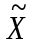¹A₁) state has C_{2v} symmetry and electronic configuration: (1a₁)²(2a₁)²(3a₁)²(1b₁)². It displays richly structured absorption at VUV wavelengths λ <190 nm as a result of the excitation of one electron from the 1b₁ or 3a₁ orbital to a Rydberg orbital. The absorption spectrum in the ~190-120 nm region consists of two broad, well-separated bands with maxima at ~167 nm and ~128 nm, respectively⁴⁵. These bands are assigned to, respectively, the A¹B₁←X¹A₁ (3sa₁←1b₁) and B¹A₁←X¹A₁ (3sa₁←3a₁) transitions. The first intense, sharp bands peaking at ~124 nm and ~122 nm are attributed to, respectively, the C¹B₁←X¹A₁ (3pa₁←1b₁) and D¹A₁←X¹A₁ (3pb₁←1b₁) Rydberg transitions and most of the sharp features in the ~118-92 nm region are attributed to nd←1b₁ (n ≥ 3) excitations²⁸.
Fig. S2 Absorption spectrum of H₂O vapor at room temperature (adapted from ref. 32 with revision).

3. Experimental results at eight more VUV wavelengths
Fig. S3 shows TKER spectra derived from H atom TOF spectra following photodissociation of H₂O at λ = 109.0, 106.7, 105.7, 101.3, 98.1, 96.2, 94.5 and 92.0 nm, respectively, with the detection axis aligned at 54.7º (magic angle) to the polarization direction of the VUV FEL beam. The simulated profiles for the TBD (O(¹D) + 2H and O(³P) + 2H fragments) are shown by the red dashed curves. The divided profiles for each TBD channel are a little arbitrary due to severe overlap between the two three-body channels at shorter wavelengths, thus are not shown here. The derived branching ratios for the binary and TBD channels are shown in Table 1.
Fig. S3 Experimental TKER spectra (blue solid curve) derived from H atom TOF measurements following photodissociation of H₂O at λ = 109.0, 106.7, 105.7, 101.3, 98.1, 96.2, 94.5 and 92.0 nm with the detection axis aligned 54.7º (magic angle) to the polarization direction of the VUV FEL beam, along with the simulated profiles (red dashed curve) for the TBD leading to O(¹D) + 2H and O(³P) + 2H products. The uncertainty in the fraction of the total signal attributed to the TBD is estimated to be no more than ±10% in the branching fractions reported in Table 1.

4. The relative abundances of different gases in the early atmosphere of the Earth
The origin of Earth’s atmosphere is a profound question. The conventional wisdom is that the earliest atmosphere of the Earth arose from the outgassing of volatiles from minerals during and/or after planetary accretion. Recent studies have reported outgassing of ordinary chondritic material and the implications of such measurements for the composition of Earth’s early atmosphere^{36, 46}. Fig. S4 shows gas compositions obtained by heating ordinary chondritic material to the solidus temperature (T ~1225 K)⁴⁷. The abundance of gas phase H₂O is found to be >10 times that of CO₂ at T ~1000 K, which is a plausible surface temperature for the nascent Earth. The formation of the Earth’s core due to gravitational sinking may have released tremendous amounts of heat, raising the Earth’s surface temperature. Norman et al.³⁵ suggested that the surface temperature of the nascent Earth may have reached ~2300 K prior to gradual radiative cooling, and we note that the photochemical model introduced by Yung et al.³⁹ assumed an H₂O abundance of ~50 times greater than that of CO₂. In the estimation of the relative oxygen yields from H₂O and CO₂ in Earth’s primitive atmosphere, we assumed that H₂O is 10 times more abundant than CO₂.
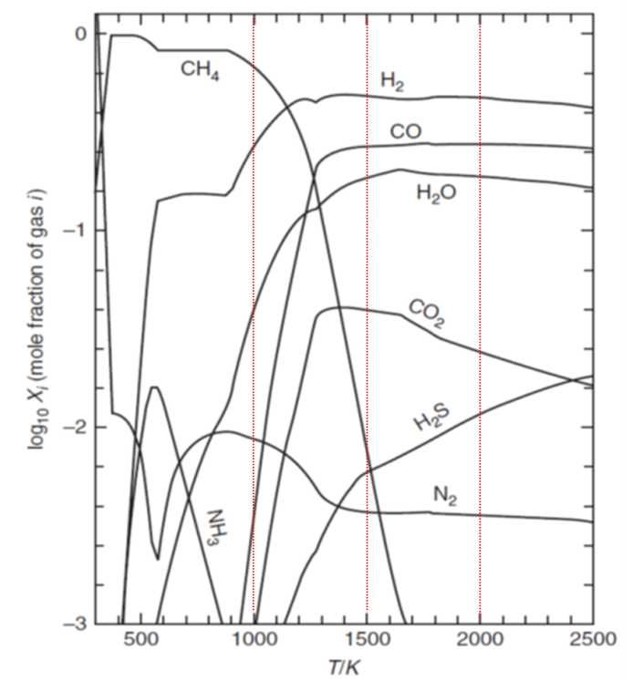
Fig. S4 Gas composition in equilibrium with ordinary H-type chondrites at a pressure p = 100 bar. Ordinary chondrites are often regarded as indicative of the bulk material of the Earth. The gases are reduced and methane is strongly favored at p = 100 bar (adapted from Ref. 36 with revision).

5. Possible TBD pathways for H₂O
Oxygen atom production from H₂O molecules could, in principle, occurs via a simultaneous or a sequential TBD process (Fig. S5). In the former case, pathway 1 in Fig. S4 (H₂O → O + H + H, see below), the two O–H bonds break simultaneously and the two H atom fragments should be formed with equal kinetic energies. In contrast, in a sequential dissociation, pathway 2 in Fig. S5 (i.e., H₂O → H + OH*→ O + H + H), the H₂O molecule first splits into an H atom and a rovibrationally excited OH* radical and the latter then dissociates to yield an O atom and a second H atom. In either case, we can consider limiting models involving either a linear or nonlinear predissociative transition state of H₂O, as illustrated in Fig. S5.
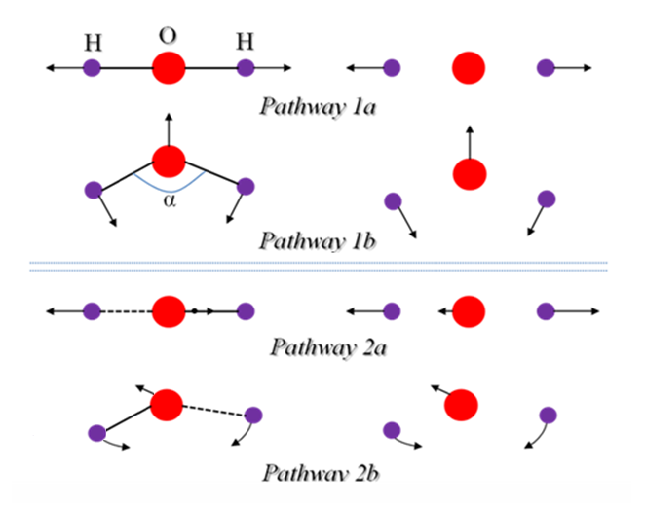
Fig. S5 Schematic of possible TBD pathways of H₂O. The top panel depicts the simultaneous processes, in which three fragments (an O atom and two H atoms) are released simultaneously. The lower panel shows the sequential processes, wherein the initial dissociation yields a ‘hot’ (i.e. highly vibrationally and/or rotationally excited) intermediate OH species.
Focussing first on the pathway 1 case, the kinetic energies of any H atoms produced via such a simultaneous TBD process can be derived using momentum and energy conservation arguments⁴⁸, i.e.
E_{KE} =$\frac{E_{a}}{2×(1+2×\left(\frac{m_{H}}{m_{o}}\right)\cos^{2}\left(\frac{θ}{2}\right))}$ (S1)
where m_{H} and m_{O} are the respective atomic masses, E_{a} is the available energy (i.e. E_{hv} + E_{int}(H₂O) − E_{th}, where E_{th} is the threshold energy for the TBD process of interest) and $θ$ is the molecular inter-bond angle. As Fig. S6 shows, the TKER spectra predicted for this scenario using Eq. S1 consist of narrow peaks centred at kinetic energy values close to one half of E_{a} (i.e., at ~290 cm⁻¹ and at ~8224 cm⁻¹ for the O(¹D) + 2H and O(³P) + 2H channels, respectively). The big mass difference between the H and O atoms ensures that the two H atoms each recoil with almost (or, in the limit that θ = 180° (pathway 1a) exactly) half of the total available energy. This is clearly not the case in the present experiment (see Fig. 1 in the main text), implying that sequential three-body dissociations (pathway 2 in Fig. S5) are the dominant source of the observed atomic products.
Fig. S6 Simulated kinetic energy spectra of the O(¹D) + 2H and O(³P) + 2H products arising from the simultaneous dissociation of H₂O molecules with an equilibrium bond angle of 109º (appropriate for the nd Rydberg states⁴⁹). Calculations for other initial bond angles yield very similar kinetic energy distributions.

6. Electronic Structure Considerations
To shed further insights into the photodissociation mechanisms of H₂O molecules from higher excited states, we have calculated ten adiabatic potential energy surfaces (PESs) of H₂O (five ¹A' electronic states $\tilde{X}$, $\tilde{B}$, $\tilde{D}$, ${\tilde{E}}^{'},$ and $\tilde{F}$, and five ¹A" electronic states $\tilde{A}$, $\tilde{I}$, $\tilde{C}$, $\tilde{D}'$, and $\tilde{D}"$ in the C_{s} point group) using the internally contracted multi-reference configuration interaction method with the Davidson correction (icMRCI+Q) and a large basis set⁵⁰⁻⁵².
Fig. S7 shows the energy level diagram correlating the calculated vertical excitation energies of these excited states of H₂O and the various binary and three-body dissociation limits. The $\tilde{X}$, $\tilde{A}$, and $\tilde{I}$ states correlate to the O(³P) + 2H asymptote (where $\tilde{I}$ represents ¹A₂(3pb₂←1b₁) state), while the $\tilde{B}$, $\tilde{C}$, $\tilde{D}$, $\tilde{D}'$, and $\tilde{E}'$ states are predicted to correlate with the O(¹D) + 2H product asymptote. It is noted that the $\tilde{C}$, $\tilde{D}'$, and $\tilde{E}'$ states have large barriers along the O(¹D) + 2H dissociation pathway.
Previous studies^{49, 53-55} have suggested that the nd Rydberg states excited in the present work may undergo fast internal conversion to the D state PES, and further to lower lying electronic states, i.e., the $\tilde{B}$ and $\tilde{X}$ states. In addition to the documented avoided crossing between the D and B states at a bond angle of about 100^{o 20}, the present calculations find a conical intersection seam between the adiabatic PESs for the D and B states at C_{2v} geometries and O–H bond lengths in the range 0.95-1.6 Å, with a minimum energy of ~11.04 eV at R_{OH} = 1.12 Å and θ_{HOH} =78°, providing clear theoretical evidence of fast conversion from D to B. Thus, H₂O molecules on the D state PES could dissociate in several possible ways: (1) Direct dissociation on the D state PES to yield the three-body dissociation products O(¹D) + 2H. This dissociation pathway has no barrier, which may explain the relatively large recoil anisotropy of the observed O(¹D) + 2H products. (2) Fast non-adiabatic coupling to the 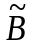 state and direct dissociation on the state PES to yield the binary fragments OH(A) + H. If the OH(A) products acquire sufficient internal energy they can dissociate further to produce an O(¹D) atom and a second H atom. This process should be expected to have a relatively smaller angular anisotropy. (3) Fast internal conversion to the state, followed by further non-adiabatic coupling to the state via either of the two documented conical intersections between the and state PESs, leading to both binary (OH(X) + H) and three-body (O(³P) + 2H) dissociations. Earlier trajectory calculations by Dixon²⁵ suggested that almost all the trajectories leading of the O(³P) + 2H products couple to the ground state PES at near linear O–H–H geometries, and that the dissociation is sequential, via an H + O–H intermediate step, in good accord with the present experimental findings. However, accurate dynamics calculations for three-body dissociations from highly excited Rydberg states are not possible at this time.
Fig. S7 Energy level diagram for various binary and TBD channels of H₂O. The quoted excited state energies are for the respective zero-point (i.e. v=0) levels, defined relative to the, v=0 level.

7. Oxygen production rate for CO₂ VUV photochemistry
We have drawn the wavelength dependences of the solar photon flux in the early period (10 My=1×10⁷ year)³², the total photoabsorption cross sections of the parent CO₂ molecule in the VUV region (90-200 nm)⁵⁶, and assuming the production yields of O-atom being unity, as shown in Fig. S8. The photodissociation rate constant for O production: J_{CO2}=~1.8×10⁻⁴ s⁻¹. Then this gives the O production rate: N_{CO2}(O)= J_{CO2}×[CO₂]=1.8×10⁻⁴[CO₂], where [CO₂] is the density of CO₂.

Fig. S8 Plot showing the wavelength dependences of the reconstructed VUV solar flux (90-200 nm) at ~10My, the total absorption (σ_{tot}) cross-sections of CO₂, and assuming the quantum yield for forming oxygen atom photoproducts being unity. We assume the total absorption cross-section is the same as the photodissociation cross section for CO₂, due to the predissociation rate of CO₂ is sufficiently fast that the fluorescence quantum yield must be negligible.

References:
44. Chang, Y., et al. Hydroxyl super rotors from vacuum ultraviolet photodissociation of water. Nat. Commun. 10, 1250 (2019).
45. Mota, R. et al. Water VUV electronic state spectroscopy by synchrotron radiation. Chem. Phys. Lett. 416, 152-159 (2005).
46. Schaefer, L. & Fegley, B. Outgassing of ordinary chondritic material and some of its implications for the chemistry of asteroids, planets, and satellites. Icarus 186, 462-483 (2007).
47. Schaefer, L. & Fegley, B. Volatile element chemistry during metamorphism of ordinary chondritic material and some of its implications for the composition of asteroids. Icarus 205, 483-496 (2010).
48. Maul, C. & Gericke, K. H. Photo induced three body decay. Int. Rev. Phys. Chem. 16, 1-79 (1997).
49. Hirst, D. M. & Child, M. S. Ab initio bending potential energy curves for Rydberg states of H₂O. Mol. Phys. 77, 463-476 (1992).
50. Werner, H. J. & Knowles, P. J. An efficient internally contracted multiconfiguration reference configuration interaction method. J. Chem. Phys. 89, 5803-5814 (1988).
51. Knowles, P. J. & Werner, H. J. An efficient method for the evaluation of coupling coefficients In configuration interaction calculations. Chem. Phys. Lett. 145, 514-522 (1988).
52. Davidson, E. R. & Silver, D. W. Size consistency in dilute helium gas electronic structure. Chem. Phys. Lett. 52, 403-406 (1977).
53. Chang, Y. et al. Hydroxyl super rotors from vacuum ultraviolet photodissociation of water. Nat. Commun. 10, 1250 (2019).
54. Theodorakopoulos, G. et al. Bending potentials for H₂O in the ground and the first six singlet excited states. Chem. Phy.s Lett. 105, 253-257 (1984).
55. Petsalakis, I. D., Theodorakopoulos, G. & Child, M. S. Ab initio multichannel quantum defects for the ¹A₁ Rydberg states of H₂O. J. Phys. B: At. Mol. Opt. 28, 5179-5192 (1995).
56. Archer, L. E. et al. Room temperature photoabsorption cross section measurements of CO₂ between 91,000 and 115,000 cm⁻¹. J. Quant. Spectrosc. Radiat. Transf. 117, 88-92 (2013).

