Supplementary Information

Exploring the molecular mechanisms underpinning H₂O₂-induced oxidative stress hypersensitivity in D-erythroascorbic acid-deficient yeast cells
Running title: ara2Δ-medited stress sensitivity mechanism at transcriptional level

Il-Sup Kim

Advanced Bio-resource Research Center, Kyungpook National University, Daegu 41566, Republic of Korea
*Correspondence: 92kis@hanmail.net

Table S1 Genotype of S. cerevisiae strains used in this study
Strain | Genotype | Source
BY4741 (WT) | MATa; his3Δ1; leu2Δ0; met15Δ0; ura3Δ0 | Euroscarf
ara2Δ | MATa; his3Δ1; leu2Δ0; met15Δ0; ura3Δ0; YMR041c::kanMX4 | Euroscarf

Table S2 Two-fold changed gene in ara2Δ cells under oxidative stress
Gene symbol | Fold change  (ara2Δ /WT)
Gene symbol | Fold change  (ara2Δ /WT) | Gene | Description
YGR190C | 24.678 |  | Dubious open reading frame
YLR458W | 23.574 |  | Dubious open reading frame
tF(GAA)D | 23.402 |  | Phenylalanine tRNA (tRNA-Phe)
YAL064W | 22.545 |  | Protein of unknown function
YNR062C | 21.550 | PUL3 | Putative pulcherrimin transporter
YFL015W-A | 21.516 |  | Dubious open reading frame
YJL214W | 20.701 | HXT8 | Protein of unknown function with similarity to hexose transporters
YGR236C | 18.621 | SPG1 | Protein required for high temperature survival during stationary phase
YCR021C | 13.264 | HSP30 | Negative regulator of the H(+)-ATPase Pma1p
YMR013W-A | 12.425 |  | Dubious open reading frame
YIL057C | 11.900 | RGI2 | Protein of unknown function
tC(GCA)G | 11.595 |  | Cysteine tRNA (tRNA-Cys)
YLR327C | 11.227 | TMA10 | Protein of unknown function that associates with ribosomes
tG(UCC)G | 10.760 | SUF4 | Glycine tRNA (tRNA-Gly)
YDL024C | 10.681 | DIA3 | Protein of unknown function
YHR212C | 10.527 |  | Dubious open reading frame
tD(GUC)J4 | 9.364 |  | Aspartate tRNA (tRNA-Asp)
YOL141W | 9.033 | PPM2 | AdoMet-dependent tRNA methyltransferase
YPR196W | 8.862 |  | Putative maltose-responsive transcription factor
YEL048C | 8.517 | TCA17 | Component of transport protein particle (TRAPP) complex II
YGR242W | 8.185 |  | Dubious open reading frame
YOR268C | 8.131 |  | Putative protein of unknown function
YIL066W-A | 7.876 |  | Dubious open reading frame
YML100W-A | 7.497 |  | Putative protein of unknown function
tD(GUC)J3 | 7.079 |  | Aspartate tRNA (tRNA-Asp)
tG(UCC)N | 6.874 | SUF6 | Glycine tRNA (tRNA-Gly)
tG(UCC)O | 6.843 | SUF1 | Glycine tRNA (tRNA-Gly)
YHL042W | 6.657 |  | Endoplasmic reticulum protein
tG(GCC)O2 | 6.423 | SUF17 | Glycine tRNA (tRNA-Gly)
tD(GUC)I2 | 6.189 |  | Aspartate tRNA (tRNA-Asp)
YHR189W | 5.958 | PTH1 | One of two mitochondrially-localized peptidyl-tRNA hydrolases
snR36 | 5.956 | SNR36 | H/ACA box small nucleolar RNA (snoRNA)
snR58 | 5.901 | SNR58 | C/D box small nucleolar RNA (snoRNA)
YOR049C | 5.862 | RSB1 | Sphingoid long-chain base (LCB) efflux transporter
YCR022C | 5.638 |  | Putative protein of unknown function
YNR001W-A | 5.584 |  | Dubious open reading frame unlikely to encode a functional protein
YLR111W | 5.447 |  | Putative protein of unknown function
tQ(UUG)H | 5.281 |  | Glutamine tRNA (tRNA-Gln)
snR73 | 5.229 | SNR73 | C/D box small nucleolar RNA (snoRNA)
tG(GCC)J1 | 5.217 |  | Glycine tRNA (tRNA-Gly)
YMR290W-A | 5.174 |  | Dubious open reading frame
tL(UAA)D | 5.168 |  | Leucine tRNA (tRNA-Leu)
YGL158W | 5.101 | RCK1 | Protein kinase involved in oxidative stress response
YPR119W | 4.917 | CLB2 | B-type cyclin involved in cell cycle progression
tY(GUA)M1 | 4.851 | SUP5 | Tyrosine tRNA (tRNA-Tyr)
YOR055W | 4.773 |  | Dubious open reading frame
tX(XXX)D | 4.716 |  | tRNA of undetermined specificity
YOR235W | 4.620 | IRC13 | Putative protein of unknown function
YHL046C | 4.602 | PAU13 | Protein of unknown function
snR55 | 4.585 | SNR55 | C/D box small nucleolar RNA (snoRNA)
YLR365W | 4.551 |  | Putative protein of unknown function
YOR072W | 4.532 |  | Putative protein of unknown function
YCR049C | 4.415 |  | Dubious open reading frame
tA(AGC)L | 4.383 |  | Alanine tRNA (tRNA-Ala)
YFL050C | 4.349 | ALR2 | Probable Mg(2+) transporter
tK(CUU)E2 | 4.253 |  | Lysine tRNA (tRNA-Lys)
YIL021C-A | 4.179 |  | Dubious open reading frame
YKL107W | 4.172 |  | NADH-dependent aldehyde reductase
tD(GUC)K | 4.158 |  | Aspartate tRNA (tRNA-Asp)
snR71 | 4.122 | SNR71 | C/D box small nucleolar RNA (snoRNA)
YJL107C | 4.113 |  | Putative protein of unknown function
YOL037C | 4.040 |  | Dubious open reading frame
tS(AGA)D2 | 4.035 |  | Serine tRNA (tRNA-Ser)
YIL142C-A | 4.012 |  | Dubious open reading frame
YPR202W | 3.969 |  | Putative protein of unknown function
YGR204C-A | 3.941 |  | Putative protein of unknown function
snR66 | 3.899 | SNR66 | C/D box small nucleolar RNA (snoRNA)
YOR214C | 3.896 | SPR2 | Putative spore wall protein
YGR006W | 3.866 | PRP18 | Splicing factor and component of snRNP U5
snR67 | 3.815 | SNR67 | C/D box small nucleolar RNA (snoRNA)
snR190 | 3.775 | SNR190 | C/D box small nucleolar RNA (snoRNA)
YPL014W | 3.770 | CIP1 | Cyclin-dependent kinase inhibitor
YCL069W | 3.729 | VBA3 | Permease of basic amino acids in the vacuolar membrane
YFR009W-A | 3.697 |  | Dubious open reading frame
YLR154W-B | 3.684 |  | Dubious open reading frame
YMR107W | 3.544 | SPG4 | Protein required for high temperature survival during stationary phase
YBR132C | 3.537 | AGP2 | Plasma membrane regulator of polyamine and carnitine transport
YHR050W-A | 3.536 |  | Protein of unknown function
YOL162W | 3.534 |  | Putative protein of unknown function
YGL192W | 3.529 | IME4 | mRNA N6-adenosine methyltransferase required for entry into meiosis
YLR154W-A | 3.495 |  | Dubious open reading frame
YIR042C | 3.486 |  | Putative protein of unknown function
YLL057C | 3.471 | JLP1 | Fe(II)-dependent sulfonate/alpha-ketoglutarate dioxygenase
YPL136W | 3.449 |  | Dubious open reading frame
YFR012W | 3.446 | DCV1 | Protein of unknown function
YPL155C | 3.413 | KIP2 | Kinesin-related motor protein involved in mitotic spindle positioning
YPR195C | 3.364 |  | Putative protein of unknown function
tG(CCC)D | 3.321 | SUF3 | Glycine tRNA (tRNA-Gly)
YGL208W | 3.299 | SIP2 | One of three beta subunits of the Snf1 kinase complex
YLR041W | 3.298 |  | Dubious open reading frame
YDL194W | 3.297 | SNF3 | Plasma membrane low glucose sensor
YIL164C | 3.245 | NIT1 | Nitrilase
YNL179C | 3.207 |  | Dubious open reading frame
YKR097W | 3.202 | PCK1 | Phosphoenolpyruvate carboxykinase
tL(CAA)D | 3.180 |  | Leucine tRNA (tRNA-Leu)
YLR366W | 3.169 |  | Dubious open reading frame
YPL130W | 3.155 | SPO19 | Meiosis-specific prospore protein
YBL074C | 3.152 | AAR2 | Component of the U5 snRNP complex
YLR037C | 3.149 | PAU23 | Cell wall mannoprotein
YNR069C | 3.147 | BSC5 | Protein of unknown function
YPR076W | 3.130 |  | Dubious open reading frame
YNL284C-A | 3.120 |  | Retrotransposon TYA Gag gene co-transcribed with TYB Pol
YHL002C-A | 3.097 |  | Dubious open reading frame
tT(AGU)H | 3.065 |  | Threonine tRNA (tRNA-Thr)
YPL272C | 3.028 | PBI1 | Putative protein of unknown function
snR191 | 2.969 | SNR191 | H/ACA box small nucleolar RNA (snoRNA)
YGL075C | 2.961 | MPS2 | Essential membrane protein localized at nuclear envelope and SPBs
YOL046C | 2.921 |  | Dubious open reading frame
YBL100W-C | 2.911 |  | Putative protein of unknown function
YBL006W-A | 2.901 |  | Dubious open reading frame
YFR008W | 2.859 | FAR7 | Protein involved in recovery from pheromone-induced cell cycle arrest
YCR024C-A | 2.848 | PMP1 | Regulatory subunit for the plasma membrane H(+)-ATPase Pma1p
YFL015C | 2.843 |  | Putative protein of unknown function
YIR018C-A | 2.833 |  | Putative protein of unknown function
YDR419W | 2.824 | RAD30 | DNA polymerase eta
YEL008W | 2.818 |  | Putative protein of unknown function
tT(CGU)K | 2.815 | TRT2 | Threonine tRNA (tRNA-Thr)
YNL285W | 2.814 |  | Dubious open reading frame
YLR364C-A | 2.810 |  | Dubious open reading frame
YKL031W | 2.808 |  | Dubious open reading frame
YIR020C-B | 2.805 |  | Dubious open reading frame
YML045W-A | 2.797 |  | Retrotransposon TYA Gag gene co-transcribed with TYB Pol
YNR063W | 2.792 | PUL4 | Putative zinc-cluster transcription factor
YGL217C | 2.774 |  | Dubious open reading frame
YPL162C | 2.752 |  | Putative protein of unknown function
YDR540C | 2.734 | IRC4 | Protein similar to bacterial secreted DfsB proteins
YER103W | 2.729 | SSA4 | Heat shock protein that is highly induced upon stress
YBR072W | 2.720 | HSP26 | Small heat shock protein (sHSP) with chaperone activity
YDL160C | 2.709 | DHH1 | Cytoplasmic DEAD-box helicase
YDR098C-A | 2.697 |  | Retrotransposon TYA Gag gene co-transcribed with TYB Pol
YPL044C | 2.695 |  | Dubious open reading frame
tP(UGG)F | 2.683 | SUF9 | Proline tRNA (tRNA-Pro)
YGR142W | 2.680 | BTN2 | v-SNARE binding protein
YDR536W | 2.668 | STL1 | Glycerol proton symporter of the plasma membrane
YDL109C | 2.664 |  | Putative lipase
YLR280C | 2.664 |  | Dubious open reading frame
YOR142W-A | 2.664 |  | Retrotransposon TYA Gag gene co-transcribed with TYB Pol
YAR068W | 2.663 |  | Fungal-specific protein of unknown function
YMR081C | 2.650 | ISF1 | Serine-rich, hydrophilic protein
YAR035W | 2.647 | YAT1 | Outer mitochondrial carnitine acetyltransferase
snR7-S | 2.645 | SNR7-S | U5 spliceosomal RNA (U5 snRNA)
YLR091W | 2.644 | GEP5 | Protein of unknown function
YBL109W | 2.641 |  | Dubious open reading frame
YOR358W | 2.638 | HAP5 | Subunit of the Hap2p/3p/4p/5p CCAAT-binding complex
RDN5-1 | 2.635 | RDN5-1 | 5S ribosomal RNA (5S rRNA)
YMR182C | 2.629 | RGM1 | Putative zinc finger DNA binding transcription factor
YBR277C | 2.625 |  | Dubious open reading frame
YDR210C-C | 2.624 |  | Retrotransposon TYA Gag gene co-transcribed with TYB Pol
YJR020W | 2.616 |  | Dubious open reading frame
YBR217W | 2.611 | ATG12 | Ubiquitin-like modifier involved in autophagy and the Cvt pathway
tD(GUC)G1 | 2.611 |  | Aspartate tRNA (tRNA-Asp)
RDN18-1 | 2.611 | RDN18-1 | 18S ribosomal RNA (18S rRNA)
RDN18-2 | 2.605 | RDN18-2 | 18S ribosomal RNA (18S rRNA)
YDR210W-A | 2.604 |  | Retrotransposon TYA Gag gene co-transcribed with TYB Pol
YGR287C | 2.604 | IMA1 | Major isomaltase (alpha-1,6-glucosidase/alpha-methylglucosidase)
YDR285W | 2.599 | ZIP1 | Transverse filament protein of the synaptonemal complex
YLR317W | 2.593 |  | Dubious open reading frame
YIL102C | 2.590 |  | Putative protein of unknown function
LSR1 | 2.583 | LSR1 | U2 spliceosomal RNA (U2 snRNA)
YAR047C | 2.575 |  | Dubious open reading frame
Q0065 | 2.572 | AI4 | Endonuclease I-SceII
Q0060 | 2.572 | AI3 | Endonuclease I-SceIII
Q0055 | 2.572 | AI2 | Reverse transcriptase required for splicing of the COX1 pre-mRNA
tL(CAA)G1 | 2.571 |  | Leucine tRNA (tRNA-Leu)
YLR393W | 2.570 | ATP10 | Assembly factor for the F0 sector of mitochondrial F1F0 ATP synthase
YPL166W | 2.568 | ATG29 | Autophagy-specific protein
YDR009W | 2.543 | GAL3 | Transcriptional regulator
YLR466C-B | 2.542 |  | Dubious open reading frame
YHR214C-C | 2.539 |  | Retrotransposon TYA Gag gene co-transcribed with TYB Pol
YOL134C | 2.538 |  | Dubious open reading frame
YNR002C | 2.534 | ATO2 | Putative transmembrane protein involved in export of ammonia
YFR056C | 2.534 |  | Dubious open reading frame
YIL059C | 2.527 |  | Dubious open reading frame
YLR157C-C | 2.513 |  | Putative protein of unknown function
RDN5-4 | 2.513 | RDN5-4 | Variant 5S ribosomal rRNA (5S rRNA) gene
tA(UGC)A | 2.512 | TGA1 | Alanine tRNA (tRNA-Ala)
tL(UAA)K | 2.502 |  | Leucine tRNA (tRNA-Leu)
tL(UAA)B1 | 2.501 |  | Leucine tRNA (tRNA-Leu)
YMR051C | 2.492 |  | Retrotransposon TYA Gag gene co-transcribed with TYB Pol
tN(GUU)O1 | 2.489 |  | Asparagine tRNA (tRNA-Asn)
YGL184C | 2.488 | STR3 | Peroxisomal cystathionine beta-lyase
YJR055W | 2.478 | HIT1 | Protein involved in C/D snoRNP assembly
YOR363C | 2.473 | PIP2 | Autoregulatory, oleate-activated transcription factor
YDR096W | 2.465 | GIS1 | Histone demethylase and transcription factor
YPR158W-A | 2.461 |  | Retrotransposon TYA Gag gene co-transcribed with TYB Pol
YGR161C-C | 2.453 |  | Retrotransposon TYA Gag gene co-transcribed with TYB Pol
YEL019C | 2.452 | MMS21 | Highly conserved SUMO E3 ligase subunit of SMC5-SMC6 complex
YGR038C-A | 2.451 |  | Retrotransposon TYA Gag gene co-transcribed with TYB Pol
YJL106W | 2.449 | IME2 | Serine/threonine protein kinase involved in activation of meiosis
YPL047W | 2.448 | SGF11 | Integral subunit of SAGA histone acetyltransferase complex
YHL040C | 2.448 | ARN1 | ARN family transporter for siderophore-iron chelates
tR(ACG)J | 2.446 |  | Arginine tRNA (tRNA-Arg)
YHL022C | 2.441 | SPO11 | Meiosis-specific protein that initiates meiotic recombination
YNL331C | 2.437 | AAD14 | Putative aryl-alcohol dehydrogenase
YLR159C-A | 2.435 |  | Putative protein of unknown function
RDN5-5 | 2.435 | RDN5-5 | Variant 5S ribosomal rRNA (5S rRNA) gene
YDR246W-A | 2.433 |  | Putative protein of unknown function
YBR012W-A | 2.431 |  | Retrotransposon TYA Gag gene co-transcribed with TYB Pol
tK(UUU)K | 2.431 |  | Lysine tRNA (tRNA-Lys)
YHR157W | 2.430 | REC104 | Protein involved in early stages of meiotic recombination
YJL019W | 2.425 | MPS3 | Nuclear envelope protein
YLL055W | 2.421 | YCT1 | High-affinity cysteine-specific transporter
YOL080C | 2.421 | REX4 | Putative RNA exonuclease
RDN58-2 | 2.420 | RDN58-2 | 5.8S ribosomal RNA (5.8S rRNA)
YLL038C | 2.419 | ENT4 | Protein of unknown function
YPL233W | 2.416 | NSL1 | Essential component of the MIND kinetochore complex
YLR162W | 2.412 |  | Protein of unknown function
YGL053W | 2.411 | PRM8 | Pheromone-regulated protein
YLR217W | 2.405 |  | Dubious open reading frame
YKL220C | 2.398 | FRE2 | Ferric reductase and cupric reductase;
snR49 | 2.398 | SNR49 | H/ACA box small nucleolar RNA (snoRNA)
ICR1 | 2.392 | ICR1 | Long intergenic regulatory ncRNA
YLR281C | 2.391 | RSO55 | Mitochondrial protein of unknown function
YKR005C | 2.391 |  | Putative protein of unknown function
YOR344C | 2.389 | TYE7 | Serine-rich protein that contains a bHLH DNA binding motif
YPR054W | 2.386 | SMK1 | Middle sporulation-specific mitogen-activated protein kinase (MAPK)
snR7-L | 2.364 | SNR7-L | U5 spliceosomal RNA (U5 snRNA)
YCR068W | 2.362 | ATG15 | Phospholipase
snR78 | 2.361 | SNR78 | C/D box small nucleolar RNA (snoRNA)
YAR028W | 2.355 |  | Putative integral membrane protein
RPR1 | 2.351 | RPR1 | RNA component of nuclear RNase P
YDL113C | 2.348 | ATG20 | Sorting nexin family member
YLR312C | 2.347 | ATG39 | Autophagy receptor with a role in degradation of the ER and nucleus
YOL103W-A | 2.340 |  | Retrotransposon TYA Gag gene co-transcribed with TYB Pol
YHR044C | 2.337 | DOG1 | 2-deoxyglucose-6-phosphate phosphatase
YDR324C | 2.333 | UTP4 | Subunit of U3-containing 90S preribosome and SSU processome complexes
tD(GUC)I1 | 2.320 |  | Aspartate tRNA (tRNA-Asp)
YPL167C | 2.320 | REV3 | Catalytic subunit of DNA polymerase zeta
YBL100W-A | 2.317 |  | Retrotransposon TYA Gag gene co-transcribed with TYB Pol
tY(GUA)F2 | 2.316 | SUP6 | Tyrosine tRNA (tRNA-Tyr)
YML037C | 2.316 |  | Putative protein of unknown function
YDR316W-A | 2.308 |  | Retrotransposon TYA Gag gene co-transcribed with TYB Pol
YOR263C | 2.307 |  | Dubious open reading frame
YER041W | 2.305 | YEN1 | Holliday junction resolvase
YER159C-A | 2.302 |  | Retrotransposon TYA Gag gene co-transcribed with TYB Pol
YNR014W | 2.299 |  | Putative protein of unknown function
RDN37-2 | 2.295 | RDN37-2 | 35S ribosomal RNA (35S rRNA) transcript
YIL102C-A | 2.294 |  | Putative protein of unknown function
RDN37-1 | 2.290 | RDN37-1 | 35S ribosomal RNA (35S rRNA) transcript
YJR026W | 2.290 |  | Retrotransposon TYA Gag gene co-transcribed with TYB Pol
YOL160W | 2.289 |  | Putative protein of unknown function
YDR389W | 2.289 | SAC7 | GTPase activating protein (GAP) for Rho1p
YDR403W | 2.288 | DIT1 | Sporulation-specific enzyme required for spore wall maturation
YNL128W | 2.280 | TEP1 | PTEN homolog with no demonstrated inositol lipid phosphatase activity
RDN25-2 | 2.275 | RDN25-2 | 25S ribosomal RNA (25S rRNA)
RDN25-1 | 2.271 | RDN25-1 | 25S ribosomal RNA (25S rRNA)
YNL054W-A | 2.266 |  | Retrotransposon TYA Gag gene co-transcribed with TYB Pol
snR3 | 2.263 | SNR3 | H/ACA box small nucleolar RNA (snoRNA)
YLR162W-A | 2.263 | RRT15 | Putative protein of unknown function
YLR154W-C | 2.262 | TAR1 | Protein potentially involved in regulation of respiratory metabolism
YLR010C | 2.259 | TEN1 | Protein that regulates telomeric length
YOR208W | 2.253 | PTP2 | Nuclear phosphotyrosine-specific phosphatase involved in osmosensing
YLR279W | 2.251 |  | Dubious open reading frame
YJL066C | 2.243 | MPM1 | Mitochondrial intermembrane space protein of unknown function
YOR077W | 2.242 | RTS2 | Basic zinc-finger protein
YOR387C | 2.239 |  | Putative protein of unknown function
YPR123C | 2.236 |  | Dubious open reading frame
YKR073C | 2.228 |  | Putative protein of unknown function
YLR052W | 2.226 | IES3 | Subunit of the INO80 chromatin remodeling complex
YAR073W | 2.225 | IMD1 | Nonfunctional protein with homology to IMP dehydrogenase
YJL067W | 2.225 |  | Dubious open reading frame
YPL171C | 2.219 | OYE3 | Conserved NADPH oxidoreductase containing flavin mononucleotide (FMN)
YCR045C | 2.217 | RRT12 | Probable subtilisin-family protease
YKL042W | 2.215 | SPC42 | Central plaque component of spindle pole body (SPB)
YMR206W | 2.213 |  | Putative protein of unknown function
tK(CUU)D1 | 2.213 |  | Lysine tRNA (tRNA-Lys)
YPL257W-A | 2.212 |  | Retrotransposon TYA Gag gene co-transcribed with TYB Pol
YJL213W | 2.212 |  | Protein of unknown function that may interact with ribosomes
YPL216W | 2.210 |  | Putative protein of unknown function
YDR170W-A | 2.208 |  | Retrotransposon TYA Gag gene
YKR021W | 2.207 | ALY1 | Alpha arrestin
YCL020W | 2.204 |  | Retrotransposon TYA Gag gene co-transcribed with TYB Pol
YFR017C | 2.204 | IGD1 | Cytoplasmic protein that inhibits Gdb1p glycogen debranching activity
YNL009W | 2.202 | IDP3 | Peroxisomal NADP-dependent isocitrate dehydrogenase
YJR115W | 2.194 |  | Putative protein of unknown function
YGR160W | 2.192 |  | Dubious open reading frame
YER079W | 2.191 |  | Putative protein of unknown function
YJR093C | 2.189 | FIP1 | Subunit of cleavage polyadenylation factor (CPF)
YCL021W-A | 2.186 |  | Putative protein of unknown function
YGR117C | 2.182 |  | Putative protein of unknown function
snR51 | 2.178 | SNR51 | C/D box small nucleolar RNA (snoRNA)
YHL037C | 2.177 |  | Putative protein of unknown function
tL(GAG)G | 2.176 |  | Leucine tRNA (tRNA-Leu)
YDR076W | 2.173 | RAD55 | Protein that stimulates strand exchange
YBR299W | 2.167 | MAL32 | Maltase (alpha-D-glucosidase)
YBR047W | 2.166 | FMP23 | Putative protein of unknown function
YML032C | 2.166 | RAD52 | Protein involved in homologous recombination
YFL002W-B | 2.161 |  | Retrotransposon TYA Gag gene co-transcribed with TYB Pol
tD(GUC)N | 2.156 |  | Aspartate tRNA (tRNA-Asp)
YBR194W | 2.153 | AIM4 | Protein proposed to be associated with the nuclear pore complex
YGR161W-A | 2.151 |  | Retrotransposon TYA Gag gene co-transcribed with TYB Pol
YHR195W | 2.149 | NVJ1 | Nuclear envelope protein
YOR313C | 2.148 | SPS4 | Protein whose expression is induced during sporulation
YIR027C | 2.142 | DAL1 | Allantoinase
YML045W | 2.142 |  | Retrotransposon TYA Gag and TYB Pol genes
YPL055C | 2.140 | LGE1 | Protein involved in histone H2B ubiquitination
YJR028W | 2.133 |  | Retrotransposon TYA Gag gene co-transcribed with TYB Pol
YNL226W | 2.129 |  | Dubious open reading frame
YPR137C-A | 2.125 |  | Retrotransposon TYA Gag gene co-transcribed with TYB Pol
YIL160C | 2.124 | POT1 | 3-ketoacyl-CoA thiolase with broad chain length specificity
YBL066C | 2.124 | SEF1 | Putative transcription factor
YOR142W-B | 2.124 |  | Retrotransposon TYA Gag and TYB Pol genes
YEL068C | 2.122 |  | Protein of unknown function
YGL177W | 2.118 |  | Dubious open reading frame
YMR017W | 2.112 | SPO20 | Meiosis-specific subunit of the t-SNARE complex
YKL050C | 2.101 |  | Protein of unknown function
YIL152W | 2.100 |  | Putative protein of unknown function
YLR154W-F | 2.098 |  | Dubious open reading frame
YNL187W | 2.098 | SWT21 | Protein involved in mRNA splicing
YAL039C | 2.096 | CYC3 | Cytochrome c heme lyase (holocytochrome c synthase)
YGR046W | 2.092 | TAM41 | Mitochondrial phosphatidate cytidylyltransferase (CDP-DAG synthase)
YIL150C | 2.090 | MCM10 | Essential chromatin-associated protein
YML040W | 2.090 |  | Retrotransposon TYA Gag gene co-transcribed with TYB Pol
YBR117C | 2.085 | TKL2 | Transketolase
tS(AGA)J | 2.083 |  | Serine tRNA (tRNA-Ser)
YDR098C-B | 2.081 |  | Retrotransposon TYA Gag and TYB Pol genes
YHL024W | 2.081 | RIM4 | Putative RNA-binding protein
YAR010C | 2.077 |  | Retrotransposon TYA Gag gene co-transcribed with TYB Pol
YCL001W-A | 2.076 |  | Putative protein of unknown function
YDR210C-D | 2.074 |  | Retrotransposon TYA Gag and TYB Pol genes
YER137C | 2.072 |  | Putative protein of unknown function
Q0285 | 2.068 | RPM1 | RNA component of mitochondrial RNase P
Q0297 | 2.068 |  | Dubious open reading frame
tH(GUG)G1 | 2.066 |  | Histidine tRNA (tRNA-His)
YLR338W | 2.061 | OPI9 | Dubious open reading frame
RDN58-1 | 2.057 | RDN58-1 | 5.8S ribosomal RNA (5.8S rRNA)
YLR256W-A | 2.057 |  | Retrotransposon TYA Gag gene co-transcribed with TYB Pol
YML057C-A | 2.056 |  | Dubious open reading frame
YGR289C | 2.055 | MAL11 | High-affinity maltose transporter (alpha-glucoside transporter)
tF(GAA)M | 2.052 |  | Phenylalanine tRNA (tRNA-Phe)
YDR360W | 2.051 | OPI7 | Dubious open reading frame
YPR158W-B | 2.050 |  | Retrotransposon TYA Gag and TYB Pol genes
YPR029C | 2.049 | APL4 | Gamma-adaptin
YLR211C | 2.048 | ATG38 | Homodimeric subunit of autophagy-specific PtdIns-3-kinase complex I
YMR030W | 2.044 | RSF1 | Protein required for respiratory growth
YOL089C | 2.042 | HAL9 | Putative transcription factor containing a zinc finger
YLR157C-A | 2.039 |  | Retrotransposon TYA Gag gene co-transcribed with TYB Pol
YDR443C | 2.039 | SSN2 | Subunit of the RNA polymerase II mediator complex
YKL132C | 2.032 | RMA1 | Putative dihydrofolate synthetase
YDR261C-C | 2.029 |  | Retrotransposon TYA Gag gene co-transcribed with TYB Pol
YBR203W | 2.029 | COS111 | Protein required for antifungal drug ciclopirox olamine resistance
YDR343C | 2.027 | HXT6 | High-affinity glucose transporter
YEL018C-A | 2.027 |  | Dubious open reading frame
YOR380W | 2.025 | RDR1 | Transcriptional repressor involved in regulating multidrug resistance
YGR038C-B | 2.024 |  | Retrotransposon TYA Gag and TYB Pol genes
YDR070C | 2.024 | FMP16 | Protein of unknown function
YOR337W | 2.021 | TEA1 | Ty1 enhancer activator involved in Ty enhancer-mediated transcription
YKL115C | 2.019 |  | Dubious open reading frame
YMR069W | 2.019 | NAT4 | N alpha-acetyl-transferase
YER170W | 2.019 | ADK2 | Mitochondrial adenylate kinase
YOR073W-A | 2.017 |  | Dubious open reading frame
YJL093C | 2.016 | TOK1 | Outward-rectifier potassium channel of the plasma membrane
YLR377C | 2.016 | FBP1 | Fructose-1,6-bisphosphatase
YDR171W | 2.015 | HSP42 | Small heat shock protein (sHSP) with chaperone activity
YBR136W | 2.015 | MEC1 | Genome integrity checkpoint protein and PI kinase superfamily member
YJL113W | 2.015 |  | Retrotransposon TYA Gag and TYB Pol genes
YPR042C | 2.014 | PUF2 | PUF family mRNA-binding protein
YDL214C | 2.013 | PRR2 | Serine/threonine protein kinase
YPL176C | 2.013 | TRE1 | Transferrin receptor-like protein
YGL156W | 2.013 | AMS1 | Vacuolar alpha mannosidase
snR161 | 2.009 | SNR161 | H/ACA small nucleolar RNA (snoRNA)
YPR193C | 2.008 | HPA2 | Tetrameric histone acetyltransferase
YGR003W | 2.008 | CUL3 | Ubiquitin-protein ligase
YJR106W | 2.007 | ECM27 | Protein involved in calcium homeostasis and exit from quiescence
YJL163C | 2.006 |  | Putative protein of unknown function
YBR065C | 2.006 | ECM2 | Pre-mRNA splicing factor
YJL022W | 2.004 |  | Dubious open reading frame
YER032W | 2.003 | FIR1 | Protein involved in 3' mRNA processing
YDR033W | 2.002 | MRH1 | Protein that localizes primarily to the plasma membrane
YDR065W | 2.001 | RRG1 | Protein of unknown function
YDR178W | 0.500 | SDH4 | Membrane anchor subunit of succinate dehydrogenase (SDH)
YDR224C | 0.500 | HTB1 | Histone H2B
YDR232W | 0.500 | HEM1 | 5-aminolevulinate synthase
YML091C | 0.499 | RPM2 | Protein subunit of mitochondrial RNase P
YGR232W | 0.499 | NAS6 | Evolutionarily conserved 19S regulatory particle assembly-chaperone
YDL224C | 0.498 | WHI4 | Putative RNA binding protein
YPL147W | 0.498 | PXA1 | Subunit of heterodimeric peroxisomal ABC transport complex, with Pxa2p
YOL105C | 0.498 | WSC3 | Sensor-transducer of the stress-activated PKC1-MPK1 signaling pathway
YDR215C | 0.495 |  | Putative protein of unknown function
YNL311C | 0.495 | SKP2 | F-box hypothetical protein
YNL216W | 0.495 | RAP1 | Essential DNA-binding transcription regulator that binds many loci
snR77 | 0.494 | SNR77 | C/D box small nucleolar RNA (snoRNA)
YKR077W | 0.490 | MSA2 | Putative transcriptional activator
YOR376W | 0.489 |  | Putative protein of unknown function
YBR006W | 0.489 | UGA2 | Succinate semialdehyde dehydrogenase
YCR073W-A | 0.488 | SOL2 | Protein with a possible role in tRNA export
YDL241W | 0.488 |  | Putative protein of unknown function
YNL199C | 0.488 | GCR2 | Transcriptional activator of genes involved in glycolysis
YBR284W | 0.487 |  | Putative metallo-dependent hydrolase superfamily protein
YJR039W | 0.486 | MLO127 | Mitochondrial protein of unknown function
YMR193C-A | 0.484 |  | Dubious open reading frame
YPL126W | 0.484 | NAN1 | U3 snoRNP protein
YJR037W | 0.483 |  | Dubious open reading frame
YJR141W | 0.482 | IPA1 | Protein implicated in pre-mRNA processing and proteasomal degradation
YDL022W | 0.482 | GPD1 | NAD-dependent glycerol-3-phosphate dehydrogenase
YIL077C | 0.482 | RCI37 | Protein that associates with the large mitoribosomal subunit
YHR021C | 0.482 | RPS27B | Protein component of the small (40S) ribosomal subunit
YNL076W | 0.482 | MKS1 | Pleiotropic negative transcriptional regulator
YJL064W | 0.481 |  | Dubious open reading frame
YNL015W | 0.480 | PBI2 | Cytosolic inhibitor of vacuolar proteinase B (PRB1)
YOR234C | 0.480 | RPL33B | Ribosomal 60S subunit protein L33B
YHR198C | 0.479 | AIM18 | Protein of unknown function
YHR039C | 0.479 | MSC7 | Protein of unknown function
YPL252C | 0.478 | YAH1 | Ferredoxin of the mitochondrial matrix
YML042W | 0.478 | CAT2 | Carnitine acetyl-CoA transferase
YGR180C | 0.476 | RNR4 | Ribonucleotide-diphosphate reductase (RNR) small subunit
YDR367W | 0.475 | KEI1 | Component of inositol phosphorylceramide (IPC) synthase
YDL210W | 0.474 | UGA4 | GABA (gamma-aminobutyrate) permease
YDR188W | 0.474 | CCT6 | Subunit of the cytosolic chaperonin Cct ring complex
YIL070C | 0.471 | MAM33 | Specific translational activator for the mitochondrial COX1 Mrna
YFR010W-A | 0.471 |  | Dubious open reading frame
tP(UGG)O2 | 0.470 | SUF11 | Proline tRNA (tRNA-Pro)
YML131W | 0.470 |  | Protein of unknown function
YML063W | 0.470 | RPS1B | Ribosomal protein 10 (rp10) of the small (40S) subunit
YDR160W | 0.469 | SSY1 | Component of the SPS plasma membrane amino acid sensor system
YNR036C | 0.468 | MRPS12 | Mitochondrial protein
YJR023C | 0.466 |  | Putative protein of unknown function
YNL253W | 0.465 | TEX1 | Protein involved in mRNA export
YCR013C | 0.464 |  | Dubious open reading frame
YDR364C | 0.464 | CDC40 | Pre-mRNA splicing factor
YPL236C | 0.464 | ENV7 | Vacuolar membrane protein kinase
YCR024C-B | 0.464 |  | Putative protein of unknown function
YCR012W | 0.464 | PGK1 | 3-phosphoglycerate kinase
YOR106W | 0.463 | VAM3 | Syntaxin-like vacuolar t-SNARE
YNL027W | 0.463 | CRZ1 | Transcription factor
YLL025W | 0.462 | PAU17 | Protein of unknown function
YPL189C-A | 0.462 | COA2 | Cytochrome oxidase assembly factor
YGR024C | 0.461 | THG1 | tRNAHis guanylyltransferase
YHR203C | 0.461 | RPS4B | Protein component of the small (40S) ribosomal subunit
YMR057C | 0.460 |  | Dubious open reading frame
YJR135C | 0.458 | MCM22 | Outer kinetochore protein and component of the Ctf3 subcomplex
snR32 | 0.458 | SNR32 | H/ACA box small nucleolar RNA (snoRNA)
tF(GAA)F | 0.457 |  | Phenylalanine tRNA (tRNA-Phe)
YER084W-A | 0.456 |  | Dubious open reading frame
YLR363C | 0.454 | NMD4 | Protein that may be involved in nonsense-mediated mRNA decay
YML035C | 0.453 | AMD1 | AMP deaminase
YGL126W | 0.453 | SCS3 | Protein required for inositol prototrophy
YOL001W | 0.451 | PHO80 | Cyclin
YIL167W | 0.450 | SDL1 | Blocked reading frame otherwise encoding L-serine dehydratase
YKR084C | 0.450 | HBS1 | GTPase with similarity to translation release factors
YJL189W | 0.450 | RPL39 | Ribosomal 60S subunit protein L39; required for ribosome biogenesis
YJL089W | 0.448 | SIP4 | C6 zinc cluster transcriptional activator
YLR370C | 0.448 | ARC18 | Subunit of the ARP2/3 complex
YJL026C-A | 0.447 |  | Dubious open reading frame
YBR028C | 0.446 | YPK3 | AGC kinase
YKL208W | 0.446 | CBT1 | Protein involved in 5' RNA end processing;
YLL061W | 0.446 | MMP1 | High-affinity S-methylmethionine permease
YOR166C | 0.444 | SWT1 | RNA endoribonuclease involved in perinuclear mRNP quality control
YFR027W | 0.443 | ECO1 | Acetyltransferase
YBR182C | 0.441 | SMP1 | MADS-box transcription factor involved in osmotic stress response
snR6 | 0.440 | SNR6 | U6 spliceosomal RNA (U6 snRNA)
YJL161W | 0.439 | FMP33 | Putative protein of unknown function
YBR134W | 0.439 |  | Dubious open reading frame
YDR016C | 0.439 | DAD1 | Essential subunit of the Dam1 complex (aka DASH complex)
YMR313C | 0.438 | TGL3 | Bifunctional triacylglycerol lipase and LPE acyltransferase
tL(CAA)A | 0.438 | SUP56 | Leucine tRNA (tRNA-Leu)
YBR159W | 0.438 | IFA38 | Microsomal beta-keto-reductase
YJL181W | 0.438 | RBH1 | Putative protein of unknown function
YCL001W-B | 0.438 |  | Putative protein of unknown function
YGR216C | 0.437 | GPI1 | Membrane protein involved in the synthesis of GlcNAc-PI
YNR044W | 0.435 | AGA1 | Anchorage subunit of a-agglutinin of a-cells
YIR017C | 0.435 | MET28 | bZIP transcriptional activator in the Cbf1p-Met4p-Met28p complex
YOR288C | 0.434 | MPD1 | Member of the protein disulfide isomerase (PDI) family
YLR139C | 0.433 | SLS1 | Mitochondrial membrane protein
tS(GCU)O | 0.431 |  | Serine tRNA (tRNA-Ser)
snR63 | 0.431 | SNR63 | C/D box small nucleolar RNA (snoRNA)
YFL029C | 0.430 | CAK1 | Cyclin-dependent kinase-activating kinase
YMR111C | 0.430 | EUC1 | Sequence-specific DNA binding protein
YOR060C | 0.430 | SLD7 | Protein with a role in chromosomal DNA replication
YJL172W | 0.428 | CPS1 | Vacuolar carboxypeptidase S
YDR400W | 0.426 | URH1 | Uridine nucleosidase (uridine-cytidine N-ribohydrolase)
YEL047C | 0.425 | FRD1 | Soluble fumarate reductase
YJL188C | 0.424 | BUD19 | Dubious open reading frame
YHR207C | 0.423 | SET5 | Methyltransferase involved in methylation of histone H4 Lys5, -8, -12
YML086C | 0.423 | ALO1 | D-Arabinono-1,4-lactone oxidase
YHL033C | 0.422 | RPL8A | Ribosomal 60S subunit protein L8A
YJR010C-A | 0.421 | SPC1 | Subunit of the signal peptidase complex (SPC)
YOL127W | 0.421 | RPL25 | Ribosomal 60S subunit protein L25
tE(UUC)C | 0.420 |  | Glutamine tRNA (tRNA-Glu)
YJR012C | 0.420 |  | Protein of unknown function
YOR125C | 0.420 | CAT5 | Protein required for ubiquinone (Coenzyme Q) biosynthesis
YPL178W | 0.420 | CBC2 | Small subunit of the heterodimeric cap binding complex with Sto1p
YOL109W | 0.419 | ZEO1 | Peripheral membrane protein of the plasma membrane
YPL221W | 0.417 | FLC1 | Flavin adenine dinucleotide transporter
YBR176W | 0.416 | ECM31 | Ketopantoate hydroxymethyltransferase
YPR166C | 0.414 | MRP2 | Mitochondrial ribosomal protein of the small subunit
YNL289W | 0.414 | PCL1 | Cyclin
YJL077W-A | 0.413 |  | Protein of unknown function
YOL015W | 0.413 | IRC10 | Protein of unknown function
YPR036W-A | 0.410 | SPO24 | Small (67 amino acids) protein involved in sporulation
YPL191C | 0.408 | MIY2 | K48-specific deubiquitinating (DUB) enzyme
YOR160W | 0.406 | MTR10 | Nuclear import receptor
YGL263W | 0.405 | COS12 | Endosomal protein involved in turnover of plasma membrane proteins
YGL024W | 0.405 |  | Dubious open reading frame
YLL049W | 0.404 | LDB18 | Component of the dynactin complex
YPL114W | 0.403 |  | Dubious open reading frame
YIR016W | 0.401 |  | Putative protein of unknown function
YFR028C | 0.400 | CDC14 | Protein phosphatase required for mitotic exit
Q0130 | 0.400 | OLI1 | F0-ATP synthase subunit c (ATPase-associated proteolipid)
YPL007C | 0.398 | TFC8 | Subunit of RNA polymerase III transcription initiation factor complex
YCR105W | 0.397 | ADH7 | NADPH-dependent medium chain alcohol dehydrogenase
YLR299C-A | 0.397 |  | Dubious open reading frame
YER085C | 0.393 |  | Putative protein of unknown function
YHR014W | 0.393 | SPO13 | Meiotic regulator
YKL138C-A | 0.393 | HSK3 | Essential subunit of the Dam1 complex (aka DASH complex)
YOR156C | 0.392 | NFI1 | SUMO E3 ligase
YCR060W | 0.391 | TAH1 | Component of conserved R2TP complex (Rvb1-Rvb2-Tah1-Pih1)
YDR315C | 0.389 | IPK1 | Inositol 1,3,4,5,6-pentakisphosphate 2-kinase
YMR164C | 0.389 | MSS11 | Transcription factor
YKL055C | 0.386 | OAR1 | Mitochondrial 3-oxoacyl-[acyl-carrier-protein] reductase
YMR252C | 0.384 | MLO1 | Mitochondrial protein of unknown function
YER046W-A | 0.384 |  | Dubious open reading frame
YBR145W | 0.383 | ADH5 | Alcohol dehydrogenase isoenzyme V
YGR248W | 0.383 | SOL4 | 6-phosphogluconolactonase
YHR186C | 0.382 | KOG1 | Subunit of TORC1
YMR144W | 0.382 | FDO1 | Protein involved in directionality of mating type switching
YOR144C | 0.381 | ELG1 | Subunit of an alternative replication factor C complex
YGL033W | 0.379 | HOP2 | Meiosis-specific protein that localizes to chromosomes
YHR133C | 0.378 | NSG1 | Protein involved in regulation of sterol biosynthesis
YAL027W | 0.378 | SAW1 | 5'- and 3'-flap DNA binding protein
tK(CUU)E1 | 0.377 |  | Lysine tRNA (tRNA-Lys)
YPL113C | 0.377 |  | Glyoxylate reductase
YLR031W | 0.373 |  | Putative protein of unknown function
YML127W | 0.373 | RSC9 | Component of the RSC chromatin remodeling complex
YGL188C-A | 0.373 |  | Putative protein of unknown function
YOL082W | 0.371 | ATG19 | Receptor protein for the cytoplasm-to-vacuole targeting (Cvt) pathway
YGL124C | 0.371 | MON1 | Subunit of a heterodimeric guanine nucleotide exchange factor (GEF)
YOL007C | 0.370 | CSI2 | Protein of unknown function
YJL108C | 0.368 | PRM10 | Pheromone-regulated protein
YOR357C | 0.367 | SNX3 | Sorting nexin for late-Golgi enzymes
YIL116W | 0.367 | HIS5 | Histidinol-phosphate aminotransferase
YPL267W | 0.363 | ACM1 | Pseudosubstrate inhibitor of the APC/C
YPR061C | 0.358 | JID1 | Probable Hsp40p co-chaperone
YJR047C | 0.355 | ANB1 | Translation elongation factor eIF-5A
tF(GAA)H2 | 0.350 |  | Phenylalanine tRNA (tRNA-Phe)
YEL045C | 0.349 |  | Dubious open reading frame
YHR071C-A | 0.348 |  | Dubious open reading frame
YJL199C | 0.348 | MBB1 | Putative protein of unknown function
YDR004W | 0.346 | RAD57 | Protein that stimulates strand exchange
YLR246W | 0.346 | ERF2 | Subunit of a palmitoyltransferase
YMR271C | 0.346 | URA10 | Minor orotate phosphoribosyltransferase (OPRTase) isozyme
YPR134W | 0.345 | MSS18 | Nuclear encoded protein needed for splicing of mitochondrial intron
YBR191W-A | 0.344 |  | Dubious open reading frame
YDR409W | 0.344 | SIZ1 | SUMO E3 ligase
YBL098W | 0.338 | BNA4 | Kynurenine 3-monooxygenase
YHR035W | 0.337 | NEL1 | Activator of Sar1p GTPase activity
YPL051W | 0.334 | ARL3 | ARF-like small GTPase of the RAS superfamily
YFR007W | 0.333 | YFH7 | Putative kinase with similarity to the PRK/URK/PANK kinase subfamily
YOR256C | 0.332 | TRE2 | Transferrin receptor-like protein
YHR115C | 0.332 | DMA1 | Ubiquitin-protein ligase (E3)
YER044C-A | 0.326 | MEI4 | Meiosis-specific protein involved in forming DSBs
YDR191W | 0.325 | HST4 | NAD(+)-dependent protein deacetylase
snR60 | 0.323 | SNR60 | C/D box small nucleolar RNA (snoRNA)
YLR245C | 0.323 | CDD1 | Cytidine deaminase
YHR021W-A | 0.318 | ECM12 | Putative protein of unknown function
YHR132W-A | 0.317 | IGO2 | Protein required for initiation of G0 program
YER052C | 0.317 | HOM3 | Aspartate kinase (L-aspartate 4-P-transferase)
YJR022W | 0.315 | LSM8 | Lsm (Like Sm) protein
YCR075C | 0.315 | ERS1 | Protein involved in cystine transport
YMR232W | 0.313 | FUS2 | Cell fusion regulator
YDR133C | 0.313 |  | Dubious open reading frame
YKL211C | 0.313 | TRP3 | Indole-3-glycerol-phosphate synthase
YDR206W | 0.312 | EBS1 | Protein involved in translation inhibition and nonsense-mediated decay
YAL041W | 0.312 | CDC24 | Guanine nucleotide exchange factor (GEF) for Cdc42p
YML024W | 0.311 | RPS17A | Ribosomal protein 51 (rp51) of the small (40s) subunit
YBR013C | 0.309 |  | Putative protein of unknown function
YML124C | 0.306 | TUB3 | Alpha-tubulin
YBR191W | 0.301 | RPL21A | Ribosomal 60S subunit protein L21A
YBL049W | 0.300 | MOH1 | Protein of unknown function
YMR117C | 0.297 | SPC24 | Component of the kinetochore-associated Ndc80 complex
YPL108W | 0.289 |  | Cytoplasmic hypothetical protein
YFR023W | 0.288 | PES4 | Poly(A) binding protein
YDL011C | 0.285 |  | Dubious open reading frame
YDR014W | 0.281 | RAD61 | Subunit of a complex that inhibits sister chromatid cohesion
YOR314W | 0.278 |  | Putative protein of unknown function
tS(GCU)F | 0.278 |  | Serine tRNA (tRNA-Ser)
YDL211C | 0.277 |  | hypothetical protein; green fluorescent protein (GFP)-fusion protein localizes to the vacuole; YDL211C has a paralog, TDA7, that arose from the whole genome duplication
YBR201C-A | 0.260 | MIN7 | Mitochondrial protein of unknown function
tF(GAA)G | 0.256 |  | Phenylalanine tRNA (tRNA-Phe)
YPR070W | 0.255 | MED1 | Subunit of the RNA polymerase II mediator complex
YKL189W | 0.255 | HYM1 | Component of the RAM signaling network
Q0255 | 0.254 |  | Maturase-like protein
YNR074C | 0.251 | AIF1 | Mitochondrial cell death effector
YDR523C | 0.251 | SPS1 | Putative protein serine/threonine kinase
YLR230W | 0.244 |  | Dubious open reading frame unlikely to encode a functional protein
YPR005C | 0.240 | HAL1 | Cytoplasmic protein involved in halotolerance
YDR506C | 0.237 | GMC1 | Protein involved in meiotic progression
YDL114W-A | 0.230 |  | Dubious open reading frame
YFL031C-A | 0.222 |  | Dubious open reading frame
YNL282W | 0.222 | POP3 | Subunit of both RNase MRP and nuclear RNase P
YHL030W-A | 0.219 |  | Dubious open reading frame
YPR052C | 0.218 | NHP6A | High-mobility group (HMG) protein
YMR191W | 0.218 | SPG5 | Protein required for proteasome assembly during quiescence
YMR041C | 0.217 | ARA2 | NAD-dependent arabinose dehydrogenase
YLR403W | 0.216 | SFP1 | Regulates transcription of ribosomal protein and biogenesis genes
YMR037C | 0.214 | MSN2 | Stress-responsive transcriptional activator
YJR016C | 0.214 | ILV3 | Dihydroxyacid dehydratase
YDR134C | 0.212 |  | Cell wall protein
YDR106W | 0.211 | ARP10 | Component of the dynactin complex
YOL155W-A | 0.210 |  | Putative protein of unknown function
YMR101C | 0.206 | SRT1 | Forms the dehydrodolichyl diphosphate syntase (DDS) complex with NUS1
YHR029C | 0.202 | YHI9 | Protein of unknown function
YDR373W | 0.201 | FRQ1 | N-myristoylated calcium-binding protein
YDR522C | 0.198 | SPS2 | Protein expressed during sporulation
YPR053C | 0.196 |  | Putative protein of unknown function
tG(CCC)O | 0.188 | SUF5 | Glycine tRNA (tRNA-Gly)
YJL007C | 0.187 |  | Putative protein of unknown function
YER174C | 0.187 | GRX4 | Glutathione-dependent oxidoreductase and glutathione S-transferase
YPL185W | 0.185 |  | Dubious open reading frame
YHL015W | 0.173 | RPS20 | Protein component of the small (40S) ribosomal subunit
YDR034W-B | 0.163 |  | Predicted tail-anchored plasma membrane protein
YML019W | 0.159 | OST6 | Subunit of the oligosaccharyltransferase complex of the ER lumen
YGR058W | 0.158 | PEF1 | Penta-EF-hand protein
YPR200C | 0.140 | ARR2 | Arsenate reductase required for arsenate resistance
YGL162W | 0.129 | SUT1 | Zn(II)2Cys6 family transcription factor
YMR122W-A | 0.128 | NCW1 | Protein of unknown function
YMR149W | 0.128 | SWP1 | Delta subunit of the oligosaccharyl transferase glycoprotein complex
YML058W | 0.122 | SML1 | Ribonucleotide reductase inhibitor
tF(GAA)P1 | 0.118 |  | Phenylalanine tRNA (tRNA-Phe)
YGL212W | 0.105 | VAM7 | Vacuolar SNARE protein
YPL033C | 0.105 | SRL4 | Protein of unknown function
tR(ACG)K | 0.104 |  | Arginine tRNA (tRNA-Arg)
YNL018C | 0.103 |  | Putative protein of unknown function
YMR150C | 0.102 | IMP1 | Catalytic subunit of mitochondrial inner membrane peptidase complex
YCR083W | 0.090 | TRX3 | Mitochondrial thioredoxin
YCL048W | 0.089 | SPS22 | Protein of unknown function
tL(CAA)L | 0.085 |  | Leucine tRNA (tRNA-Leu)
YIL132C | 0.077 | CSM2 | Component of Shu complex (aka PCSS complex)
YKL162C | 0.076 |  | Putative protein of unknown function
Q0115 | 0.067 | BI3 | Mitochondrial mRNA maturase
YHR206W | 0.066 | SKN7 | Nuclear response regulator and transcription factor
YDL023C | 0.064 |  | Dubious open reading frame
YJL150W | 0.063 |  | Dubious open reading frame
YKR075W-A | 0.060 |  | Dubious open reading frame unlikely to encode a protein
Q0105 | 0.058 | COB | Conserved phosphatase acting as a metabolite repair enzyme
YDL236W | 0.051 | PHO13 | Conserved phosphatase acting as a metabolite repair enzyme
YNL269W | 0.050 | BSC4 | Protein of unknown function
YJL136W-A | 0.048 |  | Putative protein of unknown function
YBR224W | 0.048 |  | Dubious open reading frame
YOR345C | 0.042 |  | Dubious open reading frame
YDR374C | 0.041 | PHO92 | Posttranscriptional regulator of phosphate metabolism
YDR252W | 0.039 | BTT1 | Heterotrimeric nascent polypeptide-associated complex beta3 subunit
YAR023C | 0.029 |  | Putative integral membrane protein
YDR082W | 0.026 | STN1 | Telomere end-binding and capping protein

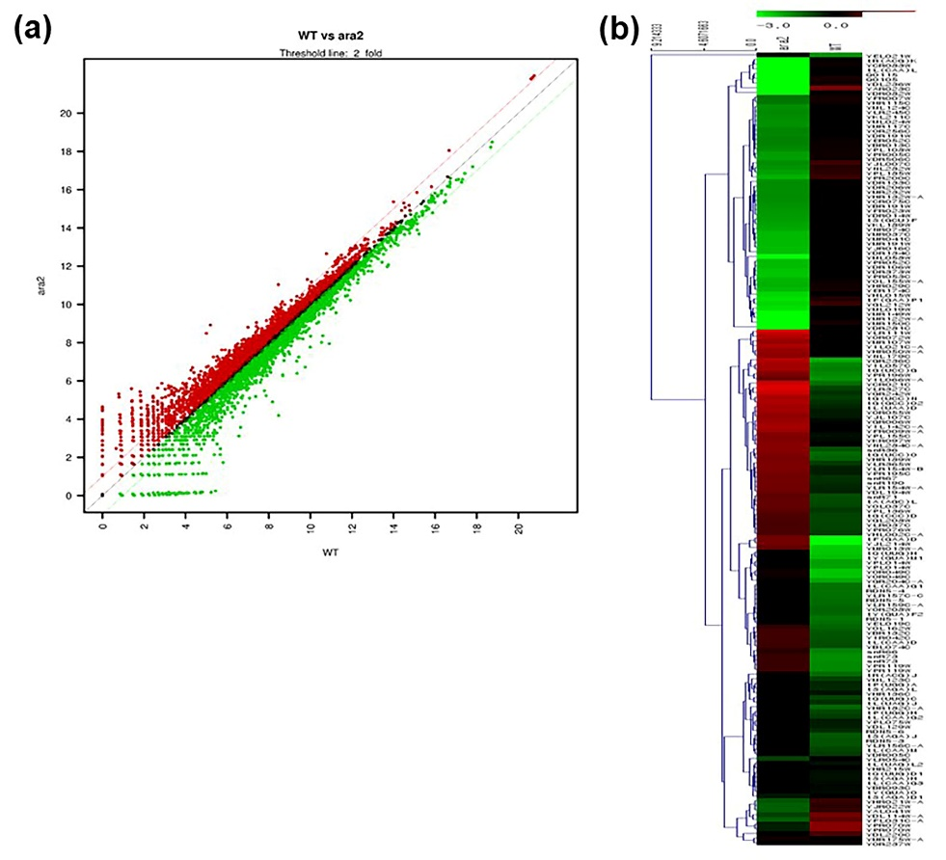
Fig. S1 Scatter plot (a) and heat map (b) obtained from 3′-quant RNA-Seq analysis.

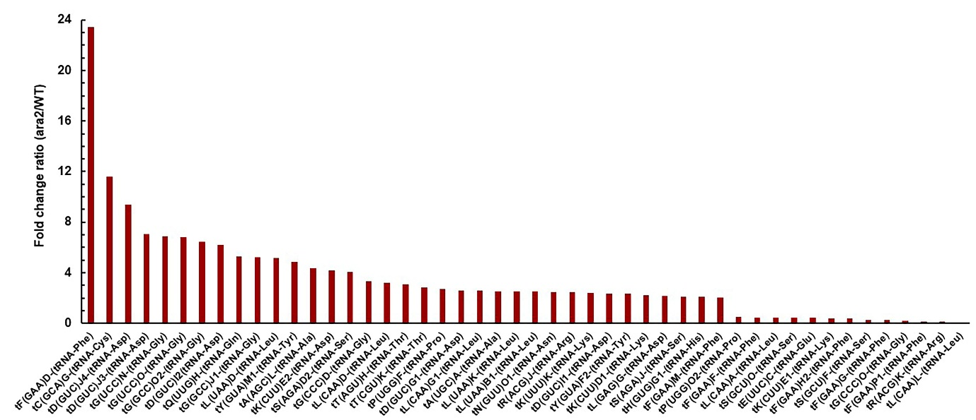
Fig. S2 Identification of two-fold changes in transcripts coding amino-acyl tRNA in ara2Δ cells under H₂O₂–induced oxidative stress. WT, wild-type cells; ara2Δ, ARA2-deleted yeast cells.

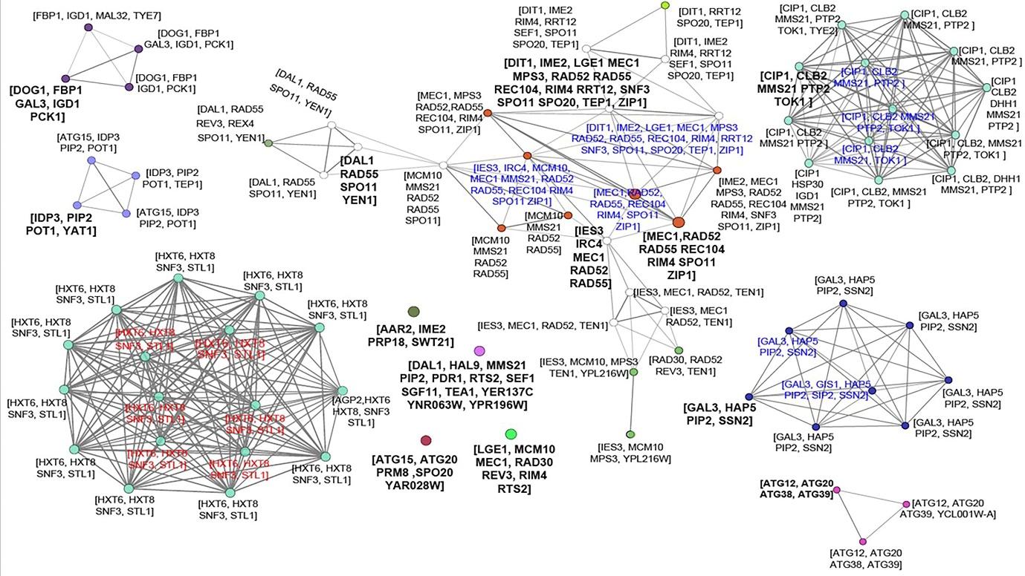
Fig. S3 Genetic network of two-fold changes in genes corresponding to meiotic cell cycle progress, reciprocal meiotic recombination, mitotic recombination, endonuclease activity, pre-autophagosomal complex, monosaccharide metabolic process, fatty acid metabolism, small nuclear ribonucleoprotein complex, zinc ion binding, DNA replication, vesicle organization, carbon catabolite activator, regulation of transferase activity, and glucose transmembrane transporter activity in ara2Δ cells under oxidative stress. ara2, ARA2-deleted yeast cells.

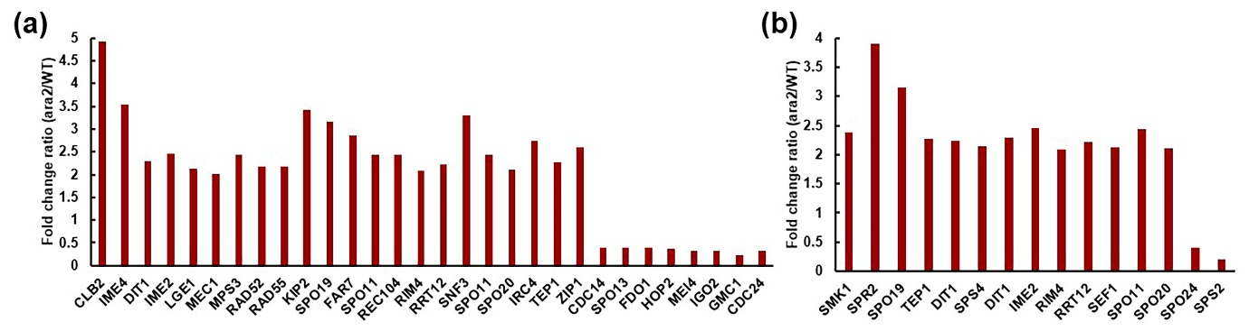
Fig. S4 Identification of two-fold changes in genes involved in the cell cycle (a) and sporulation process (b) in ara2Δ cells under oxidative stress. WT, wild-type cells; ara2Δ, ARA2-deleted yeast cells.

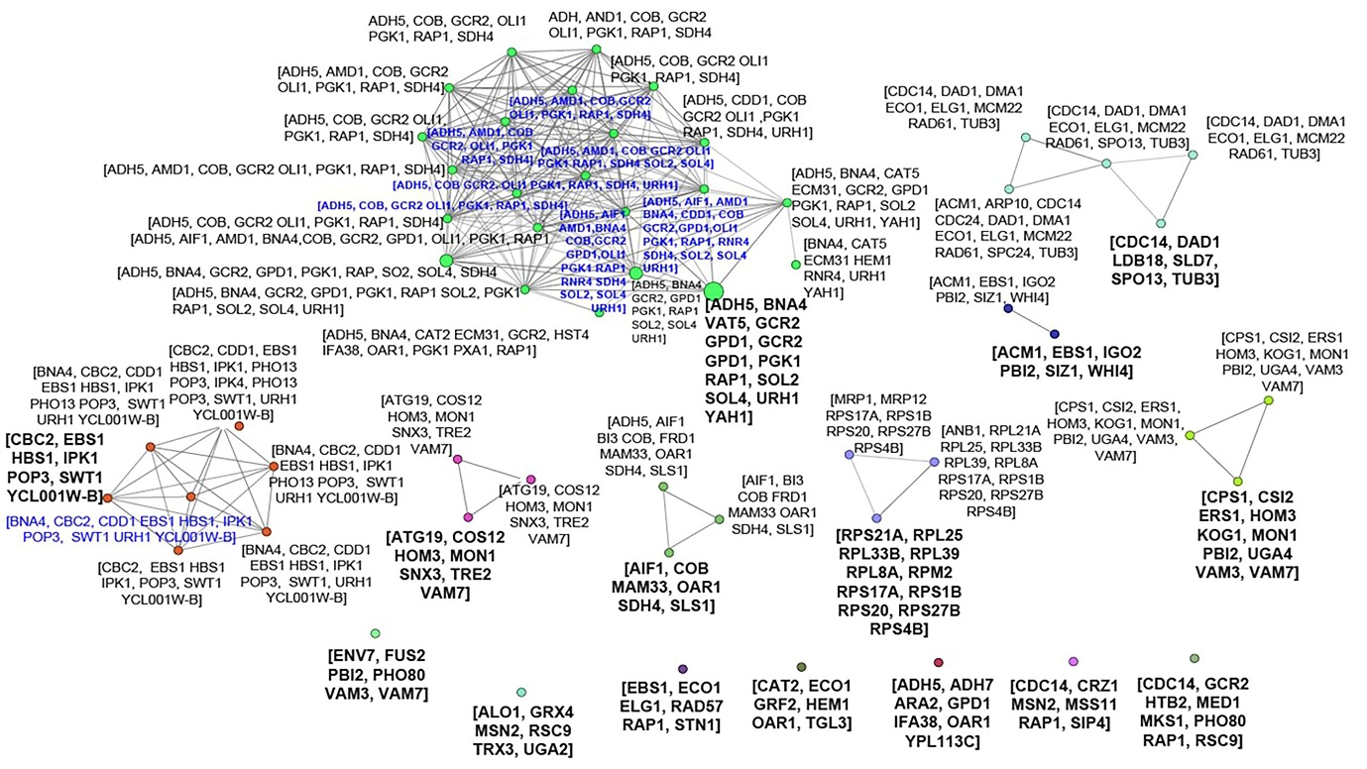
Fig. S5 Gene-based genetic network analysis of downregulated genes corresponding to negative regulation of cellular protein metabolism, protein targeting to vacuole, aerobic metabolism, cytoplasmic translation, vacuole function, organelle fusion, cellular response to oxidative stress, telomere organization, transferase activity, oxidoreductase activity, transcription activity, negative regulation of transcription, oxidoreduction coenzyme metabolism, unclear-transcribed mRNA catabolism, and spindle in ara2Δ cells under oxidative stress. ara2, ARA2-deleted yeast cells.

