Stenotrophomonas nematodicola sp. nov., a novel intestinal lifespan-prolonging bacterium for Caenorhabditis elegans that assists in host resistance to Bacillus nematocida colonization
Rui Han^{1#}, Yu Wang^{1#}, Yang Deng², Yuqin Zhang², Lin Zhang^{1*}, Qiuhong Niu^{1*}

¹College of Life Science and Agricultural Engineering, Nanyang Normal University, 1638 Wolong Road, Nanyang, Henan 473061, China
²Institute of Medicinal Biotechnology, Chinese Academy of Medical Sciences & Peking Union Medical College, Beijing, 100050, China

#These two authors Rui Han and Yu Wang contributed equally to the work.
*Corresponding author A: Lin Zhang
E-mail: zhanglin201207@163.com
*Corresponding author B: Qiuhong Niu
E-mail: qiuhongniu723@163.com

Table. S1 Diﬀerential characteristics between strain CPCC 101271^{T}, Stenotrophomonas rhizophila JCM 13333^{T} and Stenotrophomonas bentonitica DSM 103927^{T}
+, Positive; −, negative.
Characteristic | CPCC 101271^{T} | JCM 13333^{T} | DSM 103927^{T}
Temperature range for growth (°C) | 22-37 | 4-37 | 15-37
Salt tolerance (%) | 0-4.0 | 0-4.5 | 0-2.5
Reduction of nitrate to nitrite | - | - | +
Carbon sources utilized for growth:
D-Trehalose | - | + | +
D-Cellobiose | - | + | +
D-Melibiose | - | + | -
β-Methyl-D-Glucoside | - | + | +
D-Salicin | - | - | +
D-Fructose | - | + | -
D-Fructose-6-PO₄ | + | - | -
L-Glutamic Acid | + | weakly positive | -
L-Histidine | + | + | -
Pectin | + | - | -
D-Lactic Acid Methyl Ester | + | + | -
L-Lactic Acid | + | + | -
Bromo-Succinic Acid | + | + | -
Resistance to antibiotics | ampicillin (10 μg), cefaclor (30 μg), chloramphenicol (30 μg), clindamycin (2 μg), erythromycin (15 μg), gentamycin (10 μg), kanamycin (30 μg), netilmicin (30 μg), novobiocin (5 μg), penicillin (10 IU), vancomycin (30 μg), tetracycline (30 μg), tobramycin (10 μg), treptomycin (10 μg) | tobramycin (10 μg) | clindamycin (2 μg), novobiocin (5 μg), cefaclor (30 μg), penicillin (10 IU)
Predominant cellular fatty acids  (>5 % of total) | C_{16:0}, antesio-C_{15:0}, iso-C_{11:0}, iso-C_{15:0}, iso-C_{17:0} | C_{16:0}, antesio-C_{15:0}, iso-C_{11:0}, iso-C_{15:0} | C_{16:0}, antesio-C_{15:0}, iso-C_{11:0}, iso-C_{15:0}, C_{16:1}ω6c/C_{16:1}ω7c, C_{16:0} 10-methyl
The genomic characteristics
Contig (s) | 19 | 8 | 12
N50 Length (bp) | 738,821 | 736,911 | 2,475,248
Genome size (Mbp) | 4.4 | 4.6 | 4.4
G+C (mol%) | 67.3 | 67.3 | 66.5
Genome coverage (%) | 100 x | 38 x | 100 x
DDBJ/EMBL/GenBank accession number of darft genome | WIAY00000000.1 | NZ_CP007597.1
GenBank/RefSeq assembly accession number | GCA_009467805.1 | GCA_000661955.1
Putatively encoding genes in genome
Glucosylglycerol phosphate synthase | G9274_RS14805, B861_RS0201980, E5352_RS00975 | DX03_RS04545 | B861_RS0201980, G9274_RS14805, E5352_RS00975
Trehalose phosphate synthase | BN96_RS08035, BIZ42_RS05395, C0R07_RS03270,  GDJ08_RS08470 | DX03_RS04425 | DX03_RS04430
Figure S1 Polar lipid profile of strain CPCC 101271^{T} determined by two-dimensional TLC separation
Lipids were detected by spraying the plate with (a) molybdatophosphoric acid reagent, (b) molybdenum blue stain reagent, or (c) ninhydrin stain reagent.
DPG, Diphosphatidylglycerol; PG, phosphatidylglycerol; PE, phosphatidylethanolamine; UPL, unidentified phospholipid.
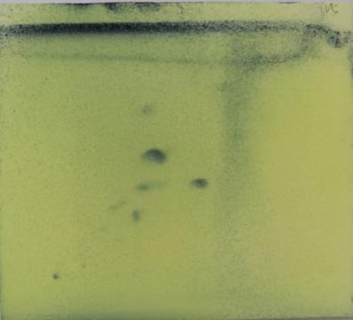
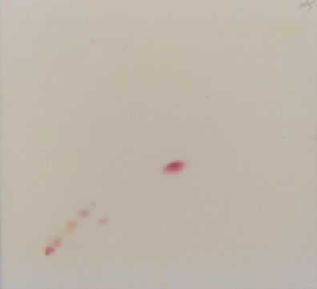
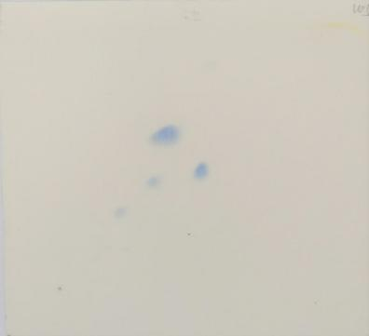
(c)
(a)
(b)
DPG
DPG
- DPG
I
I
UPL
UPL
PG
PE
PG
PE
PE
PG
I
II
II
II

Figure S2 Variation in the abundance of Stenotrophomonas and alpha-trehalose-phosphate synthase-encoding gene sequences based on metagenomic sequence analysis.

Figure S3 Variation in the abundance of Bacillus and trehalose-6-phosphate hydrolase-encoding gene sequences based on metagenomic sequence analysis

