Supplementary information for

In silico ADMET, molecular docking and molecular simulation-based study of glabridin’s natural and semisynthetic derivatives as potential tyrosinase inhibitors

Arti Kumari¹*, Rakesh kumar², Gira Sulabh³, Pratishtha Singh⁴, Jainendra Kumar⁵, Vijay Kumar Singh², and Krishna Kumar Ojha²
¹ Department of Biotechnology, Patna Women’s College, Patna (Bihar), India
²Department of Bioinformatics, Central University of South Bihar, Gaya (Bihar), India
³Department of Pharmacology, Manipal TATA medical College, Jamshedpur, Manipal academy of higher education, Manipal, India
⁴School of Life Sciences, Jawaharlal Nehru University, New Delhi, India
⁵Professor (Retd.), Patliputra University, Patna (Bihar), India

*Correspondence may be addressed to: arti.mbio@patnawomenscollege.in

Supplementary Tables
Tables 1S - 5S

Supplementary Data
Data 1S: Supplementary Data 1S: Percent inhibition of melanoma cells by glabridin concentration (5 µg/ml to 200 µg/ml) in 24 hours
Data 2S: Supplementary Data 1S: Percent inhibition of melanoma cells by glabridin concentration (5 µg/ml to 200 µg/ml) in 48 hours
Data 3S: Calculation of percent inhibition and IC₅₀ of glabridin concentration and its representative graph

Table 1S- Glabridin and its derivative compounds used in the study and their background data
Sl No | Name of compound/ Pubchem ID/Mol formula | Reported Biological Activity | Source (Natural/ Artificial) | Reference
1. | Glabridin/124052/C₂₀H₂₀O₄ | Tyrosinase inhibition, | G. glabra/ Natural | Yokata et al., 1998
2. | (R)- glabridin/ 4484219/C₂₀H₂₀O₄ | No biological activity reported | G. glabra/ Natural | Yannai et al, 2004
3. | 5’prenyl glabridin/ 23641093/C₂₅H₂₈O₄ | Antimalarial, Antibacterial | - | Pubchem (NCBI)
4. | Glabridin dimethyl ether (2’,4’-O- dimethyl glabridin)/480856/ C₂₂H₂₄O₄ | anticancer | G. glabra/ Semi- synthetic | Fukai et al., 2000
5. | glabridin dimer/5481978/C₄₀H₄₀O₈ | anticancer | G. glabra/ Natural | Fukai et al., 2000
6. | R- Hispaglabridin A/4484221/C₂₅H₂₈O₄ | Not known | G. glabra/ Natural | Yannai et al, 2004
7. | R-Hispaglabridin B/5318057/C₂₅H₂₆O₄ | Anti influenza activity | G. glabra/ Natural | Huang Z, 2019,  Grienke et al., 2014
8. | 5'-formyl glabridin/46230506/C₂₁H₂₀O₅ | Anti-diabetic (binding to PPARs receptors) | G. glabra/ Natural | Kuroda et al., 2010
9. | 4'-O-Methyl preglabridin/44257508/ | Not known | G. glabra/ Natural | -
10. | 4'-O-prenyl glabridin/480861/ | Anticancer | G. glabra/ Natural | Fukai et al., 2000,
11. | 4'-O-methyl glabridin/5319664/ | Inhibition of serotonin reuptake | G. glabra/ Natural | Ofir et al., 2003
12. | 3'-hydroxy-4'methoxy glabridin/10338211/ | Prevent NADPH dependent peroxidation, protect mitochondrial enzyme function | G. glabra/ Natural | Haraguchi et al., 2000
13. | 2'-O-methylglabridin/74830193/ | Breast neoplasm, depressive disorder | G. glabra/ Semi- synthetic | Ofir et al., 2003, Tamir et al., 2000
14. | 2'-O,5'-C-diprenylglabridn/480868/ | anticancer | G. glabra/ Natural | Fukai et al., 2000
15. | Hispaglabridin A/ 442774/ | Antimicrobial, Antioxidant | G. glabra/ Natural | Mitcher et al, 1980; Haraguchi et al., 2000
16. | Hispaglabridin B/15228661/ | Antimicrobial, Antioxidant | G. glabra/ Natural | Mitcher et al, 1980; Haraguchi et al., 2000

Table 2S: Secondary Structure elements in modelled hTYR

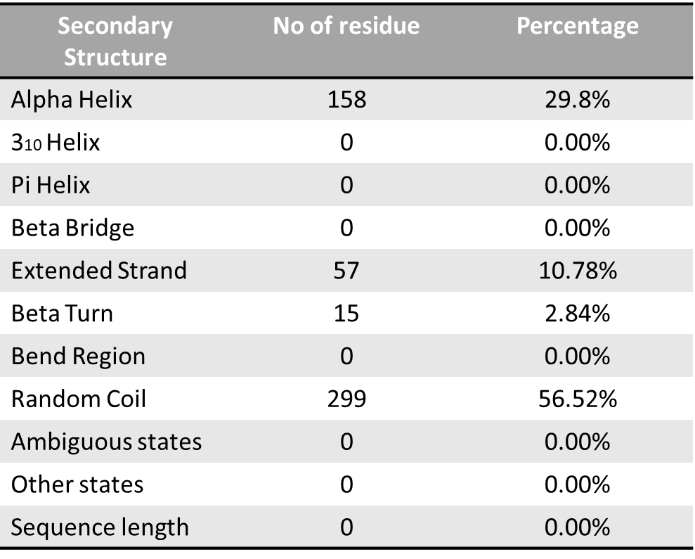

Table 3S: Amino acids composition of site 1 active site of modelled hTYR analysed by Cast P webserver

SeqID | AA | SeqID | AA | SeqID | AA | SeqID | AA
41 | GLY | 173 | ILE | 322 | PHE | 343 | ILE
43 | GLN | 174 | ASP | 330 | ALA | 349 | MET
44 | PHE | 254 | LEU | 331 | ASP | 350 | SER
155 | HIS | 258 | ASN | 332 | ALA | 351 | GLN
156 | TYR | 281 | LYS | 333 | SER | 352 | VAL
159 | SER | 283 | ARG | 334 | GLN | 353 | GLN
160 | MET | 308 | ASP | 309 | LYS | 361 | PHE
161 | ASP | 309 | LYS | 338 | HIS | 361 | PHE
171 | ARG | 310 | ALA | 339 | ASN | 365 | HIS
172 | ASP | 320 | GLU | 342 | HIS | 392 | PRO
393 | ILE

Table 4S: Interacting residues of human tyrosinase with other glabridin derivatives

Sl No | Ligand | Interaction Site | Other Interacting Amino acids | No of hydrogen bond formed
1. | 4’-O-methyl glabridin | ASP-339 | HIS-342, ILE-343, HIS-338, SER-350, MET-349, GLN-351, SER-355, MET-349, VAL-352, GLY-357 | 1
2. | 4’-0-prenyl glabridin | HIS-338 | ALA-340, ASN-339, HIS-342, MET-349, SER-350, GLN-351, SER-355, VAL-352, HIS-365, ILE-343, ASN-346, GLY-357 | 1
3. | 4’-0-methylprenyl  glabridin | PHY-322  GLY-321 | HIS-338, HIS-365, GLY-321, PHE-322, ILE-343, GLN-351, HIS-342, SER-355, PHE-361, ILE-343, HIS-177, ALA- 332, LYS- 309 | 2
4. | 2’-O,5’-C-di-prenyl glabridin | ASP-174 | HIS-155, GLN- 353, VAL-352, HIS-177, SER-355, ASP-174, PHE-322, HIS-338, ALA-340, ILE-343, HIS-342, ARG- 171 | 1
5. | Glabridin di- methylether | HIS -338 | ASN-339, ALA-340, ILE-343, VAL-352, SER-350, THR-348, AASN-346, | 1
6. | Hispaglabridin A | LYS-281 | ASN-346, ILE-343, HIS-342, GLY-347, VAL-352, HIS-338, ASN-339, PHE-322, ALA-332, ARG-171 | 1
7. | 2’-O-Methyl glabridin | ARG-171  ASP-161 | VAL-352, HIS-155, HIS-342, LYS-281, PHE-361, ILE-173, ILE-343, HIS-177, HIS-338 | 2
8. | (R)-hispa glabridin A | ASN-339  SER-350 | HIS-338, HIS-342, PHE-322, HIS-177, VAL-352, GLN-351, THR-348, SER-336, ILE-343, GLY-347, LYS-281 | 2
9. | (R)-hispa glabridin B | LYS-281 | SER-350, GLY-347, PHE-322, ASN-339, SER-335, SER-350, ASN-346, HIS-338, HIS-342, | 1
10. | Hispaglabridin B | SER-350  ASN-339 | PHE-322, HIS-177, SER-336, HIS-338, HIS-342, ILE-343, VAL-352, GLN-351, THR-348, LYS-281 | 2

Table 5S: - Molinspiration bioactivity score (v2018.03) of glabridin and its derivatives. The larger the value of the score is, the higher is also probability that the particular molecule will be active. All molecules used in present study has better score towards nuclear receptor ligand and as enzyme inhibitor.

Sl N0 | Name of the compound | GPCR ligand | ion channel modulator | Kinase inhibitor | Nuclear receptor ligand | Protease inhibitor | Enzyme inhibitor
1. | Glabridin | 0.19 | -0.07 | 0.08 | 0.83 | 0.09 | 0.50
2. | R- GLABRIDIN | 0.19 | -0.07 | 0.08 | 0.83 | 0.09 | 0.50
3. | 5’-formylglabridin | 0.04 | 0.16 | 0.03 | 0.71 | -0.03 | 0.39
4. | 5’-prenyl glabridin | 0.17 | -0.03 | 0.05 | 0.81 | 0.08 | 0.54
5. | Glabridin dimer | -0.35 | -1.12 | -0.88 | -0.48 | -0.24 | 0.58
6. | 4’- O-methylglabridin | 0.12 | -0.13 | 0.03 | 0.71 | 0.05 | 0.43
7. | 4’-O-methylprenyl glabridin | 0.16 | 0.03 | 0.03 | 0.72 | -0.01 | 0.42
8. | 4’- O-prenylglabridin | 0.10 | -0.06 | -0.06 | 0.74 | -0.00 | 0.46
9. | 2’-O-methylglabridin | 0.17 | -0.09 | 0.06 | 0.74 | 0.07 | 0.45
10. | 3’-hydroxy-4’-methoxyglabridin | 0.11 | -0.09 | 0.05 | 0.57 | 0.02 | 0.43
11. | 2’-o-5’-C-diprenylglabridin | 0.13 | -0.02 | -0.01 | 0.72 | 0.00 | 0.47
12. | (R)- Hispaglabridin B | 0.16 | -0.03 | 0.02 | 0.63 | 0.11 | 0.42
13. | Hispaglabridin B | 0.16 | -0.03 | 0.02 | 0.63 | 0.11 | 0.42
14. | (R)- Hispaglabridin A | 0.24 | 0.05 | 0.04 | 0.88 | 0.16 | 0.63
15. | Hispaglabridin A | 0.24 | 0.05 | 0.04 | 0.88 | 0.16 | 0.63
16. | 4’- methoxyglabridin | 0.10 | -0.15 | 0.00 | 0.60 | 0.04 | 0.37

Supplementary data 1S:
Percent inhibition of melanoma cells by glabridin concentration (5 µg/ml to 200 µg/ml) in 24 hours
24 h | OD 1 | OD2 | OD3 | MEAN | % VIABILITY | % INHIBITION
Control | 0.82 | 0.82 | 0.823 | 0.821 | 100 | 0
solvent control | 0.79 | 0.797 | 0.794 | 0.79366667 | 96.67072676 | 3.329273244
positive control | 0.355 | 0.357 | 0.378 | 0.36333333 | 44.25497361 | 55.74502639
5 µg/ml | 0.754 | 0.755 | 0.715 | 0.74133333 | 90.29638652 | 9.703613479
10 µg/ml | 0.683 | 0.689 | 0.679 | 0.68366667 | 83.27243199 | 16.72756801
15 µg/ml | 0.608 | 0.614 | 0.627 | 0.61633333 | 75.07105156 | 24.92894844
20 µg/ml | 0.598 | 0.588 | 0.58 | 0.58866667 | 71.70117743 | 28.29882257
25 µg/ml | 0.562 | 0.569 | 0.561 | 0.564 | 68.69671133 | 31.30328867
30 µg/ml | 0.503 | 0.508 | 0.503 | 0.50466667 | 61.46975233 | 38.53024767
35 µg/ml | 0.493 | 0.497 | 0.495 | 0.495 | 60.29232643 | 39.70767357
40 µg/ml | 0.471 | 0.479 | 0.47 | 0.47333333 | 57.65326837 | 42.34673163
45 µg/ml | 0.451 | 0.452 | 0.45 | 0.451 | 54.93300853 | 45.06699147
50 µg/ml | 0.37 | 0.33 | 0.35 | 0.35 | 42.63093788 | 57.36906212
100 µg/ml | 0.305 | 0.302 | 0.309 | 0.30533333 | 37.19041819 | 62.80958181
200 µg/ml | 0.283 | 0.289 | 0.288 | 0.28666667 | 34.91676817 | 65.08323183

Supplementary data 2S:
Percent inhibition of melanoma cells by glabridin concentration (5 µg/ml to 200 µg/ml) in 48 hours
48h | OD 1 | OD2 | OD3 | MEAN | % VIABILITY | % INHIBITION
Control | 0.82 | 0.82 | 0.823 | 0.821 | 100 | 0
solvent control | 0.991 | 0.992 | 0.99 | 0.991 | 95.01438159 | 4.985618408
Positive control | 0.339 | 0.332 | 0.231 | 0.300667 | 28.82710131 | 71.17289869
5 µg/ml | 0.79 | 0.795 | 0.799 | 0.794667 | 76.19047619 | 23.80952381
10 µg/ml | 0.659 | 0.66 | 0.655 | 0.658 | 63.08724832 | 36.91275168
15 µg/ml | 0.592 | 0.593 | 0.595 | 0.593333 | 56.8871844 | 43.1128156
20 µg/ml | 0.51 | 0.512 | 0.512 | 0.511333 | 49.02524768 | 50.97475232
25 µg/ml | 0.418 | 0.415 | 0.42 | 0.417667 | 40.04474273 | 59.95525727
30 µg/ml | 0.364 | 0.365 | 0.367 | 0.365333 | 35.02716523 | 64.97283477
35 µg/ml | 0.319 | 0.31 | 0.311 | 0.313333 | 30.04154682 | 69.95845318
40 µg/ml | 0.256 | 0.257 | 0.259 | 0.257333 | 24.6724193 | 75.3275807
45 µg/ml | 0.22 | 0.22 | 0.21 | 0.216667 | 20.77341004 | 79.22658996
50 µg/ml | 0.19 | 0.195 | 0.196 | 0.193667 | 18.56823266 | 81.43176734
100 µg/ml | 0.156 | 0.154 | 0.155 | 0.155 | 14.86097795 | 85.13902205
200 µg/ml | 0.11 | 0.109 | 0.108 | 0.109 | 10.4506232 | 89.5493768

Supplementary data 3S
Calculation of IC₅₀
% inhibition = 100- (OD of treated cells) * 100
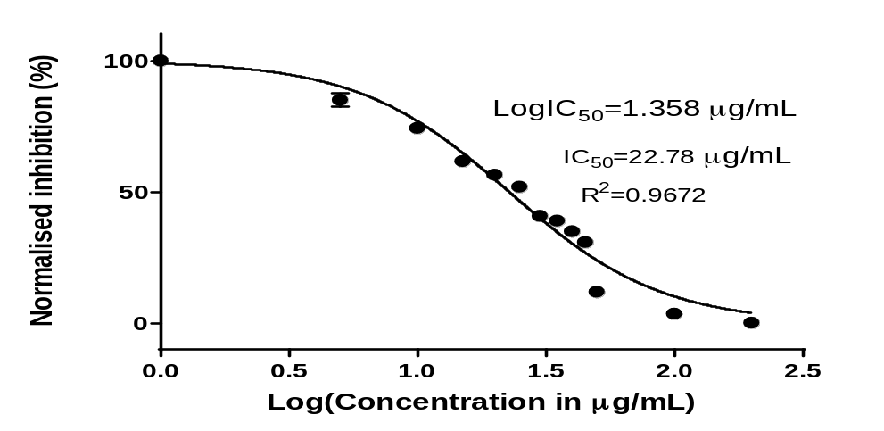 (OD of control cells)

Normalized IC₅₀ of the glabridin for 24hrs. IC₅₀ was determined to be 22.78 µg/ml
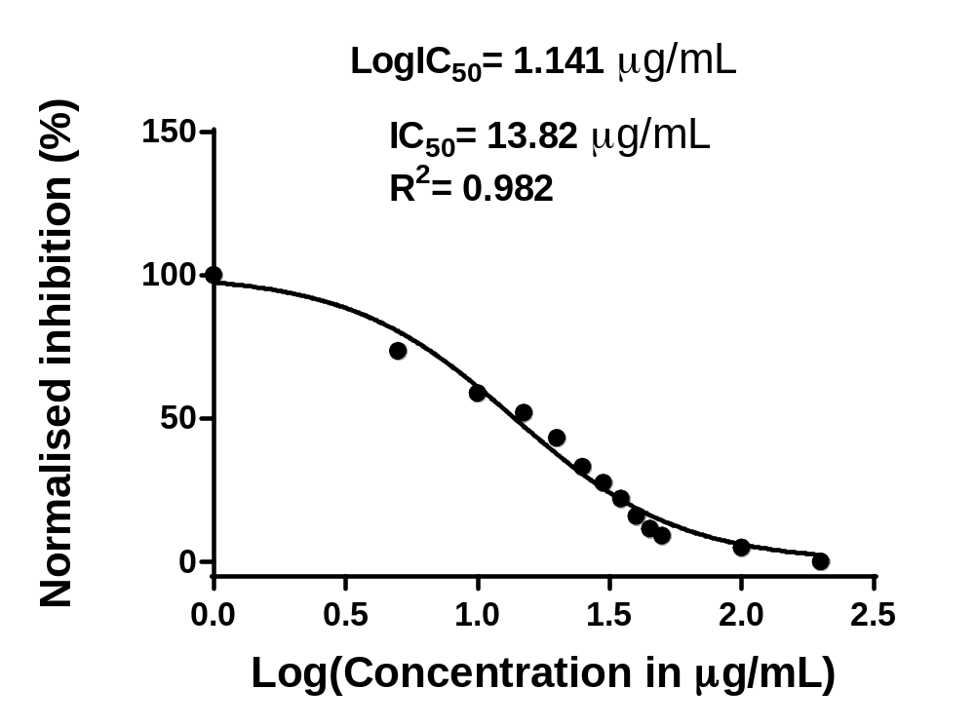

Normalized IC₅₀ of glabridin for 48hrs. IC₅₀ was determined to be 13.82 µg/ml

