Supplementary Information

Large-area synthesis of nanoscopic catalyst-decorated conductive MOF film using microfluidic-based solution shearing
Jin-Oh Kim^{1,4},Won-Tae Koo^{1,2,4}, Hanul Kim³, Chungseong Park^{1,2,}, Calvin Andreas Hutomo¹, Siyoung Q. Choi³, Il-Doo Kim^{1,2,} and Steve Park¹

¹Department of Materials Science and Engineering, Korea Advanced Institute of Science and Technology (KAIST), 291 Daehak-ro, Yuseong-gu, Daejeon 34141, Republic of Korea
²Membrane Innovation Center for Anti-virus & Air-quality Control, KAIST Institute for Nanocentury, 291, Daehak-ro, Yuseong-gu, Daejeon 34141, Republic of Korea
³Department of Chemical and Biomolecular Engineering, Korea Advanced Institute of Science and Technology (KAIST), Daejeon 34141, Korea
⁴These authors contributed equally: Jin-Oh Kim, Won-Tae Koo.

Corresponding authors: I.-D.K (idkim@kaist.ac.kr), S.P. (stevepark@kaist.ac.kr)

Table of Contents
- Supplementary Table 1. Summary of various fabrication methods of ultrathin C–MOFs.
- Supplementary Table 2. Mixing index and the concentration distribution of ligand for 10 microfluidic cycles without Pt solution’s flow.
- Supplementary Table 3. 3D surface and 2D cross sectional concentration distribution of ligand for 10 microfluidic cycles without Pt solution’s flow.
- Supplementary Table 4. Mixing index and the concentration distribution of ligand for 15 microfluidic cycles with Pt solution’s flow.
- Supplementary Table 5. 3D surface and 2D cross sectional concentration distribution of ligand for 15 microfluidic cycles with Pt solution’s flow.
- Supplementary Table 6. The weight ratio of Cu and Pt in Pt@Cu₃(HHTP)₂ at various flow rates of Pt precursors.
- Supplementary Table 7. Summary of the reaction rate constants of the sensors.
- Supplementary Table 8. Summary of sensing properties of 2D material-based NO₂ sensors.
- Supplementary Fig. 1. Fabrication of microfluidic blade.
- Supplementary Fig. 2. Computational fluid dynamics simulation of microfluidic blade
- Supplementary Fig. 3. Effect of mixing time on the degree of mixing at various flow rates.
- Supplementary Fig. 4. Surface roughness profile measurement of Pt@Cu₃(HHTP)₂ thin-film.
- Supplementary Fig. 5. XRD patterns of Pt@Cu₃(HHTP)₂ after MiCS process, and only after microfluidic synthesis process without solution shearing.
- Supplementary Fig. 6. TEM images of Pt@Cu₃(HHTP)₂
- Supplementary Fig. 7. HRTEM image of Pt@Cu₃(HHTP)₂ under different synthesis processes.
- Supplementary Fig. 8. AFM topographic images of a manually scratched Pt@Cu₃(HHTP)₂ films at various shearing speeds.
- Supplementary Fig. 9. N₂ adsorption and desorption isotherms of the Cu₃(HHTP)₂ and Pt@Cu₃(HHTP)₂ samples at 77 K.
- Supplementary Fig. 10. Comparison of electrical properties of films fabricated through MiCS process and conventional solution shearing process.
- Supplementary Fig. 11. Responses of Pt@Cu₃(HHTP)₂ thin-film at different ratios of Pt NPs.
- Supplementary Fig. 12. Response traces of the sensors to 0.1–1 ppm of NO₂.
- Supplementary Fig. 13. Response times of the sensors to 0.1–3 ppm of NO₂.
- Supplementary Fig. 14. Additional sensing results.
- Supplementary Fig. 15. Exponential fitting curves of the sensors.
- References

Supplementary Table 1. Summary of various fabrication methods of C-MOF-based films
Methods | Example  materials | Process times | THKª | Pros | Cons | Ref^{b}
Drop casting | Cu₃(HITP)₂ | 1. Synthesis:  ~2 days  2. Deposition:  ~30 min | ≥ µm | Facile processes  Applicable to various supports | Poor uniformity  High surface roughness  Difficult to produce ultra-thin layers  Long processing time  Difficult to synthesize at large-scale with high uniformity | 1, 2, 3
Drop casting | Ni₃(HHTP)₂
Drop casting | Cu₃(HHTP)₂
Drop casting | Co₃(HHTP)₂
Layer-by-layer (LbL) growth | Cu₃(HHTP)₂ | 1. Preparing substrates:  ~1 days  2. LbL growth:  ~1 min/cycle | ~2 nm/  cycle | High uniformity  Accurate control of film THK  Ultra-thin structure | Need of chemical modification on substrates  Sequential LbL steps that can lead to long processing time | 1, 4
Liquid-liquid interfacial reaction | Ag₃BHT₂ | 30 min | ~280 nm | Fast synthesis  High uniformity | Difficult to control THK of films  Difficult to synthesize at large-scale with high uniformity | 5
Liquid-liquid interfacial reaction | Au₃BHT₂ | 6.5 h | ~320 nm | Fast synthesis  High uniformity |  | 5
Microfluidic-based solution shearing  (MiCS) | Cu₃(HHTP)₂ | 10 min | ~100 nm | Facile synthesis  Ultra-fast synthesis  High uniformity  Accurate control of film THK  Ultra-thin structure  Large scale synthesis  Simultaneous incorporation of nanocatalyst in the pores. |  | This work
THKª is the thickness of the C-MOF-based films. Ref^{b} is reference.

Supplementary Table 2. Mixing index and the concentration distribution of ligand for 10 microfluidic cycles without Pt solution’s flow.
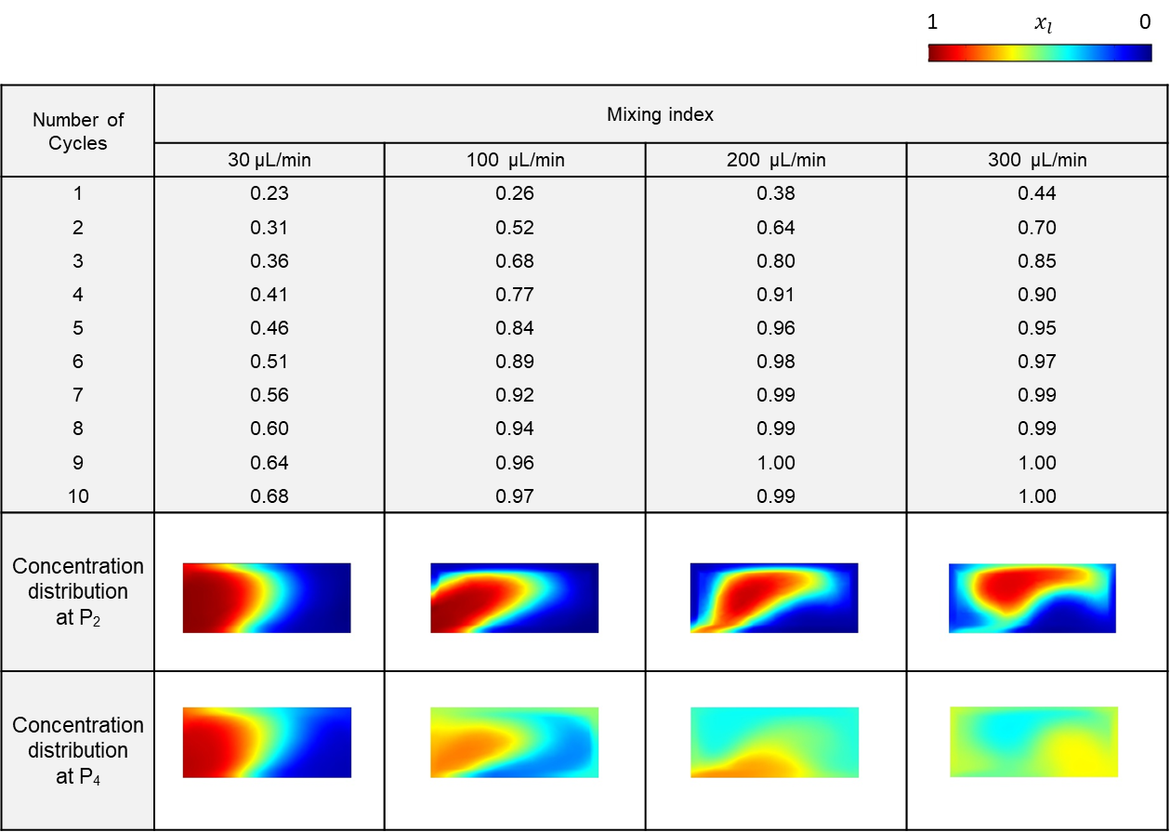

Supplementary Table 3. 3D surface and 2D cross sectional concentration distribution of ligand for 10 microfluidic cycles without Pt solution’s flow.
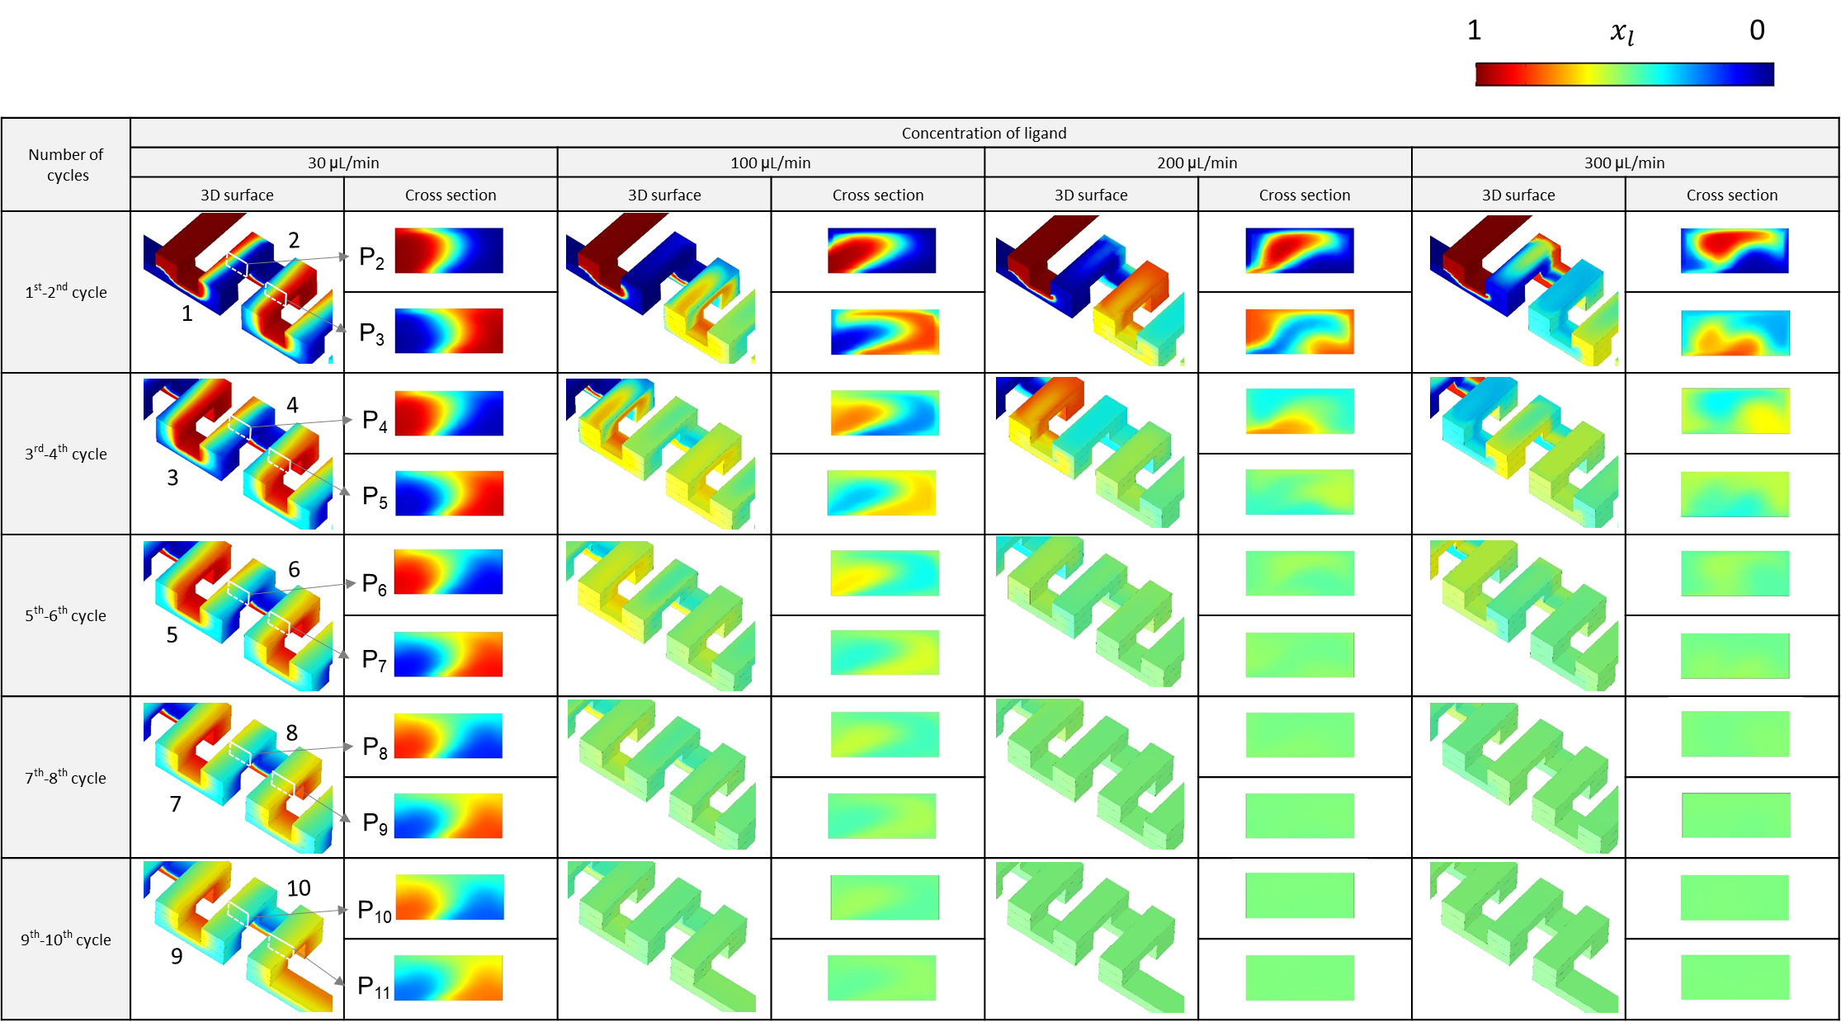

Supplementary Table 4. Mixing index and the concentration distribution of ligand for 15 microfluidic cycles with Pt solution’s flow.
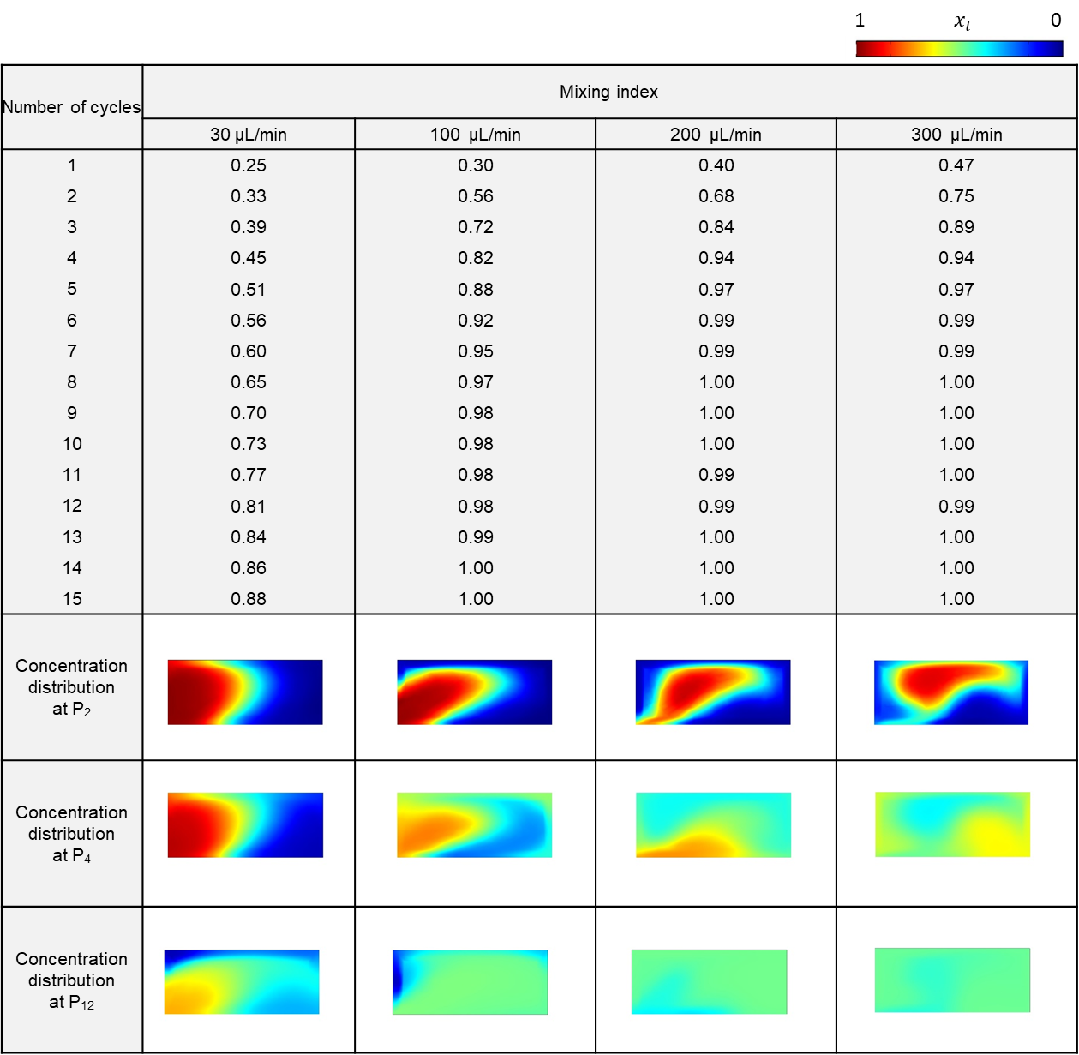

Supplementary Table 5. 3D surface and 2D cross sectional concentration distribution of ligand for 15 microfluidic cycles with Pt solution’s flow.
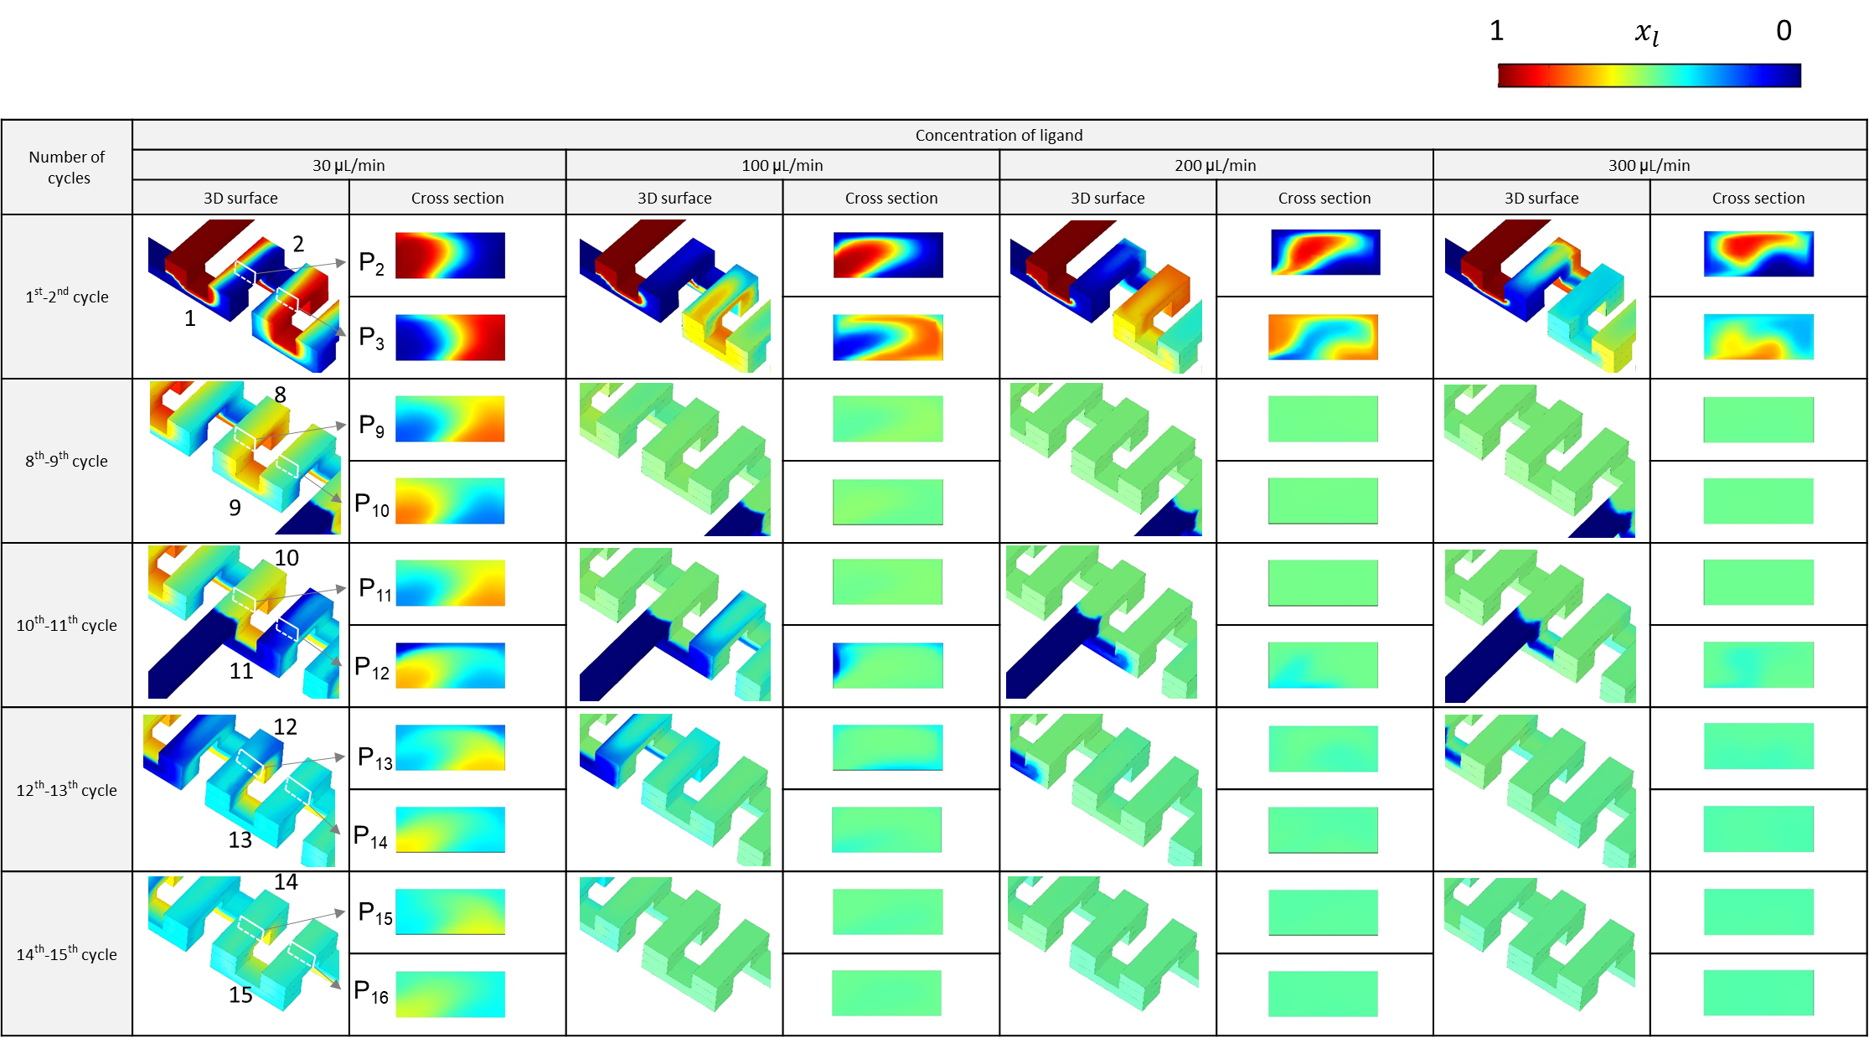

Supplementary Table 6. The weight ratio of Cu and Pt in Pt@Cu₃(HHTP)₂ at various flow rates of Pt precursors.
Flow rate  (μL/min) | Cu  (Weight ratio %) | Pt  (Weight ratio %)
50 | 20.1 | 0.9
100 | 20.0 | 2.3
150 | 20.2 | 2.7
200 | 20.4 | 3.5

Supplementary Table 7. Summary of the reaction rate constants of the sensors.
 | k_{ads} (ppm⁻¹ s⁻¹) | k_{des} (s⁻¹) | K (k_{ads}/k_{des}, ppm⁻¹)
Cu₃(HHTP)₂ powder | 8.77 ± 0.26 × 10⁻³ | 8.60 ± 0.08 × 10⁻⁵ | 10.2 ± 0.3
Cu₃(HHTP)₂ thin-film | 1.51 ± 0.03 × 10⁻³ | 2.60 ± 0.05 × 10⁻⁵ | 58.2 ± 1.2
Pt@Cu₃(HHTP)₂ thin-film | 2.34 ± 0.22 × 10⁻³ | 4.83 ± 0.49 × 10⁻⁵ | 48.5 ± 4.6
k_{ads} is adsorption rate constant, k_{des} is desorption rate constant, and K is the equilibrium constant.

Supplementary Table 8. Summary of sensing properties of 2D material-based NO₂ sensors operated at room temperature in air.
Materials | Measurement | Reponse definition | Humidity | Response | Detection  limit | Ref.ª
Pt@Cu₃(HHTP)₂ thin-film | Resistance | ΔR_{g}/R₀ | Dry | 89.9%  to 3 ppm | 0.1 ppm | This work
Cu₃(HHTP)₂  thin-film | Resistance | ΔR_{g}/R₀ | Dry | 53.7%  to 3 ppm | 0.1 ppm | This work
Cu₃(HHTP)₂ powder | Resistance | ΔR_{g}/R_{a} | Dry | 11.8%  to 3 ppm | 1 ppm | This work
Pd@Cu₃(HHTP)₂ powder | Resistance | ΔR_{g}/R_{a} | Dry | 42.8%  to 3 ppm | 1 ppm | 6
MOF-templated PdO-Co₃O₄ | Resistance | ΔR_{g}/R_{a} | Dry | 5%  to 5 ppm | 1 ppm | 7
MOF-derived carbons | Resistance | ΔR_{g}/R_{a} | Dry | 1%  to 5 ppm | 0.1 ppm | 8
Scrolled graphene | Resistance | ΔR_{g}/R_{a} | Dry | 67.9%  to 3 ppm | 1 ppm | 9
Sulfonated RGO^{b} | Resistance | ΔR_{g}/R_{a} | Dry | 58%  to 10 ppm | 0.12 ppm | 10
In₂O₃/RGO | Resistance | ΔR_{g}/R_{a} | Dry | 50%  at 10 ppm | 1 ppm | 11
MoS₂ nanosheets | Resistance | ΔR_{g}/R_{a} | Dry | 15%  at 5 ppm | 1.5 ppm | 12
WS₂/Ag nanowire | Resistance | ΔR_{g}/R_{a} | Dry | 58%  at 25 ppm | 1 ppm | 13
WS₂ nanosheets | Resistance | ΔR_{g}/R_{a} | Dry | 38 %  at 2 ppm | 0.1 ppm | 14
CdTe/MoS₂ | Resistance | ΔR_{g}/R_{a} | Dry | 27%  at 5 ppm | 0.1 ppm | 15
RGO/MoS₂ | Conductance | ΔG_{g}/G_{a} | Dry | 28%  at 4 ppm | 1 ppm | 16
Ref.ª: the reference number in the manuscript. RGO^{b} is the reduced graphene oxide.

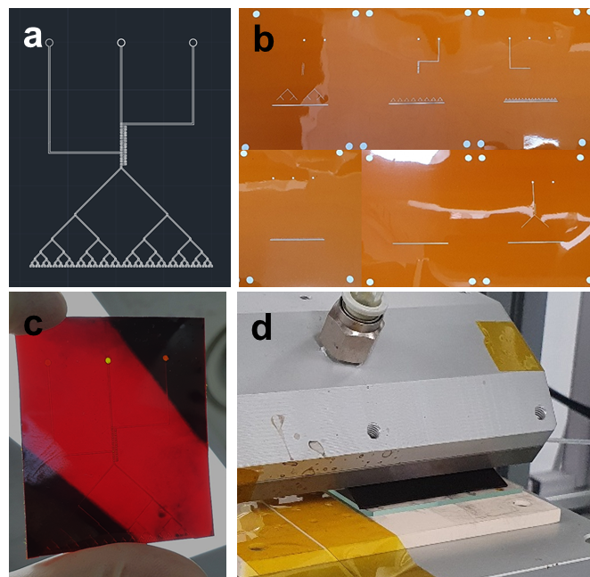
Supplementary Fig. 1 Fabrication of microfluidic blade. (a) CAD image of the microfluidic blade channel design, (b) Photo image of laser-ablated polyimide film with microchannel design on each layer. (c) Photo image of fabricated microfluidic blade and (d) Photo image of solution shearing process with the fabricated microfluidic blade.

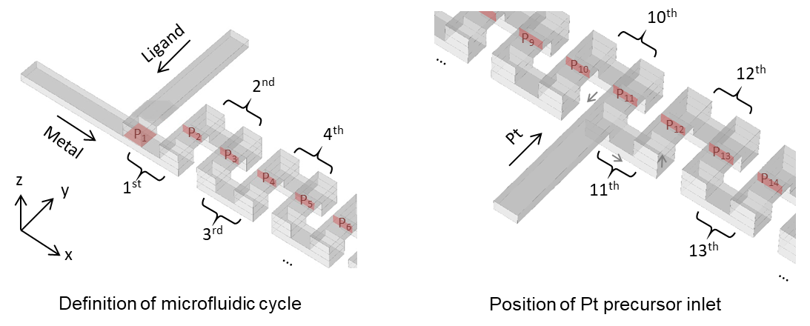
Supplementary Fig. 2 Computational fluid dynamics simulation of microfluidic channels.

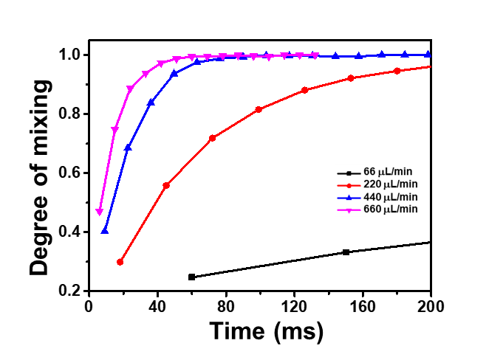
Supplementary Fig. 3 Effect of mixing time on the degree of mixing at various flow rates.
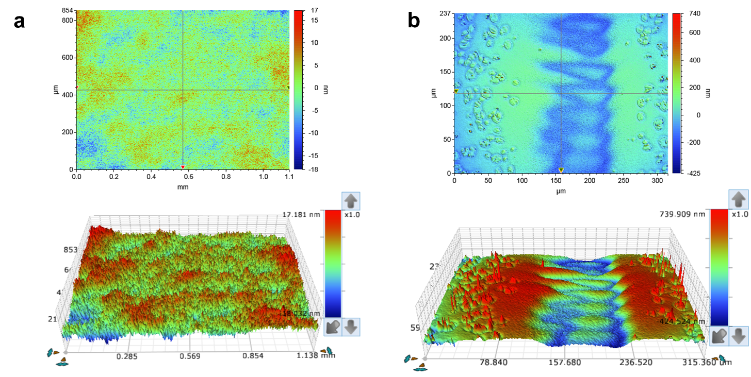
Supplementary Fig. 4 Surface roughness profile measurement of Pt@Cu₃(HHTP)₂ thin-film fabricated by (a) MiCS and (b) conventional solution shearing at 150 ºC (shearing speed: 5 mm/s). (R_{a} values: (a) 2.8 nm, (b) 92.3 nm)

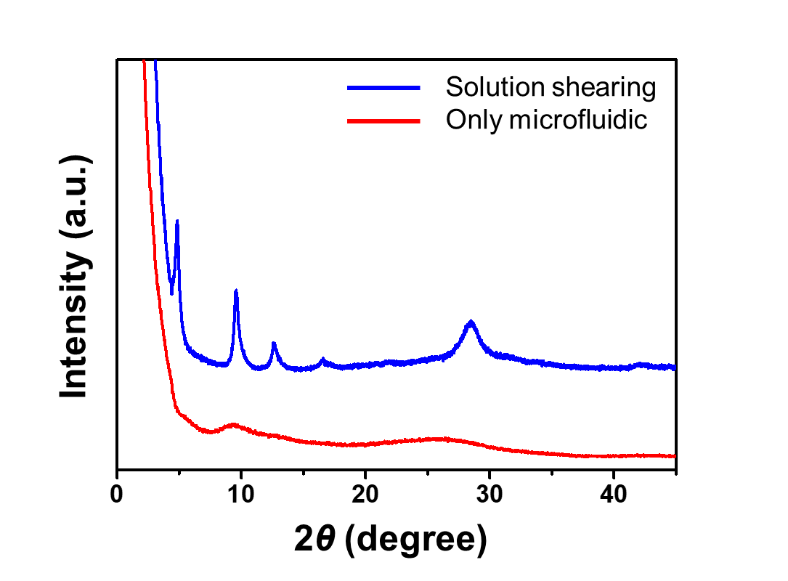
Supplementary Fig. 5 XRD patterns of Pt@Cu₃(HHTP)₂ after MiCS process, and only after microfluidic synthesis process without solution shearing.

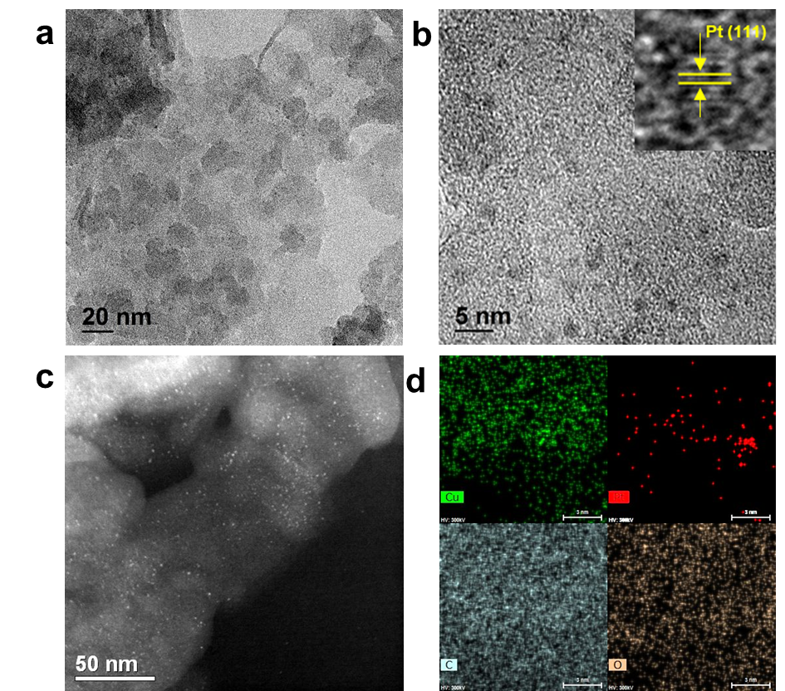
Supplementary Fig. 6 (a) TEM image of Pt@Cu₃(HHTP)₂, (b) HRTEM image of Pt@Cu₃(HHTP)₂, (c) STEM image of Pt@Cu₃(HHTP)₂ and (d) TEM-EDS mapping of Pt@Cu₃(HHTP)₂.

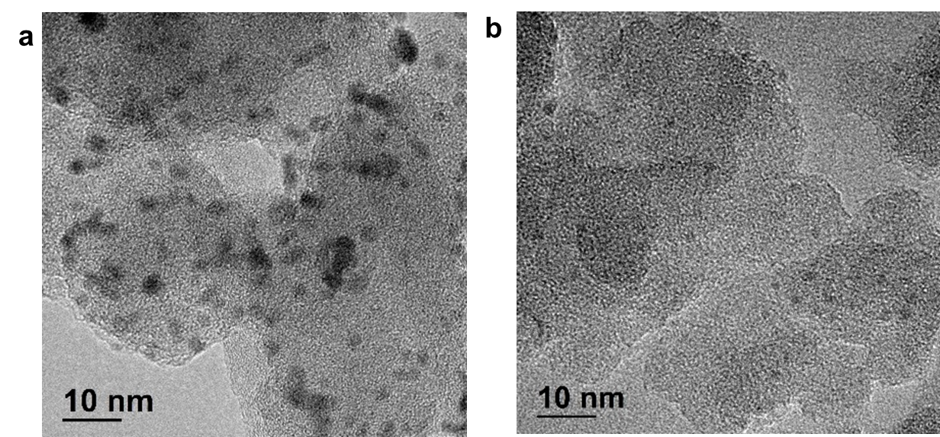
Supplementary Fig. 7 HRTEM images of Pt@Cu₃(HHTP)₂ under different synthesis processes.: (a) synthesized using bulk synthetic technique, (b) synthesized using microfluidic-based solution shearing process.
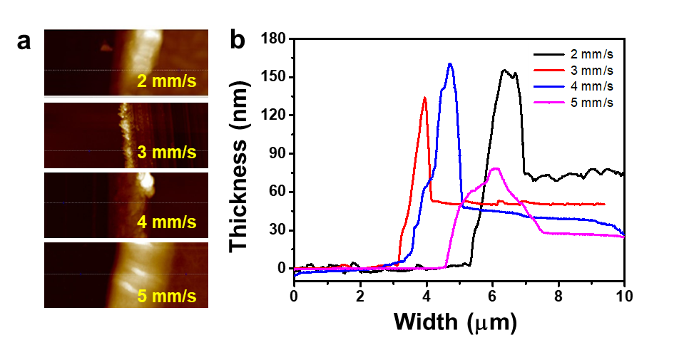
Supplementary Fig. 8 AFM topographic images of a manually scratched Pt@Cu₃(HHTP)₂ films at various shearing speeds.

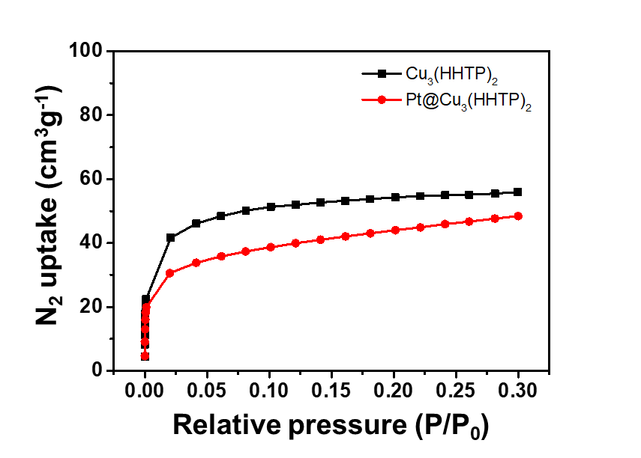
Supplementary Fig. 9 N₂ adsorption and desorption isotherms of the Cu₃(HHTP)₂ and Pt@Cu₃(HHTP)₂ samples at 77 K.
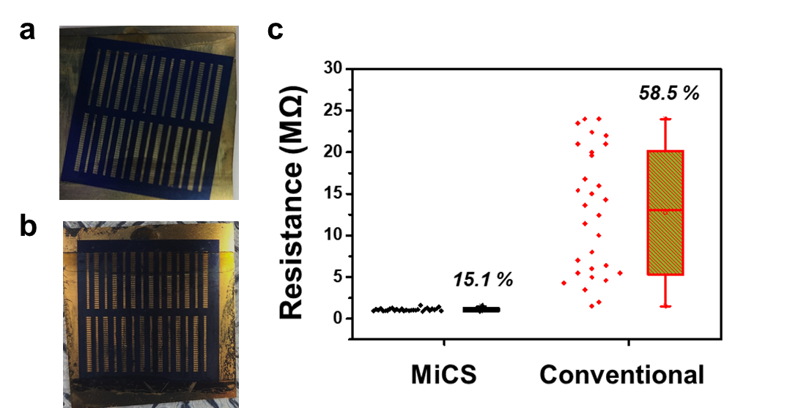
Supplementary Fig. 10 Comparison of electrical properties of C-MOF films fabricated through MiCS process and conventional solution shearing process: Optical images of C-MOF films fabricated by (a) MiCS process and (b) conventional solution shearing process. (c) Comparison of electrical properties of C-MOF films fabricated using MiCS process and conventional solution shearing process. Coefficient of variation (%) for each process is italicized.

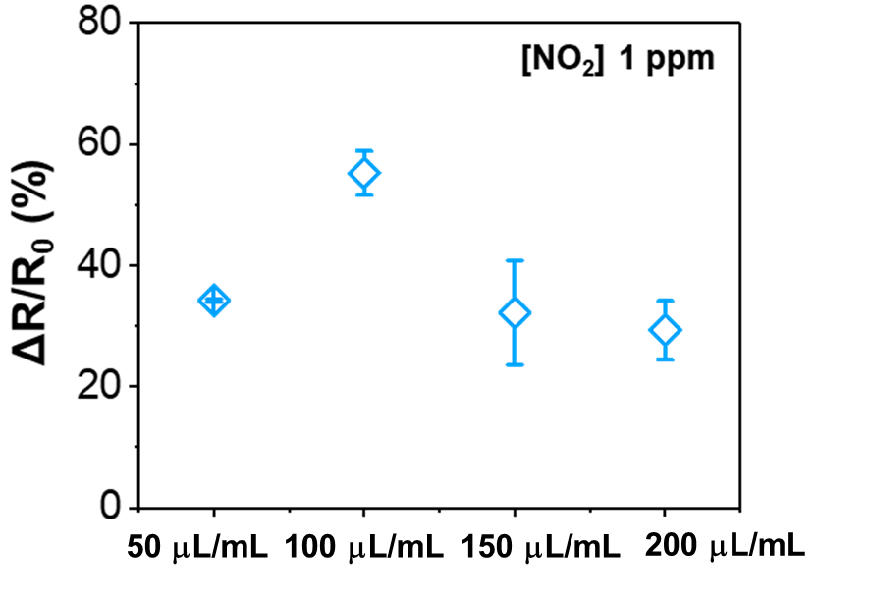
Supplementary Fig. 11 Responses of Pt@Cu₃(HHTP)₂ thin-film to different flow rates of Pt precursor solution.

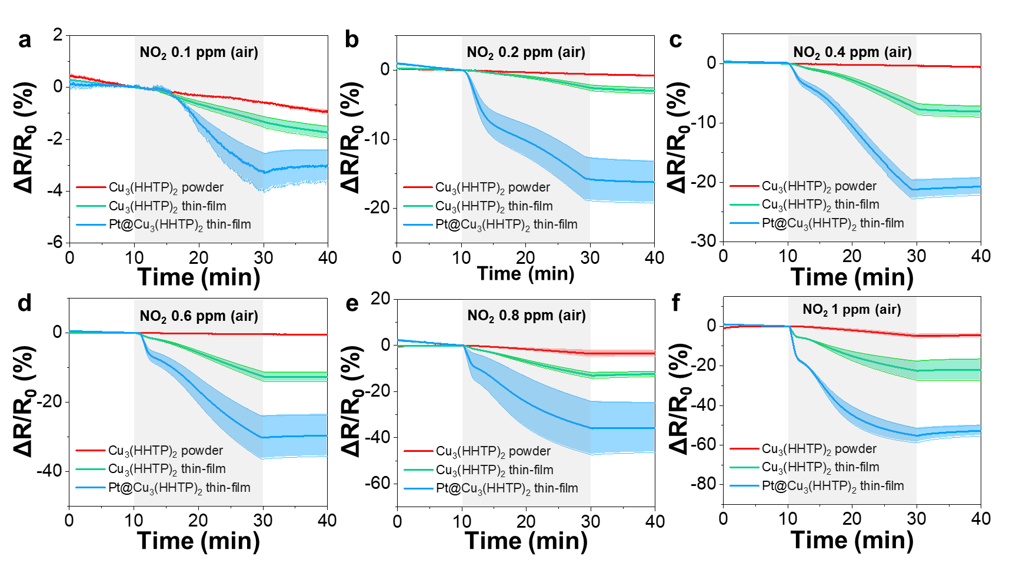
Supplementary Fig. 12 Response traces of the sensors to 0.1–1 ppm of NO₂: (a) 0.1, (b) 0.2, (c) 0.4, (d) 0.6, (e) 0.8, and (f) 1 ppm of NO₂. The shaded area indicates the standard deviation of the sensors (N ≥ 4).

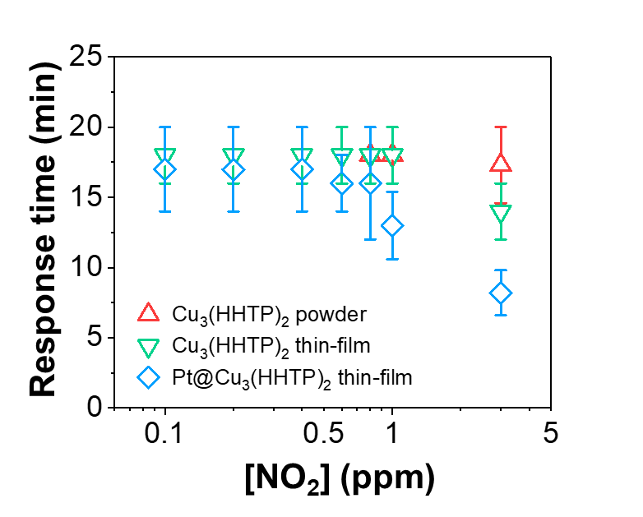
Supplementary Fig. 13 Response times of the sensors to 0.1–3 ppm of NO₂.

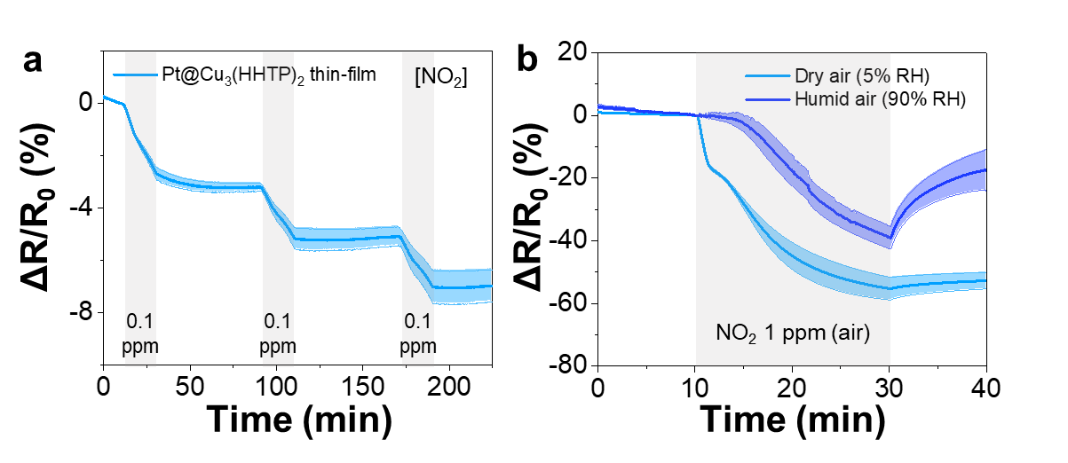
Supplementary Fig. 14 Additional sensing results. (a) Response traces of Pt@Cu₃(HHTP)₂ thin-film to multiple exposures of NO₂ 0.1 ppm. (b) Response traces of the sensors to NO₂ 1 ppm in dry and humid air. The shaded area in each graph presents the standard deviation of the sensors (N ≥ 4).

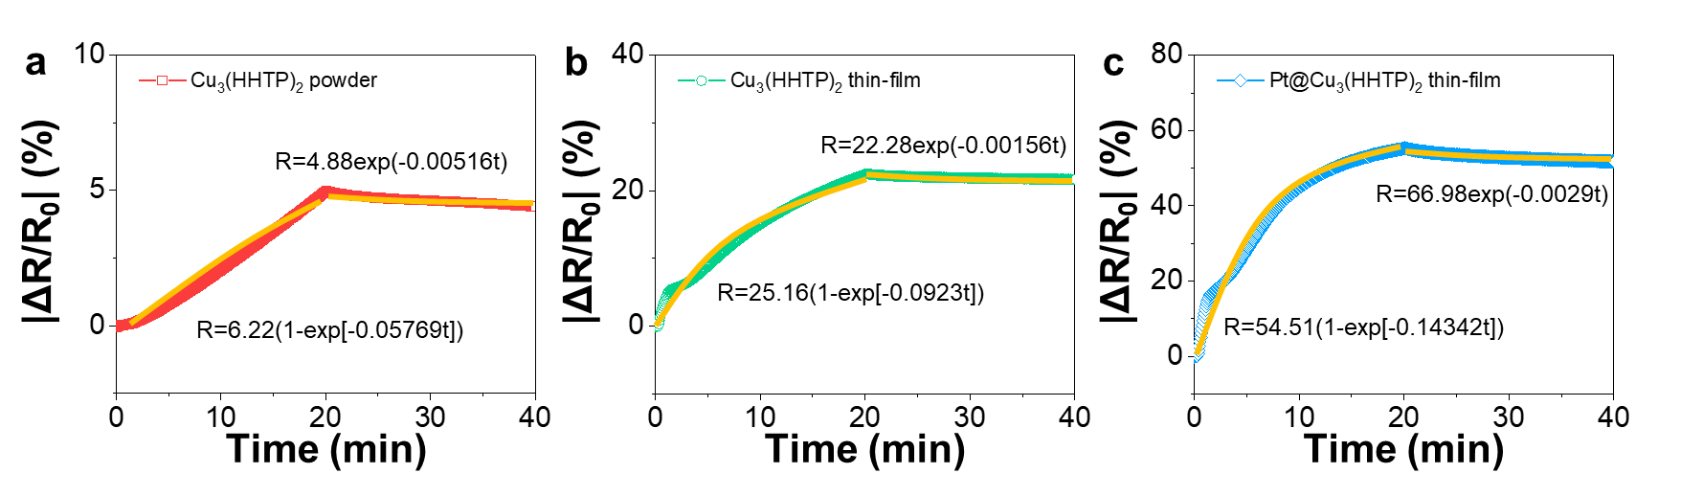
Supplementary Fig. 15 Exponential fitting curves of the sensors. Response traces of the sensors to 1 ppm of NO₂: (a) Cu₃(HHTP)₂ powder, (b) Cu₃(HHTP)₂ thin-film, and (c) Pt@Cu₃(HHTP)₂ thin-film. Reaction rate constants were calculated by the exponential fitting of response traces.

In detail, NO₂ reaction rate constants of the sensors were calculated by (1) the mass action law of NO₂ reactions and (2) the assumption that response is proportional to the amounts of adsorbed NO₂ molecules^{2,3}. The reaction rate constants were obtained from the exponential fitting of the response trace curves [R(t)] using following equations.

$R\left(t\right) for NO_{2} adsorption=R_{max}∙\frac{C_{g}K}{1+C_{g}K}(1-\exp\left[-\frac{{1+C}_{g}K}{K}{∙k}_{ads}∙t\right])$ (1)
$R\left(t\right) for NO_{2} desorption=R_{0}exp⁡[-k_{des}∙t]$ (2)

where K is the equilibrium constant, k_{ads} is the adsorption rate constant, and K_{des} is the desorption rate constant, R_{max} is the maximum response, and C_{g} is the concentration of gas (NO₂) molecules.

References
1. Ko, M., Mendecki, L., Mirica. K.A. Conductive two-dimensional metal-organic frameworks as multifunctional materials. Chem. Commun. 54, 7873-7891 (2018).
2. Campbell, M.G., Sheberla, D., Liu, S.F., Swager, T.M., Dinca, M. Cu₃(hexaiminotriphenylene₂: an electrically conductive 2D metal-organic framework for chemiresistive sensing. Angew. Chem., Int. Ed. 54, 4349-4352 (2015).
3. Mendecki, L., Mirica, K.A. Conductive metal-organic frameworks as ion-to-electron transducers in potentiometric sensors. ACS Appl. Mater. Interfaces 10, 19248-19257 (2018).
4. Yao, M.S. et al. Layer‐by‐layer assembled conductive metal–organic framework nanofilms for room‐temperature chemiresistive sensing. Angew. Chem., Int. Ed. 56, 16510-16514 (2017).
5. Chen, I.-F., Lu, C.-F., Su, W.-F. Highly conductive 2D metal–organic framework thin film fabricated by liquid–liquid interfacial reaction using one-pot-synthesized benzenehexathiol. Langmuir 34, 15754-15762 (2018).
6. Koo, W.-T., Kim, S.-J., Jang, J.-S., Kim, D.-H., Kim, I.-D. Catalytic metal nanoparticles embedded in conductive metal–organic frameworks for chemiresistors: highly active and conductive porous materials. Adv. Sci. 6, 1900250 (2019).
7. Choi, S.-J., Choi, H.-J., Koo, W.-T., Huh, D., Lee, H., Kim, I.-D. Metal-organic framework-templated PdO-Co₃O₄ nanocubes functionalized by SWCNTs: improved NO₂ reaction kinetics on flexible heating film. ACS Appl. Mater. Interfaces 9, 40593-40603 (2017).
8. Rui, K. et al. Dual-function metal-oganic framework-based wearable fibers for gas probing and energy storage. ACS Appl. Mater. Interfaces 10, 2837-2842 (2018).
9. Chen, Z. et al. Mimicking a dog's nose: scrolling graphene nanosheets. ACS Nano 12, 2521-2530 (2018).
10. Yuan, W., Liu, A., Huang, L., Li, C., Shi, G. High-performance NO₂ sensors based on chemically modified graphene. Adv. Mater. 25, 766-771 (2013).
11. Yang, W., Wan, P., Zhou, X., Hu, J., Guan, Y., Feng, L. Additive-free synthesis of In₂O₃ cubes embedded into graphene sheets and their enhanced NO₂ sensing performance at room temperature. ACS Appl. Mater. Interfaces 6, 21093-21100 (2014).
12. Cho, B. et al. Charge-transfer-based gas sensing using atomic-layer MoS₂. Sci. Rep. 5, 8052 (2015).
13. Ko, K.Y. et al. Improvement of gas-sensing performance of large-area tungsten disulfide nanosheets by surface functionalization. ACS Nano 10, 9287-9296 (2016).
14. Xu, T. et al. The ultra-high NO₂ response of ultra-thin WS₂ nanosheets synthesized by hydrothermal and calcination processes. Sens. Actuators, B 259, 789-796 (2018).
15. Jaiswal, J., Sanger, A., Tiwari, P., Chandra, R. MoS₂ hybrid heterostructure thin film decorated with CdTe quantum dots for room temperature NO₂ gas sensor. Sens. Actuators, B 305, 127437 (2020).
16. Zhou, Y., Liu, G., Zhu, X., Guo, Y. Ultrasensitive NO₂ gas sensing based on rGO/MoS₂ nanocomposite film at low temperature. Sens. Actuators, B 251, 280-290 (2017).

