Supplementary Figures
Selective Single-Bacteria Extraction Based on Capture and Release of Microemulsion Droplets

Jiyu Li^{1,2,#}, Dinglong Hu^{1,3,#}, Chee Kent Lim⁴, Jifeng Ren^{1,5}, Xin Yao⁶, Chao Ma⁷, Marcos⁶, Weiqiang Chen⁷, Patrick K. H. Lee*^{,2,4} and Raymond H. W. Lam*^{,1,2,8,9}

¹ Department of Biomedical Engineering, City University of Hong Kong, Hong Kong, China
² Centre for Biosystems, Neuroscience, and Nanotechnology, City University of Hong Kong, China
³ Institute of Biointelligence Technology, BGI-Shenzhen, Shenzhen 518083, China
⁴ School of Energy and Environment, City University of Hong Kong, Hong Kong, China
⁵ School of Biomedical Engineering, Capital Medical University, Beijing 100069, China
⁶ School of Mechanical and Aerospace Engineering, Nanyang Technological University, Singapore
⁷ Department of Biomedical Engineering, New York University, New York, NY 10003
⁸ Centre for Robotics and Automation, City University of Hong Kong, Hong Kong, China
⁹ City University of Hong Kong Shenzhen Research Institute, Shenzhen 519057, China

*Correspondence should be addressed to R.H.W. Lam (email address: rhwlam@cityu.edu.hk; Tel: +852-3442-8577; Fax: +852-3442-0172) and P.K.H. Lee (email address: patrick.kh.lee@cityu.edu.hk; Tel: +852-3442-4625; Fax: +852-3442-0688)

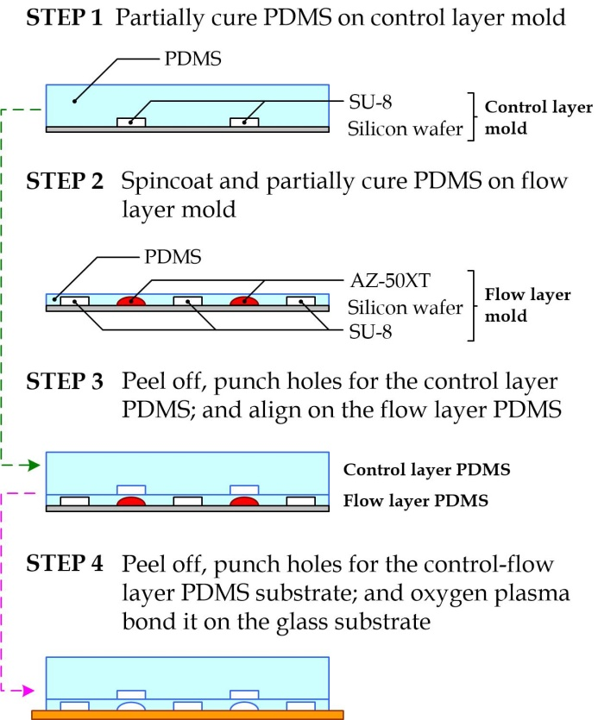
Figure S1. Fabrication process for the microfluidic single-bacteria isolation device.

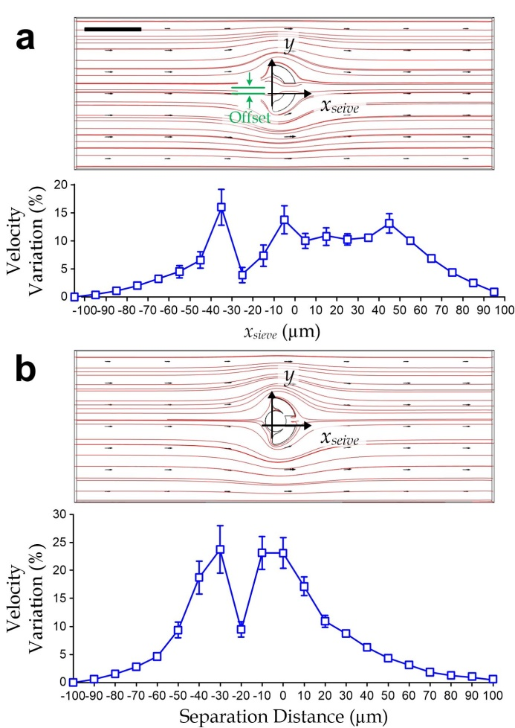
Figure S2. Simulated velocity profiles and velocity variation profiles for (a) an unoccupied micro-sieve and (b) an occupied micro-sieve. The velocity profiles include local velocities (arrow) and streamlines (red line) in the mid-height top view cross-section of an isolation microchannel section. Scale bar: 50 μm. The velocity variations along the isolation microchannel section are also plotted against a separation distance from the x-position of micro-sieve. We further quantified the velocity profile as a dimensionless quantity as the average value of the relative velocity magnitude deviating from the flow along the microchannel length, average(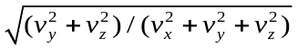), where v_{x}, v_{y} and v_{z} represent the velocity components x-axis (channel length), y-axis (channel width) and z-axis (channel width), respectively, at a location inside the microchannel region.

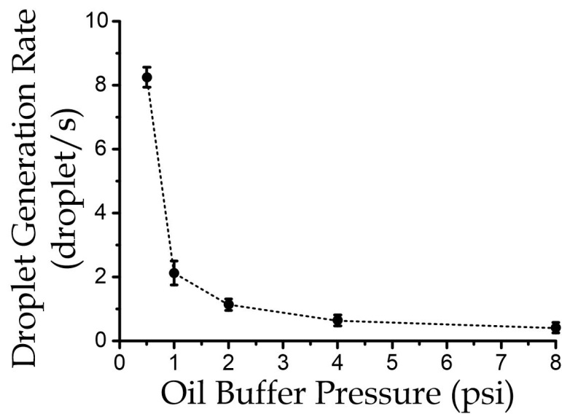
Figure S3. Generation rate of micro-droplets for different levels of the oil buffer inlet pressure (N = 4).

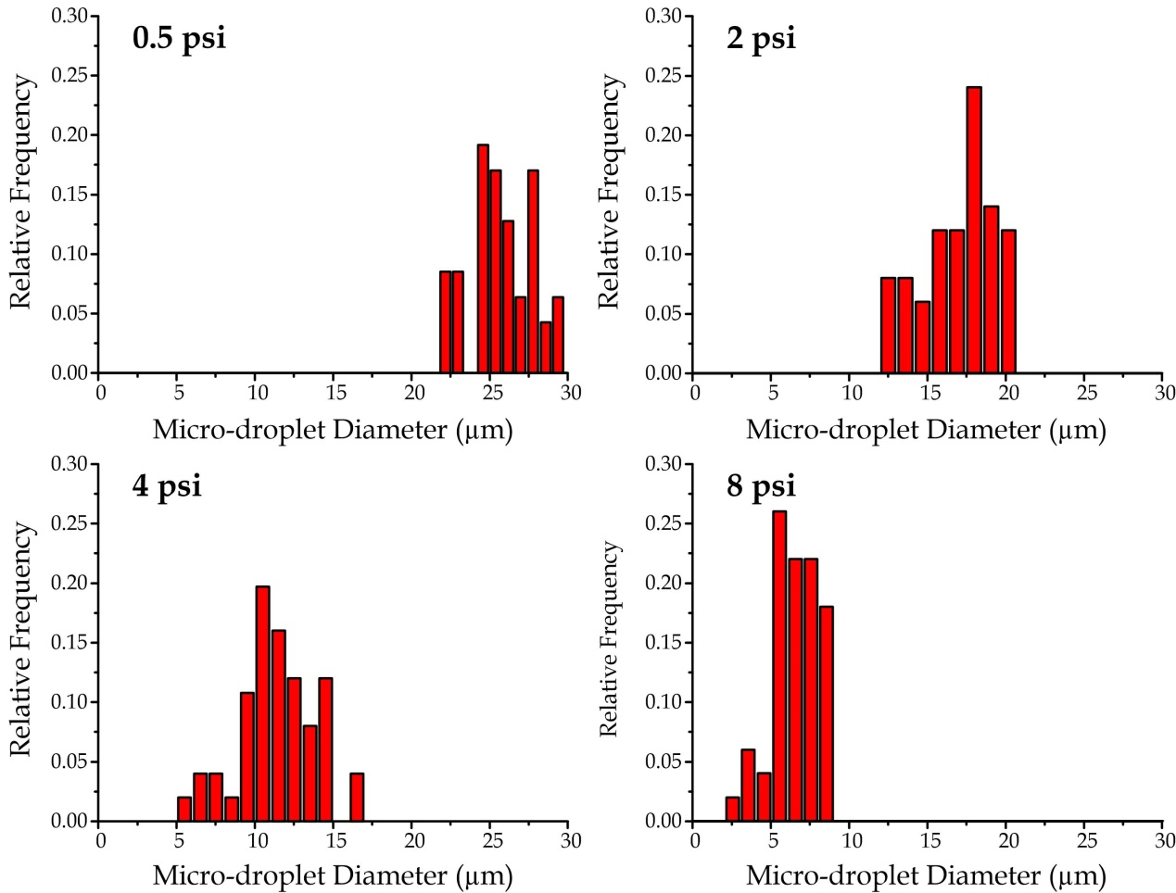
Figure S4. Diameter distributions of micro-droplet generated under the oil buffer pressure level of 0.5 psi, 2 psi, 4 psi and 8 psi.

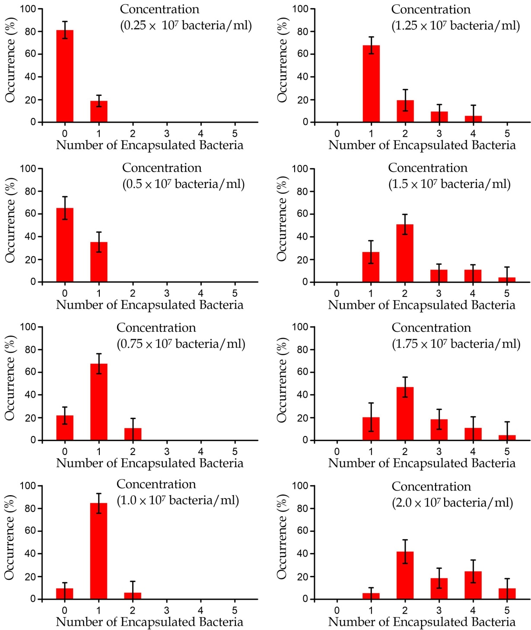
Figure S5. Statistics of the number of encapsulated bacteria in a generated micro-droplet upon different bacteria concentrations in the biosample.

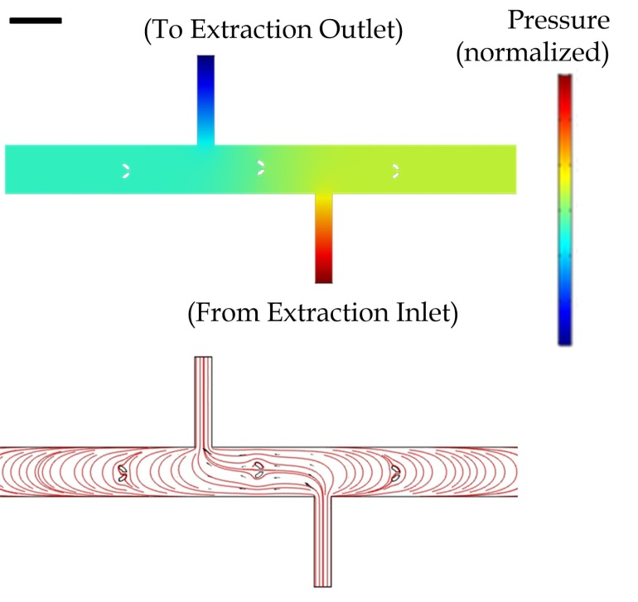
Figure S6. Simulated pressure profiles (upper) and streamlines (lower) of liquid flow from the extraction inlet along microchannel section containing a micro-seieve. Scale bar: 100 μm.

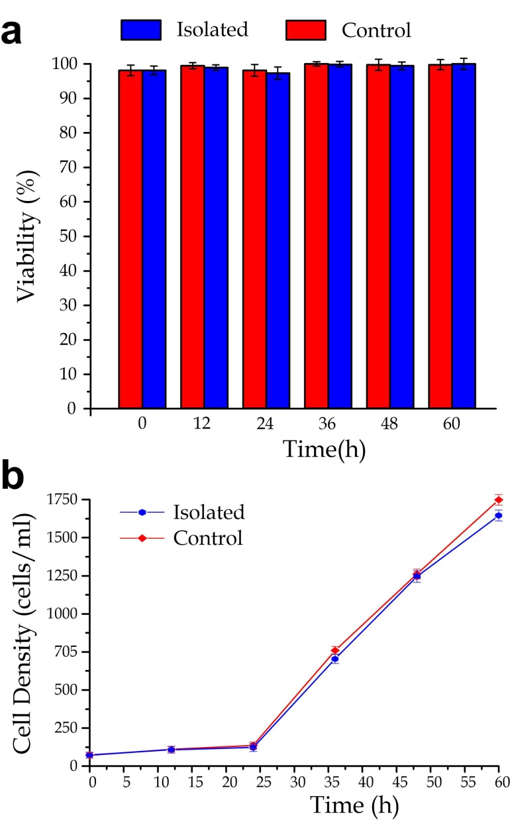
Figure S7. (a) Viability and (b) density of M. extorquens AM1 bacteria (with and without processed by the single-bacteria isolation) over different culture periods from 12 h to 60 h (N = 4 for each point).

a
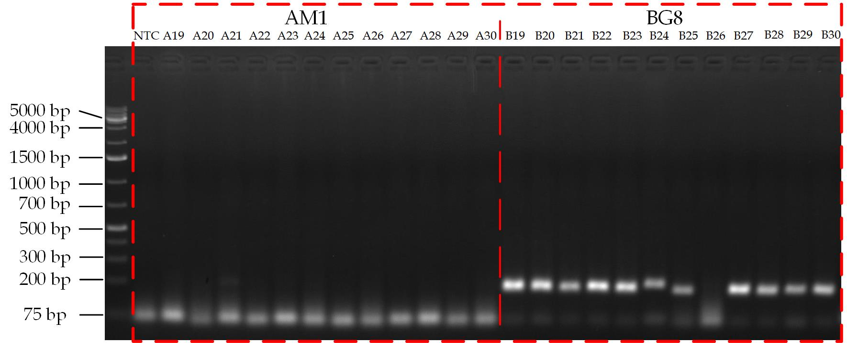
b
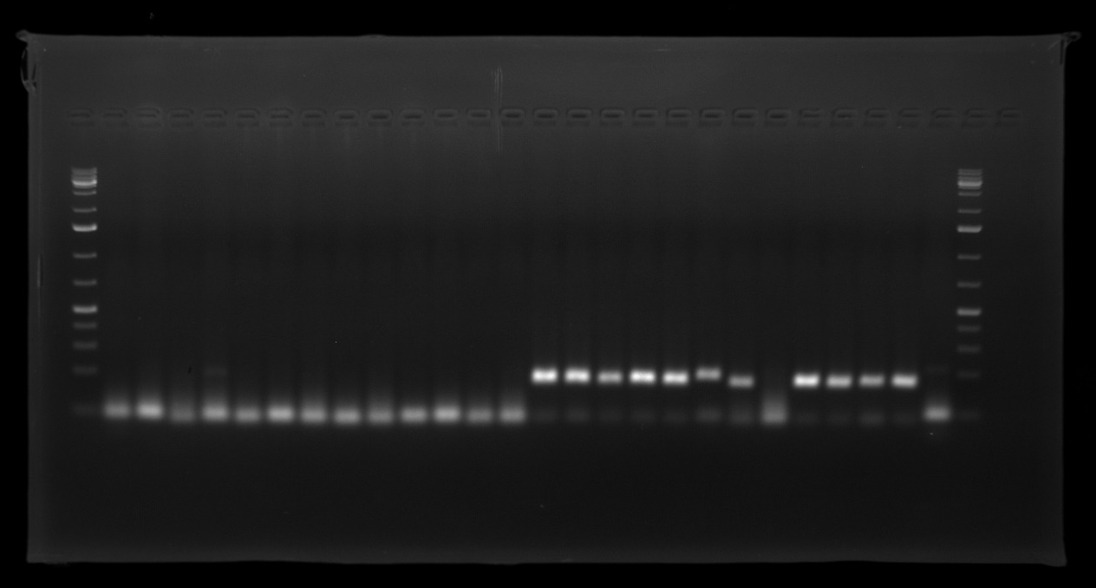
Figure S8. (a) PCR band profiles of isolated individual cells of M. extorquens AM1 (11 cells, labeled as A19 to A30) and M. album BG8 (11 cells, labeled as B19 to B30) using the QpmoA-FWD-7 and QpmoA-REV-7 primer set specific for M. album BG8. NTC corresponds to non-template control. (b) Original gel image, captured by the Azure C600 imaging system (Azure Biosystems, Dublin, California, United States) at an ultraviolet wavelength of 302 nm.

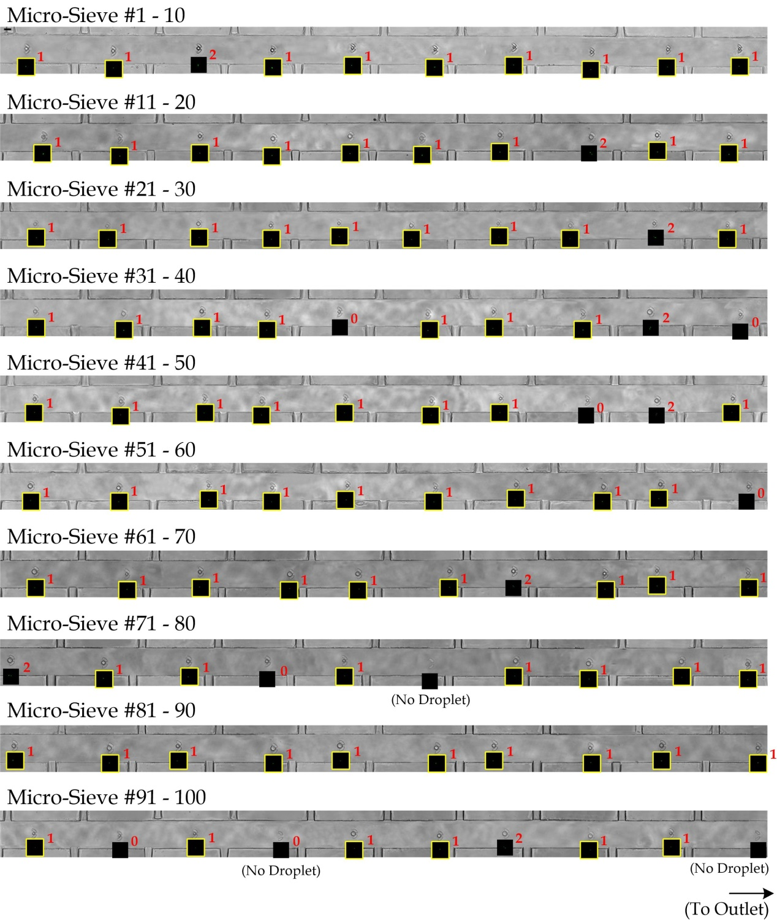
Figure S9. Micrographs of the cell-containing microdroplets in micro-sieves after the cell/droplet capture step. The corresponding florescence images at the micro-sieves (located below the brightfield image regions, with the same image scale) were also taken for visualizing the number of encapsulated bacteria, as numbered next to the fluorescence images. In this particular experiment, 98 cell-containing micro-droplets were generated, with 97 droplets captured and 1 droplet missed. Among the captured droplets, 83 droplets contained one cell. Scale bar: 50 μm.

