Supplementary materials
Neuroprotective effect of a new free radical scavenger HL-008 against ischemia-reperfusion injury
Yahong Liu^{1#}, Ying Cheng^{2#}, Wei Zhang^{2*}, Hongqi Tian^{1*}
¹Tianjin Key Laboratory of Radiation Medicine and Molecular Nuclear Medicine, Institute of Radiation Medicine, Chinese Academy of Medical Sciences and Peking Union Medical College, No. 238, Baidi Road, Tianjin, China
²Center for Marine Bioproducts Development, College of Medicine and Public Health, Flinders University, Bedford Park, Adelaide, SA, 5042, Australia
* Correspondence should be addressed to Hongqi Tian: tianhongqi@irm-cams.ac.cn and Wei Zhang: wei.zhang@flinders.edu.au
# Yahong Liu and Ying Cheng are the co-first authors for this research paper
Table S1 Pharmacokinetic parameters of HL-008 after intraperitoneal injection
Parameters | Unit | Plasma | Brain
T1/2 | Hr | 9.73 | 3.20
Tmax | Hr | 1.00 | 0.0833
Cmax | ng/mL | 522 | 468
AUC (0-t) | ng*ng/mL | 1525 | 932
AUC (0-∞) | ng*ng/mL | 3264 | 1149
B/P Ratio |  |  | 35.2%
Table S2 Average value and improvement rate of the neurological function score and cerebral infarction volume in each group
Group | Neurological score | P value | Improvement rate of the neurological function score | Infraction volume (mm³) | P value | Improvement rate of the infarct volume
Control | 0.00 ± 0.00 | - | - | 0.00 ± 0.00 | - | -
I/R | 3.00 ± 0.63 |  | - | 160.41±13.68 | - | -
HL-008  100 mg/kg | 1.20 ± 0.40** | 0.0013 | 60.00% | 21.01 ± 27.49**** | < 0.0001 | 86.90%
HL-008  50 mg/kg | 1.00 ± 0.00*** | 0.0002 | 66.67% | 26.85 ± 15.48**** | < 0.0001 | 83.26%
HL-008  25 mg/kg | 1.00 ± 0.00*** | 0.0002 | 66.67% | 25.46 ± 15.91**** | < 0.0001 | 84.13%
HL-00 8vs. I/R, *p < 0.05, **p < 0.01, ***p < 0.001, ****p < 0.0001
Table S3 Average value and improvement rate of the neurological function score and cerebral infarction volume in each group
Group | Neurological score | P value | Improvement rate of the neurological function score | Infraction volume (mm³) | P value | Improvement rate of the infarct volume
Control | 0.00 ± 0.00 | - | - | 0.00 ± 0.00 | - | -
I/R | 3.00 ± 0.71 | - | - | 198.23 ± 15.37 | - | -
HL-008  100 mg/kg | 1.00 ± 0.00*** | 0.0002 | 66.67% | 62.36 ± 16.87**** | <0.0001 | 68.54%
Edaravone  3 mg/kg | 1.8 ± 0.45* | 0.013 | 40.00% | 107.97 ± 29.25*** | 0.0003 | 45.54%
HL-00 8 vs. I/R, *p < 0.05, **p < 0.01, ***p < 0.001, ****p < 0.001

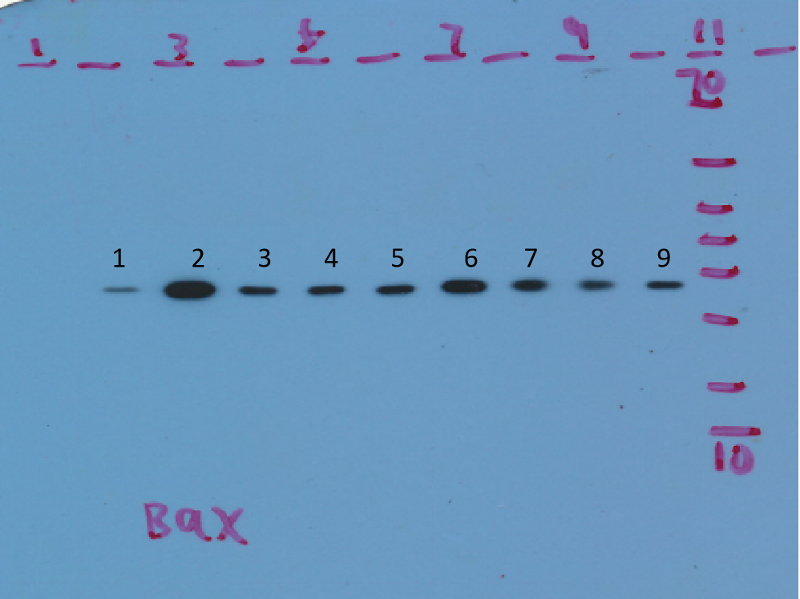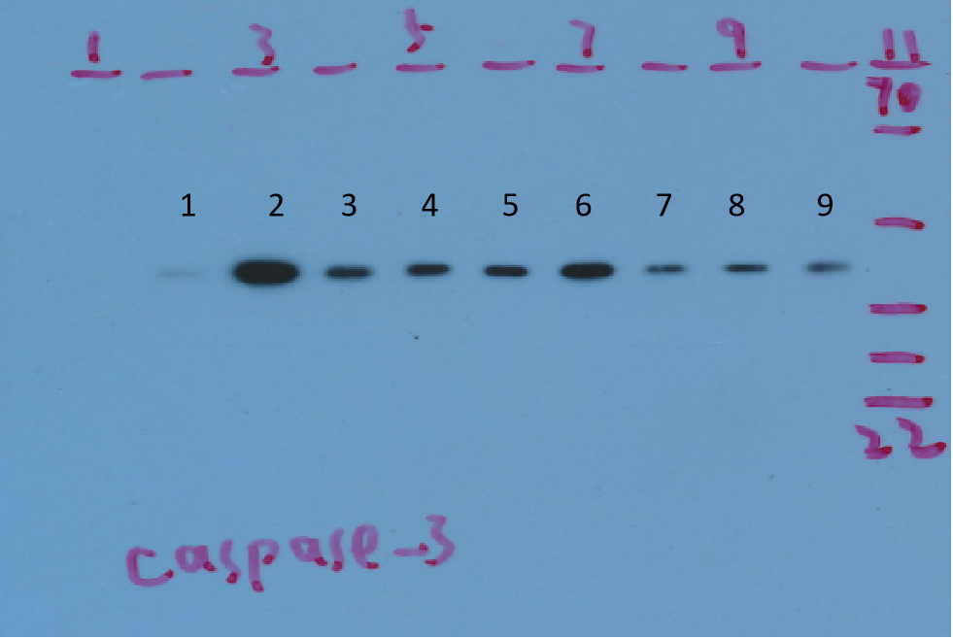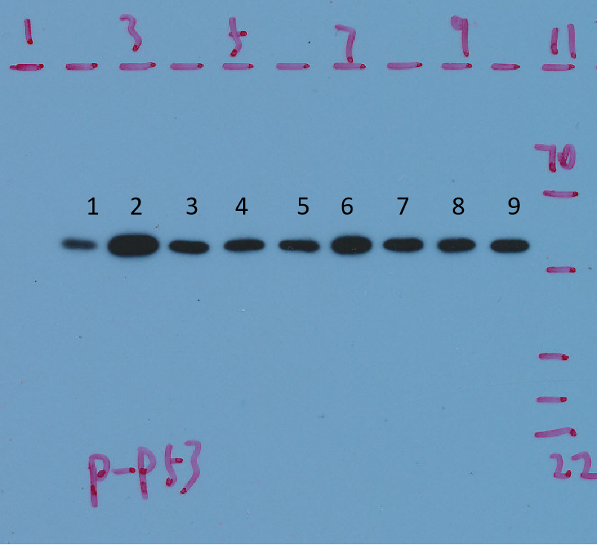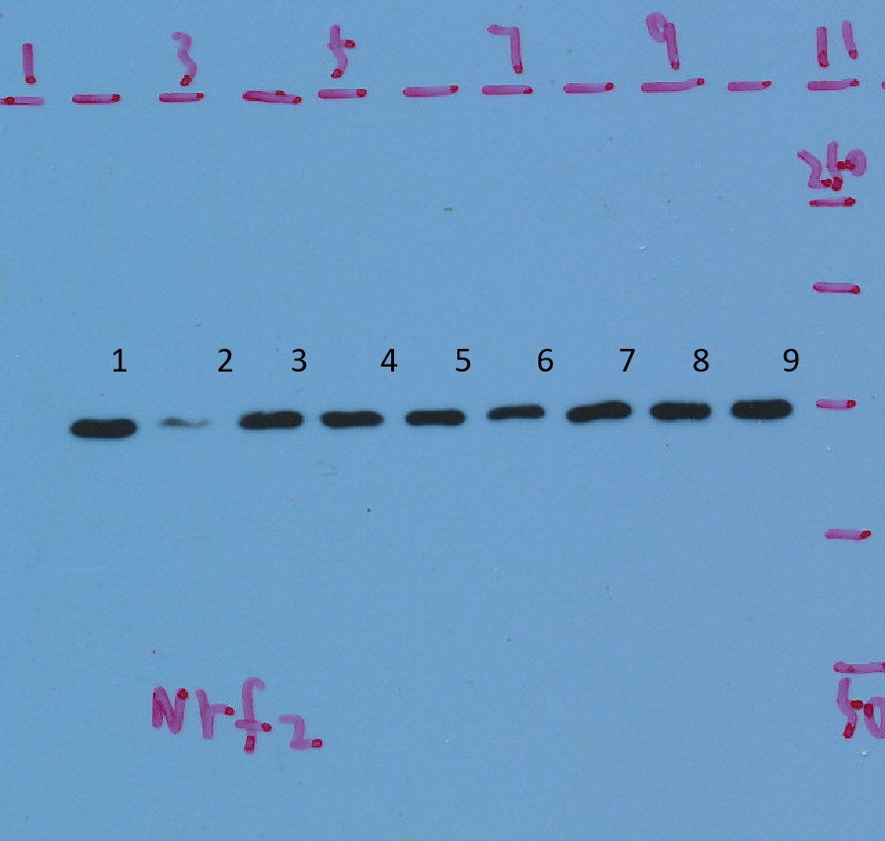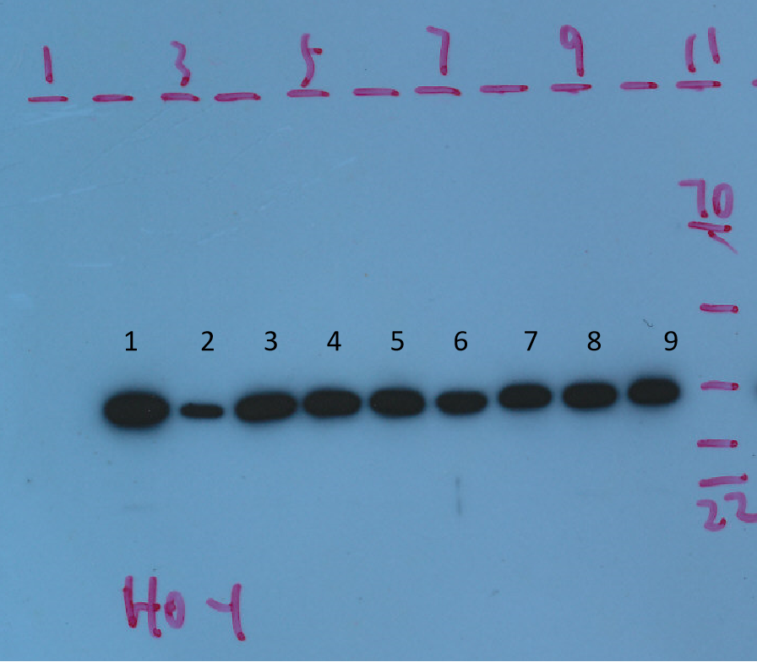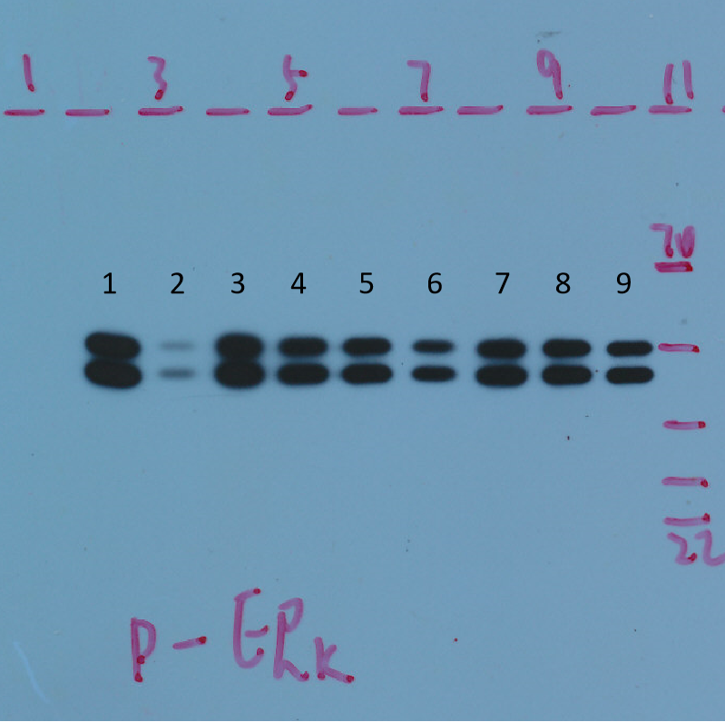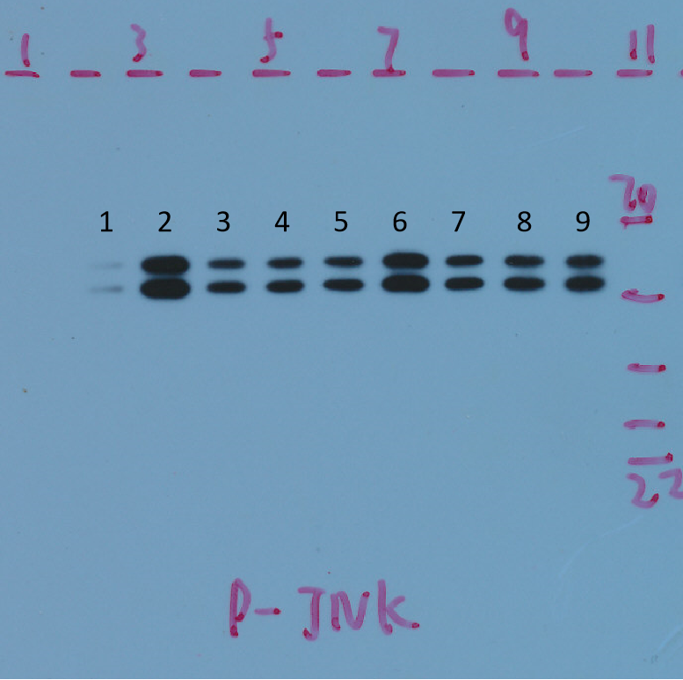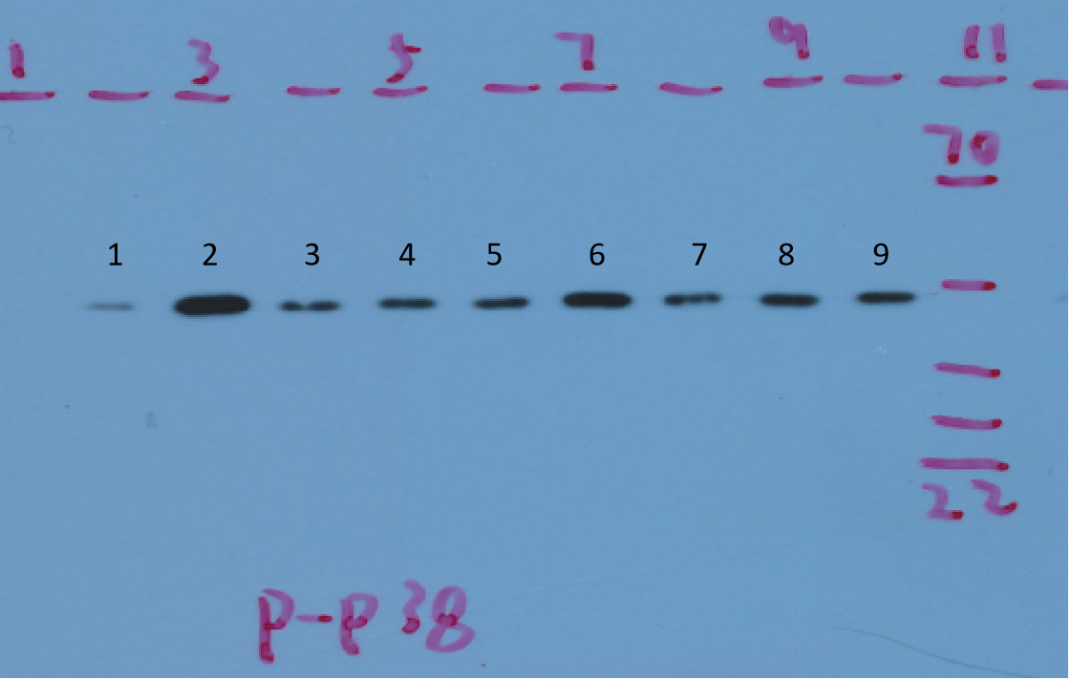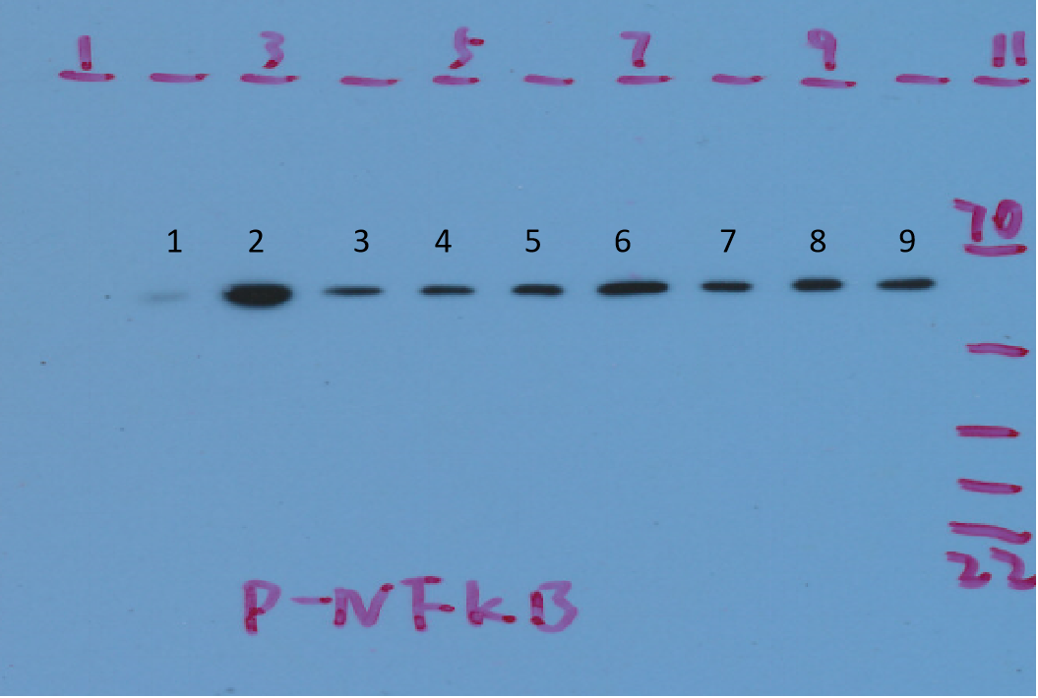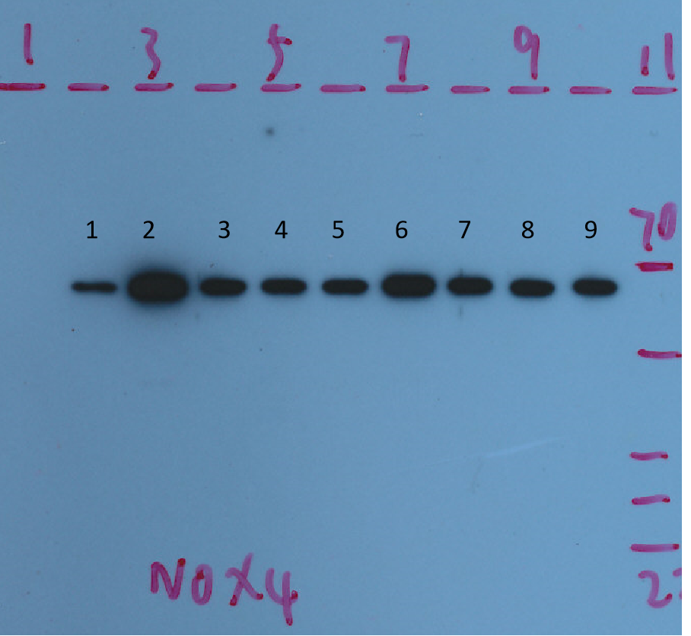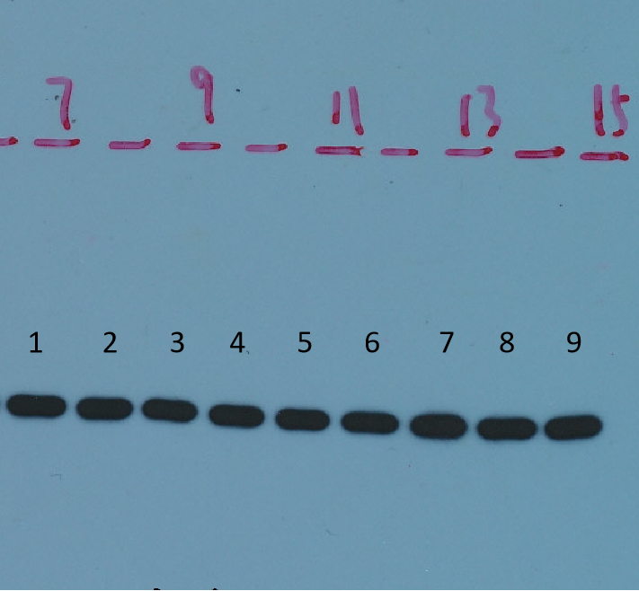
Figure S1 HL-008 played a neuroprotective role by regulating the expression of multiple pathway proteins. Twenty-four hours after reperfusion, the tissue lysate was analyzed by western blot with indcated antibodies. The order from left to right is: (1) control; (2) IR; (3) HL-008 100 mg/kg; (4) HL-003-100mg/kg; (5) control or sham; (6) IR; (7) HL-008 100 mg/kg; (8) HL-003-100mg/kg; (9) HL-003 100 mg/kg. Note: HL-003 is not among the compounds in this study. The samples treated with HL-008 and HL-003 were analysized by Western blot at the same time.

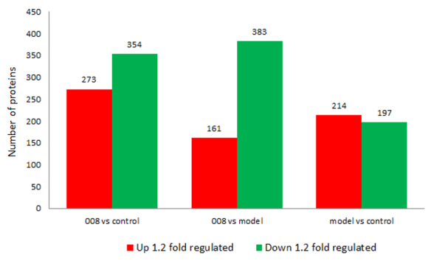
Figure S2 A columnar chart of proteins showing significant difference between the groups. When the ratio of protein expression in the treatment group was 1.2 times higher than that in the control group (P < 0.05), the protein expression was regarded as significantly enhanced or significantly decreased as the screening criteria.

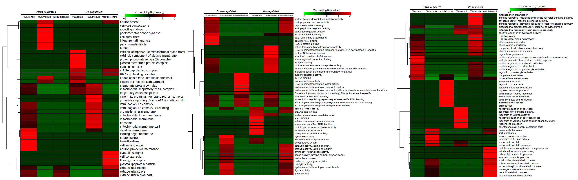
A B C

Figure S3 A. Significant thermogram of the differential protein cellular components (CC) among the HL-008 group, I/R group, and control group; B. Significant thermogram of the differential protein molecular functions (MF) among the HL-008 group, I/R group, and control group; C. Significant thermogram of differential protein biological processes (BP) among the HL-008 group, I/R group, and control group.

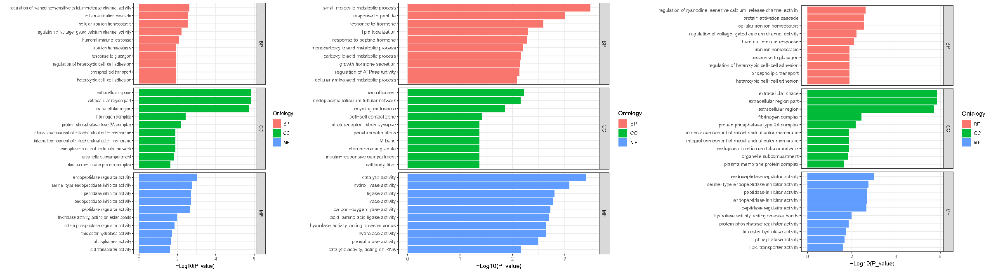

A B C

Figure S4 A. Differential protein GO enriched significantly arranged the top 10 in HL-008 vs Control group; B. Differential protein GO enriched significantly arranged the top 10 in HL-008 vs I/R group; C. Differential protein GO enriched significantly arranged the top 10 in I/R vs Control group.

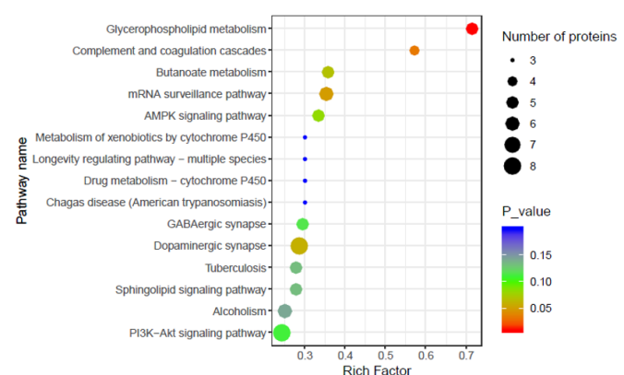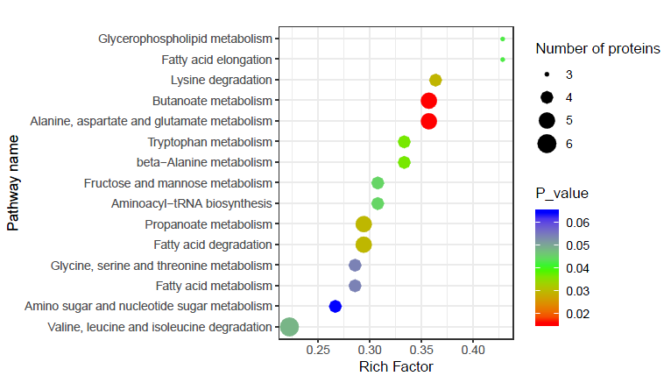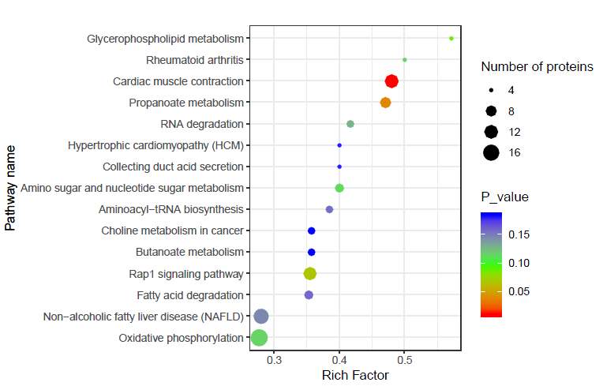
A B C
Figure S5 A. KEGG enrichment (top15) pathway in model vs HL-008; B. HL-008 vs Control group; C. KEGG enrichment (top15) pathway in I/R vs Control group.

