Supplementary Information

Mechanisms linking multi-year La Niña with preceding extreme El Niño

Tomoki Iwakiri^{1,*} and Masahiro Watanabe¹
¹Atmosphere and Ocean Research Institute, The University of Tokyo

*Corresponding author: Tomoki Iwakiri (iwakiri@aori.u-tokyo.ac.jp)
5-1-5 Kashiwanoha, Kashiwa, Chiba 277-8568, Japan

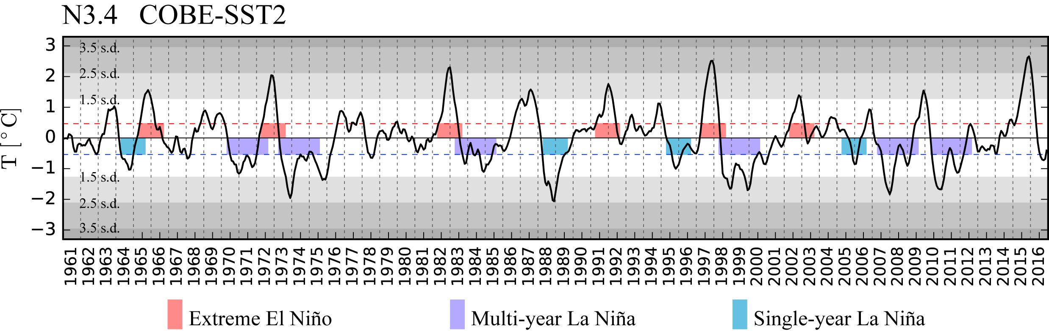
Supplementary Figure 1. Observed time series of N3.4. Black line indicates observed time series of N3.4 from COBE-SST2. Red and blue dashed lines denote 0.5 K and -0.5 K, respectively. Bars indicate individual ENSO events classified into extreme El Niño, multi-year La Niña, and single-year La Niña.

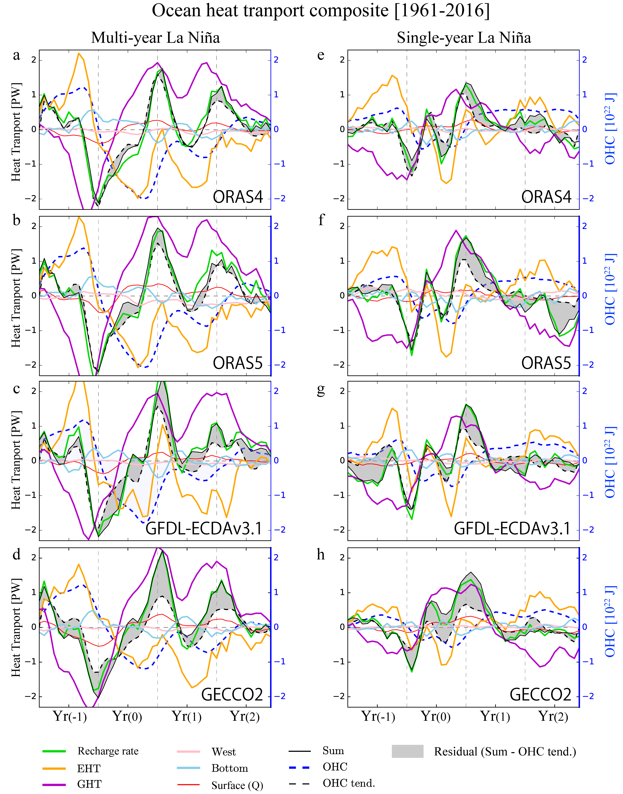
Supplementary Figure 2. Ocean heat transport composites in the equatorial Pacific box among four ocean reanalysis datasets. (a) ORAS4, (b) ORAS5, (c) GFDL-ECDAv3.1, and (d) GECCO2 for multi-year La Niña. (e-h) As in (a-d) but for single-year La Niña.

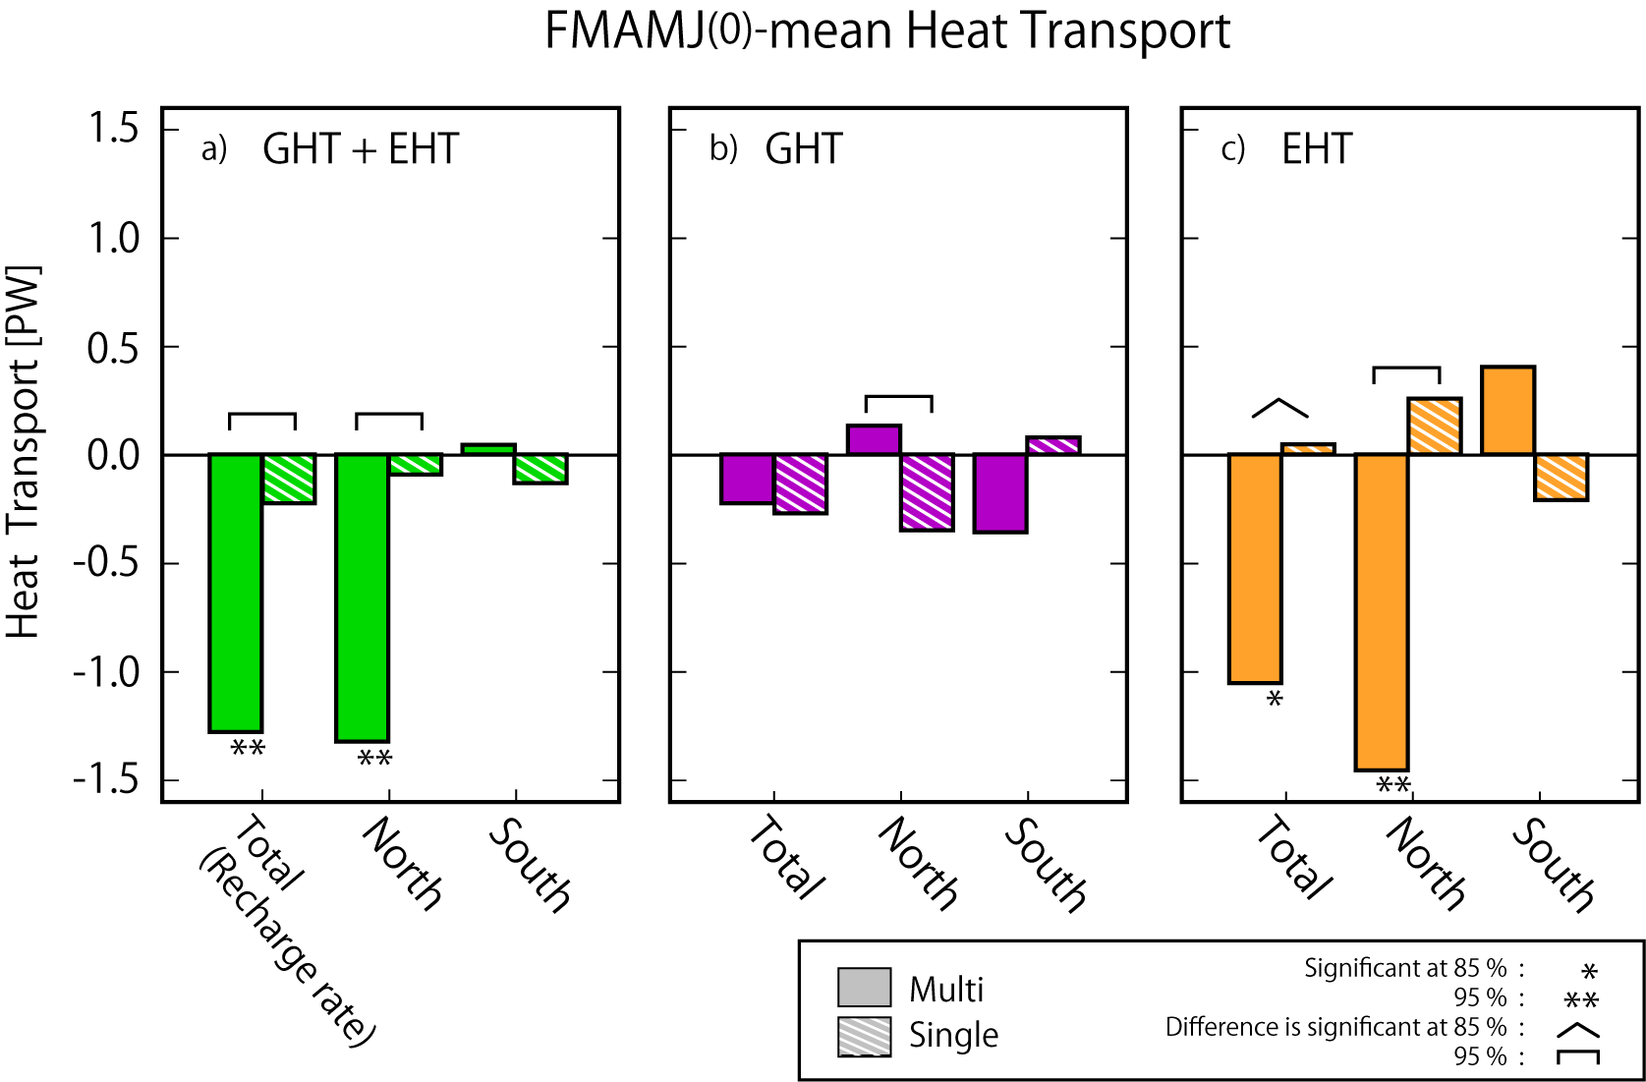
Supplementary Figure 3. FMAMJ(0)-mean ocean heat transport across north and south boundaries of the equatorial Pacific box. (a) Recharge rate equivalent to the sum of EHT and GHT, (b) GHT, and (c) EHT. Solid (hatched) bars are the composites for multi-year (single-year) La Niña. In each panel, total heat transport and contributions at the northern and southern boundaries are shown from left to right. Asterisks and brackets represent the level of statistical significance, as explained in the figure legend.

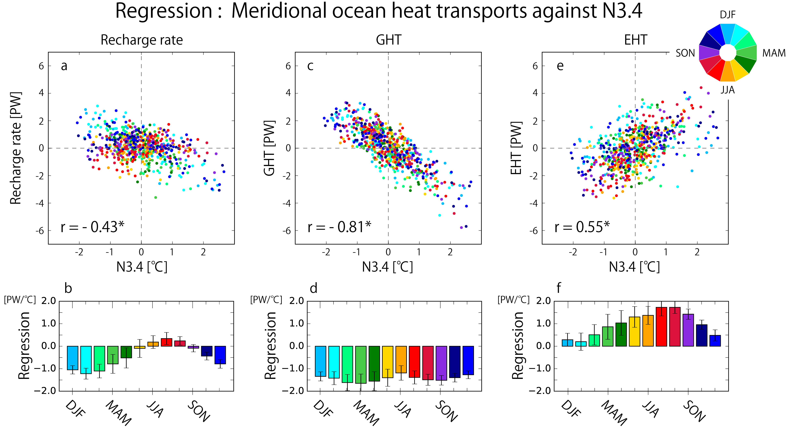
Supplementary Figure 4. Sensitivity of meridional ocean heat transports to the ENSO SST anomaly and its seasonal dependency. (top) Scatter plots of meridional heat transports versus N3.4. Left bottom numbers are correlation coefficients throughout the entire period. Asterisks indicate the value statistically significant at the 99% confidence level. (bottom) Bar plots are regression coefficients of meridional heat transport against N3.4 for each season represented by different colors. The vertical error bar indicates the 95% confidence interval. (a,b) Recharge rate versus N3.4. (c,d) GHT versus N3.4. (e,f) EHT versus N3.4.

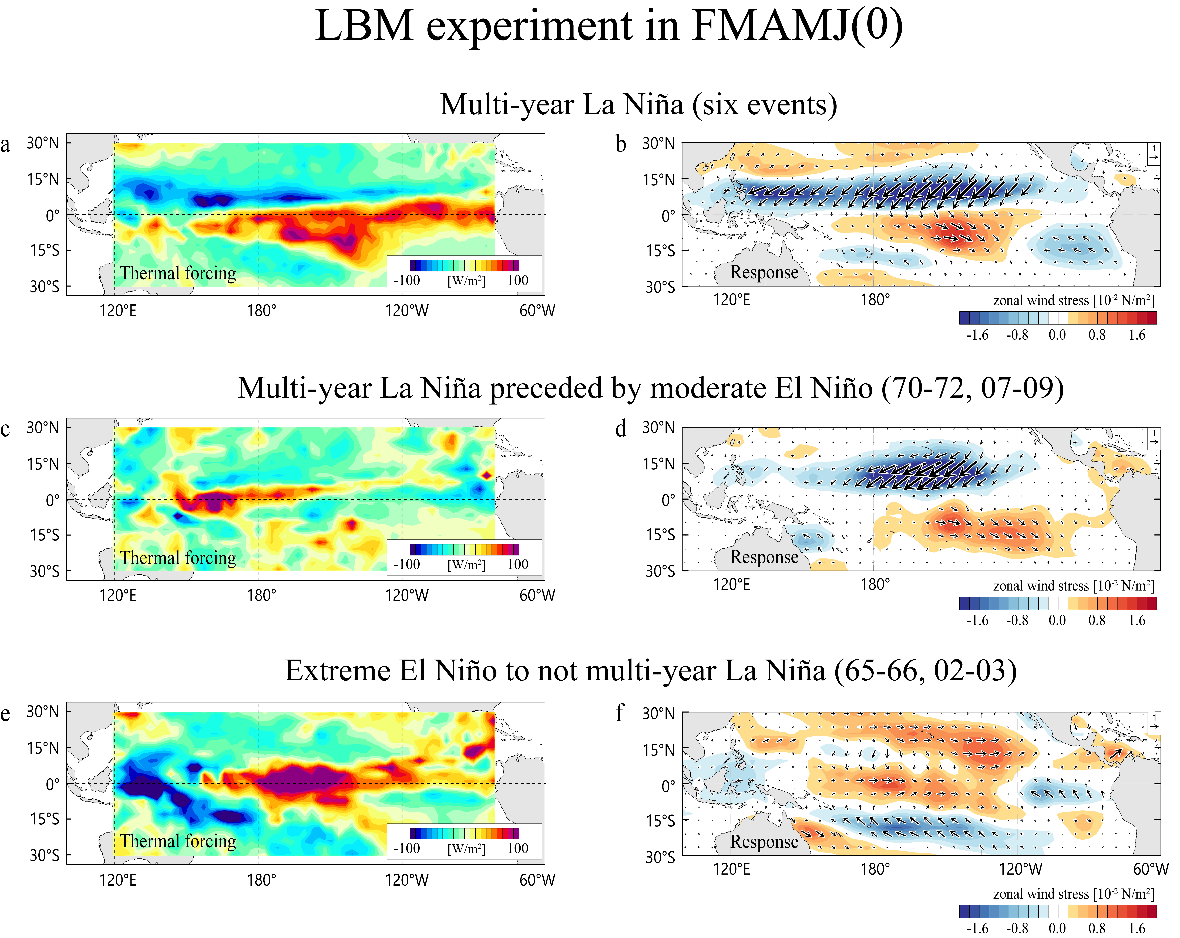
Supplementary Figure 5. Diagnosing thermally forced steady linear response during FMAMJ(0). (a) Vertically integrated prescribed thermal forcing in multi-year La Niña composite (six events mean). Forcing is assumed to be zero outside of the tropical Pacific. (b) Steady response based on LBM experiments (Methods) of surface zonal wind stress (shading) and wind stresses (vector: unit in 10⁻² N/m²) forced by the diabatic heating shown in (a). (c,d) As in (a,b) but for the composite of multi-year La Niña preceded by moderate El Niño (two events mean). (e,f) As in (a,b) but for composite of extreme El Niño to not multi-year La Niña case (two events mean).

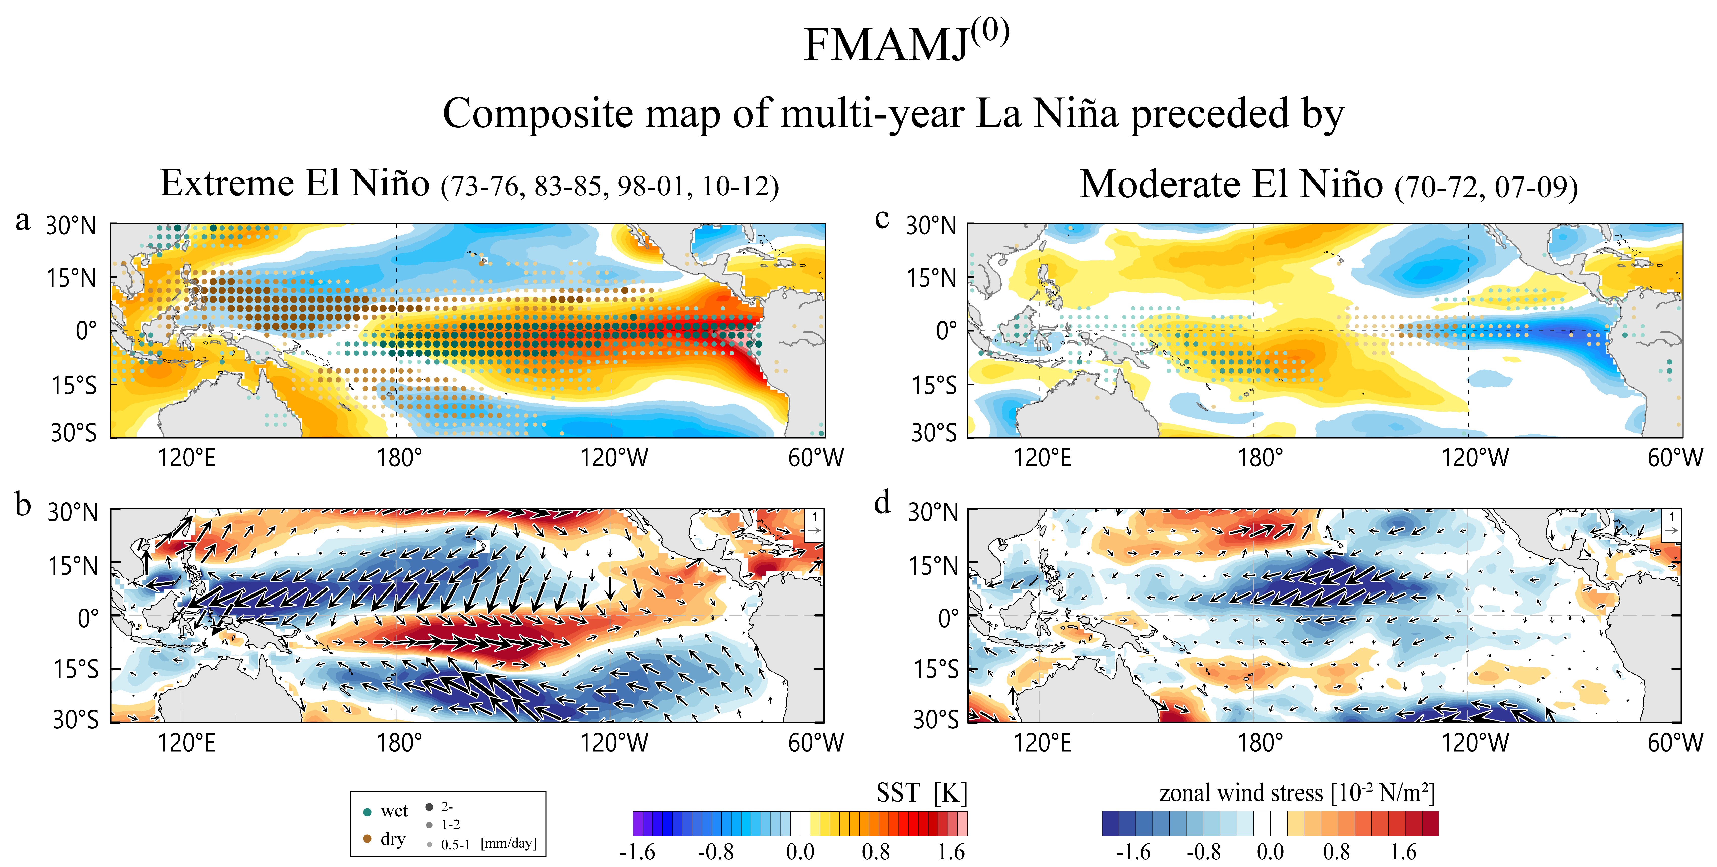
Supplementary Figure 6. Composite map for multi-year La Niña based on preceding year El Niño amplitude. (a) Anomalous SST (shading) and precipitation (dots) for multi-year La Niña preceded by extreme El Niño in FMAMJ(0) (four events mean). (b) zonal wind stress (shading) and wind stress (vector: units 10⁻² N/m²). (c,d) As in (a)-(b) but for preceded by a moderate El Niño (two events mean).

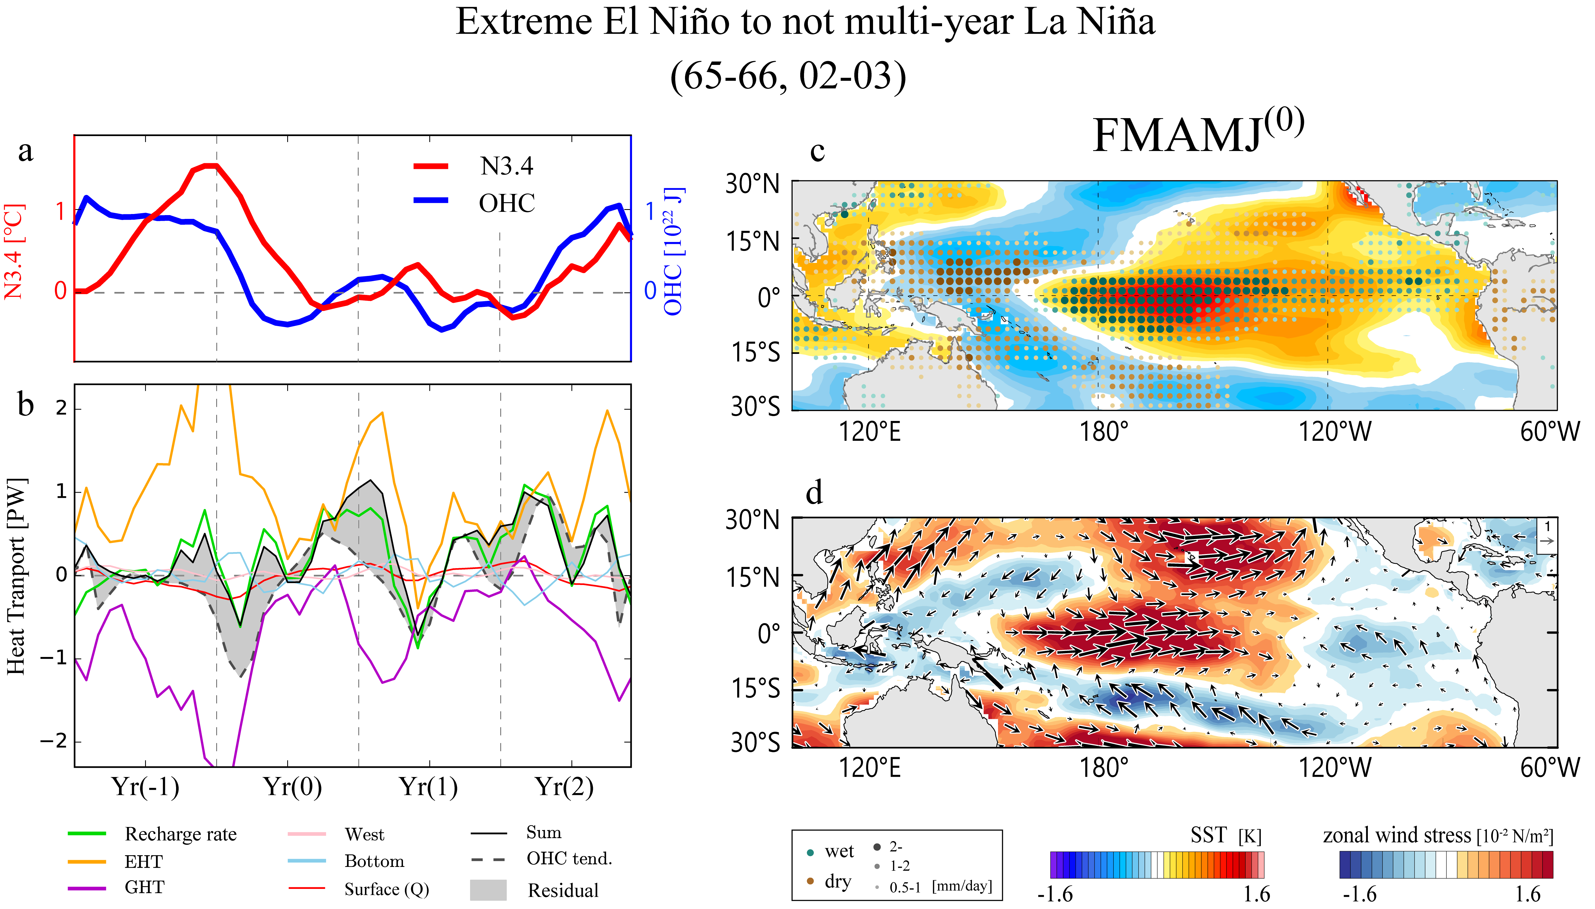

Supplementary Figure 7. Composite map of extreme El Niño which does not accompany multi-year La Niña. (a) Time evolution of N3.4 and OHC, (b) ocean heat transport as in Fig. S3a, and (c,d) as in Fig. S4a,b.

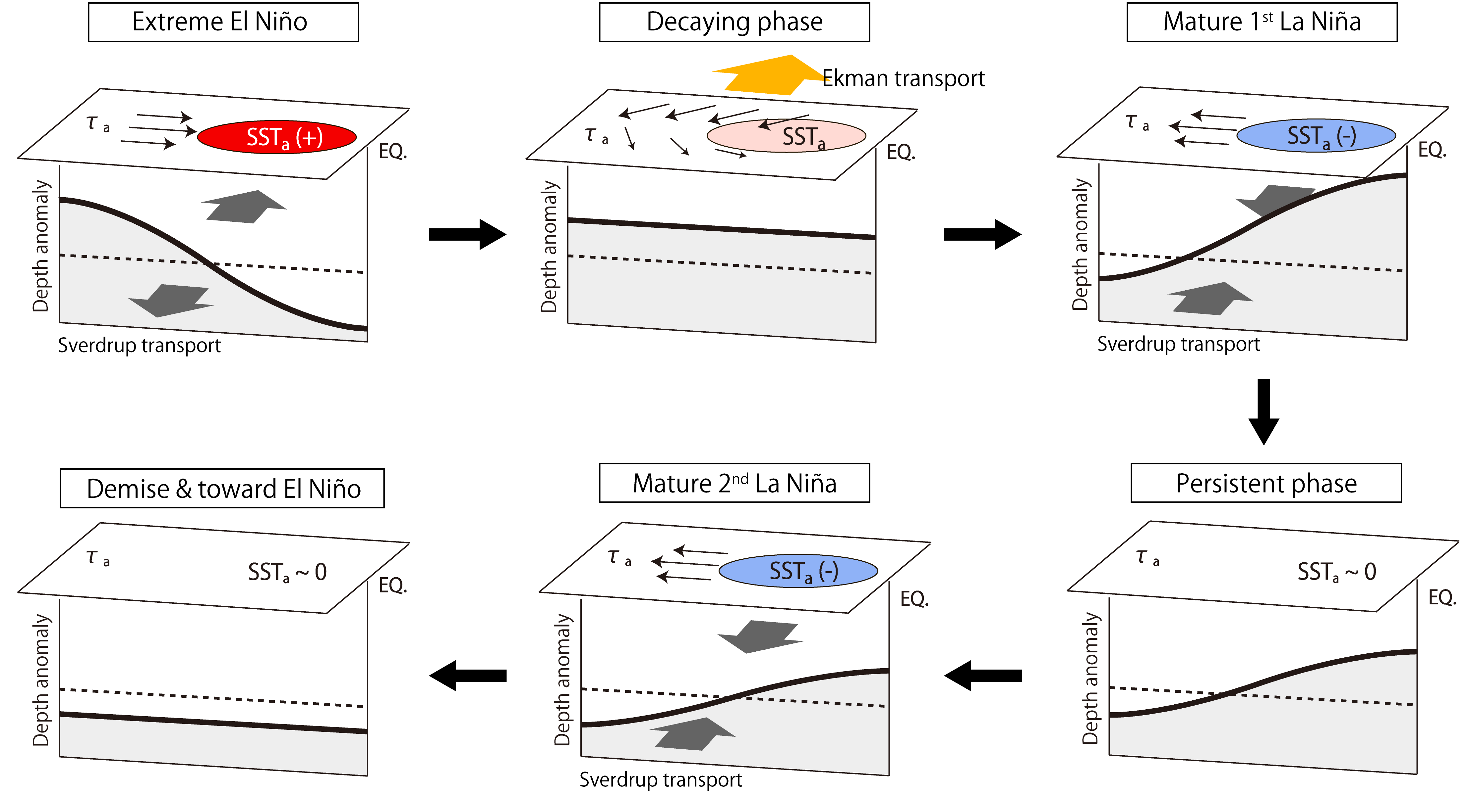

Supplementary Figure 8. Schematic representation of the transition from extreme El Niño to multi-year La Niña. Thick line indicates the thermocline depth anomaly from zero line (dashed line). Horizontal vector represents the surface wind stress anomaly. Horizontal shadings are the SST anomaly. Thick meridional arrows represent the geostrophic (gray) and Ekman (yellow) heat transports. Figure is modified from schematic diagram for recharge oscillator⁷.

Supplementary Table 1. N3.4 and GHT-induced recharge rate during NDJ(-1/0).

NDJ(-1/0) | Multi-year | Single-year
N3.4 [K] | 1.68 | 0.94
GHT [PW] | -2.13 | -1.31
Normalized GHT [PW/K] | -1.27 | -1.39

Supplementary Table 2. 37 CMIP6 models used in the present study and observational SST data. Number of ENSO events are also summarized.
Model/Data | Period | #Number of
Model/Data | Period | Multi  La Niña | Single  La Niña | Extreme  El Niño | Extreme El Niño  to  Multi La Niña
CMIP6 models | (500 years)
ACCESS-CM2 | 950-1449 | 9 | 119 | 54 | 2
ACCESS-ESM1-5 | 101-600 | 19 | 104 | 53 | 4
BCC-CSM2-MR | 1850-2349 | 3 | 122 | 38 | 0
CAMS-CSM1-0 | 2900-3390 | 19 | 107 | 58 | 13
CESM2-WACCM-FV2 | 1-500 | 34 | 82 | 69 | 23
CESM2 | 1-500 | 29 | 76 | 52 | 10
CNRM-CM6-1 | 1850-2349 | 17 | 91 | 46 | 6
CNRM-ESM2-1 | 1850-2349 | 21 | 99 | 50 | 8
CanESM5 | 5201-5700 | 25 | 73 | 35 | 6
E3SM-1-0 | 1-500 | 31 | 75 | 51 | 15
EC-Earth3-Veg | 1850-2349 | 29 | 89 | 55 | 12
EC-Earth3 | 2259-2758 | 30 | 73 | 50 | 13
FGOALS-f3-L | 600-1099 | 24 | 99 | 59 | 19
FGOALS-g3 | 200-699 | 4 | 131 | 44 | 1
FIO-ESM-2-0 | 301-800 | 28 | 74 | 48 | 9
GFDL-CM4 | 151-650 | 32 | 75 | 54 | 14
GFDL-ESM4 | 1-500 | 43 | 56 | 59 | 16
GISS-E2-1-G | 4150-4649 | 41 | 55 | 31 | 4
GISS-E2-1-H | 3180-3679 | 19 | 82 | 45 | 6
HadGEM3-GC31-LL | 1850-2349 | 30 | 70 | 46 | 11
HadGEM3-GC31-MM | 1850-2349 | 35 | 68 | 60 | 18
INM-CM4-8 | 1850-2349 | 25 | 79 | 40 | 5
INM-CM5-0 | 1850-2349 | 19 | 74 | 38 | 1
IPSL-CM6A-LR | 1850-2349 | 22 | 89 | 46 | 6
MCM-UA-1-0 | 1-500 | 35 | 32 | 49 | 1
MIROC-ES2L | 1850-2349 | 47 | 33 | 64 | 31
MIROC6 | 3200-3699 | 43 | 44 | 56 | 17
MPI-ESM-1-2-HAM | 1850-2349 | 19 | 88 | 42 | 4
MPI-ESM1-2-HR | 1850-2349 | 27 | 54 | 46 | 6
MPI-ESM1-2-LR | 1850-2349 | 38 | 46 | 48 | 14
MRI-ESM2-0 | 1850-2349 | 33 | 77 | 51 | 13
NESM3 | 1000-1499 | 27 | 78 | 41 | 5
NorCPM1 | 1-500 | 32 | 74 | 50 | 17
NorESM2-LM | 1600-2099 | 37 | 60 | 55 | 19
NorESM2-MM | 1200-1699 | 35 | 60 | 60 | 20
SAM0-UNICON | 1-500 | 34 | 61 | 55 | 16
UKESM1-0-LL | 1960-2459 | 29 | 66 | 50 | 8
Observations
COBE-SST2 | 1961-2016 | 6 | 4 | 6 | 4
COBE-SST2 | 1901-2018 | 10 | 11 | 16 | 4

