Supplementary Materials for

Novel structure of active platinum-bismuth site for oxidation of carbon monoxide

Bing Nan,^{1, 5} Qiang Fu,² Miao Shu,¹ Lulu Zhou,² Weiwei Wang,² Chun-Jiang Jia,²* Chao Ma,³* Jun-Xiang Chen,⁴ Lina Li,^{1, 6} Rui Si,^{1, 6}*
*Correspondence to: Email: sirui@sinap.ac.cn (R.S.); cma@hnu.edu.cn (C.M.); jiacj@sdu.edu.cn (C.-J.J.)

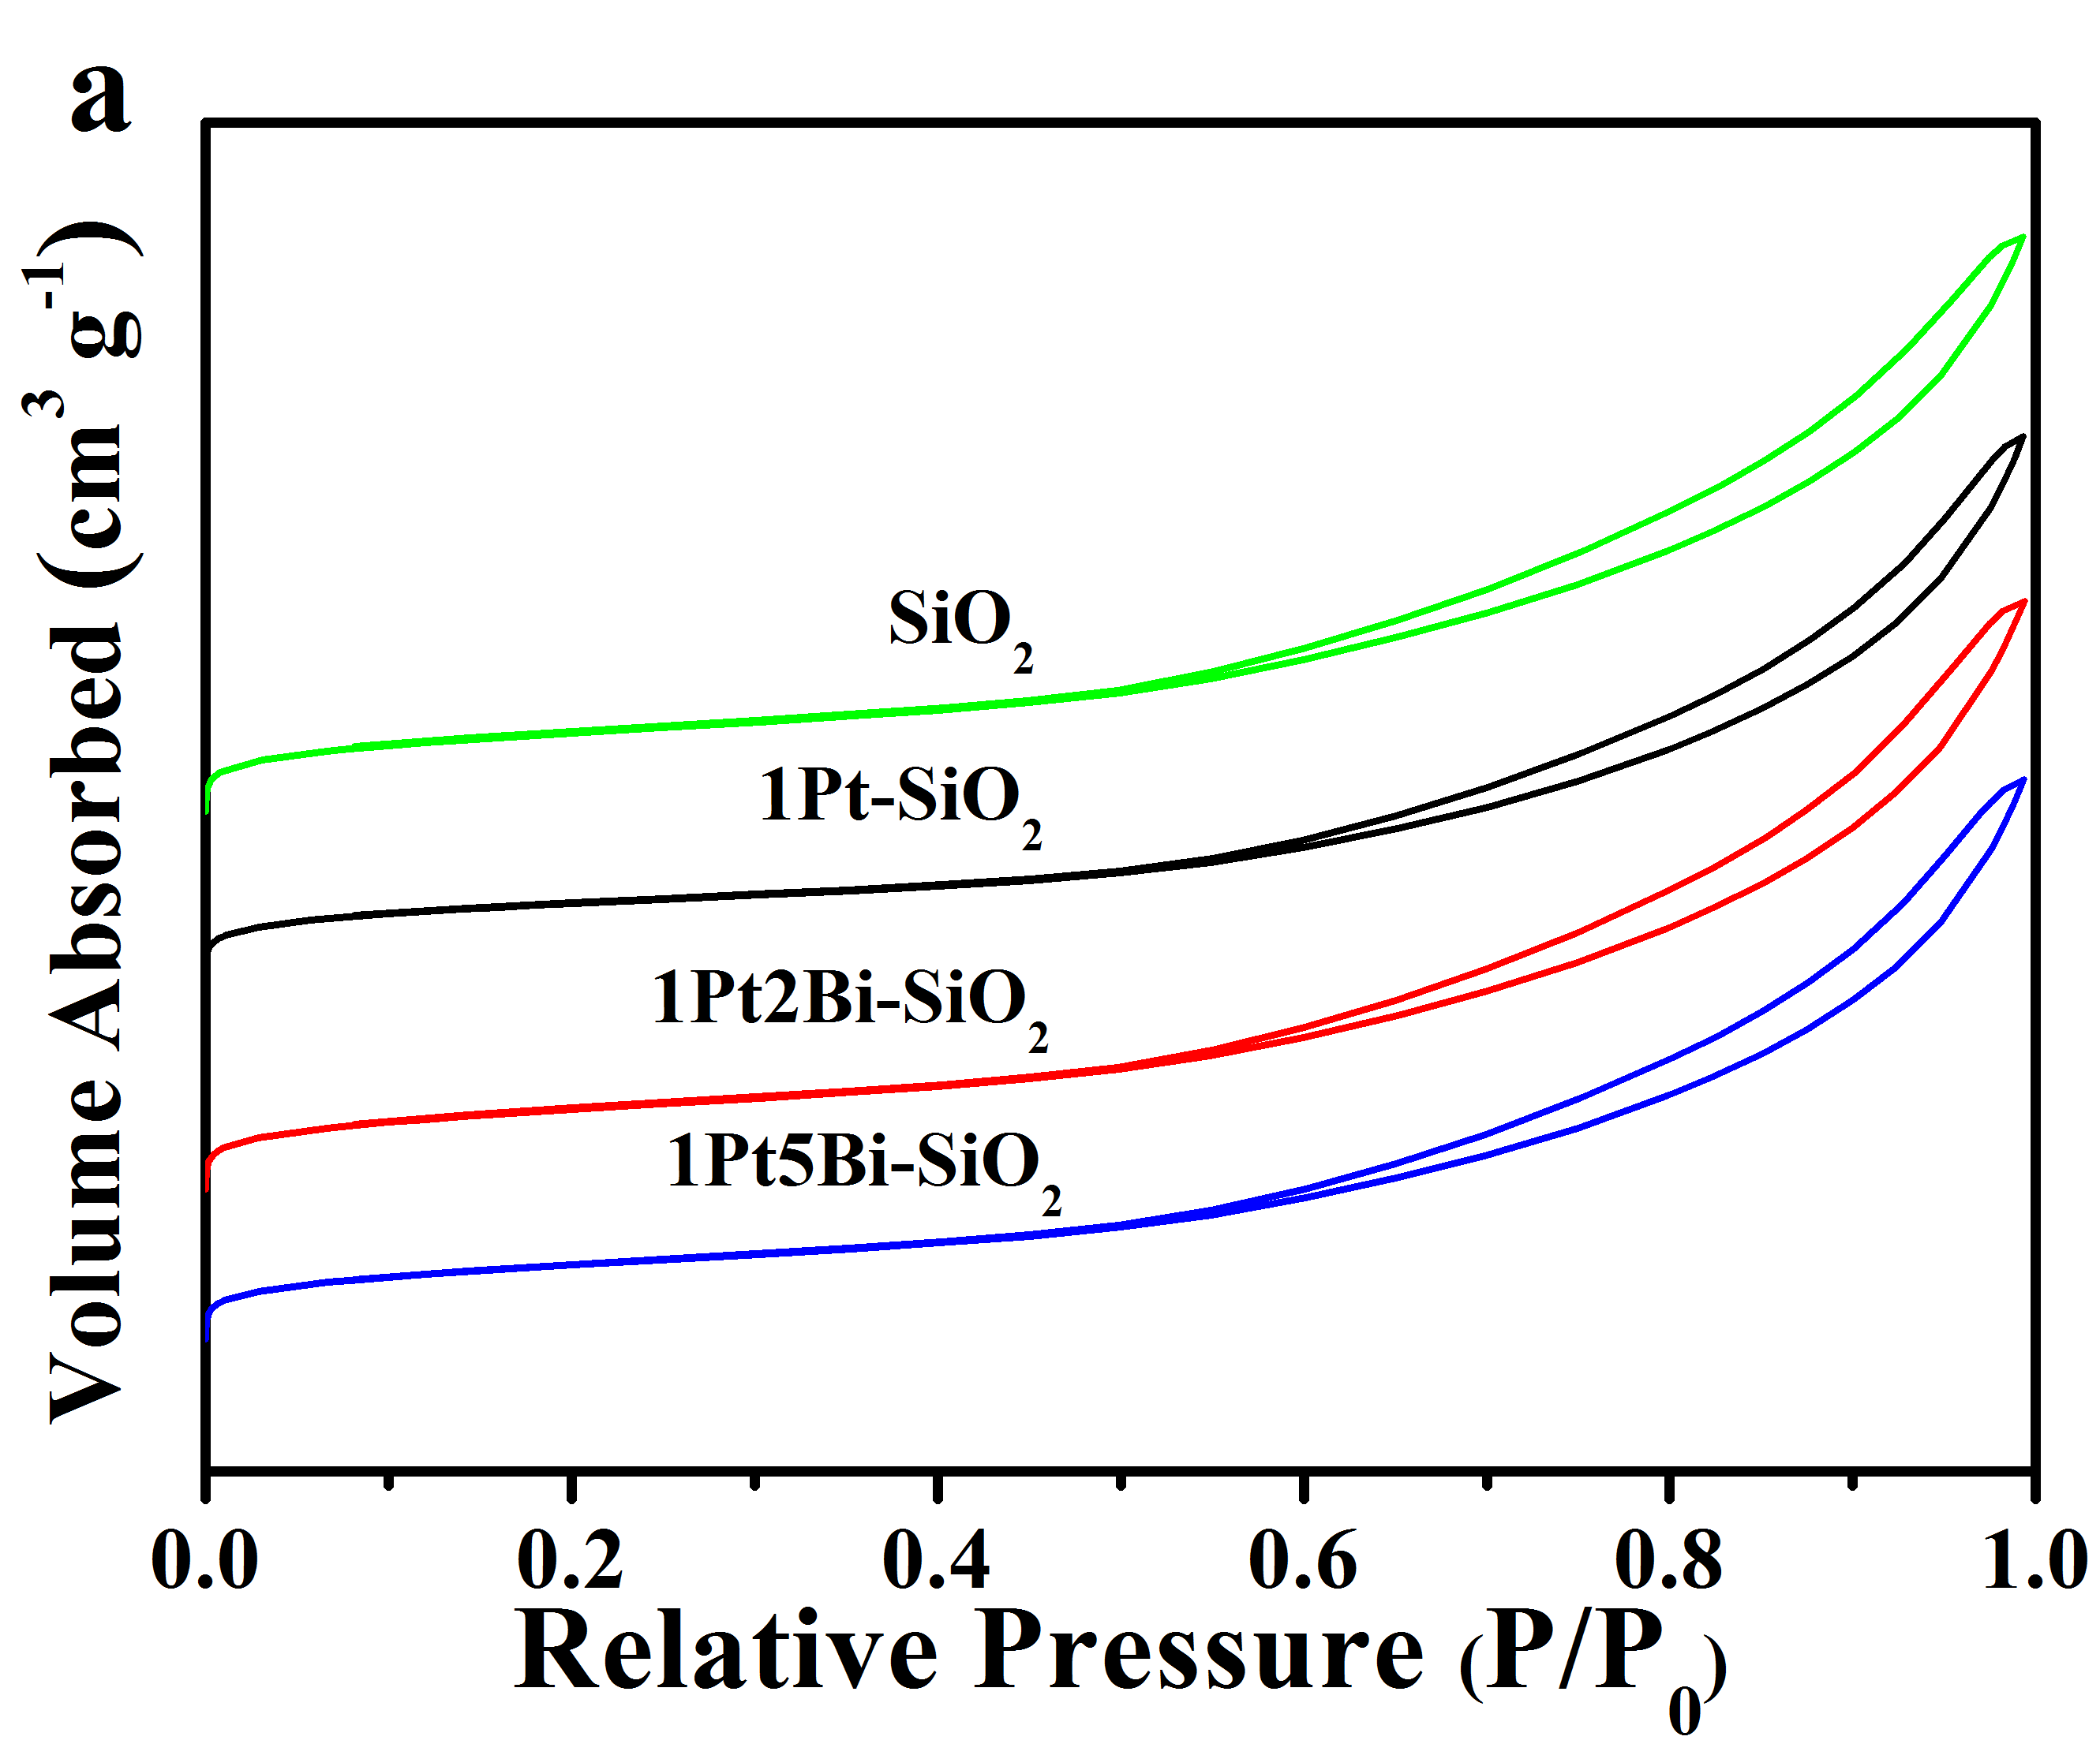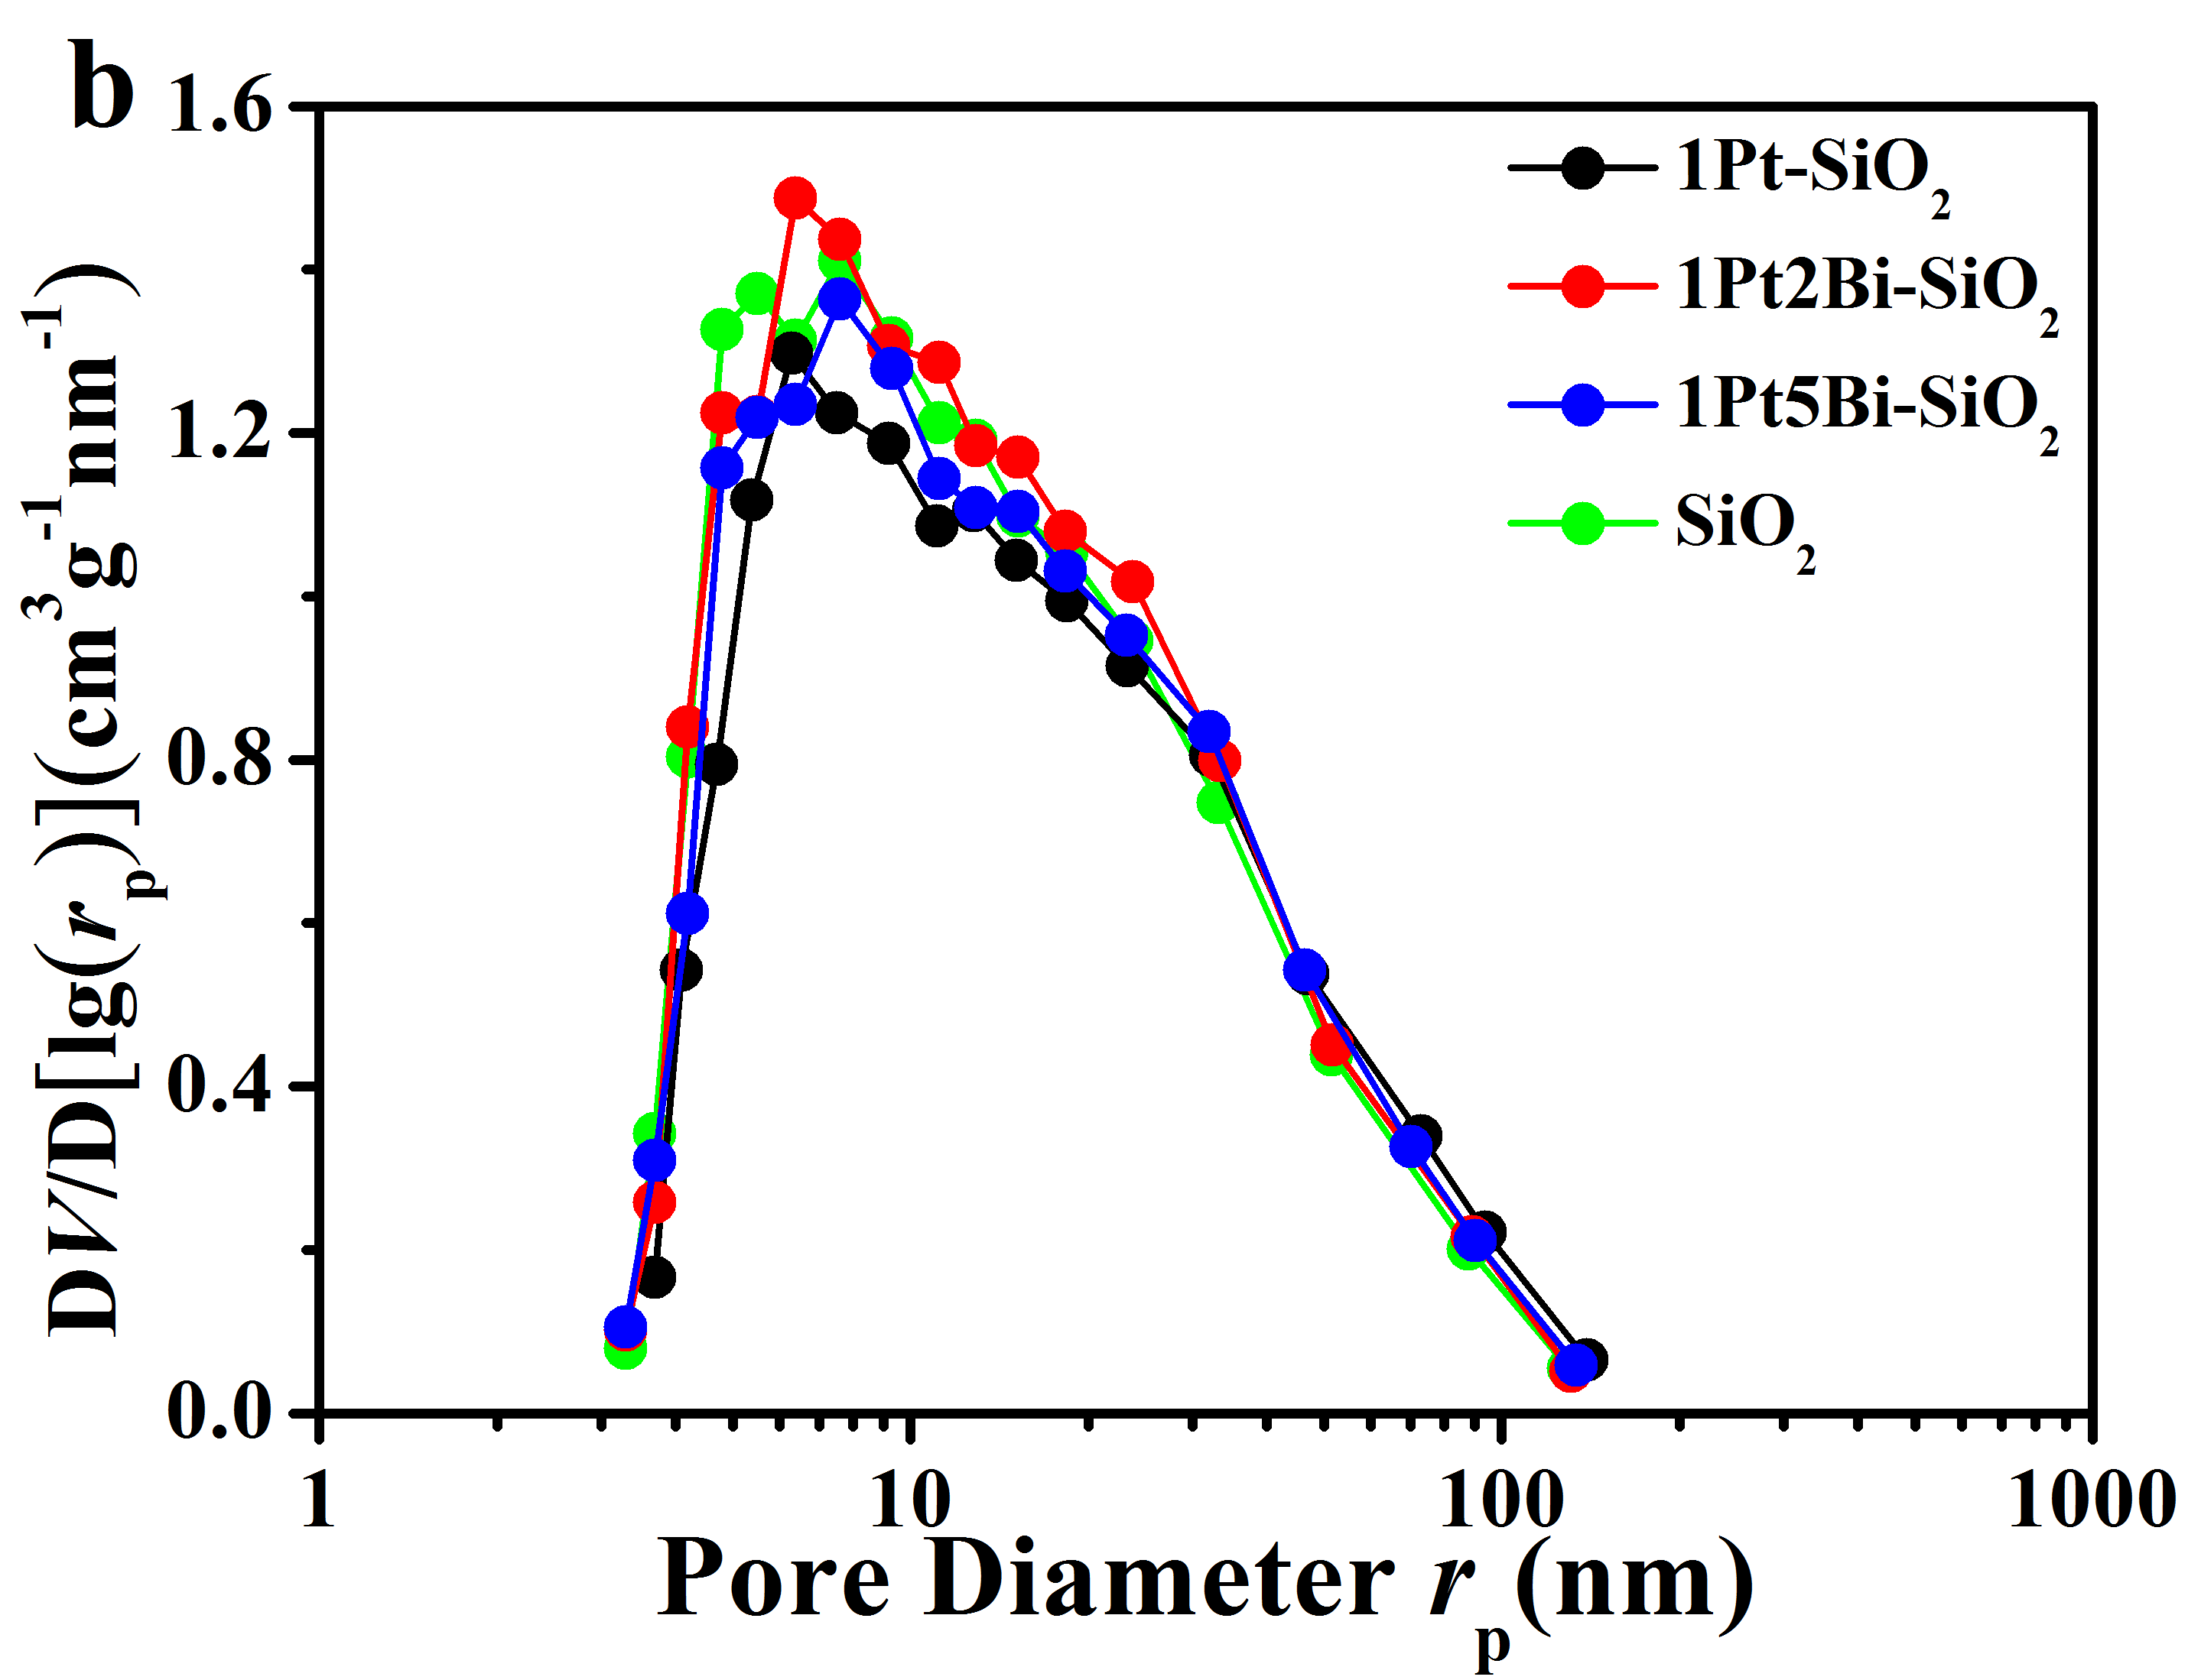
Supplementary Fig. 1 Nitrogen adsorption measurements of fresh Pt/PtBi-SiO₂ samples: (a) adsorption-desorption isotherm and (b) BJH pore size distribution.

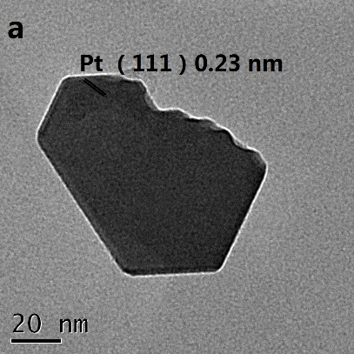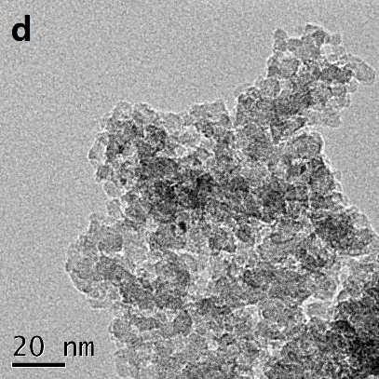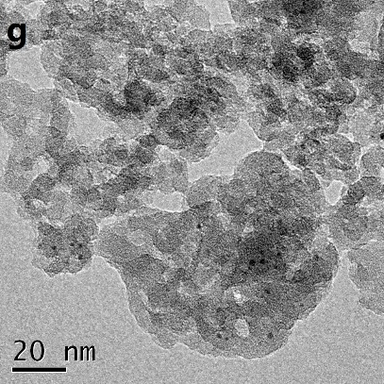
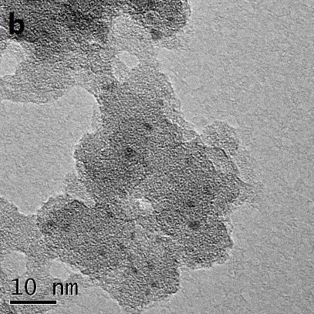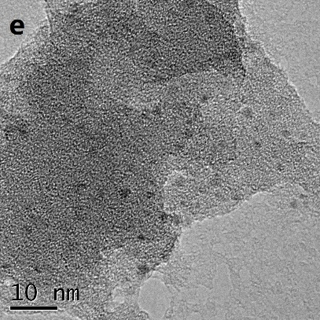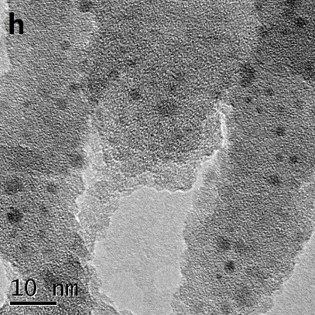
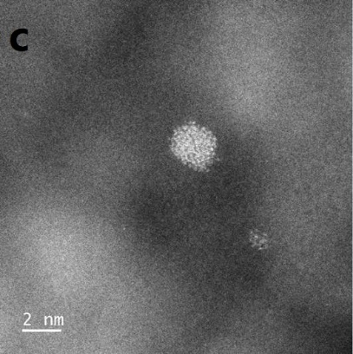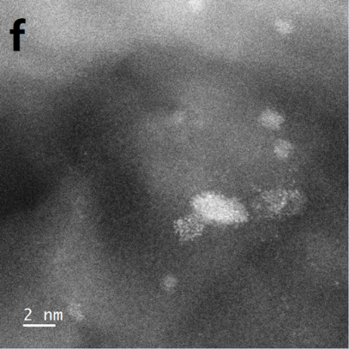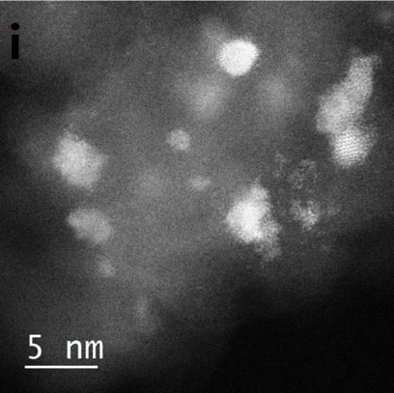
Supplementary Fig. 2 TEM (a,d,g), HRTEM (b,e,h) and aberration-corrected HAADF-STEM (c,f,i) images of fresh Pt/PtBi-SiO₂ samples: (a,b,c) 1Pt-SiO₂; (d,e,f) 1Pt2Bi-SiO₂; (g,h,i) 1Pt5Bi-SiO₂.

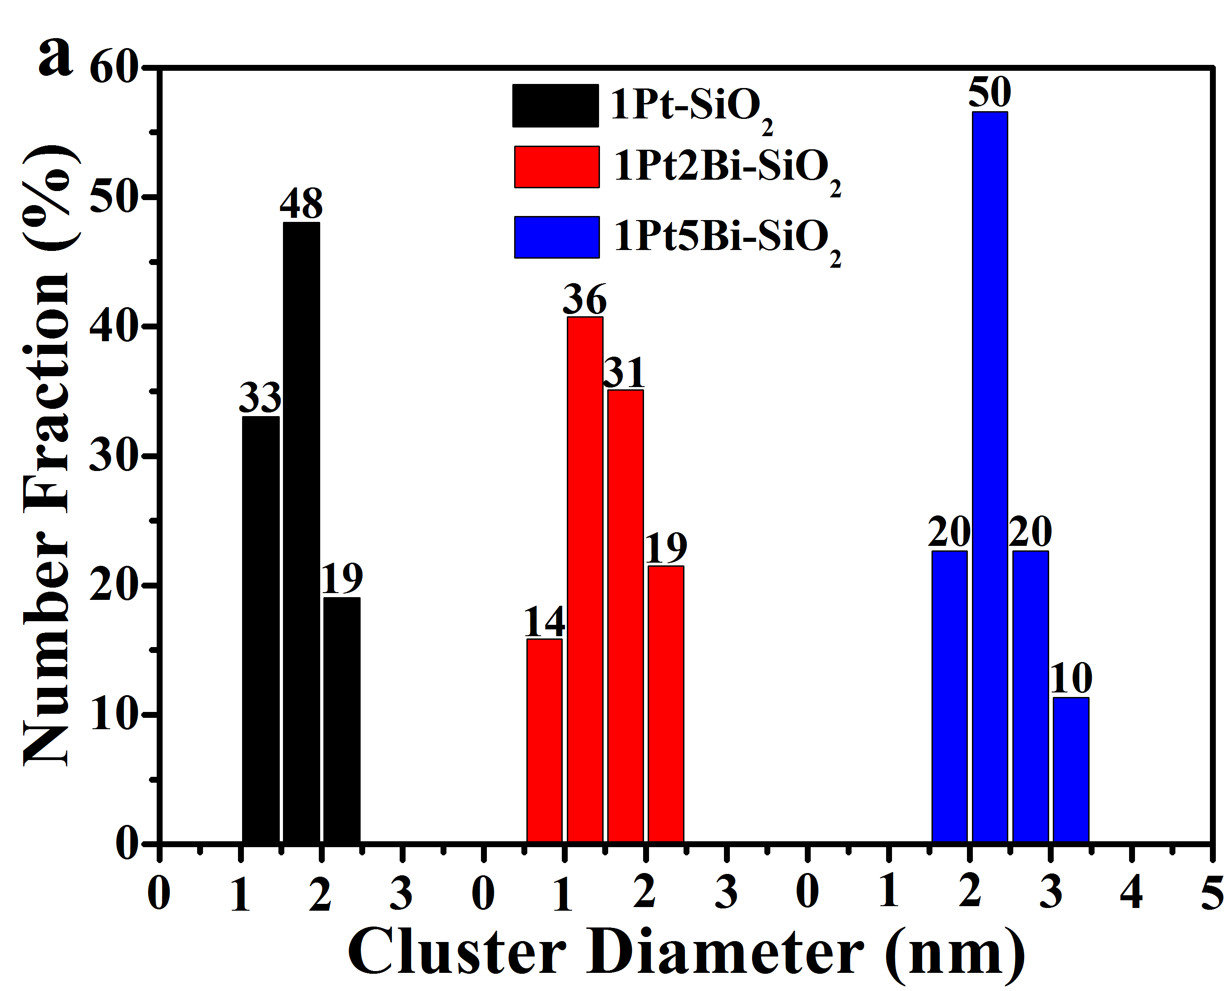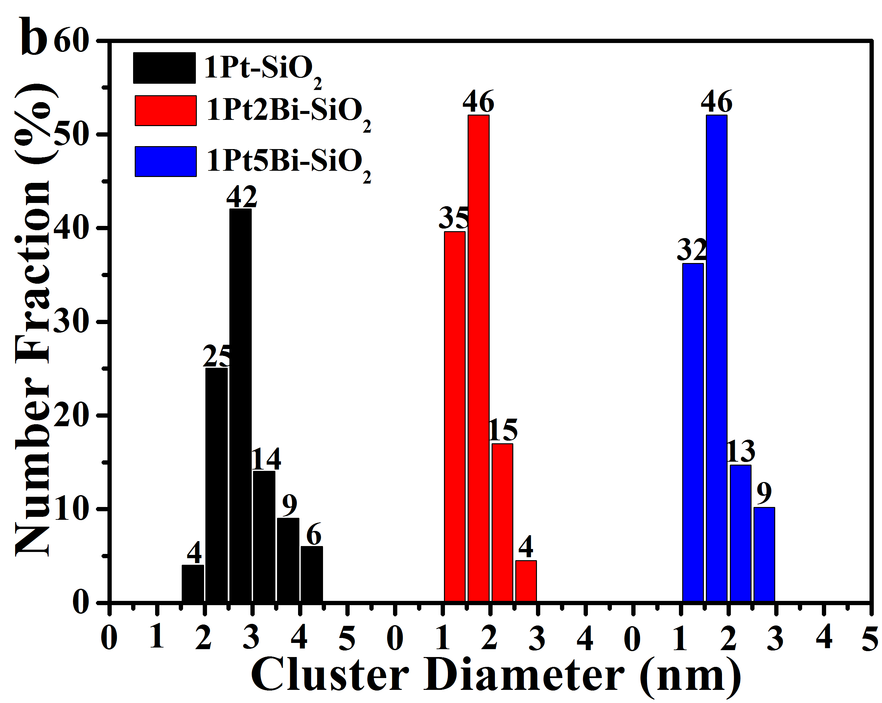
Supplementary Fig. 3. Diameter histograms on oxide cluster of fresh (a) and used (b) Pt/PtBi-SiO₂ samples on the basis of HAADF-STEM data.

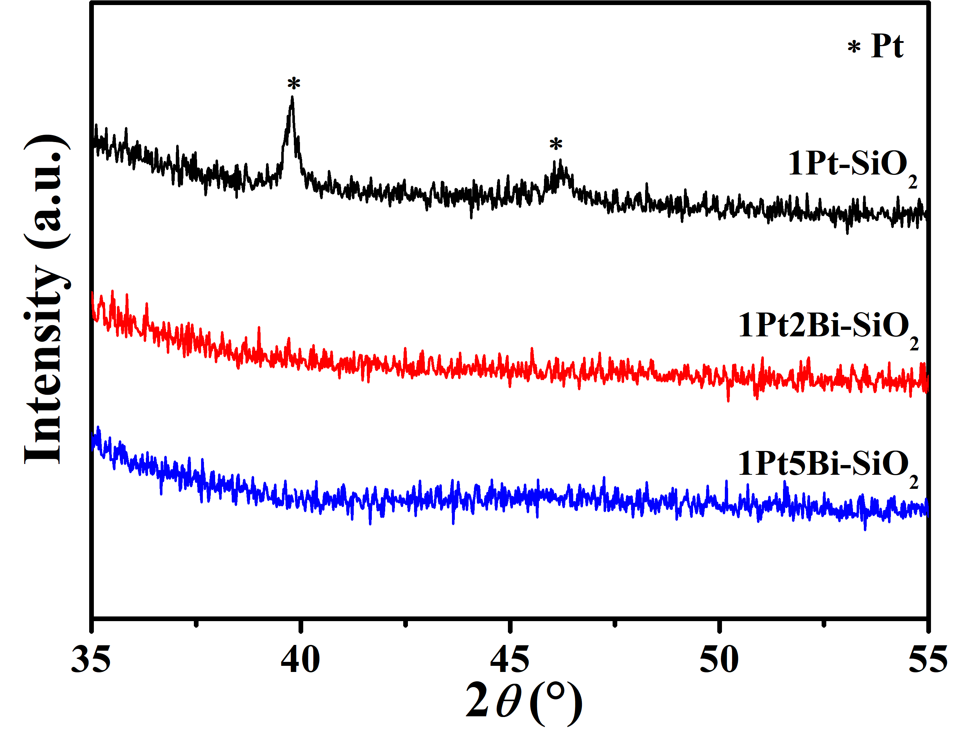
Supplementary Fig. 4 The XRD patterns of fresh Pt/PtBi-SiO₂ samples with a “slow-scan” mode (scanning rate of 1° min⁻¹) from 35 to 55°.

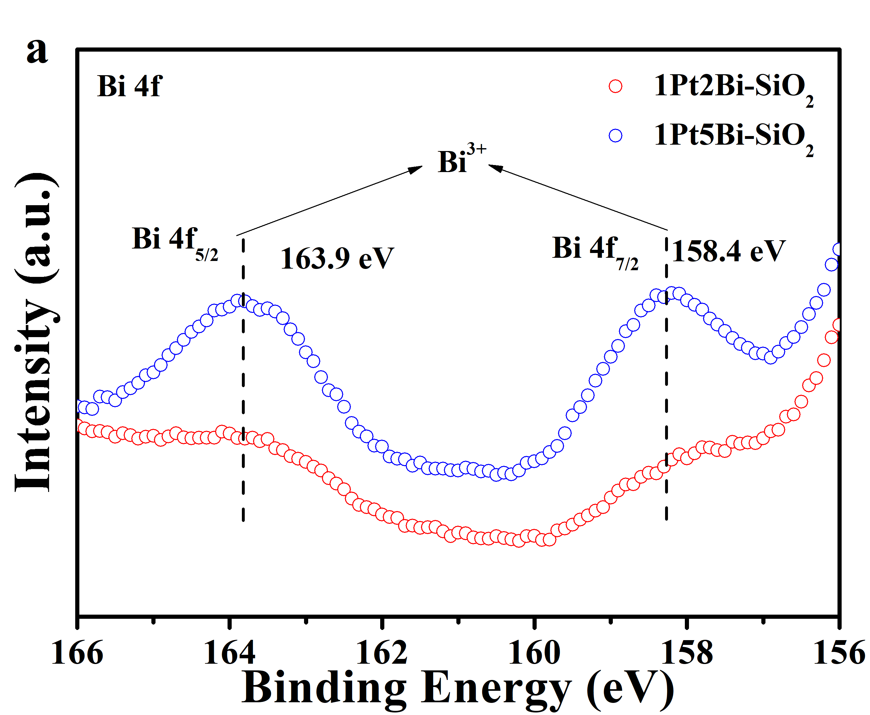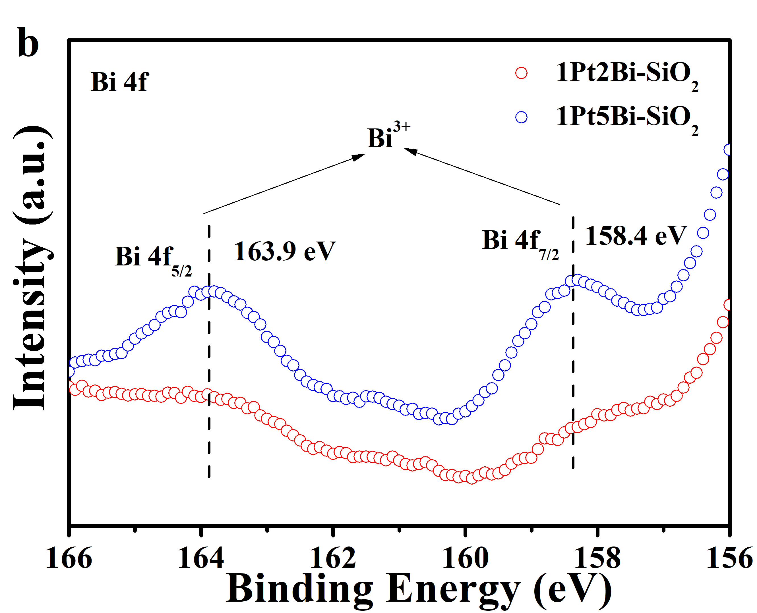
Supplementary Fig. 5 X-ray photoelectron spectroscopy profiles of PtBi-SiO₂ samples: (a) fresh; (b) used.

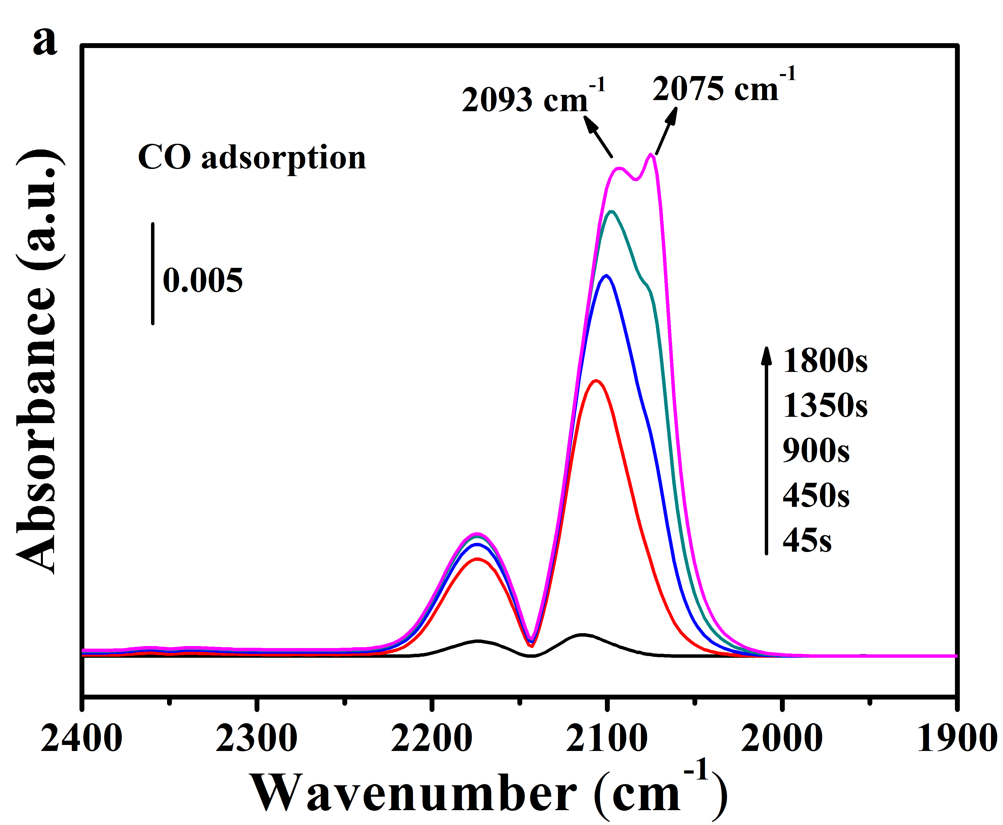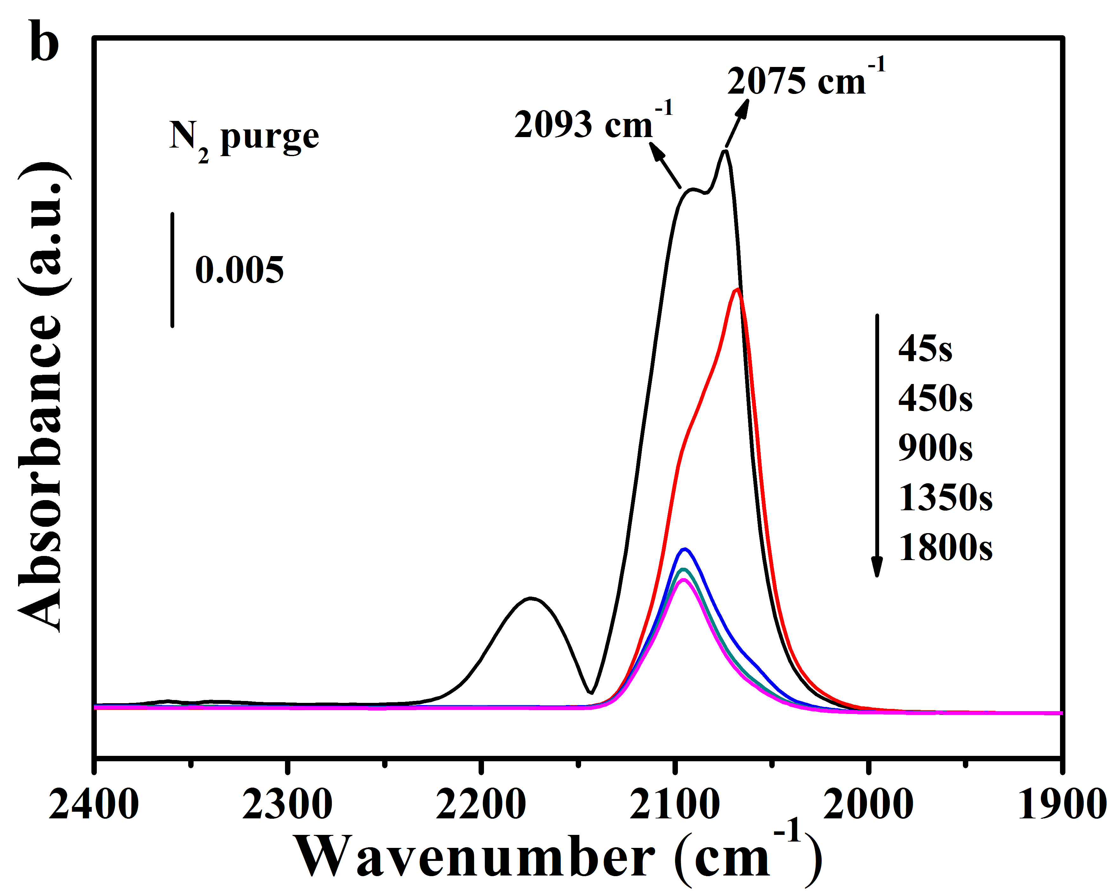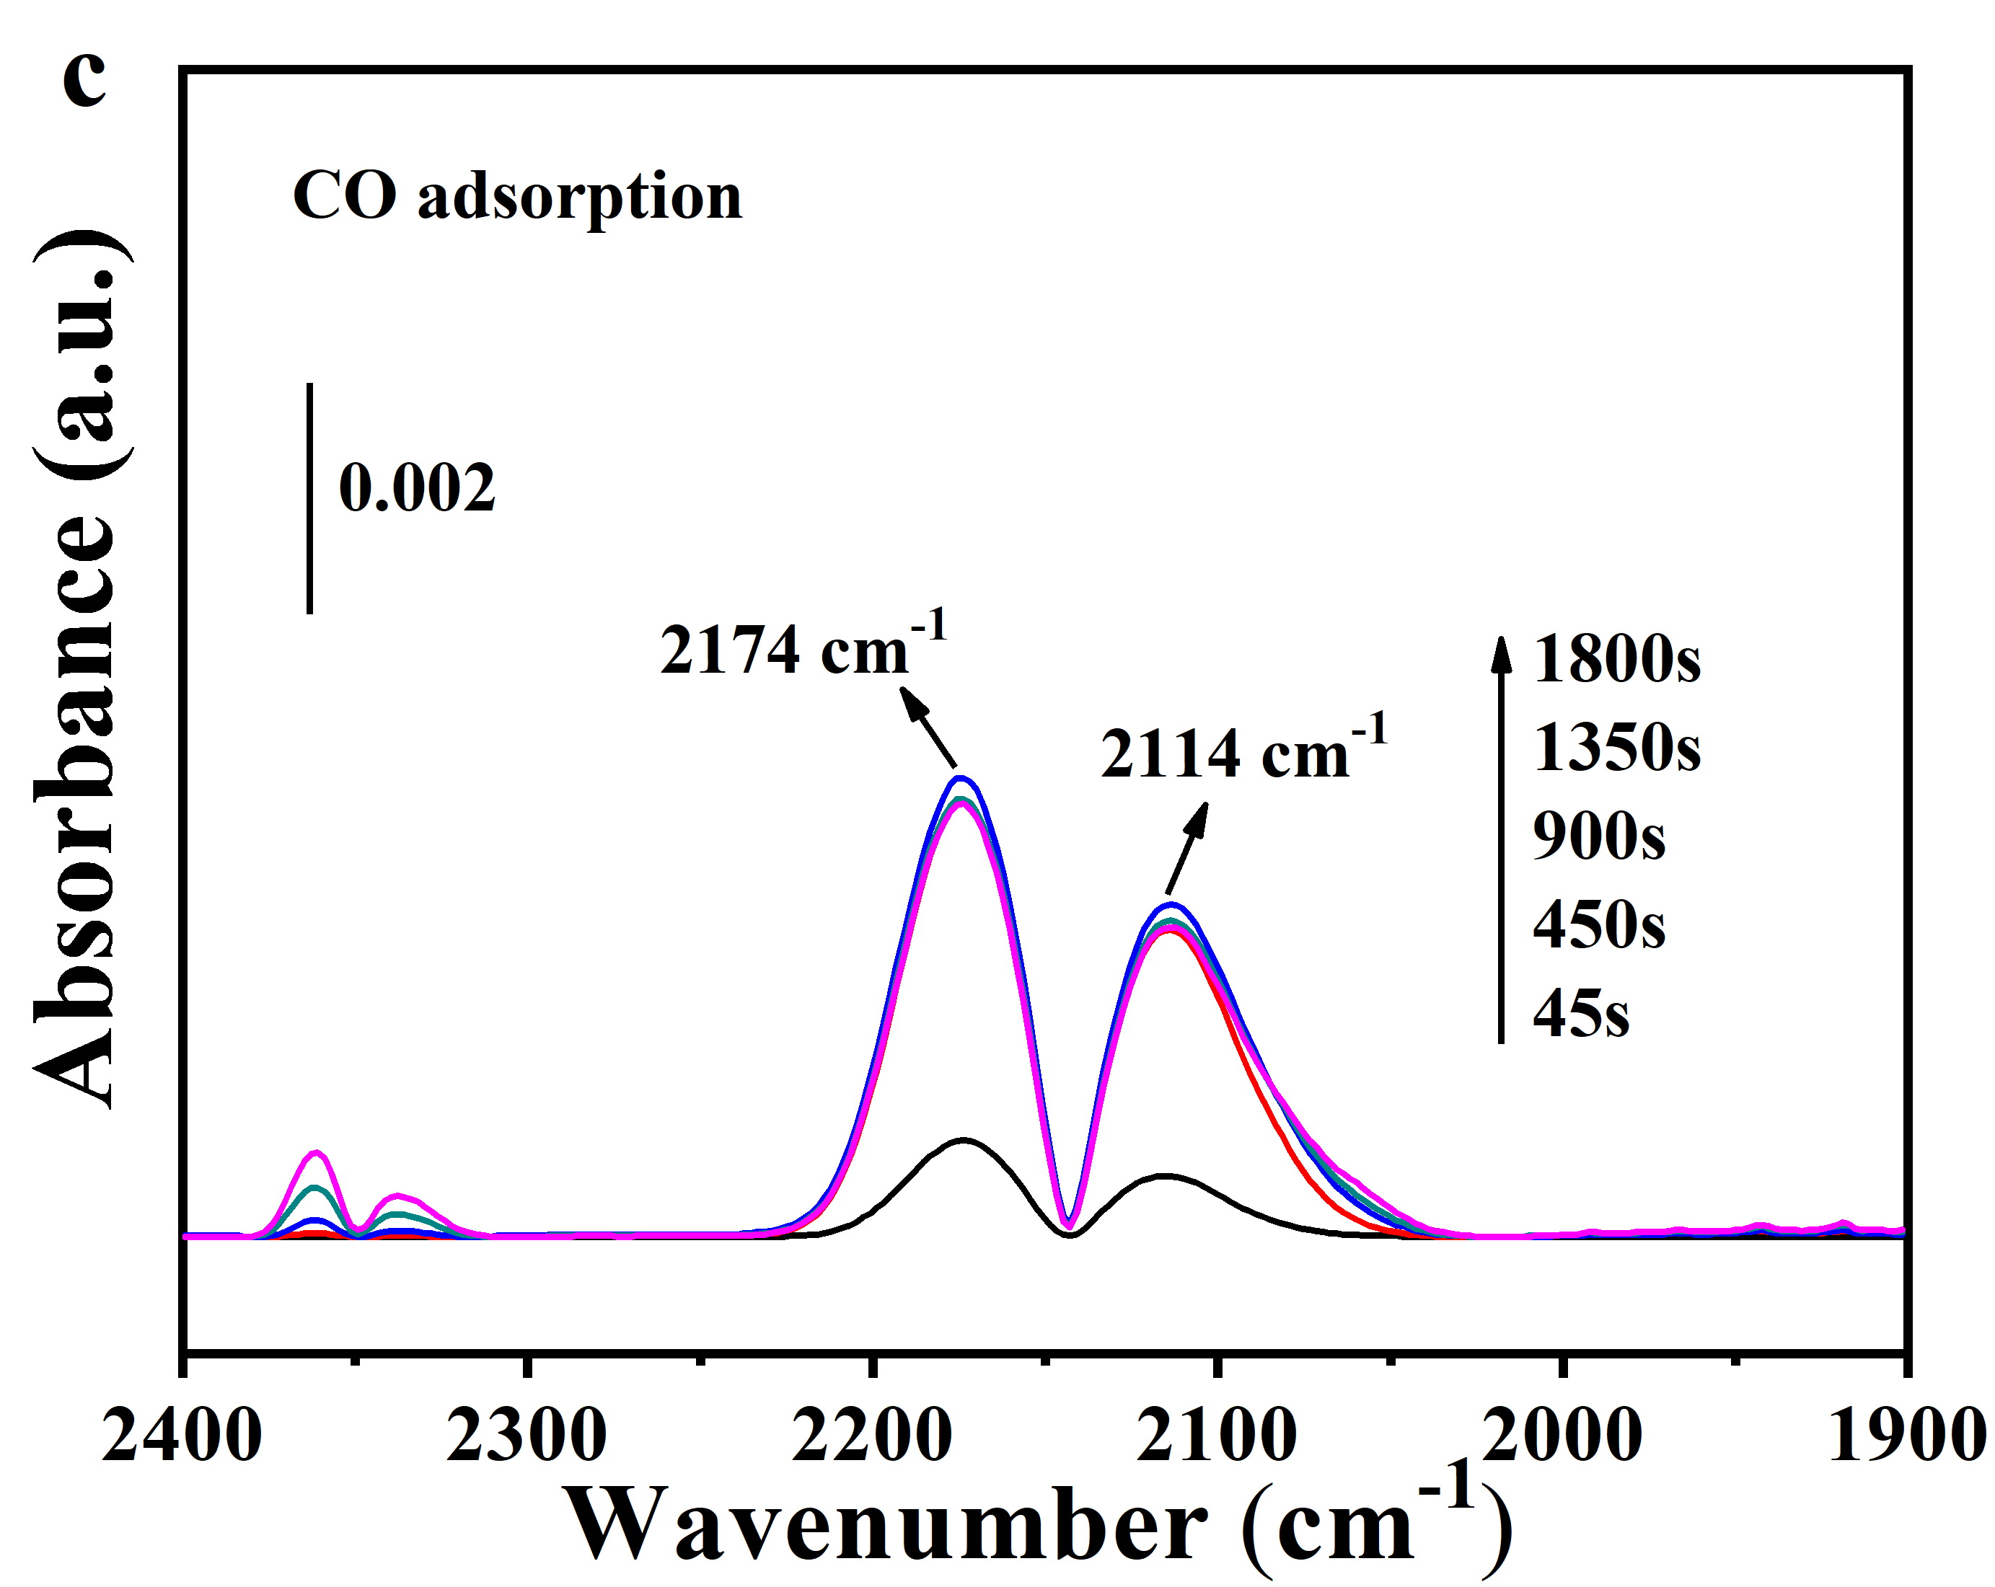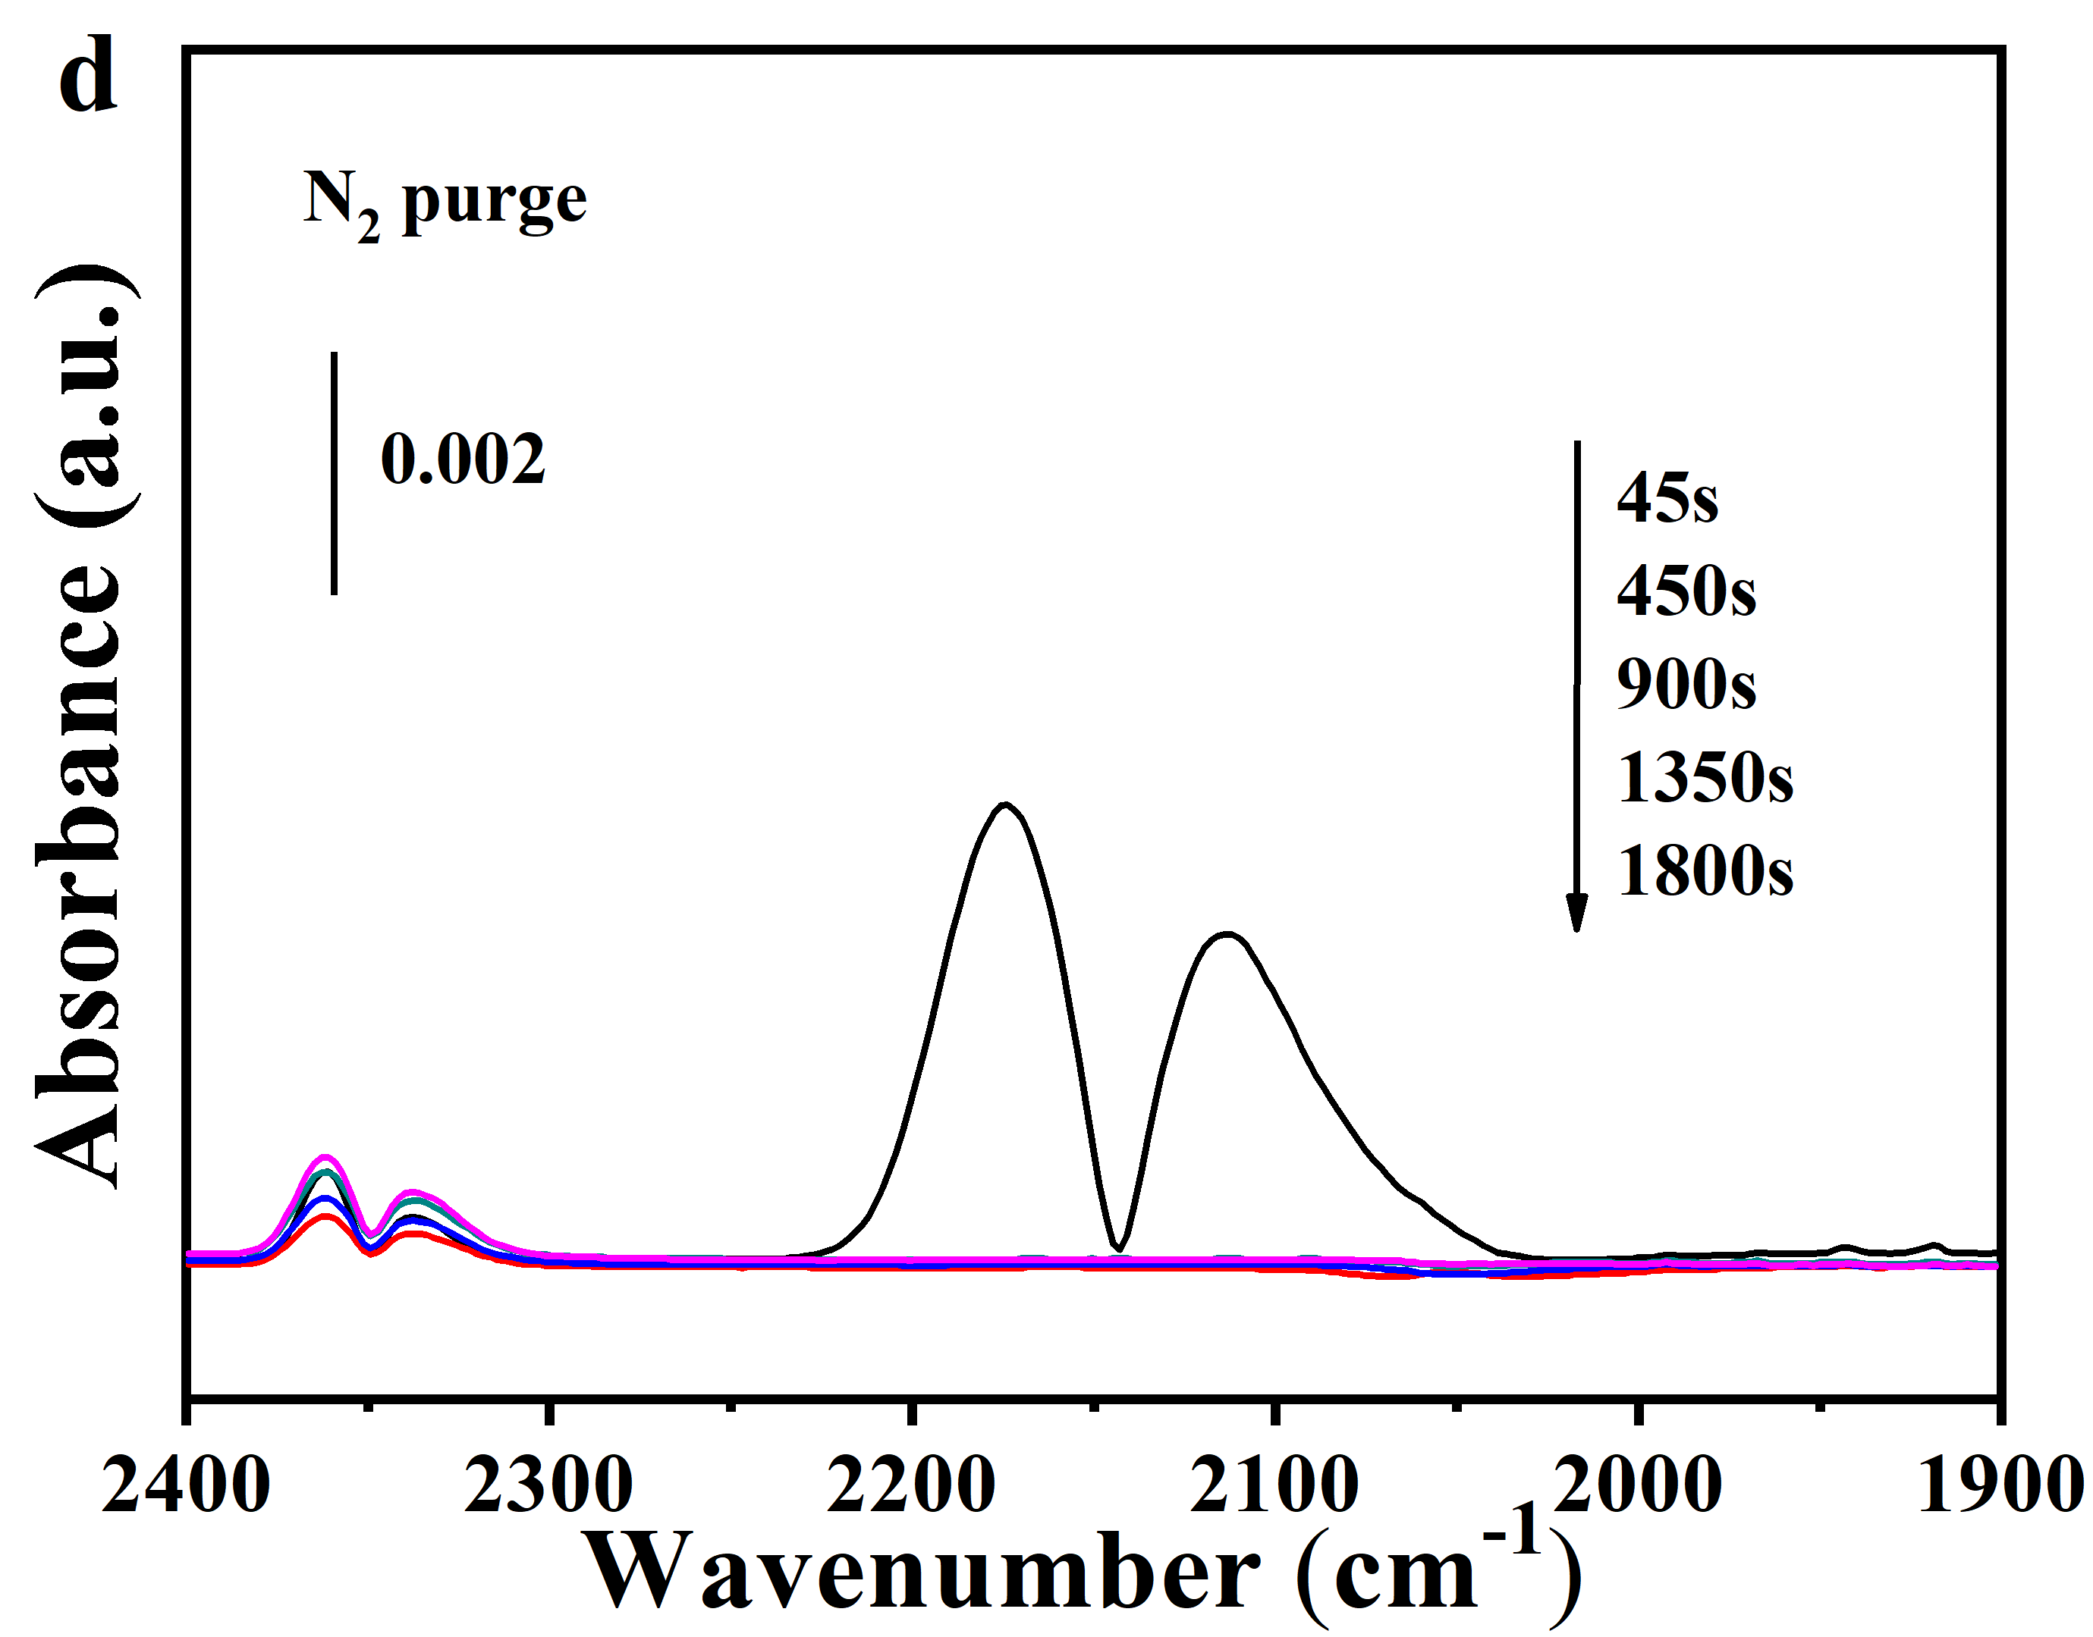
Supplementary Fig. 6 In-situ DRIFTS study of (a,c) CO adsorption, (b,d) N₂ purging on fresh 1Pt-SiO₂-400 (a,b) and 1Pt2Bi-SiO₂ (c,d). The catalysts were pretreated in situ at 300 °C under O₂ flow in the DRIFTS reaction cell before data collection (CO flow rate: 30 mL min⁻¹; catalyst mass: 20 mg; temperature: 100 °C)

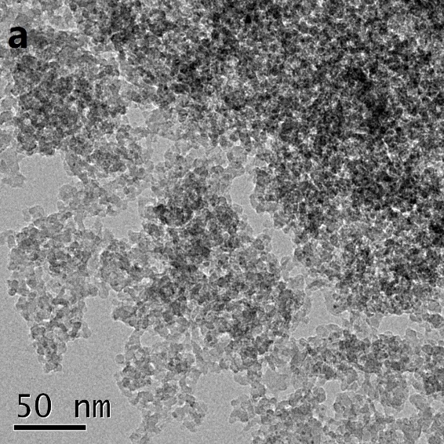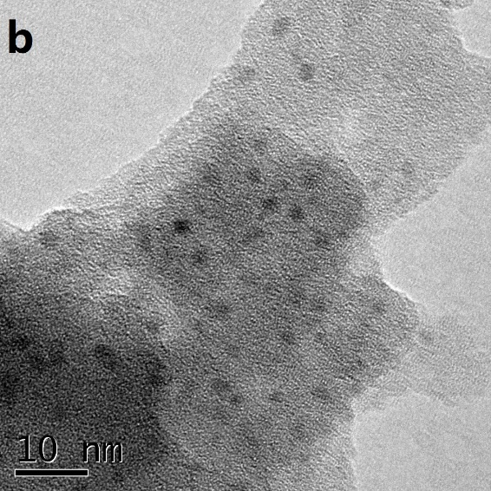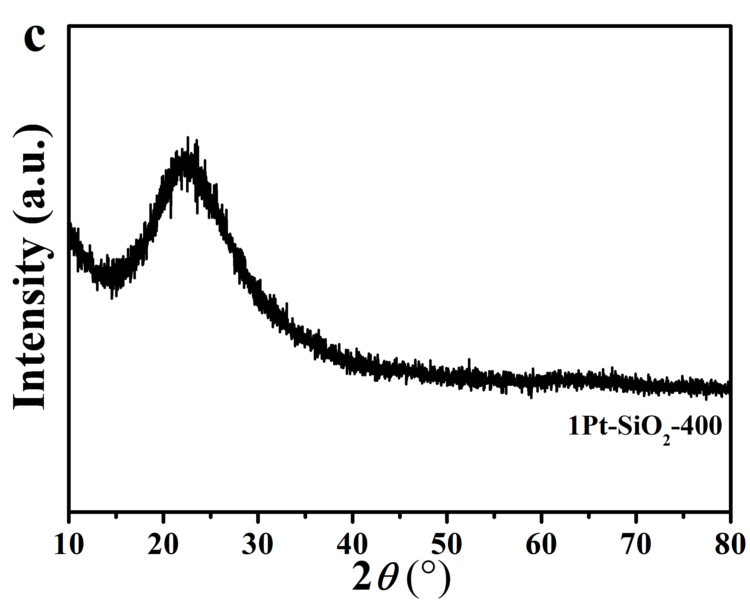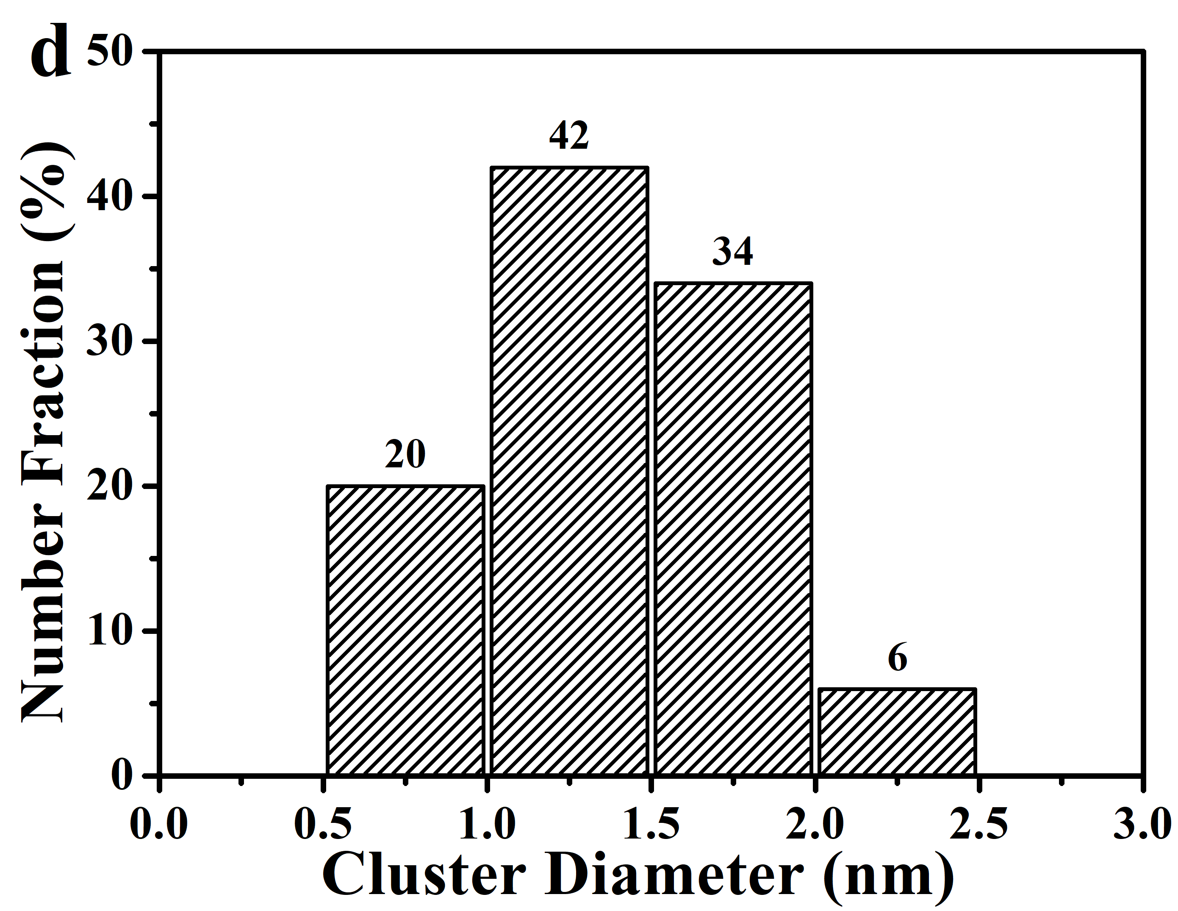
Supplementary Fig. 7 TEM/HRTEM (a,b) images; XRD profile (c) and diameter histograms on oxide clusters (d) for fresh 1Pt-SiO₂-400.

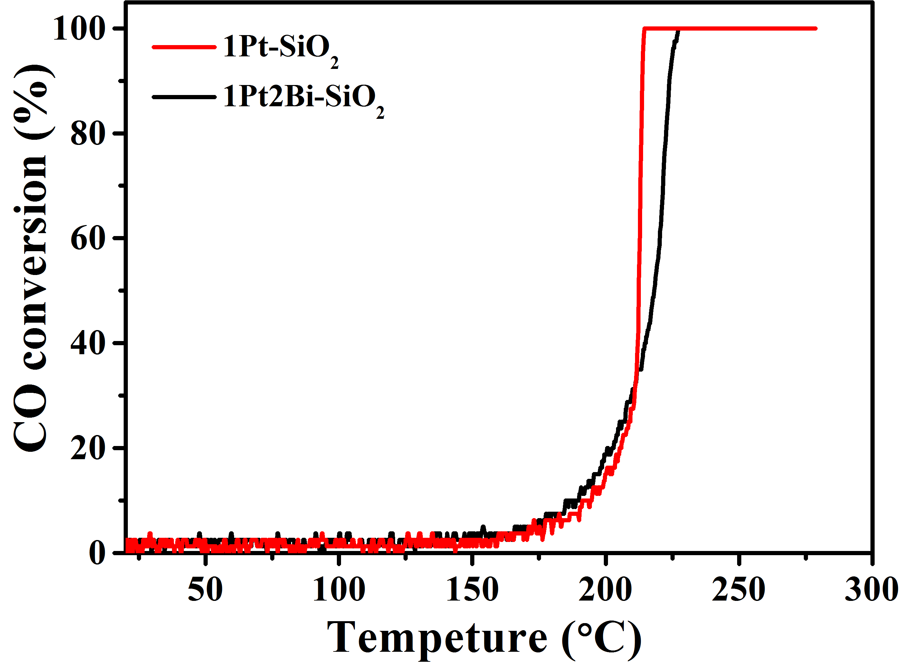
Supplementary Fig. 8 CO oxidation light-off experiments for Pt/PtBi-SiO₂ samples with pretreatment at 300 °C under air ( 1% CO/20% O₂/79% N₂, 134,000 mL g_{cat}⁻¹ h⁻¹).

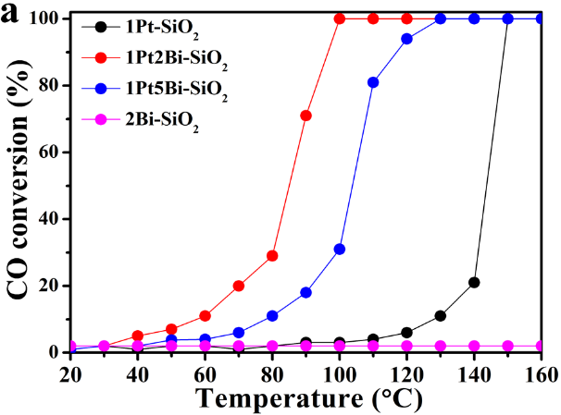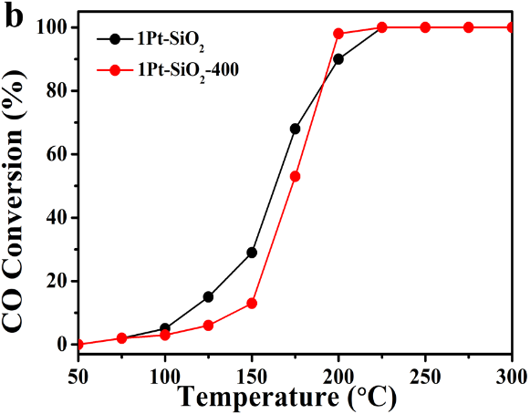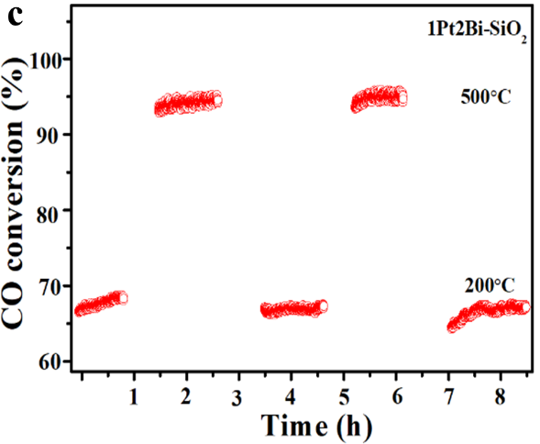
Supplementary Fig. 9 (a) the “light-off” experiments over Pt/PtBi-SiO₂ samples; (b) the catalytic performance of 1Pt-SiO₂ and 1Pt-SiO₂-400; and (c) the cyclic stability of the 1Pt2Bi-SiO₂ alternatingly tested at 500 and 200 °C (2% CO/1% O₂/He, 10 mg of catalyst, GHSV: 300, 000 mL·gcat⁻¹·h⁻¹)

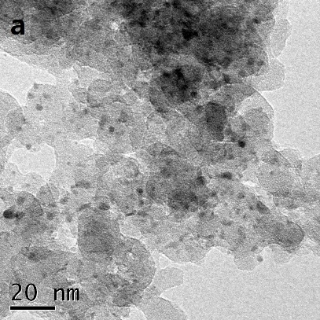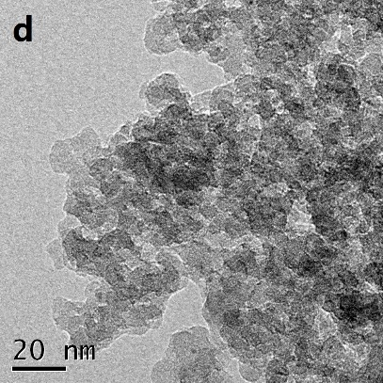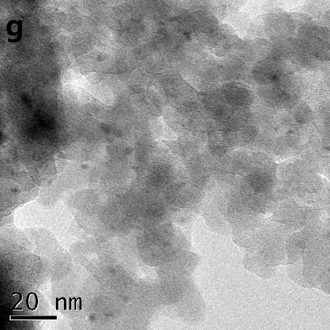
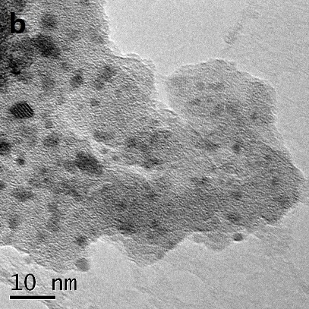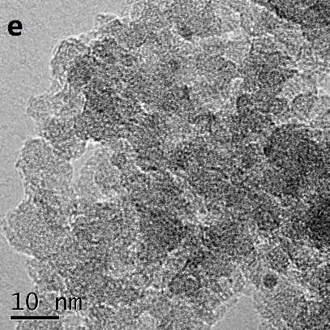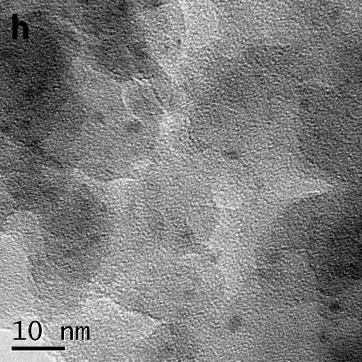
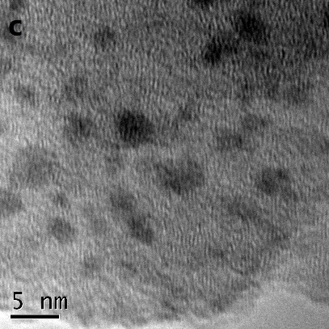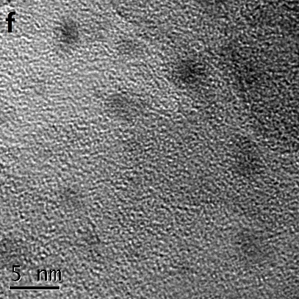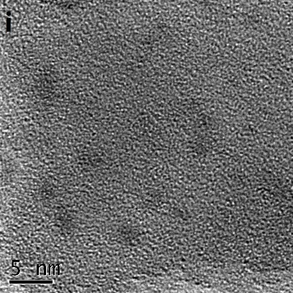
Supplementary Fig. 10 TEM and HRTEM images of used Pt/PtBi-SiO₂ samples: (a,b,c) 1Pt-SiO₂; (d,e,f) 1Pt2Bi-SiO₂; (g,h,i) 1Pt5Bi-SiO₂.

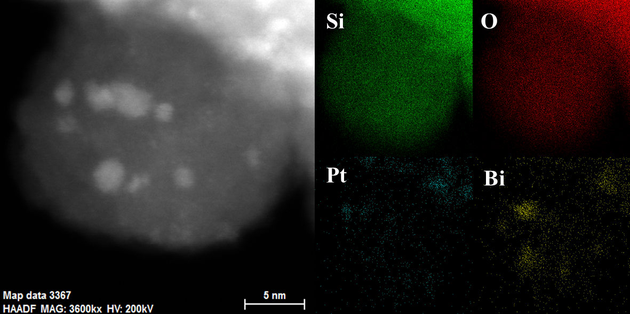
Supplementary Fig. 11 Representative aberration-corrected HAADF-STEM images (a,b,c) and STEM-EDS elemental mapping images (d) of used 1Pt2Bi-SiO₂.

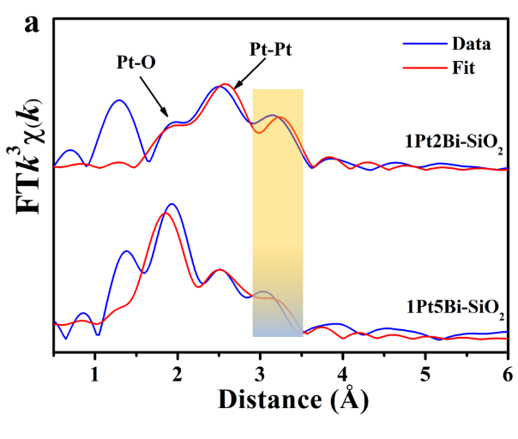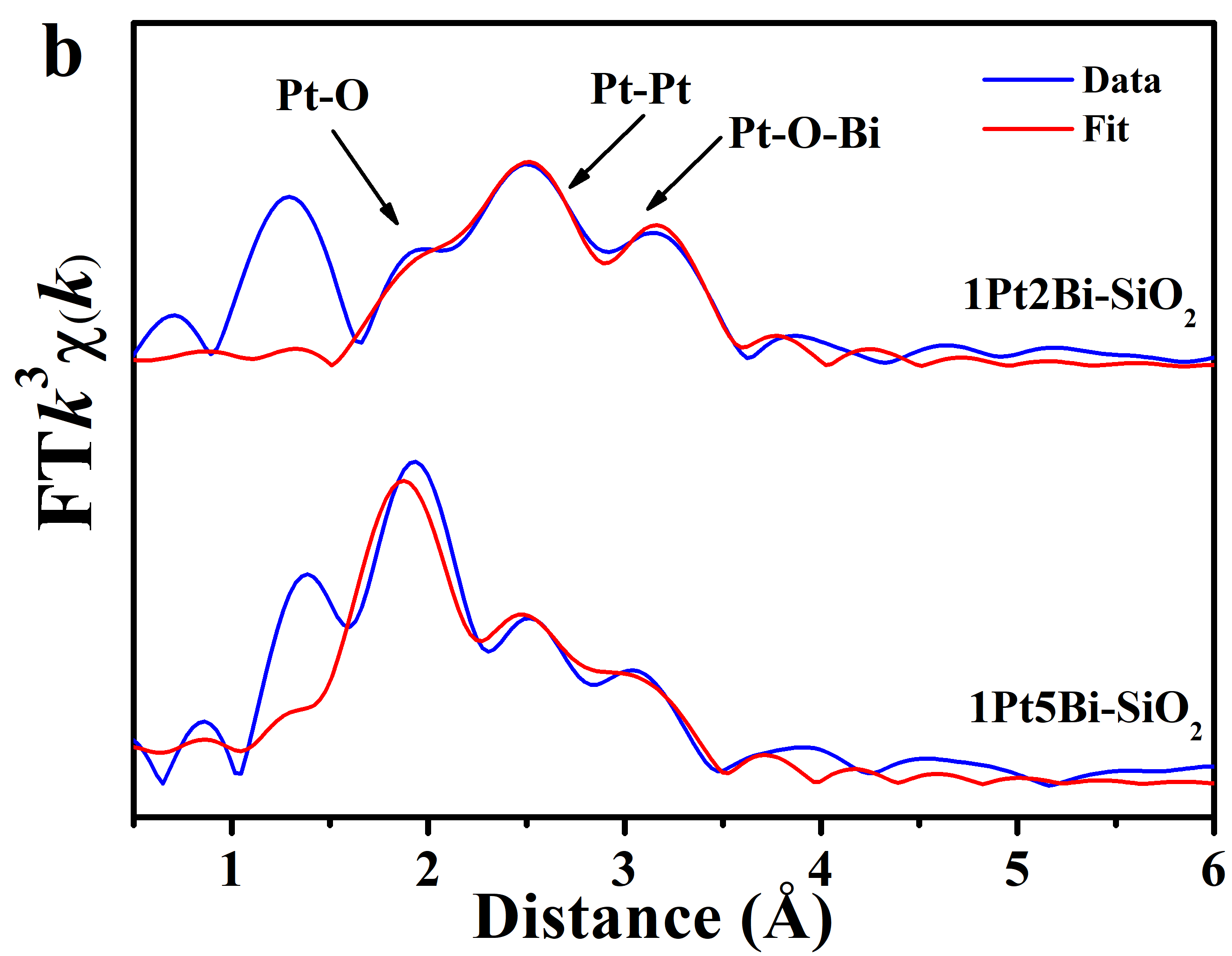
Supplementary Fig. 12 The EXAFS fitting results in R space of PtBi-SiO₂ samples after hydrogen reduction at 210 °C for 30 mins without air exposure until finishing XAFS experiments: (a) only Pt−O and metallic Pt−Pt shells and (b) Pt−O, metallic Pt−Pt and Pt−O−Bi shells for EXAFS fitting.
We have conducted the XAFS tests for Bi-doped samples after hydrogen reduction at 210 °C without air exposure, well consistent with the pretreatment condition before CO oxidation “light off” experiment to detect structural evolution of active site. Firstly, we supposed that the hydrogen reduction destroyed Pt−[O]_{x}−Bi structure completely with metallic Pt−Pt shell (small-size metallic Pt clusters or particles) plus a minor Pt−O shell. However, the fitting results with only Pt−Pt and Pt−O shells in Supplementary Fig. 12a were not well consistent with EXAFS data, especially in ~3.0 Å lacking a specific shell. Therefore, we appended an additional Pt−O−Bi shell for Bi-promoted samples, in which the fitting curves could match EXAFS data pretty well. It indicated that after hydrogen reduction the active site was composed of metallic Pt phase plus Pt−[O]_{x}−Bi structure.

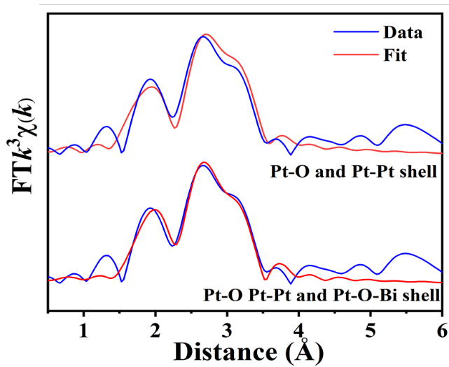
Supplementary Fig. 13 The comparison of different shells over EXAFS fitting results in R space for 1Pt2Bi-SiO₂.
In order to require more reliable local structure for used Bi-promoted samples, we firstly conducted the EXAFS fitting process with Pt−O and metallic Pt−Pt shells. Although we can obtain the relatively reasonable coordination number and bond distance for Pt−O and metallic Pt−Pt shells, the fitting curves were not consistent with EXAFS profiles very well, especially in 3.0−3.5 Å. After addition of Pt−O−Bi shell, we can acquire the most suitable EXAFS fitting results in Supplementary Fig. 13.

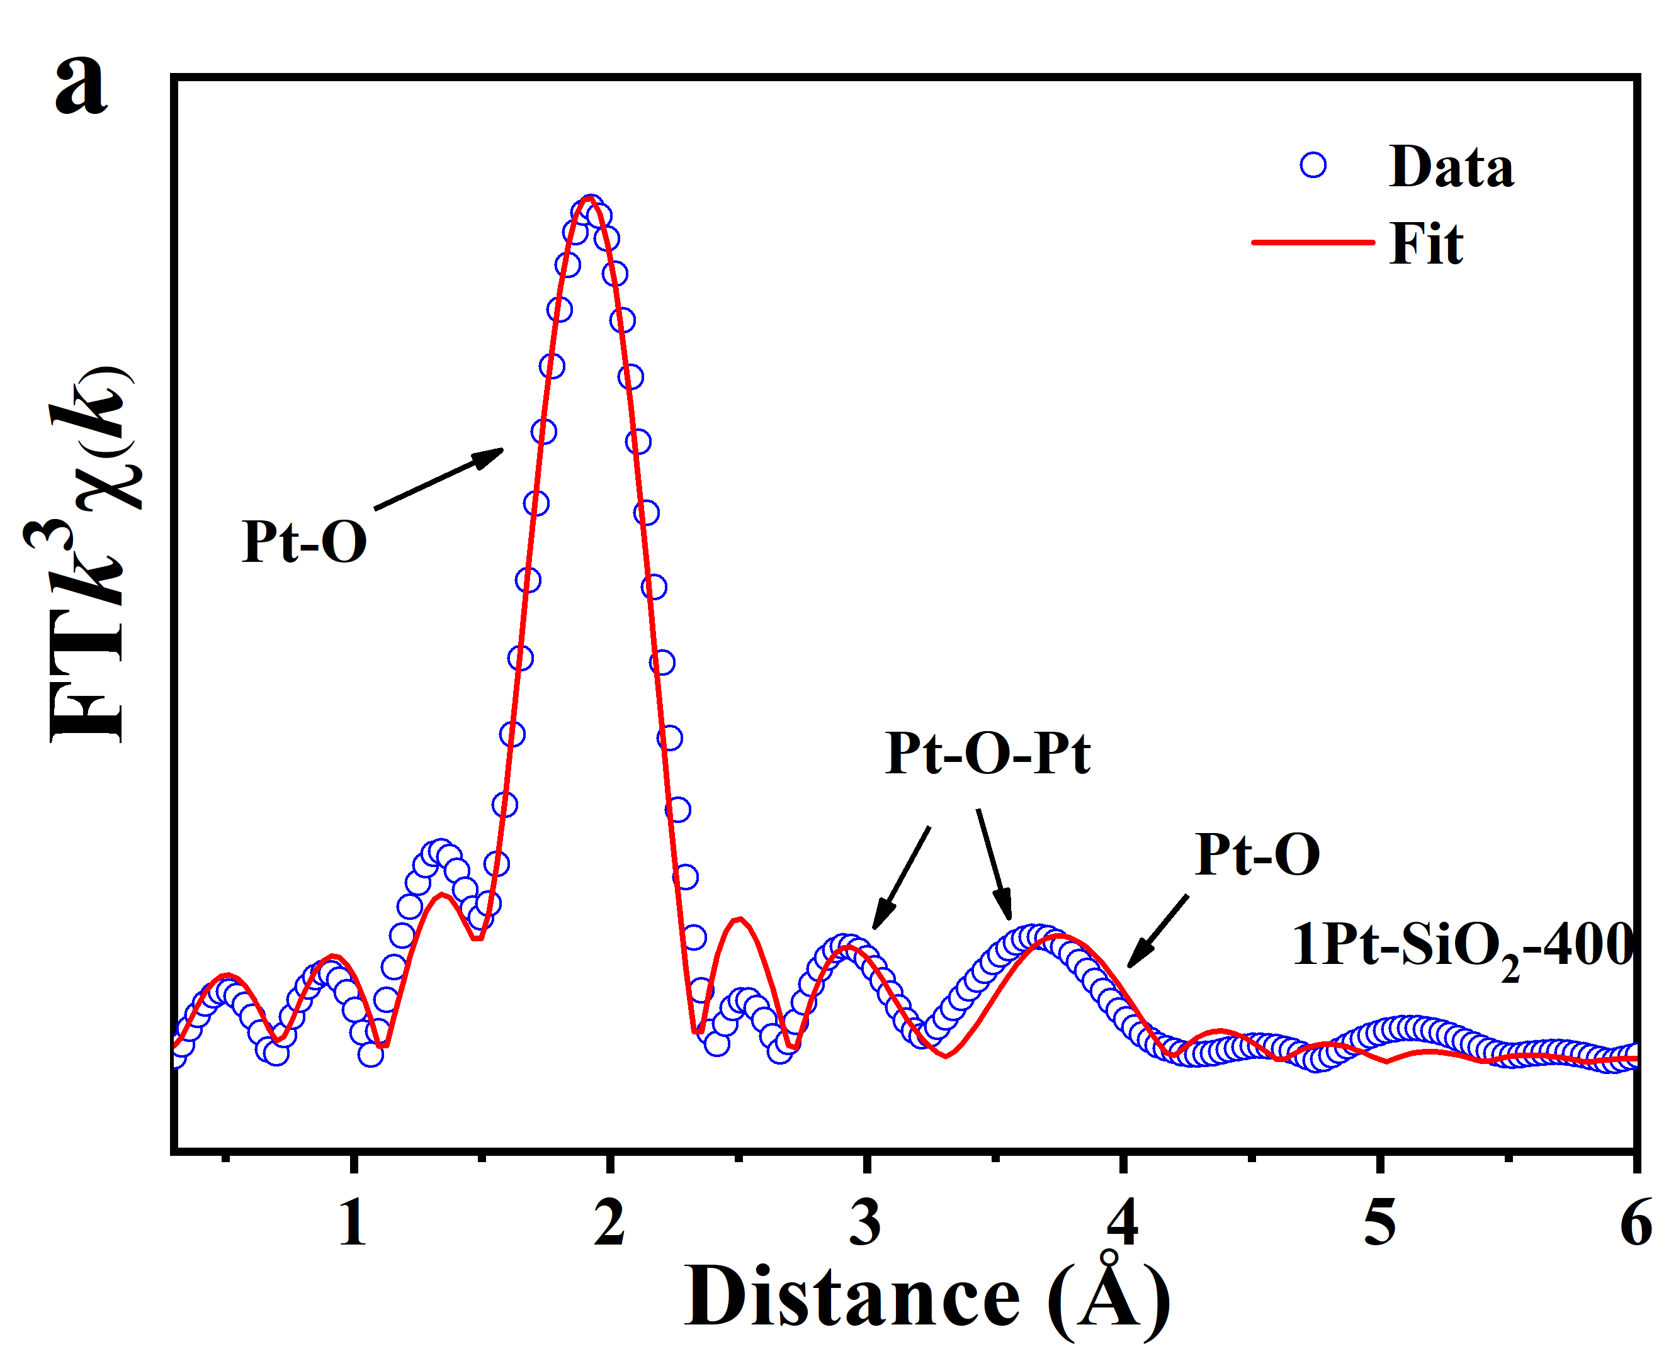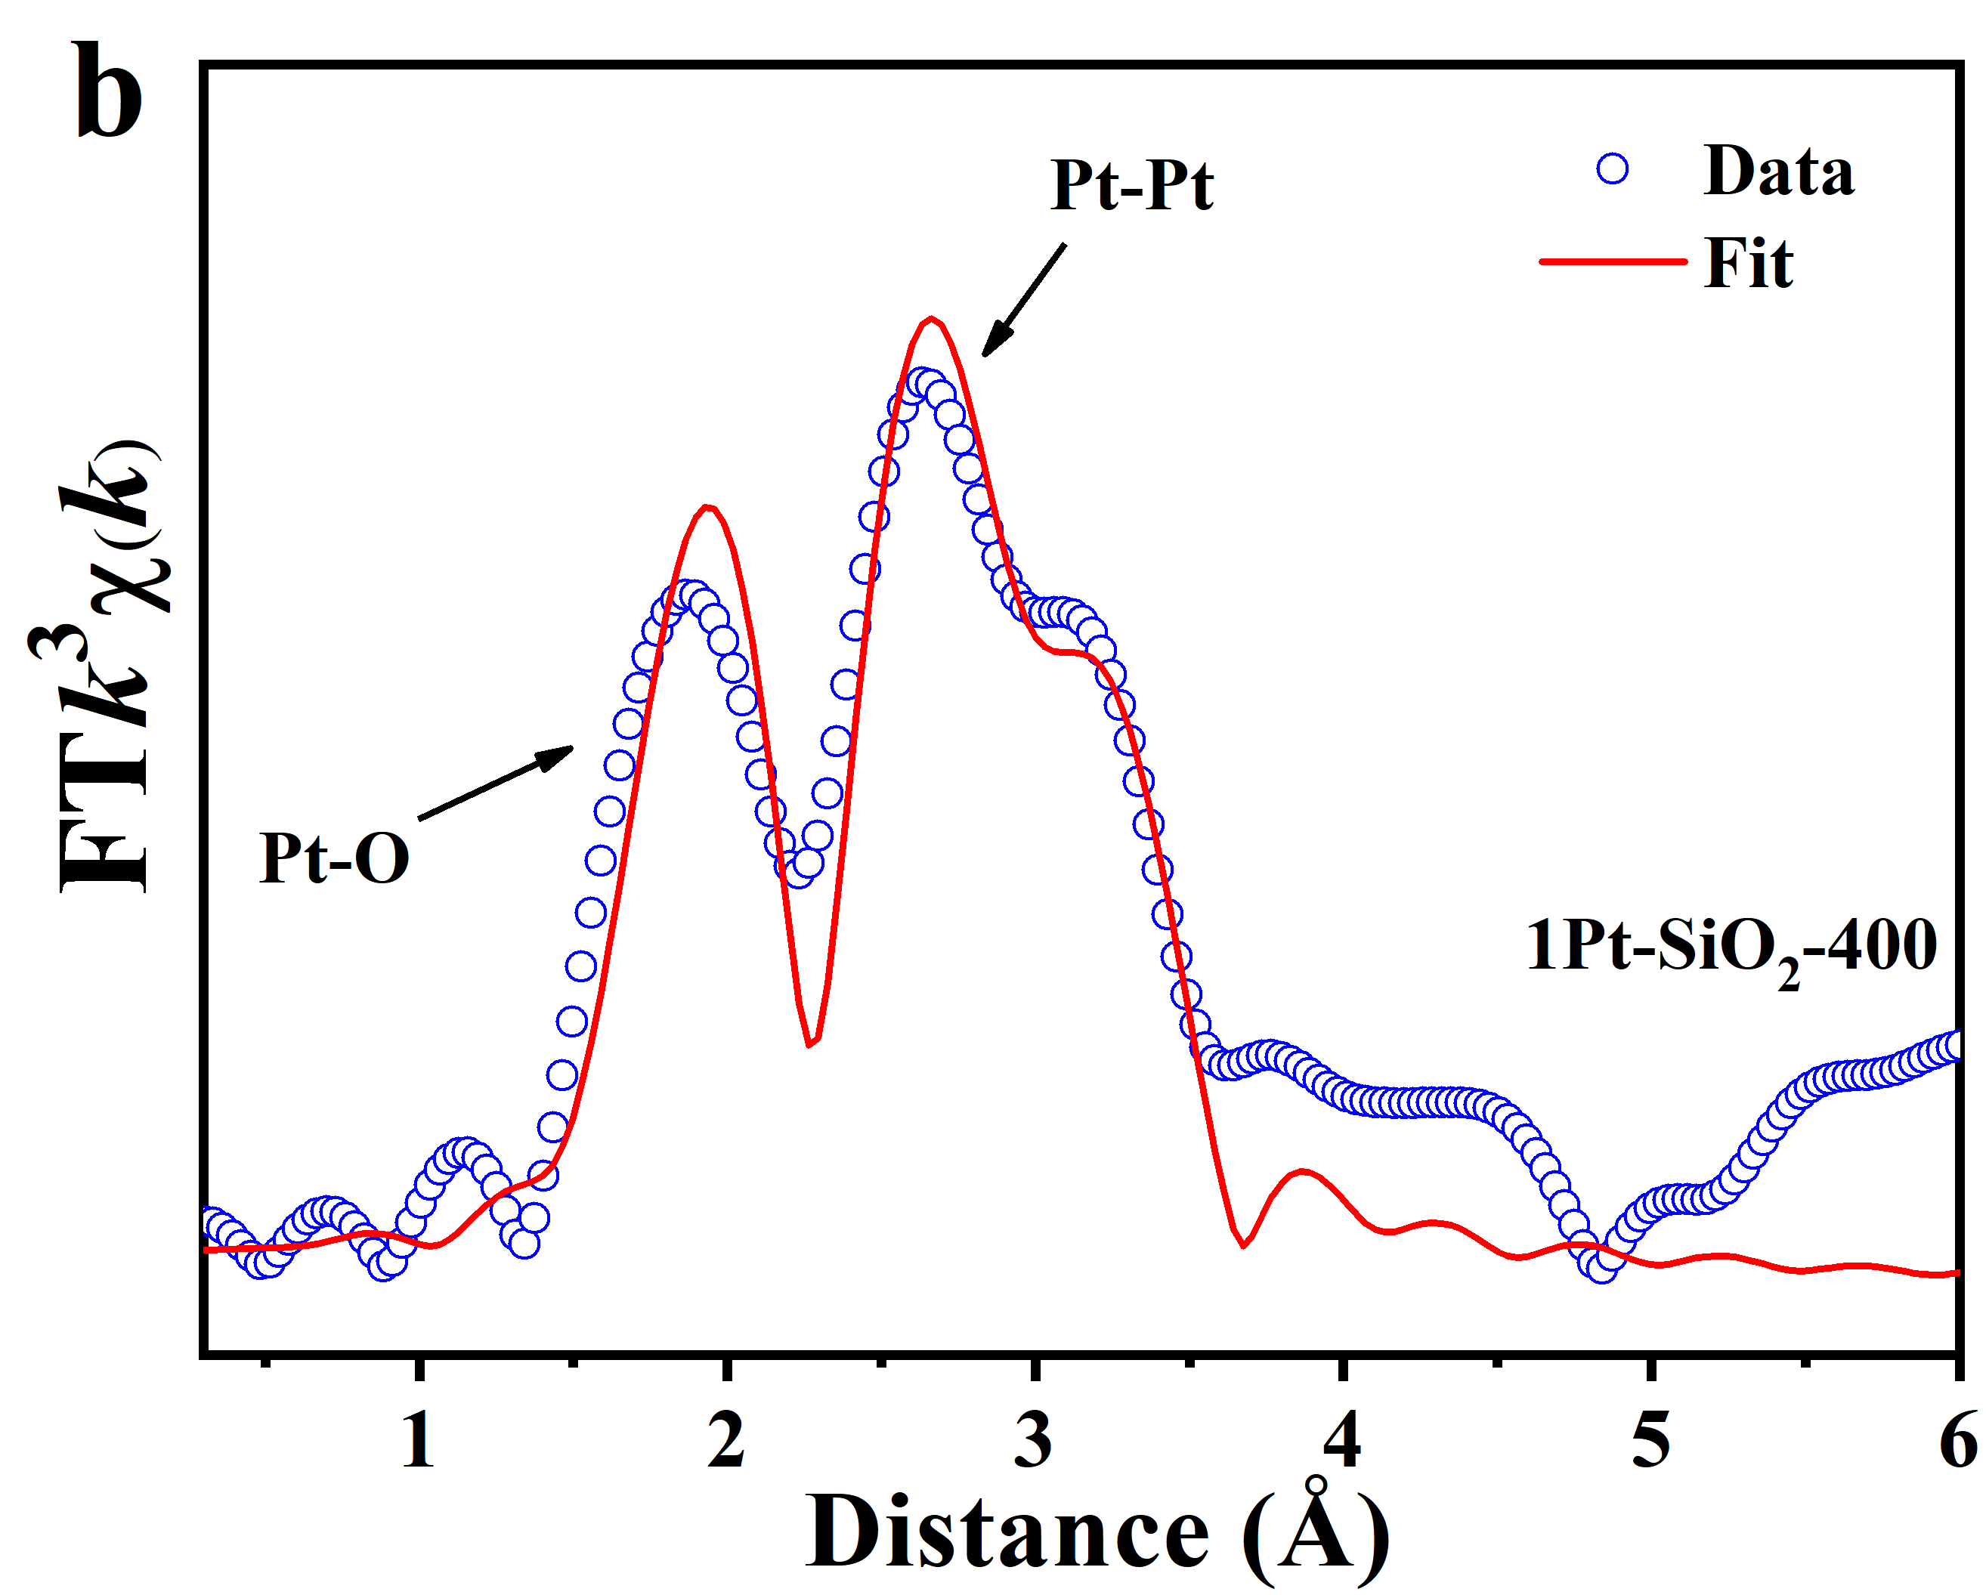
Supplementary Fig. 14 Pt L₃–edge EXAFS fitting results in R space for (a) fresh and (b) used 1Pt-SiO₂-400.
As a reference, 1Pt-SiO₂-400 calcinated at 400 °C possesses almost identical local coordination structure and active site size with Bi-promoted samples except for Pt–[O]_{x}–Bi structure. After CO oxidation, the Pt active site is in a low oxidized state for 1Pt-SiO₂-400 (+0.9) sample and EXAFS results indicate the Pt–O (R ≈ 2.00 Å, CN ≈ 2.0) and metallic Pt–Pt (R ≈ 2.75 Å, CN ≈ 5.8) shell about ~1 nm nanoparticle with surface partial oxide platinum site.

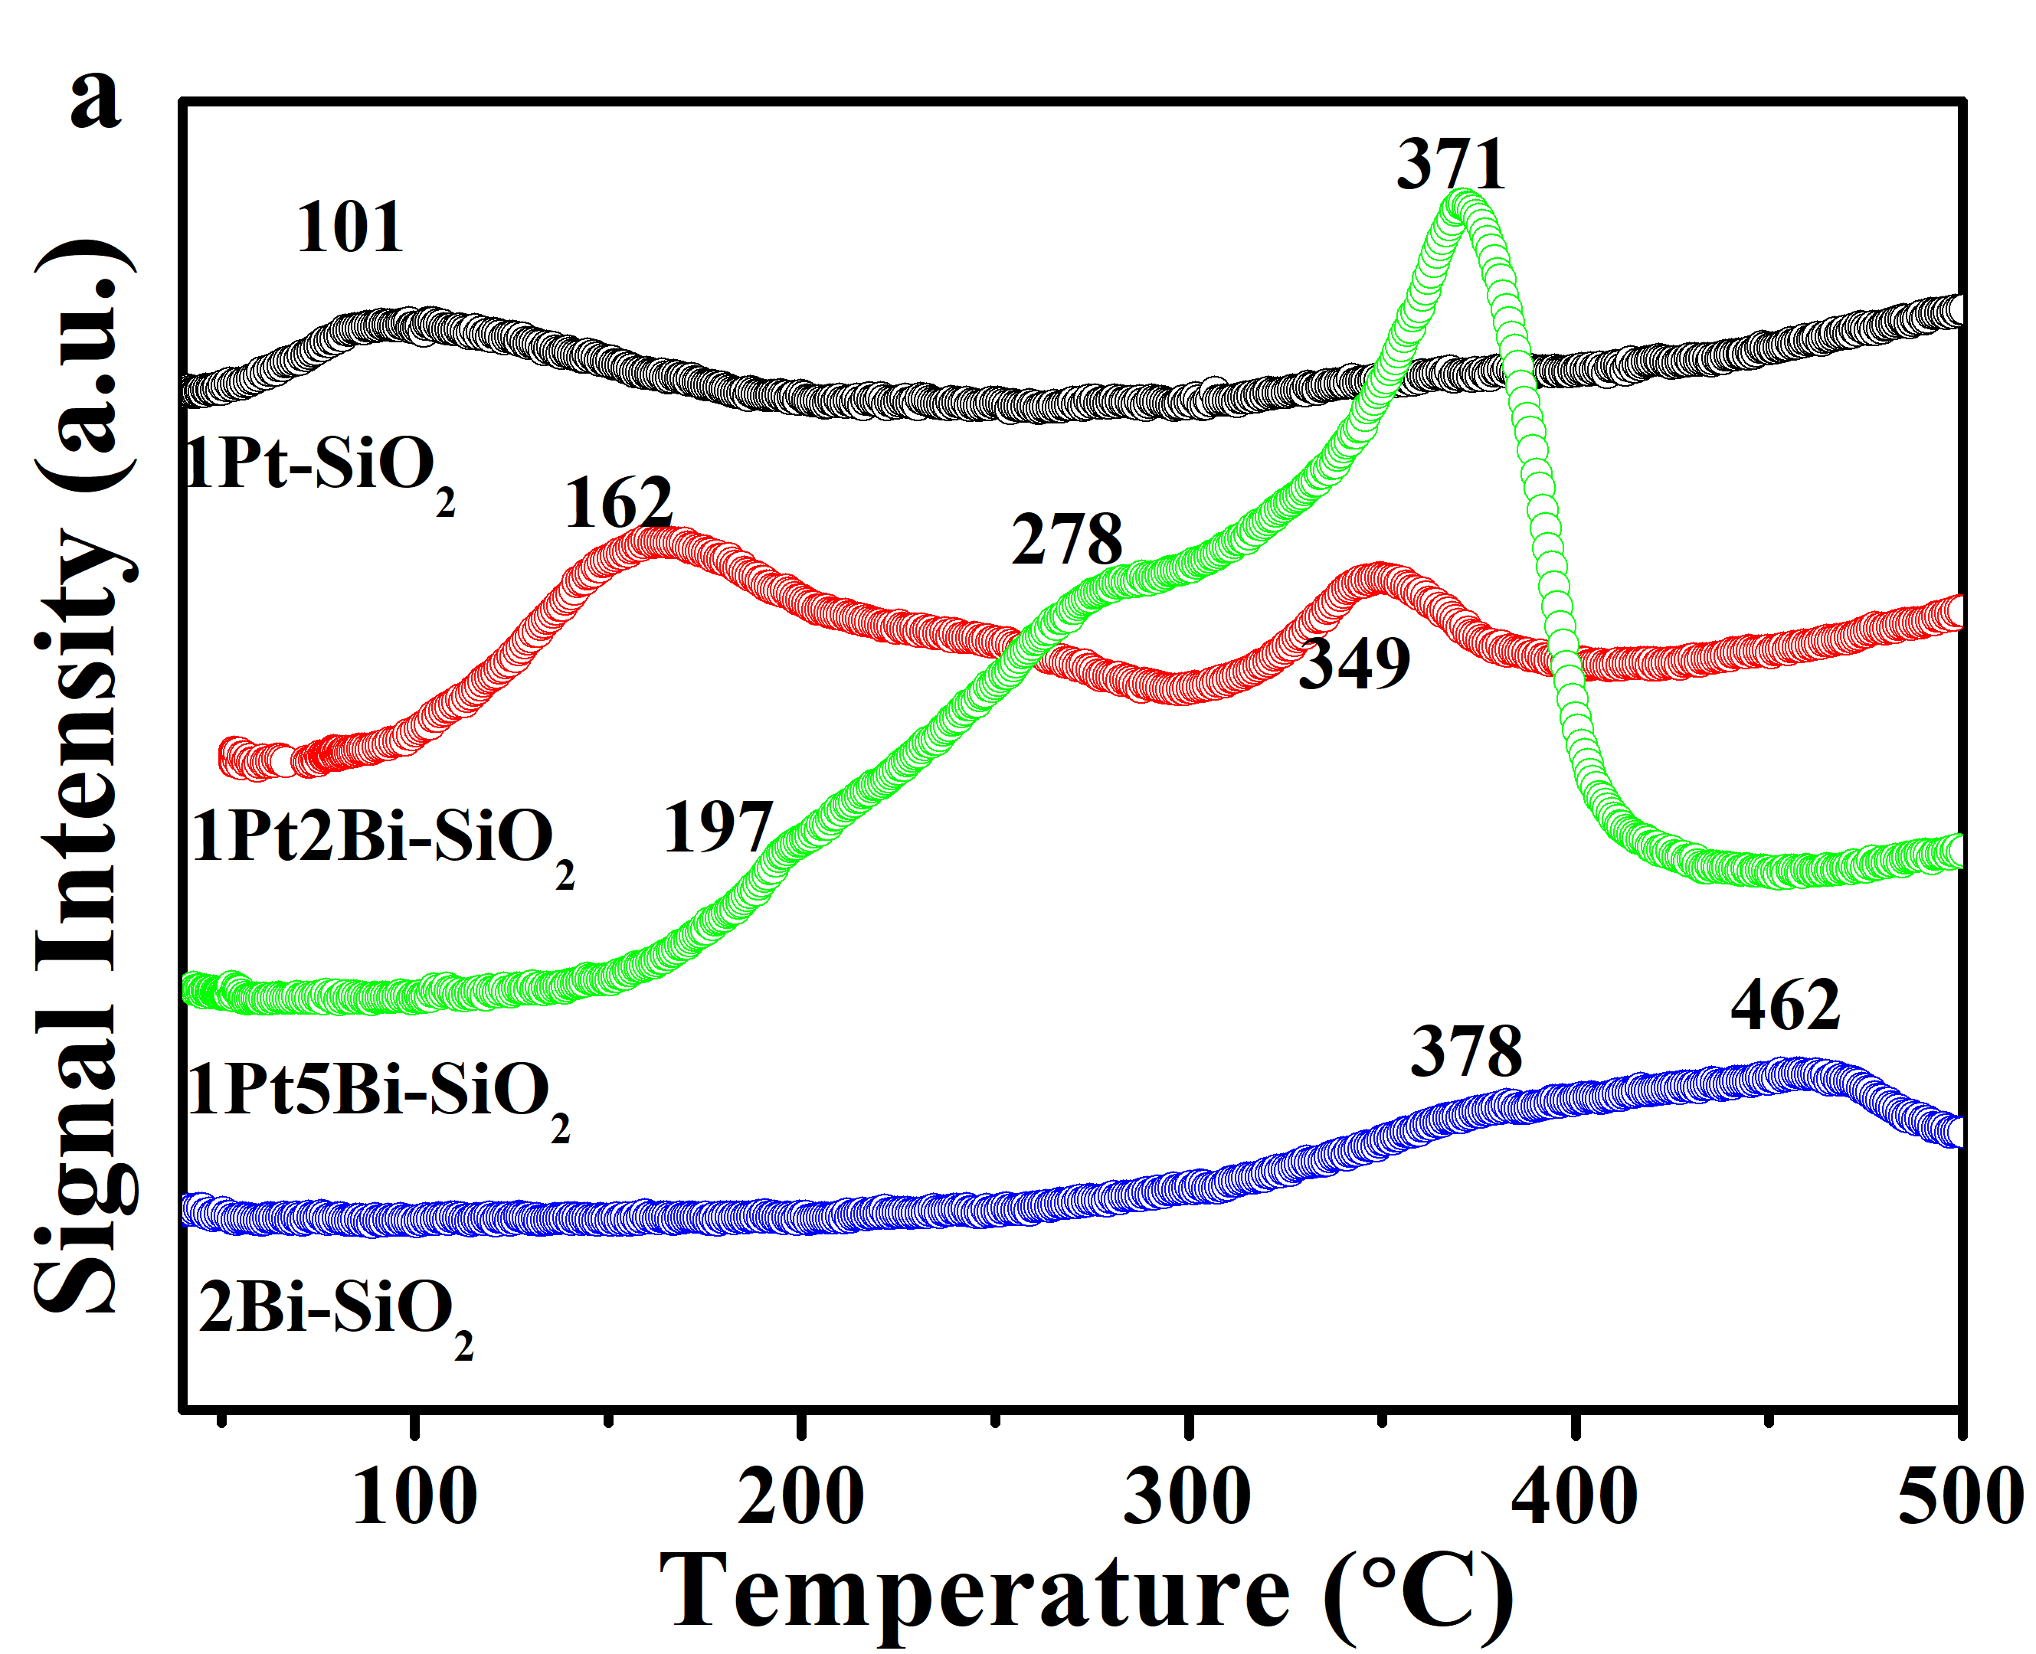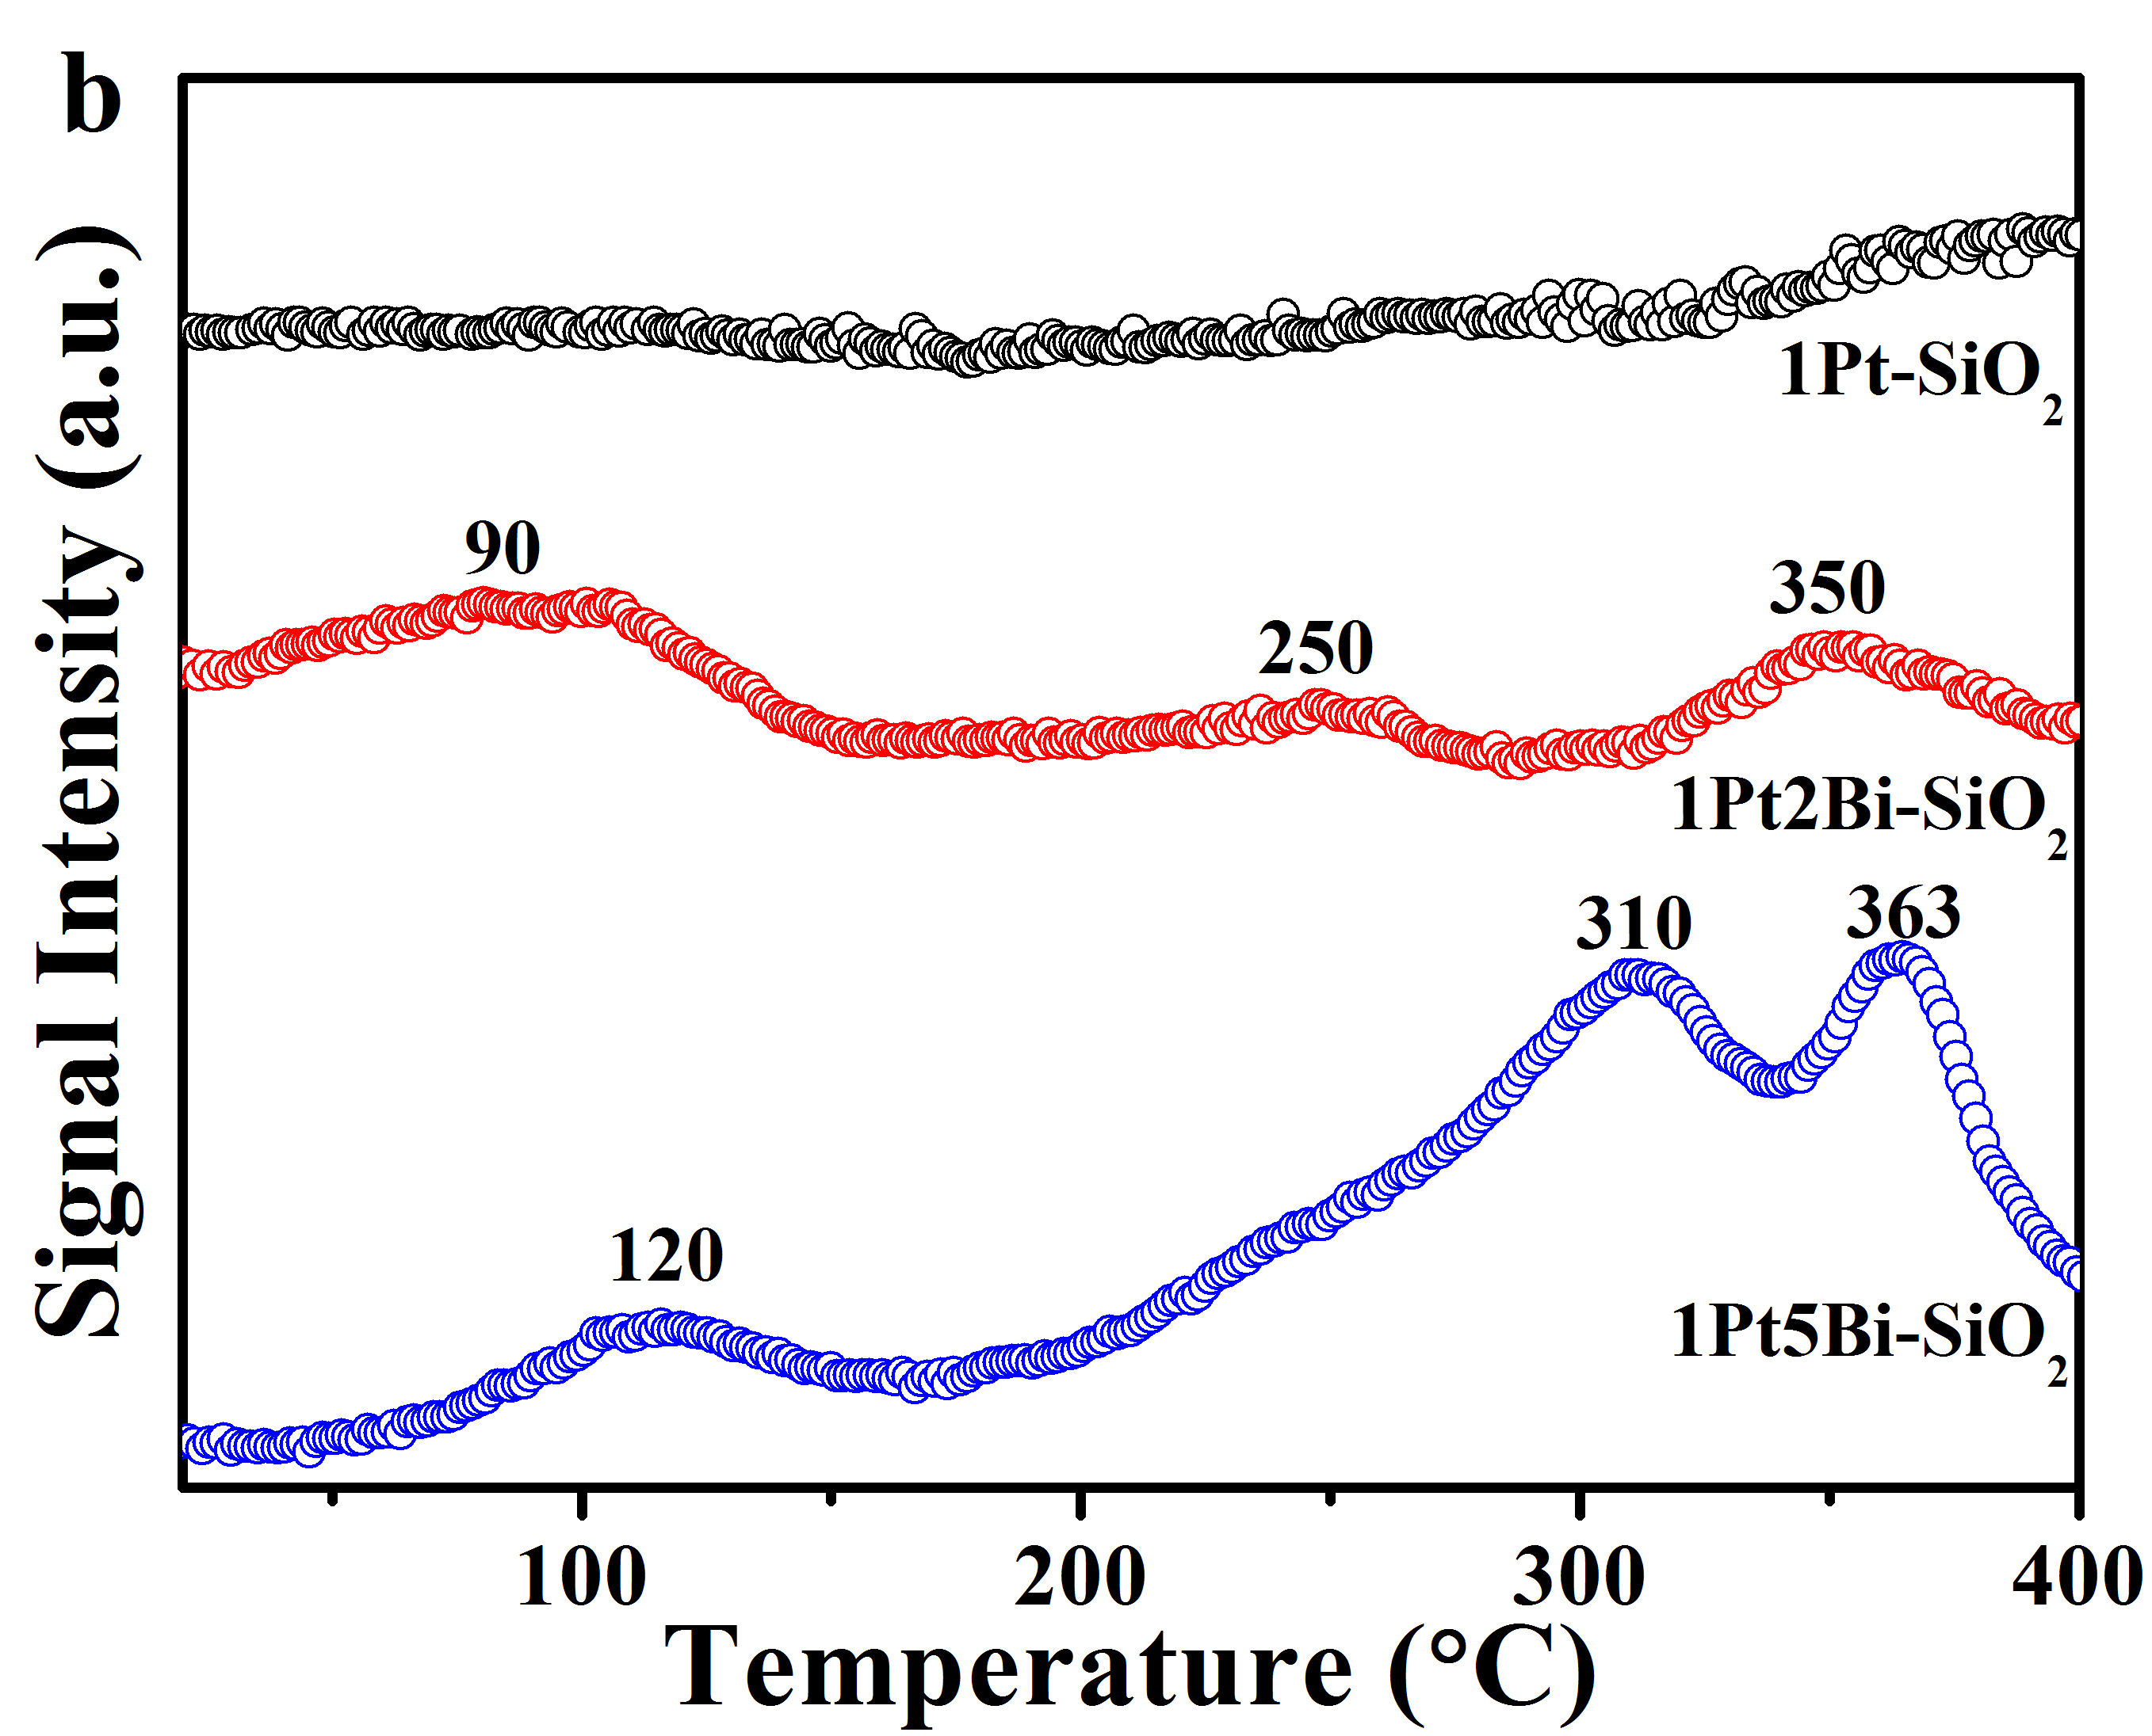
Supplementary Fig. 15 H₂−TPR profiles of fresh (a) and used (b) Pt/PtBi-SiO₂ catalysts. The H₂-TPR for used samples was conducted after CO oxidation without exposing to air.
For used samples, the reducible oxygen in 1Pt-SiO₂ has been taken away by hydrogen pretreatment at 210 °C, being metallic platinum particle. However, a low temperature reduction peaks for used Bi-promoted samples further confirmed the maintaining of Pt−[O]_{x}−Bi structure. We calculated the hydrogen consumption of 1Pt2Bi-SiO₂ (78μmol/g) and 1Pt5Bi-SiO₂ (95μmol/g) for Pt−[O]_{x}−Bi structure, which was much less than that of fresh Bi-promoted samples. It indicated that the most Pt−[O]_{x}−Bi structure was destroyed. Moreover, no temperature shift occurred on peaks for isolated BiO_{x} cluster (350−400 °C), revealing that BiO_{x} cluster structure could be maintained after hydrogen reduction and make no contribution on improvement of CO oxidation activity.

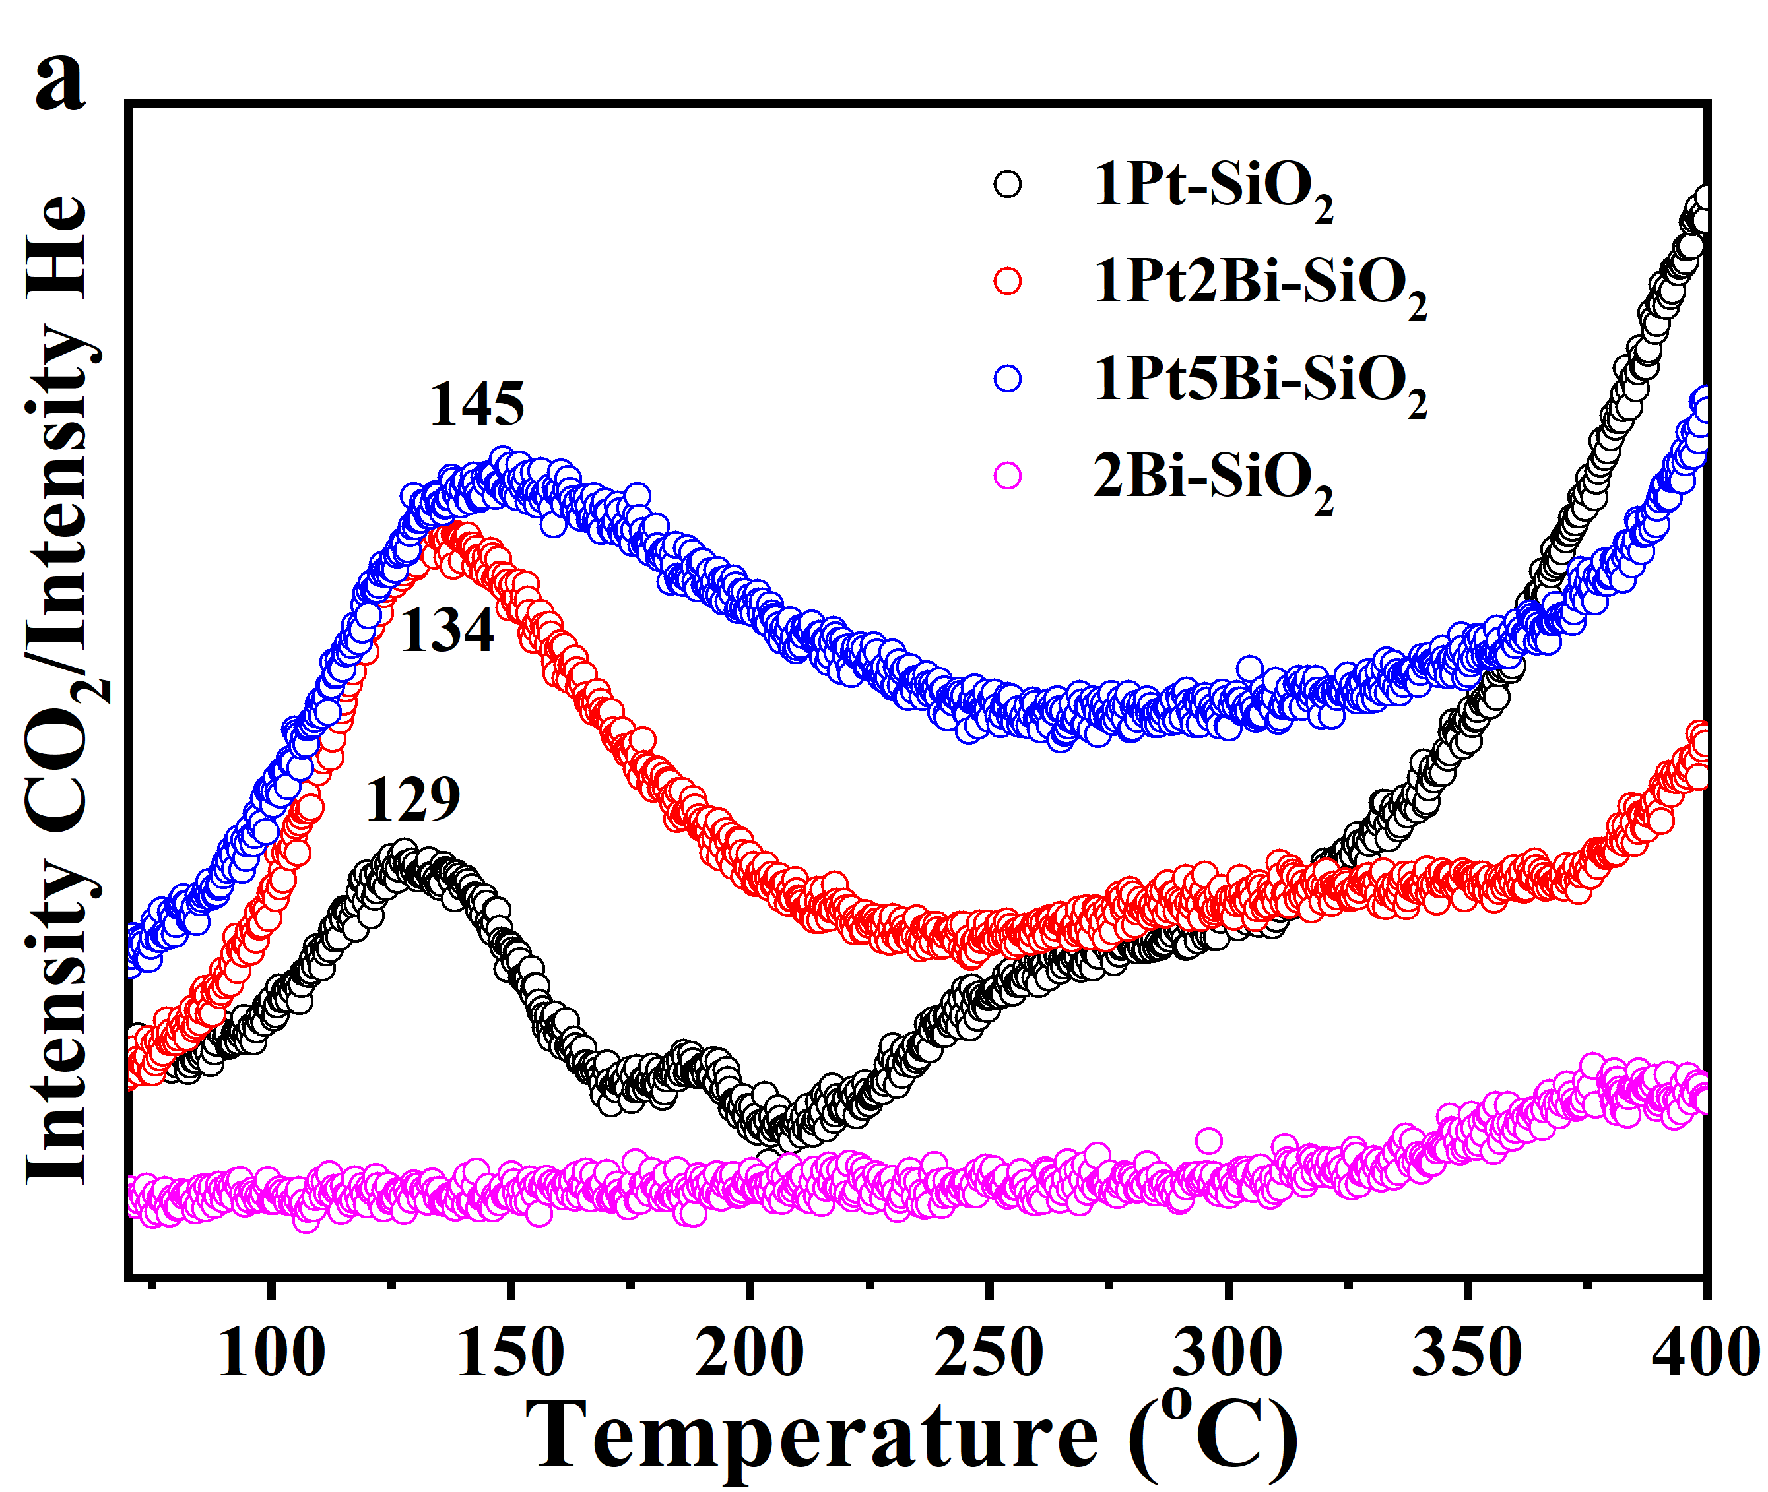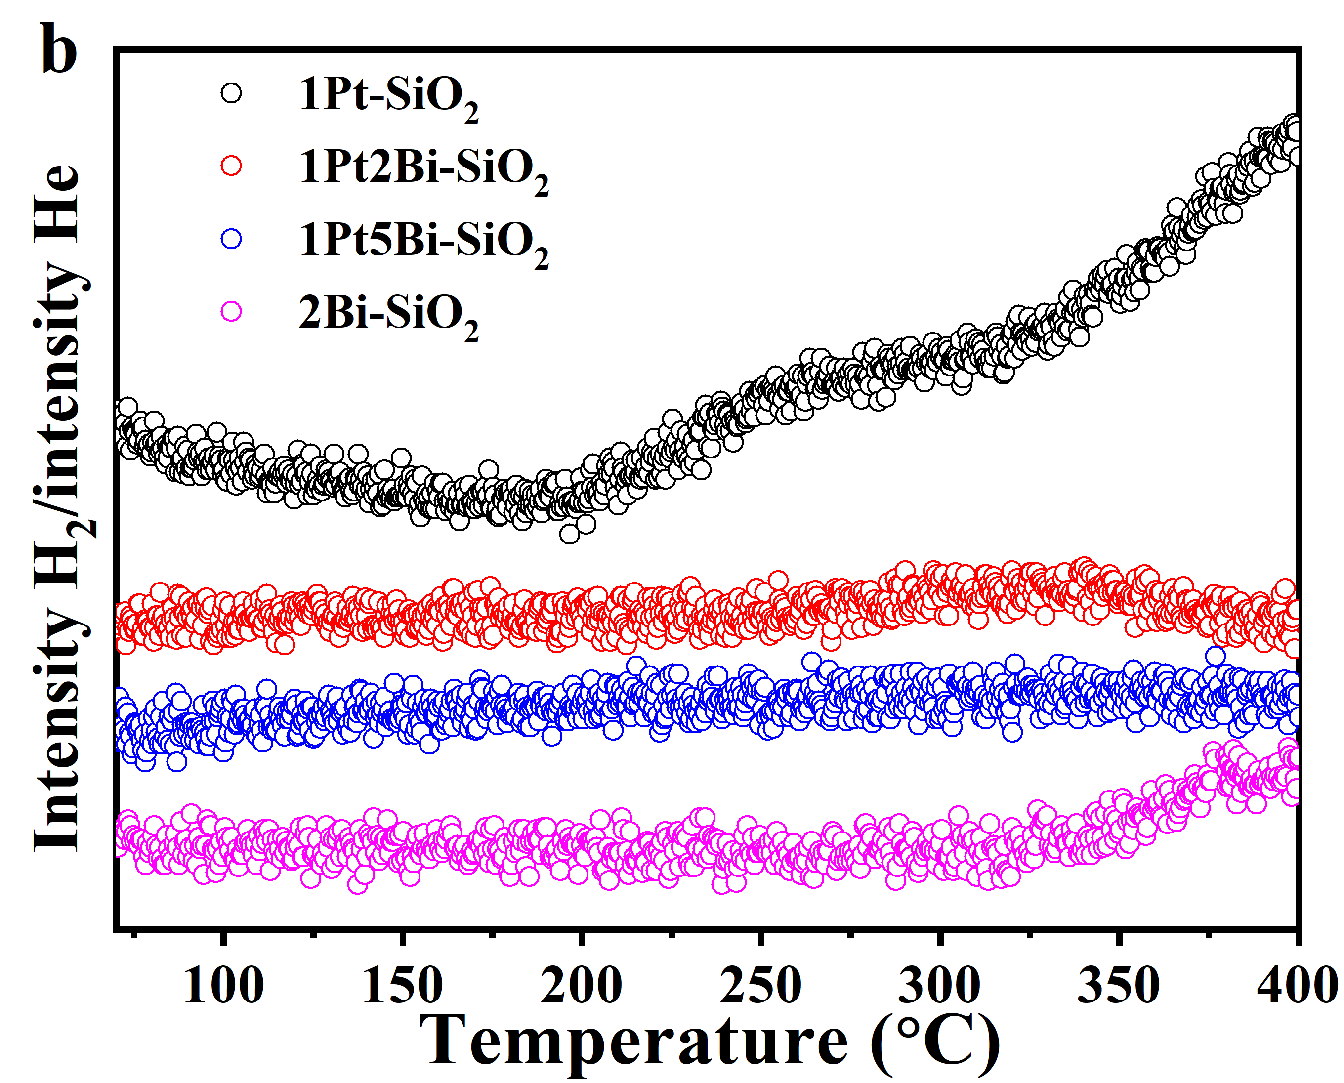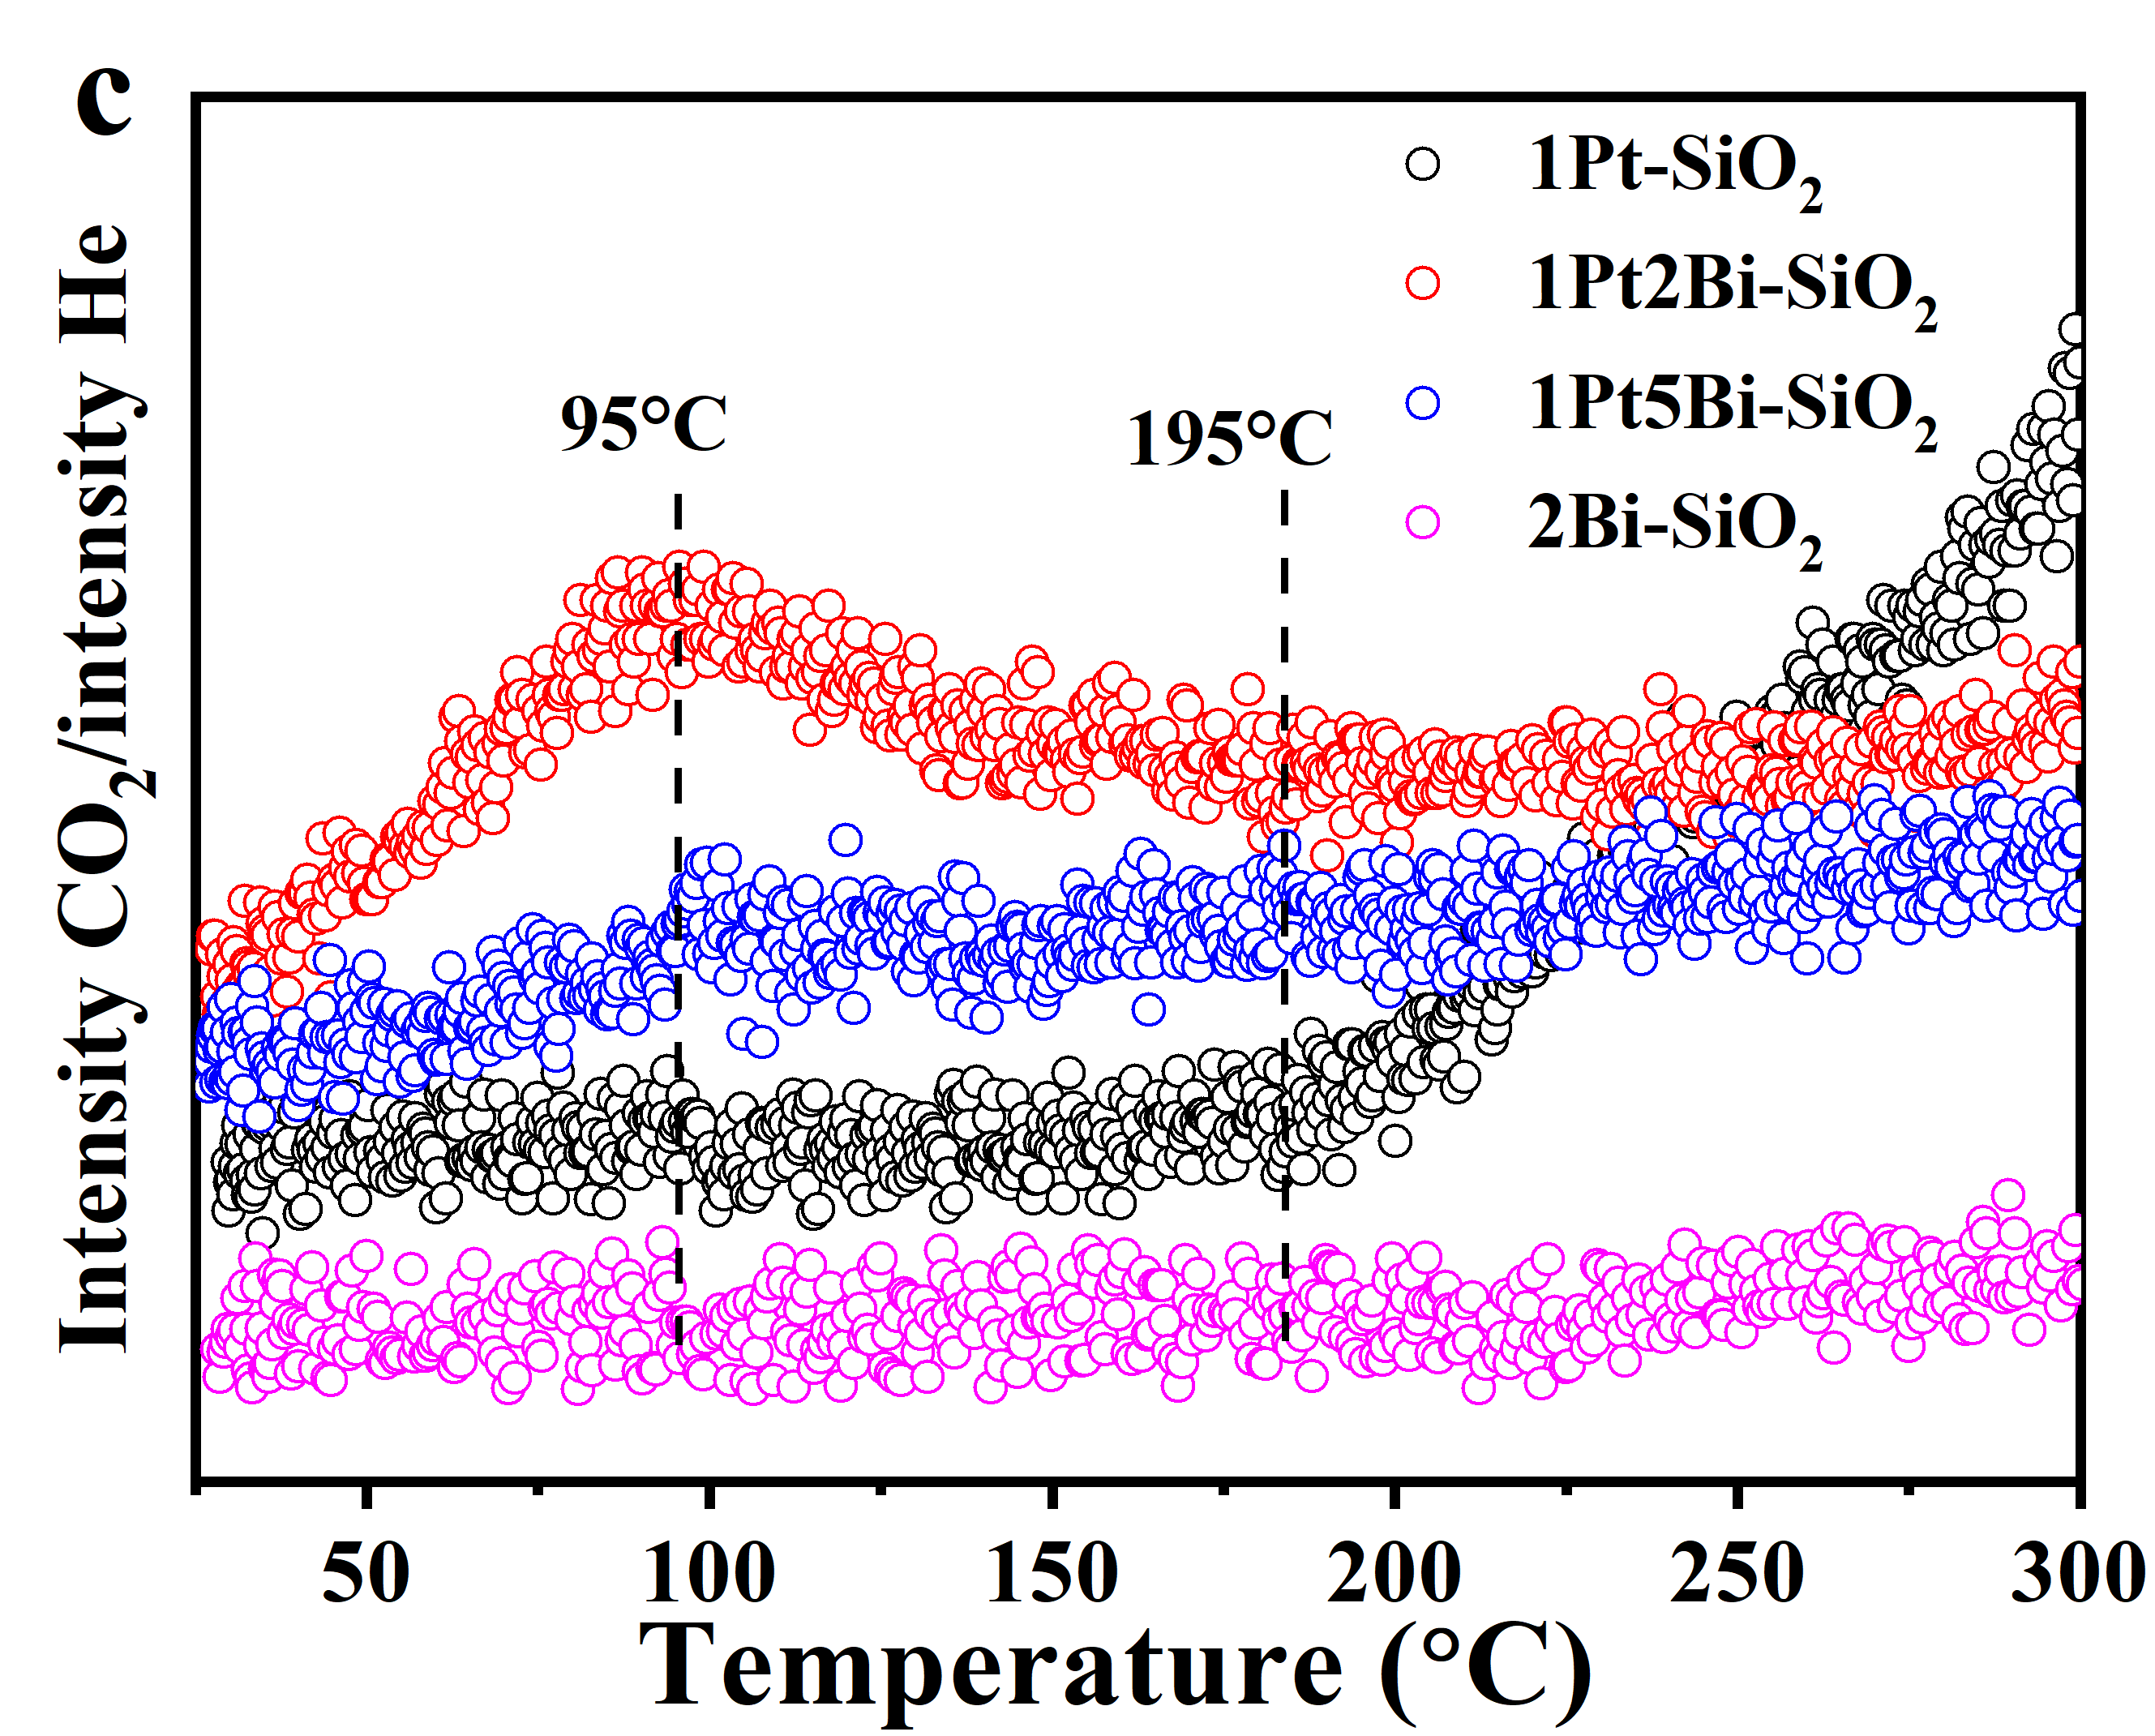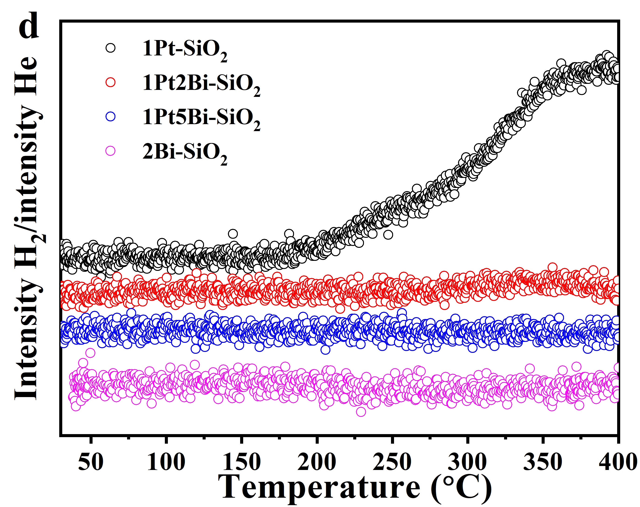
Supplementary Fig. 16 CO−TPR profiles of (a,b) fresh (pretreatment condition: 300 ºC for 30 min in 5 vol.% O₂/He) and (c,d) used (after CO oxidation without air exposure) Pt/PtBi-SiO₂ samples, (5 vol.% CO/He, 20 cm³ min⁻¹, with ramping rate at 5 °C min⁻¹)
The amount of surface oxygen was calculated by following formula:
Active oxygen quantity: R = (V × 0.05 × Con.) / (22.4 × M) × 1000 × t (1)
V: gas flow rate Con.: conversion of 5%CO/He M: mass of catalyst t: time of first peak for CO-TPR 0.05: 5%CO/He

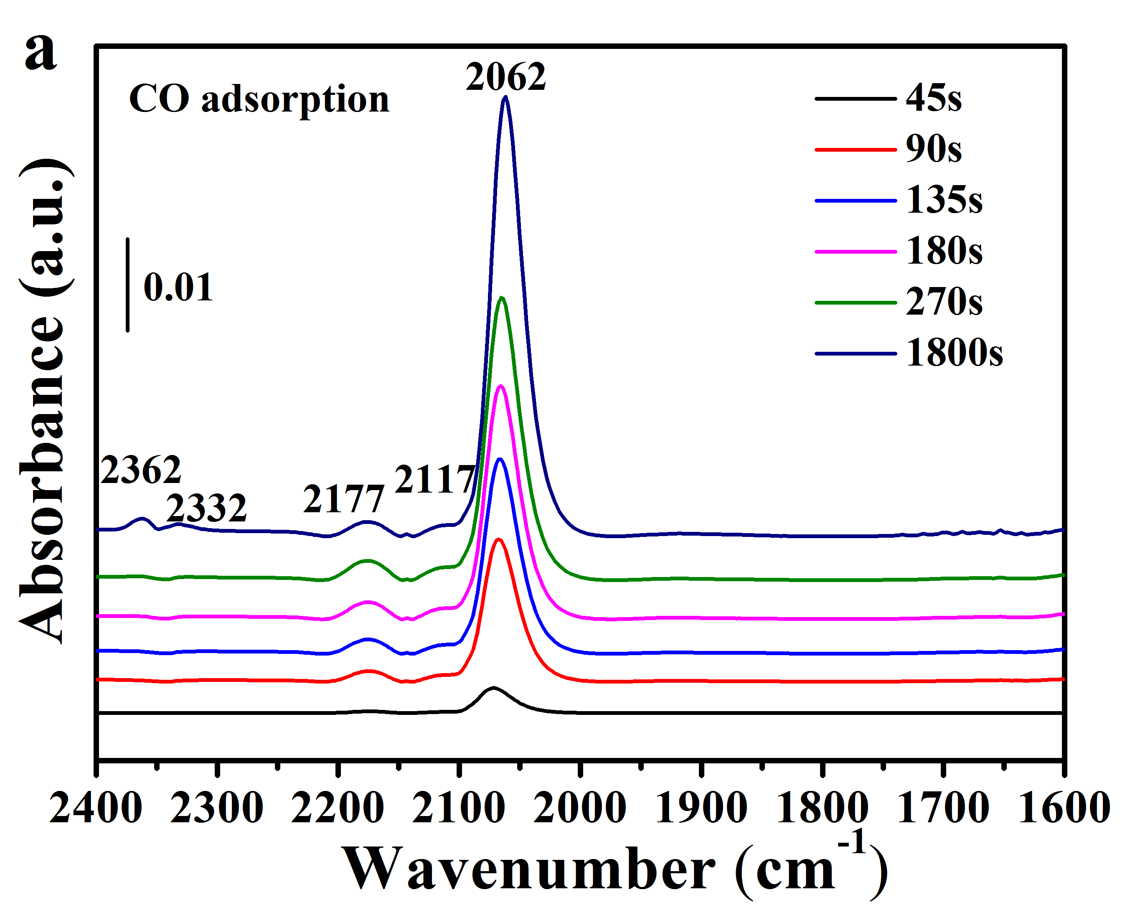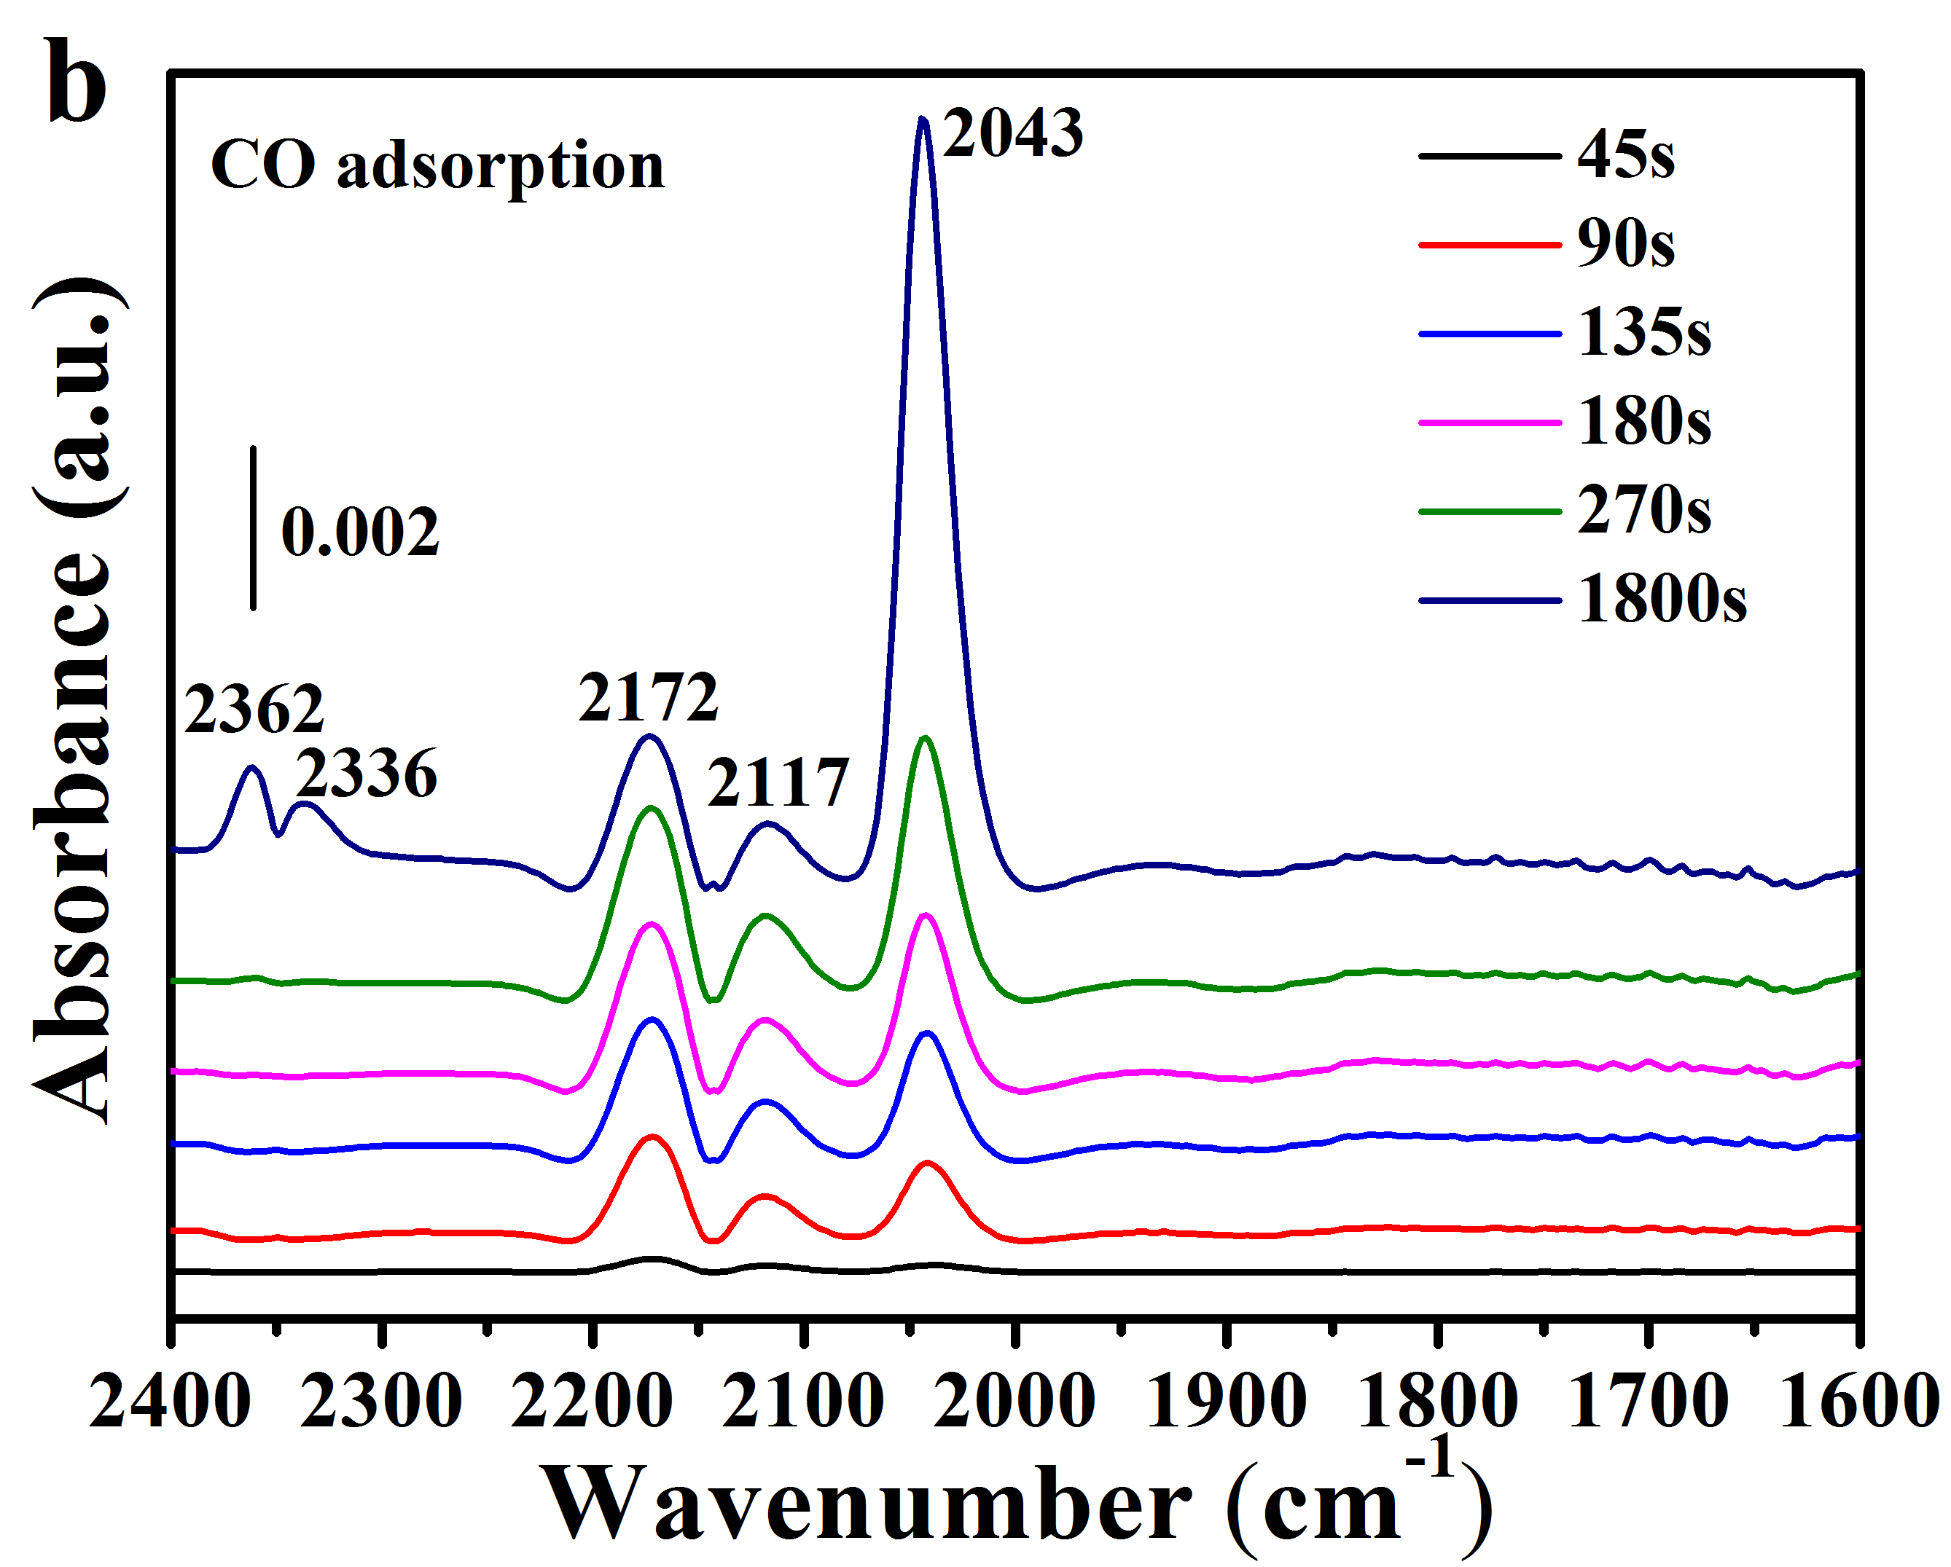
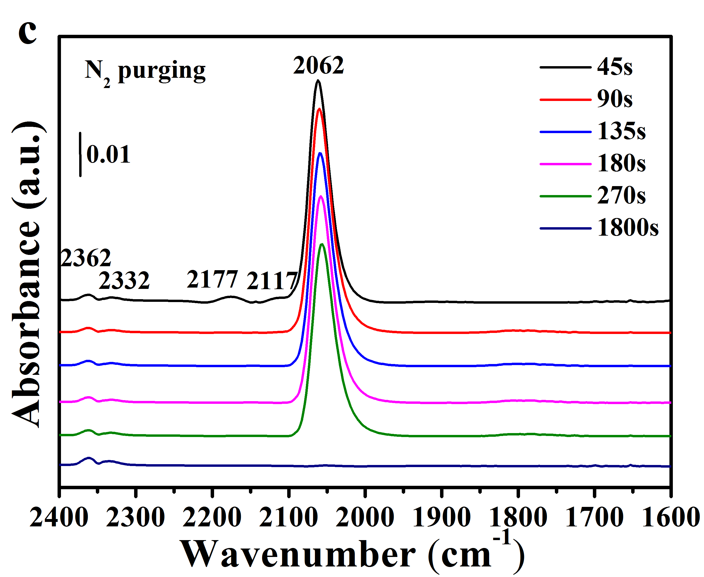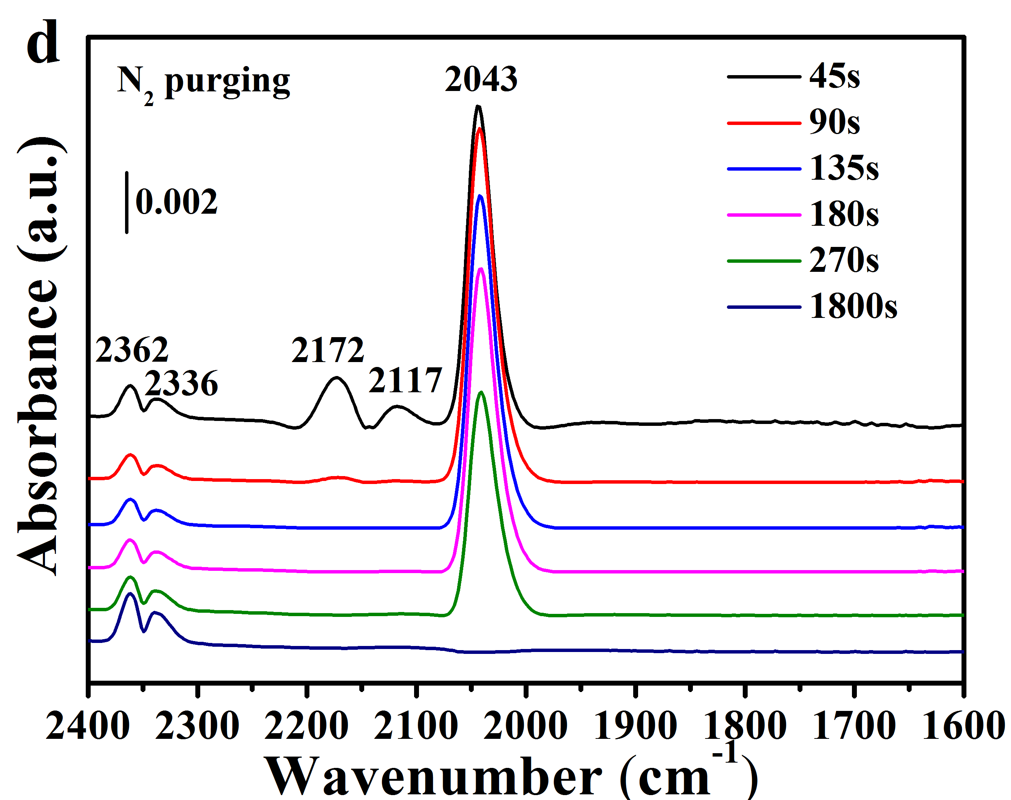
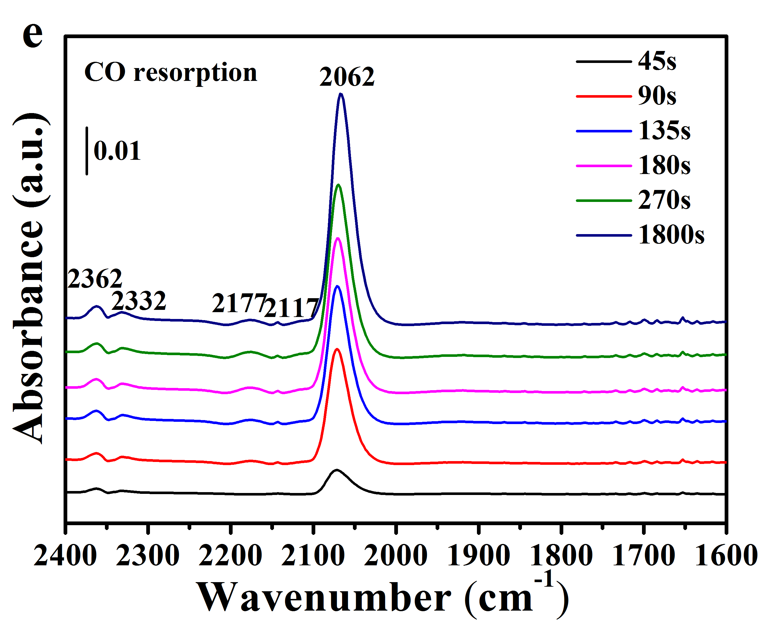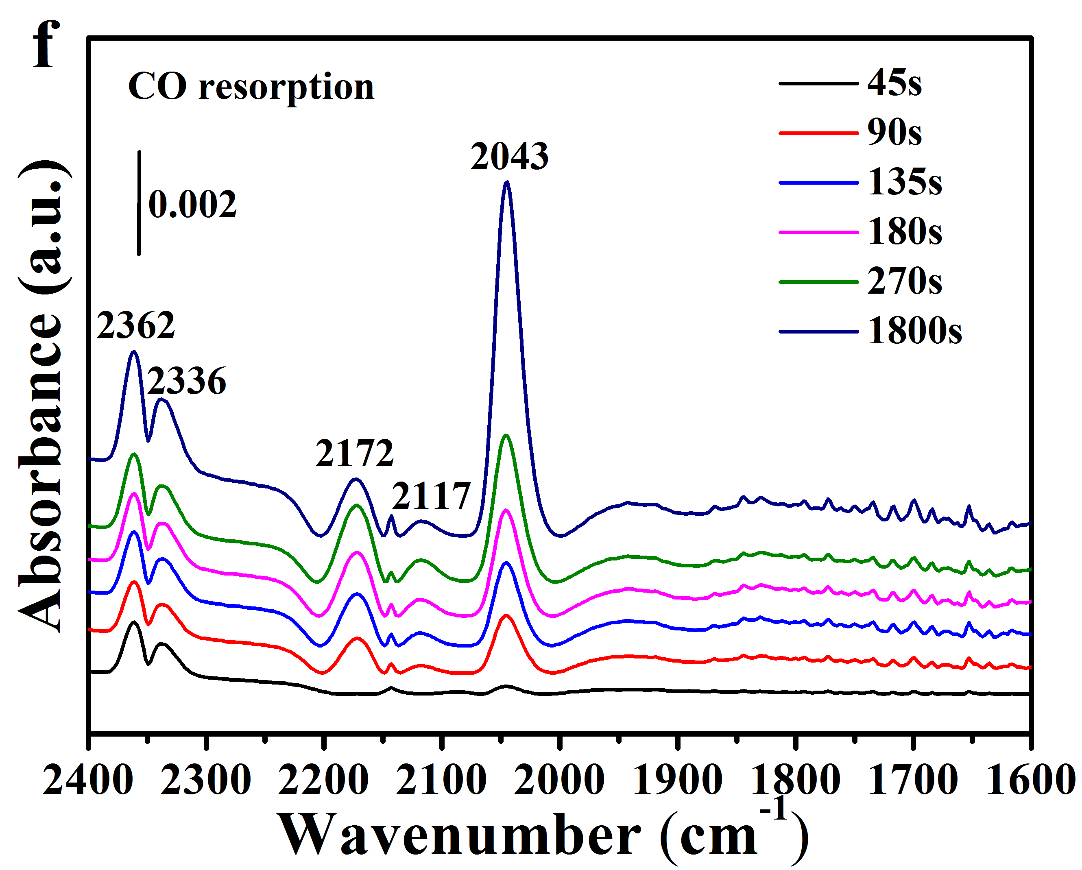
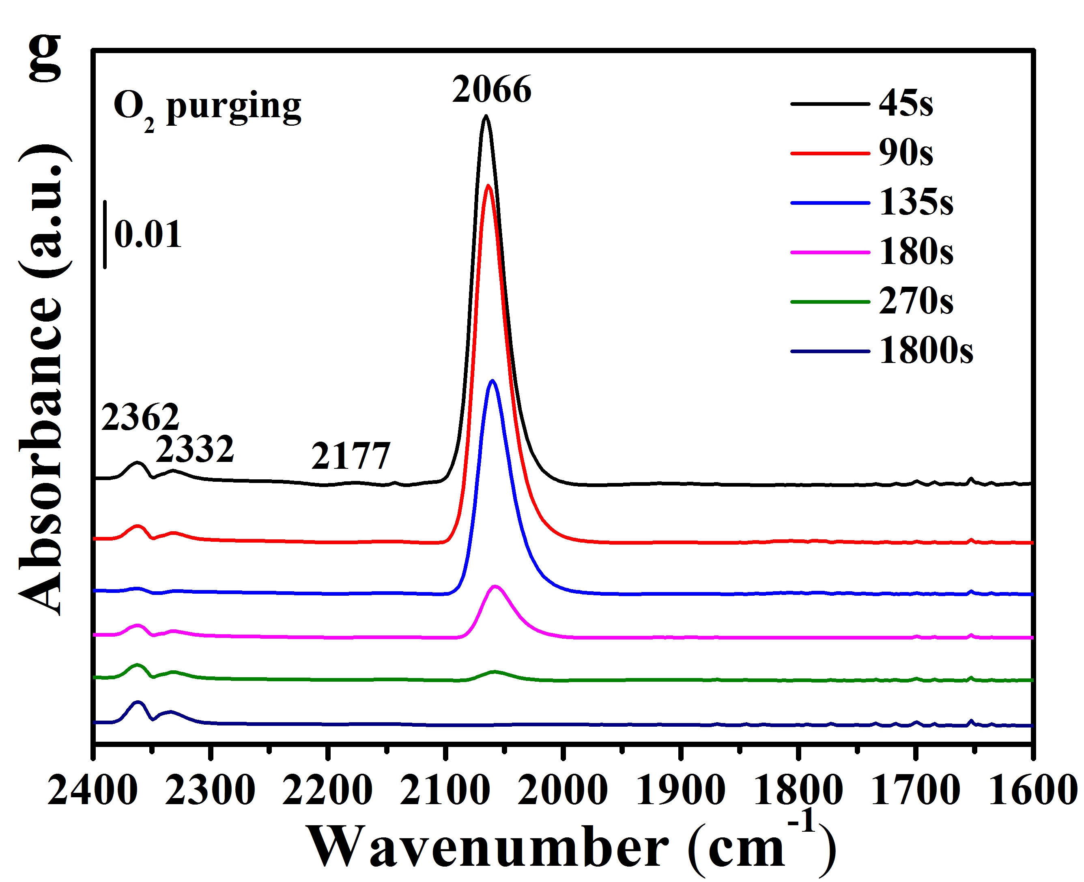
Supplementary Fig. 17 In-situ DRIFTS study of (a, b) CO adsorption, (c, d) N₂ purging, (e, f) CO resorption, and (g, h) O₂ removal on (a, c, e, g) 1Pt-SiO₂ and (b, d, f, h) 1Pt2Bi-SiO₂. The catalysts were pretreated in situ at 210 °C under 5 vol.% H₂/N₂ flow in the DRIFTS reaction cell before data collection (CO flow rate: 30 mL min⁻¹; catalyst mass: 20 mg; temperature: 100 °C).

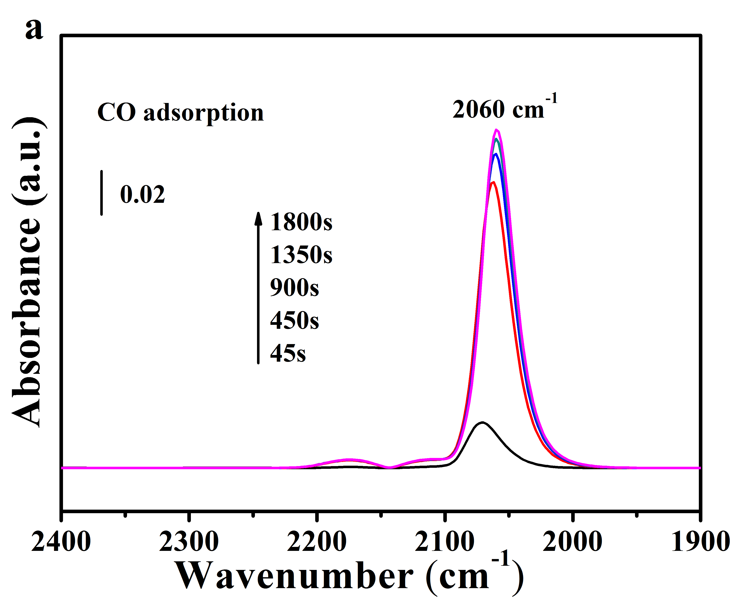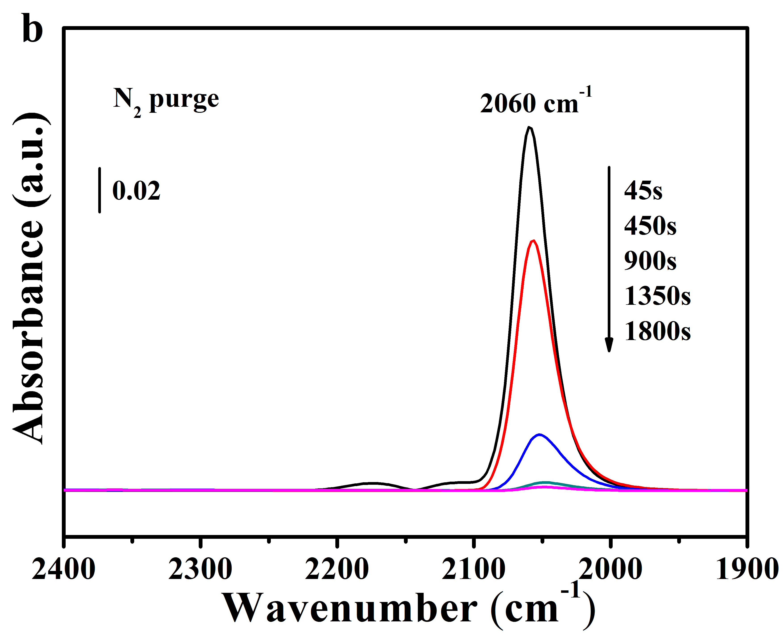
Supplementary Fig. 18 In-situ DRIFTS study of (a) CO adsorption, (b) N₂ purging on 1Pt-SiO₂-400. The catalysts were pretreated in situ at 210 °C under 5 vol.% H₂/N₂ flow in the DRIFTS reaction cell before data collection (CO flow rate: 30 mL min⁻¹; catalyst mass: 20 mg; temperature: 100 °C)

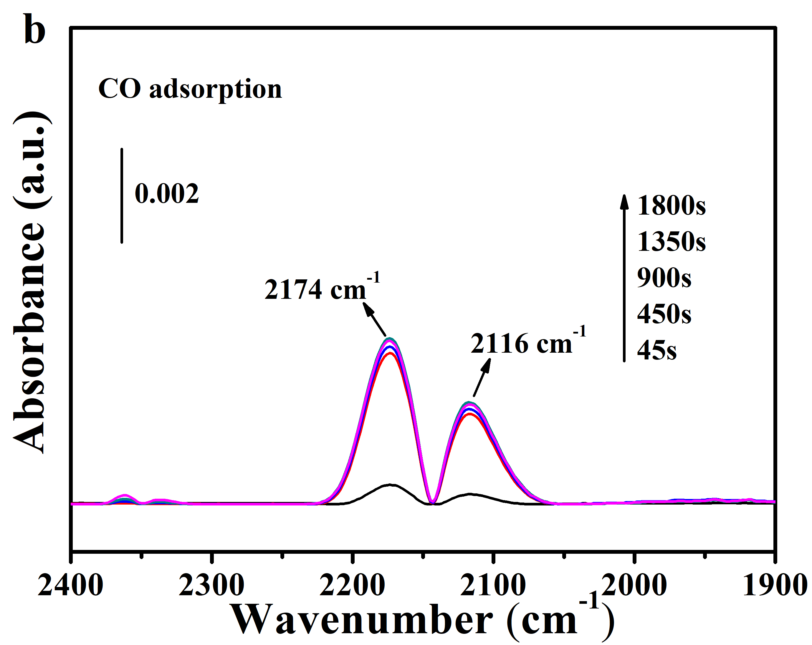
Supplementary Fig. 19 In-situ DRIFTS study of CO adsorption on 2Bi-SiO₂ with different pretreatment condition. The catalysts were pretreated in situ (a) at 300 °C under air and (b) at 210 °C under 5 vol.% H₂/N₂ flow in DRIFTS reaction cell before data collection (CO flow rate: 30 mL min⁻¹; catalyst mass: 20 mg; temperature: 100 °C)

Supplementary Fig. 20 In-situ DRIFTS study of CO absorption on different doping of bismuth species. (CO flow rate: 30 mL min⁻¹; catalyst mass: 20 mg; temperature: 100 °C).

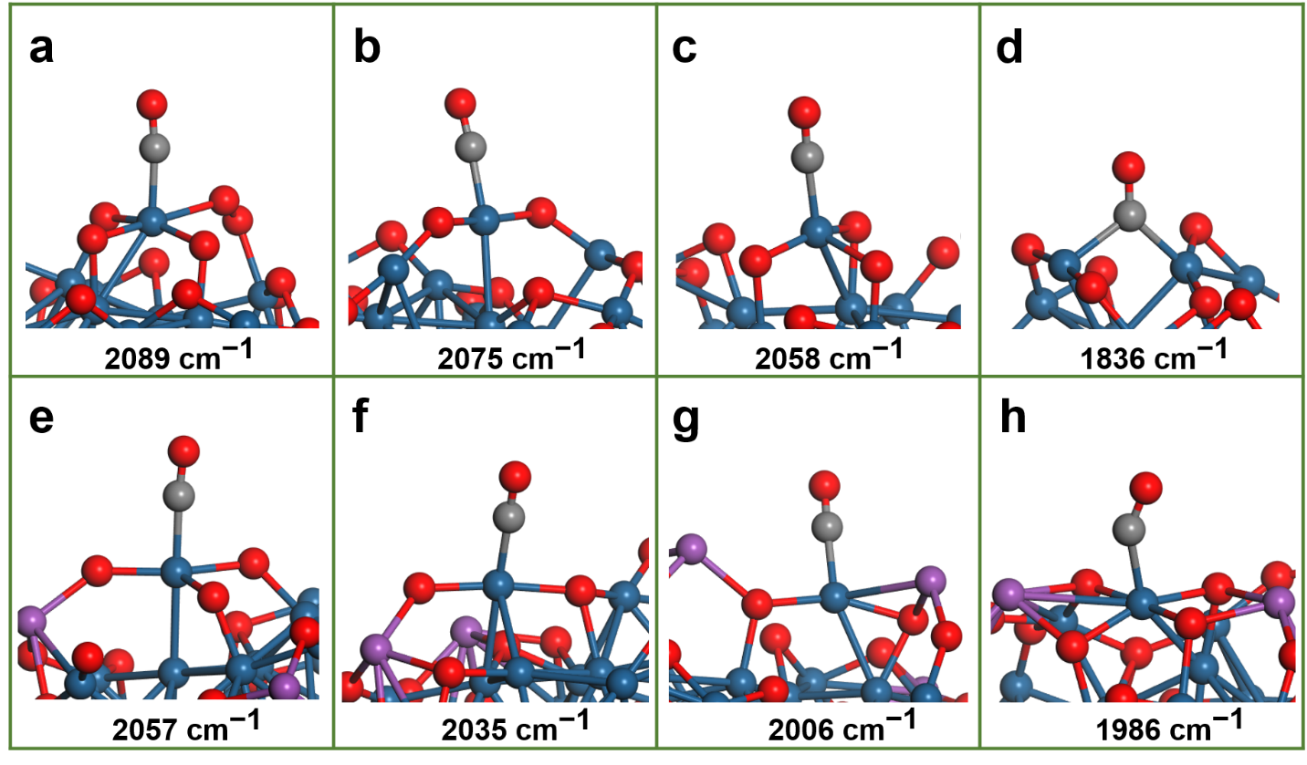
Supplementary Fig. 21 Frequencies of a CO adsorbate on the Pt@PtO_{x} model without (a-d) and with (e-h) Bi dopant. The teal blue, gray, red and purple spheres represent Pt, C, O, and Bi atoms, respectively.

Supplementary Fig. 22 Density of states (DOS) for the d electrons of the Pt atom on which the CO molecule adsorbs. The red and blue lines correspond to the models in Supplementary Figs. 20c (without Bi atom) and 20f (with Bi atom), respectively. The Fermi level is set to 0 (black dash line).

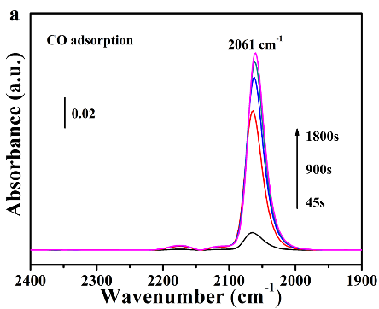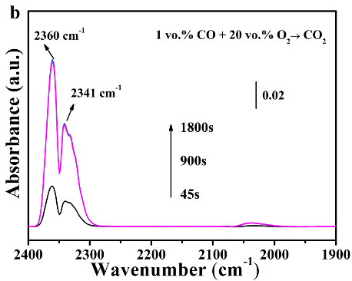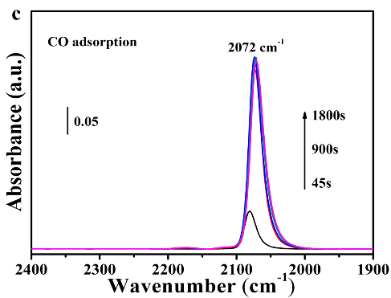
Supplementary Fig. 23 In-situ DRIFTS in the mode: “CO adsorption → reaction conditions (1% CO/ 20% O₂/N₂ flow) at 200°C → CO adsorption” on 1Pt-SiO₂ without catalyst replacement and air exposure, (CO flow rate: 30 mL min⁻¹; catalyst mass: 20 mg).

Supplementary Table 1: Bulk Pt and Bi concentration, BET specific surface areas (S_{BET}), BJH pore volume (V_{p}), average cluster sizes (D) for Pt/PtBi-SiO₂ and SiO₂ samples.
Sample | Pt  (wt.%)ª | Bi  (wt.%)ª | T_{R} (°C) | H₂ (μmol g⁻¹)^{b} | S_{BET}  (m²/g)^{c} | V_{p}  (cm³/g)^{c} | D  (nm)^{d}
SiO₂ | — | — | — | — | 430 | 1.322 | —
1Pt-SiO₂ | 0.8 | — | 101 | 157^{α}, 82^{β} | 400 | 1.225 | 1.7±0.4  3.0±0.6e
1Pt2Bi-SiO₂ | 0.9 | 2.3 | 162, 248, 349 | 254^{α}, 247^{β} | 424 | 1.352 | 1.6±0.5  1.8±0.3e
1Pt5Bi-SiO₂ | 0.9 | 6.1 | 197, 278, 371 | 657^{α}, 529^{β} | 405 | 1.286 | 1.7±0.3  2.0±0.4e
ª Determined by ICP-AES; ^{b} Actual value of H₂ consumptions (α) and theoretical values of H₂ consumption calculated according to Pt⁴⁺ → Pt⁰ and Bi³⁺ → Bi⁰ (β); ^{c} From N₂ adsorption/desorption experiments; ^{d} Statistic data of cluster on the basis of TEM images; ^{e} after CO oxidation.

Supplementary Table 2: Oxidation state of platinum (δ) and Pt L₃-edge EXAFS fitting results (R: distance; CN: coordination number; σ²: Debye-Waller factor ª; △E₀: inner potential correction ^{b}) of Pt/PtBi-SiO₂ samples.
Sample | δ | Pt-O |  | Pt-Pt(metal) |  | Pt-O-Pt/Bi
Sample | δ | R (Å) | CN | R (Å) | CN | R (Å) | CN
1Pt-SiO₂  (fresh) | 1.8 | 2.01±0.01 | 2.4±0.3 | 2.78±0.01 | 6.4±0.8 | 3.09±0.02 | 2.7±1.0
1Pt-SiO₂-400  (fresh) | 3.2 | 2.00±0.01  3.78±0.03 | 4.5±0.2  2.4±1.0 | — | — | 3.10±0.04 | 1.2±0.6
1Pt2Bi-SiO₂  (fresh) | 3.0 | 2.00±0.01  3.77±0.04 | 4.9±0.1  2.4±1.7 | — | — | 3.03±0.02 | 3.0±0.7
1Pt5Bi-SiO₂  (fresh) | 3.5 | 2.00±0.01  3.80±0.03 | 5.7±0.3  1.7±0.7 | — | — | 3.05±0.04 | 4.0±1.0
1Pt2Bi-SiO₂  (hydrogen^{c}) | 0.2 | 2.06±0.03 | 0.6±0.2 | 2.73±0.01 | 6.8±1.4 | 2.90±0.04 | 2.6±1.2
1Pt5Bi-SiO₂  (hydrogen^{c}) | 0.4 | 2.00±0.01 | 2.0±0.2 | 2.72±0.01 | 5.0±1.2 | 2.90±0.04 | 1.4±0.9
1Pt-SiO₂  (used) | 0.4 | — | — | 2.76±0.01 | 9.4±1.0 | — | —
1Pt-SiO₂-400  (used) | 0.9 | 1.97±0.01 | 2.0±0.2 | 2.75±0.01 | 5.8±0.5 | — | —
1Pt2Bi-SiO₂  (used) | 0.7 | 1.99±0.01 | 1.0±0.1 | 2.77±0.01 | 8.4±1.7 | 2.99±0.02 | 2.2±0.8
1Pt5Bi-SiO₂  (used) | 1.3 | 1.99±0.01 | 2.5±0.1 | 2.70±0.01 | 4.7±1.0 | 2.96±0.03 | 2.2±0.6
ªσ² = 0.0030, 0.008 and 0.008Å² for all the analyzed Pt−O, Pt−Pt and Pt−Bi shells, respectively; ^{b}△E₀ = 11.2, 13.3 and 14.1 eV for fresh 1Pt-SiO₂, 1Pt2Bi-SiO₂ and 1Pt5Bi-SiO₂, respectively, which were obtained from the linear combination fits on XANES profiles and the fitting results of Pt foil (△E₀ = 8.3 ± 1.2 eV) and PtO₂ (△E₀ = 15.0 ± 0.9 eV) standards; △E₀ = 7.4 ± 1.8 eV for all used samples; ^{c} the samples was reduced with 5 vol. %H₂/N₂ at 210 °C for 30 min.

Supplementary Table 3: Temperature of 50% (T_{50%}) and 90% (T_{90%}) CO conversion, rates normalized by catalyst weight (r_{w}), rates normalized by platinum amount (r_{Pt}) and apparent activation energies (E_{a}) for the carbon monoxide oxidation reaction over Pt/PtBi-SiO₂ samples.
Sample | T_{50%} | T_{90%} | r_{w} (μmol_{CO}·g_{cat}⁻¹·s⁻¹) |  |  | r_{Pt} (mmol_{CO}·mol_{Pt}⁻¹·s⁻¹) |  |  | E_{a}(kJ/mol)
Sample | T_{50%} | T_{90%} | 90°C | 100°C | 110°C | 90°C | 100°C | 110°C | E_{a}(kJ/mol)
1Pt-SiO₂ | 144 | 150 | 0.2 | 0.3 | 0.7 | 4.8 | 7.3 | 17.1 | 70±4
1Pt2Bi-SiO₂ | 85 | 96 | 1.7 | 3.1 | 3.9 | 41.4 | 75.5 | 95.1 | 52±4
1Pt5Bi-SiO₂ | 103 | 117 | 0.9 | 1.5 | 2.2 | 21.9 | 36.6 | 53.6 | 56±3

Supplementary Table 4: Testing conditions of Arrhenius plots (r_{w}) for Pt/PtBi-SiO₂ samples.
1Pt-SiO₂ | 60,000 mL·g_{cat}⁻¹·h⁻¹ |  | 1Pt2Bi-SiO₂ | 224,000 mL·g_{cat}⁻¹·h⁻¹
 | Conv.(%) | r_{w}(μmol_{CO}·g_{cat}⁻¹·s⁻¹) |  | Conv.(%) | r_{w}(μmol_{CO}·g_{cat}⁻¹·s⁻¹)
90°C | 2.7 | 0.2 | 90°C | 5.0 | 1.7
100°C | 4.3 | 0.3 | 100°C | 10.0 | 3.1
110°C | 8.9 | 0.7 | 110°C | 15.2 | 3.9
1Pt5Bi-SiO₂ | 100,000 mL·g_{cat}⁻¹·h⁻¹
 | Conv.(%) | r_{w}(μmol_{CO}·g_{cat}⁻¹·s⁻¹)
90°C | 3.3 | 0.9
100°C | 5.4 | 1.5
110°C | 7.9 | 2.2

Supplementary Table 5: H₂-TPR peak temperature (T_{R}), and experiment hydrogen consumption (H₂) over Pt/PtBi-SiO₂ samples.
Sample | T_{R} (°C) |  | H₂ (μmol g⁻¹)  for first peak
Sample | fresh | used | fresh | used
1Pt-SiO₂ | 101 | − | 107 | 0
1Pt2Bi-SiO₂ | 162, 248, 349 | 90, 250, 349 | 185 | 78
1Pt5Bi-SiO₂ | 197, 278, 371 | 120, 310, 363 | 199 | 95

