Supplementary Material

Enhanced osseointegration of dental implants with reduced graphene oxide coating

Yong Cheol Shin^{1,2†}, Ji-Hyeon Bae^{3†}, Jong Ho Lee^{4†}, Iruthayapandi Selestin Raja⁵, Moon Sung Kang¹, Bongju Kim⁶, Suck Won Hong¹*, Jung-Bo Huh³*, Dong-Wook Han^{1,5}*

¹Department of Cogno-Mechatronics Engineering, College of Nanoscience & Nanotechnology, Pusan National University, Busan 46241, Republic of Korea
²Department of Biomedical Engineering, The University of Texas at Austin, Austin, TX 78712, USA
³Department of Prosthodontics, Dental Research Institute, Dental and Life Science Institute, Education and Research Team for Life Science on Dentistry, School of Dentistry, Pusan National University, Yangsan 50612, Republic of Korea
⁴Daan Korea Co., Ltd., Busan 47149, Republic of Korea
⁵BIO-IT Foundry Technology Institute, Pusan National University, Busan 46241, Republic of Korea
⁶Dental Life Science Research Institute / Innovation Research & Support Center for Dental Science, Seoul National University Dental Hospital, Seoul 03080, Republic of Korea

* Corresponding authors.
Email addresses: swhong@pusan.ac.kr (S.W. Hong), huhjb@pusan.ac.kr (J.-B. Huh), nanohan@pusan.ac.kr (D.-W. Han)

† These authors contributed equally to this work.
Table S1. Optimization of rGO coating on SLA Ti (ST) surface (10-1000 μg/mL). Surface properties and cellular behaviors of hMSCs on the R-ST discs were investigated. Data are expressed with mean ± SD, significantly difference from the control (ST, ª p < 0.05, ^{b} p < 0.01, and ^{c} p < 0.001, n = 6).
Variables | Control (ST) | R-ST (μg/mL, rGO concentration)
Variables | Control (ST) | 10 | 100 | 1000
Arithmetic average  roughness (R_{a}, nm) | 79.3 ± 0.9 | 76.4 ± 1.2 | 87.1 ± 1.8 ^{b} | 104.4 ± 2.3 ^{c}
Contact angle (°) | 70.5 ± 1.9 | 58.2 ± 6.0 ª | 53.6 ± 11.9 ^{b} | 48.5 ± 3.7 ^{b}
Surface energy (mN/m) | 42.0 ± 1.4 | 50.2 ± 4.8 ^{b} | 53.4 ± 8.4 ^{c} | 55.4 ± 3.9 ^{c}
Cell attachment (%) | 100 ± 1 | 123 ± 5 ^{b} | 146 ± 3 ^{c} | 119 ± 8 ^{b}
Cell proliferation (%) at 21 d | 406 ± 52 | 417 ± 29 | 482 ± 17 ^{b} | 214 ± 41 ^{c}
ALP activity  (nmol/mL/min) at 14 d | 14 ± 5 | 67 ± 7 ^{c} | 95 ± 7 ^{c} | 22 ± 6
Mineralized nodule (%) at 21 d | 298 ± 32 | 3282 ± 26 ^{c} | 4612 ± 21 ^{c} | 1010 ± 24 ^{c}

Table S2. qRT-PCR primer sequences for RUNX2, OCN, OPN, Vinculin, and β-actin.
Gene | Forward sequence (5′ → 3′) | Reverse sequence (5′ → 3′)
RUNX2 | CACTACCCAGCCACCTTTAC | GGATGCTGACGAAGTACCATAG
OCN | CCAAGCAGGAGGGCAATAA | TCGTCACAAGCAGGGTTAAG
OPN | ACGACGATGATGACGATGATG | GTAGGGACGATTGGAGTGAAAG
Vinculin | GGCAGAGGTAGTGGAAACTATG | CTCCTGCTGTCTCTCATCAATC
β-actin | CGTTCAATACCCCAGCCATG | GACCCCGTCACCAGAGTCC

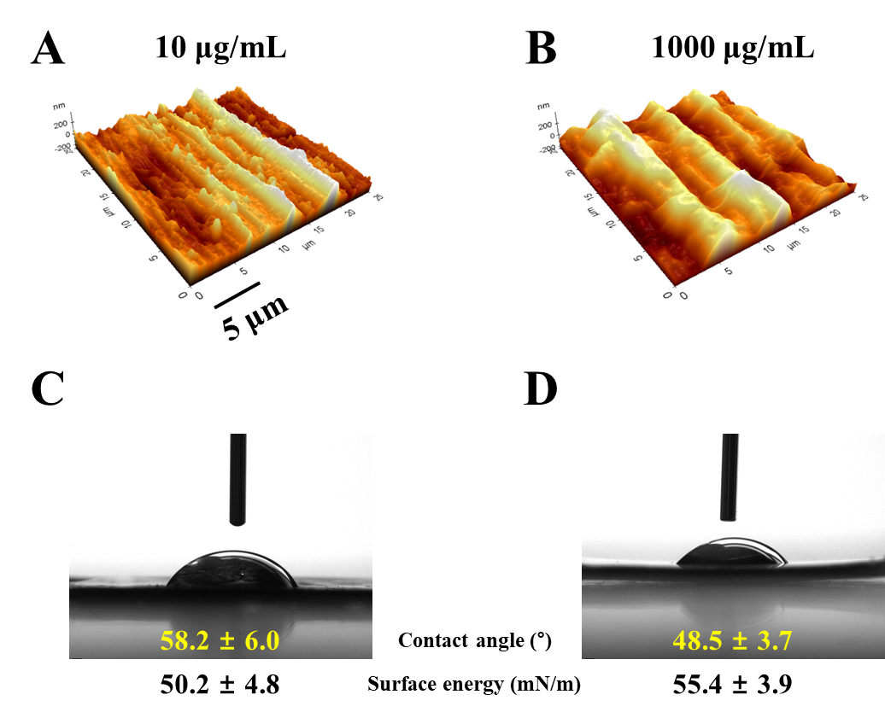
Fig. S1. Microscopic and contact angle analyses of R-ST surfaces coated with 10 and 1000 μg/mL of rGO. 3D AFM images of R-ST surfaces coated with (A) 10 and (B) 1000 μg/mL of rGO. Water contact angles (θ) of R-ST surfaces coated with (C) 10 and (D) 1000 μg/mL of rGO.

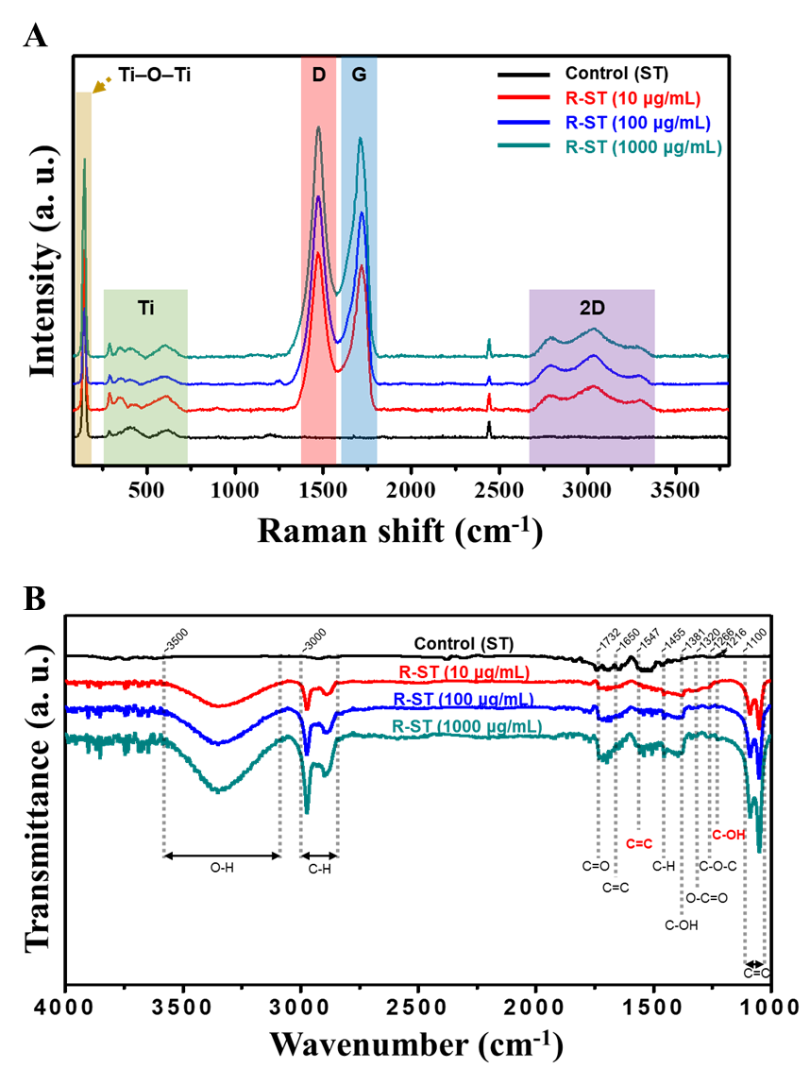
Fig. S2. Spectral analysis of ST and R-ST surfaces coated with a range of rGO concentrations (10, 100, and 1000 μg/mL). (A) Raman and (B) FTIR spectra of ST and R-ST discs.

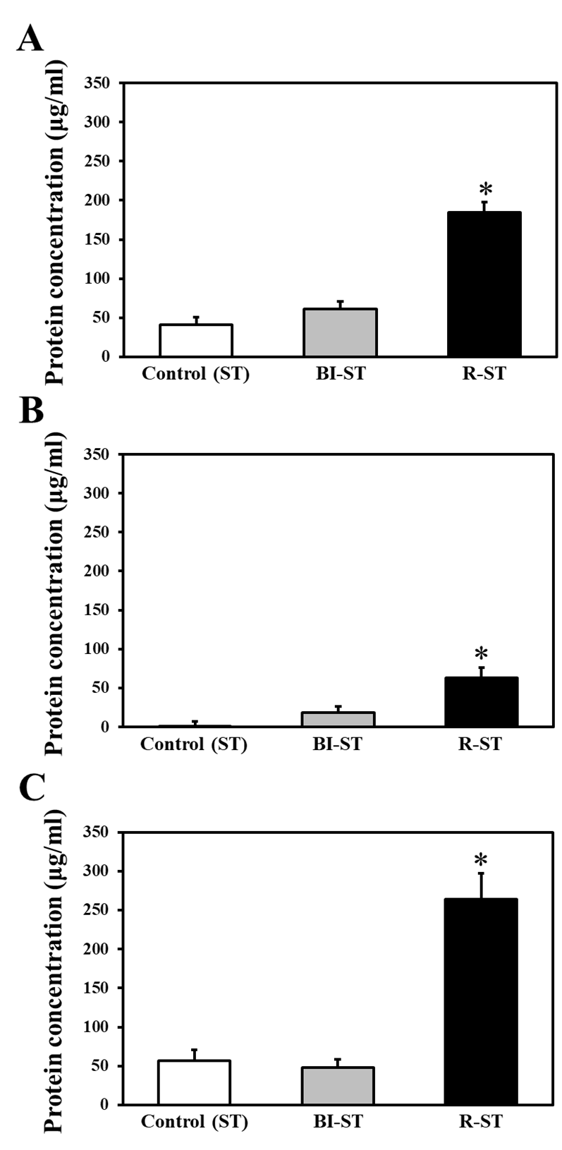
Fig. S3. Quantification of the surface protein adsorption on the ST, BI-ST, and R-ST discs. Protein concentrations were determined by the bicinchoninic acid (BCA) assay after incubation with (A) Dulbecco’s phosphate-buffered saline containing 10% fetal bovine serum (FBS), (B) basal media (α-MEM without any supplements and FBS), and (C) complete media (α-MEM with supplements and FBS) for 24 h at 37°C. The data are expressed as the mean ± SD (n = 6). An asterisk (*) denotes a statistically significant difference compared to the control (ST), p < 0.05.
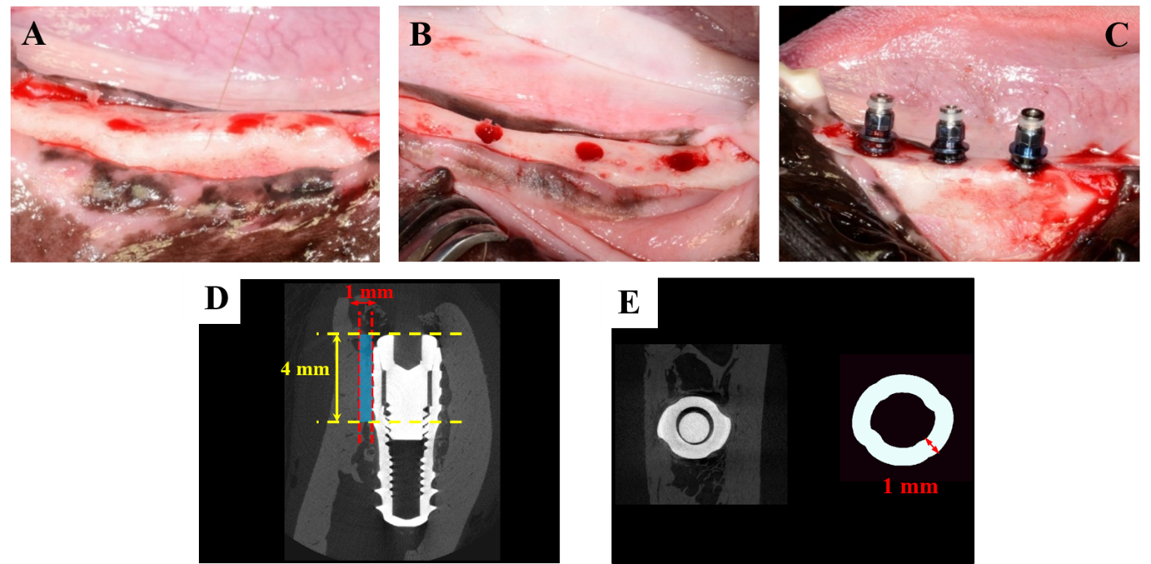
Fig. S4. (A) Clinical photographs depicting the flattening of alveolar bone, (B) trimming alveolar ridge into a flat ridge and making drilled holes for the implant placement. (C) implants inserted into the alveolar ridge by surgical procedures. The micro-computed tomography (μ-CT) images of mesiodistal section of all the implant sites were reconstructed. (D) The region of interest (ROI, shown in blue shade) with implant contact site displayed with a width of 1.0 mm and height of 4.0 mm. (E) 3D reconstructed μ-CT image of occlusal section of the implant site (left) and ROI around the implant (right).

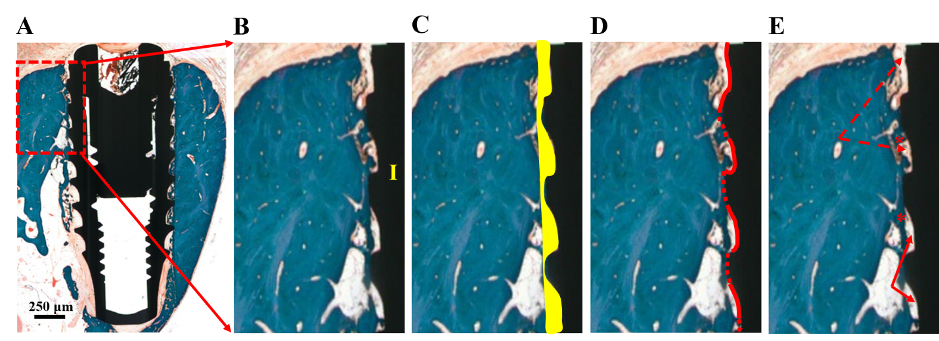
Fig. S5. (A) Histological specimen of ST implant (control). (B) A magnified view of the upper three threads of a region of interest (ROI), from which histomorphometric parameters such as bone-to-implant contact (BIC) area and intra-thread bone density (ITBD) were measured (A symbol, ‘I’ represents an implant fixture.). (C) BIC area shown with yellow shade. (D) The boundary line (red) has been drawn over the implant surface. The dotted line indicates the place of implant contact with the regenerated bone tissue whereas the solid line implies the void left. (E) The biological components involved in the bone tissue regeneration process are indicated as follows: solid arrow (void); dashed arrow (osteoid); new bone (*).

