SUPPLEMENTARY FIGURES

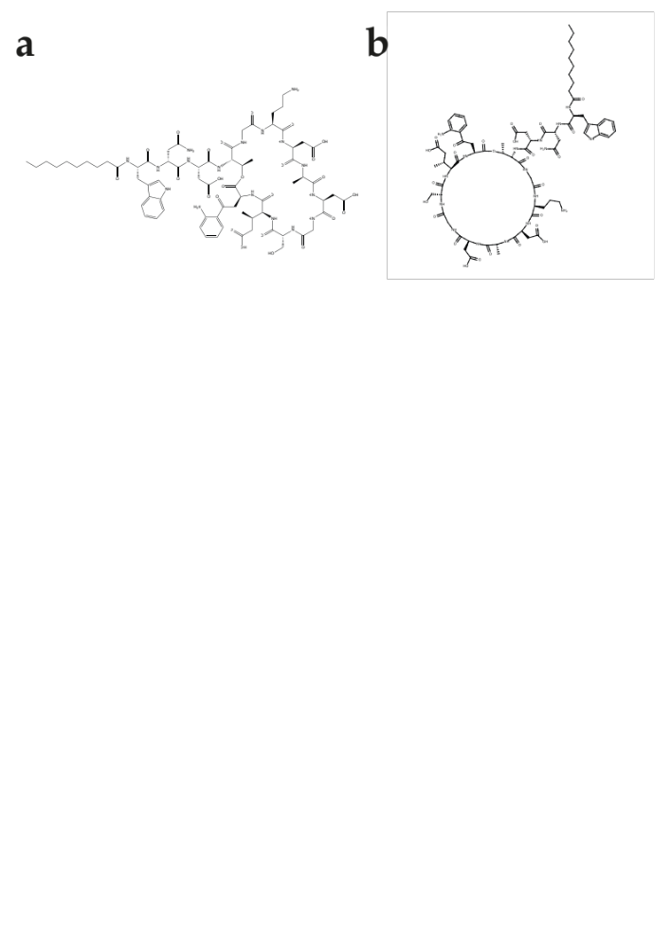
Figure S1. Two approaches for visualising macrocycles. A. Daptomycin visualised using the 'honeycomb’ approach in ChemDraw. B. Daptomycin visualised using the 'polygon' approach in PIKAChU.

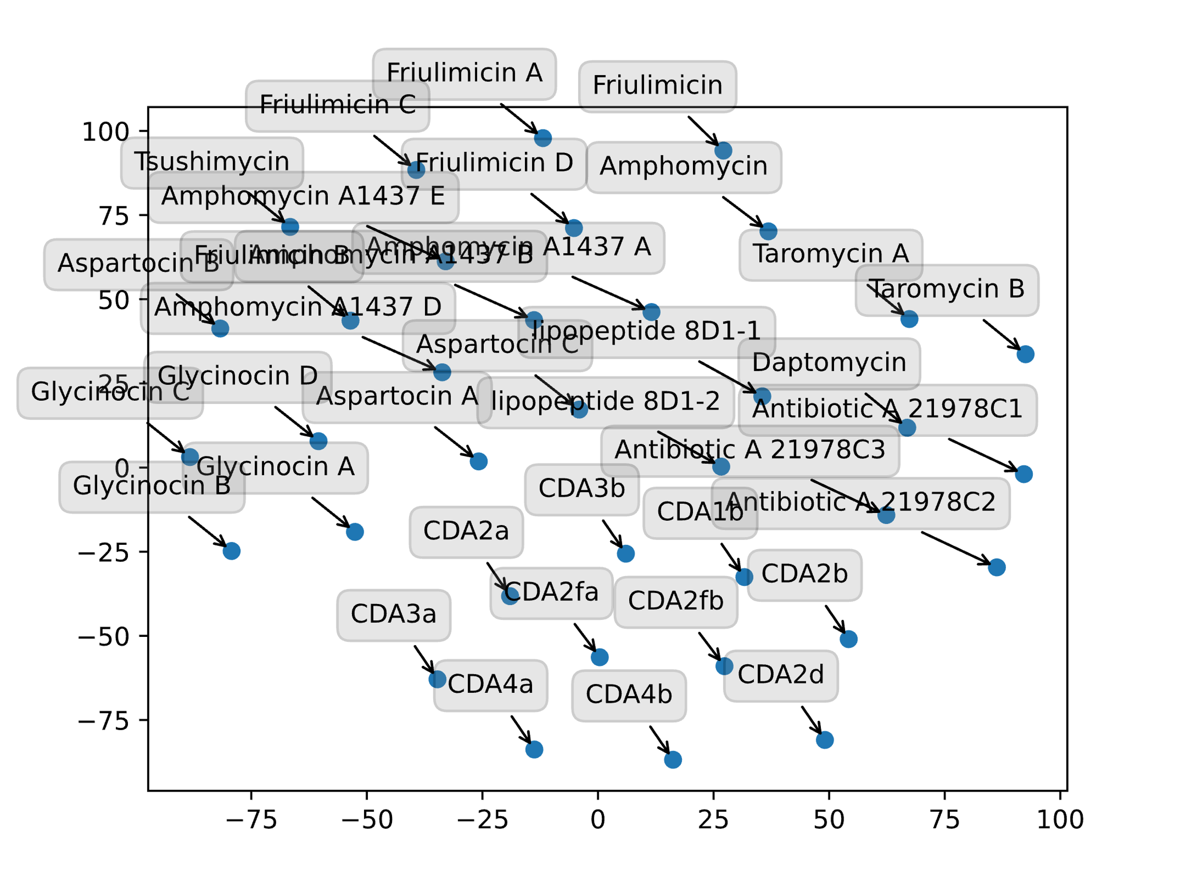
Figure S2: tSNE plot of 36 calcium-dependent lipopeptides drawn in a 2D plane based on the Tanimoto distances between their structures as computed by PIKAChU. The script and structures used to draw this figure can be found in the example_scripts and example_structures folders in GitHub, respectively.
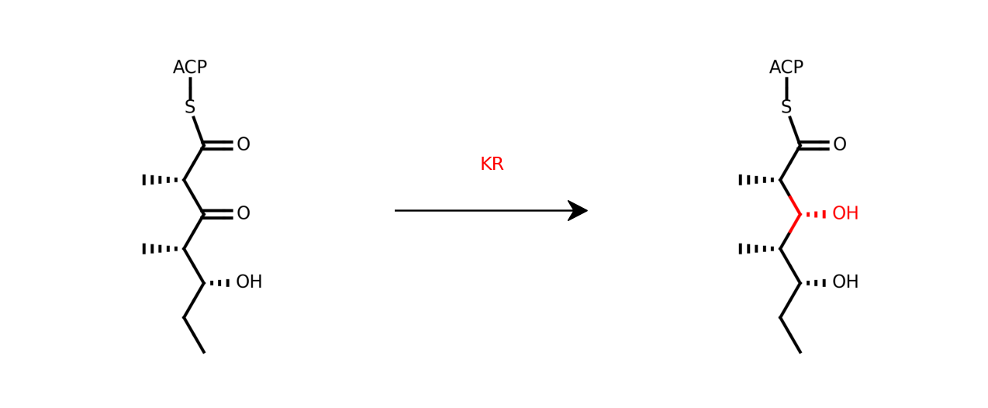
Figure S3. Visualisation of the polyketide ketoreduction reaction, built and visualised by PIKAChU. The reduced group is highlighted in red. The script performing this reaction can be found on GitHub.

