Supplementary Information for

Thermoelectric signature of quantum critical phase
in a doped spin liquid candidate

Crystal structure and band filling
Most of κ-type BEDT-TTF compounds have the composition of κ-(BEDT-TTF)₂X with anion, X. κ-(BEDT-TTF)₂X has a quasi-two-dimensional structure with conducting BEDT-TTF layers and insulating X layers alternately stacked. In the conducting layer, BEDT-TTF dimers form an isosceles triangular lattice characterised by two different transfer integrals, t and t’. In the insulating layer, anion, X, electronically has a closed shell structure with valence of -1. Therefore, the valence of BEDT-TTF is +0.5; namely, one hole resides per one dimer site so that the band is half-filled in most κ-(BEDT-TTF)₂X systems.
κ-(BEDT-TTF)₄Hg_{2.89}Br₈ is exceptional in that the lattice periodicity of Hg ions in the insulating layer is incommensurate with that of BEDT-TTF molecules in conducting layers^{1,2}, resulting in a deviation from the half filling of the band³. The incommensurability, namely, the nonstoichiometry in κ-(BEDT-TTF)₄Hg_{2.89}Br₈ is not varied but fixed by chemistry to give 11% hole doping to half-filing. Note that mercury-included compounds often have incommensurate structures⁴.
The ratio, t’/t, in κ-HgBr is 1.02 according to Ref.⁵, where the t and t’ values are evaluated by tight-biding approximations based on the extended Hückel calculations of molecular orbitals.

Contour plot of -S/T of sample #2
Figure S1 shows the contour plot of -S/T of sample #2 in pressure-temperature plane. The open circles are superconducting transition temperature evaluated from the temperature dependence of -S/T. The contour plot of sample #2 well reproduces that of sample #1 shown as Fig. 2b in the main text.

Temperature dependences of the resistivity and -S/T at 0.4 and 1.5 GPa
Figures S2a and S2b show the temperature dependences of -S/T and the resistivity of sample #2. The resistivity is normalised to the value at 15 K. The Seebeck coefficient and resistivity were measured simultaneously at the same setup. At 1.5 GPa, the resistivity shows the squared temperature dependence and -S/T is nearly constant at low temperatures, confirming the Fermi liquid behaviour. At 0.4 GPa, the resistivity shows linear-in-temperature dependence down to T_{c} and -S/T exhibit the logarithmic divergence down to T_{c}.

Definition of T_{c} and T*
Figure S3 shows the temperature dependence of -S/T at zero field under 0.3 GPa for sample #1. The uppermost and lowermost values and the midpoint defined in Fig. 3b correspond to the upper and lower bounds of the error bar. The onset temperature, T*, is defined as the temperature at which -S/T begins to deviate from the high-temperature normal-state behaviour.

Pressure dependence of |γ’| and T_{c}
Figure S4 shows the pressure dependences of |γ’| and T_{c}. The γ’ value was evaluated by fitting the form, S/T = γ’ln(T/T₀), to the experimental data. The T_{c} is the midpoint as described above.

γ’ values of S/T = γ’ln(T/T₀) for other materials
Table S1 lists the |γ’| values reported in literatures⁶⁻¹⁸, where γ’ values were evaluated from the behaviour of S/T = γ’ln(T/T₀).

References
1. Lyubovskaya, R. N. et al. Is the organic metal (ET)₄Hg₃Br₈ a Quasi-2d superconductor? JETP Lett. 45, 530–533 (1987).
2. Li, R., Petricek, V., Yang, G., Coppens, P. & Naughton, M. Room- and Low-Temperature Crystallographic Study of the Ambient Pressure Organic Superconductor (Bisethylene dithiotetrathiofulvalene)₄Hg_{2.89}Br₈. Chem. Mater. 10, 1521-1529 (1998).
3. Yamamoto, T. et al. Examination of the Charge-Sensitive Vibrational Modes in Bis(ethylenedithio)tetrathiafulvalene. J. Phys. Chem. B 109, 15226-15235 (2005).
4. Gillespie, R. J. et al. The Preparation and Structure of Chain and Sheet Mercury Compounds. Phil. Trans. R. Sot. Lond. A 314, 105 (1985).
5. Shimizu, Y., Maesato, M. & Saito, G. Uniaxial Strain Effects on Mott and Superconducting Transitions in κ-(ET)₂Cu₂(CN)₃. J. Phys. Soc. Jpn. 80, 074702 (2011).
6. Daou, R. et al. Thermopower across the stripe critical point of La_{1.6-x}Nd_{0.4}Sr_{x}CuO₄: evidence for a quantum critical point in a hole-doped high-T_{c} superconductor. Phys. Rev. B 79, 180505 (2009).
7. Laliberté, F. et al. Fermi-surface reconstruction by stripe order in cuprate superconductors. Nature Commun. 2, 432 (2011).
8. Lizaire, M. et al. Transport signatures of the pseudogap critical point in the cuprate superconductor Bi₂Sr_{2−x}La_{x}CuO_{6+δ}. Phys. Rev. B 104, 014515 (2021).
9. Mandal, P. R., Sarkar, T. & Greene, R. L. Anomalous quantum criticality in the electron-doped cuprates. Proc. Natl Acad. Sci. USA 116, 5991–5994 (2019).
10. Limelette, P., Saulquin, W., Muguerra, H. & Grebille, D., From quantum criticality to enhanced thermopower in strongly correlated layered cobalt oxide. Phys. Rev. B 81, 115113 (2010).
11. Arsenijević, S. et al. Signatures of quantum criticality in the thermopower of Ba(Fe_{1-x}Co_{x})₂As₂. Phys. Rev. B 87, 224508 (2013).
12. Malone, L. et al. Thermoelectricity of the ferromagnetic superconductor UCoGe. Phys. Rev. B 85, 024526 (2012).
13. Hartmann, S. et al. Thermopower evidence for an abrupt Fermi surface change at the quantum critical point of YbRh₂Si₂. Phys. Rev. Lett. 104, 096401 (2010)
14. Kuwai, T. et al. Thermoelectric Power at Low Temperatures in Ce(Ni_{1-x}Pd_{x})₂Ge₂ and CeCu_{5.9}Au_{0.1} in the Vicinity of Antiferromagnetic Quantum Critical Point. J. Phys. Soc. Jpn. 80, SA064 (2011).
15. Matusiak, M., Gnida, D. & Kaczorowski, D. Quantum criticality in Ce₂PdIn₈: A thermoelectric study. Phys. Rev. B 84, 115110 (2011).
16. Mun, E. D., Bud’ko, S. L. & Canfield, P. C. Thermoelectric power investigations of YbAgGe across the quantum critical point. Phys. Rev. B 82, 174403 (2010).
17. Mun, E. D. et al. Magnetic-field-tuned quantum criticality of the heavy fermion system YbPtBi. Phys. Rev. B 87, 075120 (2013).
18. Maiwald, J., Jeevan, H. S. & Gegenwart, P. Signatures of quantum criticality in hole-doped and chemically pressurized EuFe₂As₂ single crystals. Phys. Rev. B 85, 024511 (2012).

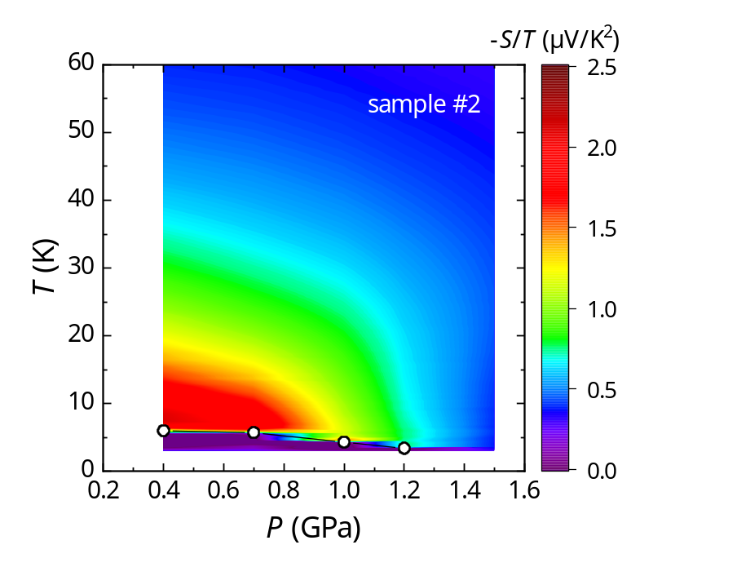
Figure S1 | Contour plot of -S/T in κ-HgBr for sample #2.
The graph shows the contour plot of -S/T for sample #2 in the pressure-temperature plane. The open circles indicate the superconducting transition temperature.

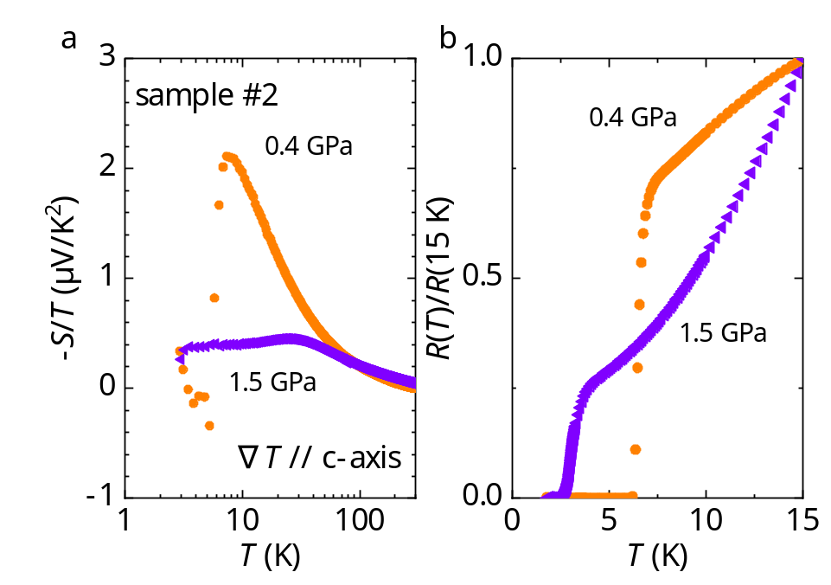
Figure S2 | Temperature dependences of the -S/T and resistivity simultaneously measured for sample #2 at 0.4 and 1.5 GPa.
a, Temperature dependence of -S/T in the logarithmic temperature scale. At 0.4 GPa, -S/T exhibits lnT behaviour. At 1.5 GPa, however, the Fermi liquid behaviour of -S/T=constant was observed. b, Temperature dependence of the resistivity normalised to its value of 15 K. The linear- and quadratic-in-temperature resistivity above T_{c} under 0.4 and 1.5 GPa indicate non-Fermi liquid and Fermi liquid behaviours, respectively.

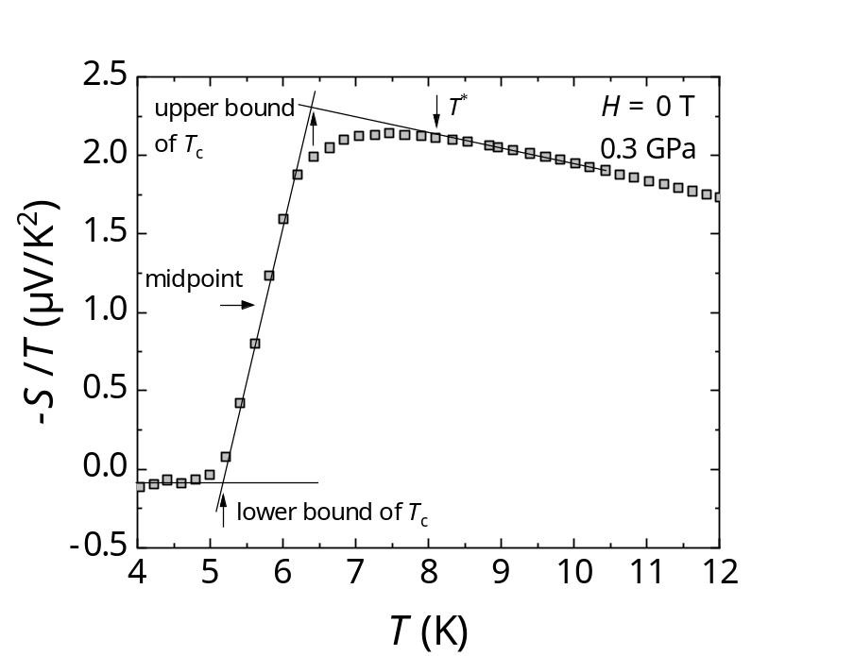
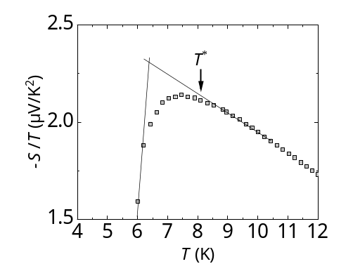
Figure S3 | Definition of T_{c} and T*.
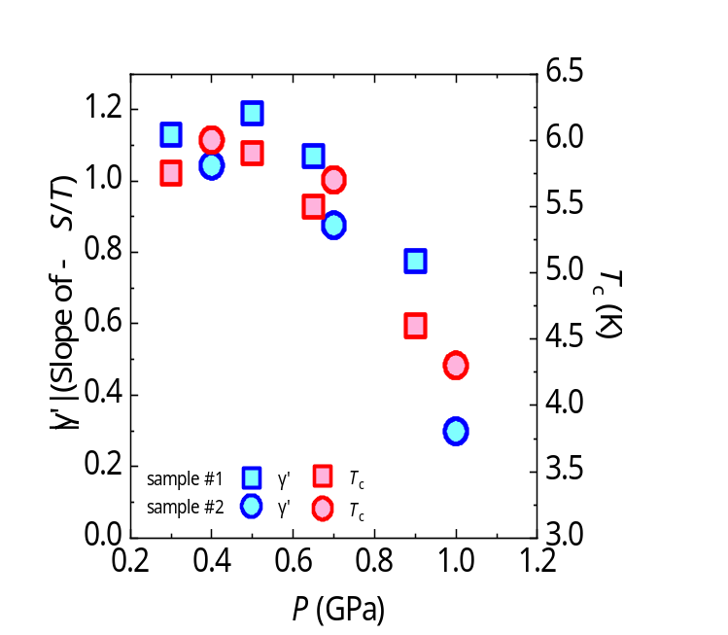
The definitions of bulk T_{c}, its error and the onset, T*, are shown for the 0.3 GPa data of -S/T of sample #1, for example. The bulk T_{c} is defined by the midpoint. The upper and lower bounds of T_{c} indicated in the figure determines the error bar of T_{c}. T* is defined as the temperature at which -S/T starts to deviate from the normal-state behaviour. The inset shows the enlarged view of the -S/T behaviour in the vicinity of T*.
Figure S4 | Pressure dependence of |γ’| and T_{c} in κ-HgBr.
The |γ’| and T_{c} values for sample #1 and #2 are plotted as a function of pressure. The squares and circles correspond to the data of sample #1 and #2, respectively. The blue and red symbols indicate |γ’| and T_{c}, respectively.

Table S1 | |γ’| values in the logarithmic part of -S/T in some materials
The |γ’| values in the behaviour of S/T = γ’ln(T/T₀) for other materials⁶⁻¹⁸ are listed in µV/K².

Material | Slope value | Material | Slope value
Nd-LSCO (p = 0.24) (ref.⁶) | 0.11 | UCoGe (H=11.1 T) (ref.¹²) | 2.3
Eu-LSCO (p = 0.24) (ref.⁷) | 0.16 | YbRh₂Si₂ (ref.¹³) | 4.5
Bi2201 (p = 0.39) (ref.⁸) | 0.05 | CeCu_{5.9}Au_{0.1} (ref.¹⁴) | 6.2
PCCO (x = 0.16-0.19) (ref.⁹) | 0.012-0.038 | Ce₂PdIn₈ (ref.¹⁵) | 1.6
LCCO (x = 0.15-0.17) (ref.⁹) | 0.0095 – 0.049 | YbAgGe (ref.¹⁶) | 4.7
[BiBa_{0.66}K_{0.36}O₂]CoO₂ (ref.¹⁰) | 0.62 | YbPtBi (ref.¹⁷) | 0.25
Ba(Fe_{1−x}Co_{x})₂As₂  (p=0.022-0.13) (ref.¹¹) | 0.32 - 0.895 | EuFe₂(As_{1-y}P_{y})₂  (y=0.26, 0.36) (ref.¹⁸) | 0.077, 0.16

