Supplementary Information
Supplementary Figures

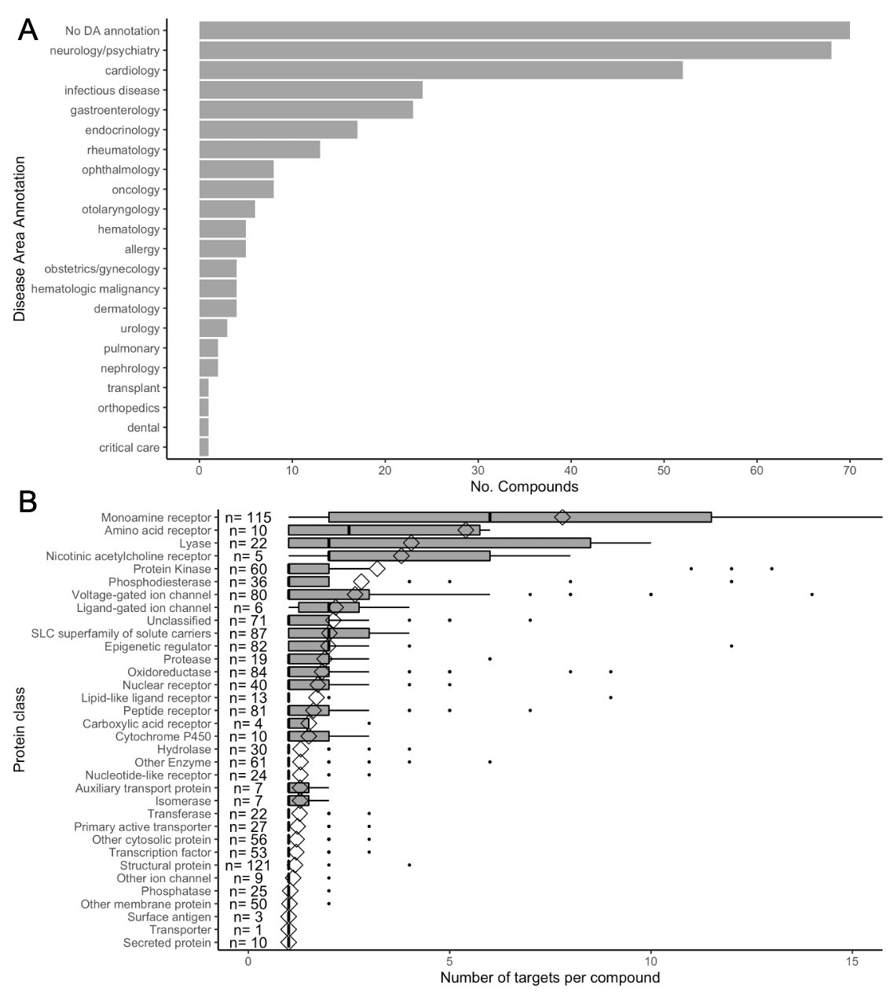
Supplementary Figure 1: Distribution of Disease Area annotations (A) and target protein classes (obtained from ChEMBL) (B) in the set of compounds used in this study. The number of unique compounds targeting proteins in each class is annotated next to each protein class label.

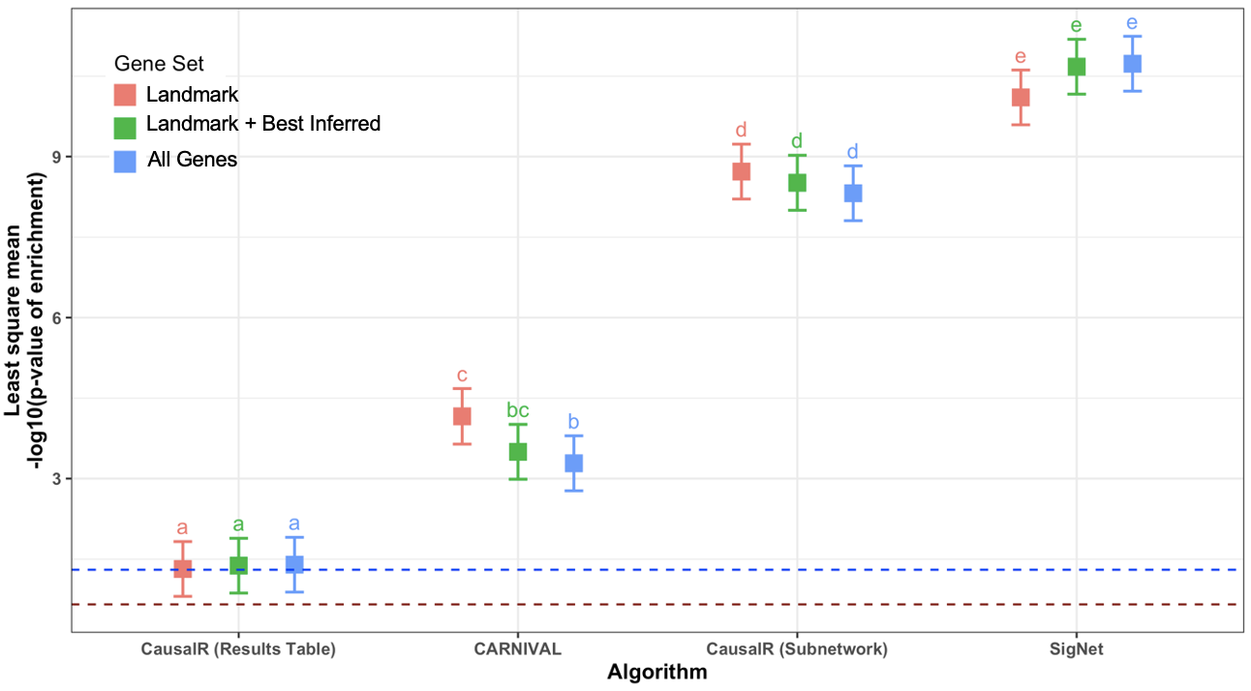
Supplementary Figure 2: Interaction plot showing post-hoc least square means results for the Algorithm:Gene set interaction effect from the full-factorial fixed effects ANOVA of compound-associated pathway recovery across all other factors. Means sharing a letter are not significantly different according to pairwise comparisons of least square means with Tukey adjustment for multiple comparisons. Error bars indicate the 95% confidence levels. Baseline comparison with mean results from input gene expression data is indicated with a dashed red line, while the significance threshold p=0.05 is indicated with a blue dashed line. It can be seen that the least square mean differences are not significant within each algorithm, except for a small increase in performance using landmark genes vs. all genes with CARNIVAL.

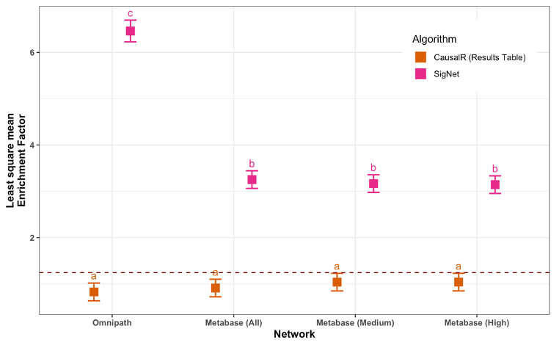
Supplementary Figure 3: Interaction plot showing post-hoc least square means results for the Network:Algorithm interaction effect from the full-factorial fixed effects ANOVA of Enrichment Factor across all factors (for the two ranked table outputs, CausalR and SigNet). Means sharing a letter are not significantly different according to pairwise comparisons of least square means with Tukey adjustment for multiple comparisons. Error bars indicate the 95% confidence levels. Baseline comparison with mean results from input gene expression data is indicated with a dashed red line.

Supplementary Figure 4: Percentage of network nodes belonging to each protein class for each network used in this study, showing that all networks are biased towards protein kinases
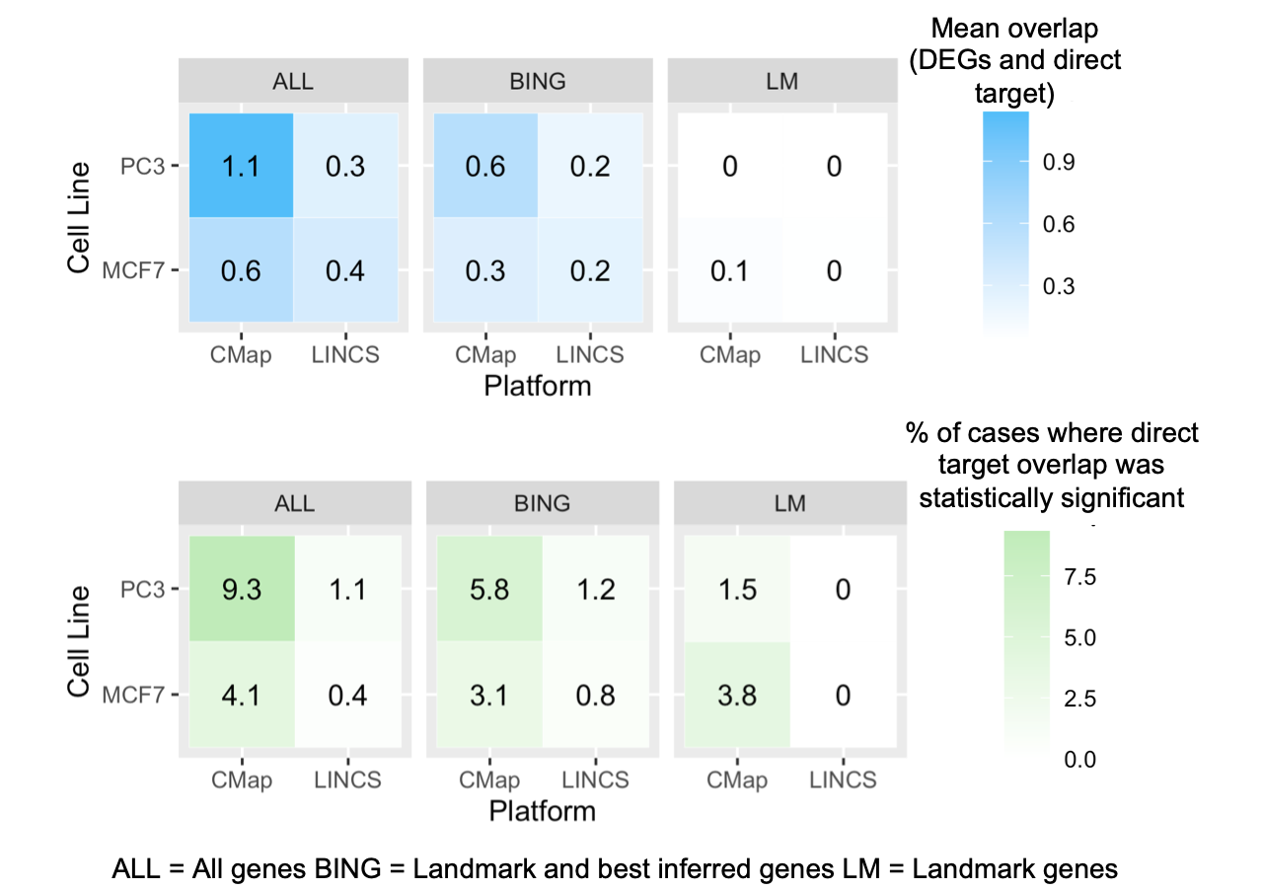
Supplementary Figure 5: Mean number of recovered direct targets (blue) and mean percentage of cases where the number of targets recovered was statistically significant (Fisher’s Exact Test p < 0.05) (green) based on direct target recovery from differentially expressed genes (DEGs) across all compounds, separated into the different combinations of cell line, platform and gene set.
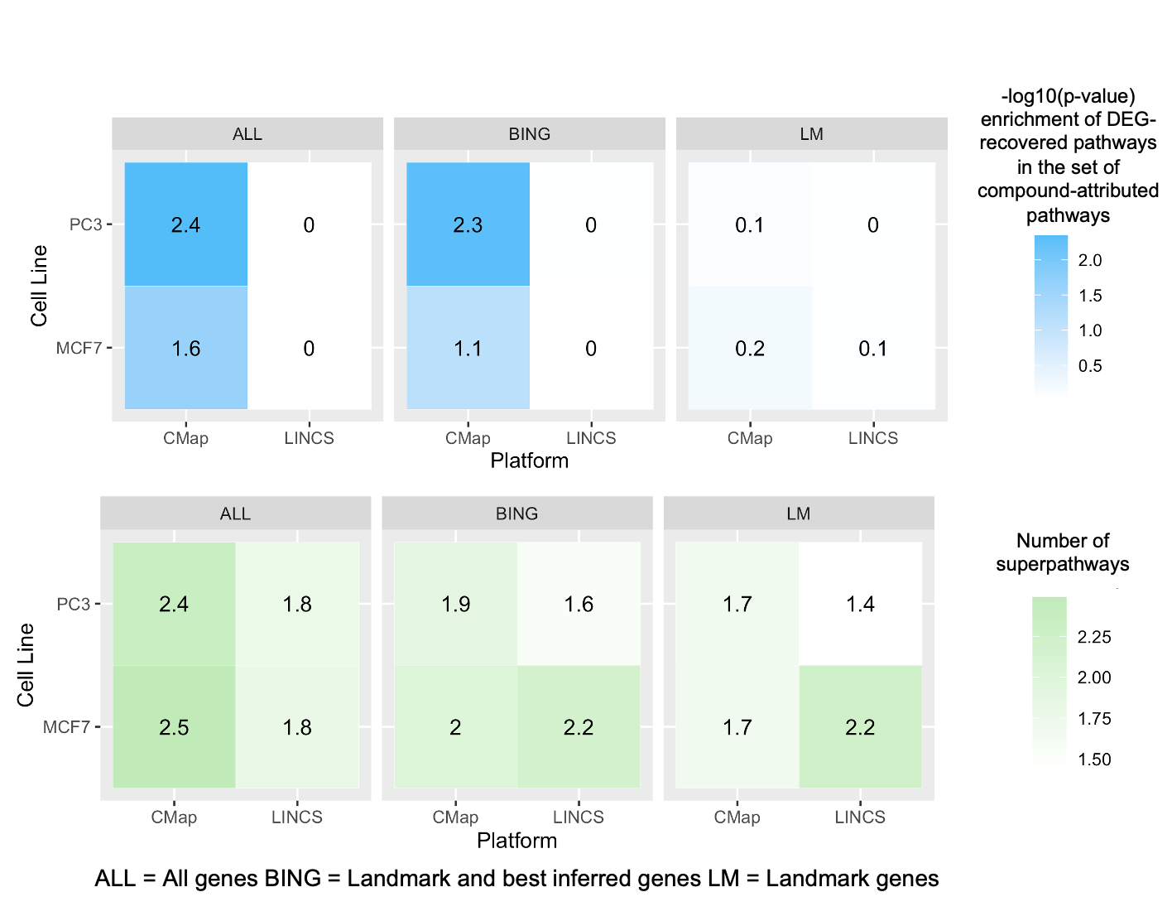
Supplementary Figure 6: Mean significance of compound-associated pathway enrichment (blue) and mean number of superpathways of recovered pathways (green), based on pathway enrichment with DEGs across all compounds, separated into the different combinations of cell line, platform,and gene set.

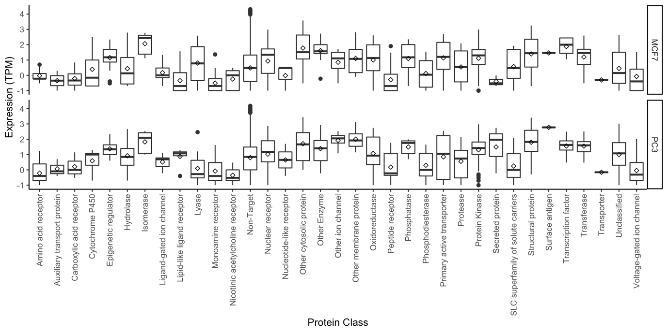
Supplementary Figure 7: RNA-Seq expression level (log10 TPM or Transcripts Per Million) distribution per-protein class (ChEMBL), baseline expression in MCF7 and PC3 cell lines, data from ExpressionAtlas¹ .

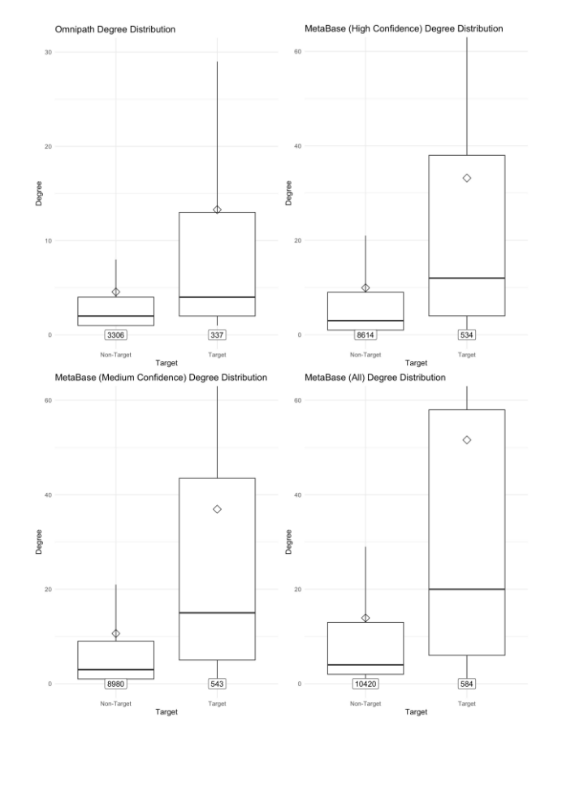
Supplementary Figure 8: Distributions of the degree of connectivity for target vs. non-target nodes on each network. Each distribution was compared with a one-sided Wilcoxon rank sum test to assess the probability of the target nodes being more densely connected than non-target nodes by random chance, found to be significant (p < 0.0001) in all cases.

Supplementary Tables

Supplementary Table 1: Statistics relating to the 4 prior knowledge networks used in this analysis, including number of nodes and edges, network density (median and mean degree of nodes), and their coverage of the targets modulated by the compounds in the test set
Network | Nodes | Edges | Median Degree | Mean Degree | Target Coverage  N = 681
Omnipath | 3610 | 9306 | 2 | 5 | 49.5% (337)
Metabase  (All confidence levels) | 11004 | 87556 | 5 | 16 | 85.7% (584)
Metabase  (Medium confidence) | 9523 | 57758 | 4 | 12 | 79.7% (543)
Metabase  (High confidence) | 9148 | 51730 | 4 | 11 | 78.4% (534)

Supplementary Table 2: ANOVA results for the target overlap evaluation metric showing main and interaction effects. Pr(>F) = probability of F value being at least as high as randomly expected
 | Degrees of freedom | Sum of Squares | Mean Square | F value | Pr(>F)
Network | 3 | 35 | 11.6 | 8.873 | 7.10E-06
Algorithm | 3 | 4036 | 1345.3 | 1028.681 | < 2e-16
Platform | 1 | 2 | 1.7 | 1.305 | 0.2534
Gene_Set | 2 | 6 | 3 | 2.257 | 0.1047
Cell_Line | 1 | 4 | 4 | 3.022 | 0.0821
Network:Algorithm | 9 | 1146 | 127.3 | 97.326 | < 2e-16
Network:Platform | 3 | 0 | 0.1 | 0.058 | 0.9818
Network:Gene_Set | 6 | 0 | 0 | 0.02 | 1
Network:Cell_Line | 3 | 1 | 0.4 | 0.329 | 0.8045
Algorithm:Platform | 3 | 3 | 0.9 | 0.682 | 0.563
Algorithm:Gene_Set | 6 | 6 | 1 | 0.753 | 0.6073
Algorithm:Cell_Line | 3 | 3 | 1.1 | 0.865 | 0.4583
Platform:Gene_Set | 2 | 7 | 3.7 | 2.865 | 0.057
Platform:Cell_Line | 1 | 0 | 0 | 0.013 | 0.9091
Gene_Set:Cell_Line | 2 | 0 | 0.2 | 0.16 | 0.8522
Residuals | 49399 | 64606 | 1.3

Supplementary Table 3: ANOVA results for the two-step enrichment evaluation metric showing main and interaction effects. Pr(>F) = probability of F value being at least as high as randomly expected
 | Degrees of freedom | Sum of Squares | Mean Square | F value | Pr(>F)
Network | 3 | 91179 | 30393 | 222.863 | < 2e-16
Algorithm | 3 | 687191 | 229064 | 1679.648 | < 2e-16
Platform | 1 | 5 | 5 | 0.037 | 0.84738
Gene_Set | 2 | 179 | 90 | 0.658 | 0.51786
Cell_Line | 1 | 19 | 19 | 0.136 | 0.71246
Network:Algorithm | 9 | 121165 | 13463 | 98.718 | < 2e-16
Network:Platform | 3 | 156 | 52 | 0.381 | 0.76659
Network:Gene_Set | 6 | 356 | 59 | 0.435 | 0.85594
Network:Cell_Line | 3 | 13 | 4 | 0.031 | 0.99264
Algorithm:Platform | 3 | 118 | 39 | 0.289 | 0.83307
Algorithm:Gene_Set | 6 | 2980 | 497 | 3.642 | 0.00129
Algorithm:Cell_Line | 3 | 74 | 25 | 0.18 | 0.90993
Platform:Gene_Set | 2 | 82 | 41 | 0.3 | 0.74052
Platform:Cell_Line | 1 | 47 | 47 | 0.348 | 0.55545
Gene_Set:Cell_Line | 2 | 292 | 146 | 1.069 | 0.34327
Residuals | 51030 | 6959270 | 136

Supplementary Table 4: Full least square means results for the Network:Algorithm interaction effect for the direct target recovery ANOVA model (depicted graphically in Figure 3), showing the 95% confidence levels, group letter, and the % of cases where the number of targets recovered was statistically significant (p<=0.05, Fisher’s Exact Test).
Network | Algorithm | lsmean | Lower CL | Upper CL | Group | % Significant
Metabase All | CARNIVAL | 0.071 | 0.00997 | 0.132 | a | 3.21
Metabase Med | CARNIVAL | 0.121 | 0.06153 | 0.181 | a | 3.4
Metabase High | CARNIVAL | 0.125 | 0.06502 | 0.185 | a | 3.4
Omnipath | CausalR Table | 0.155 | 0.09449 | 0.215 | a | 1.27
Omnipath | CausalR Network | 0.307 | 0.24625 | 0.367 | b | 7.76
Omnipath | CARNIVAL | 0.369 | 0.30847 | 0.429 | b | 6.14
Metabase High | CausalR Table | 0.512 | 0.4521 | 0.572 | c | 3.43
Metabase All | CausalR Table | 0.558 | 0.49867 | 0.618 | cd | 3.77
Metabase Med | CausalR Table | 0.571 | 0.5109 | 0.63 | cd | 4.37
Metabase Med | CausalR Network | 0.576 | 0.5165 | 0.636 | cd | 14.25
Metabase High | CausalR Network | 0.584 | 0.52468 | 0.644 | cd | 14.47
Metabase All | CausalR Network | 0.638 | 0.57816 | 0.698 | d | 14.47
Metabase All | SigNet | 0.853 | 0.79266 | 0.912 | e | 20.93
Metabase Med | SigNet | 0.913 | 0.85351 | 0.973 | e | 21.57
Metabase High | SigNet | 0.924 | 0.86366 | 0.983 | e | 22.19
Omnipath | SigNet | 1.379 | 1.30459 | 1.453 | f | 23.36

Supplementary Table 5: Full least square means results for the Network:Algorithm interaction effect for the compound-associated pathway recovery ANOVA model (depicted graphically in Figure 3), showing the 95% confidence levels and group letter
Network | Algorithm | lsmean | Lower CL | Upper CL | Group
Metabase High | CausalR Table | 1.02 | 0.414 | 1.63 | a
Metabase All | CausalR Table | 1.15 | 0.539 | 1.76 | ab
Metabase Med | CausalR Table | 1.21 | 0.597 | 1.81 | abc
Omnipath | CausalR Table | 2.08 | 1.471 | 2.69 | bcd
Metabase All | CARNIVAL | 2.19 | 1.567 | 2.81 | cd
Metabase High | CARNIVAL | 2.85 | 2.239 | 3.46 | d
Metabase Med | CARNIVAL | 3.07 | 2.464 | 3.68 | d
Omnipath | CARNIVAL | 6.48 | 5.871 | 7.09 | e
Metabase High | SigNet | 7.66 | 7.049 | 8.27 | f
Omnipath | CausalR Network | 7.91 | 7.294 | 8.52 | fg
Metabase Med | SigNet | 8.22 | 7.61 | 8.83 | fg
Metabase High | CausalR Network | 8.59 | 7.978 | 9.19 | fgh
Metabase All | CausalR Network | 8.74 | 8.133 | 9.35 | gh
Metabase Med | CausalR Network | 8.83 | 8.224 | 9.44 | gh
Metabase All | SigNet | 9.35 | 8.745 | 9.96 | h
Omnipath | SigNet | 16.8 | 16.193 | 17.41 | i

References:
1 I. Papatheodorou, N. A. Fonseca, M. Keays, Y. A. Tang, E. Barrera, W. Bazant, M. Burke, A. Füllgrabe, A. M.-P. Fuentes, N. George, L. Huerta, S. Koskinen, S. Mohammed, M. Geniza, J. Preece, P. Jaiswal, A. F. Jarnuczak, W. Huber, O. Stegle, J. A. Vizcaino, A. Brazma and R. Petryszak, Expression Atlas: gene and protein expression across multiple studies and organisms, Nucleic Acids Res, 2018, 46, D246–D251.

