Table 1: Showing the names, chemical structure, molar mass, molecular formulae, and the biological activities of each compound identified by GCMS analysis.
Peak Numbers | R. Time | Peak Area % | Height % | A/H | Mark Name | Chemical formulae | Molecular Structure | Molecular weight (g/mol) | Biological activities
1 | 5.727 | 0.14 | 0.32 | 4.28 | 1-(2-furanyl)-Ethanone | C₆H₆O₂ | 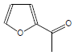 | 110 | Antioxidant and antifungal agent³²
2 | 5.932 | 0.4 | 1.54 | 2.62 | 2(5H)-Furanone | C₄H₄O₂ | 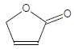 | 84 | Antimicrobial agent³³
3 | 6.043 | 0.3 | 0.88 | 3.46 | 2-ethyl-2-Butenal | C₆H₁₀O | 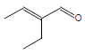 | 98 | Not reported
4 | 6.21 | 0.75 | 2.31 | 3.27 | 5-methyl-2(5H)-Furanone | C₅H₆O₂ | 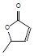 | 98 | Flavoring agent, antifungal and antibacterial³⁴
5 | 6.251 | 0.27 | 1.42 | 1.9 | N-cyclohexylidene-Methanamine, | ‎C₇H₁₃N | 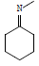 | 111 | Anticonvulsant agent³⁵
6 | 6.379 | 3.2 | 8.17 | 3.93 | 5-methyl-2-Furancarboxaldehyde | C₆H₆O₂ | 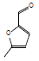 | 110 | Fungicide and nematicide, antibacterial, antiinflammatory, Proteinase inhibitor³⁶
7 | 6.451 | 0.57 | 1.89 | 3.02 | 1,4,5-trimethyl-imidazole | C₆H₁₀N₂ | 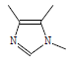 | 110 | Carcinogenic³⁷
8 | 6.584 | 0.57 | 1.72 | 3.36 | 1-(3-thienyl)-ethanone | C₆H₆OS | 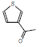 | 126 | Antifungal, antitubercular, and anticancer activities³⁸
9 | 6.653 | 0.87 | 4.37 | 1.99 | 2,4-Dihydroxy-2,5-dimethyl-3(2H)-furan-3 | ‎C₆H₈O₄ | 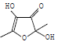 | 144 | Antibacterial and antifungal activities Flavoring³⁹
10 | 6.69 | 0.42 | 1.79 | 2.35 | 4-oxo-methyl ester-pentanoic acid | C₆H₁₀O₃ | 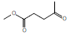 | 130 | Antioxidant and antimicrobial agent⁴⁰
11 | 6.957 | 1.17 | 1.41 | 8.31 | Triethylenediamine | C₆H₁₂N₂ | 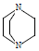 | 112 | Herbicidal and antibacterial⁴¹
12 | 7.483 | 0.53 | 1.77 | 3 | Benzeneacetaldehyde | C₈H₈O |  | 120 | Antioxidant, mutagenic, and antimicrobial⁴²
13 | 8.194 | 2.18 | 3.97 | 5.52 | 1-(2-furanyl)-1-propanone | C₇H₈O₂ | 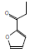 | 124 | Antibacterial⁴³
14 | 8.272 | 3.14 | 4.13 | 7.63 | Methyl 2-furoate | C₆H₆O₃ | 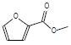 | 126 | Biofilm inhibitors, Antifungal, Antioxidant activity⁴⁴
15 | 8.723 | 3.21 | 3.78 | 8.52 | Levoglucosenone | C₆H₆O₃ | 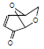 | 126 | Anticancer and antitumor activity⁴⁵
16 | 9.281 | 8.85 | 11.32 | 7.84 | methyl ester-Hepta-2,4-dienoic acid | C₈H₁₂O₂ | 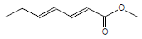 | 140 | Antioxidant activity⁴⁶
17 | 9.417 | 3.4 | 3.19 | 10.69 | 2,3-dihydro-3,5-dihydroxy-4H-pyran-4-one | ‎C₅H₆O₄ | 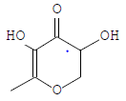 | 130 | Antibiofilm, Melanin production inhibitor, Antioxidant, Antimicrobial activity⁴⁷
18 | 10.302 | 1.05 | 1.64 | 6.39 | 3-Methyl-2-furoic acid | 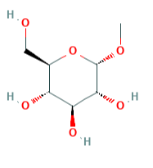  C₆H₆O₃ | 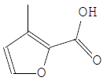 | 126 | Bactericidal, fungicidal and nematocidal agent⁴⁸
19 | 11.175 | 31.06 | 8.74 | 35.66 | 5-Hydroxymethylfurfural | C₆H₆0₃ | 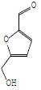 | 126 | Antioxidant, antimicrobial, Antiproliferative, Antibiofilm⁴⁹
20 | 11.388 | 0.42 | 0.69 | 6.16 | 3-(hydroxymethyl)-6-2-C  cyclohexen-1-one | C₇H₁₀O₂ | 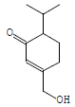 | 126 | Not reported
21 | 11.952 | 1.29 | 1.61 | 8.05 | 2-Heptanol, acetate | C₉H₁₈O₂ | 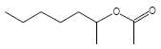 | 158 | Ovicidal and lavicidal⁵⁰
22 | 12.406 | 0.47 | 0.53 | 8.9 | O-α-D-glucopyranosyl-(1.fwdarw.3)-β-D-fructofuranosyl-α-D-Glucopyranoside | C₁₈H₃₂O₁₆ | 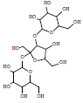 | 504 | Anti-diabetic, anti-hyperlipidemic, anti-oxidant activity⁵¹
23 | 12.838 | 0.47 | 1.11 | 4.25 | 5-(2-furanylmethyl 2-furancarboxaldehyde | C₁₀H₈O₃ | 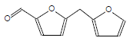 | 176 | Antimicrobial⁵²
24 | 13.612 | 0.3 | 0.75 | 4.01 | 3,5-Dimethyl-1H-pyrazol-4-yl)acetic acid | C₇H₁₁N₃O₂ | 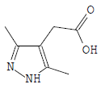 | 154 | Herbicidal and antimicrobial⁵³
25 | 13.744 | 1.08 | 3.68 | 2.95 | 5-[(5-methyl-2-furanyl)-methyl2-furancarboxaldehyde | C₆H₆O₂ | 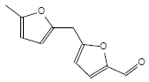 | 190 | fungicide and nematicide⁵⁴
26 | 14.803 | 9.95 | 2.91 | 34.25 | 1,6-anhydro-β-D-glucopyranose | C₆H₁₀O₅ | 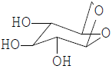 | 162 | Human metabolites, biomarkers, anti-human immunodeficiency virus, and blood  anti-coagulant⁵⁵
27 | 15.573 | 2.18 | 1.52 | 14.34 | O-α-D-glucopyranosyl-(1.fwdarw.3)-β-D-fructofuranosyl-α-D-glucopyranoside | C₁₈H₃₂O₁₆ |  | 504 | Anticonvulsant, antioxidant, antitumor, antibactetria⁵⁶
28 | 16.885 | 16.31 | 5.43 | 30.12 | 3-O-Methyl-d-glucose | C₇H₁₄O₆ | 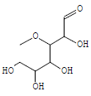 | 194 | Preservatives, anti-inflammatory, and antitumor agent^{57,58}
29 | 17.21 | 1.38 | 5.19 | 2.68 | n-Hexadecanoic acid | ‎C₁₆H₃₂O₂ | 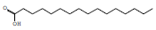 | 256 | Nematicide, Hemolytic, Anti-androgenic, Antidiabetic Hypocholesterolemic, Anti-oxidant and pesticidal⁵⁹
30 | 17.508 | 0.28 | 0.97 | 2.89 | 9-oxabicyclo[6.1.0]non-6-en-2-one | C₈H₁₀O₂ | 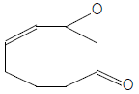 | 138 | Unknown
31 | 17.702 | 0.32 | 0.48 | 4.54 | 2-(hydroxymethyl)-cyclohexanone | C₇H₁₂O₂ | 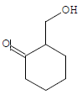 | 128 | Antibacterial activities⁶⁰
32 | 18.052 | 0.38 | 2.19 | 1.76 | methyl ester, (Z)-7-hexadecenoic acid | C₁₇H₃₂O₂ | 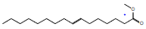 | 268 | Antimicrobial and antioxidant⁶¹
33 | 18.368 | 2.35 | 6.68 | 3.53 | cis-Vaccenic acid | C₁₈H₃₄O₂ | 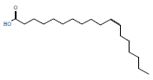 | 283 | Antimicrobial⁶²
34 | 18.459 | 0.09 | 0.67 | 1.31 | Octadecanoic acid | C₁₈H₃₆O₂ | 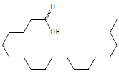 | 285 | Anticancer and antibacterial activity⁶³
35 | 20.534 | 0.11 | 0.48 | 2.17 | 2-hydroxy-1-(hydroxymethyl)ethyl ester-hexadecanoic acids | C₁₉H₃₈O₄ | 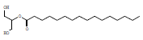 | 330 | Antioxidant, antimicrobial, Flavoring agent, 5-Alpha reductase-inhibitor, Pesticide, Antifibrinolytic, and Hemolytic agent⁶⁴
36 | 21.796 | 0.55 | 0.52 | 10.61 | (Z)-2,3-dihydroxypro-9-octadecenoic acid | C₂₁H₄₀O₄ | 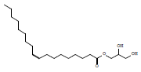 | 357 | Flavoring agent, Lubricant, Antioxidant, Larvicidal, and analgesic activities⁶⁵
37 | 22.229 | 0.12 | 0.22 | 5.45 | β-Sitosterol | C₂₉H₅₀O | 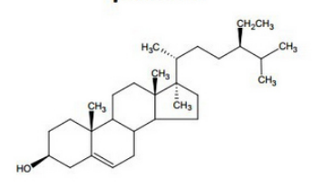 | 414 | Antimicrobial, Antioxidant anti-inflammatory, antidiabetic, Immunomodulatory, Anthelminthic and Anti-mutagenic Activities⁶⁶

