Voluminous storage and rapid magma ascent beneath La Palma revealed by seismic tomography

Luca D'Auria^{1,2}, Ivan Koulakov^{3,4,5}, Janire Prudencio^{6,7}, Iván Cabrera-Pérez¹, Jesús M. Ibáñez^{6,7 *}, Jose Barrancos^{1,2}, Rubén García-Hernández¹, David Martínez van Dorth^{1,2}, Germán D. Padilla^{1,2}, Monika Przeor^{1,2}, Victor Ortega¹, Pedro Hernández^{1,2}, Nemesio M. Peréz^{1,2}
- Instituto Volcanológico de Canarias (INVOLCAN), Calle Álvaro Martín Díaz, 2, San Cristóbal de La Laguna, Tenerife, Spain
- Instituto Tecnológico y de Energías Renovables (ITER), Polígono Industrial de Granadilla s/n, 38600, Granadilla de Abona, Tenerife, Spain
- Trofimuk Institute of Petroleum Geology and Geophysics SB RAS, Prospekt Koptyuga, 3, 630090 Novosibirsk, Russia
- Novosibirsk State University, Novosibirsk, Russia, Pirogova 2, 630090 Novosibirsk, Russia
- Institute of the Earth’s Crust SB RAS, Lermontova 128, Irkutsk, Russia
- Department of Theoretical Physics and Cosmos. Science Faculty. Avd. Fuenteneueva s/n. University of Granada. 18071. Granada. Spain.
- Andalusian Institute of Geophysiscs. Campus de Cartuja. University of Granada. C/Profesor Clavera 12. 18071. Granada. Spain.
* Corresponding author: Jesús M. Ibáñez (jibanez@ugr.es)

Supplementary materials
Previous Canary Islands structural studies
There is a lack of consensus on the origin and evolution of the Canary Islands archipelago, in part because knowledge of deep structures is scarce and inconclusive. One model presents a mantle plume beneath the western Canary Islands (El Hierro and La Palma)^{7,25}. In this model, material flows from the plume to the east, crossing the north-western African continent, travelling along the base of the oceanic lithosphere below the Canary Islands, and finally flowing into a sub-continental lithospheric corridor beneath the Atlas Mountain system.
Using compressional to shear (P to S) converted seismic phases from teleseismic receiver functions, Lodge et al.²⁶ parameterised the crustal and upper mantle structure below La Palma. They identified discontinuities at ∼8 and 14 km depth. The discontinuity at ~8 km depth may correspond to the Moho, while that at 14 km offers clear evidence of magmatic underplating.
Based on P-receiver functions, Martínez-Arévalo et al.²⁷ suggested that the Moho discontinuity beneath the Canary Islands deepens towards the east, varying in depth from 11.5 to 12.5 km beneath the western islands (El Hierro and La Palma) and up to 20–30 km beneath the eastern islands (Lanzarote and Fuerteventura). They identified a low velocity layer beneath the lithospheric mantle (at 45–65 km depth), which they interpret as a large plume feeding the Canary Islands volcanic system.
From seismic velocity tomography of El Hierro island, García-Yeguas et al.⁹ determined the base of the oceanic crust to be at 10–12 km depth. They did not observe a magma reservoir. Based on their results, they suggest that the magma intrusion responsible of the 2011 eruptive process warped the Moho below the island, causing localised thinning of the oceanic crust to < 8 km.
Numerous seismic tomography studies of volcanic regions have identified shallow low-velocity structures that are interpreted as highly fractured, unconsolidated, and/or hydrothermally altered volcanic materials, including those for Deception Island volcano^{28–30} and Mt. Etna^{31,32}. Similar anomalies have been observed beneath the island of Tenerife^{8,10}.

Supplementary references
- Van den Bogaard, P. The origin of the Canary Island Seamount Province-New ages of old seamounts. Sci. Rep. 3(1), 1–7 (2013).
- Lodge, A., Nippress, S. E. J., Rietbrock, A., García-Yeguas, A. & Ibáñez, J. M. Evidence for magmatic underplating and partial melt beneath the Canary Islands derived using teleseismic receiver functions. Phys. Earth Planet. Int. 212, 44–54 (2012).
- Martinez-Arevalo, C., de Lis Mancilla, F., Helffrich, G. & Garcia, A. Seismic evidence of a regional sublithospheric low velocity layer beneath the Canary Islands. Tectonophysics 608, 586–599 (2013).
- Zandomeneghi, D. et al. Crustal structure of Deception Island volcano from P wave seismic tomography: Tectonic and volcanic implications. J. Geophys. Rees. Solid Earth, 114(B6) (2009).
- Luzón, F., Almendros, J. & García-Jerez, A. Shallow structure of Deception Island, Antarctica, from correlations of ambient seismic noise on a set of dense seismic arrays. Geophys. J. Int. 185(2), 737–748 (2011). https://doi.org/10.1111/j.1365-246x.2011.04962.x
- Prudencio, J. et al. The 3D attenuation structure of Deception Island (Antarctica). Surv. Geophys. 36(3), 371–390 (2015).
- Díaz-Moreno, A. et al. New insights on Mt. Etna's crust and relationship with the regional tectonic framework from joint active and passive P-wave seismic tomography. Surv. Geophys. 39(1), 57–97 (2018). https://doi.org/10.1007/s10712-017-9425-3
- Castro-Melgar, I., Prudencio, J., Del Pezzo, E., Giampiccolo, E. & Ibáñez, J. M. Shallow magma storage beneath Mt. Etna: Evidence from new attenuation tomography and existing velocity models. J. Geophys. Res. Solid Earth 126, 7 (2021). https://doi.org/10.1029/2021JB022094.

Extended data figures
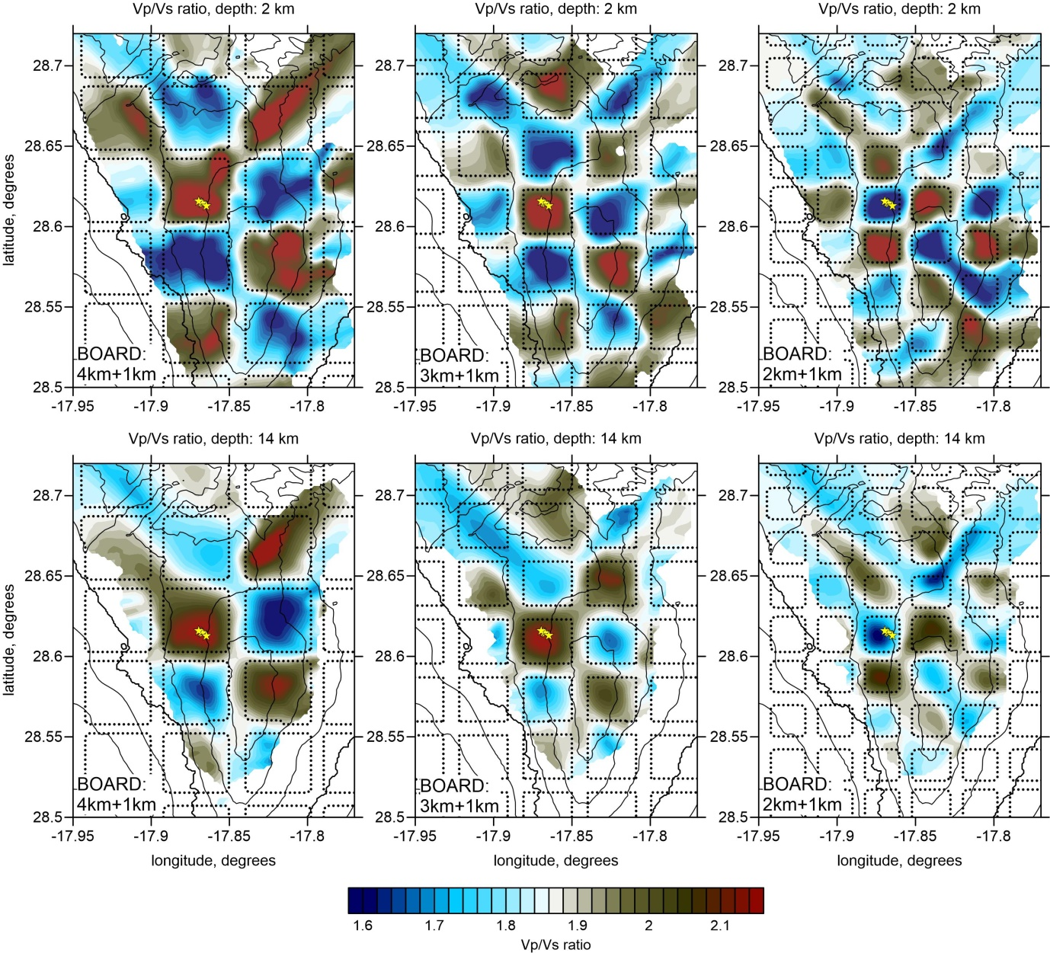

Extended Data Figure 1. Resolution test results based on the inversion of experimental Vp/Vs data shown in horizontal layers.

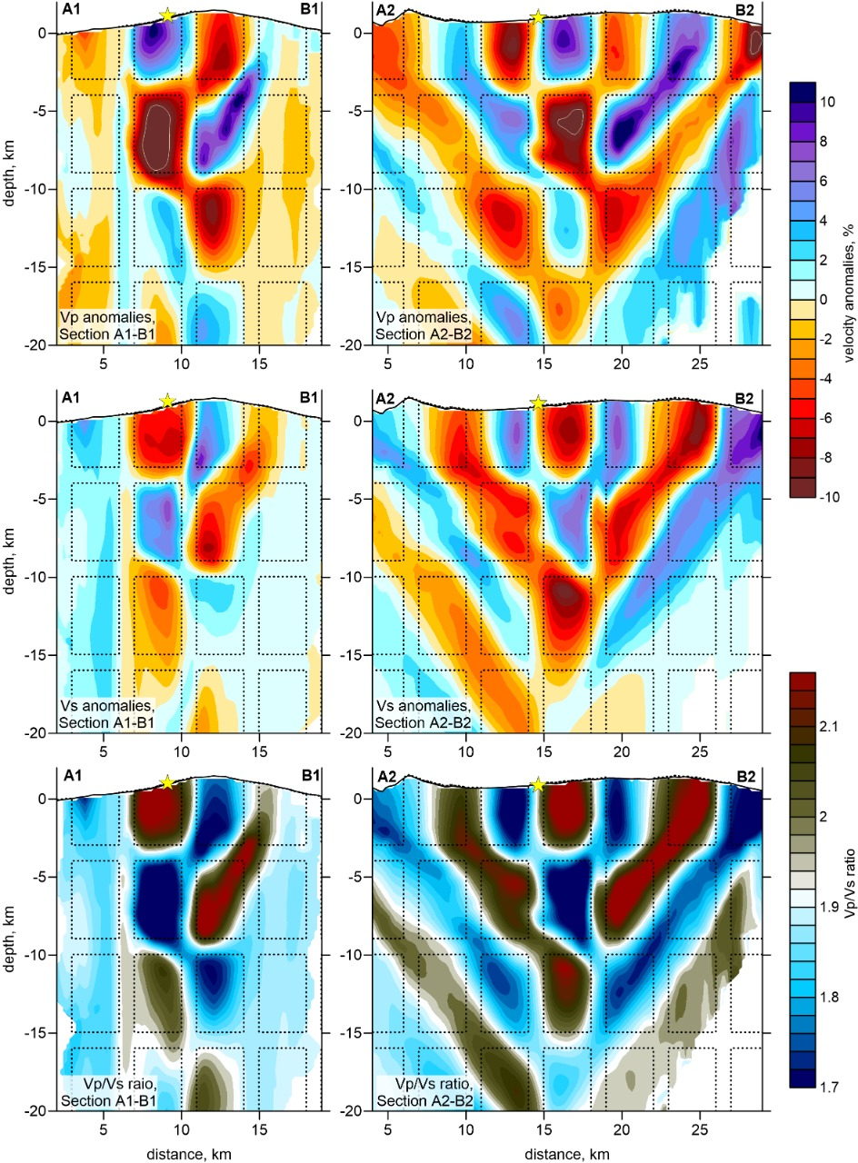
Extended Data Figure 2. Resolution test results based on the inversion of experimental Vp, Vs and Vp/Vs data shown in vertical layers.

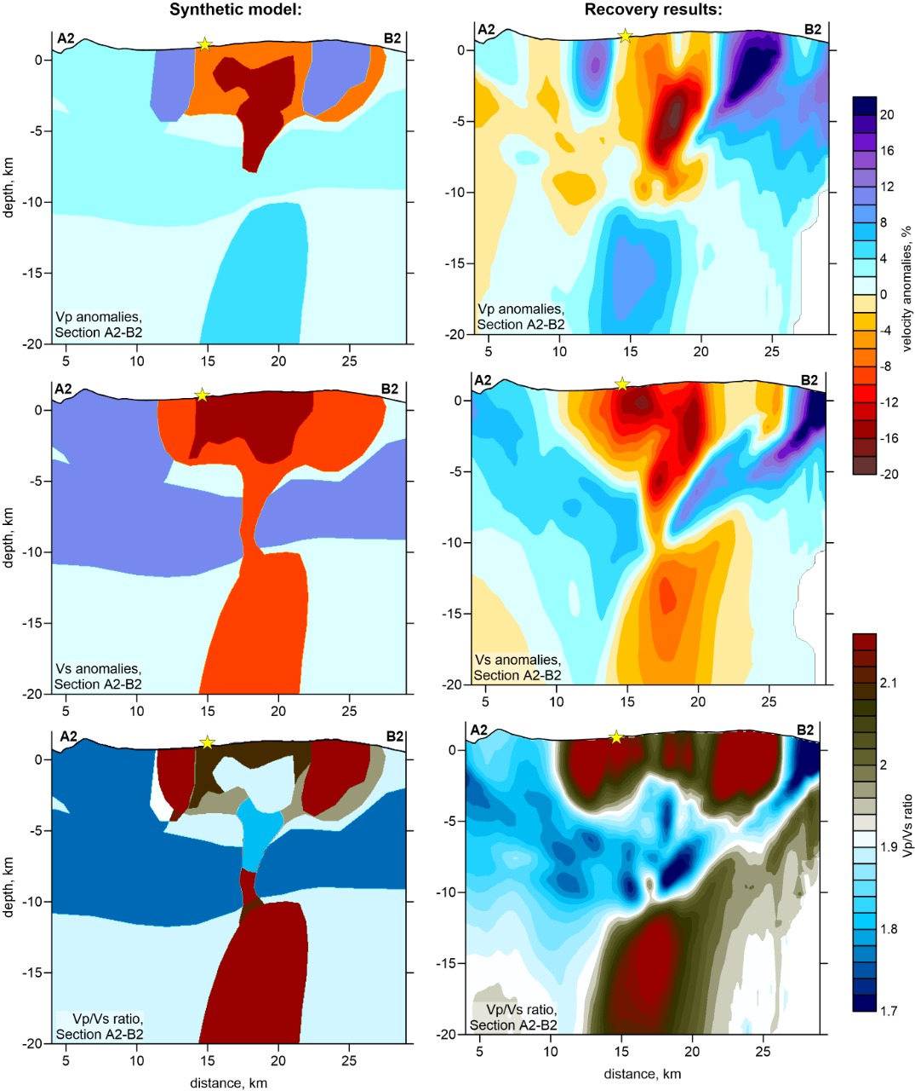 Extended Data Figure 3. Resolution test results based on the ability to solve realistic anomalies using a previous synthetic model (left column) and observing the recovery results (right column).

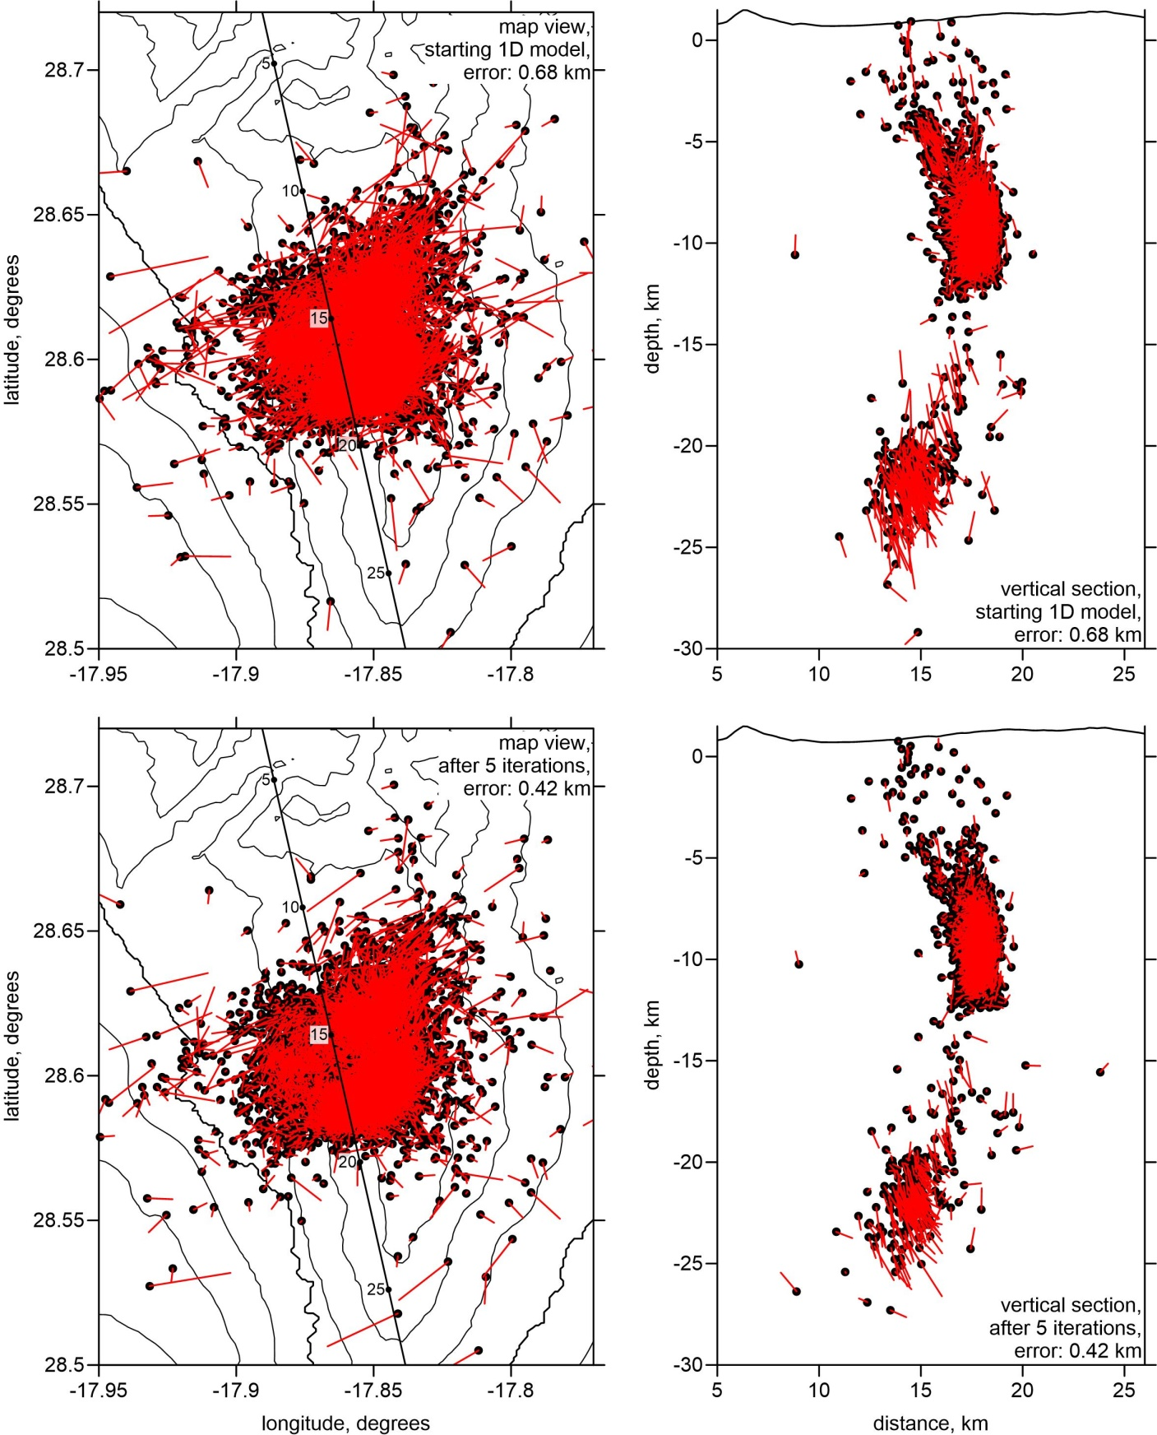
Extended Data Figure 4. Event mislocations within the model with respect to true locations in horizontal and vertical views and with a vertical checkerboard in section 2.

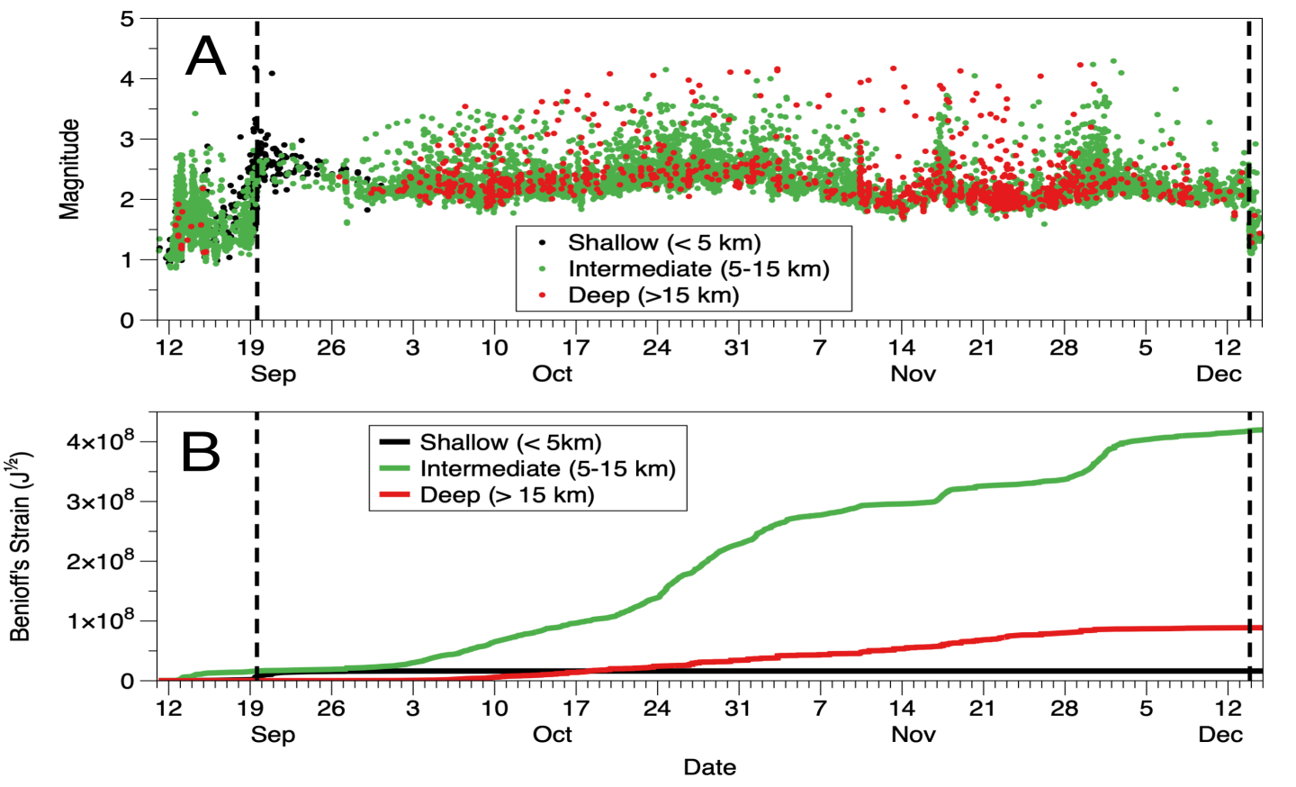
Extended Data Figure 5. Earthquake magnitudes and Benioff’s strain release. (A) Magnitudes (Ml) of located earthquakes separated by depth; (B) accumulated Benioff’s strain release for each depth class.

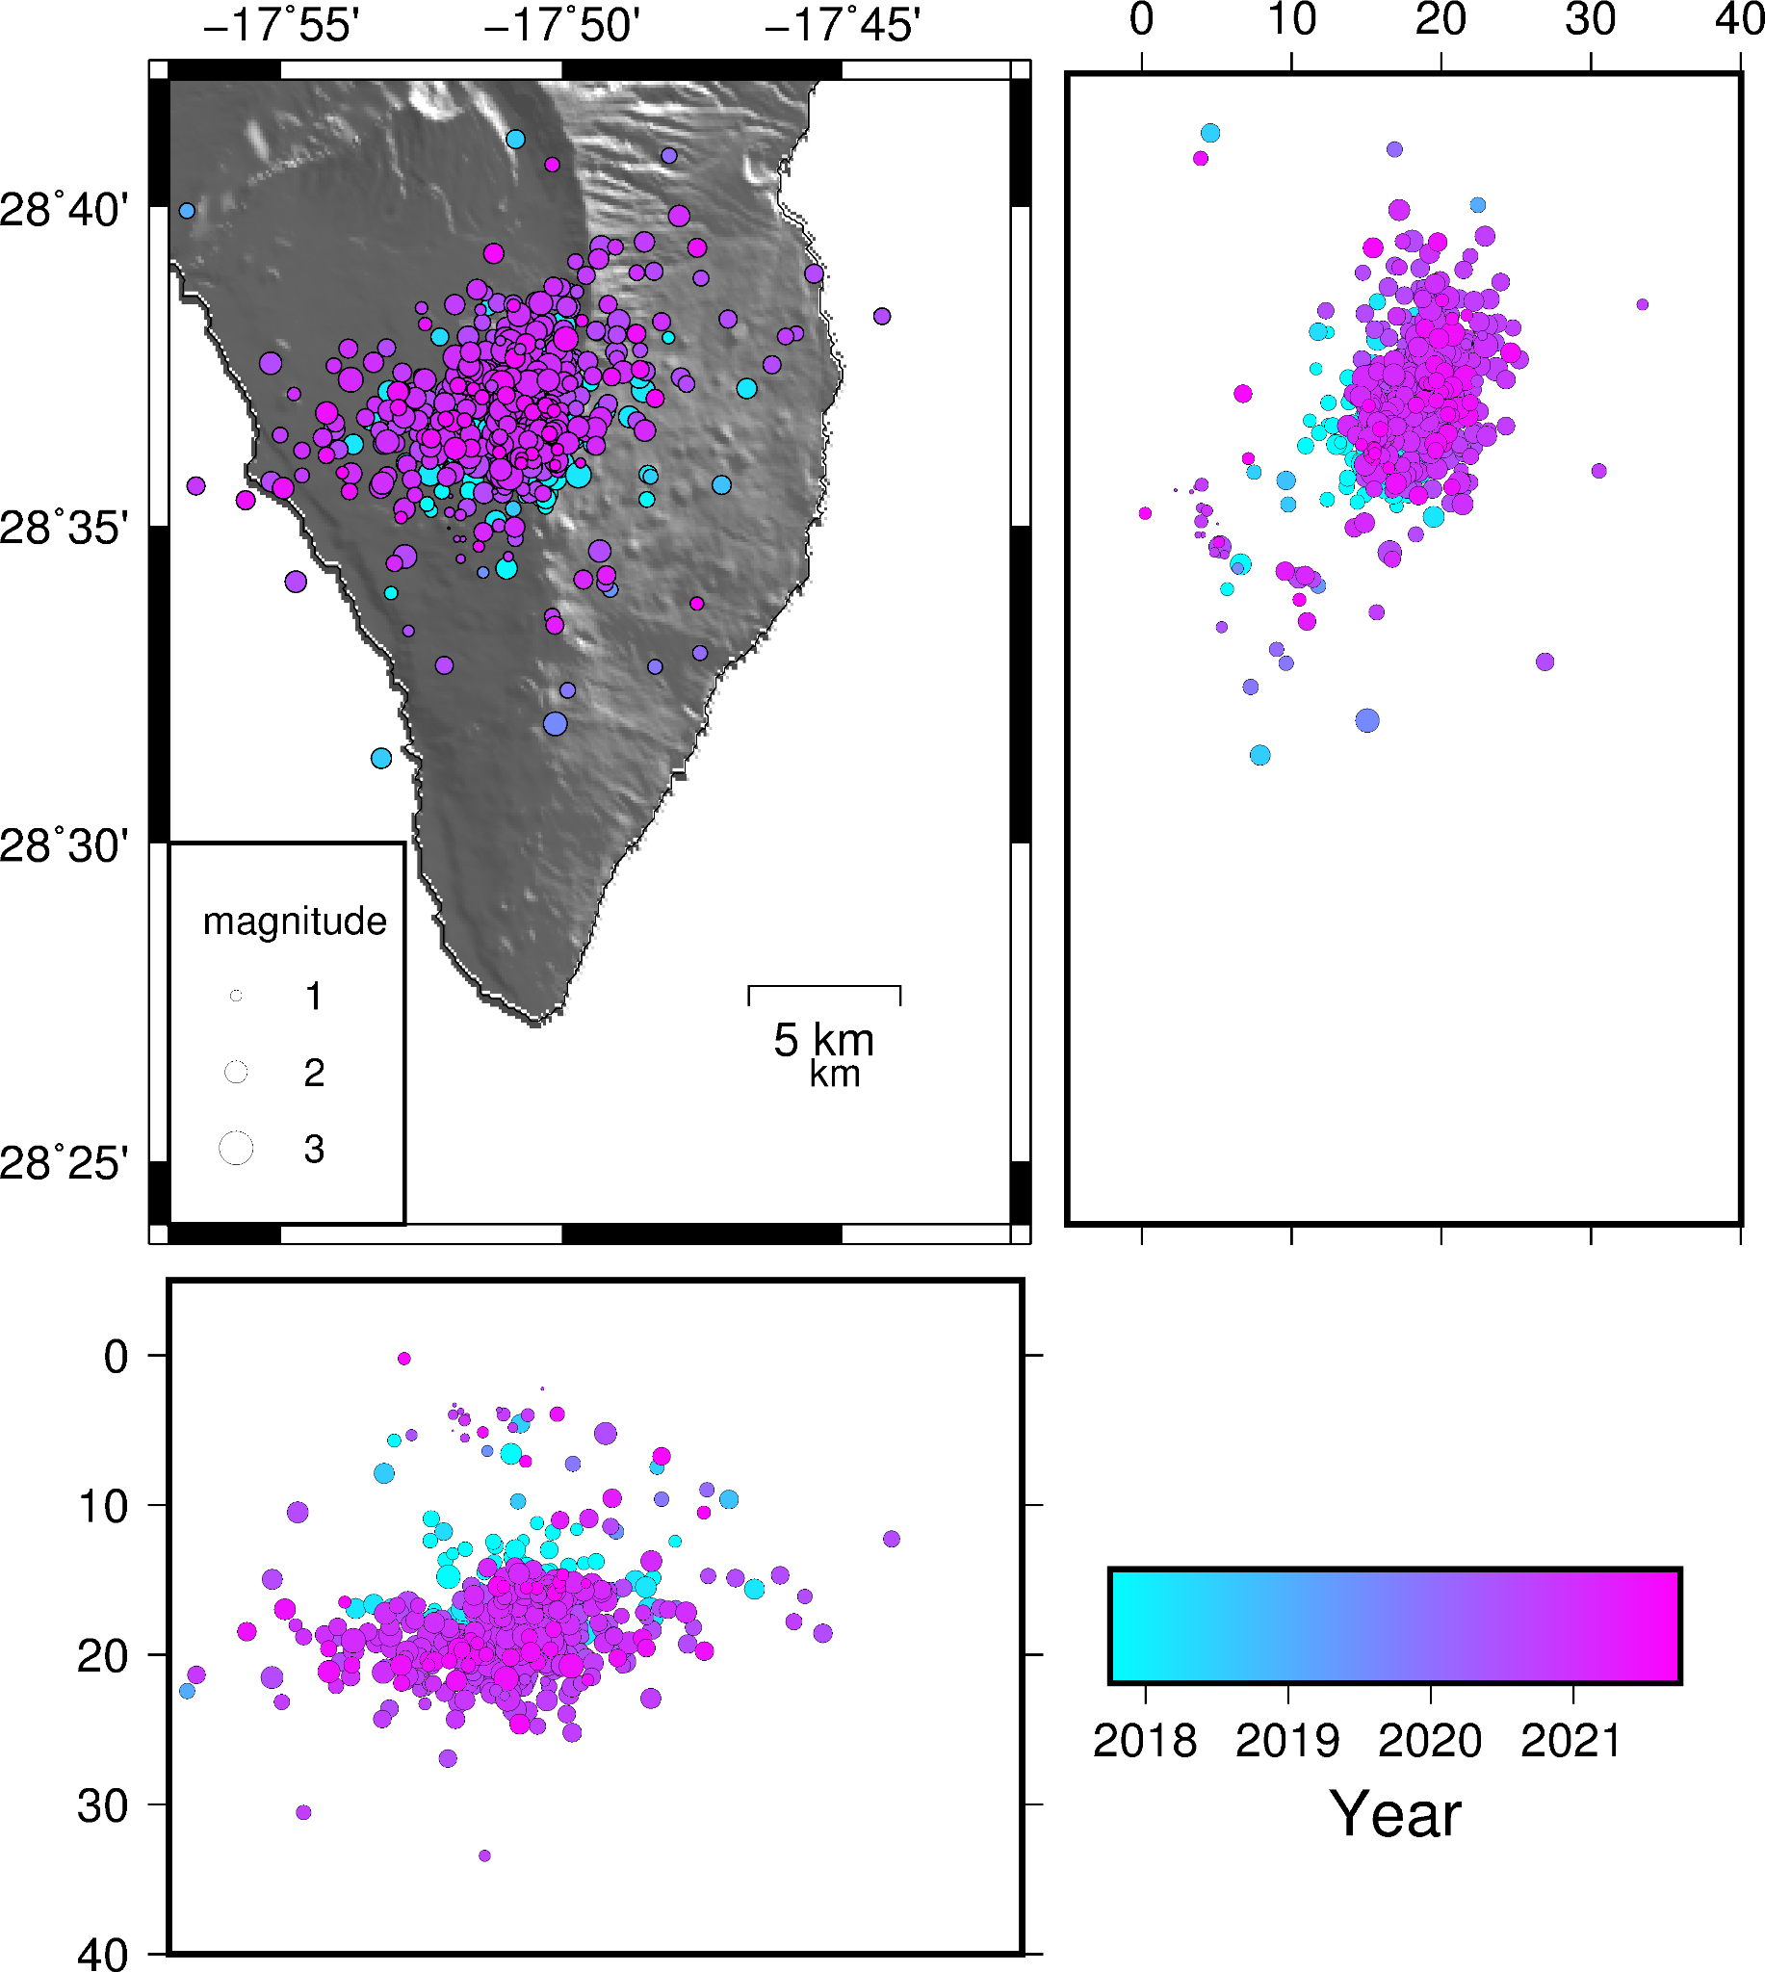
Extended Data Figure 6. Spatio-temporal distribution of relocated pre-eruptive seismicity (From the end of 2017 to August 2021) showing the epicentral distribution and foci in N–S and E–W projections. Temporal scale is represented in terms of years.

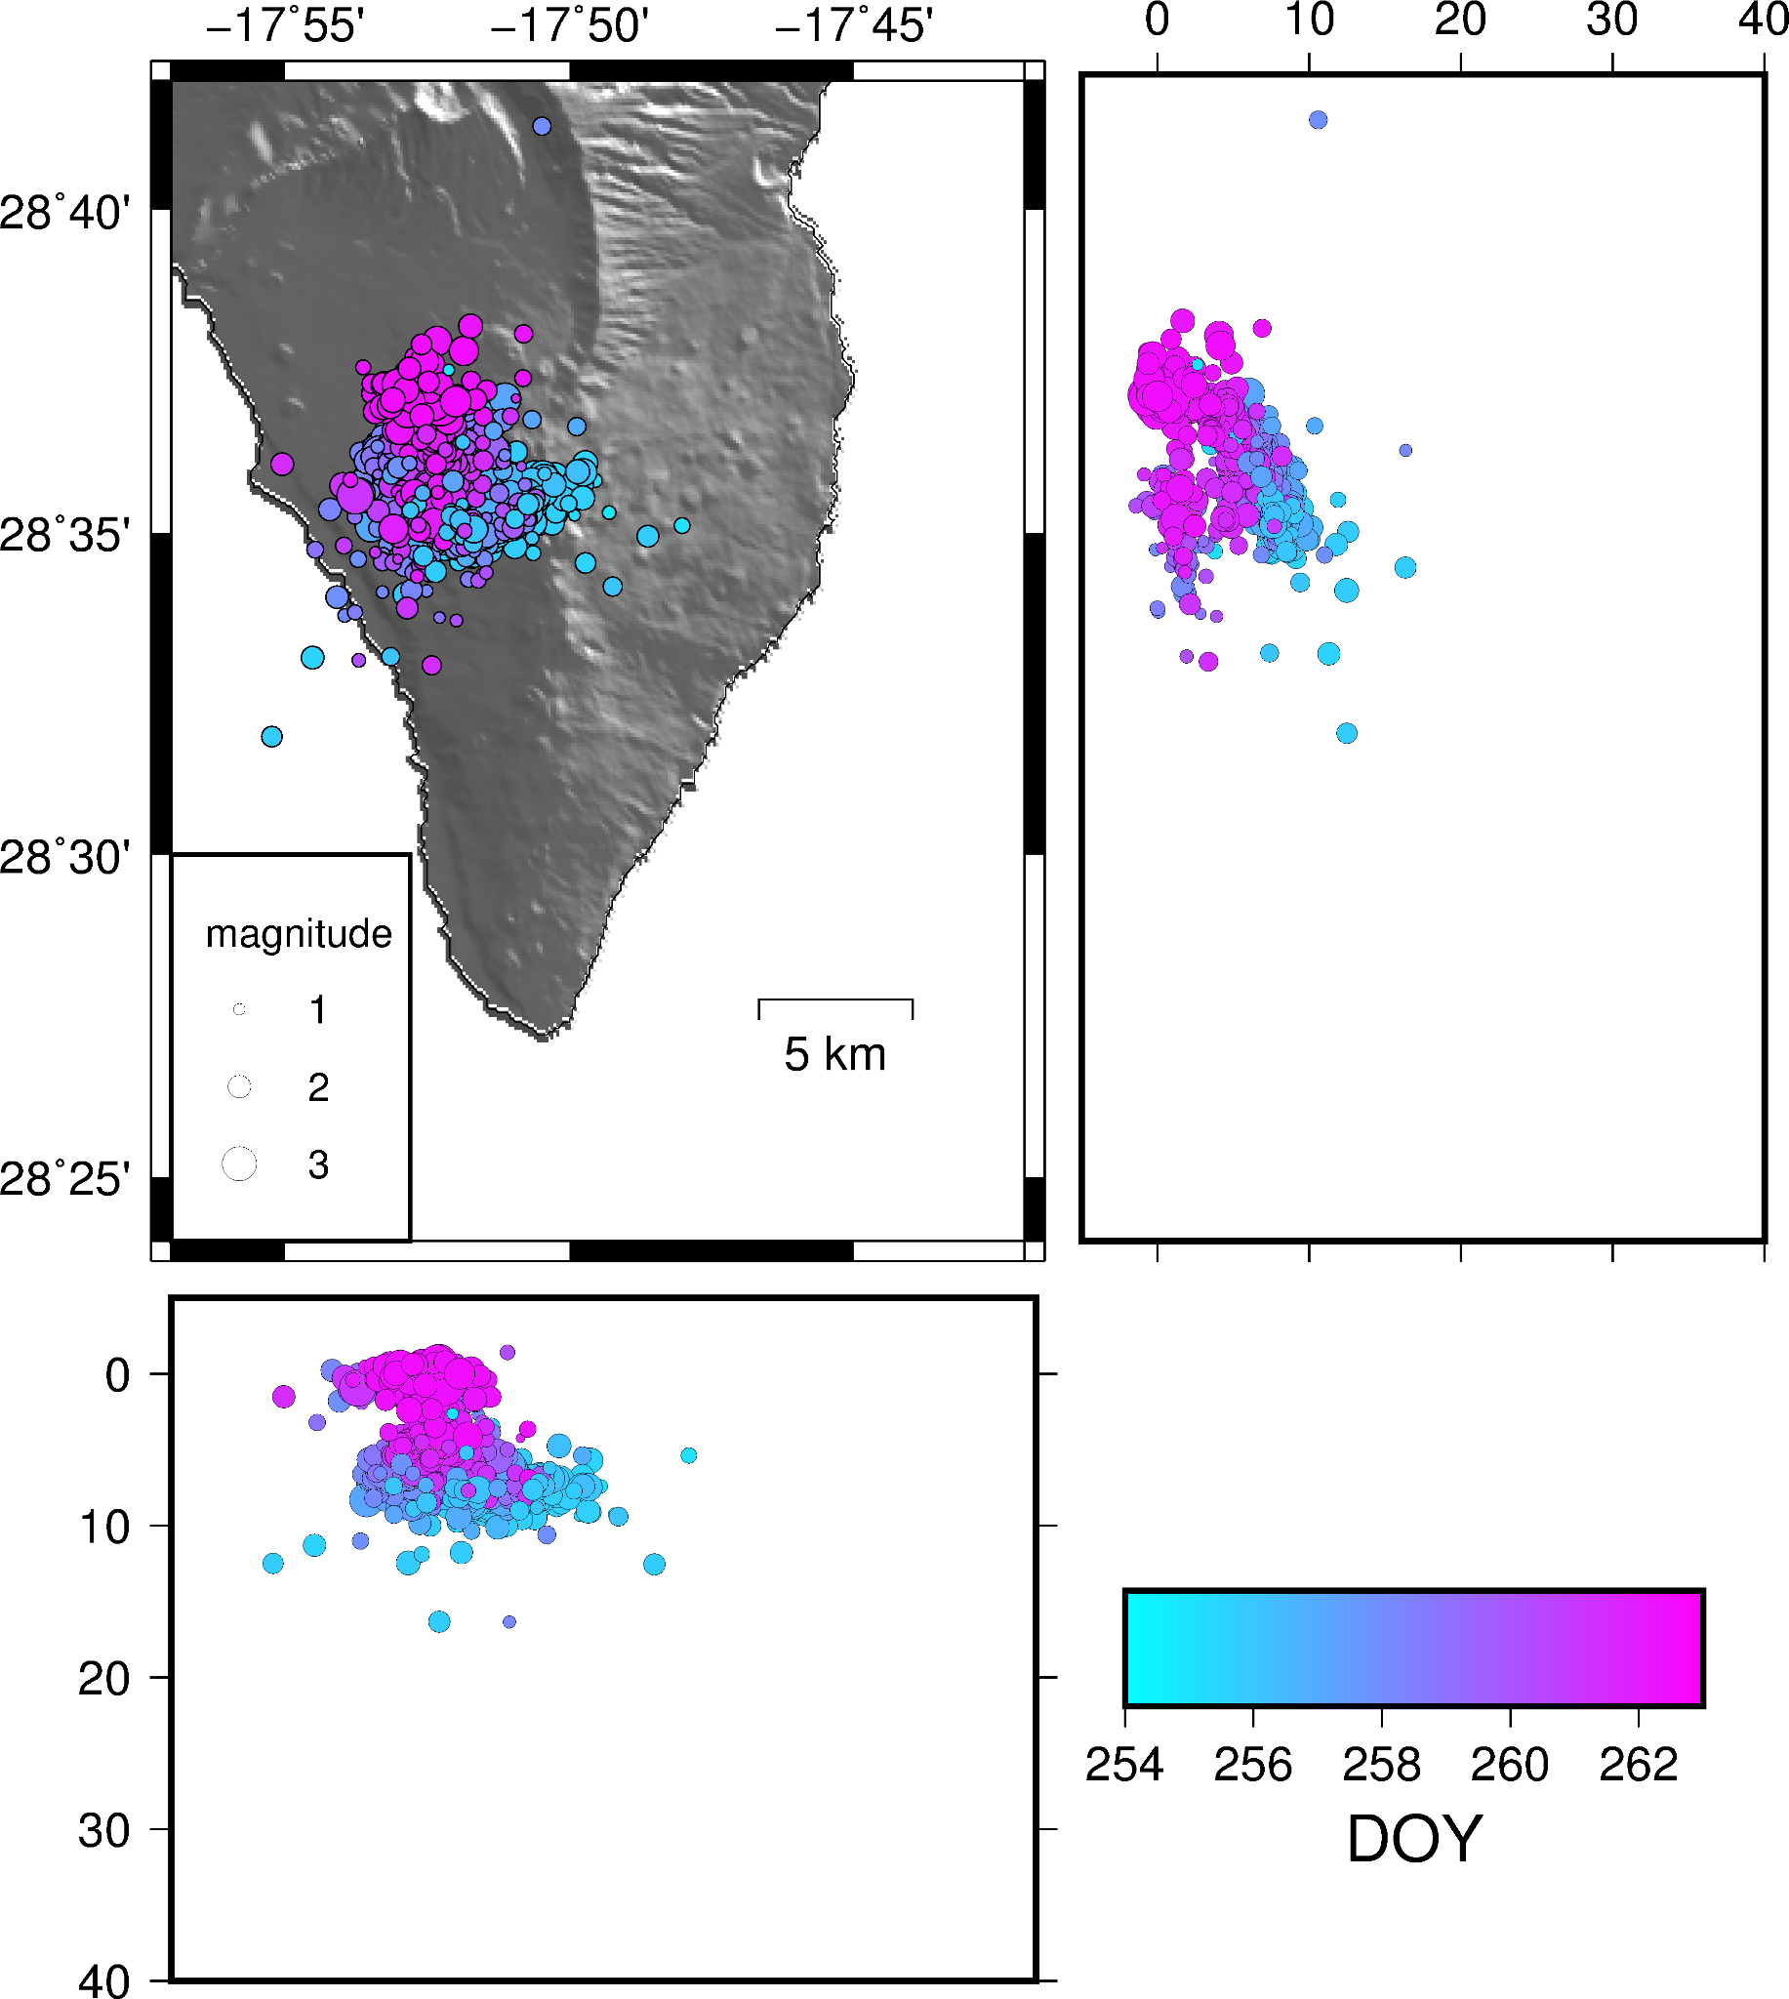
Extended Data Figure 7. Spatio-temporal distribution of relocated precursory seismicity (from 11 to 19 of September 2021) showing the epicentral distribution and foci in N–S and E–W projections. Temporal scale is represented in terms of Julian days in 2021.

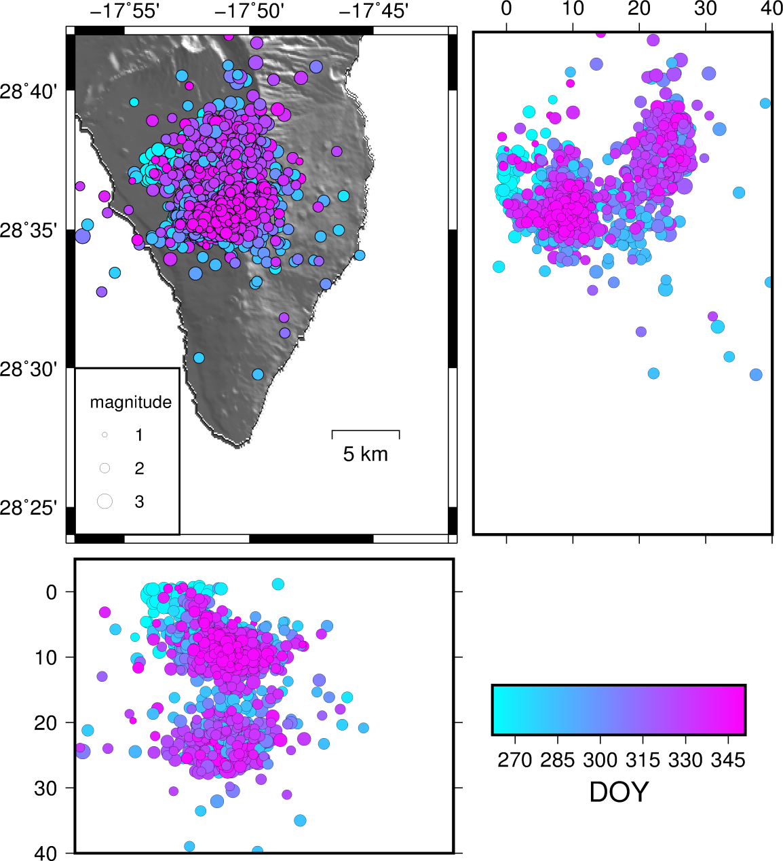
Extended Data Figure 8. Spatio-temporal distribution of relocated syn-eruptive (from 19 of September to 13 of December) seismicity showing the epicentral distribution and foci in N–S and E–W projections. Temporal scale is represented in terms of Julian days in 2021.

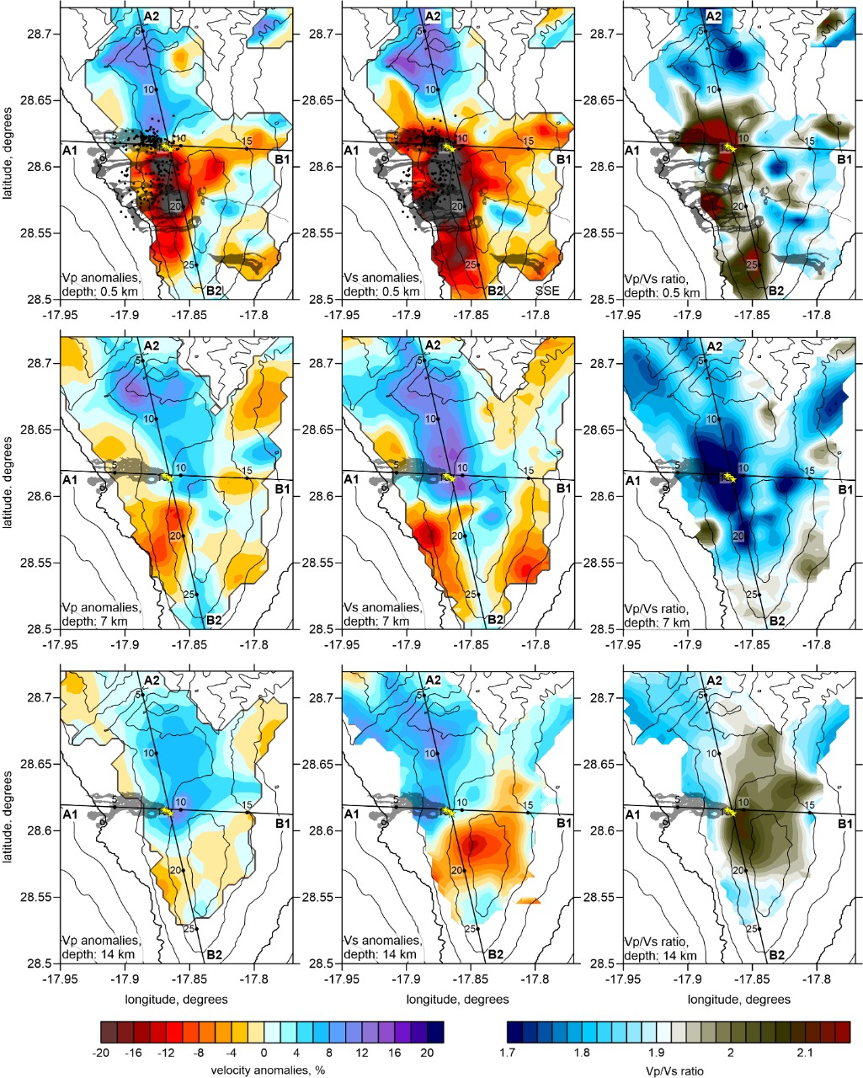

Extended Data Figure 9. Horizontal layers representing P wave velocity (left column), S wave velocity (central column), and Vp/Vs ratio anomalies (right column) for three selected depths (0.5, 7 and 14 km depth bsl).

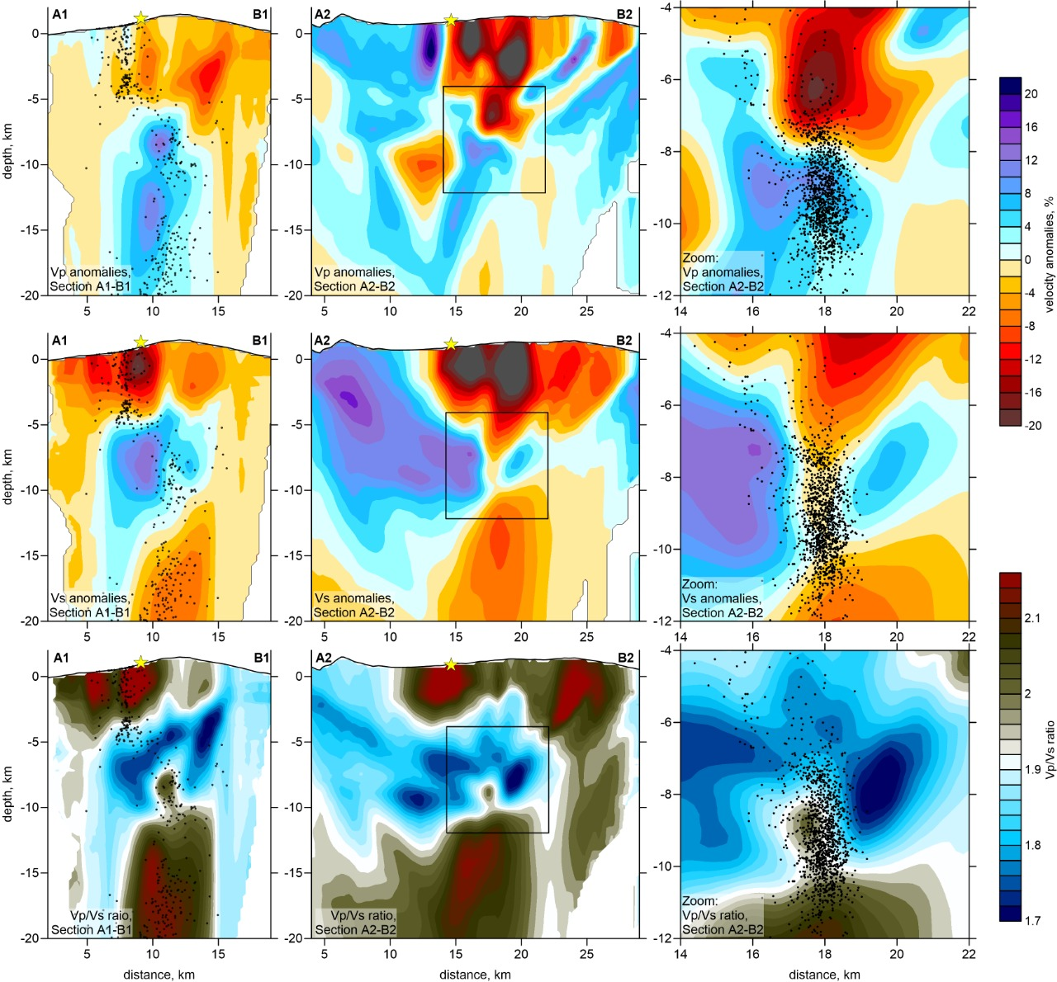

Extended Data Figure 10. Vertical projections representing P wave velocity, S wave velocity, and Vp/Vs ratio anomalies. The central squares of the A2-B2 profiles mark the area that is being zoomed in and is plotted in the right column.

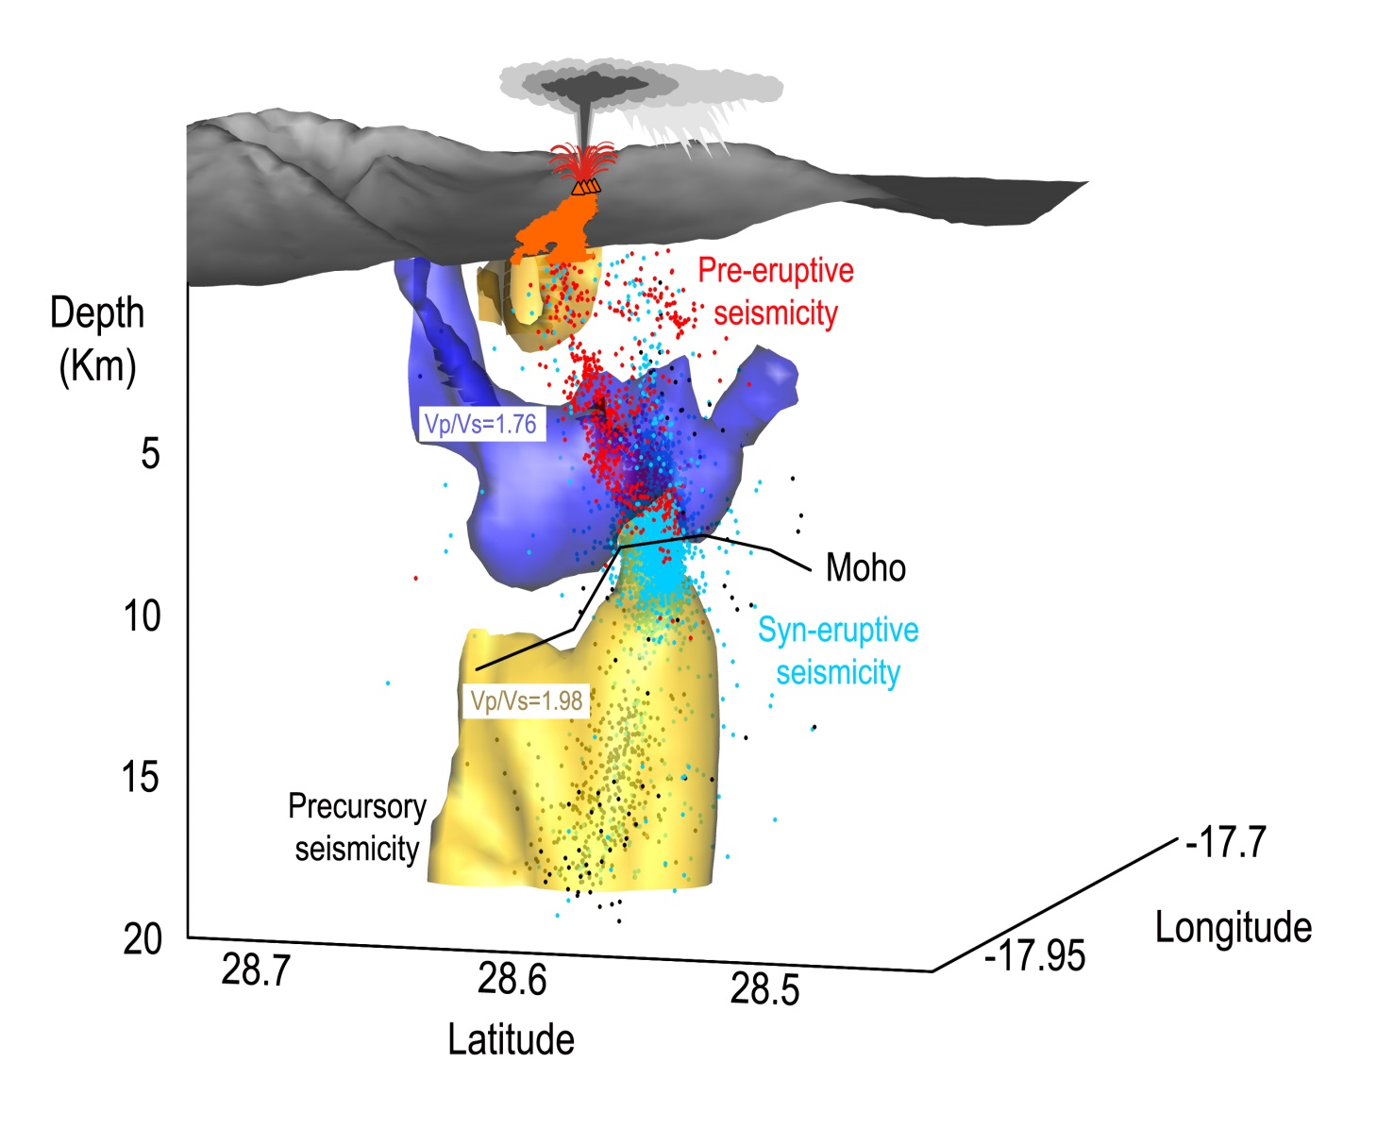
Extended Data Figure 11. Three-dimensional model of sub-surface structures based on Vp/Vs anomalies, where yellow shading denotes bodies with higher Vp/Vs, purple denotes bodies with lower Vp/Vs, the black line denotes the potential flexure of the Moho as a consequence of magma intrusion, and dots denote relocated seismicity (red, precursory seismicity; black, pre-eruptive seismicity; blue, syn-eruptive seismicity).

