“Health Technology Assessment in High, Middle and Low-income Countries: New Systematic and Interdisciplinary Approach for Sound Informed-policymaking”

Supplements
- Figures
Figure 1: EMR countries spending on research compared with the share of global wealth
Figure 2: Six key pillars of the Evidence-informed policy-making for health
- Tables
Table 1: Research settings related to World Bank countries’ classification
- Ethical approvals
Document 1: ethical approval from Philadelphia University, Jordan
Document 2: ethical approval from the Palestinian Health Research Council, Palestine
- Research tools
The HTA quantitative survey adopted from the WHO

- Figures
Figure 1: EMR countries spending on research compared with the share of global wealth
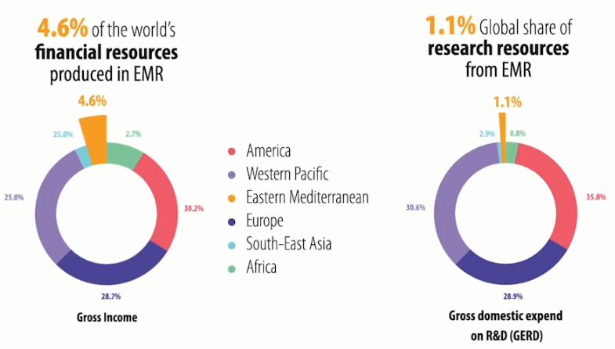
Figure 2: Six key pillars of the Evidence-informed policy-making for health
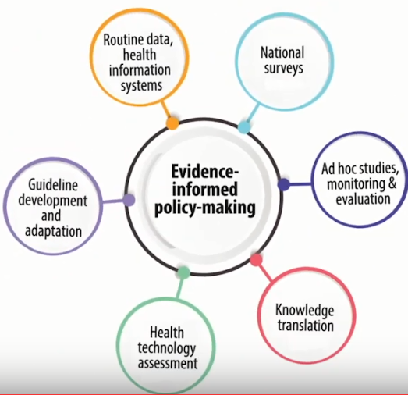

- Tables:
Table 1: Research settings related to World Bank countries’ classification
World Bank categories | Upper-middle-income economy ($3,956 to $12,235) | Lower-middle-income economy ($1,006 to $3,955) | Least-income economy ($1,005 or less) | High-income economy ($12,056 or more)
Research settings | Lebanon | Palestine | Tanzania | Canada and Switzerland  (Benchmark and comparative setting)

- Ethical approvals
Document 1: ethical approval from Philadelphia University, Jordan

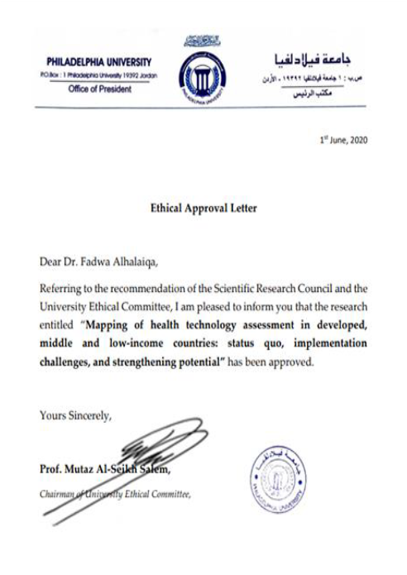
Document 2: ethical approval from the Palestinian Health Research Council, Palestine
