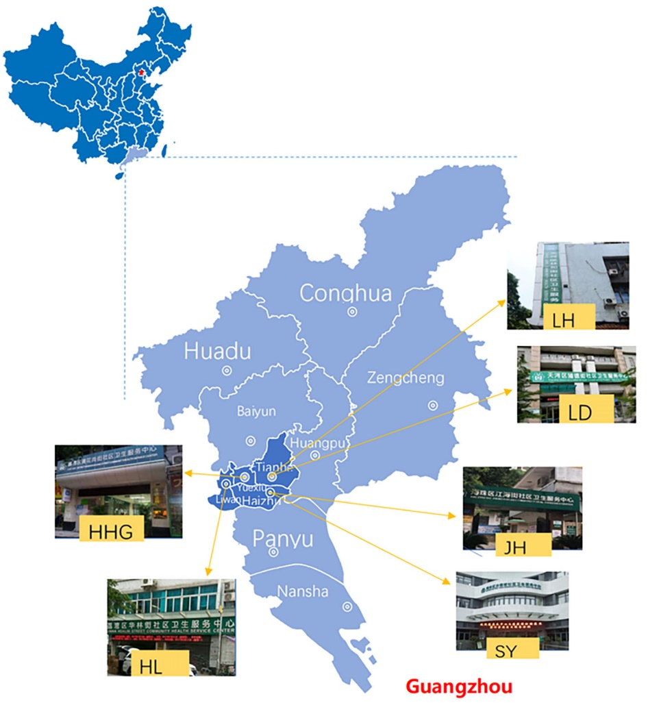
Figure S1 Map of the study area and locations of community health centers

Table S1 the relevant items of NCQA-PCMH and PCAT
Contact-access | PCMH | PCMH1. Patient-Centered Access | A1. Providing same-day appointments for routine and urgent care.
Contact-access | PCMH | PCMH1. Patient-Centered Access | A4. Availability of appointments.
Contact-access | PCAT | C First Contact-Access | C3. When your PCP is open and you get sick, would someone from there see you the same day?
Outside the clinic | PCMH | PCMH1. Patient-Centered Access | A3. Providing alternative types of clinical encounters.
Outside the clinic | PCMH | PCMH1. Patient-Centered Access | B2. Providing timely clinical advice by telephone.
Outside the clinic | PCMH | PCMH1. Patient-Centered Access | C2. The capability to view, download or transmit their health information to a third party.
Outside the clinic | PCAT | C First Contact-Access | C4. When your PCP is open, can you get advice quickly over the phone if you need it?
Outside the clinic | PCAT | D Ongoing Care | D4. If you have a question, can you call and talk to the doctor or nurse who knows you best?
Case information preservation | PCMH | PCMH1. Patient-Centered Access | B1. Providing continuity of medical record information for care and advice when office is closed.
Case information preservation | PCAT | F Coordination (Information Systems) | F3. When you go to your doctor, is your medical record always available?
Patients themselves are aware of personal health information | PCMH | PCMH1. Patient-Centered Access | C1. More than 50 percent of patients have timely access to their health information.
Patients themselves are aware of personal health information | PCMH | PCMH1. Patient-Centered Access | C3. Clinical summaries are provided to patients/families/caregivers upon request.
Patients themselves are aware of personal health information | PCMH | PCMH3. Population Health Management | Element A - Patient Information
Patients themselves are aware of personal health information | PCMH | PCMH3. Population Health Management | Element B - Clinical Data
Patients themselves are aware of personal health information | PCAT | F Coordination (Information Systems) | F2. Could you look at your medical record if you wanted to?
Patients themselves are aware of personal health information | PCAT | F Coordination (Information Systems) | F3. When you go to your PCP, is your medical record always available?
Personal continuity care | PCMH | PCMH2. Team-Based Care | A1. Assisting patients/families to select a personal clinician and documenting the selection in practice records.
Personal continuity care | PCAT | D Ongoing Care | D1. When you go to your PCP’s, are you taken care of by the same doctor or nurse each time?
FAMILY-CENTEREDNESS | PCMH | PCMH2. Team-Based Care | A4. Collaborating with the patient/family to develop/implement a written care plan for transitioning from pediatric care to adult care.
FAMILY-CENTEREDNESS | PCMH | PCMH4. Care Management and Support | B5. Is provided in writing to the patient/family/caregiver.
FAMILY-CENTEREDNESS | PCAT | I Family-Centeredness | I1. Does your PCP ask you about your ideas and opinions when planning treatment and care for you or a family member?
Referral Coordination | PCMH | PCMH2. Team-Based Care | B1. The practice is responsible for coordinating patient care across multiple settings.
Referral Coordination | PCMH | PCMH2. Team-Based Care | B8. Instructions on transferring records to the practice, including a point of contact at the practice.
Referral Coordination | PCMH | PCMH5. Care Coordination and Care Transitions | B5. Gives the consultant or specialist the clinical question, the required timing and the type of referral.
Referral Coordination | PCMH | PCMH5. Care Coordination and Care Transitions | B7. Has the capacity for electronic exchange of key clinical information and provides an electronic summary of care record to another provider for more than 10 percent of referrals.
Referral Coordination | PCMH | PCMH5. Care Coordination and Care Transitions | B9. Documents co-management arrangements in the patient medical record.
Referral Coordination | PCMH | PCMH5. Care Coordination and Care Transitions | B10. Asks patients/families about self-referrals and requesting reports from clinicians.
Referral Coordination | PCMH | PCMH5. Care Coordination and Care Transitions | C2. Shares clinical information with admitting hospitals and emergency departments.
Referral Coordination | PCMH | PCMH5. Care Coordination and Care Transitions | C3. Consistently obtains patient discharge summaries from the hospital and other facilities.
Referral Coordination | PCMH | PCMH5. Care Coordination and Care Transitions | C7. Exchanges key clinical information with facilities and provides an electronic summary-of-care record to another care facility for more than 10 percent of patient transitions of care.
Referral Coordination | PCAT | E Coordination | E8. Did your PCP discuss with you different places you could have gone to get help with that problem?
Referral Coordination | PCAT | E Coordination | E9. Did your PCP or someone working with your PCP help you make the appointment for that visit?
Referral Coordination | PCAT | E Coordination | E10. Did your PCP write down any information for the specialist about the reason for the visit?
Referral Coordination | PCAT | E Coordination | E12. After you went to the specialist or special service, did your PCP talk with you about what happened at the visit?
Referral Coordination | PCAT | F Coordination (Information Systems) | F1. When you go to your PCP, do you bring any of your own medical records, such as shot records or reports of medical care you had in the past?
Language services | PCMH | PCMH2. Team-Based Care | ELEMENT C - Culturally and Linguistically Appropriate Services
Language services | PCAT | K Culturally Competent | K2. Would you recommend your PCP to someone who does not speak English well?
Comprehensive health care | PCMH | PCMH2. Team-Based Care | D6Training and assigning members of the care team to support patients/families/caregivers in self-management, self-efficacy and behavior change.
Comprehensive health care | PCMH | PCMH4. Care Management and Support | A1. Behavioral health conditions.
Comprehensive health care | PCMH | PCMH4. Care Management and Support | B1. Incorporates patient preferences and functional/lifestyle goals.
Comprehensive health care | PCMH | PCMH4. Care Management and Support | E6. Maintains a current resource list on five topics or key community service areas of importance to the patient population including services offered outside the practice and its affiliates.
Comprehensive health care | PCAT | D Ongoing Care | D7. Does your PCP know you very well as a person, rather than as someone with a medical problem?
Comprehensive health care | PCAT | D Ongoing Care | D9. Does your PCP know what problems are most important to you?
Comprehensive health care | PCAT | J Community orientation | J1. Does anyone at your PCP’s office ever make home visits?
Patient engagement | PCMH | PCMH2. Team-Based Care | D10. Involving patients/families/caregivers in quality improvement activities or on the practice advisory council.
Patient engagement | PCAT | J Community orientation | J3. Does your PCP get opinions and ideas from people that will help to provide better health care?
Drug use follow-up | PCMH | PCMH3. Population Health Management | D5. Medication monitoring or alert.
Drug use follow-up | PCMH | PCMH4. Care Management and Support | ELEMENT C - Medication Management
Drug use follow-up | PCMH | PCMH4. Care Management and Support | C1. Reviews and reconciles medications for more than 50 percent of patients received from care transitions.
Drug use follow-up | PCMH | PCMH4. Care Management and Support | C2. Reviews and reconciles medications with patients/families for more than 80 percent of care transitions.
Drug use follow-up | PCMH | PCMH4. Care Management and Support | C3. Provides information about new prescriptions to more than 80 percent of patients/families/caregivers.
Drug use follow-up | PCMH | PCMH4. Care Management and Support | C4. Assesses understanding of medications for more than 50 percent of patients/families/caregivers, and dates the assessment.
Drug use follow-up | PCMH | PCMH4. Care Management and Support | C6. Assesses response to medications and barriers to adherence for more than 50 percent of patients, and dates the assessment.
Drug use follow-up | PCAT | H Comprehensiveness (Services Provided) | H7. Checking on and discussing the medications you are taking
Immunization | PCMH | PCMH3. Population Health Management | C1. Age- and-gender appropriate immunizations and screenings.
Immunization | PCAT | G Comprehensiveness (Services Available) | G2. Immunizations (shots)
PCAT: the Primary Care Assessment Tools; PCMH: Patient-Center Medical Home.

