Fig S1
A. List of the top five TCAIM-interacting proteins in mitochondria.
B. Domain organization of TCAIM. MLS (residues 1-24, blue), J domain (residues 24-144, orange), Unknown domain (residues 144-496, yellow orange). HPD motif in J domain is colored in red.
C. Alpha-fold-predicted the J domain of TCAIM structure. The structure is colored by rainbow, HPD motif marked by red. The N terminal and C terminal is linked by a flexible linker.
D. The N terminal alignment of TCAIM homologous proteins. The starting point for J-domain and starting point for unknown domain are marked by black arrows.
E. Gel filtration of OGDH protein, the SDS-PAGE result corresponds with the horizontal line.
F. Gel filtration of TCAIM protein, the SDS-PAGE result corresponds with the horizontal line.

Fig S1
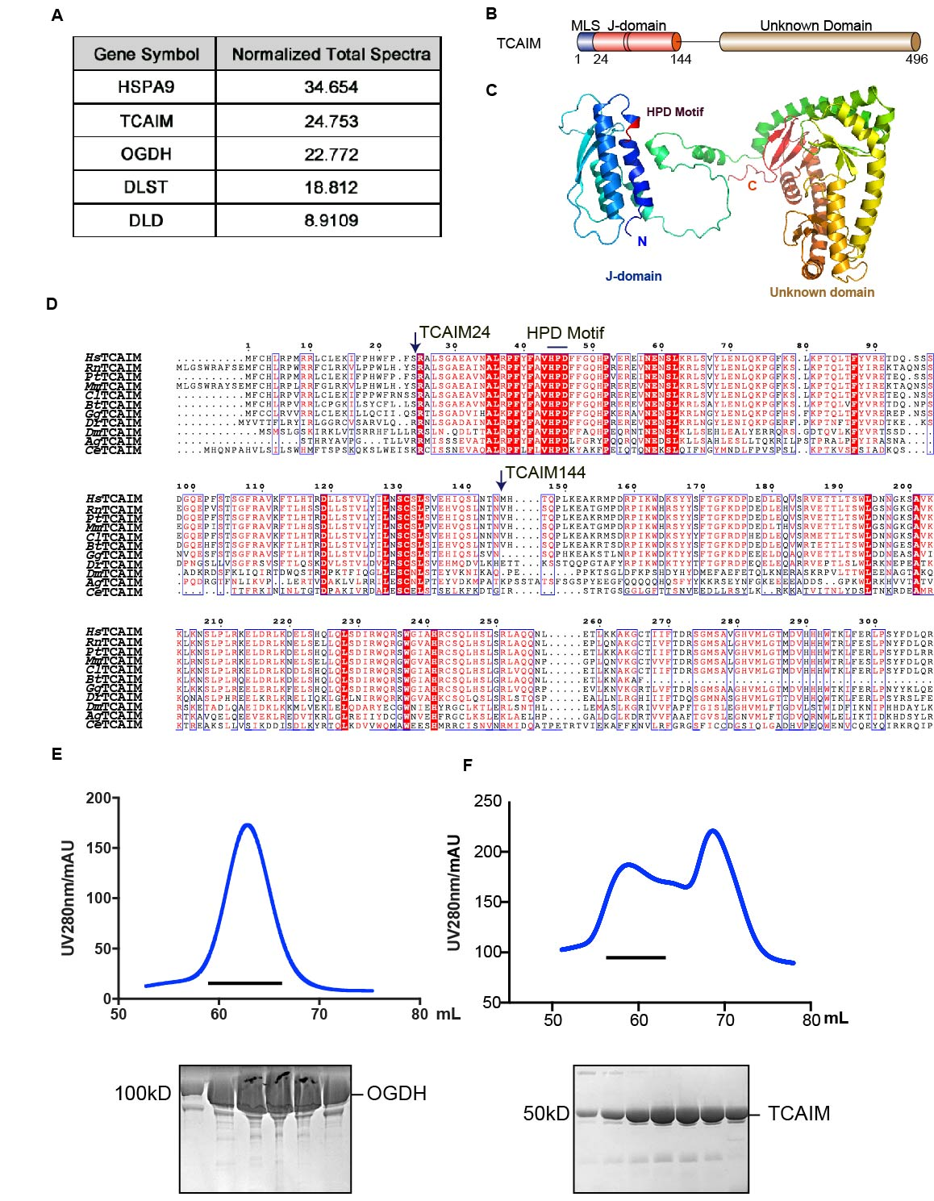

Fig S2
A． The oxygen consumption rate (OCR) of HeLa cells transiently overexpressing EGFP or TCAIM mRNA collected by Seahorse in serum-free basal DMEM containing 25 mM glucose and 4 mM glutamine. 2 μM oligomycin, 0.75 μM FCCP, 0.5 μM Rotenone/ antimycin A were added sequentially.
B． The extracellular acidification rate (ECAR) of HeLa cells transiently overexpressing EGFP or TCAIM mRNA collected using Seahorse in serum-free basal DMEM with no glucose and 4 mM glutamine. ECR: 10 mM glucose, 2 μM oligomycin, 50 mM 2-Deoxy-D-glucose were added sequentially.
C． The extracellular acidification rate (ECAR) of HeLa cells with OGDH transiently knocked down collected by Seahorse in serum-free basal DMEM with 25 mM glucose and 4 mM glutamine. 2 μM oligomycin, 0.75 μM FCCP, 0.5 μM rotenone/ antimycin A were added sequentially.

Fig S2
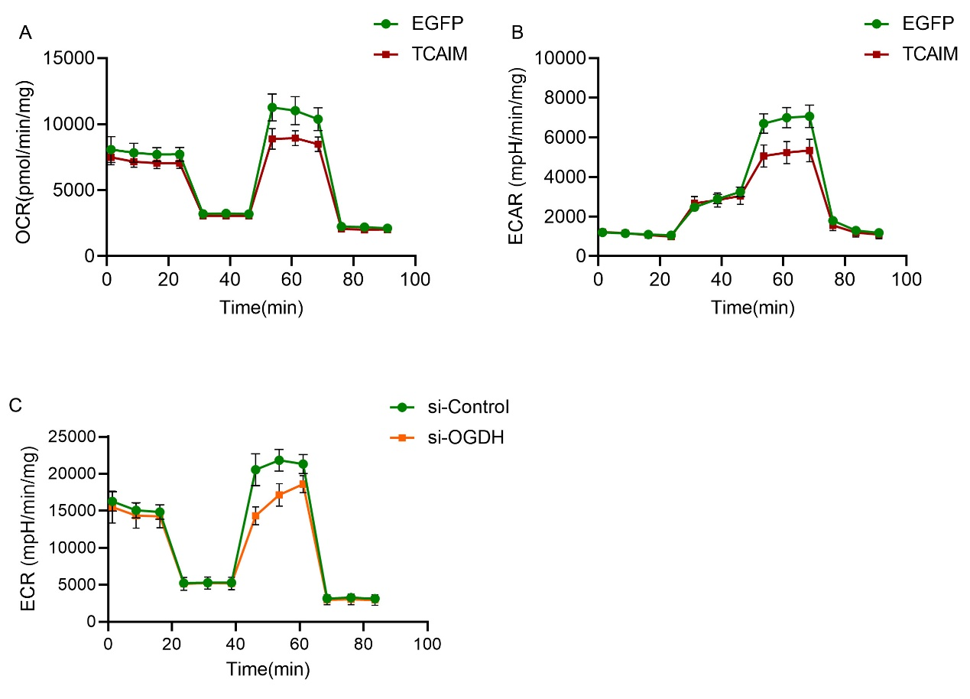

Fig S3
A. Left: Graphic of the TCAIM KO construction strategy with CRISPR technique, the locations of sgRNA denoted in dark green, the second exon denoted in blue, and the deletion region denoted in gray. Right: genotyping results of WT, TCAIM KO and heterozygote mice.
B. Whole-body RNA was extracted from TCAIM KO newborn mice and WT littermates. TCAIM mRNA levels were detected by Relative quantitative QPCR from these samples. (n = 3, ***p < 0.001).
C. The level of TCAIM mRNA in different mouse organs was tested by QPCR, normalized to the internal control (GAPDH) and then normalized to the results of the liver.
D. Partial Least Square Discriminant Analysis (PLS-DA) score plots were generated by MetaboAnalyst software package. WT sample groups are in green; TCAIM KO sample groups are in red.
E. Heatmap showing differentially expressed (all three p-values ≤0.05) serum metabolites by peak area of TCAIM KO mice (red) in comparison to WT littermates (blue). Each column represents a mouse; each row represents an individual metabolite. The more intense the red color, the higher the level of the metabolite detected. The more intense the blue color, the lower the level of the metabolite detected.
F. HEK-293 cells were treated with malonate and then lysed in MCLB lysis buffer. Protein malonylation levels measured by immunoblot with pan-anti-malonylation antibody.
G. The livers from WT and TCAIM KO mice were lysed and immunoblotted with pan-anti-acetylation (left) and pan-anti-succinylation antibody (middle), Ponceau staining was used as a loading control (right).
H. The livers from WT and TCAIM KO mice were lysed and immunoblotted with anti-SIRT5 antibody.

Fig S3
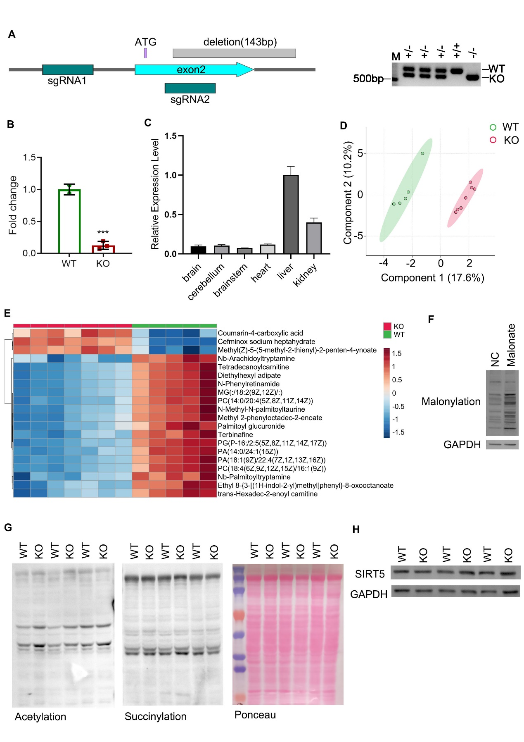

Fig S4
A. DCPIP absorbance at 610 nm overtime shows the reduction by OGDH with or without TCAIM, or with 60℃ treated TCAIM in the in vitro OGDH assay system.
B. DCPIP absorbance at 610 nm overtime shows the reduction by OGDH at different α-ketoglutarate concentrations in the in vitro OGDH assay system.
C. The enzyme activities of 3.75 m units of OGDHC with 10 μM or 20 μM TCAIM (Red) or with protein suspension buffer (Blue) collected under different concentrations of α-ketoglutarate in the in vitro OGDHC assay system.
D. DCPIP absorbance at 610 nm overtime shows the reduction by OGDH at different temperatures in the in vitro OGDH assay system.
E. OGDH (Blue), 45℃-treated OGDH incubated with protein suspension buffer, TCAIM or BSA protein (red), as well as Buffer, BSA and TCAIM proteins alone as negative controls grey) was measured for OGDH activities with DCPIP reduction rate (*p < 0.05, n = 3).
F. EMSA assay of heated OGDH and TCAIM. Different concentrations of TCAIM were incubated with OGDH on ice for 20 min and evaluated by native gel. For heated OGDH, OGDH was 45℃ treated for 10 min (down panel). The concentration was labelled above the gel.

Fig S4
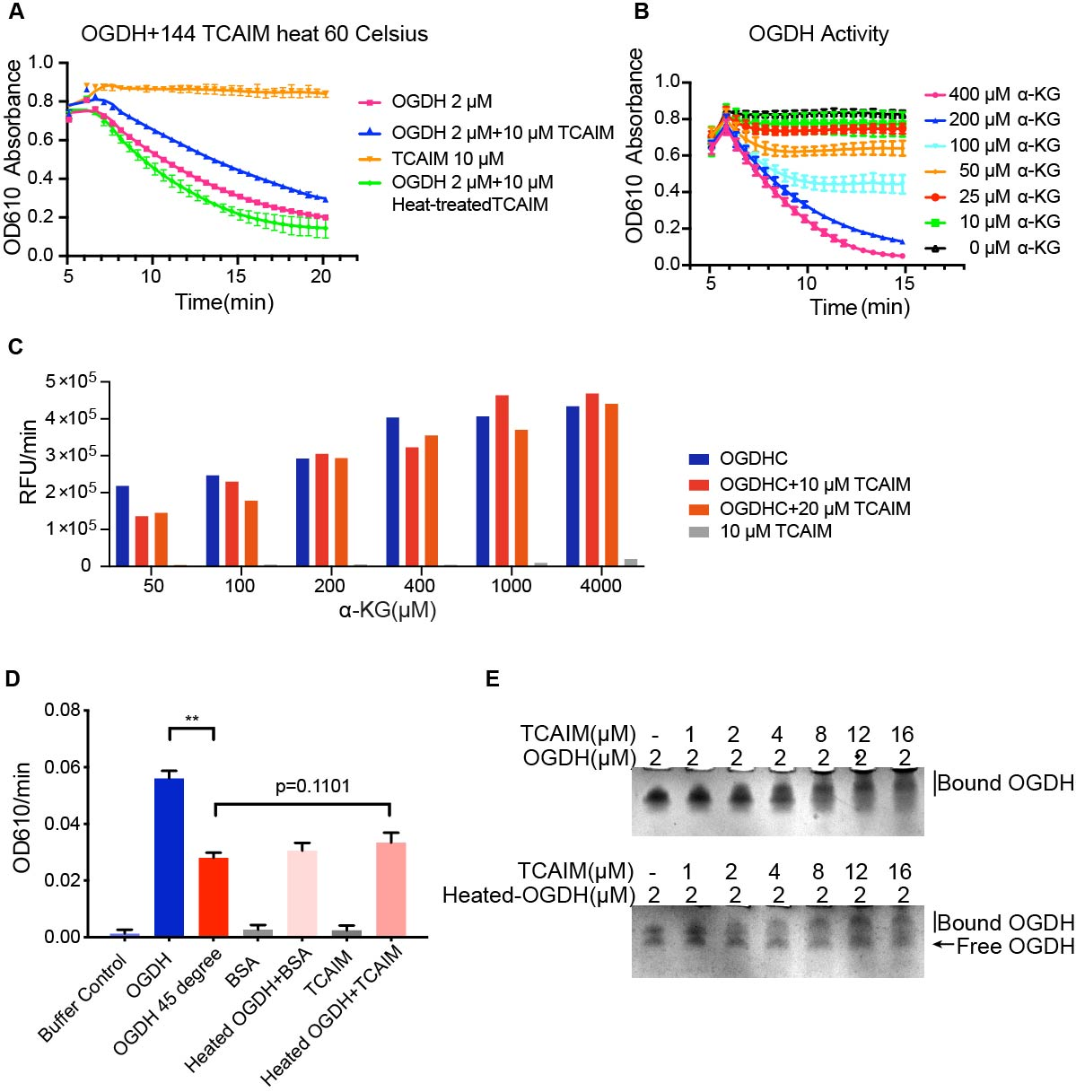

Fig S5
A-C The protein levels of OGDH, TCAIM-HA and GAPDH in cells that overexpressed EGFP or TCAIM-HA mRNA were tested by immunoblotting (left). The band intensities of OGDH were quantified using ImageJ and normalized to the band intensities of GAPDH (Right) (p < 0.05, n = 6). Stable overexpression of TCAIM-HA in HeLa cells (A), transient overexpression of TCAIM-HA in HEK293T cells (B) and stable overexpression of TCAIM-HA in HEK293T cells (C).
D-G OGDHC activities calculated using the OGDHC assay system from purified cell lysates of TCAIM-overexpressing and control cells were normalized to the protein band densities of the corresponding samples. Transient overexpression of TCAIM-HA in HeLa cells (n = 12) (D), stable overexpression of TCAIM-HA in HeLa cells (n = 12) (E), transient overexpression of TCAIM-HA in HEK293T cells (n = 12) (F), and stable overexpression of TCAIM-HA in HEK293T cells (n = 18) (G)

Fig S5
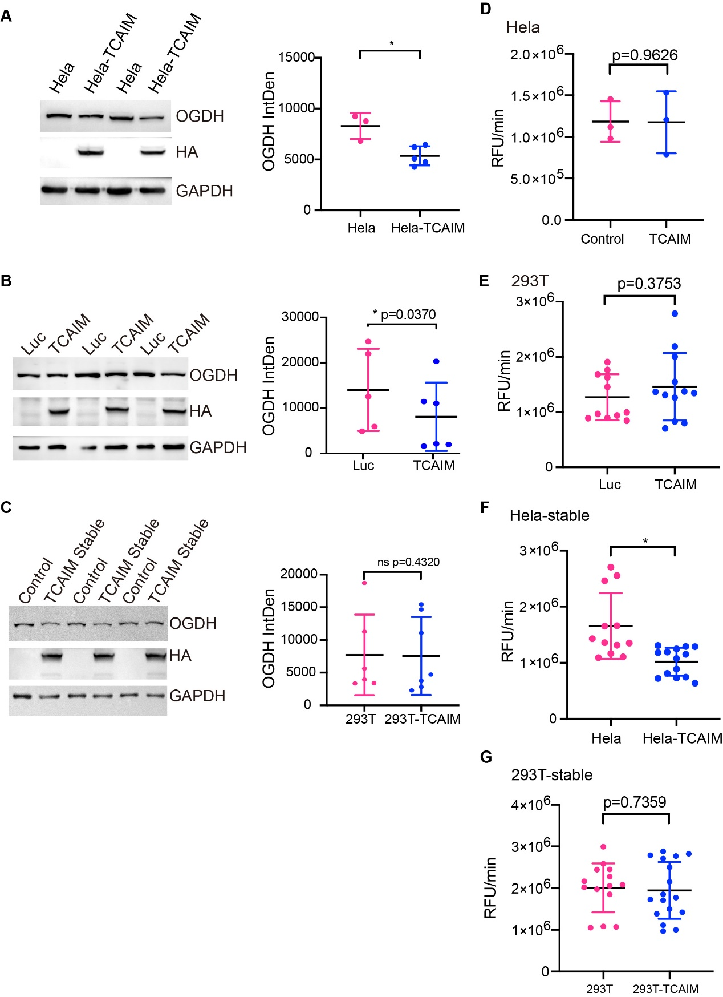

Fig S6
- Representative cryo-EM micrograph and 2D class averages of OGDH-TCAIM complex.
- Flowchart for cryo-EM data processing of OGDH-TCAIM complex.
- Fourier Shell Correlation (FSC) plot for the refinement of HsOGDH-TCAIM cyro-EM data with the overall resolution highlighted for FSC 0.143.
- Homologous TCAIM sequence alignment. Conserved residues were shaded in red, (Hs, homo sapiens; Mm, Mus musculus; Rn, Rattus norvegicus; Dr, Danio rerio; Dm, Drosophila melanogaster; Ag, Anopheles gambiae).

Fig S6
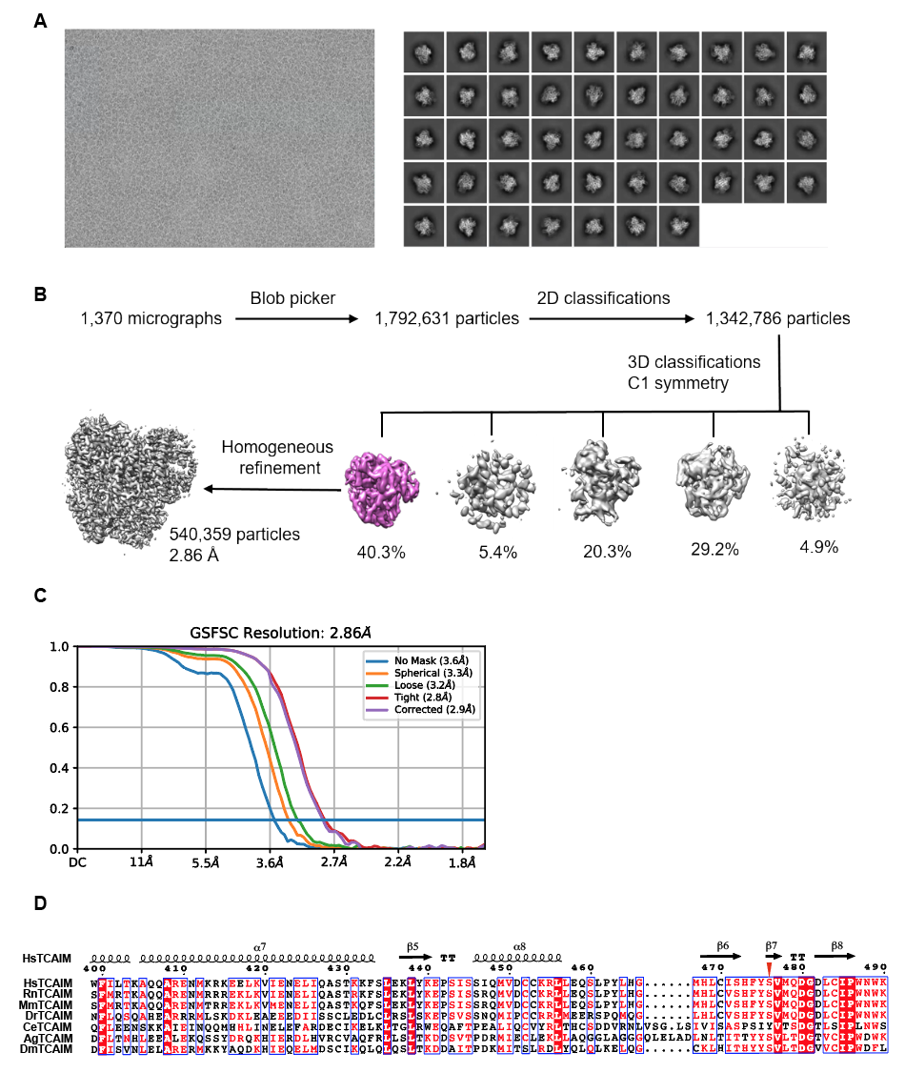

Fig S7
A. The protein levels of OGDH, TCAIM-HA, AFG3L2 and GAPDH in HeLa cells transiently knocked down for LONP1 by siRNA and transiently overexpressing EGFP mRNA or TCAIM mRNA, measured by immunoblotting.
B. The protein levels of OGDH, TCAIM-HA, CLPP and GAPDH in HeLa cells transiently knocked down for CLPP and transiently overexpressing EGFP mRNA or TCAIM mRNA, measured by immunoblotting.
C. The protein levels of OGDH, TCAIM-HA, MCL1 and GAPDH in HeLa cells transiently overexpressing EGFP or TCAIM mRNA, and then treated with MG132, measured by immunoblotting.
D. Cartoon representation of TCAIM aa161-496（left panel）and Alphafold predicted TCAIM aa161-466（right panel), TCAIM is colored in rainbow. The N terminal colored in blue, the C terminal in red.
E. The oxygen consumption rate (OCR) of HeLa cells transiently overexpressing EGFP, TCAIM or CBD-TCAIM mRNA, collected by Seahorse in serum-free basal DMEM containing 25 mM glucose and 4 mM glutamine. 2 μM oligomycin, 0.75 μM FCCP, 0.5 μM Rotenone/ antimycin A were added sequentially.

Fig S7

