Psoriasis Manuscript Appendix 1

Figure 1S. Schematic of GCM Exercise

Site identification and participant recruitment
Identification of key concepts

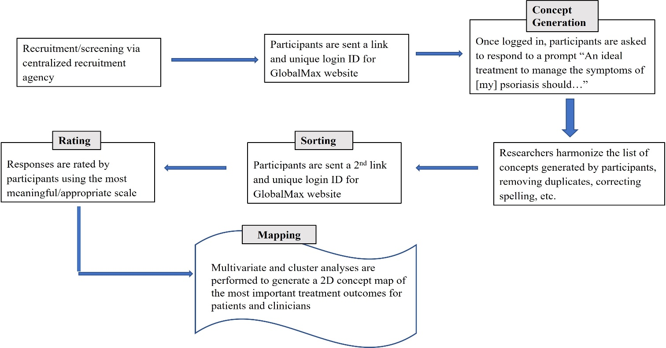

Figure 2S. Flowchart of Studies 1 and 2
