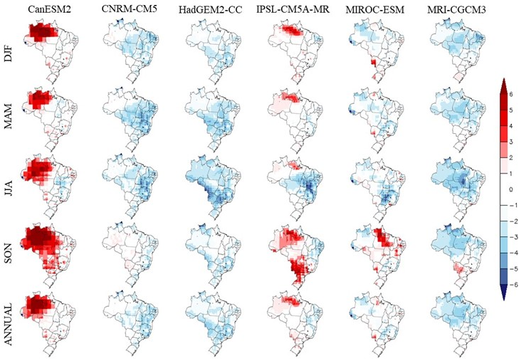
SM. 1 Seasonal and annual spatial patterns (1980-2005) for the mean near surface air temperature bias of each model compared to observed data (Xavier et al. 2016). DJF, MAM, JJA and SON refer to summer, autumn, winter, and austral spring, respectively. Units are in degrees Celsius.

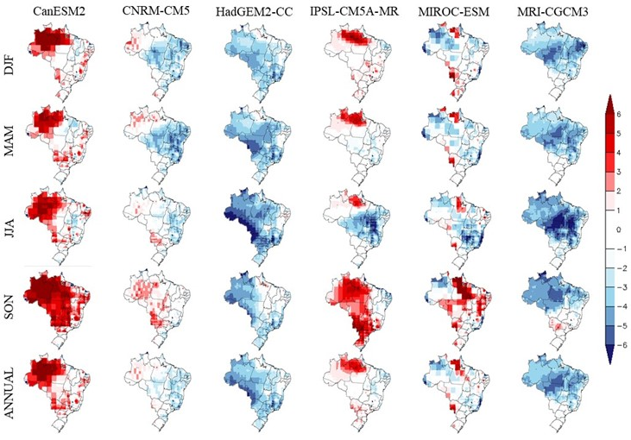
SM. 2 Seasonal and annual spatial patterns (1980-2005) for the maximum near surface air temperature bias of each model compared to observed data (Xavier et al. 2016). DJF, MAM, JJA and SON refer to summer, autumn, winter, and austral spring, respectively. Units are in degrees Celsius.

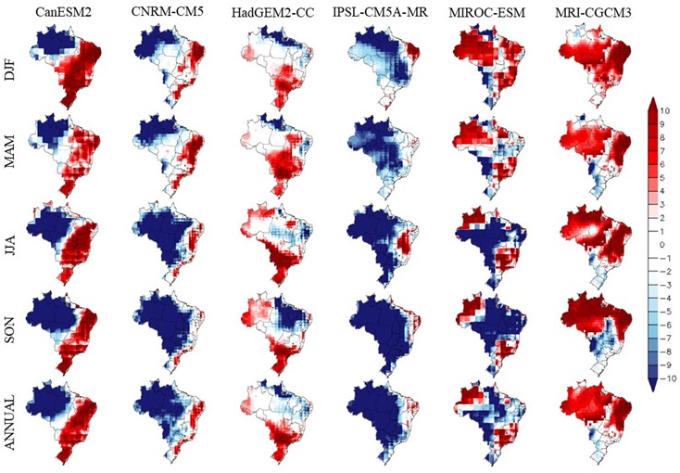
SM. 3 Seasonal and annual spatial patterns (1980-2005) for the near surface air humidity bias of each model compared to observed data (Xavier et al. 2016). DJF, MAM, JJA and SON refer to summer, autumn, winter, and austral spring, respectively. Units are in percentage.

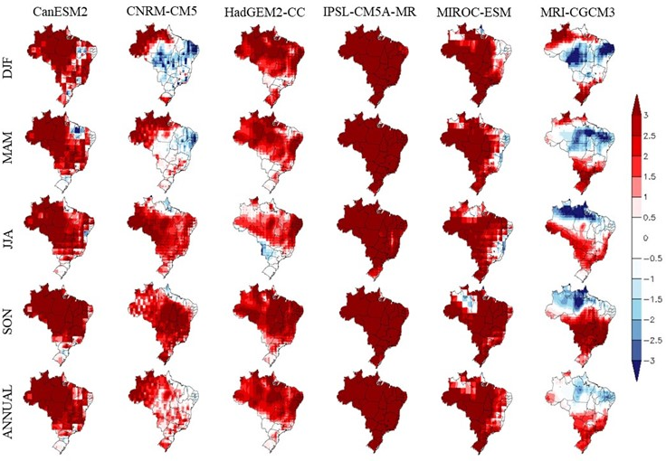
SM. 4 Seasonal and annual spatial patterns (1980-2005) for the global solar radiation bias of each model compared to observed data (Xavier et al. 2016). DJF, MAM, JJA and SON refer to summer, autumn, winter, and austral spring, respectively. Units are in MJ m⁻² per day.

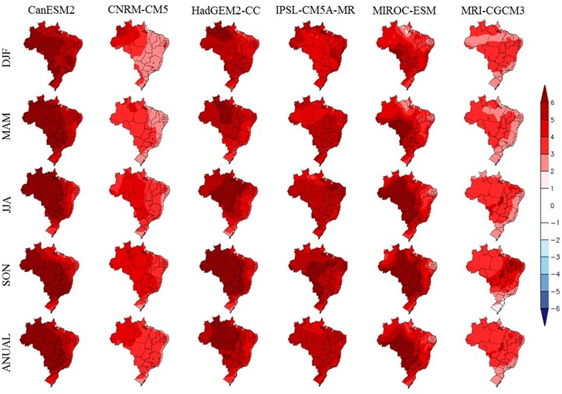
SM. 5 Seasonal and annual projected climate change in the mean near surface air temperature for the late 21st century (2071-2100) for RCP8.5. DJF, MAM, JJA and SON refer to summer, autumn, winter, and austral spring, respectively. Units are in degrees Celsius.

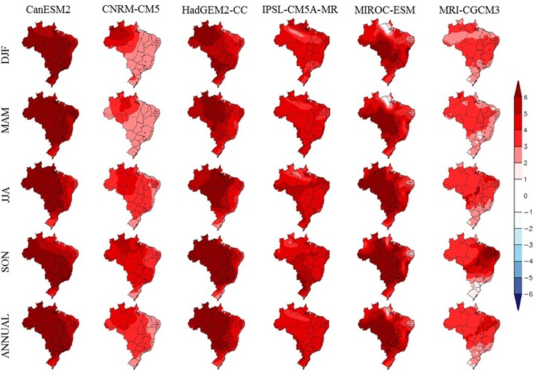
SM. 6 Seasonal and annual projected climate change in the maximum near surface air temperature for the late 21st century (2071-2100) for RCP8.5. DJF, MAM, JJA and SON refer to summer, autumn, winter, and austral spring, respectively. Units are in degrees Celsius.

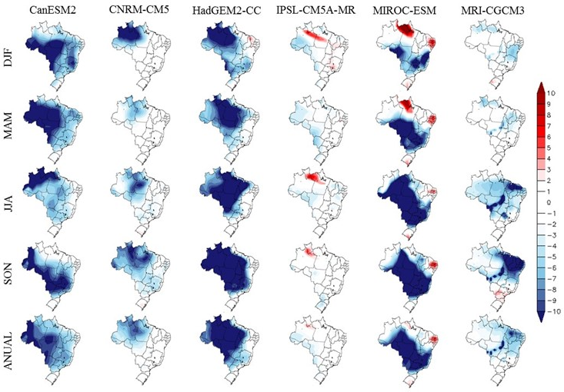
SM. 7 Seasonal and annual projected climate change in the near surface air humidity for the late 21st century (2071-2100) for RCP8.5. DJF, MAM, JJA and SON refer to summer, autumn, winter, and austral spring, respectively. Units are in percentage.

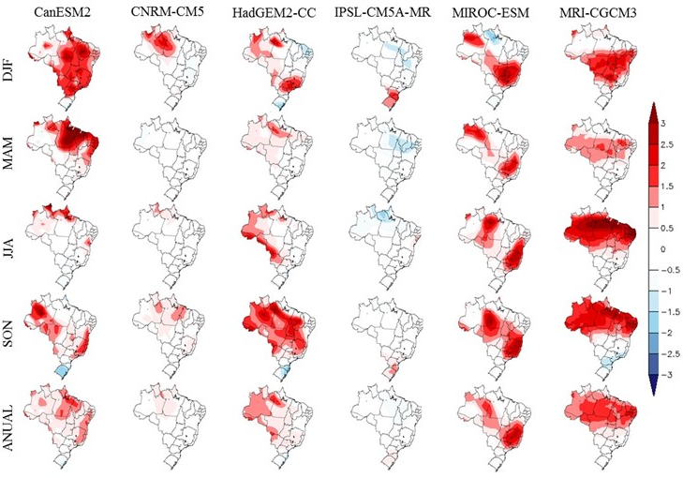
SM. 8 Seasonal and annual projected climate change in the global solar radiation for the late 21st century (2071-2100) for RCP8.5. DJF, MAM, JJA and SON refer to summer, autumn, winter, and austral spring, respectively. Units are in MJ m⁻² per day

