Supplement Table 1.
 | Pretreatment (min) | Number | BP | RO
 | Pretreatment (min) | of rats | TH | TH
Baseline |  | 8 | 1.44±0.32
0.035 mg/kg | 20 | 4 | 0.45±0.22 | 65.36±16.48
0.035 mg/kg | 40 | 6 | 0.78±0.25 | 40.24±18.93
0.035 mg/kg | 60 | 2 | 0.60±0.08 | 53.98±5.95
0.035 mg/kg | 87 | 2 | 0.94±0.16 | 27.76±12.20
0.035 mg/kg | 180 | 3 | 1.11±0.02 | 15.11±1.14
0.17 mg/kg | 40 | 4 | 0.06±0.24 | 95.74±18.93
0.17 mg/kg | 60 | 4 | 0.35±0.15 | 73.03±11.23
0.17 mg/kg | 90 | 8 | 0.47±0.21 | 63.70±16.33
0.17 mg/kg | 110 | 4 | 1.05±0.18 | 25.71±17.1
0.17 mg/kg | 210 | 2 | 1.11±0.05 | 14.82±3.84

Supplementary Table 1. Pharmacokinetic parameters for NLX doses of 0.035 and 0.17 mg/kg assessed at different pretreatment times. BP=Binding Potential, RO=Receptor Occupancy, TH=thalamus, CB=cerebellum (reference regions).

Supplement figure 1.

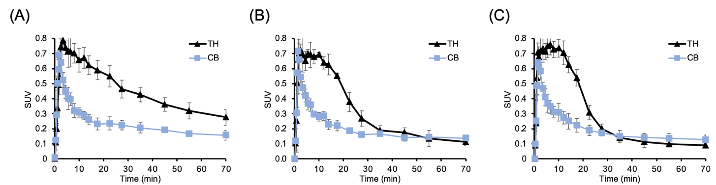

Suppl Figure 1. Averaged time-activity curves of [¹¹C]CFN for the baselines (A, n=3), NLX post-treatment scans (B, n=3; IV, 0.035 mg/kg), and NLX post-treatment scans (C, n=3; IV, 0.17 mg/kg). NLX was administered at 15 min after [¹¹C]CFN injection. [¹¹C]CFN uptake is expressed as standard uptake values (SUV) in the thalamus, (TH), which was the target region for its high specific binding and in the cerebellum (CB), which served as a reference region devoid of specific binding.

Supplement Figure 2.

Suppl Figure 2. PET brain images of [¹¹C]CFN for baseline and the NLX pretreatments (0.035 mg/kg and 0.17 mg/kg NLX). NLX was given 5 min prior [¹¹C]CFN administration to assess blocking MORs.

Supplement Figure 3.

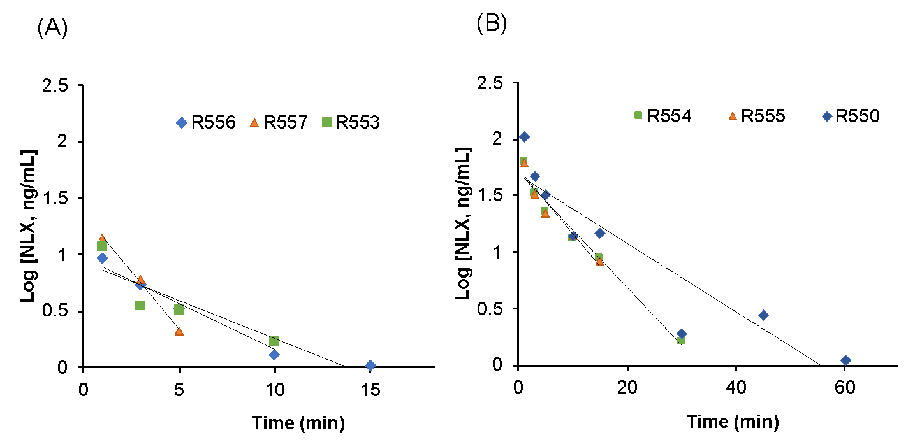

Suppl Figure 3. Plasma concentration of naloxone in individual rats for the two doses of IV NLX (A, 0.035 mg/kg, n=3; B, 0.17 mg/kg, n=3).

Supplement Figure 4.

Suppl Figure 4. Correlation between MOR occupancy and IV NLX concentration in plasma. Estimated half-maximal effect (EC₅₀) is 0.2 ng/ml.

