Supporting Information
Halogen-free, phosphorus decorated, bio-waste derived nanocomposite for highly efficient flame retardant for cotton fabric
Pratik S. Dhumalª, Madhuri A. Bhakareª, Kshama D. Lokhandeª, Mahesh P. Bondardeª, and Surajit Some*ª
a. Department of Speciality Chemicals Technology, Institute of Chemical Technology, Matunga, Mumbai 400 019, India.

Author Information
*Corresponding Author
Email: sr.some@ictmumbai.edu.in

Index
Sr. No. | Contents | Page Number
Table S1 | EDX, EA and XPS data of GCP composite (at. %) | 3
Figure S1 | XRD pattern of graphene oxide | 3
Figure S2 | A plausible mechanism of the GCP composite | 4
Table S2 | Vertical flammability test result | 5
Table S3 | Limiting oxygen index (LOI) of blank cloth, GO coated, CP coated, and GCP coated cloth | 5
Table S4 | Comparative table for reported composite | 5
Figure S3 | Tensile strength of the GCP coated cloth | 6
Table S5 | Washing fastness of the calcium carbonate, CP, and GCP | 6-7

Table S1 EDX, EA and XPS data of GCP composite (at. %)
Sample | Element | EDX (at. %) | XPS (at. %) | Elemental analysis  (Wt.%)
GCP composite | C | 30 | 29.5 | 30.5
GCP composite | O | 31.5 | 30.7 | 31
GCP composite | P | 28 | 25.3 | 26
GCP composite | Ca | 10.5 | 14.5 | 12.5

Figure S1 XRD pattern of the graphene oxide (GO)

In the mechanism of the GCP composite preparation, firstly GO and CP has the ionic interaction. In that, oxygen sites of the GO and phosphorous functional groups converted to covalent bonds. Also, the free hydroxyl of the phosphate takes part in the reaction to form a bond with the GO.

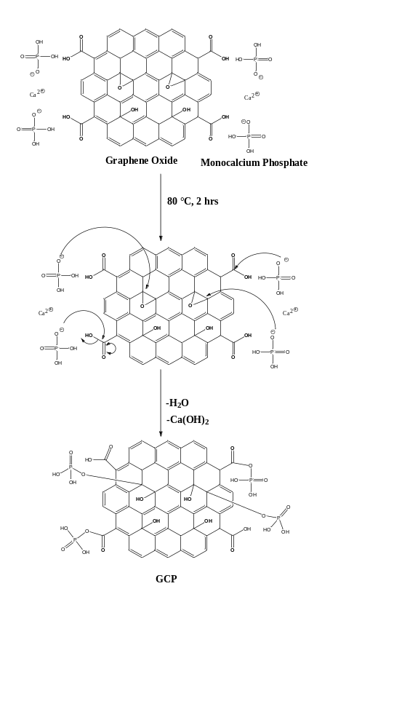
Figure S2 Plausible mechanism of the GCP composite

Table S2 Flame test result of the blank cloth, GO coated cloth, CP coated cloth, and GCP coated cloth by vertical flammability
Flammability parameter | Blank cloth | GO | CP/Cloth | GCP/Cloth
Occurring flashing over the surface | Yes | Yes | Yes | No
Burning with flame time (s) | 18 | 11 | 16 | 0
Burning with afterglow time (s) after flame stop | 0 | 0 | 0 | 2
Total burning time (s) (Flame time + afterglow time) | 18 | 11 | 16 | 2
Char length (cm) | NIL | NIL | NIL | 2.5

The limiting oxygen index (LOI) test was performed according to standard method ASTM D2863-09. For this test, the cloth sample was used of 13 cm in length and 6 cm in width. To perform the test, cloth samples were suspended vertically and ignited using a burner. According to LOI data, a value of more than 26 indicates better flame retardancy of the material. The prepared material showed a comparatively high LOI value (33.8) than the other samples. So, from the results, it was concluded that the prepared GCP composite has good flame-retardant material.

Table S3 Limiting oxygen index (LOI) of blank cloth, GO coated, CP coated, and GCP coated cloth
Sample No. | LOI of blank cloth | LOI of GO coated cloth | LOI of CP coated cloth | LOI of GCP coated cloth
1 | 17.4 | 18.2 | 18 | 34
2 | 18 | 18.5 | 18.2 | 34.5
3 | 17.5 | 18 | 17.9 | 33.8
4 | 17.6 | 18.3 | 17.8 | 34.2
5 | 17.5 | 18.2 | 18.2 | 34.4
Mean of LOI | 17.6 | 18.2 | 18 | 34.1

Table S4 Table of sample comparisons based on char length
Sr. No. | Samples | Char length concerning time | Reference
1 | CaCO₃ coated fabric | 4.8 cm in 12 s | 1
2 | GCP coated fabric | 2.5 cm in 12 s | This Work

Reference:
1) Tseghai GB, Berhe BT, Wakjira YT. Producing Fire Retardant Cotton Fabric Using Chicken Eggshell, J. Textile. Sci. Eng. 2019; 9:2.

Figure S3 Tensile strength of the GCP coated cloth

Table S5 Wash fastness of binder free GCP and with binder GCP coated cotton fabric before and after washing
Sr. No. | Sample name | Before wash weight (g) | After wash weight (g) | % Total weight loss
1 | GCP/Cloth | 1.456 | 0.578 | 60.30
1 | GCP/Cloth | 1.560 | 0.619 | 60.32
1 | GCP/Cloth | 1.4501 | 0.588 | 59.44
2 | GCP/Cloth/Binder | 1.786 | 1.345 | 24.69
2 | GCP/Cloth/Binder | 1.695 | 1.295 | 23.42
2 | GCP/Cloth/Binder | 1.725 | 1.320 | 23.47

The ISO2 method was used to test the washing fastness of the GCP composite (Teli et al. 2017). The GCP coated cloth sample (with and without binder) was washed for 45 minutes in a 5g/L soap solution with a liquor ratio of 50:1, then rinsed thoroughly with water and dried in the air. The maximum weight decrease for GCP coated cloth was observed in this study (60.32 %). The addition of a binder (Saraprint AC), on the other hand, reduces the percentage of weight loss for GCP coated cloth (24.63 %).
Reference:
1) Teli M. D.; Pintu P.;2017, J. Ind. Text. 0 (00), 2017, 1–32.

