Supplementary Table 1. NOS risk of bias scale for the included studies.

 |  | Selection |  |  |  |  | Outcome
First Author, Publication Yea r | Representativeness of the exposed cohort | Selection of the non-exposed cohort | Ascertainment of exposure | Outcome of interest not present at start of study | Comparability | Assessment of outcome | Adequacy of duration of follow-up | Adequacy of completeness of follow-up | Total score  (0-9)
Ohno 2011 | 1 | 1 | 1 | 1 | 0 | 1 | 1 | 1 | 7
Bezzina 2006 | 1 | 1 | 1 | 1 | 2(age, gender) | 1 | 1 | 1 | 9
Zhang 2021 | 1 | 1 | 1 | 1 | 0 | 1 | 1 | 1 | 7
Ishikawa 2021 | 1 | 1 | 1 | 1 | 1 (gender) | 1 | 1 | 1 | 8
Veltmann 2016 | 1 | 1 | 1 | 1 | 2 (age, gender) | 1 | 1 | 1 | 9
Lizotte 2009 | 1 | 1 | 1 | 1 | 0 | 1 | 1 | 1 | 7
Tse 2020 | 1 | 1 | 1 | 1 | 2 (age, gender)) | 1 | 1 | 1 | 9
Andorin 2016 | 1 | 1 | 1 | 1 | 1 (age) | 1 | 1 | 1 | 8
Brugada 2018 | 1 | 1 | 1 | 1 | 1 (age) | 1 | 1 | 1 | 8
Makarawate 2017 | 1 | 1 | 1 | 1 | 0 | 1 | 1 | 1 | 7
Wijeyeratne 2020 | 1 | 1 | 1 | 1 | 2 (age, gender) | 1 | 1 | 1 | 9
Juang 2014 | 1 | 1 | 1 | 1 | 2 (age, gender) | 1 | 1 | 1 | 9

Supplementary Figures

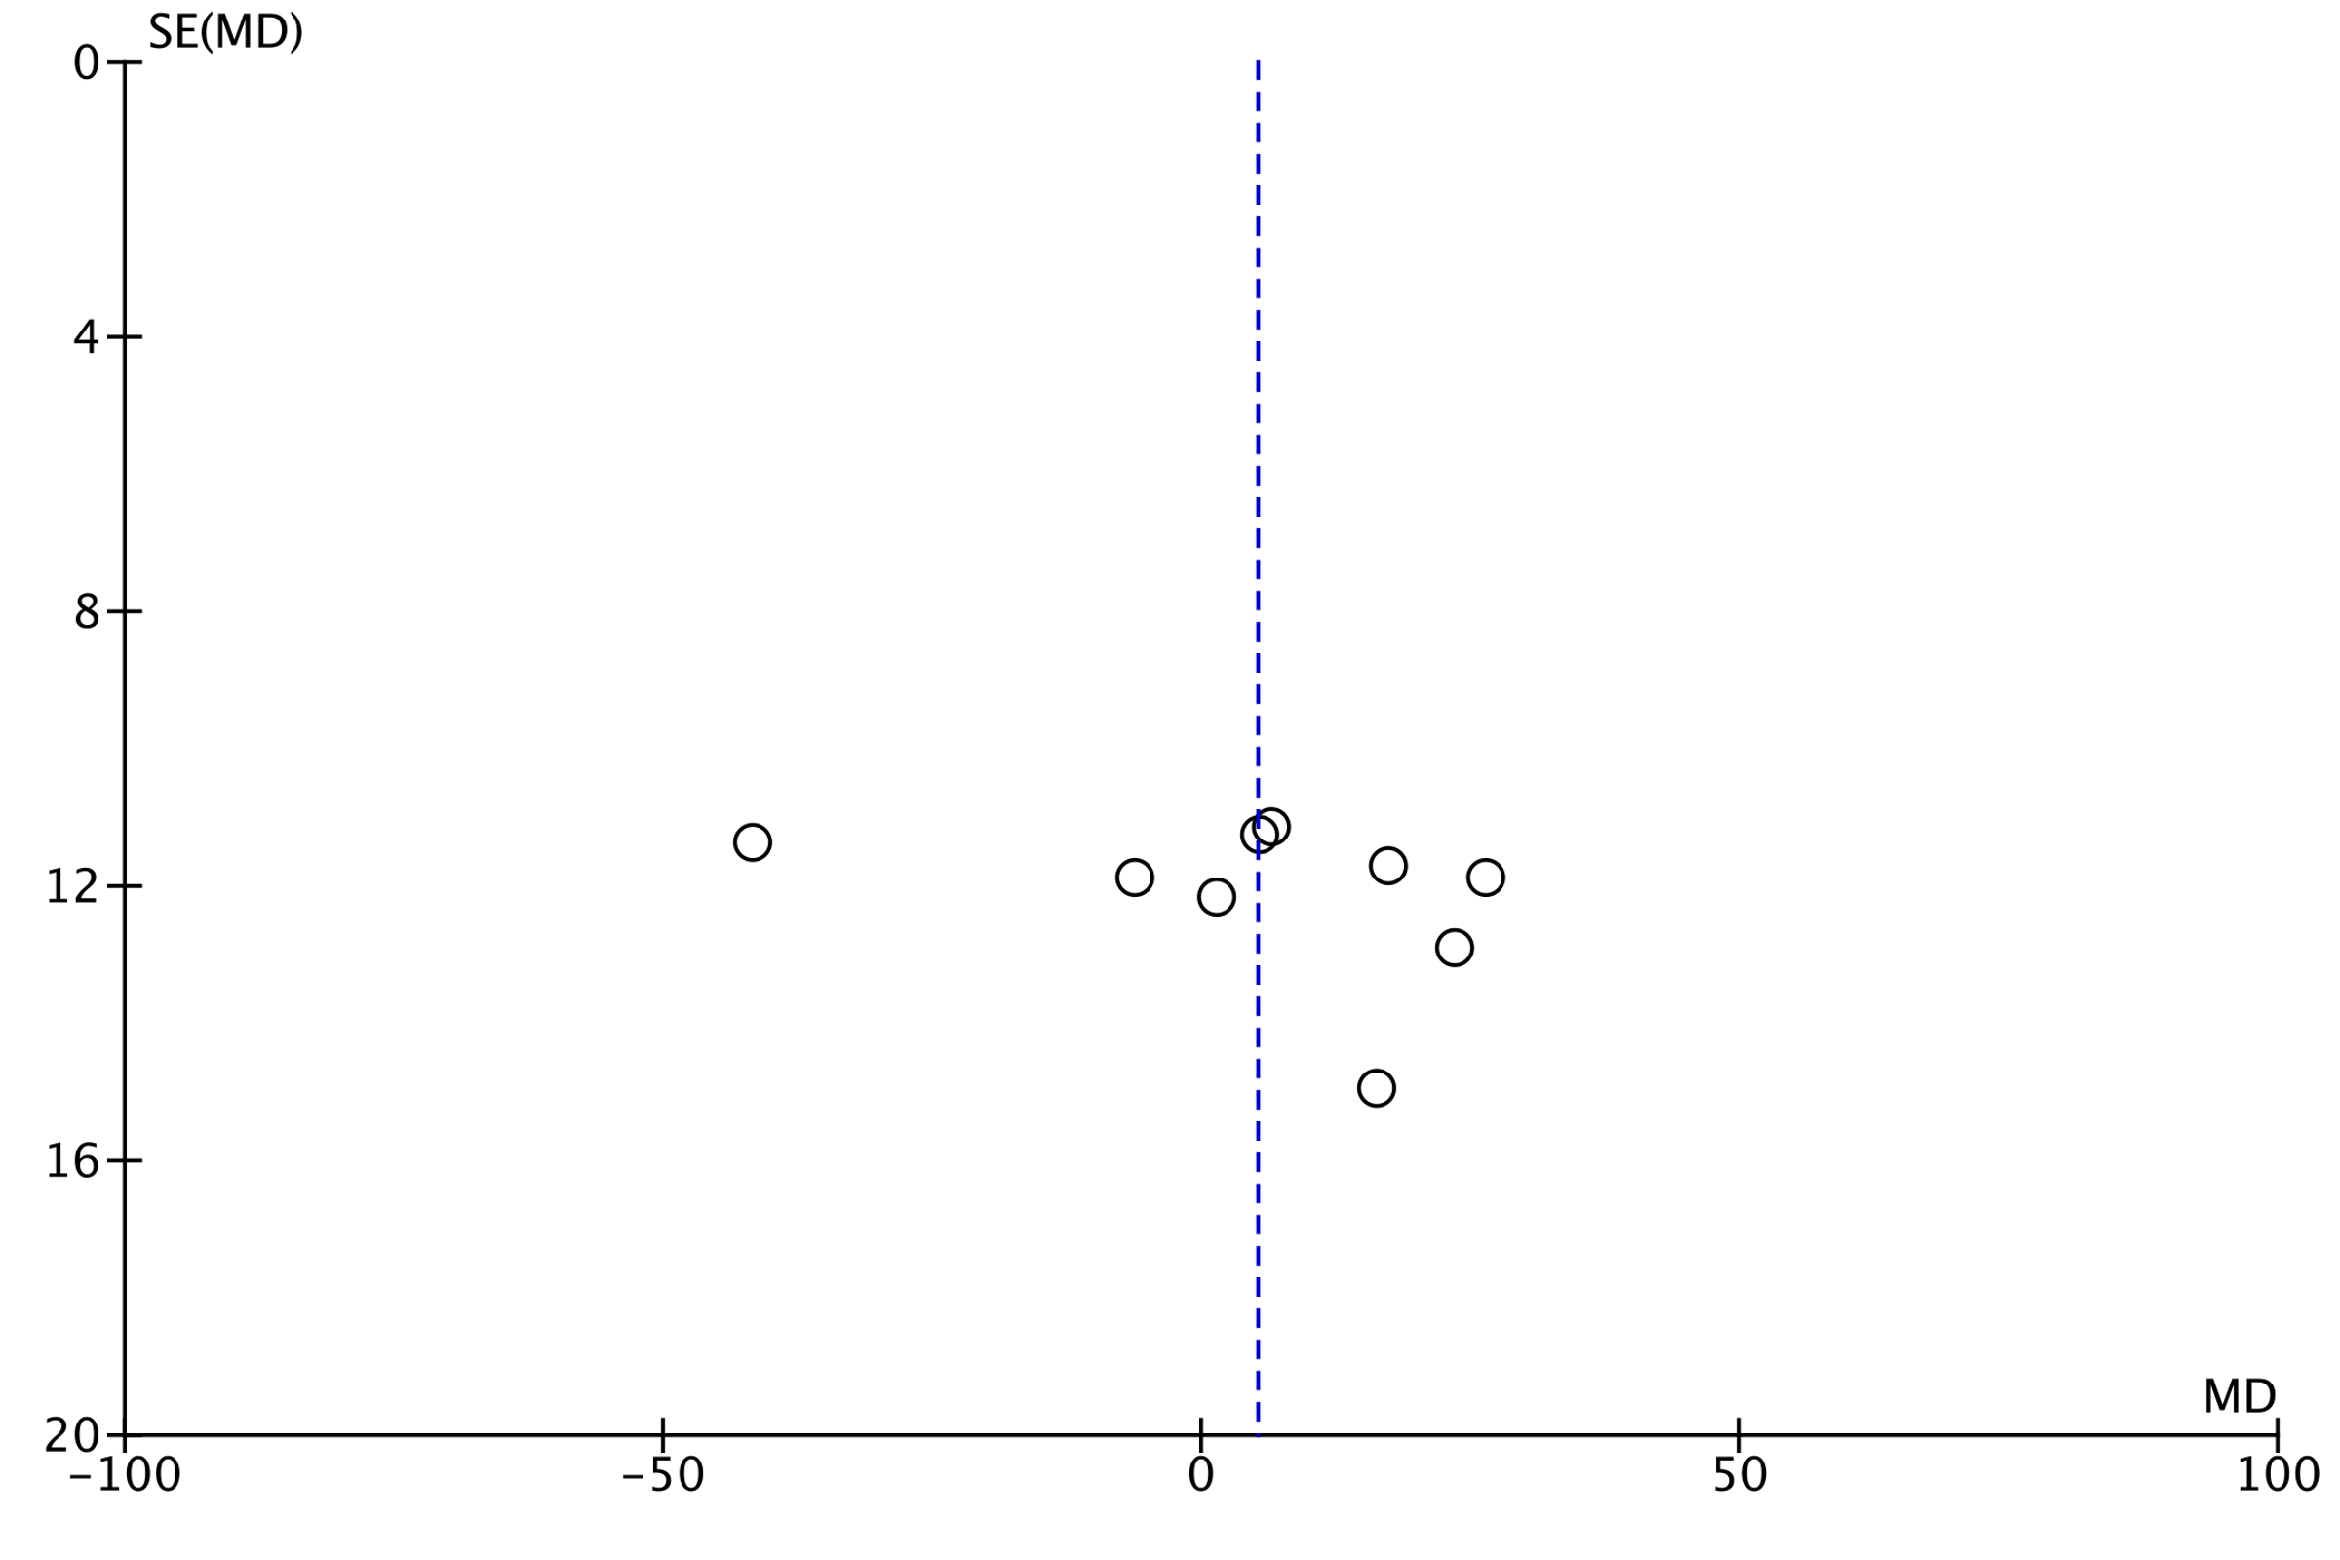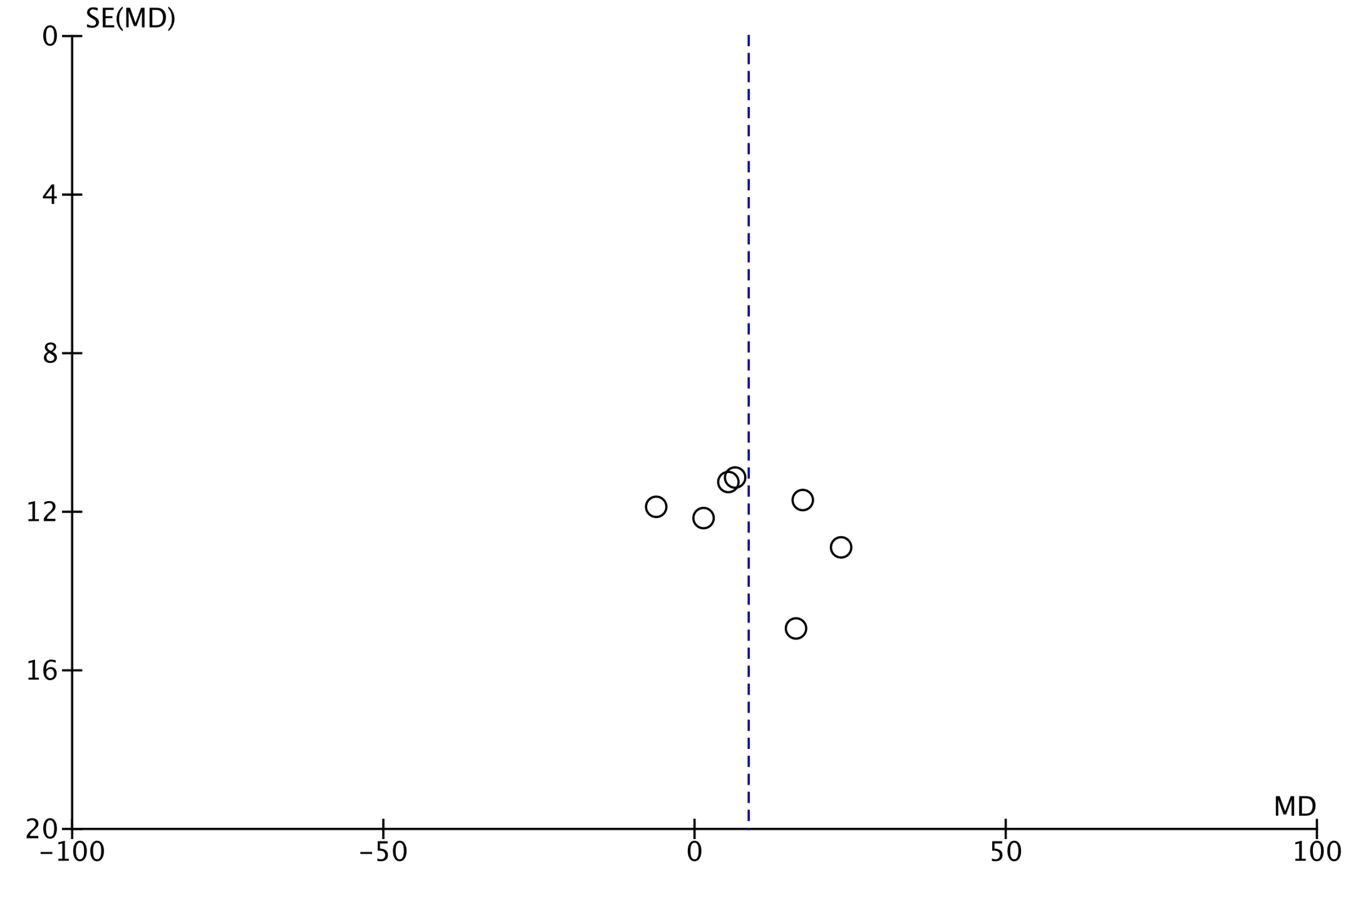
Supplementary Figure 1. PR Interval in ERS vs BrS sensitivity analysis funnel plots

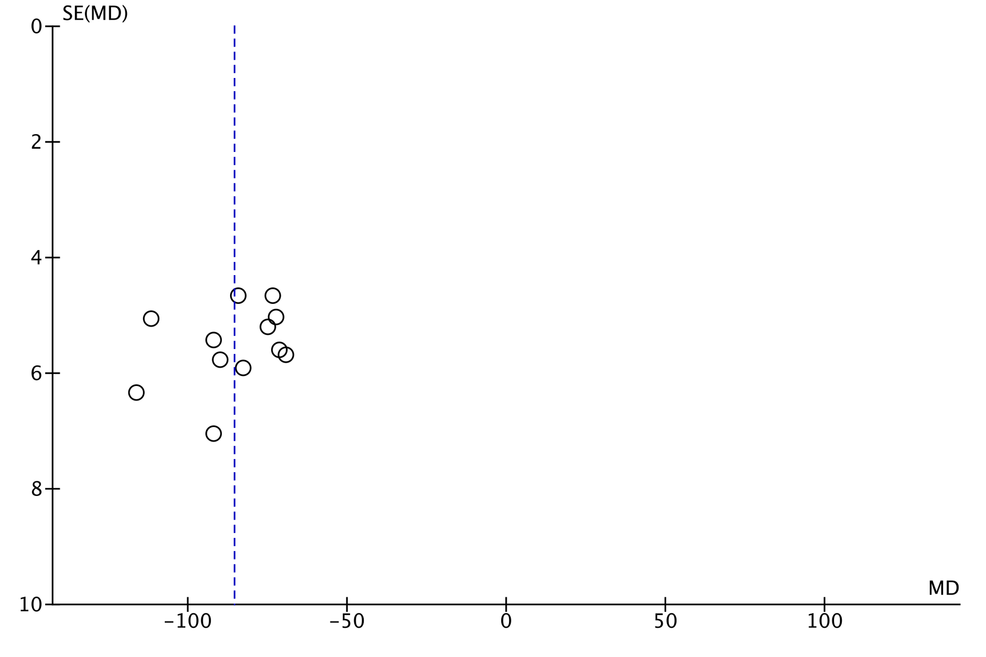
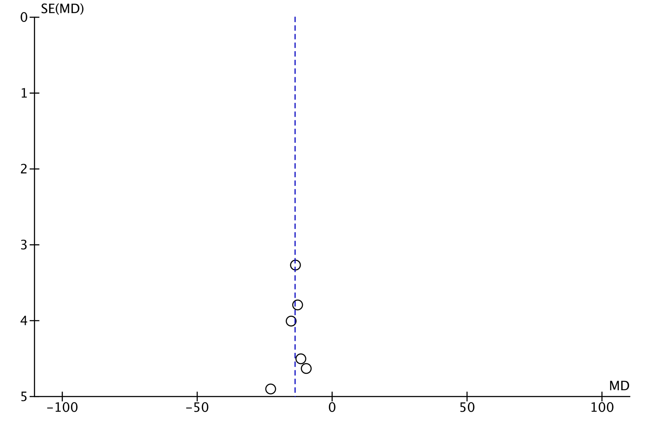
Supplementary Figure 2. QRS duration in ERS vs BrS sensitivity analysis funnel plots

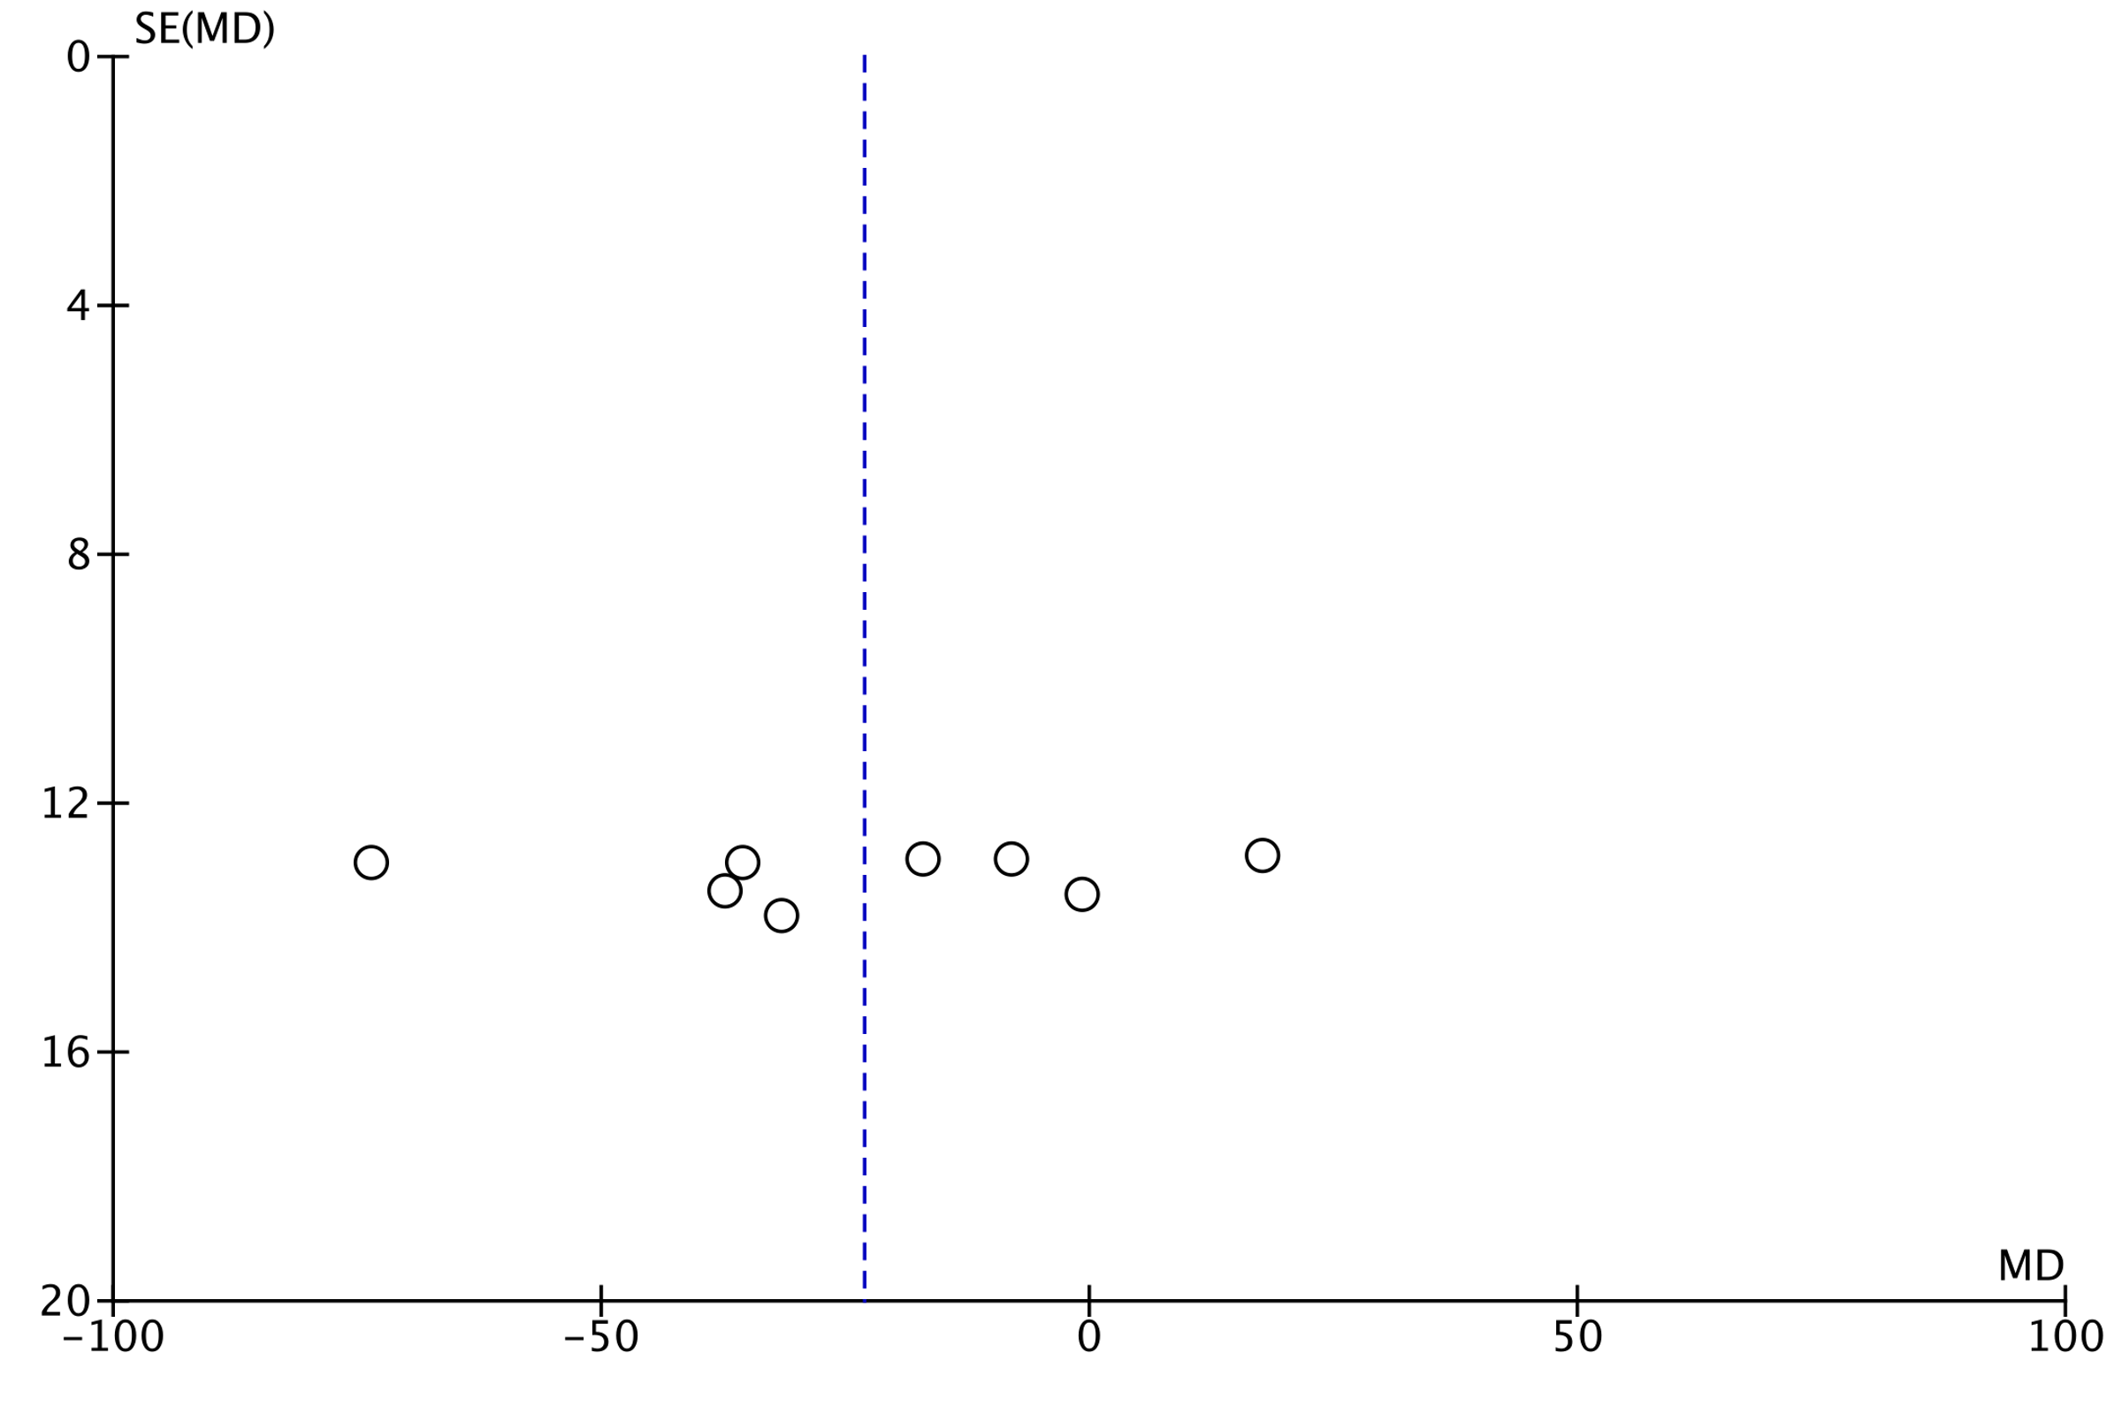
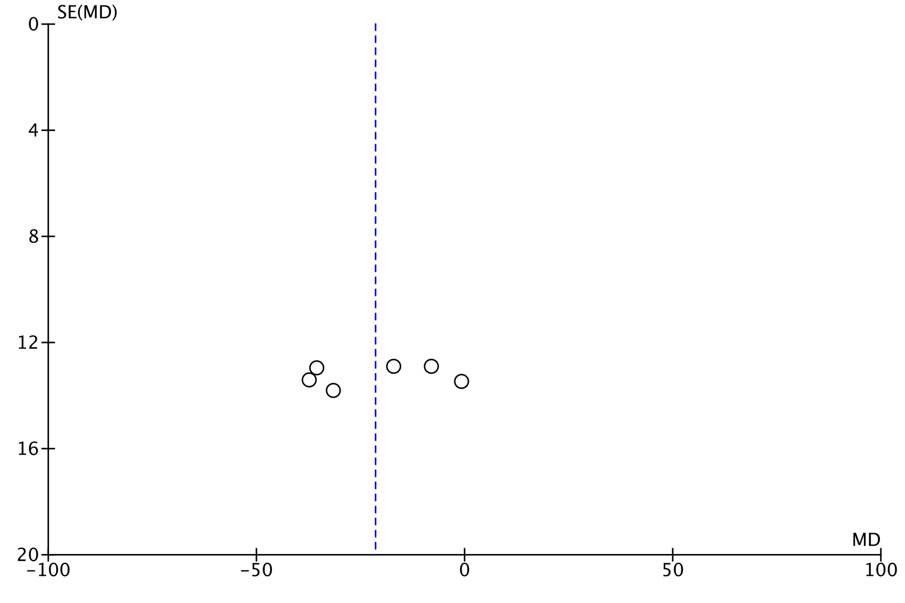
Supplementary Figure 3. QTc in ERS vs BrS sensitivity analysis funnel plots

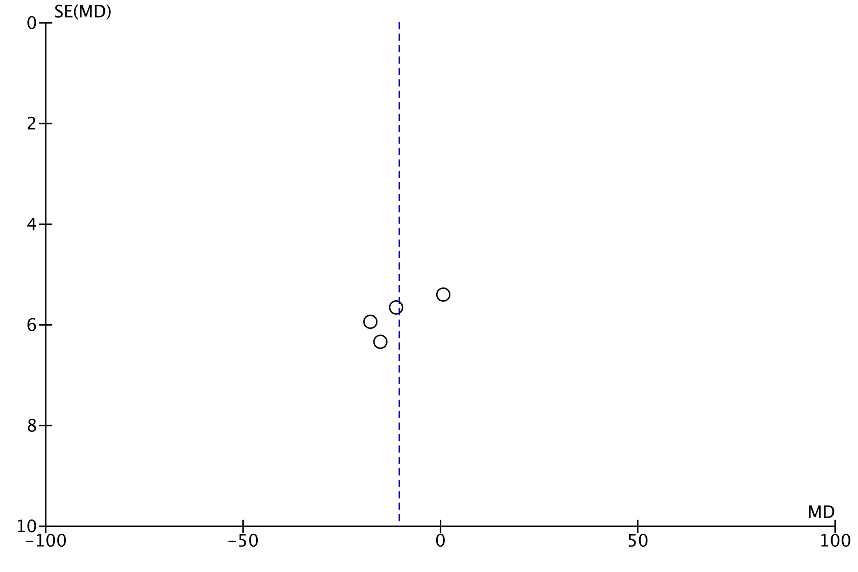
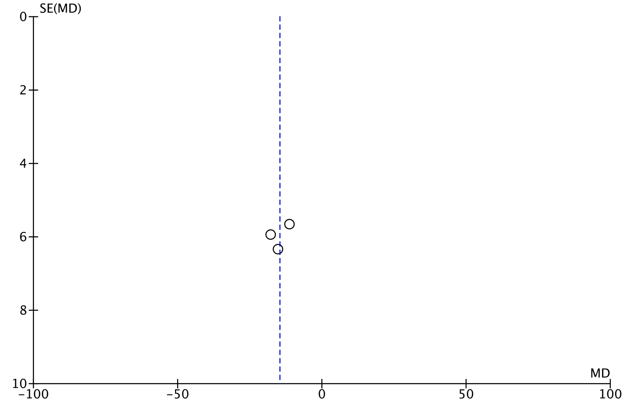
Supplementary Figure 4. Resting HR in ERS vs BrS sensitivity analysis funnel plots

