Tables
Table 1. Patient demographic characteristics, infusion volume, irrigation time and volume.
 | UB group (n=47) | OB group (n=49) | P value
Sex, male/female | 25/22 | 22/27 | 0.416
Age, y | 51.7±12.9 | 52.1±12.4 | 0.877
BMI, kg/m² | 24.8±2.9 | 24.1±2.9 | 0.231
Infusion volume, mL | 761.7±148.3 | 752.0±141.4 | 0.745
Irrigation time, min | 90.7±16.5 | 91.7±14.8 | 0.880
Irrigation volume, L | 19.7±5.5 | 18.4±5.1 | 0.522
Data are expressed as Mean ± SD.
Data in Table 1.
Patient  number | Group | Sex  (1=male,  2=female) | Age  (years) | Height  (cm) | Weight  (kg) | BMI  (kg/m2) | Infusion volume  (mL) | Irrigation time  (min) | Irrigation volume  (L)
4 | UB | 2 | 48 | 154 | 60 | 25 | 950 | 103 | 23.10
7 | UB | 1 | 62 | 179 | 76 | 24 | 1000 | 112 | 25.20
9 | UB | 2 | 53 | 149 | 52 | 23 | 600 | 66 | 10.50
11 | UB | 2 | 52 | 149 | 51 | 23 | 650 | 71 | 12.00
12 | UB | 1 | 44 | 165 | 70 | 26 | 600 | 63 | 8.70
15 | UB | 1 | 58 | 168 | 82 | 29 | 800 | 86 | 18.30
16 | UB | 1 | 57 | 179 | 82 | 26 | 1000 | 116 | 27.30
18 | UB | 2 | 45 | 165 | 70 | 26 | 750 | 79 | 17.40
19 | UB | 1 | 65 | 156 | 57 | 23 | 800 | 99 | 20.40
20 | UB | 2 | 69 | 165 | 76 | 28 | 900 | 99 | 21.60
22 | UB | 2 | 20 | 170 | 77 | 27 | 800 | 93 | 19.20
23 | UB | 1 | 34 | 172 | 75 | 25 | 700 | 78 | 18.90
25 | UB | 1 | 60 | 170 | 72 | 25 | 600 | 62 | 9.00
26 | UB | 1 | 47 | 172 | 77 | 26 | 950 | 102 | 21.90
27 | UB | 1 | 37 | 175 | 61 | 20 | 700 | 90 | 16.50
28 | UB | 2 | 42 | 164 | 62 | 23 | 600 | 65 | 10.20
29 | UB | 1 | 40 | 180 | 77 | 24 | 750 | 83 | 17.70
30 | UB | 1 | 49 | 170 | 63 | 22 | 1000 | 115 | 23.70
31 | UB | 1 | 55 | 168 | 62 | 22 | 650 | 73 | 15.90
32 | UB | 2 | 51 | 155 | 72 | 30 | 800 | 99 | 21.90
34 | UB | 1 | 66 | 171 | 62 | 21 | 1000 | 120 | 28.50
36 | UB | 2 | 65 | 148 | 60 | 27 | 650 | 91 | 23.40
39 | UB | 2 | 50 | 156 | 68 | 28 | 650 | 78 | 17.40
38 | UB | 1 | 61 | 166 | 58 | 21 | 950 | 113 | 26.10
44 | UB | 2 | 67 | 149 | 58 | 26 | 600 | 64 | 9.30
48 | UB | 2 | 48 | 151 | 68 | 30 | 900 | 116 | 27.90
49 | UB | 1 | 52 | 161 | 75 | 29 | 750 | 98 | 24.60
50 | UB | 1 | 30 | 170 | 75 | 26 | 900 | 104 | 21.30
51 | UB | 1 | 29 | 165 | 63 | 23 | 650 | 79 | 13.50
52 | UB | 2 | 61 | 155 | 48 | 20 | 550 | 74 | 17.70
53 | UB | 1 | 63 | 160 | 72 | 28 | 850 | 103 | 22.50
57 | UB | 2 | 62 | 154 | 47 | 20 | 600 | 94 | 17.10
60 | UB | 1 | 63 | 160 | 62 | 24 | 850 | 101 | 22.20
63 | UB | 2 | 64 | 156 | 60 | 25 | 600 | 87 | 16.20
66 | UB | 2 | 54 | 157 | 69 | 28 | 800 | 99 | 19.50
72 | UB | 1 | 20 | 177 | 87 | 28 | 900 | 92 | 21.60
74 | UB | 2 | 55 | 158 | 71 | 28 | 700 | 89 | 18.30
78 | UB | 1 | 45 | 176 | 86 | 28 | 950 | 112 | 29.40
80 | UB | 2 | 54 | 150 | 50 | 22 | 550 | 81 | 16.50
81 | UB | 2 | 56 | 150 | 50 | 22 | 500 | 63 | 9.00
82 | UB | 1 | 67 | 164 | 71 | 26 | 900 | 108 | 23.40
83 | UB | 1 | 28 | 172 | 70 | 24 | 750 | 100 | 21.60
87 | UB | 1 | 70 | 158 | 60 | 24 | 850 | 103 | 22.80
89 | UB | 2 | 35 | 155 | 49 | 20 | 600 | 76 | 12.60
92 | UB | 2 | 57 | 160 | 50 | 20 | 600 | 78 | 17.10
96 | UB | 2 | 62 | 158 | 57 | 23 | 650 | 79 | 16.20
100 | UB | 1 | 57 | 177 | 89 | 28 | 950 | 105 | 24.30
1 | OB | 2 | 33 | 168 | 72 | 26 | 900 | 111 | 26.10
2 | OB | 2 | 70 | 155 | 64 | 27 | 1000 | 116 | 27.60
3 | OB | 2 | 49 | 163 | 50 | 19 | 850 | 107 | 23.40
5 | OB | 2 | 46 | 160 | 60 | 23 | 550 | 65 | 9.60
6 | OB | 2 | 68 | 150 | 67 | 30 | 900 | 109 | 22.20
8 | OB | 1 | 44 | 174 | 78 | 26 | 700 | 94 | 20.10
10 | OB | 2 | 63 | 146 | 48 | 22 | 750 | 87 | 18.00
17 | OB | 1 | 61 | 155 | 52 | 22 | 700 | 74 | 12.90
13 | OB | 2 | 53 | 159 | 57 | 23 | 600 | 68 | 10.50
14 | OB | 1 | 21 | 177 | 75 | 24 | 950 | 113 | 26.10
21 | OB | 2 | 36 | 175 | 72 | 24 | 750 | 87 | 16.80
24 | OB | 2 | 52 | 157 | 48 | 19 | 800 | 109 | 23.40
35 | OB | 2 | 65 | 154 | 55 | 23 | 650 | 95 | 19.80
37 | OB | 1 | 52 | 165 | 53 | 19 | 600 | 87 | 17.10
41 | OB | 1 | 21 | 170 | 62 | 21 | 950 | 112 | 27.00
42 | OB | 2 | 53 | 156 | 67 | 28 | 600 | 91 | 17.40
43 | OB | 1 | 44 | 182 | 75 | 23 | 650 | 78 | 10.80
45 | OB | 1 | 61 | 164 | 67 | 25 | 700 | 82 | 13.80
46 | OB | 2 | 53 | 158 | 72 | 29 | 750 | 88 | 15.30
55 | OB | 1 | 36 | 175 | 85 | 28 | 950 | 108 | 23.40
54 | OB | 1 | 63 | 167 | 65 | 23 | 600 | 104 | 22.80
56 | OB | 2 | 54 | 158 | 58 | 23 | 600 | 82 | 14.70
58 | OB | 2 | 51 | 160 | 66 | 26 | 700 | 85 | 17.10
59 | OB | 1 | 55 | 161 | 73 | 28 | 950 | 117 | 27.30
61 | OB | 2 | 59 | 158 | 65 | 26 | 900 | 96 | 19.50
62 | OB | 2 | 69 | 155 | 50 | 21 | 600 | 76 | 12.60
64 | OB | 1 | 56 | 168 | 65 | 23 | 850 | 91 | 20.70
65 | OB | 1 | 53 | 167 | 70 | 25 | 1000 | 119 | 30.00
67 | OB | 1 | 57 | 154 | 50 | 21 | 650 | 87 | 18.90
68 | OB | 2 | 67 | 157 | 48 | 19 | 700 | 80 | 15.60
69 | OB | 1 | 51 | 170 | 59 | 20 | 600 | 83 | 16.80
70 | OB | 2 | 65 | 155 | 55 | 23 | 700 | 78 | 12.90
71 | OB | 2 | 57 | 160 | 75 | 29 | 750 | 89 | 17.10
73 | OB | 1 | 39 | 174 | 76 | 25 | 700 | 98 | 18.00
76 | OB | 2 | 66 | 155 | 55 | 23 | 750 | 84 | 17.40
77 | OB | 2 | 63 | 155 | 51 | 21 | 750 | 99 | 20.10
79 | OB | 1 | 53 | 168 | 65 | 23 | 750 | 86 | 18.30
84 | OB | 2 | 55 | 158 | 55 | 22 | 650 | 78 | 15.00
85 | OB | 2 | 55 | 159 | 60 | 24 | 550 | 62 | 8.10
86 | OB | 2 | 66 | 154 | 70 | 30 | 950 | 108 | 22.80
88 | OB | 2 | 49 | 155 | 72 | 30 | 750 | 72 | 12.90
90 | OB | 1 | 35 | 174 | 77 | 25 | 500 | 72 | 11.70
91 | OB | 1 | 33 | 165 | 68 | 25 | 950 | 106 | 22.80
93 | OB | 2 | 37 | 166 | 70 | 25 | 650 | 81 | 17.40
94 | OB | 1 | 28 | 168 | 60 | 21 | 850 | 87 | 18.60
95 | OB | 1 | 56 | 168 | 67 | 24 | 700 | 99 | 21.30
97 | OB | 2 | 57 | 154 | 68 | 29 | 550 | 76 | 12.90
98 | OB | 1 | 68 | 177 | 75 | 24 | 900 | 83 | 16.80
99 | OB | 1 | 54 | 160 | 55 | 21 | 1000 | 107 | 22.20

Table 2. Comparison of core body temperature (CBT) during the procedure of surgery
Timepoints | Core Body Temperature (℃) |  | P value*
Timepoints | UB group (n=47) | OB group (n=49) | P value*
T_{a} | 36.7 ± 0.4 | 36.7 ± 0.3 | 0.881
T_{b} | 36.6 ± 0.4 | 36.7 ± 0.3 | 0.549
T₀ | 36.4 ± 0.4 | 36.4 ± 0.4 | 0.907
T₁₅ | 36.2 ± 0.4 | 36.3 ± 0.4 | 0.286
T₃₀ | 36.0 ± 0.4 | 36.2 ± 0.4 | 0.101
T₄₅ | 35.9 ± 0.4 | 36.1 ± 0.4 | 0.01
T₆₀ | 35.8 ± 0.4 | 36.0 ± 0.4 | 0.003
T₇₅ | 35.7 ± 0.4 | 36.1 ± 0.4 | <0.001
T₉₀ | 35.8 ± 0.4 | 36.1 ± 0.4 | <0.001
Data are expressed as Mean ± SD. Timepoints: T_{a} = baseline, T_{b} = before general anesthesia, T₀ = pre-warming, T₁₅ = after 15 min warming, T₃₀ = after 30 min warming, T₄₅ = after 45 min warming, T₆₀ = after 60 min warming, T₇₅ = after 75 min warming, T₉₀ = after 90 min warming.
*The P value for the t test is set at 0.05.

Data in Table 2.
Patient  number | Group | Ta (℃) | Tb (℃) | T0 (℃) | T15 (℃) | T30 (℃) | T45 (℃) | T60 (℃) | T75 (℃) | T90 (℃)
4 | UB | 36.50 | 36.40 | 36.30 | 36.00 | 35.80 | 35.70 | 35.50 | 35.40 | 35.30
7 | UB | 36.30 | 36.20 | 36.00 | 35.80 | 35.60 | 35.50 | 35.40 | 35.30 | 35.20
9 | UB | 36.50 | 36.40 | 36.20 | 36.00 | 35.90 | 35.80 | 35.70 | 35.80 | 36.00
11 | UB | 36.80 | 36.60 | 36.40 | 36.30 | 36.20 | 36.10 | 35.90 | 35.90 | 36.10
12 | UB | 36.50 | 36.40 | 36.20 | 36.00 | 35.80 | 35.60 | 35.50 | 35.60 | 35.50
15 | UB | 36.50 | 36.50 | 36.40 | 36.10 | 36.00 | 35.80 | 35.70 | 35.50 | 35.60
16 | UB | 36.90 | 36.80 | 36.70 | 36.40 | 36.30 | 36.10 | 36.00 | 35.80 | 35.60
18 | UB | 37.20 | 37.10 | 36.80 | 36.60 | 36.40 | 36.20 | 36.10 | 36.00 | 36.00
19 | UB | 36.40 | 36.40 | 36.10 | 36.00 | 35.80 | 35.70 | 35.60 | 35.40 | 35.50
20 | UB | 36.30 | 36.20 | 35.80 | 35.50 | 35.30 | 35.20 | 35.10 | 35.00 | 34.90
22 | UB | 37.00 | 36.90 | 36.70 | 36.60 | 36.40 | 36.30 | 36.20 | 36.10 | 36.30
23 | UB | 36.80 | 36.70 | 36.50 | 36.30 | 36.20 | 36.10 | 35.90 | 35.80 | 36.00
25 | UB | 36.60 | 36.50 | 36.30 | 36.00 | 35.90 | 35.70 | 35.80 | 35.90 | 36.20
26 | UB | 36.50 | 36.50 | 36.30 | 36.10 | 35.80 | 35.60 | 35.40 | 35.40 | 35.30
27 | UB | 36.90 | 36.90 | 36.70 | 36.50 | 36.40 | 36.30 | 36.10 | 36.10 | 35.90
28 | UB | 36.70 | 36.60 | 36.30 | 36.10 | 35.90 | 35.70 | 35.60 | 35.80 | 36.00
29 | UB | 37.30 | 37.20 | 36.90 | 36.80 | 36.50 | 36.40 | 36.20 | 36.10 | 36.00
30 | UB | 36.90 | 36.80 | 36.70 | 36.50 | 36.30 | 36.20 | 36.20 | 36.10 | 35.90
31 | UB | 36.50 | 36.40 | 36.20 | 35.90 | 35.70 | 35.60 | 35.50 | 35.40 | 35.60
32 | UB | 37.10 | 37.00 | 36.80 | 36.60 | 36.40 | 36.20 | 36.10 | 36.00 | 35.90
34 | UB | 37.20 | 37.10 | 37.00 | 36.70 | 36.50 | 36.40 | 36.20 | 36.00 | 36.10
36 | UB | 36.40 | 36.30 | 36.00 | 35.80 | 35.60 | 35.50 | 35.40 | 35.50 | 35.30
39 | UB | 36.20 | 36.20 | 35.90 | 35.60 | 35.40 | 35.30 | 35.20 | 35.30 | 35.40
38 | UB | 36.50 | 36.50 | 36.30 | 36.00 | 35.80 | 35.70 | 35.60 | 35.60 | 35.50
44 | UB | 37.10 | 37.00 | 36.90 | 36.60 | 36.40 | 36.30 | 36.10 | 36.00 | 36.10
48 | UB | 37.20 | 37.20 | 36.90 | 36.70 | 36.50 | 36.30 | 36.40 | 36.50 | 36.30
49 | UB | 37.60 | 36.90 | 36.70 | 36.50 | 36.40 | 36.30 | 36.10 | 36.00 | 35.80
50 | UB | 37.20 | 37.10 | 36.90 | 36.70 | 36.50 | 36.40 | 36.30 | 36.20 | 36.10
51 | UB | 37.80 | 37.70 | 37.50 | 37.40 | 37.20 | 37.00 | 36.90 | 36.80 | 36.90
52 | UB | 36.40 | 36.30 | 36.10 | 35.80 | 35.60 | 35.40 | 35.30 | 35.40 | 35.50
53 | UB | 36.80 | 36.70 | 36.40 | 36.20 | 36.10 | 35.90 | 35.80 | 35.80 | 35.60
57 | UB | 36.40 | 36.30 | 36.10 | 35.90 | 35.70 | 35.60 | 35.50 | 35.50 | 35.40
60 | UB | 36.40 | 35.30 | 36.10 | 35.90 | 35.70 | 35.60 | 35.60 | 35.50 | 35.40
63 | UB | 36.30 | 36.20 | 36.00 | 35.70 | 35.60 | 35.40 | 35.50 | 35.40 | 35.50
66 | UB | 36.60 | 36.50 | 36.20 | 36.10 | 35.90 | 35.70 | 35.60 | 35.50 | 35.70
72 | UB | 37.40 | 37.30 | 37.10 | 36.90 | 36.70 | 36.50 | 36.50 | 36.60 | 36.40
74 | UB | 36.20 | 36.10 | 35.90 | 35.70 | 35.60 | 35.60 | 35.50 | 35.40 | 35.40
78 | UB | 36.90 | 36.80 | 36.60 | 36.40 | 36.30 | 36.20 | 36.10 | 36.00 | 36.00
80 | UB | 36.60 | 36.50 | 36.30 | 36.10 | 35.90 | 35.80 | 35.70 | 35.60 | 35.60
81 | UB | 36.60 | 36.50 | 36.30 | 36.10 | 35.90 | 35.70 | 35.60 | 35.80 | 35.90
82 | UB | 36.30 | 36.20 | 36.10 | 35.90 | 35.70 | 35.50 | 35.40 | 35.20 | 35.30
83 | UB | 36.80 | 36.80 | 36.60 | 36.30 | 36.20 | 36.10 | 36.00 | 35.90 | 36.10
87 | UB | 36.50 | 36.40 | 36.00 | 35.70 | 35.50 | 35.50 | 35.40 | 35.30 | 35.50
89 | UB | 37.10 | 37.10 | 36.90 | 36.70 | 36.50 | 36.40 | 36.30 | 36.20 | 36.30
92 | UB | 36.80 | 36.70 | 36.60 | 36.40 | 36.10 | 36.10 | 35.90 | 35.80 | 35.70
96 | UB | 36.60 | 36.50 | 36.20 | 36.10 | 35.70 | 35.60 | 35.40 | 35.30 | 35.40
100 | UB | 36.40 | 36.30 | 36.10 | 36.00 | 35.90 | 35.80 | 35.80 | 35.70 | 35.80
1 | OB | 36.90 | 36.80 | 36.60 | 36.40 | 36.20 | 36.10 | 35.90 | 35.90 | 35.70
2 | OB | 36.80 | 36.70 | 36.40 | 36.20 | 36.00 | 35.90 | 36.00 | 35.90 | 36.00
3 | OB | 37.20 | 37.10 | 36.90 | 36.90 | 36.70 | 36.60 | 36.50 | 36.40 | 36.30
5 | OB | 36.50 | 36.40 | 35.20 | 36.10 | 35.80 | 35.90 | 36.00 | 35.90 | 36.10
6 | OB | 36.10 | 36.00 | 35.70 | 35.50 | 35.40 | 35.40 | 35.30 | 35.40 | 35.50
8 | OB | 37.20 | 37.10 | 36.90 | 36.70 | 36.60 | 36.40 | 36.50 | 36.60 | 36.60
10 | OB | 36.60 | 36.50 | 36.20 | 36.00 | 35.90 | 35.90 | 35.70 | 35.70 | 35.90
17 | OB | 36.40 | 36.30 | 36.00 | 35.90 | 35.70 | 35.60 | 35.60 | 35.70 | 35.90
13 | OB | 36.70 | 36.60 | 36.40 | 36.10 | 36.00 | 36.00 | 35.90 | 36.00 | 36.10
14 | OB | 37.30 | 37.20 | 37.00 | 36.90 | 36.70 | 36.60 | 36.60 | 36.60 | 36.80
21 | OB | 36.80 | 36.70 | 36.50 | 36.30 | 36.20 | 36.10 | 36.10 | 36.10 | 36.20
24 | OB | 36.50 | 36.50 | 36.20 | 36.00 | 35.80 | 35.90 | 36.00 | 36.10 | 36.10
35 | OB | 36.40 | 36.30 | 36.10 | 35.90 | 35.70 | 35.60 | 35.40 | 35.50 | 35.50
37 | OB | 36.80 | 36.70 | 36.40 | 36.20 | 36.10 | 36.00 | 35.90 | 35.80 | 35.70
41 | OB | 37.20 | 37.20 | 37.00 | 36.80 | 36.80 | 36.70 | 36.50 | 36.50 | 36.60
42 | OB | 36.60 | 36.60 | 36.40 | 36.20 | 36.00 | 36.00 | 35.90 | 35.80 | 35.90
43 | OB | 36.70 | 36.70 | 36.50 | 36.30 | 36.20 | 36.20 | 36.10 | 36.00 | 36.10
45 | OB | 36.30 | 36.20 | 36.00 | 35.90 | 35.70 | 35.80 | 35.60 | 35.70 | 35.80
46 | OB | 36.80 | 36.70 | 36.40 | 36.30 | 36.30 | 36.20 | 36.10 | 36.20 | 36.30
55 | OB | 37.70 | 37.70 | 37.30 | 37.10 | 37.10 | 37.00 | 37.00 | 36.90 | 36.80
54 | OB | 36.50 | 36.30 | 36.10 | 36.10 | 36.10 | 36.00 | 35.90 | 36.00 | 36.10
56 | OB | 36.50 | 36.30 | 36.10 | 35.80 | 35.80 | 35.90 | 35.80 | 35.90 | 36.10
58 | OB | 37.20 | 37.20 | 37.10 | 36.80 | 36.80 | 36.70 | 36.70 | 36.60 | 36.60
59 | OB | 36.60 | 36.50 | 36.30 | 36.00 | 35.80 | 35.60 | 35.40 | 35.50 | 35.60
61 | OB | 36.70 | 36.70 | 36.50 | 36.30 | 36.20 | 36.20 | 36.10 | 36.10 | 36.00
62 | OB | 36.20 | 36.10 | 36.00 | 35.80 | 35.60 | 35.50 | 35.40 | 35.30 | 35.30
64 | OB | 36.50 | 36.50 | 36.30 | 36.10 | 36.00 | 35.90 | 36.00 | 36.10 | 36.20
65 | OB | 36.90 | 36.80 | 36.60 | 36.30 | 36.20 | 36.10 | 36.00 | 35.90 | 35.80
67 | OB | 36.70 | 36.60 | 36.50 | 36.30 | 36.10 | 36.00 | 35.90 | 35.80 | 35.70
68 | OB | 36.80 | 36.70 | 36.50 | 36.20 | 36.10 | 36.00 | 35.80 | 36.00 | 36.10
69 | OB | 37.00 | 36.90 | 36.80 | 36.60 | 36.40 | 36.40 | 36.50 | 36.40 | 36.50
70 | OB | 36.50 | 36.40 | 36.40 | 36.20 | 36.10 | 36.10 | 36.00 | 36.20 | 36.20
71 | OB | 36.50 | 36.40 | 36.20 | 36.10 | 36.10 | 36.00 | 36.00 | 35.90 | 36.00
73 | OB | 37.30 | 37.20 | 37.00 | 36.90 | 36.90 | 36.90 | 36.80 | 36.70 | 36.80
76 | OB | 36.70 | 36.70 | 36.50 | 36.40 | 36.20 | 36.10 | 36.00 | 35.90 | 35.80
77 | OB | 36.40 | 36.30 | 36.00 | 35.90 | 35.80 | 35.80 | 36.00 | 36.20 | 36.30
79 | OB | 36.60 | 36.60 | 36.30 | 36.10 | 35.90 | 35.90 | 35.80 | 35.90 | 36.00
84 | OB | 37.00 | 36.90 | 36.70 | 36.50 | 36.40 | 36.30 | 36.10 | 36.00 | 36.20
85 | OB | 36.50 | 36.30 | 36.00 | 35.90 | 35.80 | 35.70 | 35.70 | 35.80 | 36.00
86 | OB | 36.50 | 36.40 | 36.20 | 36.00 | 35.90 | 35.80 | 35.60 | 35.60 | 35.50
88 | OB | 36.70 | 36.60 | 36.50 | 36.50 | 36.30 | 36.20 | 36.10 | 36.20 | 36.30
90 | OB | 37.30 | 37.20 | 37.10 | 37.00 | 36.80 | 36.70 | 36.50 | 36.60 | 36.80
91 | OB | 37.10 | 37.10 | 36.90 | 36.80 | 36.60 | 36.50 | 36.60 | 36.50 | 36.50
93 | OB | 36.90 | 36.80 | 36.60 | 36.60 | 36.20 | 36.20 | 36.10 | 36.30 | 36.40
94 | OB | 36.90 | 36.90 | 36.70 | 36.70 | 36.40 | 36.30 | 36.20 | 36.30 | 36.20
95 | OB | 36.30 | 36.20 | 36.10 | 35.90 | 35.80 | 35.80 | 35.80 | 35.70 | 35.80
97 | OB | 36.70 | 36.60 | 36.30 | 36.10 | 36.10 | 36.00 | 36.00 | 36.00 | 36.10
98 | OB | 36.70 | 36.60 | 36.40 | 36.50 | 36.30 | 36.20 | 36.10 | 36.00 | 35.90
99 | OB | 36.80 | 36.70 | 36.50 | 36.40 | 36.30 | 36.20 | 36.30 | 36.50 | 36.60

Table 3. Comparison of Postoperative CBT, Incidence of Postoperative hypothermia and shivering.
 | UB group (n=47) | OB group (n=49) | P value*
postoperative CBT, (℃) | 35.9 ± 0.4 | 36.2 ± 0.4 | <0.001
Postoperative hypothermia，n (%) | 27 (57.4%) | 16 (32.7%) | 0.023
Postoperative Shivering，n (%) | 9 (19.1%) | 4 (8.2%) | 0.143
Data are expressed as means ± SDs.
*The P value for the t test and Fisher exact test is set at 0.05.
Data in Table 3.
Patient  number | Group | Postoperative CBT (℃) | Shivering
4 | UB | 35.40 | Yes
7 | UB | 35.20 | Yes
9 | UB | 36.40
11 | UB | 36.30
12 | UB | 35.90
15 | UB | 35.80
16 | UB | 35.50
18 | UB | 36.20
19 | UB | 35.70
20 | UB | 35.20 | Yes
22 | UB | 36.40
23 | UB | 36.30
25 | UB | 36.40
26 | UB | 35.50 | Yes
27 | UB | 36.00
28 | UB | 36.30
29 | UB | 36.20
30 | UB | 35.70
31 | UB | 35.90
32 | UB | 36.10
34 | UB | 36.30
36 | UB | 35.20 | Yes
39 | UB | 35.60
38 | UB | 35.30 | Yes
44 | UB | 36.40
48 | UB | 36.20
49 | UB | 36.00
50 | UB | 35.80
51 | UB | 36.80
52 | UB | 35.80
53 | UB | 35.80
57 | UB | 35.60
60 | UB | 35.20 | Yes
63 | UB | 35.80
66 | UB | 35.90
72 | UB | 36.60
74 | UB | 35.50
78 | UB | 36.10
80 | UB | 35.70
81 | UB | 36.20
82 | UB | 35.30 | Yes
83 | UB | 36.20
87 | UB | 35.40
89 | UB | 36.50
92 | UB | 36.00 | Yes
96 | UB | 35.60
100 | UB | 35.90
1 | OB | 35.60
2 | OB | 35.90
3 | OB | 36.60
5 | OB | 36.40
6 | OB | 35.70
8 | OB | 36.60
10 | OB | 36.10
17 | OB | 36.10
13 | OB | 36.40
14 | OB | 36.90
21 | OB | 36.50
24 | OB | 36.30
35 | OB | 35.70
37 | OB | 35.70
41 | OB | 36.60
42 | OB | 35.90
43 | OB | 36.30
45 | OB | 36.00
46 | OB | 36.50
55 | OB | 36.70
54 | OB | 36.20
56 | OB | 36.30
58 | OB | 36.70
59 | OB | 35.50 | Yes
61 | OB | 35.90
62 | OB | 35.40 | Yes
64 | OB | 36.40
65 | OB | 35.70
67 | OB | 35.80
68 | OB | 36.20
69 | OB | 36.60
70 | OB | 36.40
71 | OB | 36.20
73 | OB | 36.80
76 | OB | 35.90
77 | OB | 36.30
79 | OB | 36.10
84 | OB | 36.50
85 | OB | 36.40
86 | OB | 35.40 | Yes
88 | OB | 36.30
90 | OB | 36.80
91 | OB | 36.70
93 | OB | 36.60 | Yes
94 | OB | 36.50
95 | OB | 35.80
97 | OB | 36.30
98 | OB | 35.80
99 | OB | 36.80

Figures
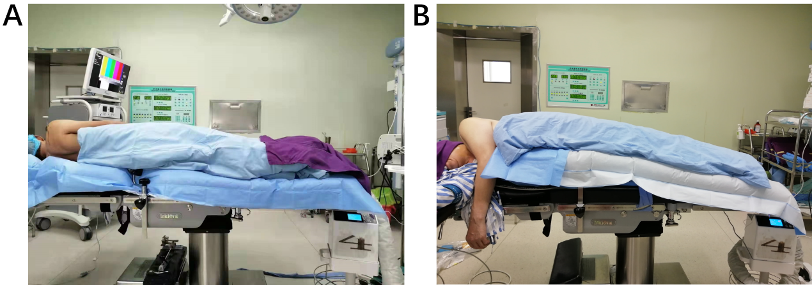
Figure 1. Patients were warmed using the forced-air warming (FAW) systems. A, FAW blanket was placed under the body of patient (UB group). B, FAW blanket was placed over the body of patient (OB group).

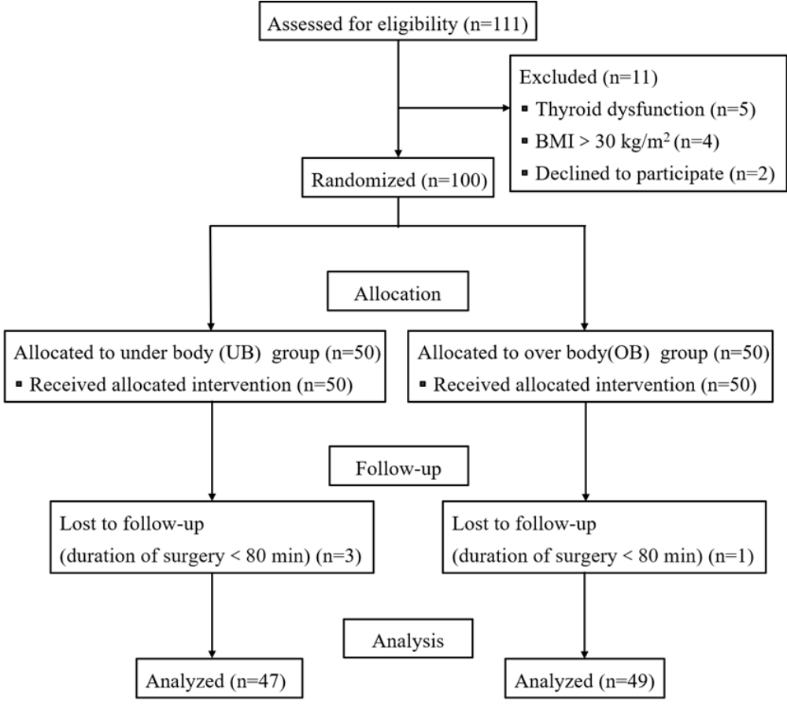

Figure 2. Consolidated Standards of Reporting Trials (CONSORT) diagram of patient flow through the study. BMI, body mass index.

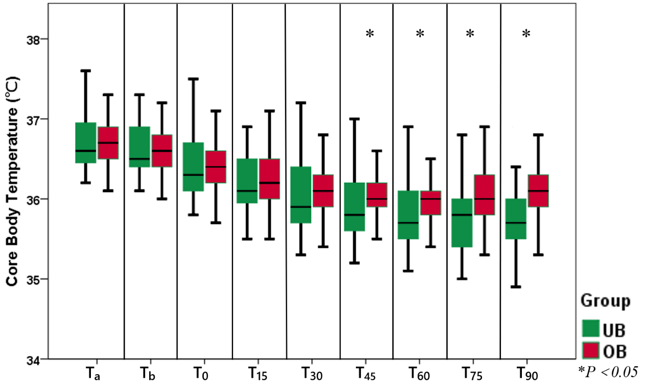
Figure 3. CBT variation during the procedure of surgery in underbody (UB) group and overbody (OB) group. Timepoints: T_{a} = baseline, T_{b} = before general anesthesia, T₀ = pre-warming, T₁₅ = after 15 min warming, T₃₀ = after 30 min warming, T₄₅ = after 45 min warming, T₆₀ = after 60 min warming, T₇₅ = after 75 min warming, T₉₀ = after 90 min warming

Data in Figure 3.
Patient  number | Group | Ta (℃) | Tb (℃) | T0 (℃) | T15 (℃) | T30 (℃) | T45 (℃) | T60 (℃) | T75 (℃) | T90 (℃)
4 | UB | 36.50 | 36.40 | 36.30 | 36.00 | 35.80 | 35.70 | 35.50 | 35.40 | 35.30
7 | UB | 36.30 | 36.20 | 36.00 | 35.80 | 35.60 | 35.50 | 35.40 | 35.30 | 35.20
9 | UB | 36.50 | 36.40 | 36.20 | 36.00 | 35.90 | 35.80 | 35.70 | 35.80 | 36.00
11 | UB | 36.80 | 36.60 | 36.40 | 36.30 | 36.20 | 36.10 | 35.90 | 35.90 | 36.10
12 | UB | 36.50 | 36.40 | 36.20 | 36.00 | 35.80 | 35.60 | 35.50 | 35.60 | 35.50
15 | UB | 36.50 | 36.50 | 36.40 | 36.10 | 36.00 | 35.80 | 35.70 | 35.50 | 35.60
16 | UB | 36.90 | 36.80 | 36.70 | 36.40 | 36.30 | 36.10 | 36.00 | 35.80 | 35.60
18 | UB | 37.20 | 37.10 | 36.80 | 36.60 | 36.40 | 36.20 | 36.10 | 36.00 | 36.00
19 | UB | 36.40 | 36.40 | 36.10 | 36.00 | 35.80 | 35.70 | 35.60 | 35.40 | 35.50
20 | UB | 36.30 | 36.20 | 35.80 | 35.50 | 35.30 | 35.20 | 35.10 | 35.00 | 34.90
22 | UB | 37.00 | 36.90 | 36.70 | 36.60 | 36.40 | 36.30 | 36.20 | 36.10 | 36.30
23 | UB | 36.80 | 36.70 | 36.50 | 36.30 | 36.20 | 36.10 | 35.90 | 35.80 | 36.00
25 | UB | 36.60 | 36.50 | 36.30 | 36.00 | 35.90 | 35.70 | 35.80 | 35.90 | 36.20
26 | UB | 36.50 | 36.50 | 36.30 | 36.10 | 35.80 | 35.60 | 35.40 | 35.40 | 35.30
27 | UB | 36.90 | 36.90 | 36.70 | 36.50 | 36.40 | 36.30 | 36.10 | 36.10 | 35.90
28 | UB | 36.70 | 36.60 | 36.30 | 36.10 | 35.90 | 35.70 | 35.60 | 35.80 | 36.00
29 | UB | 37.30 | 37.20 | 36.90 | 36.80 | 36.50 | 36.40 | 36.20 | 36.10 | 36.00
30 | UB | 36.90 | 36.80 | 36.70 | 36.50 | 36.30 | 36.20 | 36.20 | 36.10 | 35.90
31 | UB | 36.50 | 36.40 | 36.20 | 35.90 | 35.70 | 35.60 | 35.50 | 35.40 | 35.60
32 | UB | 37.10 | 37.00 | 36.80 | 36.60 | 36.40 | 36.20 | 36.10 | 36.00 | 35.90
34 | UB | 37.20 | 37.10 | 37.00 | 36.70 | 36.50 | 36.40 | 36.20 | 36.00 | 36.10
36 | UB | 36.40 | 36.30 | 36.00 | 35.80 | 35.60 | 35.50 | 35.40 | 35.50 | 35.30
39 | UB | 36.20 | 36.20 | 35.90 | 35.60 | 35.40 | 35.30 | 35.20 | 35.30 | 35.40
38 | UB | 36.50 | 36.50 | 36.30 | 36.00 | 35.80 | 35.70 | 35.60 | 35.60 | 35.50
44 | UB | 37.10 | 37.00 | 36.90 | 36.60 | 36.40 | 36.30 | 36.10 | 36.00 | 36.10
48 | UB | 37.20 | 37.20 | 36.90 | 36.70 | 36.50 | 36.30 | 36.40 | 36.50 | 36.30
49 | UB | 37.60 | 36.90 | 36.70 | 36.50 | 36.40 | 36.30 | 36.10 | 36.00 | 35.80
50 | UB | 37.20 | 37.10 | 36.90 | 36.70 | 36.50 | 36.40 | 36.30 | 36.20 | 36.10
51 | UB | 37.80 | 37.70 | 37.50 | 37.40 | 37.20 | 37.00 | 36.90 | 36.80 | 36.90
52 | UB | 36.40 | 36.30 | 36.10 | 35.80 | 35.60 | 35.40 | 35.30 | 35.40 | 35.50
53 | UB | 36.80 | 36.70 | 36.40 | 36.20 | 36.10 | 35.90 | 35.80 | 35.80 | 35.60
57 | UB | 36.40 | 36.30 | 36.10 | 35.90 | 35.70 | 35.60 | 35.50 | 35.50 | 35.40
60 | UB | 36.40 | 35.30 | 36.10 | 35.90 | 35.70 | 35.60 | 35.60 | 35.50 | 35.40
63 | UB | 36.30 | 36.20 | 36.00 | 35.70 | 35.60 | 35.40 | 35.50 | 35.40 | 35.50
66 | UB | 36.60 | 36.50 | 36.20 | 36.10 | 35.90 | 35.70 | 35.60 | 35.50 | 35.70
72 | UB | 37.40 | 37.30 | 37.10 | 36.90 | 36.70 | 36.50 | 36.50 | 36.60 | 36.40
74 | UB | 36.20 | 36.10 | 35.90 | 35.70 | 35.60 | 35.60 | 35.50 | 35.40 | 35.40
78 | UB | 36.90 | 36.80 | 36.60 | 36.40 | 36.30 | 36.20 | 36.10 | 36.00 | 36.00
80 | UB | 36.60 | 36.50 | 36.30 | 36.10 | 35.90 | 35.80 | 35.70 | 35.60 | 35.60
81 | UB | 36.60 | 36.50 | 36.30 | 36.10 | 35.90 | 35.70 | 35.60 | 35.80 | 35.90
82 | UB | 36.30 | 36.20 | 36.10 | 35.90 | 35.70 | 35.50 | 35.40 | 35.20 | 35.30
83 | UB | 36.80 | 36.80 | 36.60 | 36.30 | 36.20 | 36.10 | 36.00 | 35.90 | 36.10
87 | UB | 36.50 | 36.40 | 36.00 | 35.70 | 35.50 | 35.50 | 35.40 | 35.30 | 35.50
89 | UB | 37.10 | 37.10 | 36.90 | 36.70 | 36.50 | 36.40 | 36.30 | 36.20 | 36.30
92 | UB | 36.80 | 36.70 | 36.60 | 36.40 | 36.10 | 36.10 | 35.90 | 35.80 | 35.70
96 | UB | 36.60 | 36.50 | 36.20 | 36.10 | 35.70 | 35.60 | 35.40 | 35.30 | 35.40
100 | UB | 36.40 | 36.30 | 36.10 | 36.00 | 35.90 | 35.80 | 35.80 | 35.70 | 35.80
1 | OB | 36.90 | 36.80 | 36.60 | 36.40 | 36.20 | 36.10 | 35.90 | 35.90 | 35.70
2 | OB | 36.80 | 36.70 | 36.40 | 36.20 | 36.00 | 35.90 | 36.00 | 35.90 | 36.00
3 | OB | 37.20 | 37.10 | 36.90 | 36.90 | 36.70 | 36.60 | 36.50 | 36.40 | 36.30
5 | OB | 36.50 | 36.40 | 35.20 | 36.10 | 35.80 | 35.90 | 36.00 | 35.90 | 36.10
6 | OB | 36.10 | 36.00 | 35.70 | 35.50 | 35.40 | 35.40 | 35.30 | 35.40 | 35.50
8 | OB | 37.20 | 37.10 | 36.90 | 36.70 | 36.60 | 36.40 | 36.50 | 36.60 | 36.60
10 | OB | 36.60 | 36.50 | 36.20 | 36.00 | 35.90 | 35.90 | 35.70 | 35.70 | 35.90
17 | OB | 36.40 | 36.30 | 36.00 | 35.90 | 35.70 | 35.60 | 35.60 | 35.70 | 35.90
13 | OB | 36.70 | 36.60 | 36.40 | 36.10 | 36.00 | 36.00 | 35.90 | 36.00 | 36.10
14 | OB | 37.30 | 37.20 | 37.00 | 36.90 | 36.70 | 36.60 | 36.60 | 36.60 | 36.80
21 | OB | 36.80 | 36.70 | 36.50 | 36.30 | 36.20 | 36.10 | 36.10 | 36.10 | 36.20
24 | OB | 36.50 | 36.50 | 36.20 | 36.00 | 35.80 | 35.90 | 36.00 | 36.10 | 36.10
35 | OB | 36.40 | 36.30 | 36.10 | 35.90 | 35.70 | 35.60 | 35.40 | 35.50 | 35.50
37 | OB | 36.80 | 36.70 | 36.40 | 36.20 | 36.10 | 36.00 | 35.90 | 35.80 | 35.70
41 | OB | 37.20 | 37.20 | 37.00 | 36.80 | 36.80 | 36.70 | 36.50 | 36.50 | 36.60
42 | OB | 36.60 | 36.60 | 36.40 | 36.20 | 36.00 | 36.00 | 35.90 | 35.80 | 35.90
43 | OB | 36.70 | 36.70 | 36.50 | 36.30 | 36.20 | 36.20 | 36.10 | 36.00 | 36.10
45 | OB | 36.30 | 36.20 | 36.00 | 35.90 | 35.70 | 35.80 | 35.60 | 35.70 | 35.80
46 | OB | 36.80 | 36.70 | 36.40 | 36.30 | 36.30 | 36.20 | 36.10 | 36.20 | 36.30
55 | OB | 37.70 | 37.70 | 37.30 | 37.10 | 37.10 | 37.00 | 37.00 | 36.90 | 36.80
54 | OB | 36.50 | 36.30 | 36.10 | 36.10 | 36.10 | 36.00 | 35.90 | 36.00 | 36.10
56 | OB | 36.50 | 36.30 | 36.10 | 35.80 | 35.80 | 35.90 | 35.80 | 35.90 | 36.10
58 | OB | 37.20 | 37.20 | 37.10 | 36.80 | 36.80 | 36.70 | 36.70 | 36.60 | 36.60
59 | OB | 36.60 | 36.50 | 36.30 | 36.00 | 35.80 | 35.60 | 35.40 | 35.50 | 35.60
61 | OB | 36.70 | 36.70 | 36.50 | 36.30 | 36.20 | 36.20 | 36.10 | 36.10 | 36.00
62 | OB | 36.20 | 36.10 | 36.00 | 35.80 | 35.60 | 35.50 | 35.40 | 35.30 | 35.30
64 | OB | 36.50 | 36.50 | 36.30 | 36.10 | 36.00 | 35.90 | 36.00 | 36.10 | 36.20
65 | OB | 36.90 | 36.80 | 36.60 | 36.30 | 36.20 | 36.10 | 36.00 | 35.90 | 35.80
67 | OB | 36.70 | 36.60 | 36.50 | 36.30 | 36.10 | 36.00 | 35.90 | 35.80 | 35.70
68 | OB | 36.80 | 36.70 | 36.50 | 36.20 | 36.10 | 36.00 | 35.80 | 36.00 | 36.10
69 | OB | 37.00 | 36.90 | 36.80 | 36.60 | 36.40 | 36.40 | 36.50 | 36.40 | 36.50
70 | OB | 36.50 | 36.40 | 36.40 | 36.20 | 36.10 | 36.10 | 36.00 | 36.20 | 36.20
71 | OB | 36.50 | 36.40 | 36.20 | 36.10 | 36.10 | 36.00 | 36.00 | 35.90 | 36.00
73 | OB | 37.30 | 37.20 | 37.00 | 36.90 | 36.90 | 36.90 | 36.80 | 36.70 | 36.80
76 | OB | 36.70 | 36.70 | 36.50 | 36.40 | 36.20 | 36.10 | 36.00 | 35.90 | 35.80
77 | OB | 36.40 | 36.30 | 36.00 | 35.90 | 35.80 | 35.80 | 36.00 | 36.20 | 36.30
79 | OB | 36.60 | 36.60 | 36.30 | 36.10 | 35.90 | 35.90 | 35.80 | 35.90 | 36.00
84 | OB | 37.00 | 36.90 | 36.70 | 36.50 | 36.40 | 36.30 | 36.10 | 36.00 | 36.20
85 | OB | 36.50 | 36.30 | 36.00 | 35.90 | 35.80 | 35.70 | 35.70 | 35.80 | 36.00
86 | OB | 36.50 | 36.40 | 36.20 | 36.00 | 35.90 | 35.80 | 35.60 | 35.60 | 35.50
88 | OB | 36.70 | 36.60 | 36.50 | 36.50 | 36.30 | 36.20 | 36.10 | 36.20 | 36.30
90 | OB | 37.30 | 37.20 | 37.10 | 37.00 | 36.80 | 36.70 | 36.50 | 36.60 | 36.80
91 | OB | 37.10 | 37.10 | 36.90 | 36.80 | 36.60 | 36.50 | 36.60 | 36.50 | 36.50
93 | OB | 36.90 | 36.80 | 36.60 | 36.60 | 36.20 | 36.20 | 36.10 | 36.30 | 36.40
94 | OB | 36.90 | 36.90 | 36.70 | 36.70 | 36.40 | 36.30 | 36.20 | 36.30 | 36.20
95 | OB | 36.30 | 36.20 | 36.10 | 35.90 | 35.80 | 35.80 | 35.80 | 35.70 | 35.80
97 | OB | 36.70 | 36.60 | 36.30 | 36.10 | 36.10 | 36.00 | 36.00 | 36.00 | 36.10
98 | OB | 36.70 | 36.60 | 36.40 | 36.50 | 36.30 | 36.20 | 36.10 | 36.00 | 35.90
99 | OB | 36.80 | 36.70 | 36.50 | 36.40 | 36.30 | 36.20 | 36.30 | 36.50 | 36.60

