Table 1 Data set expansion
Image | Image flip | Image mirroring | Image brightness | Gaussian blur
Original image | 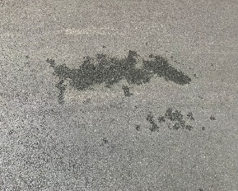 | 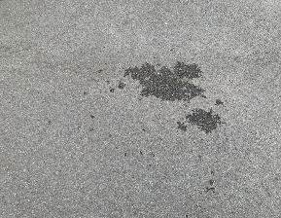 | 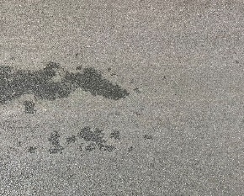 | 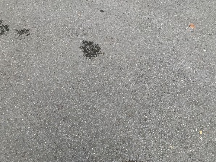
Enhanced image | 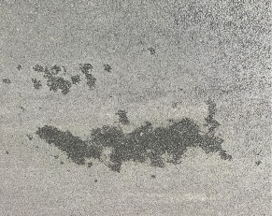 | 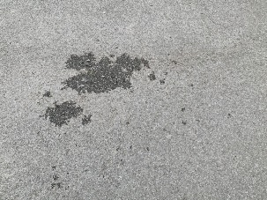 | 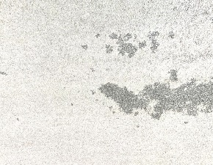 | 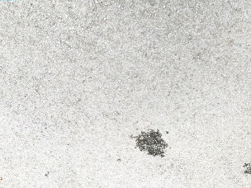

Table 3 Area calculation of water seepage area

No. | 1 | 2 | 3 | 4 | 5
Characteristic extraction  result |  | 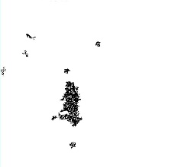 | 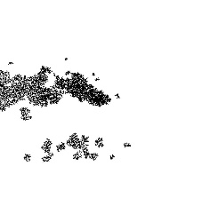 | 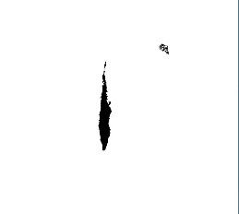 | 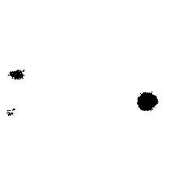
Type | Point seepage | Surface seepage | Surface seepage | Line seepage | Point seepage
Pixel value | 121116 | 230635 | 557642 | 141274 | 143366
Predicted value | 320.34cm² | 610.01cm² | 1474.91cm² | 373.66 cm² | 379.19cm²
Error | 24.86cm² | 58.89cm² | 160.29cm² | 32.04cm² | 26.31cm²
No. | 6 | 7 | 8 | 9 | 10
Characteristic extraction  result |  | 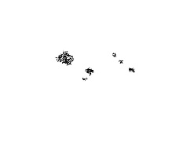 | 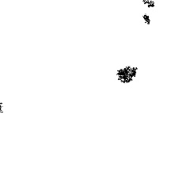 | 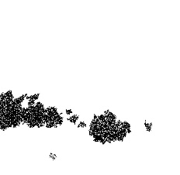 | 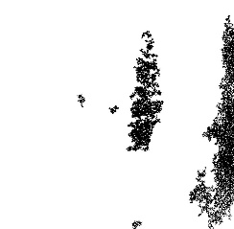
Type | Line seepage | Point seepage | Point seepage | Surface seepage | Surface seepage
Pixel value | 88610 | 65349 | 95295 | 812174 | 1049508
Predicted value | 234.36cm² | 172.84cm² | 252.05cm² | 2148.12cm² | 2775.84cm²
Error | 20.94cm² | 13.86cm² | 23.45cm² | 217.68cm² | 291.36m²

