Supplement
Our approach to select responsible frames is also inspired by certain well-known applications of entropy in information theory, such as decision trees. In the Iterative Dichotomiser 3 (ID3) decision tree algorithm, entropy is used to determine which node should be used as a parent node and whether it should be divided.¹ The lower the entropy of a set of data, the more accurate the categorization result. In our method, we focus on minimizing the difference between the FScore of the video and the FScore of the responsible frame collection, with a smaller difference suggesting that the information of the responsible frame collection is closer to the whole video. By gradually increasing the number of frames in the responsible frame collection from 1 to n, and in each step selecting the frame with the smallest difference and adding it to the responsible frame collection, we eventually obtain the local optimal responsible frame collection, with each frame contributing various features.
Figure 6 depicted a basic example of picking the top two responsible frames from a video with three frames and three feature dimensions. The video feature entropy matrix is constructed in step 1 by MaxPooling the three frame feature entropy matrices, and the FScore_{video} is 25. In step 2, we specify the number of frames in responsible frame collection as one, and there are three options with FScores of 16, 15, and 11. Since the difference between FScore_{video} and FScore_{frame1} is the lowest when selecting frame1, we choose frame1 as the first responsible frame. Step 3 increases the number of frames in the responsible frame collection to two and the first responsible frame(frame1) has already been chosen. FScore_{[frame1,frame2]} is 17 and FScore_{[frame1,frame3]} is 24, thus frame3 should be selected as the second responsible frame. Despite the fact that FScore_{frame2} is larger, we will not choose frame2 as the second responsible frame for the benefit of adding frame2 to the responsible frame collection are few. Frame2 provides almost the same features as the already selected frame1, implying that they may also look similar.
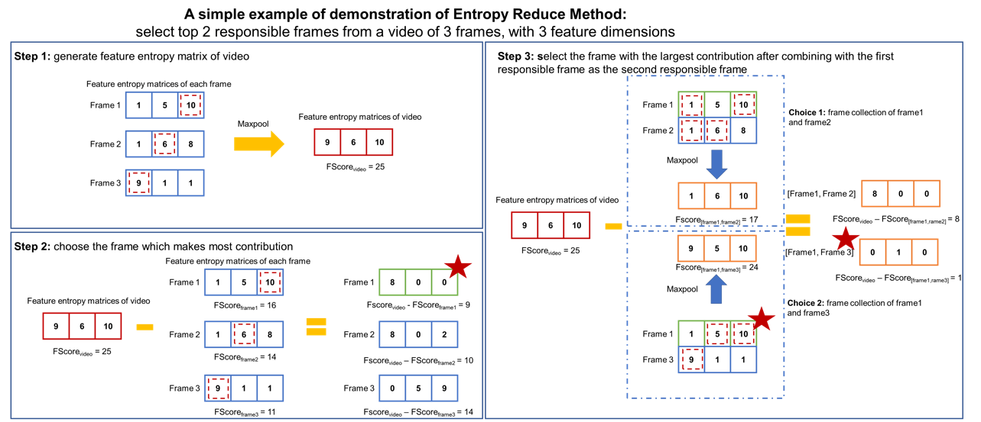
Figure 6. An example of using Entropy Reduce method to select responsible frames
Step 1: MaxPool the three frame feature entropy matrices and yield the video feature entropy matrix. Step 2: choose frame1 as the first responsible frame for it minimizing the difference between FScore_{video} and FScore_{framei}. Step 3: add another frame to the responsible frame collection, whereas step 2 already chose one. Since the FScore difference between the responsible frame collections of frame1 and frame3 is the smallest, frame3 is picked as the second responsible frame.

In math, feature entropy is the concept we developed to quantify the contribution of a frame in certain feature dimension. To structure the mathematical expression of feature entropy, we borrow the idea of entropy in information theory which is proposed by Shannon in 1948.² In information theory, entropy is a measure of the uncertainty of random variables, and mathematically described as $H\left(X\right)=\sum_{x∈X}{(-\log_{2}{ρ\left(x\right)})ρ(x)}$, where $ρ(x)$ is the probability density of random variable X, and $-\log_{2}{ρ(x)}$ measure the amount of information which is also called self-information amount. In order to serve our purpose of measuring the contribution of a frame in certain feature dimension, we revise the equation of final prediction in neural network. The output of the CNN in the basic CNN architecture could be written as $Y_{pred}={Sigmoid(\left[W_{0}, W_{1}\right]}^{T}*X+B)=[Y_{0}, Y_{1}]$, where Y₀ denotes the benign probability and Y₁ is the malignant probability. The number of $(W_{1}^{i}-W_{0}^{i})×x_{i}$ in the preceding equation represents the malignancy contribution of a single feature dimension, it could be separated into two parts: $(W_{1}^{i}-W_{0}^{i})$ representing the amount of information that feature dimention i could contribute to final possibility of malignant and $x_{i}$ representing the intensity of the frame in feature dimention i. Meanwhile we hope to concentrate on the features indicating malignancy, therefore we use the equation ${FE}_{i}^{j}=max⁡(0,\left(w_{1}^{j}-w_{0}^{j}\right))×x^{j}$ to describe the contribution of framei in jth feature dimension,, and the whole feature entropy matrix of framei can be represented as ${[FE]}_{i}=[{FE}_{i}^{1},{FE}_{i}^{2},{FE}_{i}^{3} ⋯ {FE}_{i}^{k}]$. To concentrate on the most representative characteristics of video, we used MaxPooling to alter the feature entropy matrices of all frames and constructed the video feature entropy matrix, where
$${\left[FE\right]}_{video}=MaxPool\left({\left[FE\right]}_{1},{\left[FE\right]}_{2}⋯{\left[FE\right]}_{n}\right)$$
$=[\max\left({FE}_{1}^{1},{FE}_{2}^{1}⋯{FE}_{n}^{1}\right),\max\left({FE}_{1}^{2},{FE}_{2}^{2}⋯{FE}_{n}^{2}\right)⋯\max\left({FE}_{1}^{k},{FE}_{2}^{k}⋯{FE}_{n}^{k}\right)]$.
Mathematically, we define the FScore of frame_{i} as $F{Score}_{i}=sum\left({[FE]}_{i}\right)= \sum_{j=1}^{k}{{FE}_{i}^{j}}$. When it comes to a collection of frames A (A = [frame_{a}, frame_{b}, … frame_{c}]), we use ${FScore}_{A}=sum（{[FE]}_{A max}）= \sum_{j=1}^{k}{max⁡({FE}_{a}^{j},{FE}_{b}^{j}⋯{FE}_{c}^{j})}$ to express its FScore. Here, entropy of a subset of frames is the sum of differences of its feature entropy matrix to the video feature entropy matrix, which is equal to the difference between the FScore of the subset of frames and the whole video.
The process of finding the ith responsible frame can be described as the following equation:
$$i^{th} frame=argmin\left({FScore}_{video}-{FScore}_{[top 1, top 2, top 3⋯top i-1,i]}\right)=argmin(\sum_{j=0}^{k}{(\max\left({FE}_{1}^{j},{FE}_{2}^{j}⋯{FE}_{n}^{j}\right)}-max⁡({FE}_{top 1}^{j},{FE}_{top 2}^{j}⋯{FE}_{top i-1}^{j},{FE}_{i}^{j}))$$

