Additional file 1: Table S1. Data quality assessment of each sample
Sample  Name | Clean Reads | Total Reads | GC Content | %≥Q30 | Reads aligned(%)
0h-1 | 22,248,742 | 44,497,484 | 44.38% | 85.81% | 73.16%
0h-2 | 20,558,568 | 41,117,136 | 43.77% | 85.51% | 73.78%
0h-3 | 25,880,302 | 45,007,340 | 43.71% | 85.96% | 73.19%
24h-1 | 21,797,728 | 43,595,456 | 44.09% | 85.56% | 73.41%
24h-2 | 21,472,350 | 42,944,700 | 43.78% | 86.01% | 73.70%
24h-3 | 25,019,013 | 50,038,026 | 44.79% | 85.63% | 71.99%
48h-1 | 20,348,174 | 40,696,348 | 44.25% | 85.71% | 72.59%
48h-2 | 23,102,884 | 46,205,768 | 44.10% | 86.10% | 73.27%
48h-3 | 21,121,583 | 42,243,166 | 44.15% | 86.52% | 74.47%
96h-1 | 21,766,632 | 43,533,264 | 44.52% | 86.01% | 73.23%
96h-2 | 23,102,884 | 43,851,420 | 44.24% | 85.79% | 73.34%
96h-3 | 24,339,657 | 48,679,314 | 45.14% | 86.26% | 72.26%
192h-1 | 26,070,671 | 52,141,342 | 44.84% | 85.35% | 71.41%
192h-2 | 25,880,302 | 51,760,604 | 45.18% | 85.27% | 70.64%
192h-3 | 22,887,881 | 45,775,762 | 44.49% | 85.49% | 72.02%
Sample Name (-1, -2, -3): three duplicate samples at each time point after inoculation.
%≥Q30: percentage of bases that the clean data quality value is greater than or equal to 30.

Additional file 2: Figure S1. Differentially expressed genes (DEGs) at different time points after infection. 0 h vs 24 h, 0 h vs 48 h, 0 h vs 96 h and 0 h vs 192 h: DEGs between 0 h and 24, 48, 96, and 192 h, respectively.

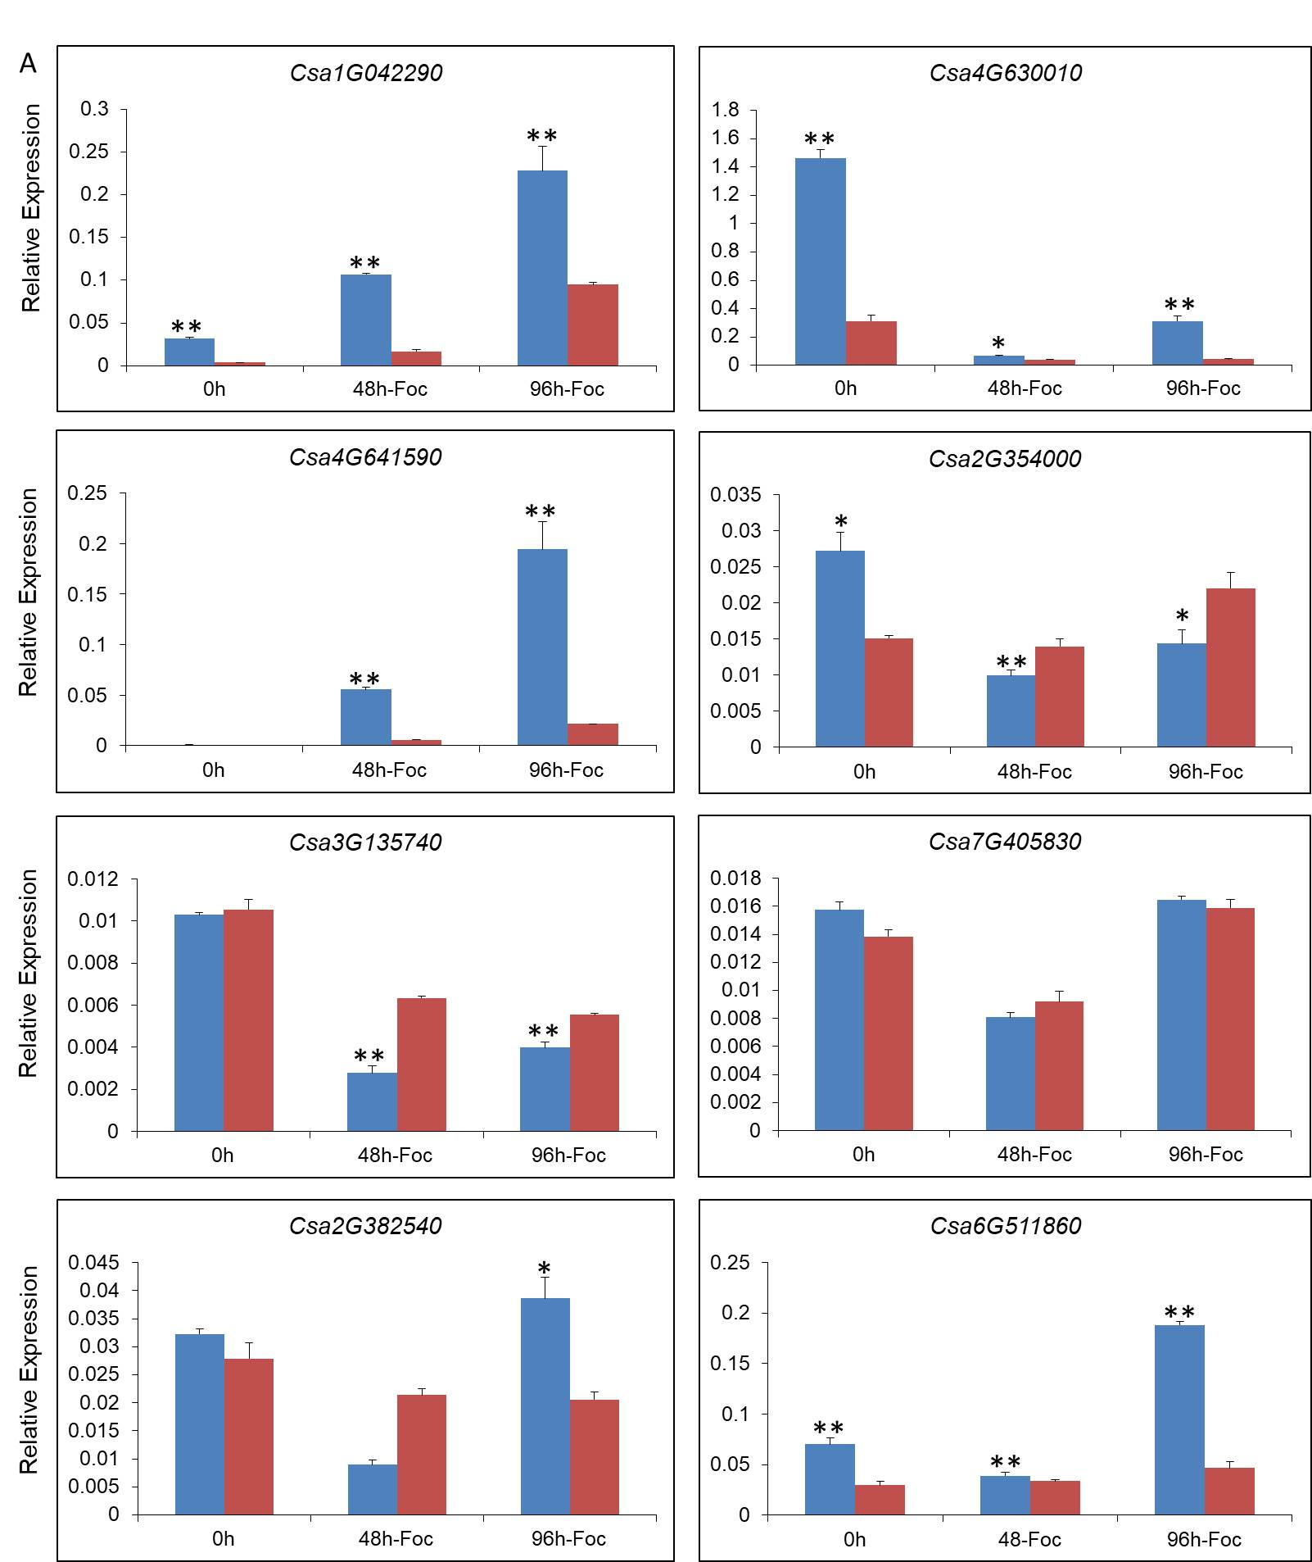
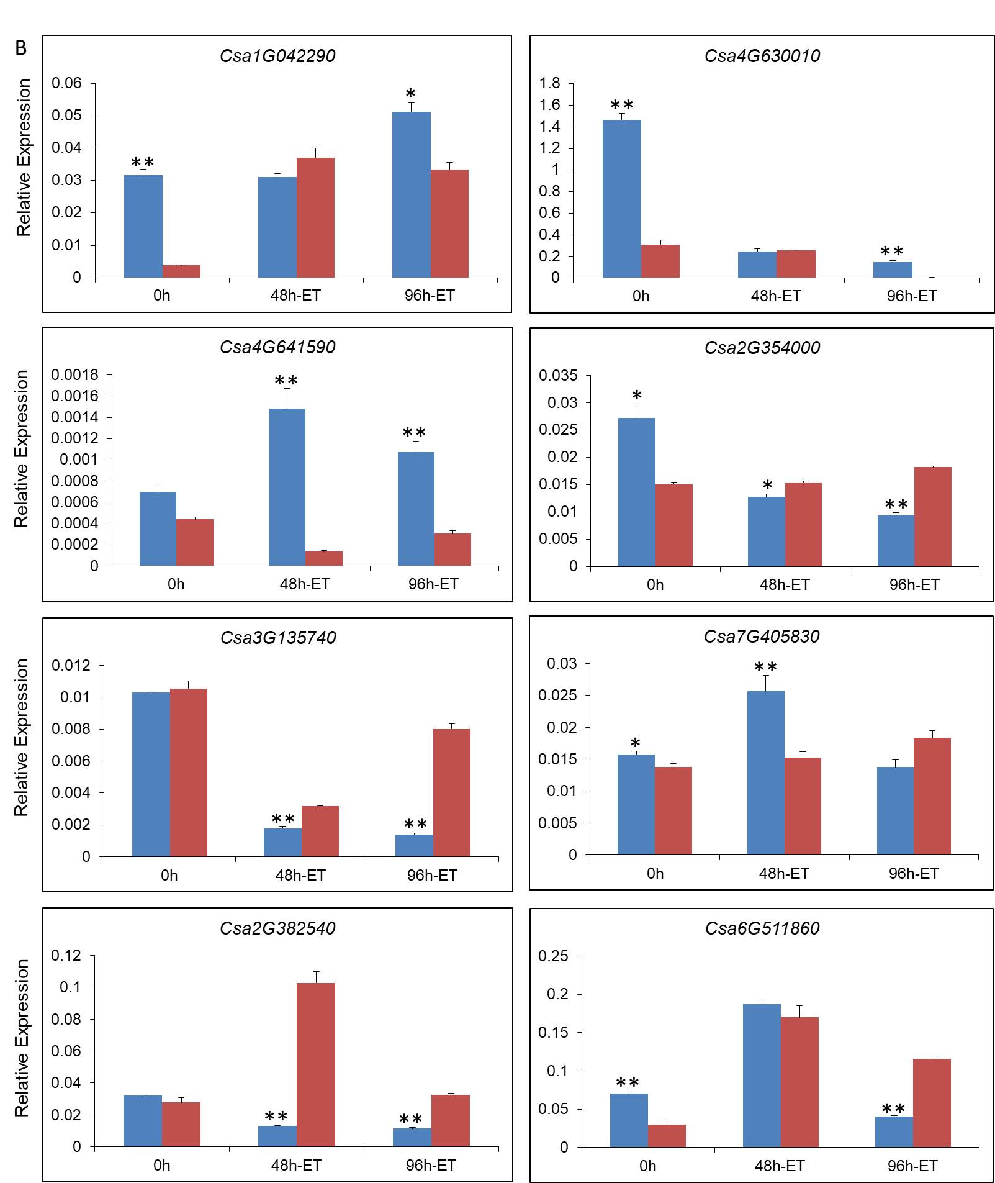
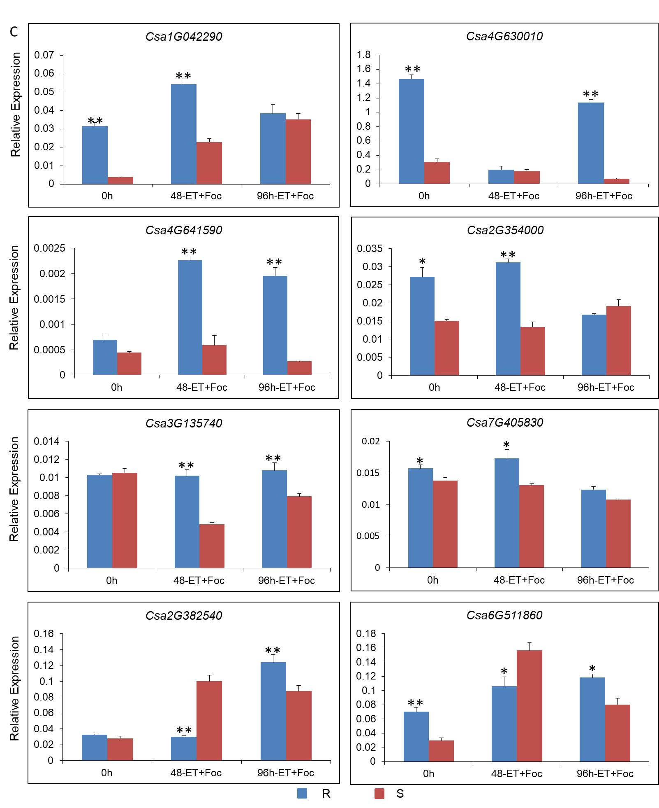
Additional file 3: Figure S2. Expression profiles of the other ethylene-related genes that showed a high relative expression level in cucumber seedlings at 0, 48, and 96 h after inoculation with Fusarium oxysporum f. sp. cucumerinum (Foc) (A); spray treatment with exogenous ET (B), and after inoculation with Foc and spray treatment with exogenous ET (C). R, ‘Rijiecheng’ (Foc-resistant line); S, ‘Superina’ (Foc-sensitive line).
Additional file 4: Table S2. Primer sequences used for ethylene-related differentially expressed genes
Gene ID | The Primer Sequences
Csa4G630010 | CCACGTAAGAAGACTAGG
 | GTTGCTGTGGTTATTGTTA
Csa3G018320 | TGGTGGTTAAGAAAGAGAA
 | CGGCATATCCTTCAAGTA
Csa7G049230 | AAGGCTAAAACCAACTTTC
 | GGTAGGACTAGGACTTTG
Csa1G042290 | TGCTGGAATACATCTGTAA
 | CGTTGGATAACTGATCGA
Csa7G405830 | GTCTGCATTCTTTCCTTATAG
 | CACGATACAATAGCACAAG
Csa2G356600 | CCGGACCTGATTTTACAA
 | CGGAGAGAAGTTTGATGA
Csa2G010390 | AGGAAGTATTATGATGATATTGG
 | GATGTCTTGTGGGTTGTA
Csa7G318990 | GGTATAATGCTTCACTTCAA
 | ATTAGATGTCTCTGCTGTT
Csa3G135690 | GATACCATCCTCACTCAA
 | TTCTCCAACATTCTCCAT
Csa6G160180 | TACTGAACCACGGAATAGA
 | GAGATGACGGAGGAAGAA
Csa7G049230 | CATTCATTCAACCTCAGT
 | ACCGTATAGGATAACCAT
Csa6G318160 | ATAGCGAGGAGCAACAAG
 | ATCATCCAAACATCCAAATCAA
Csa1G042290 | GGAGAATTACAGCAGTGAA
 | GAAGATGGTGAAGGATGAG
Csa4G630010 | TCAATACGGCAGAAGAAG
 | TTGCTGTGGTTATTGTTATC
Csa4G641590 | ATCAGAATCATCTCCAACAACA
 | ATTTCCGCAACCCACTTT
Csa2G354000 | AGTGATAATGAGGATAGTAACAAC
 | GAAGCAGAGTGAAGAGAATG
Csa3G135740 | AACGAGTGATGGAGATTG
 | GTAGTAGTGGCATACAAGT
Csa7G405830 | ATGATGGAGTCCTGTGAT
 | TAAGCAAGAGCGATTAGC
Csa2G382540 | GGATTGTGAGGAGCCATT
 | TTCCGCCGTAATCAAGTAG
Csa6G511860 | TGGTGGTCTTATTCTTCT
 | TGATAACAATGGAGTGATG

