Fig. S1 Tube scale fermentation optimization for EB243Y-pAC2, EB243Y-pAC2-ptb-buk, EB243Y-pAC2-ptb-buk2, EB243Y-pAC2-yciAh, EB243Y-pAC2-yciA, EB243Y-pAC2-tesB at aerobic condition. The culture volume was varied for adequate aeration and homogenization in a 50 ml polypropylene conical tube. The final volume of cell culture was set at 10 ml for a, 20 ml for b, and 30 ml for c. The black lines represent the yield, while red bars stand for titer obtained for each strain. “Y” stands for ΔadhE2. The data represent the means ± SD from three biological replicates.
Fig. S2 Growth and fermentation profiles of E. coli strain EB243ΔadhE2::yciAh for butyrate production, with various airflow rates of 0.3, 0.5, 0.75, and 1 vvm, respectively. Engineered E. coli strain EB243ΔadhE2::yciAh was grown in the M9Y modified medium containing 65 g/L glucose. pH was controlled at 6.8 during the fermentation. The data represent the means ± SD from two biological replicates.

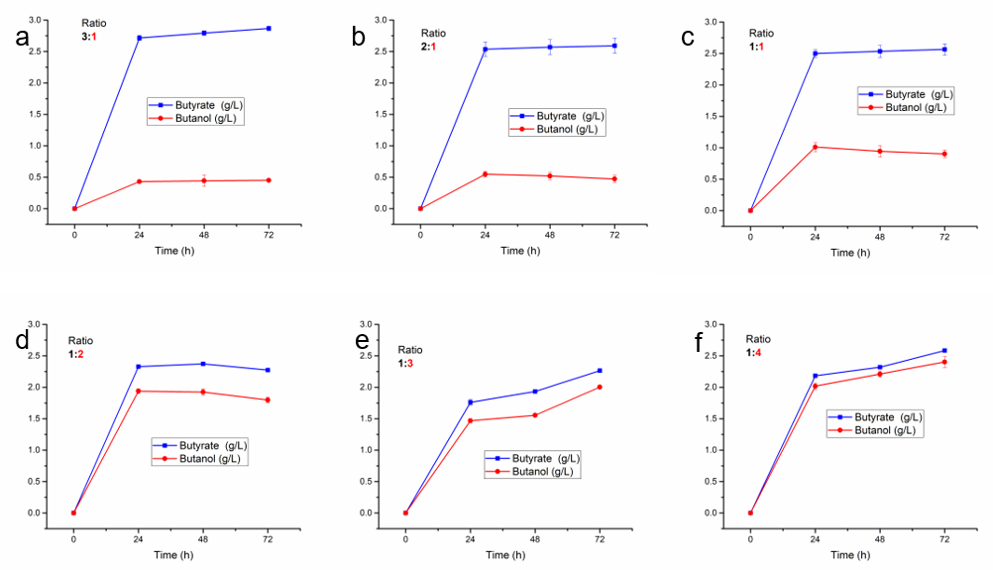
Fig. S3 Optimization of butyrate against butanol available in a synthetic microbial consortium comprising two E. coli strains. Red and black colors denote butanol and butyrate related strains. a 3:1, b 2:1, c 1:1, d 1:2, e 1:3, and f 1:4 indicate inoculation ratios in tube fermentation of butyrate producing-butyrate strain (EB243ΔadhE2-yciAh): (butanol producing-producing strain (EB243). The data represent the means ± SD from three biological replicates.
Fig. S4 Effects of rotation speeds on butyl butyrate production in tube scale fermentation. Different rotation speeds were applied on scale fermentation at (a) 100 rpm, (b) 150 rpm, (c) 200 rpm, and (d) 250 rpm. Strains were cultured in the M9Y medium containing 30 g/L glucose in a semi-sealed 50 mL polypropylene conical tube. Fermentation conditions were kept intact as (enzyme: 5 g/L, temperature: 37°C, inoculation ratio of two strains: 1:4 (butyrate strain: butanol strain), and 1:1 (fermentation broth: hexadecane as extractant)). The data represent the means ± SD from three biological replicates.

Table S1 Primers used in this study
Nº | Primer sequence 5’-3’ | Name
1 | ATGTCTACAACACATAACGTCCC | yciA-F
2 | TTACTCAACAGGTAAGGCGCGAGG | yciA-R
3 | ATGTCTGCCAATTTTACTGATAA | yciAh-F
4 | TTACAAGGGTTGTTCTGAAATTAAG | yciAh-R
5 | ATGAGTCAGGCGCTAAAAAATTTAC | tesB-F
6 | TTAATTGTGATTACGCATCACCCC | tesB-R
7 | GTGATTAAGAGTTTTAATGAAATTATC | ptb-F
8 | TTATTTATTGCCTGCAACTAAAGCTGC | ptb-R
9 | ATGTATAGATTACTAATAATCAATC | buk-F
10 | TTATTTGTATTCCTTAGCTTTTTC | buk-R
11 | TGTTGACAATTAATCATCGGCTCGTATAA | buk2-F
12 | TTATTTATATTTTTTAGCTTCTTCTTGTCC | buk2-R
13 | TCCTAGGTATAATACTAGTTGGATCCGCGATTTCTGGGAGTTTTAGAGCTAGAAATAGC | pTargetF-lldD2N20-F
14 | CAAATTGGCGTCTCTGATCTGTTG | lldD-arm1-F
15 | CACTTCGGGCTCATGAGCGCTTGTTTCGGTCATGCGTTTTTCTCCCTCGAATGCTCATT | lldD-arm1-R
16 | AATGAGCATTCGAGGGAGAAAAACGCATGACCGAAACAAGCGCTCATGAGCCCGAAGTG | adhE2-F
17 | AGCAACACTTTTAATATTTAATAAATGTTTAGGCTCTACATTTTGCGATACAGAGTTTC | adhE2-Fg1-R
18 | GAAACTCTGTATCGCAAAATGTAGAGCCTAAACATTTATTAAATATTAAAAGTGTTGCT | adhE2-Fg2-F
19 | AGAGGGTTAGGGTGAGGGGGCGCAAACGATCCTTTCGGGCTTTGTTAGCAGCCGGATCT | adhE2-R
20 | AGATCCGGCTGCTAACAAAGCCCGAAAGGATCGTTTGCGCCCCCTCACCCTAACCCTCT | lldD-arm2-F
21 | TGGCGGTACGGGTAAATCTGGTG | lldD-arm2-R

