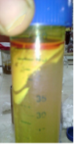
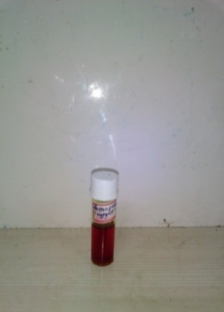

Intact Orange peel
Fermentation
Fermented and Hydrolysed peels
Fungi
Orange oil
Fermentation enzymes
Fermentation in petri -plate
Fermentation pre-treatment

Orange peel average particle size: (0.16 mm, 0.2 mm, 1 cm x 1 cm)
Selection of orange oil extracting micro-organism
Isolation and Identification of fungal strain
Culture medium
Seed culture size
Selection of orange peel sterilization technique
Fermentation parameter
Temperature: 8 to 37 ̊̊̊⁰C̊, Tryptone 1 to 3 % w/w,
Fermentation time
Enzyme activity

Extraction of fermentation product
Purification of enzyme
Enzyme Characterization
Oil Characterization

