Figure: Zone of inhibition observed for the extracted enzyme on cellulose agar plates

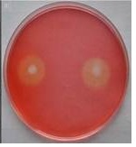

Sequesncing Report
TGCATATCAATAAGCGGAGGAAAAGAAACCAACCGGGATTGCCTCAGTAACGGCGAG
TGAAGCGGCAAGAGCTCAAATTTGAAATCTGGCCTCCCCCTCGGGGGTCCGAGTTGTA
ATTTGCAGAGGATGCTTCGGGTGCGGCCCCCGTCTAAGTGCCCTGGAATGGGCCGTCG
GAGAGGGTGAGAATCCCGTCTGGGACGGGGTGCCCGCGCCCGTGTGAAGCTCCCTCGA
CGAGTCGAGTTGTTTGGGAATGCAGCTCTAAGTGGGTGGTAAATTTCATCTAAAGCTA
AATACCGGCCGGAGACCGATAGCGCACAAGTAGAGTGATCGAAAGATGAAAAGCACC
TTGAAAAGGGAGTTAAACAGCACGTGAAATTGTTGAAAGGGAAGCGCTGACGACCAG
ACTCGCCTCCGGGGTTCAGCCGGCCTTCGGGCCGGTGTACTTCCCCGGGGGCGGGCCA
GCGTCGGTTTGGGCGGCCGGTCAAAGGCCCCCGGAATGTAGCGCCTCTCGGGGCGCCT
TATAGCCGGGGGTGCAATGCGGCCAGCCCGGACCGAGGAACGCGCTCCGGCACGGAC
GCTGGCATAATGGTCGTTAACGACCCGTCTTGAAACACGGACCA

Table: Enzyme activity profile:
 | Pectinase | Cellulase
Crude activity per ml | 86.1 Ucm⁻³ | 133 CMCcm⁻³
Crude per gram | 155 Ug⁻¹ | 239 CMC g⁻¹
Microfiltration | 125.6 Ug⁻¹ | 223 CMC g⁻¹
Ammonium sulphate fractionation
0 -20 % w/w | 58 Ug⁻¹ | 219.5 CMC g⁻¹
20 - 40 % w/w | 78 Ug⁻¹ | 220.3 CMC g⁻¹
40 - 60 % w/w | 118 Ug-1 | 222 CMC g⁻¹
60 - 80 % w/w | 136 Ug⁻¹ | 242 CMC g⁻¹
(0-20, 20-40, 40-60, 60-80) % w/w | 178 Ug⁻¹ | 435 CMC g⁻¹
Fold purity | 5.25 | 10.9
% Recovery | 53.3 % | 49.2 %

Table: Table of the composition of orange oil by High-Performance Liquid Chromatography – Mass Spectroscopy
Peak | Extracted  Oil  (%) |  | MW  (g/mol)  m/z | Compound
1 | 2.02 | 372.10 |  | Tangeritin
2 | 0.911 | 372.10 |  | Sinensetin
3 | 1.62 | 403.17 |  | Nobiletin
4 | 11.263 | 395.13 |  | Tocotrienol
5 | 12.32 | 430.00 |  | Tocopherol acetate

The calculations of fungal growth curve have been presented in Table below-
Table: Calculations of Fungal Growth Curve
NB
Hours |  | Days | Dry wt (g) |  |  |  |  | Avg | Mg |  | Std dev
24 |  | 1 | 0.00006 |  | 0.00009 |  |  | 0.000075 | 0.075 |  | 2.12E-05
48 |  | 2 | 0.0001 |  | 0 |  |  | 0.00005 | 0.05 |  | 7.07E-05
72 |  | 3 | 0.001 |  | 0.0015 |  |  | 0.00125 | 1.25 |  | 0.000354
96 |  | 4 | 0.0064 |  | 0.0058 |  |  | 0.0061 | 6.1 |  | 0.000424
120 |  | 5 | 0.013 |  | 0.014 |  |  | 0.0135 | 13.5 |  | 0.000707
144 |  | 6 | 0.013 |  | 0.013 |  |  | 0.013 | 13 |  | 0
168 |  | 7 | 0.011 |  | 0.012 |  |  | 0.0115 | 11.5 |  | 0.000707
192 |  | 8 | 0.008 |  | 0.0085 |  |  | 0.00825 | 8.25 |  | 0.000354
216 |  | 9 | 0.007 |  | 0.0065 |  |  | 0.00675 | 6.75 |  | 0.000354
NA
Hr | Days |  |  | Microbes weight (g) |  |  | Avg |  |  | Mg |  | Stddev
0 | 0 |  |  | 0.00003 |  | 0.00004 | 0.000035 |  |  | 0.035 |  | 7.07E-06
3 | 0.125 |  |  | 0 |  | 0.0001 | 0.00005 |  |  | 0.05 |  | 7.07E-05
6 | 0.25 |  |  | 0.001 |  | 0.0014 | 0.0012 |  |  | 1.2 |  | 0.000283
9 | 0.375 |  |  | 0.0058 |  | 0.0054 | 0.0056 |  |  | 5.6 |  | 0.000283
12 | 0.5 |  |  | 0.008 |  | 0.009 | 0.0085 |  |  | 8.5 |  | 0.000707
15 | 0.625 |  |  | 0.012 |  | 0.012 | 0.012 |  |  | 12 |  | 0
18 | 0.75 |  |  | 0.0156 |  | 0.0152 | 0.0154 |  |  | 15.4 |  | 0.000283
24 | 1 |  |  | 0.0184 |  | 0.0183 | 0.01835 |  |  | 18.35 |  | 7.07E-05
36 | 1.5 |  |  | 0.0175 |  | 0.0175 | 0.0175 |  |  | 17.5 |  | 0
72 | 3 |  |  | 0.016 |  | 0.016 | 0.016 |  |  | 16 |  | 0
96 | 4 |  |  | 0.015 |  | 0.0155 | 0.01525 |  |  | 15.25 |  | 0.000354
120 | 5 |  |  | 0.0148 |  | 0.0145 | 0.01465 |  |  | 14.65 |  | 0.000212
144 | 6 |  |  | 0.014 |  | 0.0142 | 0.0141 |  |  | 14.1 |  | 0.000141
168 | 7 |  |  | 0.0136 |  | 0.01365 | 0.013625 |  |  | 13.625 |  | 3.54E-05
192 | 8 |  |  | 0.0121 |  | 0.012 | 0.01205 |  |  | 12.05 |  | 7.07E-05
216 | 9 |  |  | 0.0118 |  | 0.0117 | 0.01175 |  |  | 11.75 |  | 7.07E-05

High-performance liquid chromatography of orange peel oil extracted by USAE (Ultrasound-assisted aqueous extraction), FAE (Fermentation assisted aqueous extraction), MWAE (Microwave assisted aqueous extraction) and CPAE (Cold press assisted aqueous extraction) Peak1. Tangeritin, Peak 2.Sinensetin, Peak 3.Nobiletin, Peak 4.Tocotrenol, Peak 5.Tocopherol acetate, (*n. d.: not defined)

Figure: Peak 1: HPLC- MS Fragmentation of Tangeritin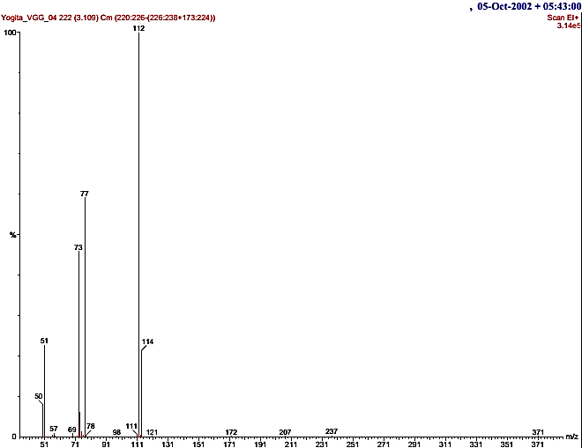

Figure: Peak 2 HPLC - MS Fragmentation of Sinensetin
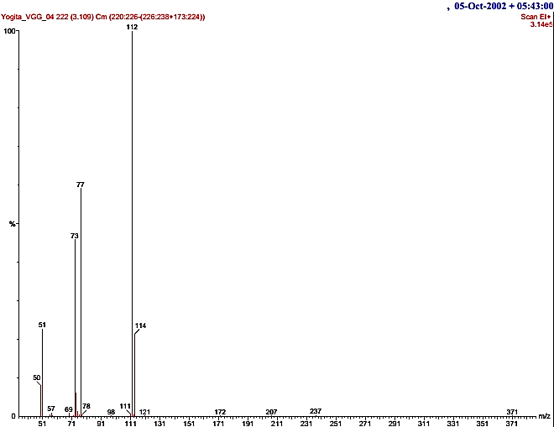

Figure: Peak 3 HPLC -MS fragmentation of Nobiletin
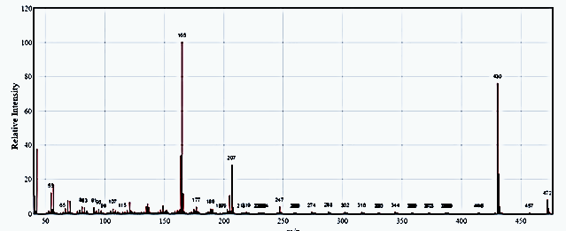

Figure: Peak 4 HPLC-MS fragmentation of Tocotrienol
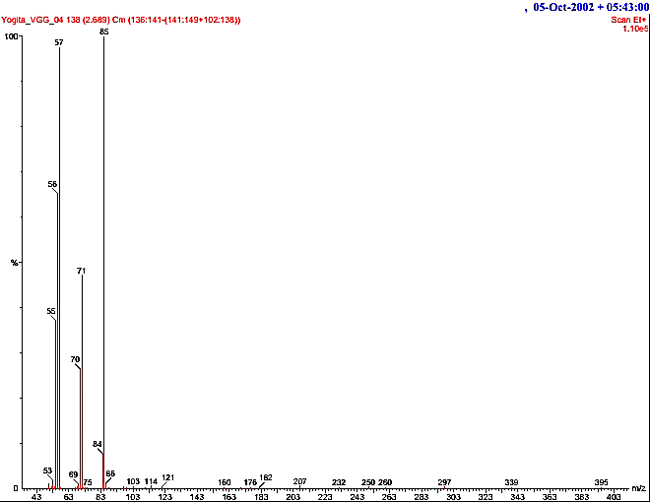

Figure: Peak 5 HPLC-MS fragmentation of Tocopherol acetate
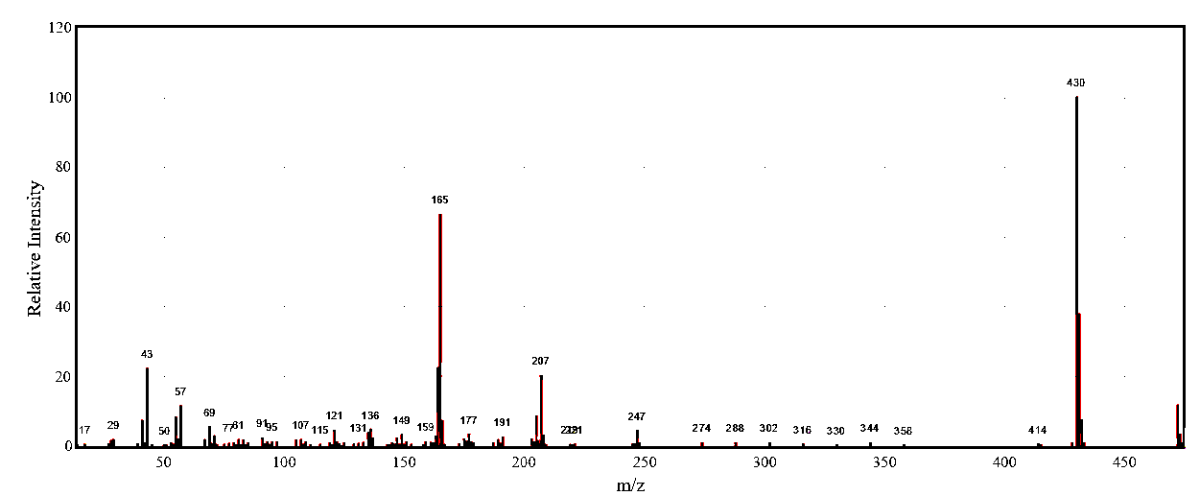

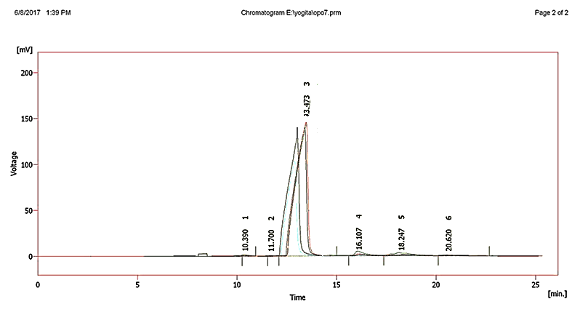
Figure: Fragmentation peak 1 ofα- Pinene
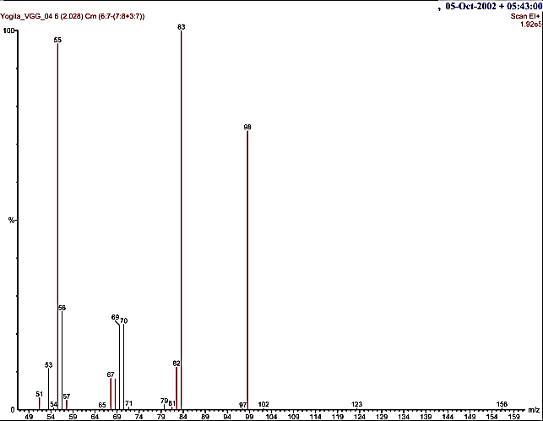

Figure: Fragmentation peak 2 of Limonene
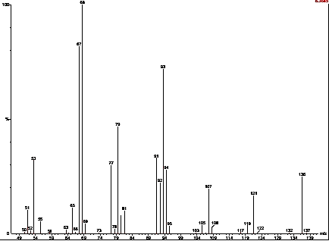

Figure: Fragmentation peak 3 of Limonene oxide
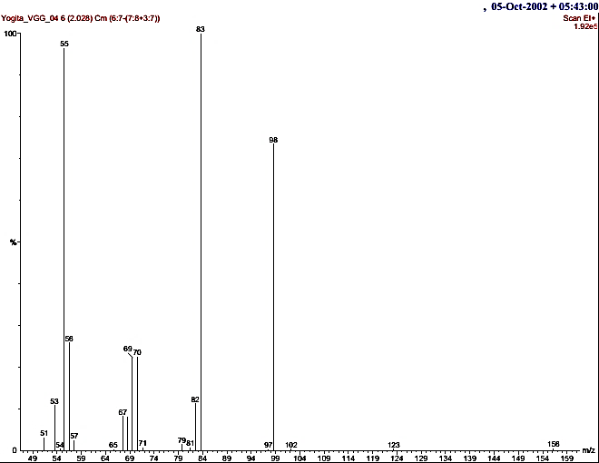

Figure: GC-MS Peak 3 Fragmentation of Linalool
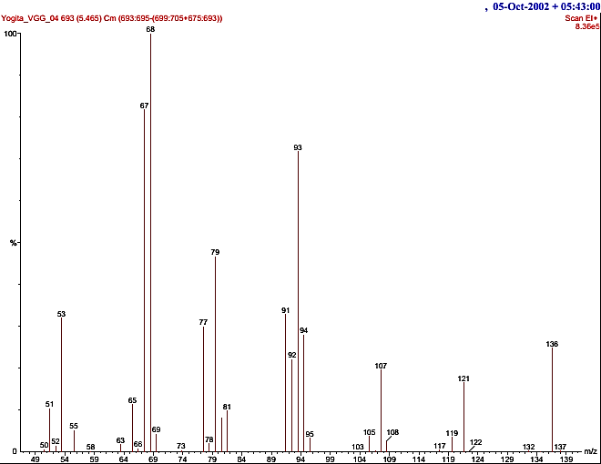

Figure: Peak 5: GC-MS Fragmentation of Citronellal
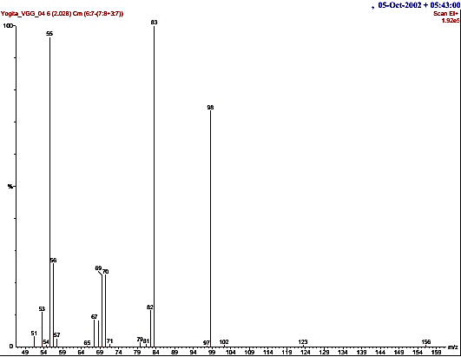

Table: of Composition of orange peel oil by Gas Chromatography-Mass Spectroscopy
Peak | Extracted Oil (w/w%) |  | MW  (g/mol)  m/z | SFC  (w/w%) |  | Compound name
 | SSF
1  2 | 2.22 | 136  136 |  |  | 0.99  88.68 | α-Pinene  Limonene
1  2 | 96.32 |  |  |  | 0.99  88.68
3 | 0.01 | 152 |  |  | --- | Limonene oxide
4 |  | 154 |  |  | 0.13 | Linalool
5 |  | 154 |  |  | 0.11 | Citronellal
(SFC: Supercritical fluid extraction- MW: Molecular weight)

