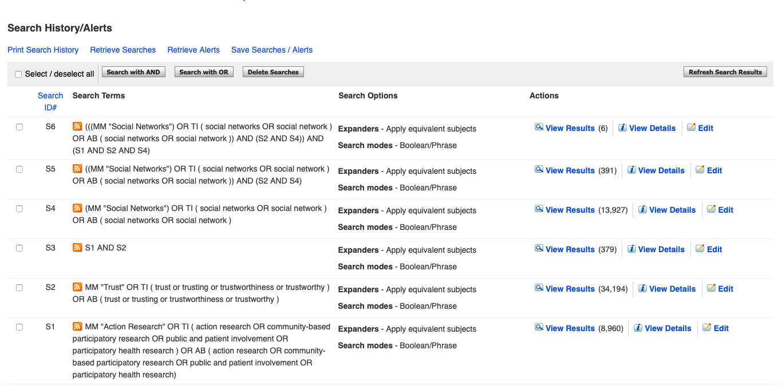
Additional File 1 CINAHL Search Strategy

