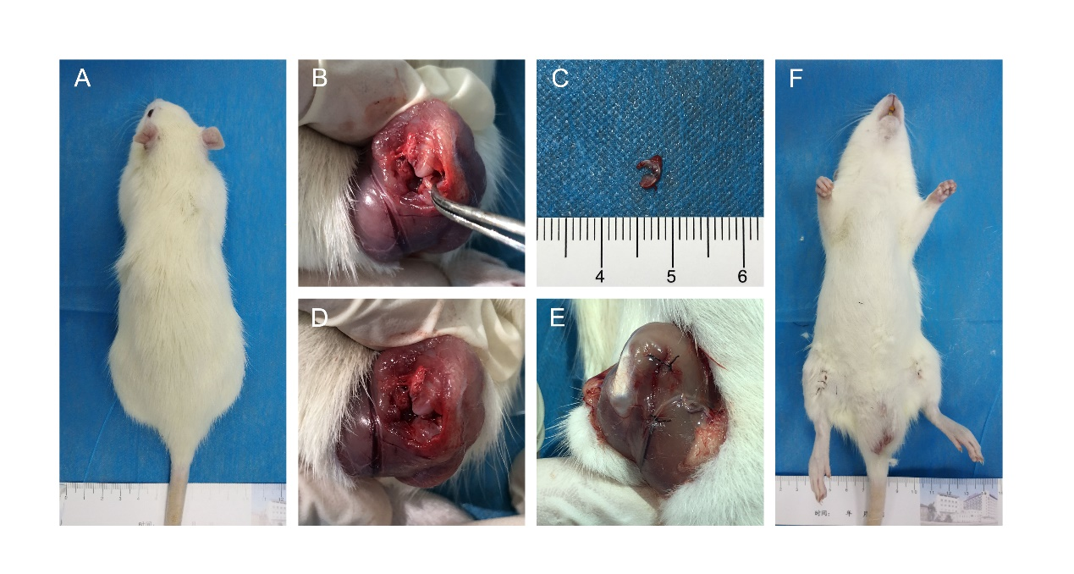
Fig.S1. Establishment of Hulth-Telhag model. (a) The general somatotype rat. (b) Expose the articular cavity, remove the medial meniscus. (c) The removal medial meniscus. (d) Articular cavity after opration. (e) Suture articular cavity. (f) Postoperative gross view.
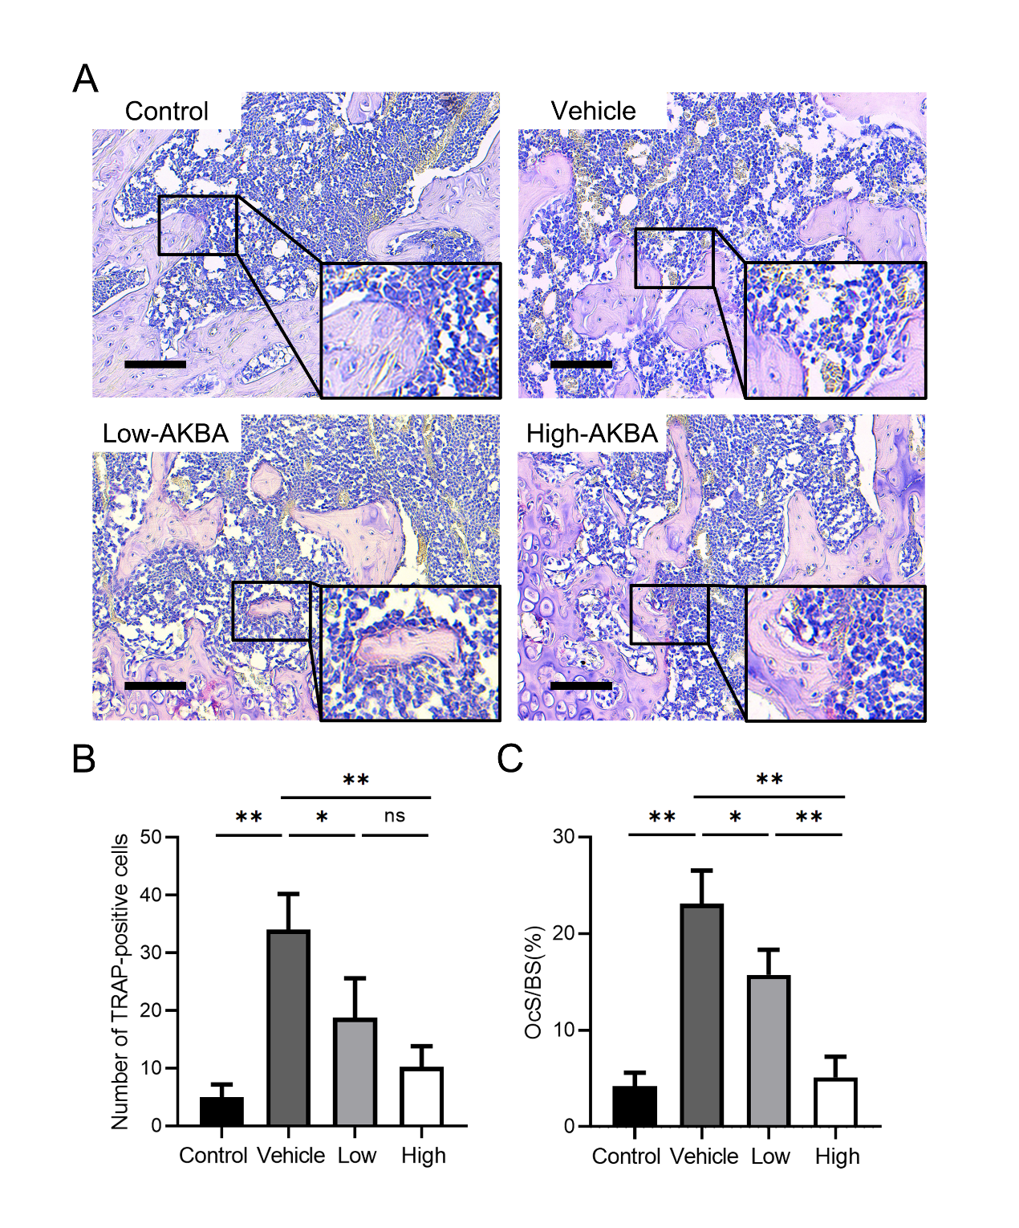
Fig.S2. AKBA intervention attenuated surgery-induced osteolysis in histological analysis of knee joint sections. (a) TRAP staining. (b) Number of TRAP-positive cells. (c) osteoclast surface/bone surface (Oc.S/BS). Both low-AKBA (2 mg/kg every other day) group and high-AKBA (8 mg/kg every other day) group received surgery intervention. n=6 per group. Scale bar=100μm. Data are presented as means ± SD. *P<0.05, **P<0.01.

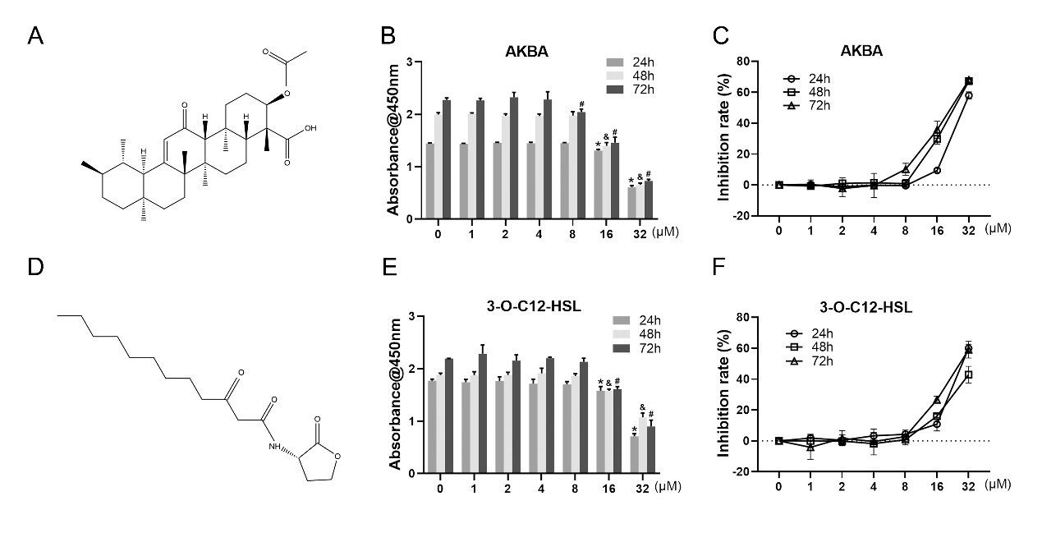
Fig.S3. Effects of AKBA on the cell viability of rat chondrocytes. (a, d) Chemical structure of AKBA and 3-O-C12-HSL. (b, e) Cell viability of AKBA and 3-O-C12-HSL after 24, 48, or 72h of treatment. CCK-8 assay was used to determine the viability after treatment. *P<0.05, compared with 0 μM treatment (24h), &P<0.05, vs. 0 μM treatment (48h), and #P<0.05, vs. 0 μM treatment (72h). (c,f) Inhibition rate of AKBA and 3-O-C12-HSL. Data are presented as means ± SD. n=6: six samples were obtained from six wells in a single experiment for the CCK-8 assay.
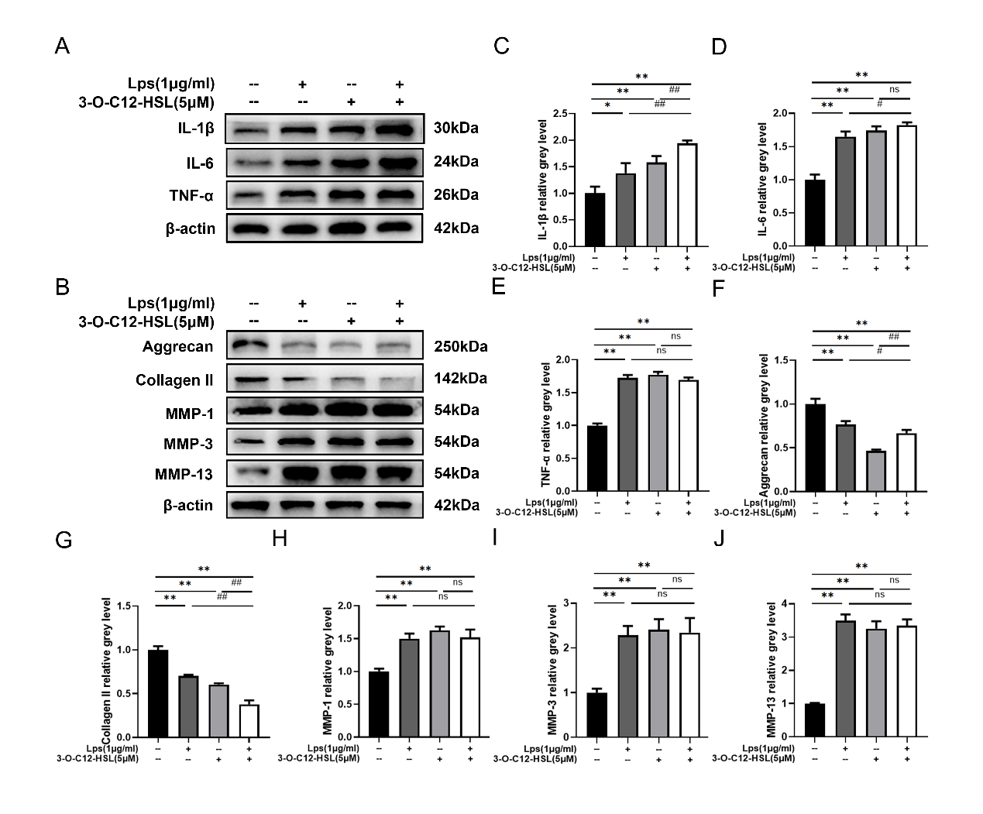
Fig.S4. 3-O-C12-HSL promoted inflammation and ECM degradation whether LPS was added or not. (a, c-e) Western blot analysis of expression levels of IL-1β, IL-6, and TNF-α. (b, f-i) Western blot analysis of expression levels of Agg, col II, MMP-1, MMP-3, and MMP-13. The concentration of LPS and 3-O-C12-HSL was 1 μg/ml and 5μM, respectively. Data are presented as means ± SD. n=6 in western blot. *P<0.05 and **P<0.01, vs. control group. #P<0.05 and ##P<0.01, vs. LPS+3-O-C12-HSL group.
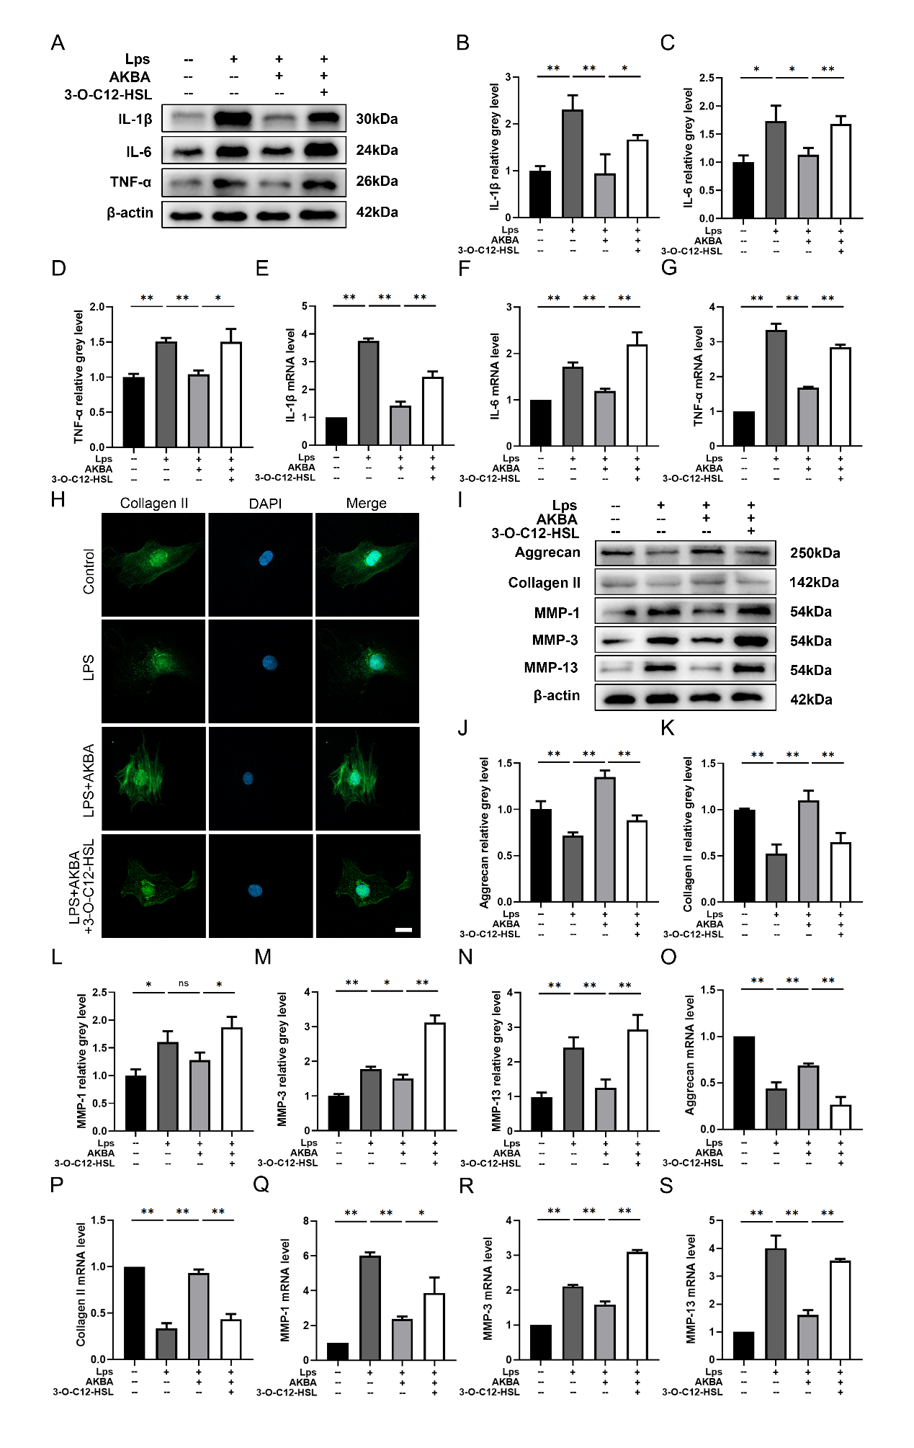
Fig.S5. 3-O-C12-HSL treatment reversed the effects of AKBA on inflammation and ECM degradation in chondrocytes. (a-d) IL-1β, IL-6, and TNF-α protein expression levels. (e-g) IL-1β, IL-6, and TNF-α mRNA expression levels. (h) Cellular immunofluorescence of col II in chondrocytes. (i-n) Agg, col II, MMP-1, MMP-3, and MMP-13 protein expression levels. (o-s) Agg, col II, MMP-1, MMP-3, and MMP-13 mRNA expression levels. Relative grey levels were quantified using Image J. The concentration of LPS, AKBA, and 3-O-C12-HSL was 1 μg/ml, 8μM, and 5μM, respectively. Dates are presented as means ± SD of six duplicate experiments. *P<0.05, **P<0.01.
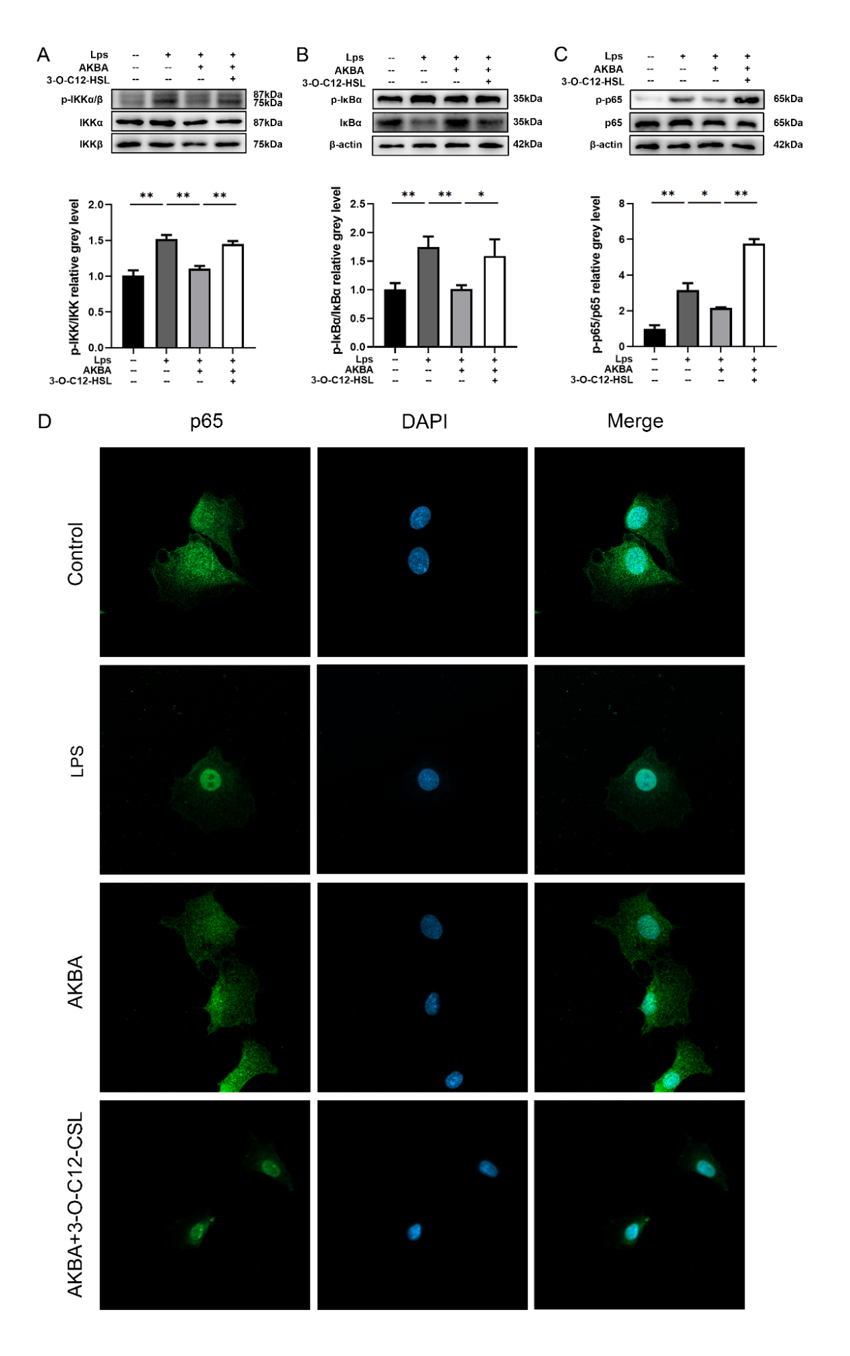
Fig.S6. 3-O-C12-HSL treatment reversed the effects of AKBA on inhibition of NF-κB signaling pathway in chondrocytes. (a-c) Western blot analysis of expression levels of p-IKK, IKK, p-IκBα, IκBα, p-P65, and P65. The relative grey levels of p-IKK/IKK, p-IκBα/IκBα, and p-P65/P65. (d) Cellular immunofluorescence of p65 in chondrocytes. Relative grey levels were quantified using Image J. The concentration of LPS, AKBA, and 3-O-C12-HSL was 1 μg/ml, 8μM, and 5μM, respectively. Dates are presented as means ± SD of six duplicate experiments. *P<0.05, **P<0.01.

