Design, synthesis of amide derivatives of scutellarin and their anti-leukemia and neuroprotection activity

Tong Han¹ ∙ Chunyu Jiang² ∙ Xing Wei¹ ∙ Meilin Sheng¹ ∙ Qin Xie¹ ∙ Jiqiang Zhang¹ ∙ Yongyi Zhang ∙ Chenghao Jin¹

¹Department of Pharmaceutical Engineering, College of Life Science & Technology, Heilongjiang Bayi Agricultural University, 5 Xinfeng Road, Daqing 163319, PR China

²Key Laboratory of Structure-Based Drug Design & Discovery, Ministry of Education, and School of Traditional Chinese Materia Medica, Shenyang Pharmaceutical University, 103 Wenhua Road, Shenyang 110016, PR China

✉ Chenghao Jin
jinchenghao3727@qq.com
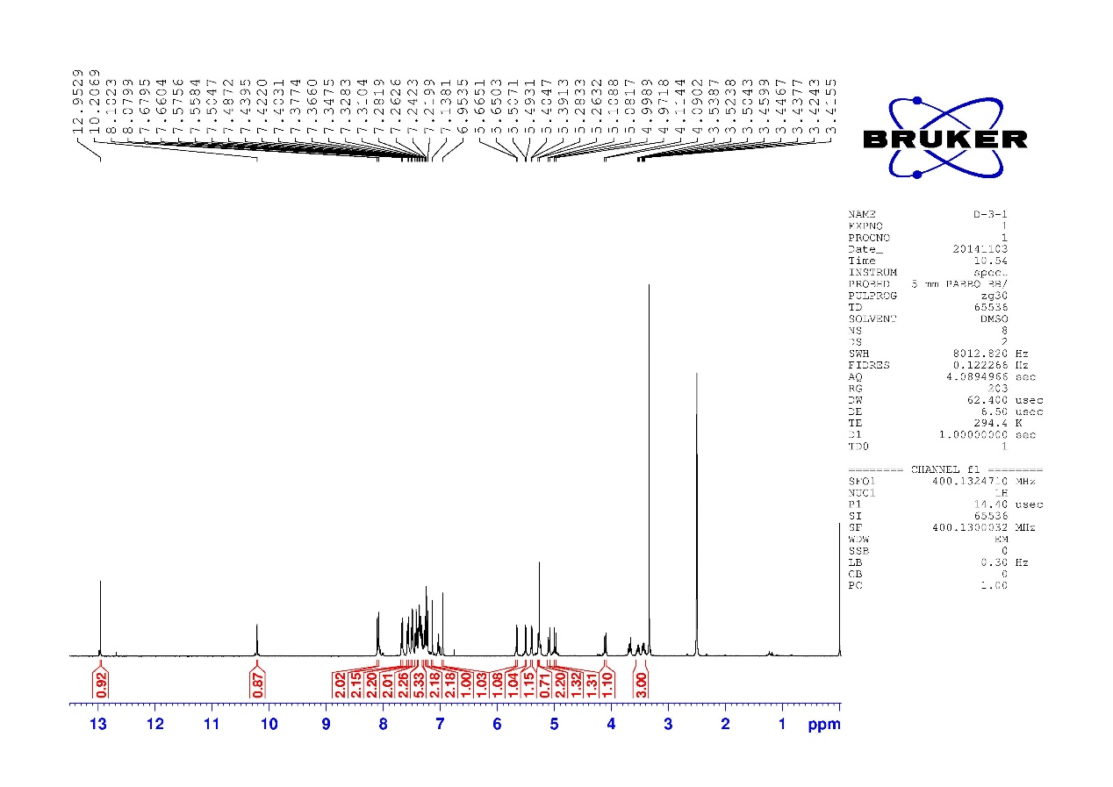
¹H NMR of compound 6a

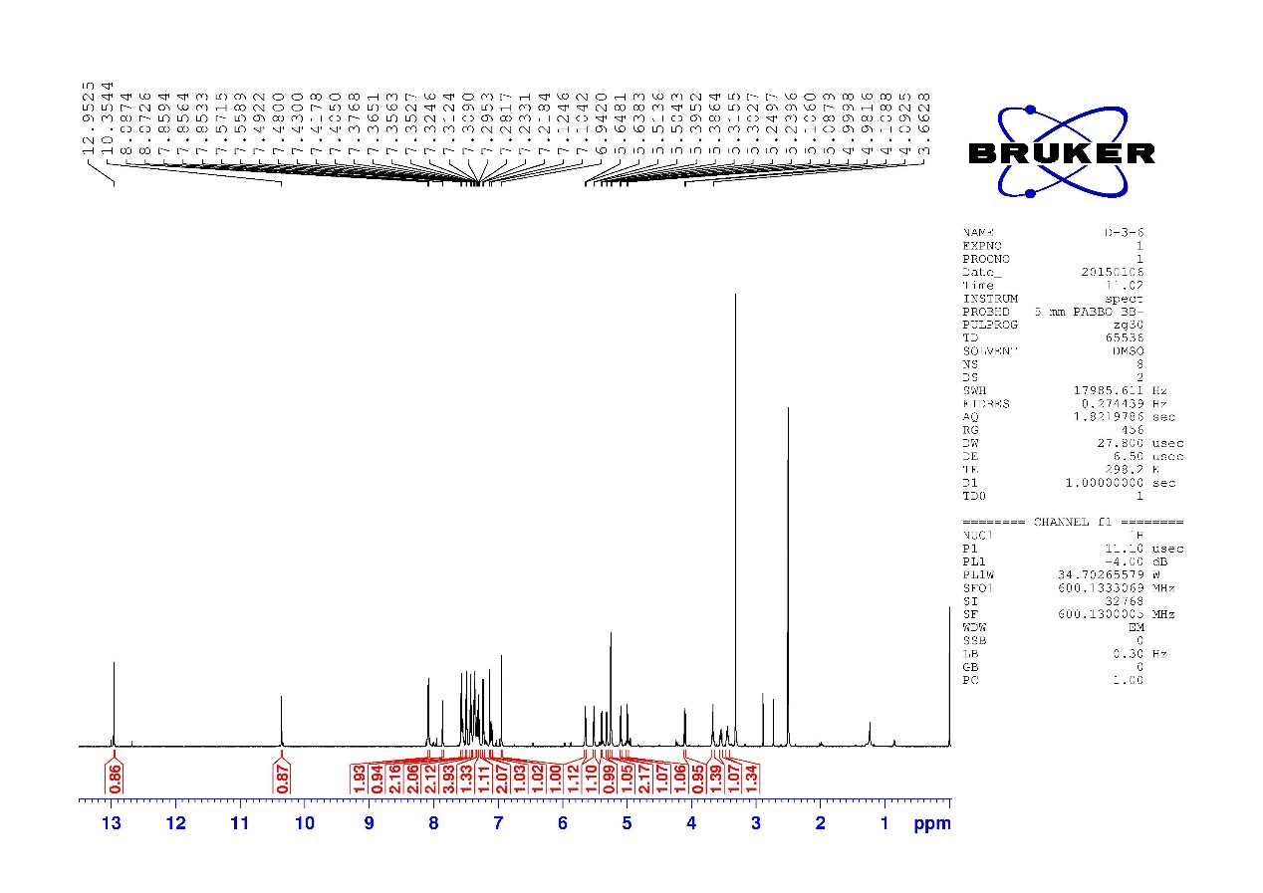
¹H NMR of compound 6b
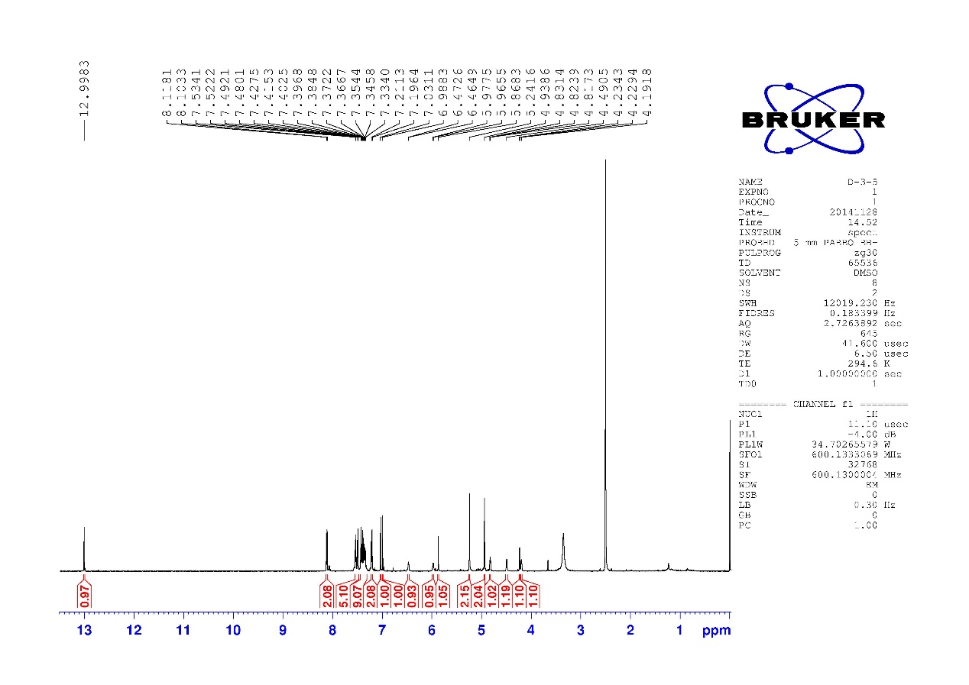
¹H NMR of compound 6c

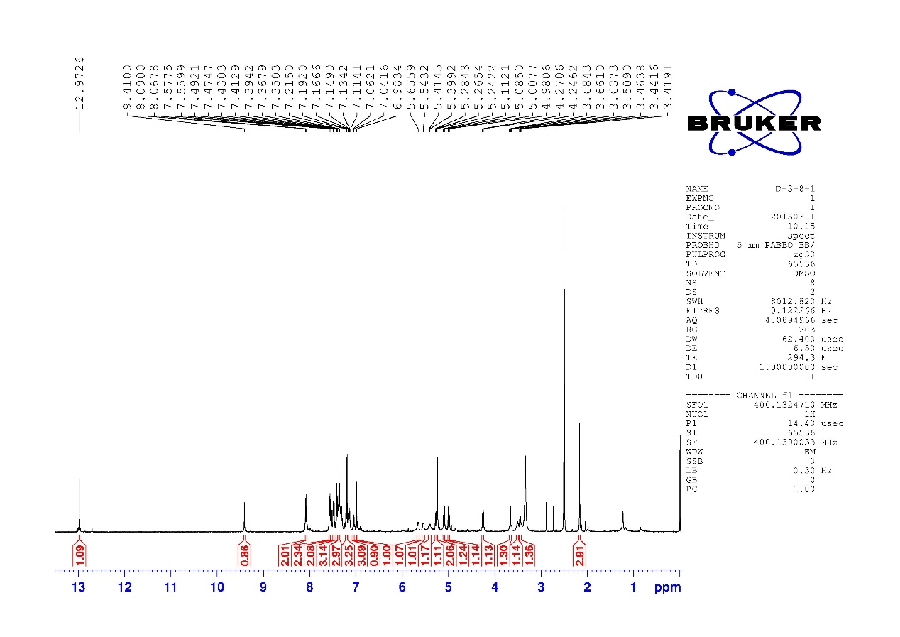
¹H NMR of compound 6d

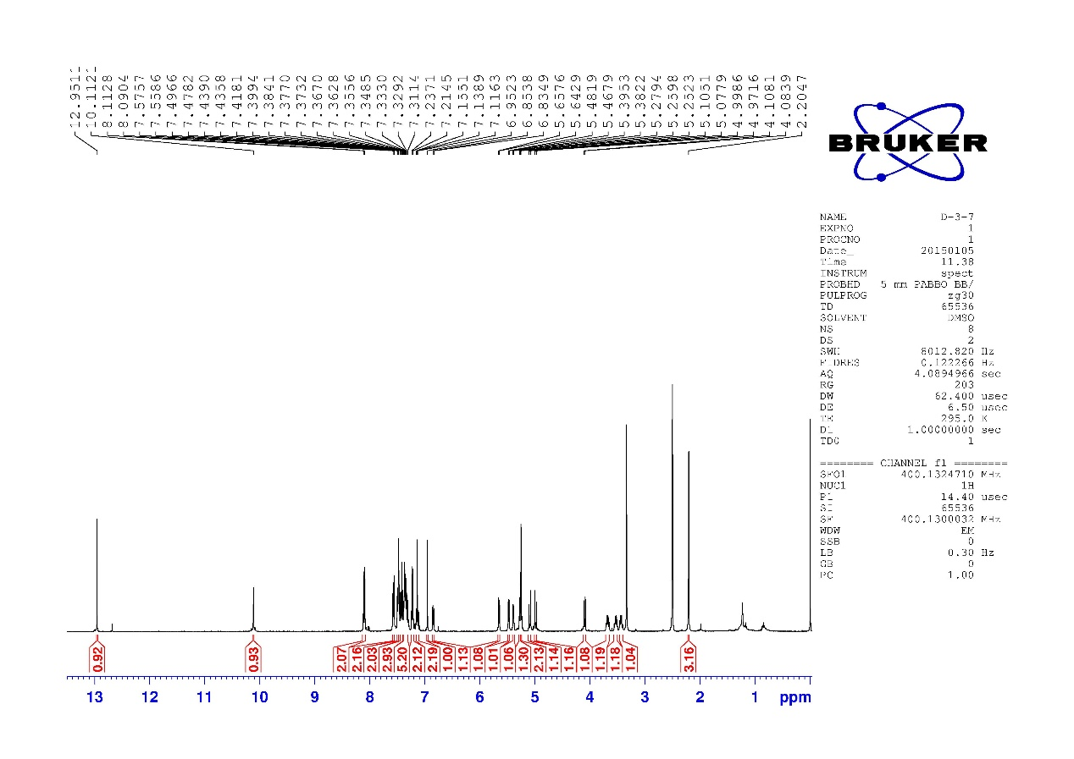
¹H NMR of compound 6e

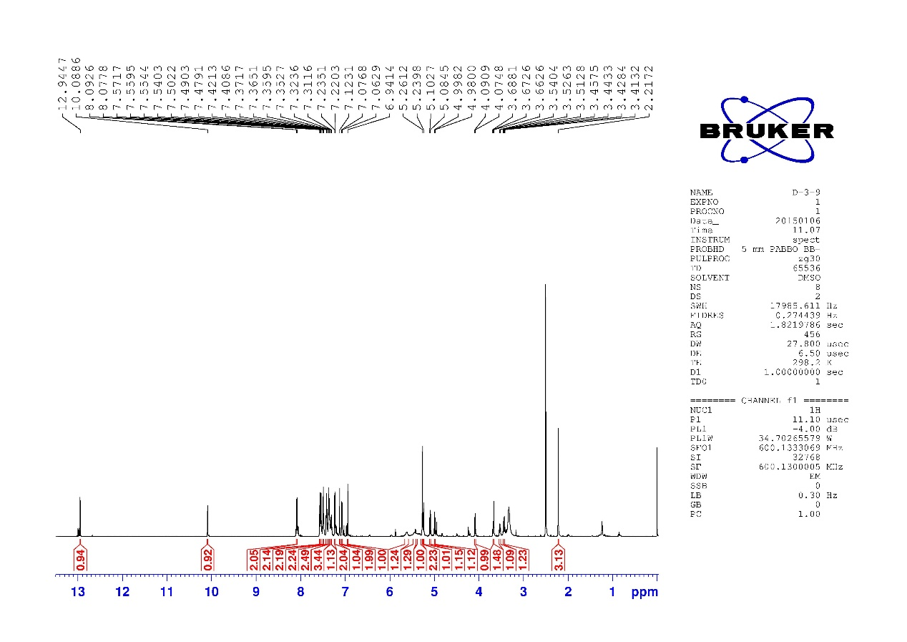
¹H NMR of compound 6f
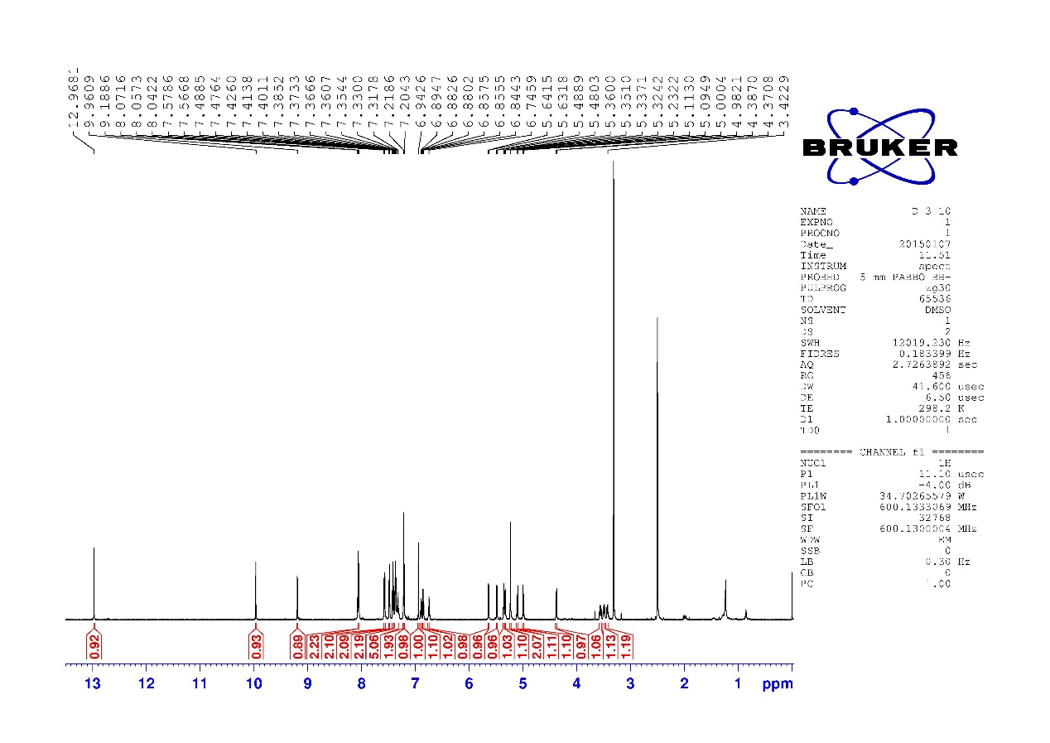
¹H NMR of compound 6g

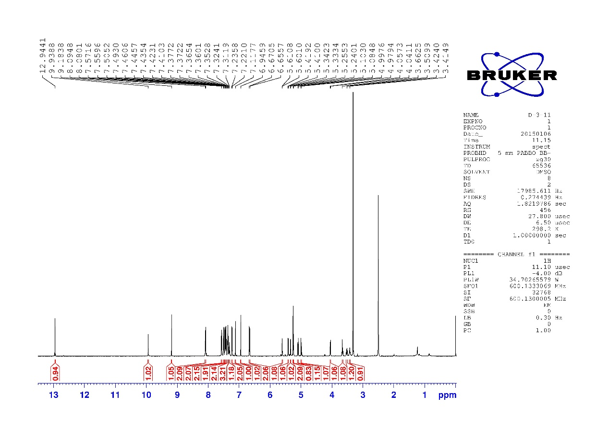
¹H NMR of compound 6h

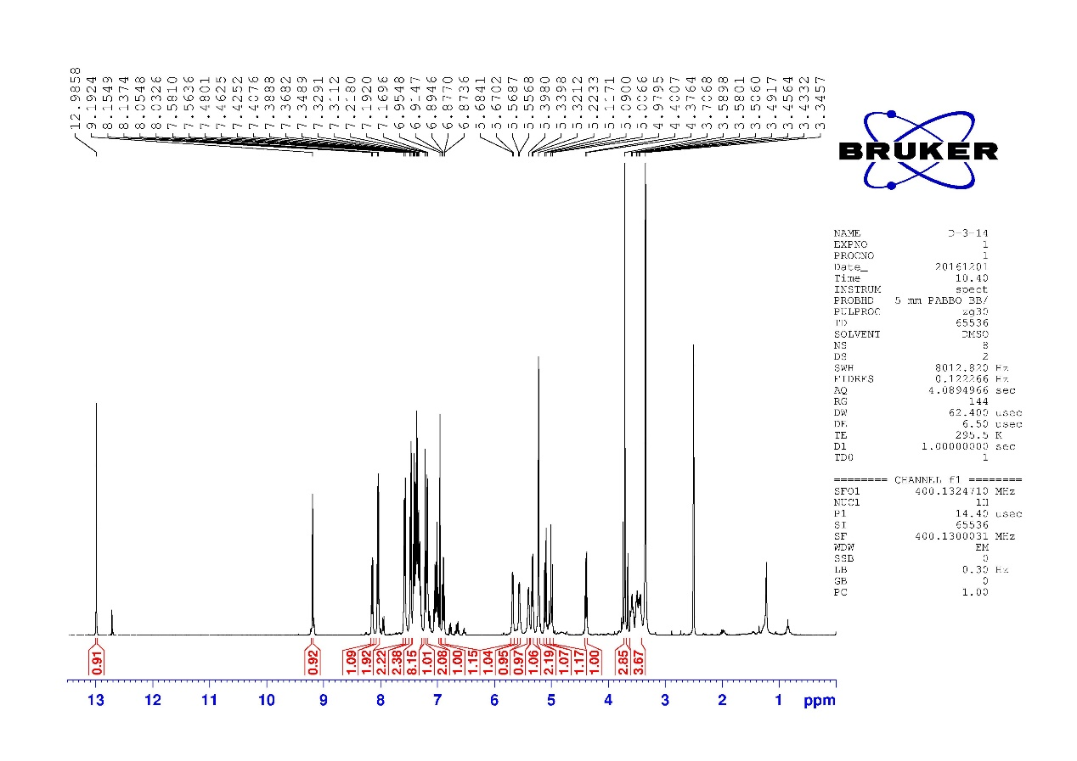
¹H NMR of compound 6i

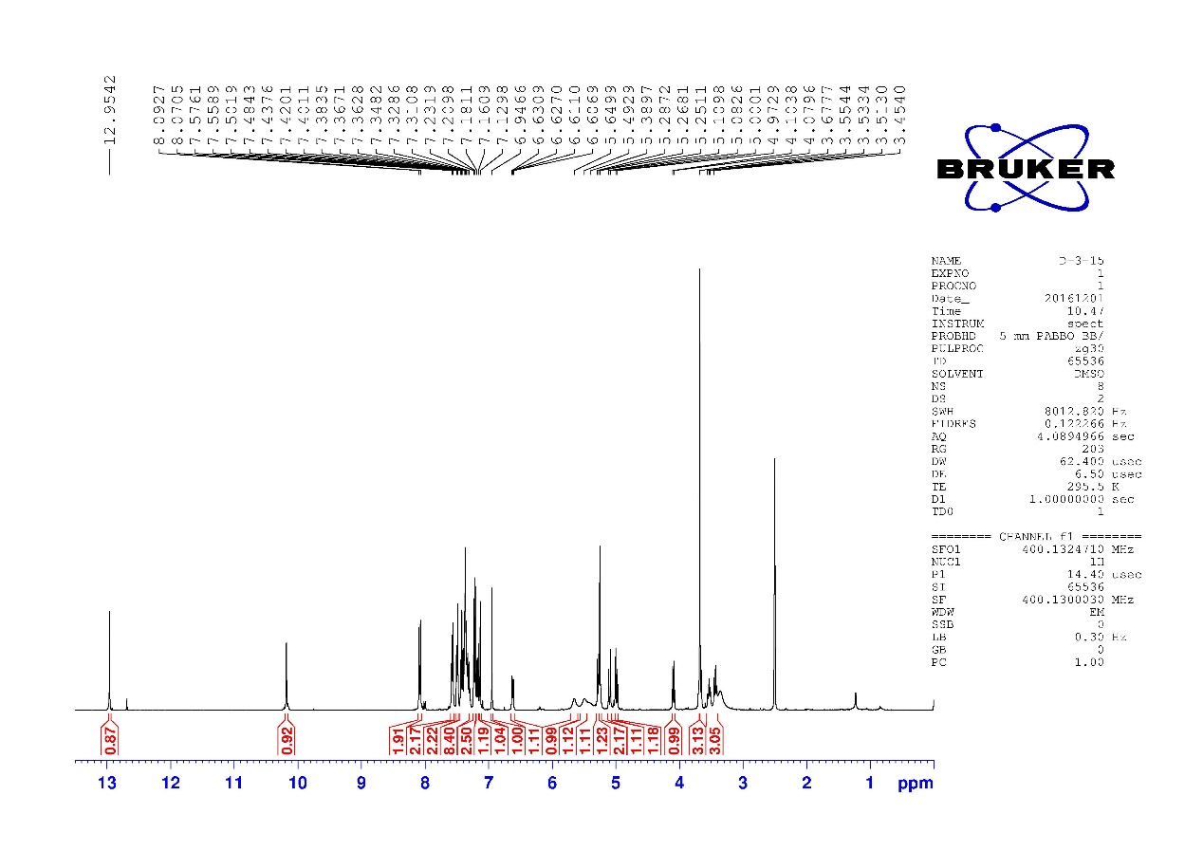
¹H NMR of compound 6j

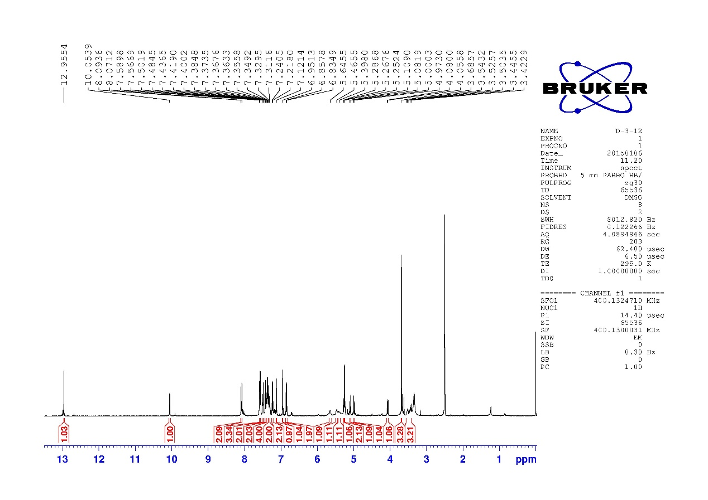
¹H NMR of compound 6k

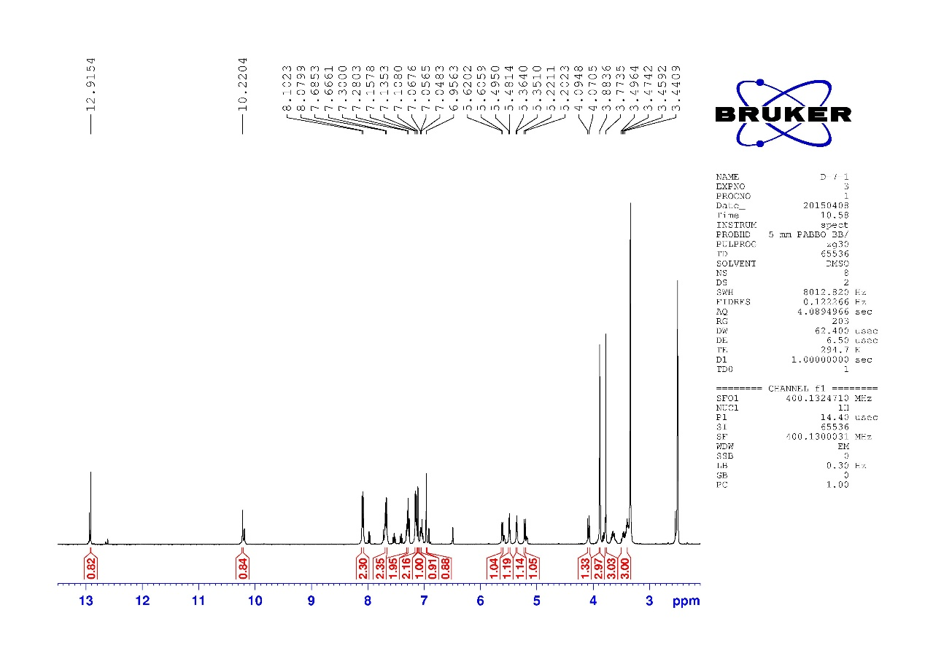
¹H NMR of compound 7a

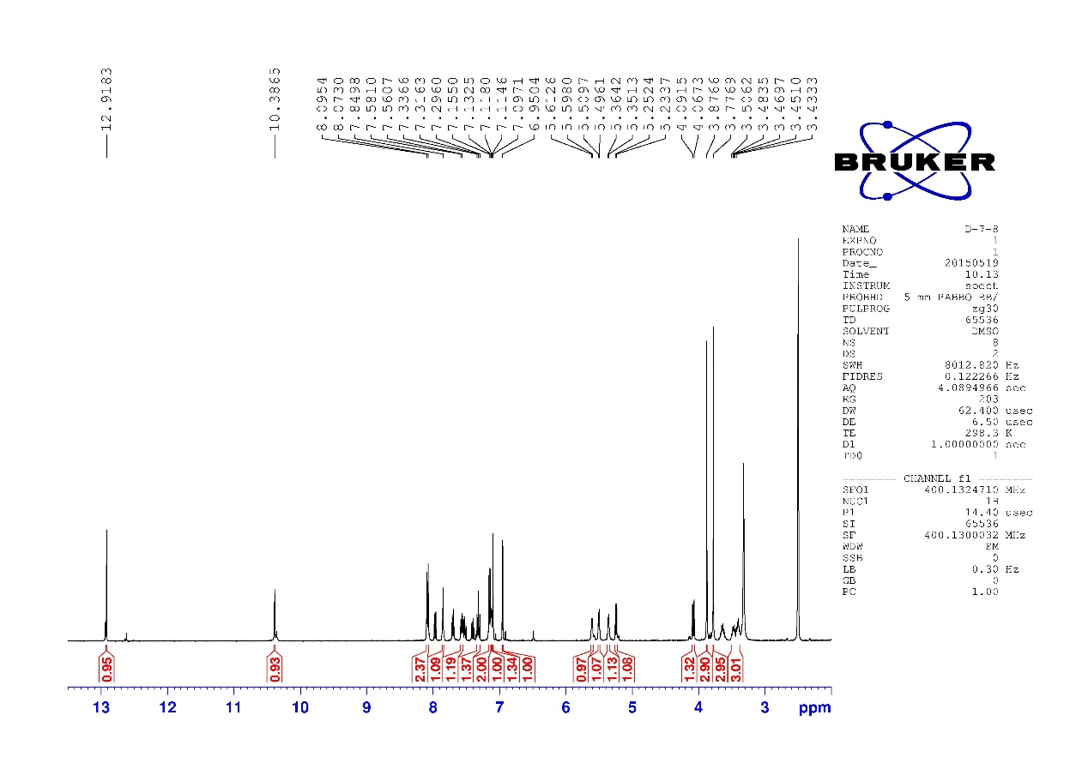
¹H NMR of compound 7b

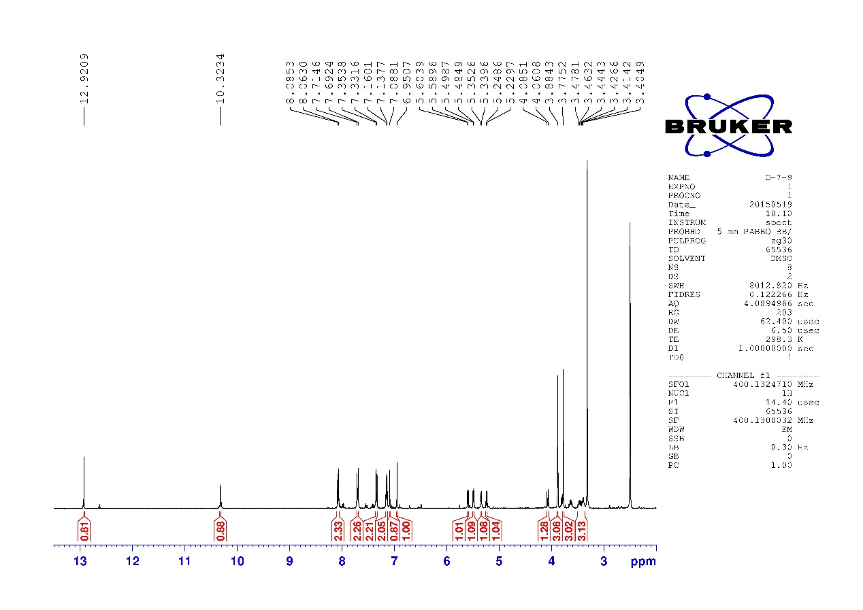
¹H NMR of compound 7c

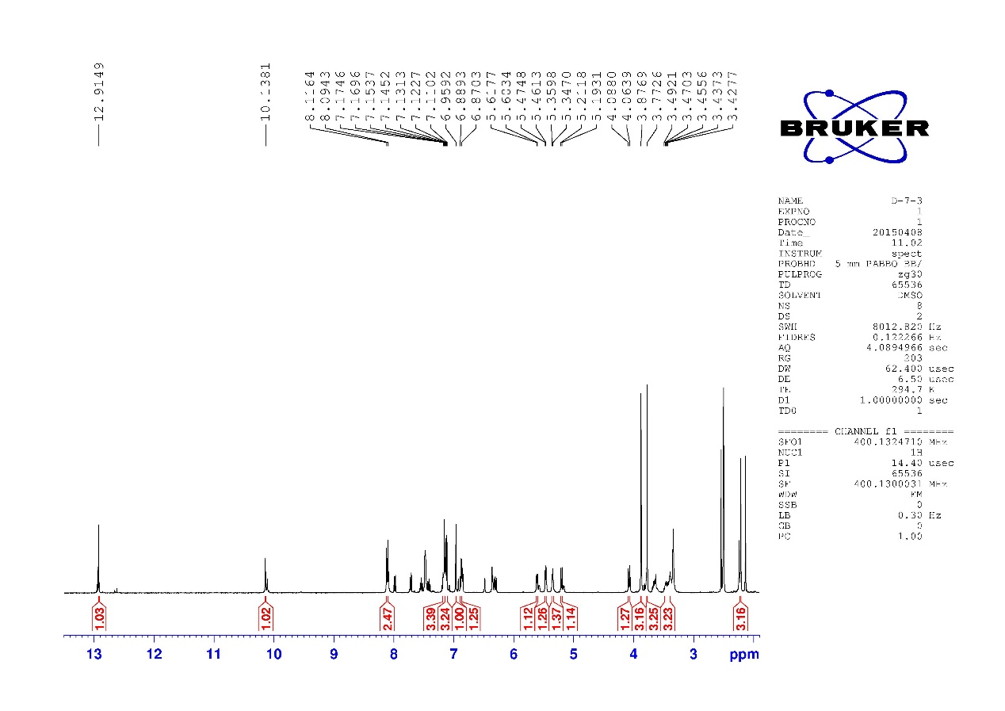
¹H NMR of compound 7e

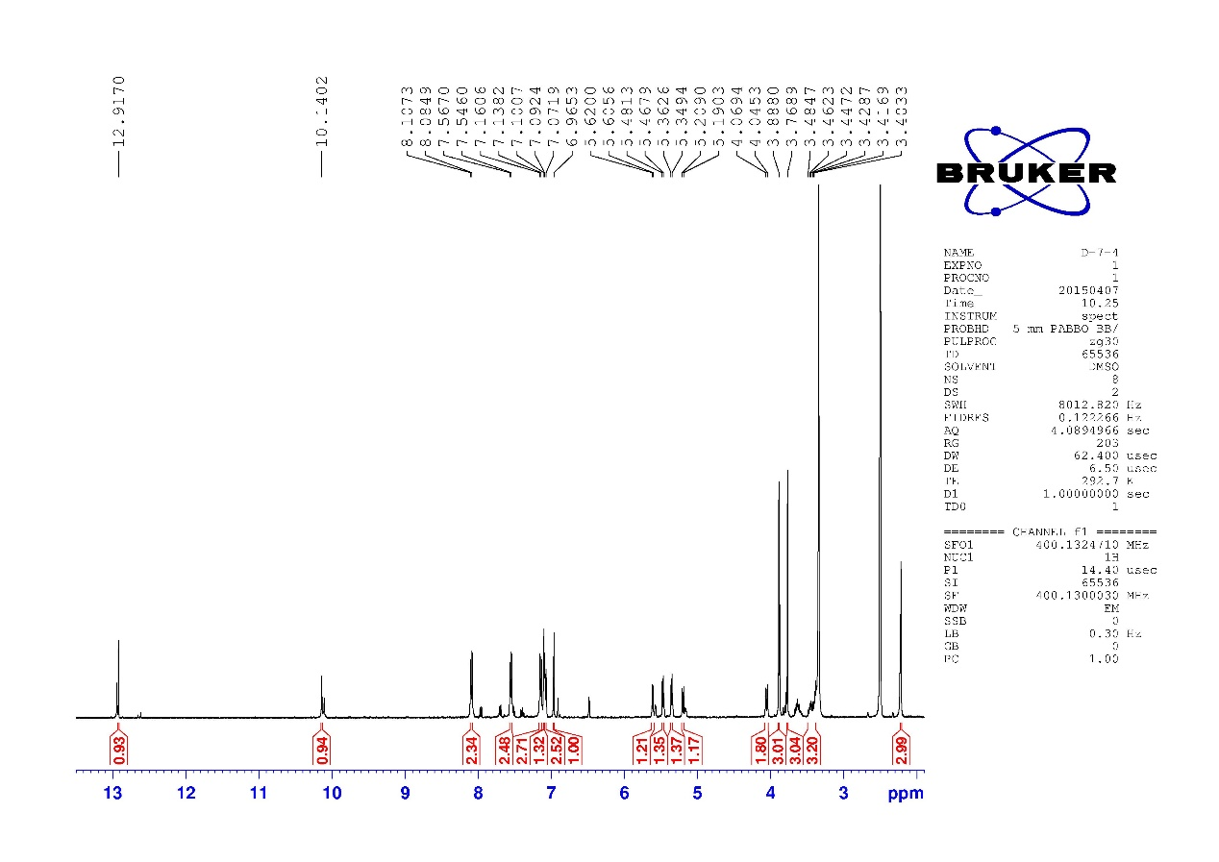
¹H NMR of compound 7f

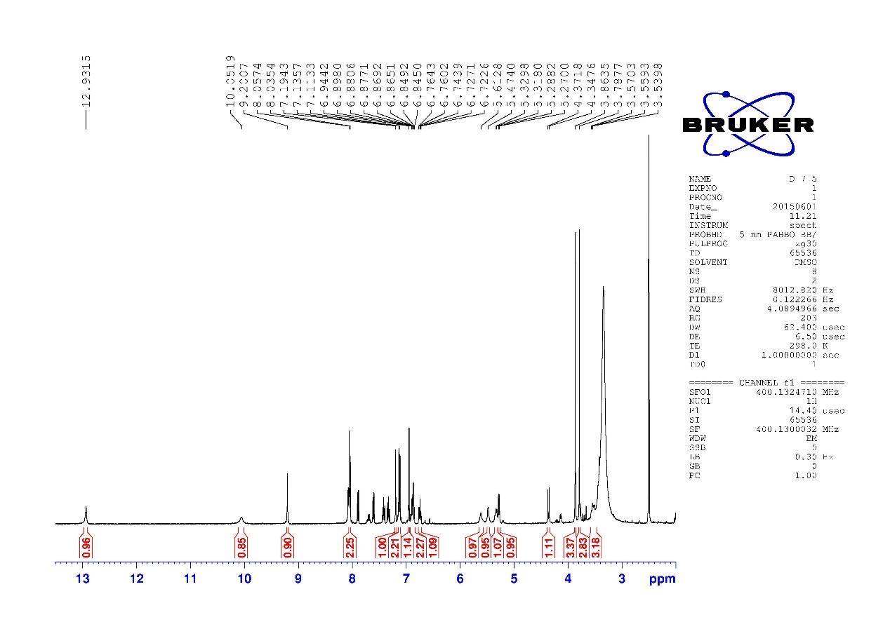
¹H NMR of compound 7g

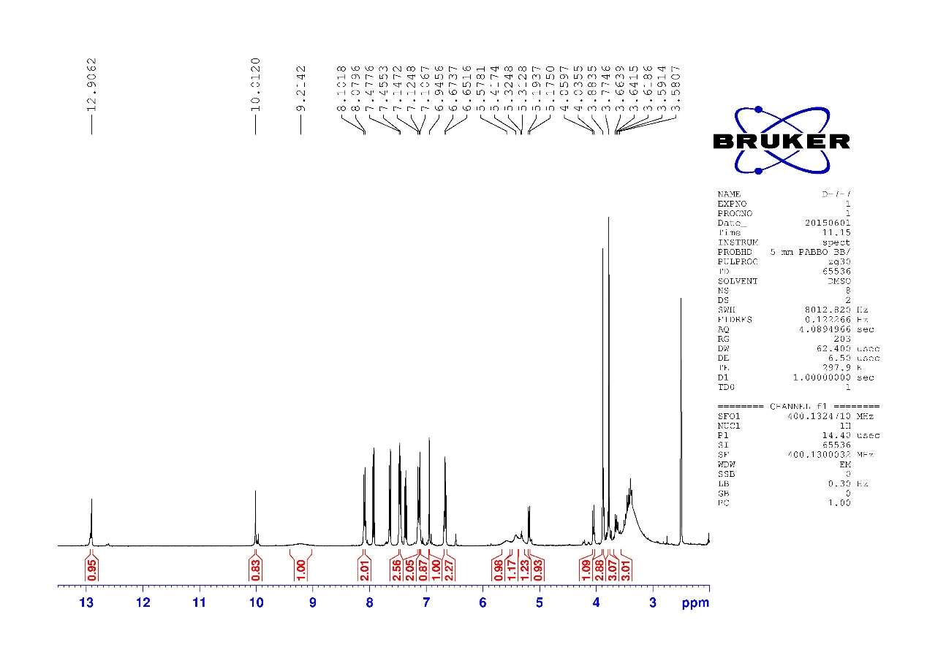
¹H NMR of compound 7h

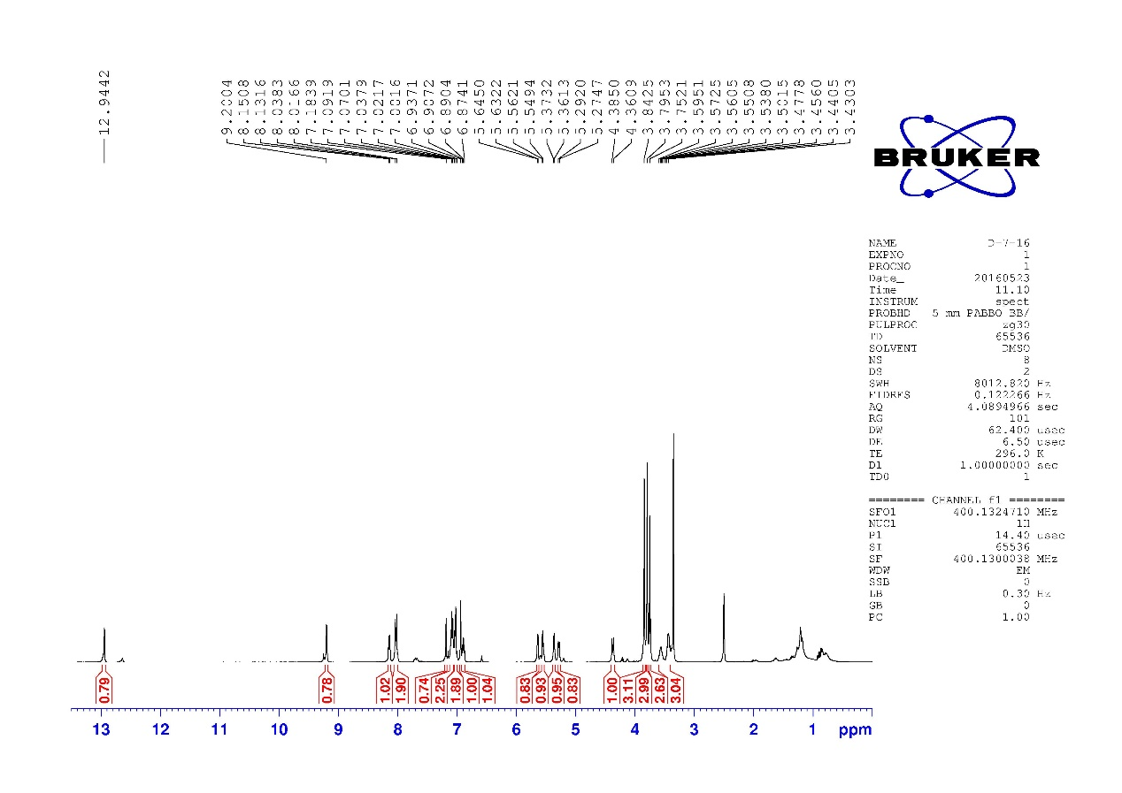
¹H NMR of compound 7i

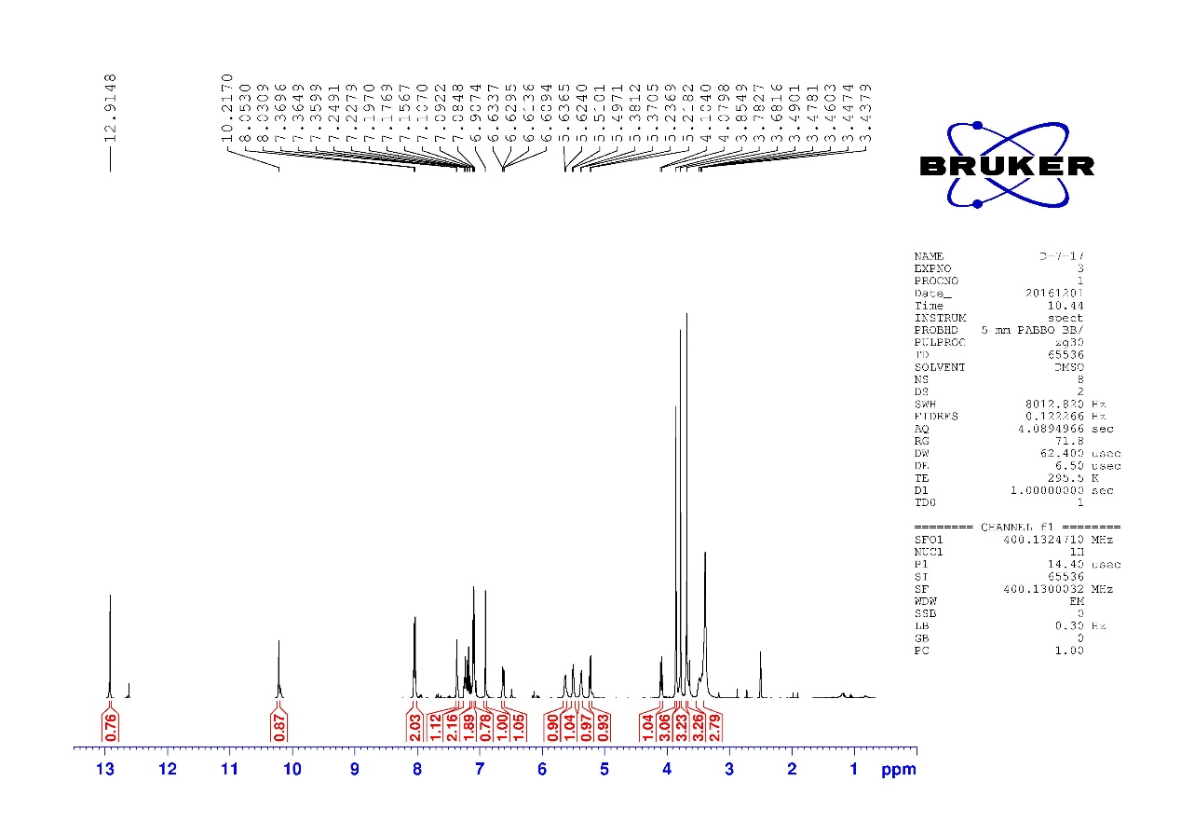
¹H NMR of compound 7j
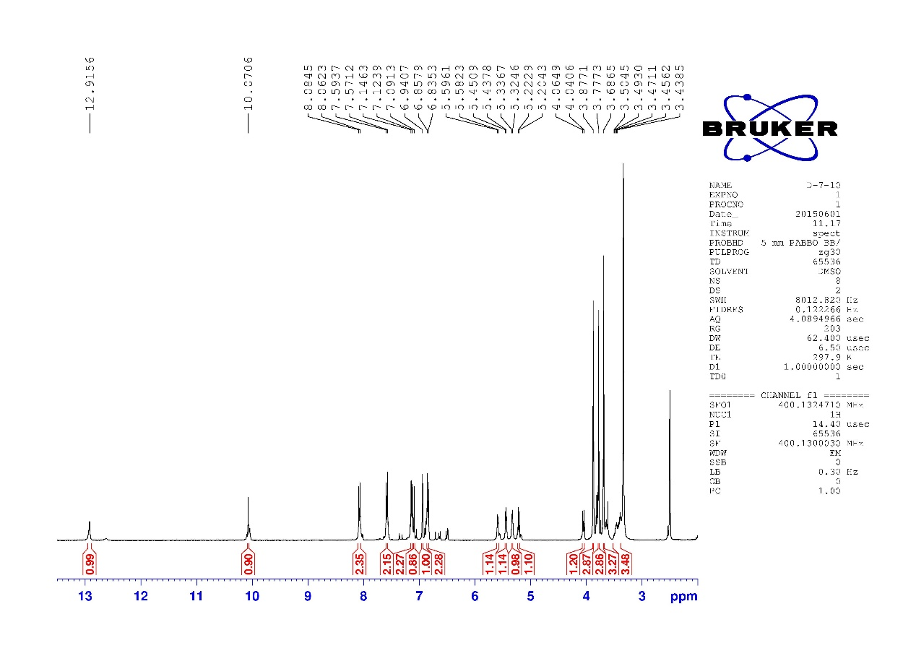
¹H NMR of compound 7k

