APPENDIX 1:
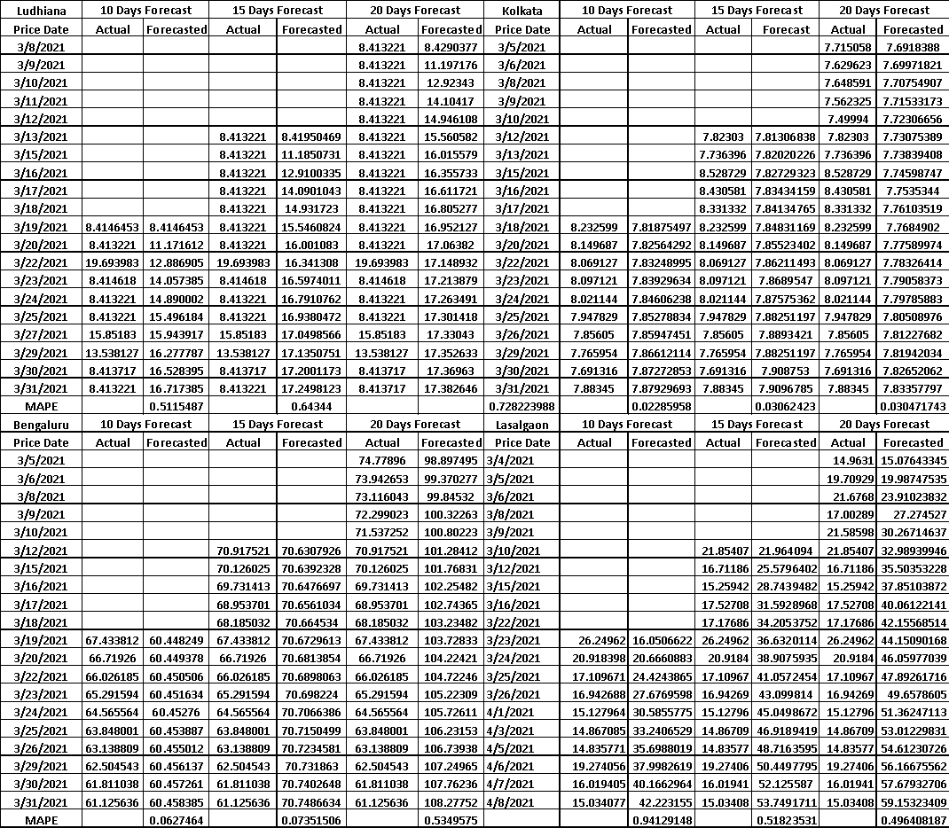
Table 2: Predictive Accuracy of 10,15 and 20 days forecast using Traditional GARCH (1,1)for Ludhiana, Kolkata, Bengaluru and Lasalgaon markets
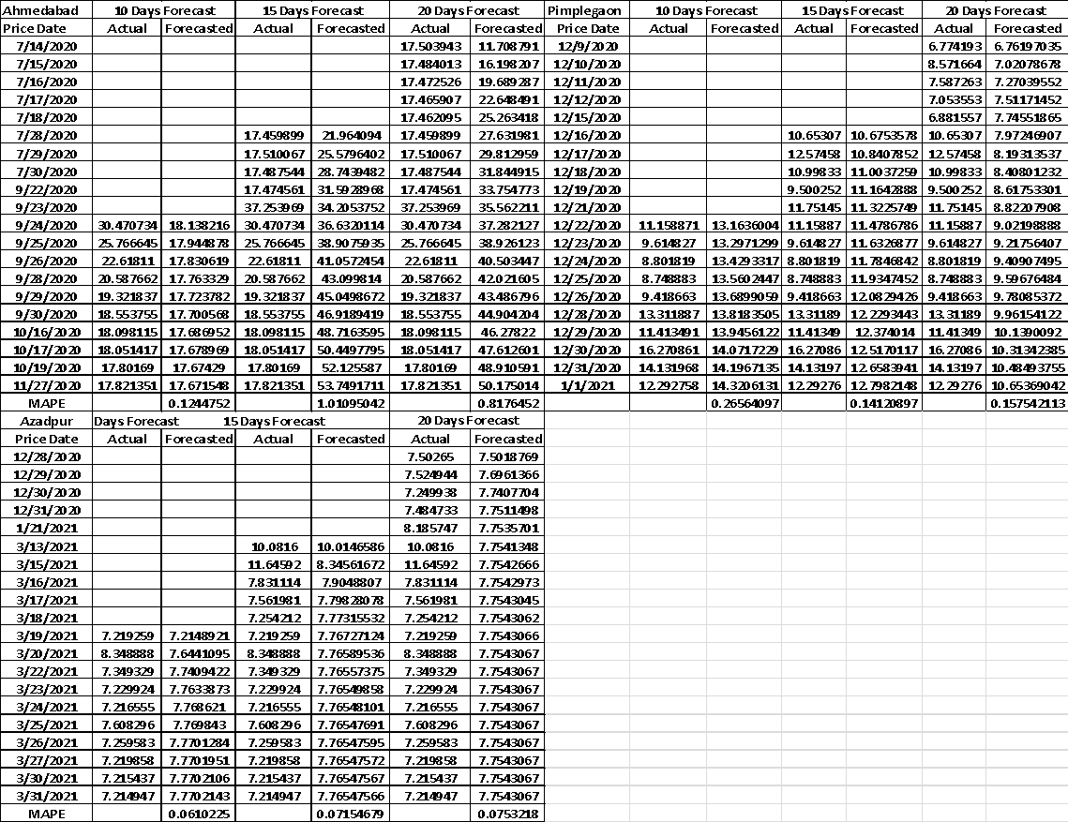

Table 3: Predictive Accuracy of 10,15 and 20 days forecast using Traditional GARCH (1,1)for Ahmedabad, Pimplegaon and Azadpur market

APPENDIX 2:
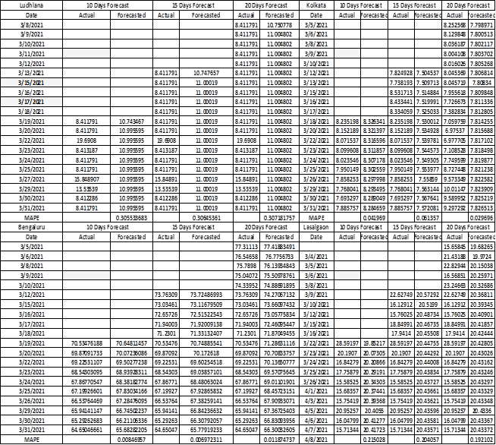
Table 4: Predictive Accuracy of 10,15 and 20 days forecast using Traditional ARIMA for Ludhiana, Kolkata, Bengaluru and Lasalgaon markets

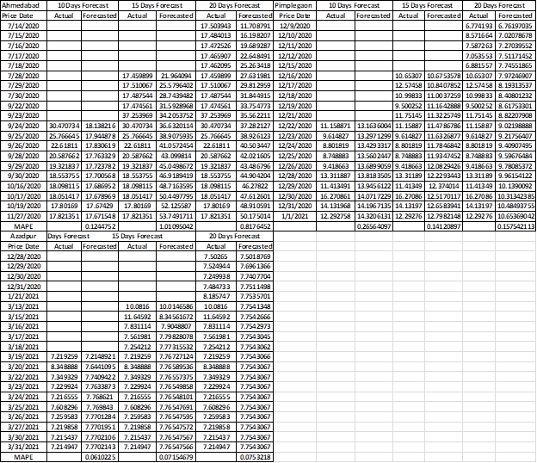
Table 5: Predictive Accuracy of 10,15 and 20 days forecast using ARIMA for Ahmedabad, Pimplegaon and Azadpur market

APPENDIX 3:
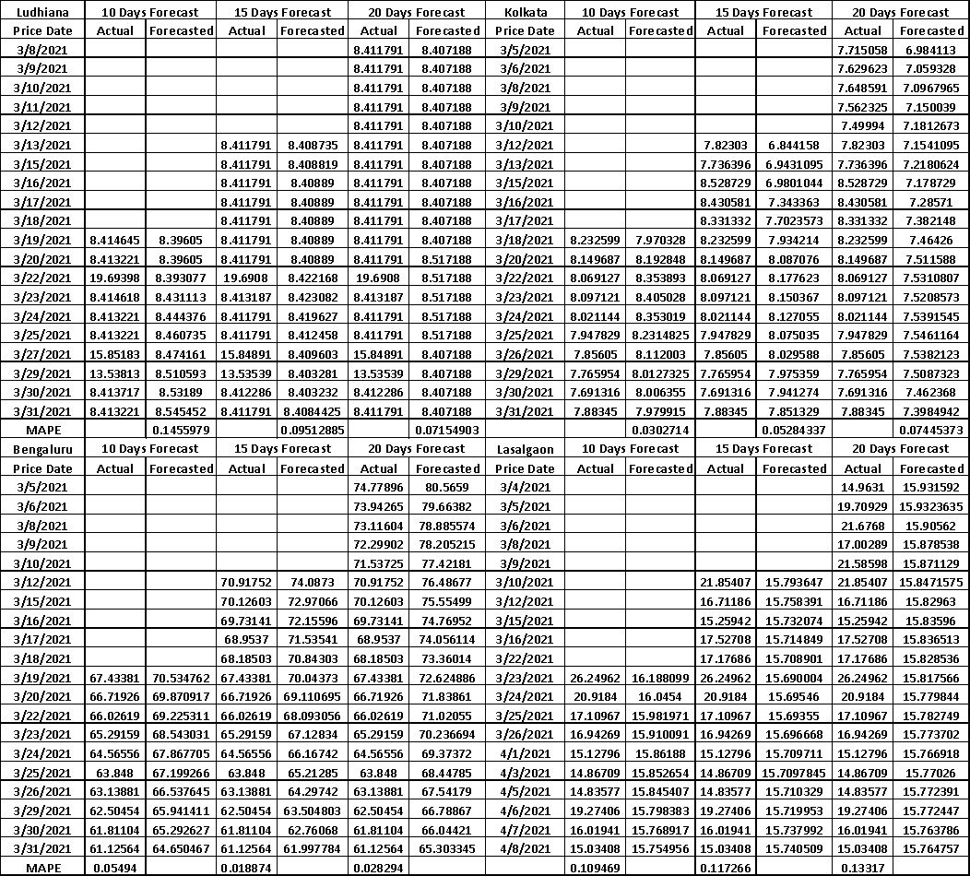
Table 6: Predictive Accuracy of 10,15 and 20 days forecast using the hybrid GARCH-LSTM Models with Max Price and Conditional Volatility as input for Ludhiana, Kolkata, Bengaluru and Lasalgaon markets
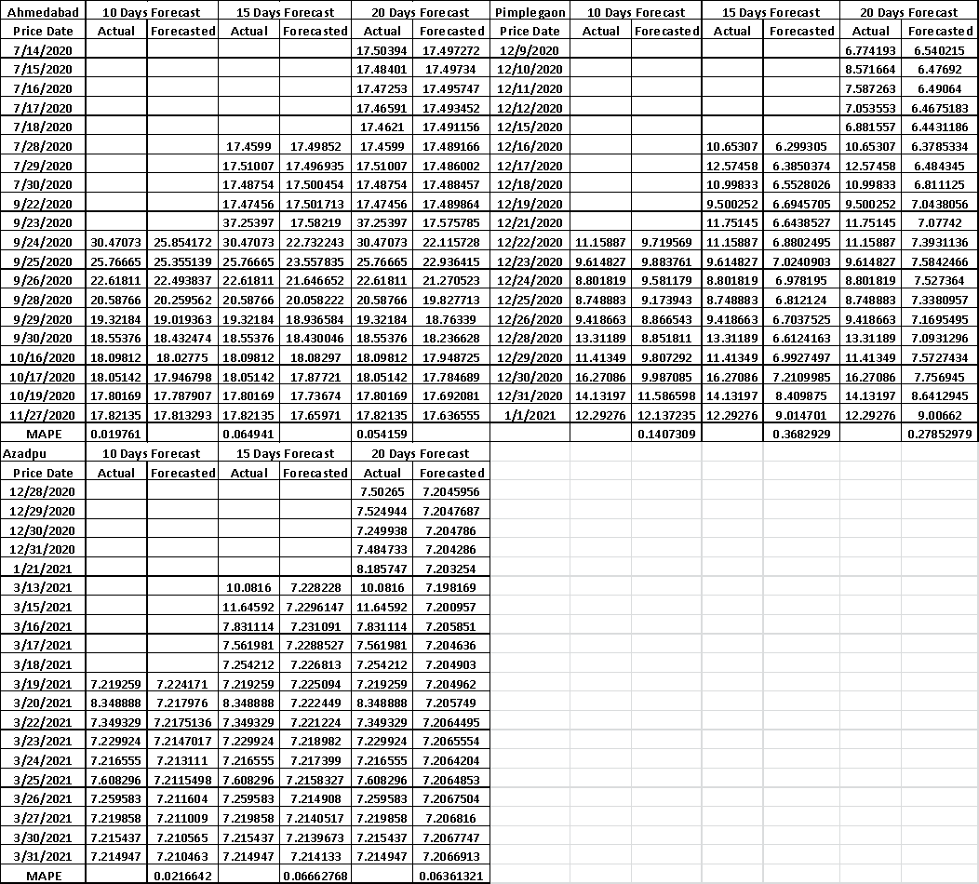
Table 7: Predictive Accuracy of 10,15 and 20 days forecast using the hybrid GARCH-LSTM Models with Max Price and Conditional Volatility as input for Ahmedabad, Pimplegaon and Azadpur markets

APPENDIX 4:

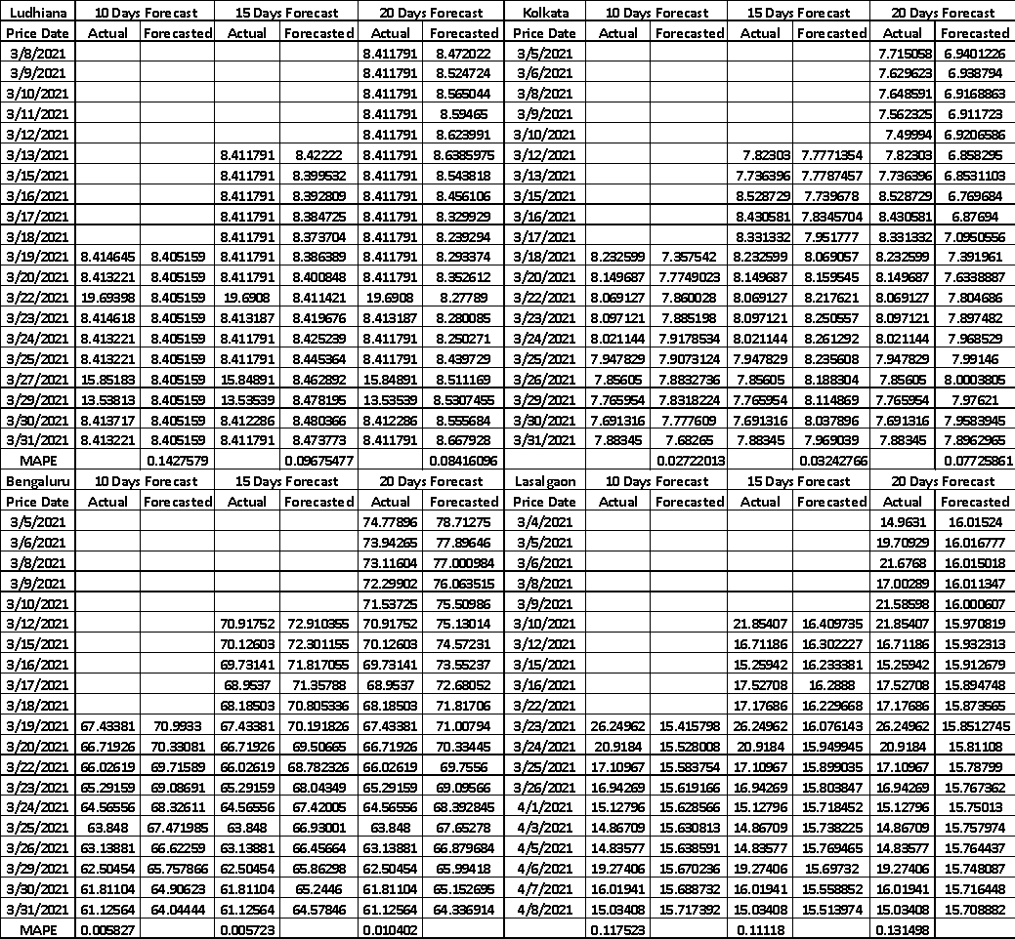
Table 8: Predictive Accuracy of 10,15 and 20 days forecast using the hybrid GARCH-LSTM Models with Max Price,Min Price and Model Price along with Conditional Volatility as input for Ludhiana, Kolkata, Bengaluru and Lasalgaon markets
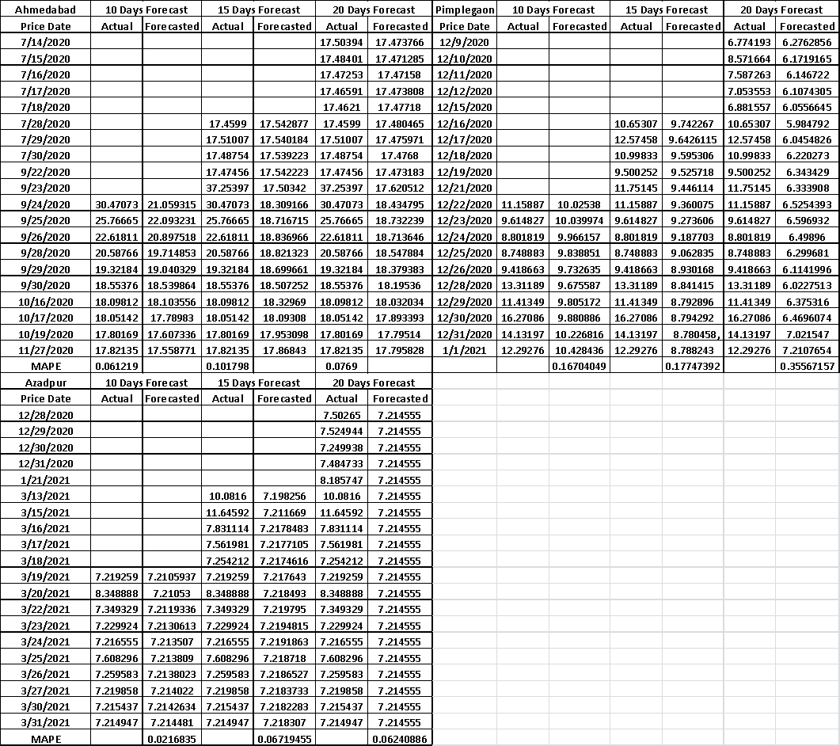
Table 9: Predictive Accuracy of 10,15 and 20 days forecast using the hybrid GARCH-LSTM Models with Max Price,Min Price and Model Price along with Conditional Volatility as input for Ahmedabad, Pimplegaon and Azadpur markets

