Supplementary information
1. Optimizing structural parameters of silicon wire waveguide
In this work, the dimensions of silicon wire waveguide (SW-WG) are selected as 460nm×220nm×5mm (width×height×length). Firstly, the height is fixed at 220nm according to the thickness of the top silicon of silicon-on-insulator (SOI) substrate. Then, the width is determined by the single-mode condition and as small as possible mode profile to obtain a higher nonlinear coefficient¹. Considering the fabrication deviation, the width of SW-WG is set as 460nm ultimately. For the length, there is a trade-off between high nonlinearity and low transition loss. To determine this value, we have fabricated three lengths of SW-WGs: 3mm, 5mm and 8mm. As shown in Fig. S1, the coincidence counts (CCs) of such three SW-WGs are measured in one minute and the SW-WG with length of 5mm is adopted to achieve relatively high CCs. Here, the pump/signal/idler wavelengths are 1552.5nm, 1557.36nm and 1547.74nm and the pump source is a pulsed laser (40MHz, the average power equals 0.4mW).
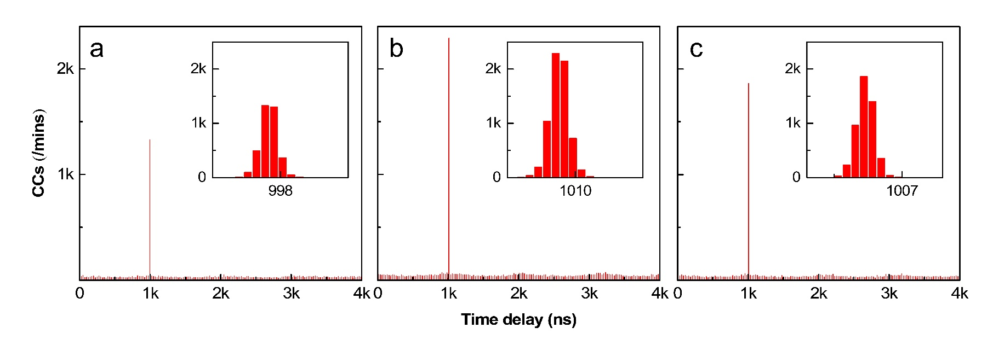
Fig. S1. The coincidence counts (CCs) of silicon wire waveguides with three lengths in one minute. a: 3mm; b: 5mm; c. 8mm. The insets are the zoomed-in views of main peaks.
2. The operation principle of OAM emitter
The generated OAM modes originate from the whispering gallery mode (WGM) in micro-ring cavity. There are 32 download waveguides (DWs) azimuthally distributed in this cavity, extracting the power from WGM and converging to the centric scattering grating. Since all DWs are equally spaced and the coupling distances with cavity are same (350nm), they could pick up part power of the WGM with uniformly phase gradient and nearly equal strength. The phase difference between adjacent waveguides is defined as²:
,
where N is the order of WGM and M=32 is the number of DWs. Furthermore, the topological charge (l) can be derived from:
Hence, when M is fixed, the topological charges of generated OAM modes are directly depend on the order of WGM. According to the equation of WGM, the order could be switched by varying the effective refractive index of micro-ring cavity as incident wavelength is fixed. In this work, the thermo-optical effect is utilized to achieve this function.
3. Identify the topological charge through interference patterns
Light beams carrying OAM have spiral phase structures, whose handedness and magnitude are described by the topological charge l³. The interference patterns between OAM modes and the fundamental Gaussian mode would present special spiral fringes which reveal the topological charges of these OAM modes. The number and rotational direction of the fringes are corresponding to the value and symbol (±) of l, respectively⁴. Fig.S2 shows the interference patterns of azimuthally polarized OAM modes with l=2~6 and l=-6~-1. A tunable laser is adopted as the input of the OAM emitter and the corresponding wavelengths are marked in the bottom. Each of OAM modes could be decomposed into left-handed circular polarized (LHCP) component with l_{L}=l+1 and right-handed circular polarized (RHCP) component with l_{R}=l-1. The topological charges of the azimuthally polarized OAM modes could be confirmed by both interference patterns.
This method could also utilized to certify the topological charges of OAM modes switched by varied driving voltage. In Fig.S3, when incident wavelength is fixed at signal wavelength (1557.36nm or 1547.72nm), the generated OAM modes corresponding to different driving voltages are measured. The results are similar to those in Fig. S2 but the tuning mechanism of l is different.
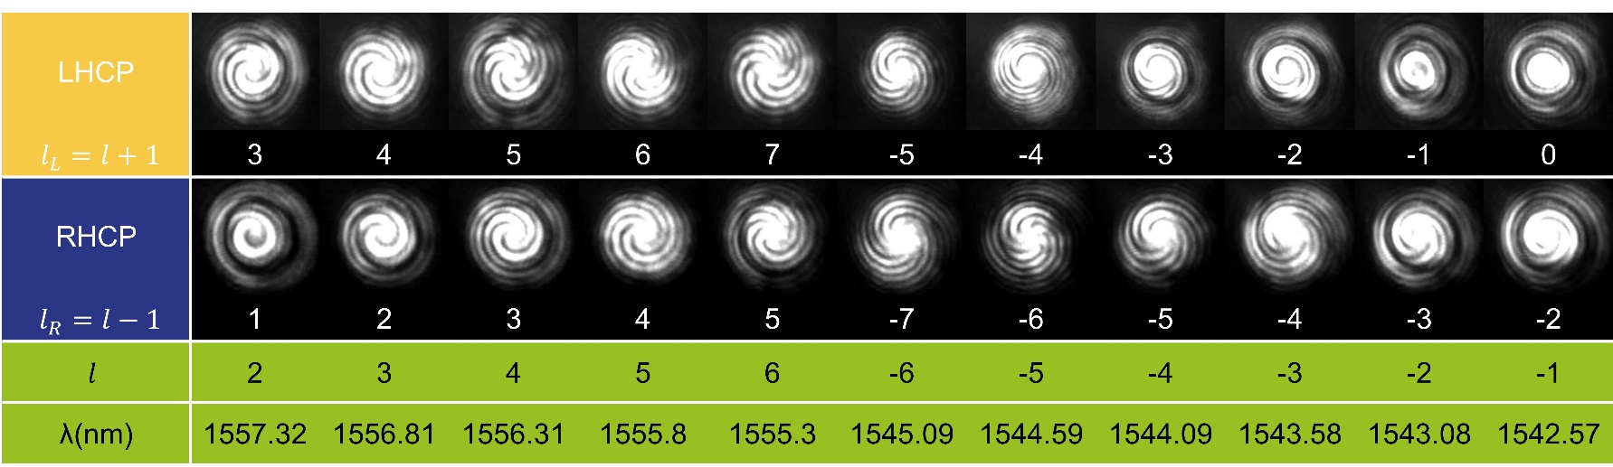
Fig. S2. The interference patterns of 11 OAM modes and the fundamental Gaussian mode. Each OAM mode corresponds two interference patterns with topological charges (l_{L} and l_{R}) marked below them. The last column shows the operating wavelengths of the corresponding OAM modes.
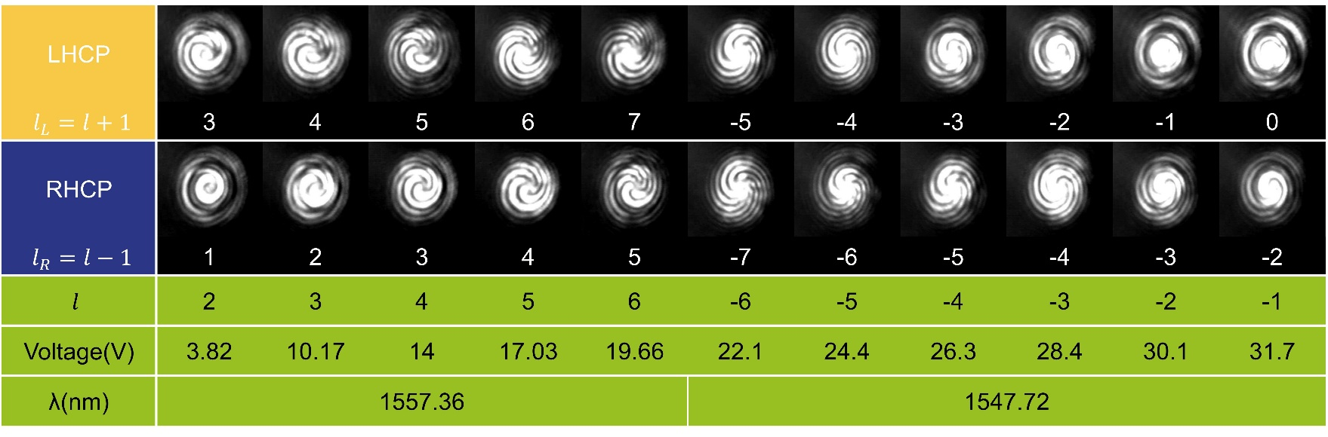
Fig. S3. The interference patterns of OAM modes whose topological charges are switched by the driving voltages. The incident wavelength is fixed at 1557.36nm for l=2~6 and 1547.72nm for l=-6~-1.
4. The arrangement of signal and idler wavelength
The photon pairs are generated through the degenerate spontaneous four-wave mixing (SFWM) in SW-WG. In this work, the pump wavelength is set as 1552.5nm according to our experimental conditions. As shown in Fig. S4 (a), the group-velocity dispersion (GVD) of SW-WG has been simulated. The pump wavelength (λ_{p}) of 1552.5nm is marked as the purple dotted line. Although the GVD at λ_{p} is not zero, the length of SW-WG is only 5mm and the total GVD is 2.355×10⁻³ps/nm. Thus, the phase matching condition of SFWM is approximately satisfied^{5–7}. When the driving voltage is 0V, λ_{p} is near the wavelength (1552.71nm) corresponding to l=11 of OAM emitter. Furthermore, the signal and idler wavelengths (λ_{s}, λ_{i}) are distributed equally on both sides of the λ_{p}. Here, λ_{s} and λ_{i} should be not too far from λ_{p} to guarantee enough generation rate of photon pairs⁸ and as close as possible to wavelengths corresponding to l=±1 (λ_{l=1}=1557.83nm, λ_{l=-1}=1542.57nm), which would be helpful to reduce the driving voltages for the alignments of λ_{s} and λ_{l=±1}. Furthermore, signal and idler photons would pass through a standard DWDM before detection so that the Raman noise can be filtered out. Thus, the λ_{s} and λ_{i} have to be aligned to the operating wavelength of the DWDM. Actually, 1558.17nm and 1545.92nm are the first choice, since they can meet both two requirements mentioned above. However, when the operating wavelength of l=2 is aligned with λ_{s}=1558.17nm through the thermo-optical controller, it can be seen from the Fig. S4 (b) that the pump and idler photons are partially coupled into the OAM emitter, which would decrease the CCs and CAR. Hence, λ_{s} and λ_{i} are finally set as 1557.36nm and 1547.72nm while the cost is the absence of the OAM mode with l=1.
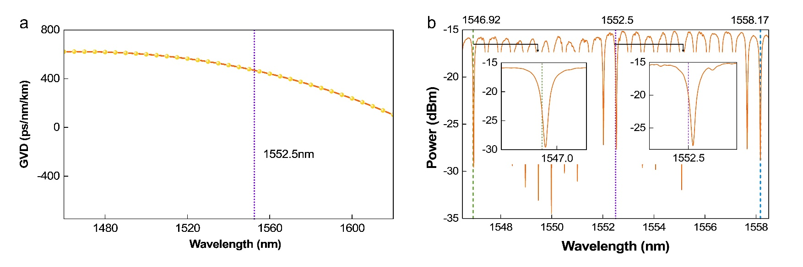
Fig.S4 a. The simulation result of the SW-WG’s group-velocity dispersion (GVD) versus wavelengths. b. The relation between pump/signal/idler and the transmission spectrum of OAM emitter when the operating wavelength of l=2 is aligned with λs=1558.17nm.
5. Measurement of mode purity
The mode purity presents the power ratio of the target OAM mode among actual generated mode. Obviously, the mode purity of a target OAM mode should be as near unity as possible. As shown in the Fig.S5 (a), the measurement can be regarded as the tomography for generated OAM mode and the spatial light modulator (SLM) serves as the mode filter. Due to the special helical phase structures, light beams with OAM possess a doughnut-like intensity cross-sections (vertical to the propagation direction)⁴ and could not be coupled into the single mode fiber (SMF) directly. Here, only the OAM mode with l=-l_{mask} corresponding to topological charge of the settled phase mask on SLM (l_{mask}) could be converted to fundamental Gaussian mode and detected by the SMF-packaged power meter. Moreover, the SLM operates with linearly polarized incidence but the generated OAM modes are azimuthally polarized. Thus, a quarter wave plate (QWP) and a polarizer (P) are utilized to transform OAM modes from azimuthal polarization to linear polarization.
Specifically, the incident wavelength is fixed at the signal wavelength (1547.72nm or 1557.36nm) and different OAM modes could be obtained by properly setting the driving voltage. For a target OAM mode, a SLM with phase masks of l_{mask}=-7~7 is utilized to extract the corresponding modes and 15 values of optical power could be obtained. The mode purity is calculated as the power ratio of target OAM mode over the sum of all 15 values. It should be noticed that one component of the LHCP with l_{L}=l+1 or RHCP with l_{R}=l-1 is firstly extracted from the azimuthally polarized mode with topological charge of l and then transformed to the linear polarization before SLM. Thus, the relation of the topological charge of the phase mask on SLM versus the OAM mode is l_{mask}= -l_{L}=-(l+1) for LHCP component or l_{mask}= -l_{R}=-(l-1) for RHCP one. Fig.S5 (b) shows a concrete example, in which the horizontal axis is the l_{mask} and the corresponding RHCP component of the OAM mode is extracted. With the relation of l_{mask}=-l_{R}=-(l-1), the actual topological charge of the corresponding OAM mode should be l=-l_{mask}+1. The transverse intensity profiles after the SLM are shown in Fig.S5 (c) with the corresponding l_{mask} marked below. It can be seen that the main OAM mode is l_{R}=-2 (l=-1) and the mode purity is 82.62%. Here, the measured power is normalized by the total power of all OAM modes. For 11 OAM modes, there are two sets of mode purities as shown in Fig. S5 (d) corresponding to LHCP and RHCP components. The results shown in Fig.4 of the main context are the average values of both LHCP and RHCP components.
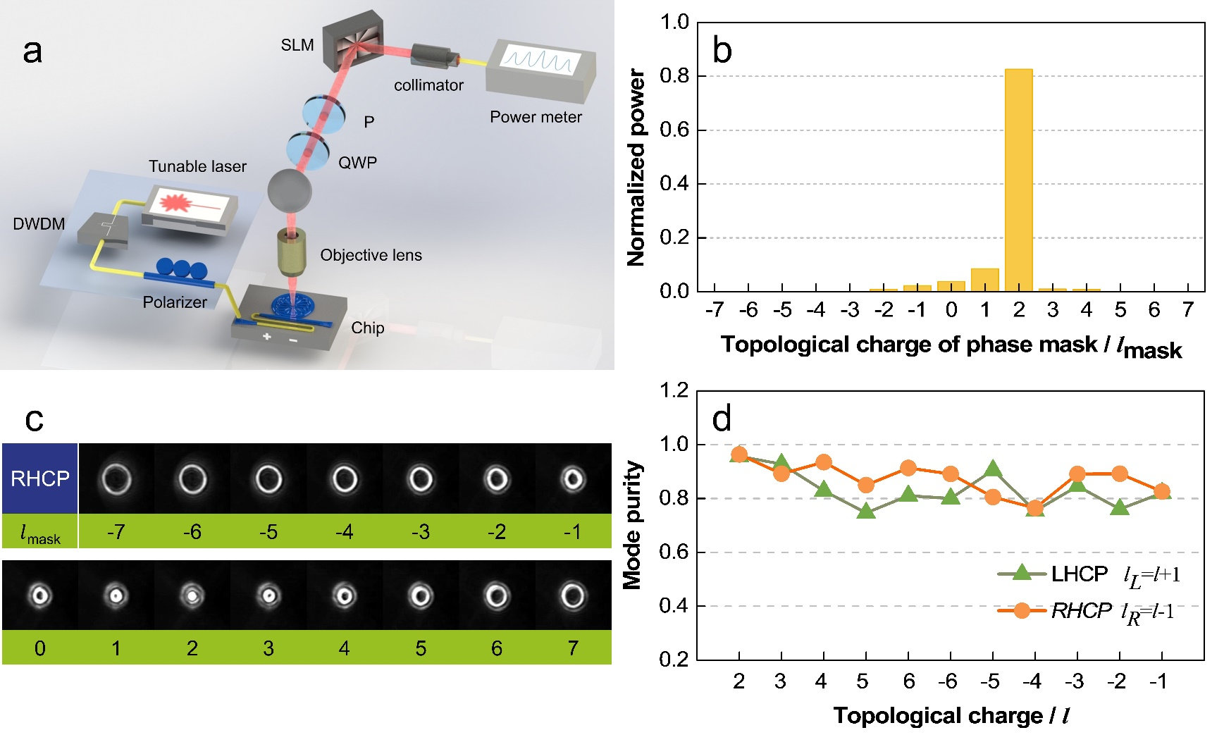
Fig.S5 a. The experimental scheme for measuring the mode purities of generated OAM modes. b. A typical result of OAM mode with l_{R} =-2. There are 15 values of normalized power and the value corresponding to l_{mask}=2 is the required mode purity. c. The transverse intensity profiles of OAM mode after different masks marked below. d. The measured mode purities of both LHCP and RHCP components corresponding to 11 OAM modes.
6. The insertion loss of detection system
The insertion loss introduced by the detection system includes the transmission loss of the objective lens, wave plates (a QWP and a polarizer), spatial light modulator (SLM) and collimator. Among them, the insertion loss of the objective lens is constant as -3.98dB. Other losses are measured for l=2~6 and -6~-1 under the fixed incident wavelength of 1557.32nm and 1547.72nm, respectively. The results are shown in Fig.S6 (a) and each value is averaged by two linear polarization (the azimuthal polarization is converted to horizontal and vertical polarization). For 11 OAM modes, the losses of wave plates and SLM are around~-4dB and nearly independent on the topological charges. For the insertion loss of collimator, it is obtained by subtracting the received power after collimator from total power before collimator. Since only the fundamental Gaussian mode can pass through the collimator, thus, the measured values shown in Fig.S6 (a) actually contain the effect due to different mode purities of different OAM modes. By comparing the insertion loss of collimator (green dots) in Fig.S6 (a) and the value of mode purities shown in Fig.4 of the main context, it can be found that both curves have the similar variation trend. Moreover, after deducting the insertion losses of detection system, the coincidence counts (CCs) are calculated and shown in the Fig.S6 (b) (Fig.7 in main context). This results could present the actual generation rate of the heralded single photons with our device.
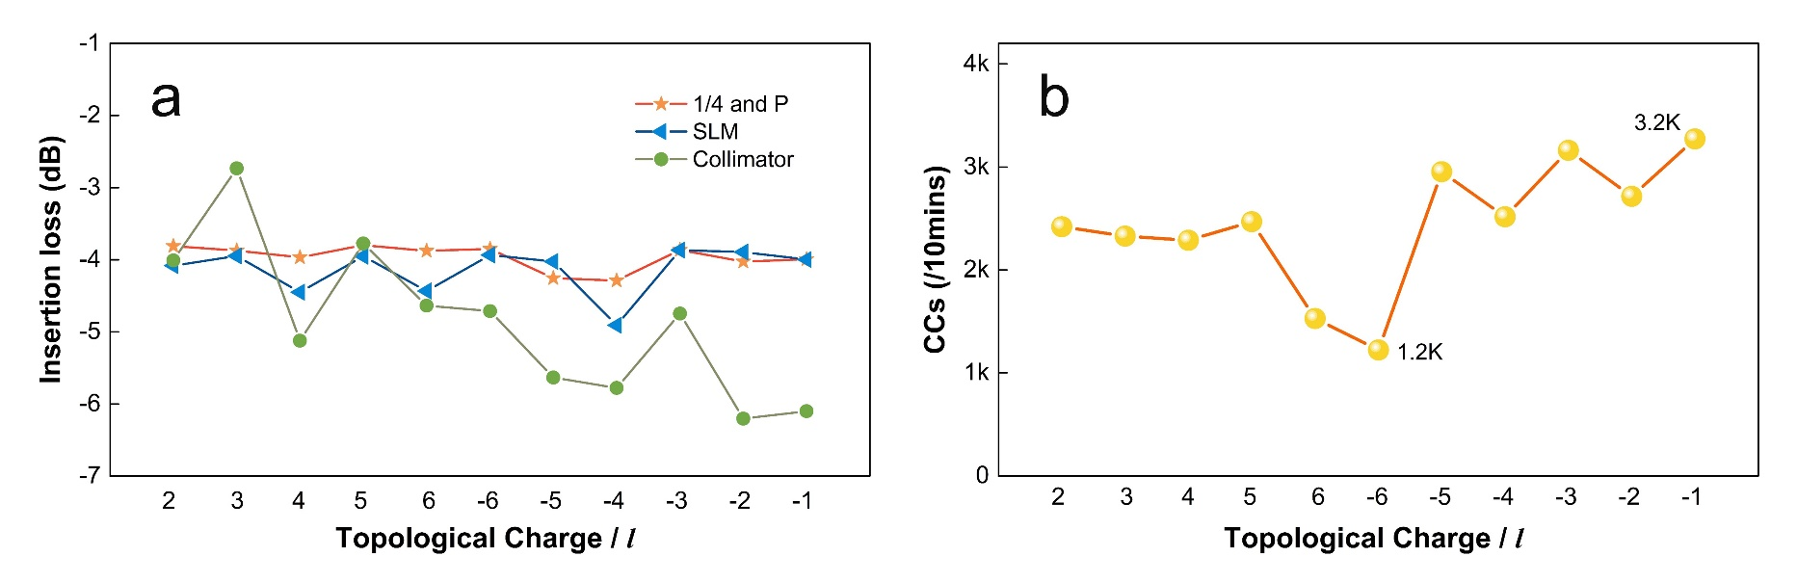
Fig.S6 a. The insertion losses of wave plates, spatial light modulator (SLM) and collimator for 11 OAM modes. b. The estimated coincidence counts (CCs) of heralded single photons after deducting the insertion loss of detection system.
7. Reference
1. Foster, M. A., Moll, K. D. & Gaeta, A. L. Optimal waveguide dimensions for nonlinear interactions. Opt. Express, OE 12, 2880–2887 (2004).
2. Wang, Y. et al. Integrated photonic emitter with a wide switching range of orbital angular momentum modes. Sci Rep 6, 22512 (2016).
3. Allen, L., Beijersbergen, M. W., Spreeuw, R. J. C. & Woerdman, J. P. Orbital angular momentum of light and the transformation of Laguerre-Gaussian laser modes. Phys. Rev. A 45, 8185–8189 (1992).
4. Andrews, D. L. & Babiker, M. The Angular Momentum of Light. (Cambridge University Press, 2012).
5. Inoue, K. & Toba, H. Wavelength conversion experiment using fiber four-wave mixing. IEEE Photonics Technology Letters 4, 69–72 (1992).
6. Foster, M. A. et al. Broad-band optical parametric gain on a silicon photonic chip. Nature 441, 960–963 (2006).
7. Turner, A. C. et al. Tailored anomalous group-velocity dispersion in silicon channel waveguides. Opt. Express 14, 4357 (2006).
8. Harada, K. et al. Frequency and Polarization Characteristics of Correlated Photon-Pair Generation Using a Silicon Wire Waveguide. IEEE Journal of Selected Topics in Quantum Electronics 16, 325–331 (2010).

