Supplementary Information for

Unveiling four decades of intensifying precipitation from tropical cyclones using satellite measurements

Eric J. Shearer, Vesta Afzali Gorooh, Phu Nguyen, Kuo-lin Hsu, Soroosh Sorooshian

Eric J. Shearer
Email: eshearer@uci.edu

This PDF file includes:
Figure S1 to S2

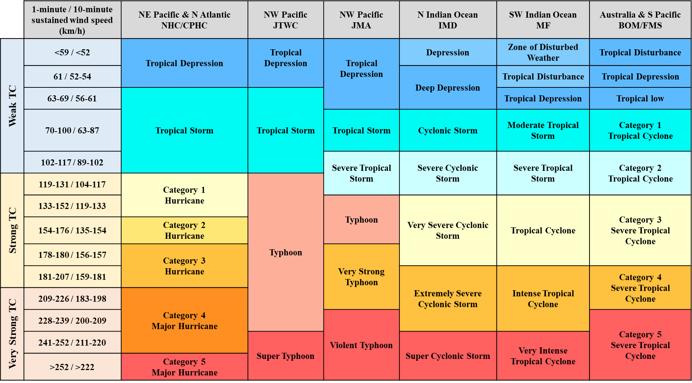
Figure S1. The grading scale used in this paper compared to 1-minute and 10-minute wind speed along with regional meteorological offices’ grading categories.

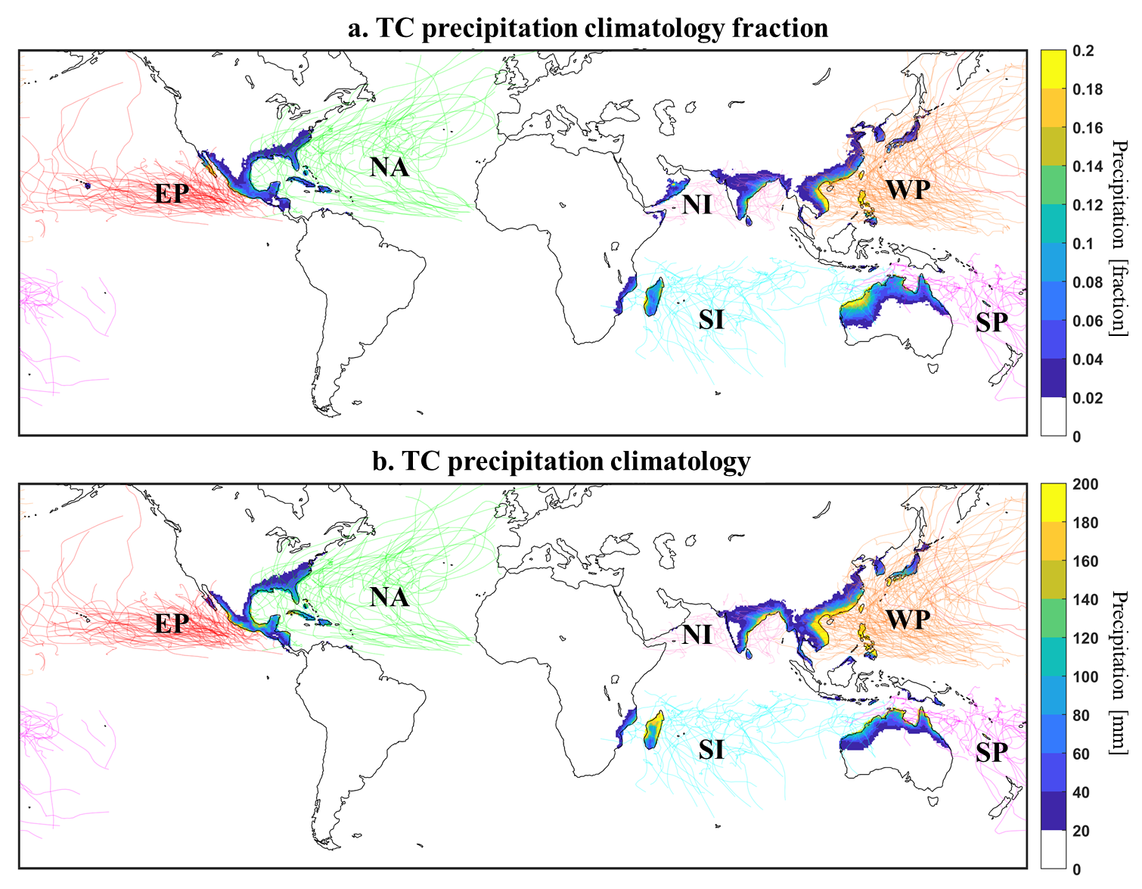
Figure S2. The distribution of landfalling TC precipitation over 1980-2019. a. TC precipitation climatology as a fraction of total precipitation climatology with color-coded lines indicating TC tracks over the 2015-2019 period. b. TC precipitation climatology in mm.

