Table S1. Phylotypes identified as contaminants in the nasopharyngeal microbiota study.
Taxa | CNP  681 | CNP  682 | CPCR  68 | MOCK  68 | Samples  (mean)
p__Proteobacteria;c__Alphaproteobacteria;o__Sphingomonadales;f__Sphingomonadaceae;g__Sphingomonas | 6626 | 1369 | 129 | 0 | 1028
p__Firmicutes;c__Erysipelotrichia;o__Erysipelotrichales;f__Erysipelotrichaceae;g__Holdemanella | 0 | 3031 | 0 | 0 | 686.9
p__Actinobacteria;c__Actinobacteria;o__Corynebacteriales;f__Corynebacteriaceae;g__Corynebacterium 1;D_6__Corynebacterium simulans | 0 | 3397 | 0 | 0 | 414.5
p__Actinobacteria;c__Actinobacteria;o__Corynebacteriales;f__Corynebacteriaceae;g__Corynebacterium | 0 | 126 | 0 | 0 | 381.1
p__Actinobacteria;c__Actinobacteria;o__Propionibacteriales;f__Propionibacteriaceae;g__Cutibacterium | 1223 | 0 | 0 | 0 | 379.7
p__Bacteroidetes;c__Bacteroidia;o__Bacteroidales;f__Rikenellaceae;g__Rikenellaceae RC9 gut group;D_6__metagenome | 2569 | 1487 | 0 | 0 | 263.3
p__Firmicutes;c__Erysipelotrichia;o__Erysipelotrichales;f__Erysipelotrichaceae;g__Holdemanella | 0 | 1253 | 0 | 0 | 251.4
p__Firmicutes;c__Clostridia;o__Clostridiales;f__Ruminococcaceae;g__[Eubacterium] coprostanoligenes group;D_6__Clostridiales bacterium 42_27 | 0 | 1690 | 0 | 0 | 224.7
p__Proteobacteria;c__Gammaproteobacteria;o__Pseudomonadales;f__Moraxellaceae;g__Moraxella | 0 | 0 | 301 | 0 | 191.1
p__Firmicutes;c__Negativicutes;o__Selenomonadales;f__Acidaminococcaceae;g__Phascolarctobacterium | 0 | 776 | 0 | 0 | 109.2
p__Actinobacteria;c__Actinobacteria;o__Propionibacteriales;f__Propionibacteriaceae;g__Cutibacterium | 0 | 599 | 0 | 0 | 90.1
p__Firmicutes;c__Clostridia;o__Clostridiales;f__Ruminococcaceae;g__Subdoligranulum | 0 | 519 | 0 | 0 | 80.4
p__Firmicutes;c__Bacilli;o__Lactobacillales;f__Enterococcaceae;g__Enterococcus | 0 | 366 | 0 | 1072 | 57.1
p__Proteobacteria;c__Gammaproteobacteria;o__Enterobacteriales;f__Enterobacteriaceae;g__Escherichia-Shigella | 438 | 0 | 0 | 2155 | 51
p__Proteobacteria;c__Alphaproteobacteria;o__Rhizobiales;f__Beijerinckiaceae;g__Methylobacterium | 0 | 662 | 0 | 0 | 49.2
p__Firmicutes;c__Bacilli;o__Bacillales;f__Bacillaceae;g__Bacillus | 980 | 0 | 0 | 1557 | 46.7
p__Proteobacteria;c__Gammaproteobacteria;o__Betaproteobacteriales;f__Burkholderiaceae;g__Herbaspirillum | 0 | 191 | 0 | 0 | 46.6
p__Bacteroidetes;c__Bacteroidia;o__Bacteroidales;f__Prevotellaceae;g__Prevotellaceae NK3B31 group;D_6__uncultured Prevotella sp. | 0 | 348 | 0 | 0 | 40.4
p__Proteobacteria;c__Gammaproteobacteria;o__Betaproteobacteriales;f__Burkholderiaceae;g__Pelomonas | 371 | 0 | 0 | 0 | 38.3
p__Firmicutes;c__Negativicutes;o__Selenomonadales;f__Veillonellaceae;g__Allisonella;D_6__uncultured bacterium | 0 | 668 | 0 | 0 | 36.7
p__Proteobacteria;c__Gammaproteobacteria;o__Pseudomonadales;f__Moraxellaceae;g__Enhydrobacter | 0 | 850 | 0 | 0 | 35
p__Bacteroidetes;c__Bacteroidia;o__Bacteroidales;f__Muribaculaceae;g__uncultured Porphyromonadaceae bacterium;D_6__uncultured Porphyromonadaceae bacterium | 0 | 297 | 0 | 0 | 34.3
p__Proteobacteria;c__Alphaproteobacteria;o__Rhizobiales;f__Xanthobacteraceae;g__Bradyrhizobium | 0 | 209 | 0 | 0 | 34.2
p__Firmicutes;c__Negativicutes;o__Selenomonadales;f__Acidaminococcaceae;g__Phascolarctobacterium | 0 | 443 | 0 | 0 | 33.6
p__Firmicutes;c__Clostridia;o__Clostridiales;f__Ruminococcaceae;g__Subdoligranulum | 0 | 712 | 0 | 0 | 32.5
p__Firmicutes;c__Negativicutes;o__Selenomonadales;f__Acidaminococcaceae;g__Phascolarctobacterium | 0 | 420 | 0 | 0 | 32.4
p__Firmicutes;c__Clostridia;o__Clostridiales;f__Ruminococcaceae;g__Ruminococcus2 | 0 | 899 | 0 | 0 | 29.1
p__Proteobacteria;c__Gammaproteobacteria;o__Pseudomonadales;f__Moraxellaceae;g__Acinetobacter | 473 | 0 | 0 | 0 | 24
p__Firmicutes;c__Clostridia;o__Clostridiales;f__Ruminococcaceae;g__Ruminococcaceae NK4A214 group | 0 | 514 | 0 | 0 | 23.8
p__Bacteroidetes;c__Bacteroidia;o__Bacteroidales;f__Prevotellaceae;g__Prevotellaceae UCG-003;D_6__uncultured bacterium | 0 | 271 | 0 | 0 | 23.7
p__Proteobacteria;c__Alphaproteobacteria;o__Azospirillales;f__Azospirillaceae;g__Azospirillum | 0 | 343 | 0 | 0 | 23
p__Proteobacteria;c__Gammaproteobacteria;o__Oceanospirillales;f__Halomonadaceae;g__Halomonas | 0 | 212 | 0 | 0 | 22.9
p__Proteobacteria;c__Gammaproteobacteria;o__Xanthomonadales;f__Xanthomonadaceae;g__Stenotrophomonas | 0 | 542 | 0 | 0 | 21.9
p__Firmicutes;c__Bacilli;o__Lactobacillales;f__Lactobacillaceae;g__Lactobacillus | 0 | 135 | 0 | 4088 | 21.4
p__Proteobacteria;c__Gammaproteobacteria;o__Betaproteobacteriales;f__Burkholderiaceae;g__Pelomonas | 0 | 335 | 0 | 0 | 20.7
p__Firmicutes;c__Clostridia;o__Clostridiales;f__Ruminococcaceae;g__[Eubacterium] coprostanoligenes group;D_6__uncultured bacterium | 0 | 149 | 0 | 0 | 16.4
p__Firmicutes;c__Clostridia;o__Clostridiales;f__Ruminococcaceae;g__Ruminococcaceae UCG-002 | 0 | 349 | 0 | 0 | 15.1
p__Bacteroidetes;c__Bacteroidia;o__Bacteroidales;f__Prevotellaceae;g__Prevotella9 | 0 | 415 | 0 | 0 | 11.4
p__Firmicutes;c__Negativicutes;o__Selenomonadales;f__Acidaminococcaceae;g__Phascolarctobacterium | 0 | 346 | 0 | 0 | 11.1
p__Firmicutes;c__Clostridia;o__Clostridiales;f__Lachnospiraceae;g__Agathobacter | 0 | 53 | 0 | 0 | 10.9
p__Firmicutes;c__Clostridia;o__Clostridiales;f__FamilyXIII;g__FamilyXIII AD3011 group;D_6__uncultured Eubacterium sp. | 0 | 118 | 0 | 0 | 10.2
p__Bacteroidetes;c__Bacteroidia;o__Bacteroidales;f__Rikenellaceae;g__Rikenellaceae RC9 gut group;D_6__uncultured bacterium | 0 | 30 | 0 | 0 | 8.3
p__Proteobacteria;c__Gammaproteobacteria;o__Betaproteobacteriales;f__Burkholderiaceae;g__Curvibacter | 0 | 88 | 0 | 0 | 6.7
Columns present the number of the reads classified as the specific phylotype in the negative controls (CNP681 and CNP682: controls during DNA extraction; CPCR68: control library preparation; MOCK68: positive control mock community for sequencing) and the mean of reads detected in all the samples. Phylotype are identified as its taxonomic classification genus level (species level when the identification was available).

Table S2. Pregnancy and perinatal outcomes in women with and without evidence of SARS-CoV-2 infection

 | SARS-CoV-2  negative  (n=38) |  | SARS-CoV-2 positive  (n=38) | p
Pregnancy outcomes
Iron intake |  | 23 (60.5%) | 13 (34.2%) | 0.022
Antibiotics during pregnancy |  | 3 (7.9%) | 4 (10.5%) | 0.692
Preeclampsia |  | 4 (10.5%) | 0 (0%) | 0.040
Gestational diabetes mellitus |  | 3 (7.9%) | 3 (7.9%) | 1.000
Spontaneous preterm labour |  | 2 (5.3%) | 2 (5.3%) | 1.000
Maternal hospital stay, days |  | 2 (2-3) | 2 (2-3) | 0.894
Delivery outcomes
Induction of labour |  | 18 (47.4%) | 15 (39.5%) | 0.488
Caesarean section |  | 8 (21.1%) | 14 (36.8%) | 0.129
Antibiotics during delivery |  | 14 (36.8) | 14 (36.8) | 1.000
Gestational age at delivery, weeks |  | 39.5 ± 2.2 | 39.5 ± 1.3 | 0.965
Preterm labour |  | 2 (5.3%) | 2 (5.3%) | 1.000
Birth weight, g |  | 3287 ± 575 | 3203 ± 483 | 0.493
Birth weight percentile |  | 46 (26-71) | 39 (13-69) | 0.335
Small-for-gestational age# |  | 5 (13.2%) | 6 (15.8%) | 0.744
Admission to neonatal intensive care unit |  | 4 (10.5%) | 0 (0%) | 0.040
Maternal breastfeeding |  | 35 (92.1%) | 36 (94.7%) | 0.644

Data are n (%) or median (IQR) or mean ± SD.
#Small-for-gestational age defined as birth weight below the 10th centile.
SARS-CoV-2: severe acute respiratory syndrome coronavirus 2 (SARS-CoV-2).

TTable S3. Differences in the nasopharyngeal microbiota at phylum level according to SARS-CoV-2 infection determined by ANCOM test
Phylum | SARS-COV-2 Negative | SARS-COV-2 Positive | clr | W
Firmicutes | 8707 [5278.3- 11625] | 8891.5 [7001- 13646.3] | 0.10 | 3
Proteobacteria | 6915.5 [4428.8- 9807.8] | 6299 [3851.5- 8462] | 0.36 | 2
Actinobacteria | 6662.5 [3807.8- 9557.8] | 4716 [2387.8- 5631.8] | 0.60 | 3
Bacteroidetes | 948 [287.8- 2963.8] | 4795.5 [3109.5- 7729.5] | -1.95 | 29*
Cyanobacteria | 1 [1- 436.8] | 266 [1- 581.3] | -0.86 | 0
Tenericutes | 1 [1- 1] | 109 [10.3- 416.8] | -2.61 | 31*
Fusobacteria | 1 [1- 1] | 1 [1- 431.8] | -1.27 | 0
Patescibacteria | 1 [1- 104.8] | 1 [1- 229.5] | 0.08 | 1
Epsilonbacteraeota | 1 [1- 1] | 1 [1- 167.8] | -0.40 | 0
Acidobacteria | 1 [1- 1] | 1 [1- 1] | 0.49 | 2
Armatimonadetes | 1 [1- 1] | 1 [1- 1] | 0.19 | 2
Chlamydiae | 1 [1- 1] | 1 [1- 1] | 0.15 | 2
Chloroflexi | 1 [1- 1] | 1 [1- 1] | 0.15 | 2
Deinococcus-Thermus | 1 [1- 1] | 1 [1- 1] | -0.25 | 1
Dependentiae | 1 [1- 1] | 1 [1- 1] | 0.31 | 2
FBP | 1 [1- 1] | 1 [1- 1] | 0.05 | 2
Fibrobacteres | 1 [1- 1] | 1 [1- 1] | 0.25 | 2
Gemmatimonadetes | 1 [1- 1] | 1 [1- 1] | 0.13 | 2
Halanaerobiaeota | 1 [1- 1] | 1 [1- 1] | 0.34 | 2
Kiritimatiellaeota | 1 [1- 1] | 1 [1- 1] | 0.48 | 2
Latescibacteria | 1 [1- 1] | 1 [1- 1] | 0.38 | 2
Margulisbacteria | 1 [1- 1] | 1 [1- 1] | 0.12 | 2
Nitrospirae | 1 [1- 1] | 1 [1- 1] | 0.39 | 2
Planctomycetes | 1 [1- 1] | 1 [1- 1] | 0.58 | 2
Spirochaetes | 1 [1- 1] | 1 [1- 1] | -0.10 | 1
Synergistetes | 1 [1- 1] | 1 [1- 1] | -0.05 | 2
TA06 | 1 [1- 1] | 1 [1- 1] | 0.30 | 2
Verrucomicrobia | 1 [1- 1] | 1 [1- 1] | 0.78 | 2
Zixibacteria | 1 [1- 1] | 1 [1- 1] | 0.31 | 2
Unclassified | 1 [1- 1] | 1 [1- 1] | 0.33 | 2

Columns NEG and POS present the median and the interquartile range (median [IQR]) of the reads classified as the specific taxa in both categories, respectively. Taxa with significant differences assessed by ANCOM test are marked in bold.

Table S4. Differences in the nasopharyngeal microbiota at genus level according to SARS-CoV-2 infection determined by ANCOM test
Taxa | SARS-CoV-2 Negative | SARS-CoV-2 Positive | clr | W
k_Bacteria;p_Firmicutes;c_Clostridia;o_Clostridiales;f_Family XI;g_Peptoniphilus | 91 [1-855.3] | 1 [1-226] | -1.12 | 19
k_Bacteria;p_Proteobacteria;c_Alphaproteobacteria;o_Azospirillales;f_Azospirillaceae;g_Azospirillum | 8 [1-170.3] | 126 [1-169.8] | 0.63 | 4
k_Bacteria;p_Actinobacteria;c_Actinobacteria;o_Corynebacteriales;f_Corynebacteriaceae;g_Lawsonella | 68 [1-541.5] | 98.5 [1-365.5] | -0.53 | 11
k_Bacteria;p_Proteobacteria;c_Alphaproteobacteria;o_Rhizobiales;f_Beijerinckiaceae;g_Methylobacterium | 62 [1-284.5] | 65 [14-229] | 0.00 | 15
k_Bacteria;p_Proteobacteria;c_Gammaproteobacteria;o_Oceanospirillales;f_Halomonadaceae;g_Halomonas | 60 [7.3-328.75] | 103 [28.5-297.8] | 0.00 | 13
k_Bacteria;p_Firmicutes;c_Bacilli;o_Lactobacillales;f_Enterococcaceae;g_Enterococcus | 57.5 [1-172] | 99.5 [19-157.8] | 0.62 | 6
k_Bacteria;p_Firmicutes;c_Clostridia;o_Clostridiales;f_Family XI;g_Anaerococcus | 53 [1-734] | 63.5 [1-324.8] | -0.54 | 12
k_Bacteria;p_Proteobacteria;c_Gammaproteobacteria;o_Betaproteobacteriales;f_Burkholderiaceae;g_Massilia | 43.5 [1-164.3] | 73 [31.5-232] | 0.42 | 10
k_Bacteria;p_Actinobacteria;c_Actinobacteria;o_Propionibacteriales;f_Propionibacteriaceae;g_Cutibacterium | 425 [133-776] | 528.5 [298.8-855.3] | 0.20 | 17
k_Bacteria;p_Proteobacteria;c_Gammaproteobacteria;o_Pseudomonadales;f_Pseudomonadaceae;g_Pseudomonas | 412.5 [23.5-938.5] | 390 [230.8-717.8] | 1.05 | 4
k_Bacteria;p_Actinobacteria;c_Actinobacteria;o_Corynebacteriales;f_Corynebacteriaceae;g_Corynebacterium 1 | 4004 [1560.5-7077.5] | 2310 [1185.3-3777] | -0.56 | 20
k_Bacteria;p_Proteobacteria;c_Gammaproteobacteria;o_Enterobacteriales;f_Enterobacteriaceae;g_Escherichia-Shigella | 29.5 [1-92] | 7.5 [1-110] | -0.56 | 19
k_Bacteria;p_Firmicutes;c_Bacilli;o_Lactobacillales;f_Streptococcaceae;g_Streptococcus | 276 [8-716.75] | 399 [57-833.8] | 0.35 | 4
k_Bacteria;p_Proteobacteria;c_Gammaproteobacteria;o_Betaproteobacteriales;f_Burkholderiaceae;g_Pelomonas | 18 [1-83.3] | 104 [1-273.3] | 1.03 | 4
k_Bacteria;p_Proteobacteria;c_Gammaproteobacteria;o_Betaproteobacteriales;f_Neisseriaceae;g_uncultured | 178.5 [1-1082.8] | 134.5 [1-910.8] | -0.66 | 10
k_Bacteria;p_Proteobacteria;c_Alphaproteobacteria;o_Rhizobiales;f_Xanthobacteraceae;g_Bradyrhizobium | 161 [38-331.5] | 239 [77.8-408] | 0.32 | 12
k_Bacteria;p_Firmicutes;c_Bacilli;o_Bacillales;f_Staphylococcaceae;g_Staphylococcus | 1594 [625.3-4686.3] | 1633 [639.5-2668] | -0.02 | 14
k_Bacteria;p_Proteobacteria;c_Gammaproteobacteria;o_Pseudomonadales;f_Moraxellaceae;g_Acinetobacter | 139.5 [9.3-273.3] | 115 [9.8-261.5] | -0.21 | 13
k_Bacteria;p_Proteobacteria;c_Alphaproteobacteria;o_Sphingomonadales;f_Sphingomonadaceae;g_Sphingomonas | 1148 [401.3-2147.8] | 1449.5 [1040.8-1815.8] | 0.38 | 16
k_Bacteria;p_Firmicutes;c_Clostridia;o_Clostridiales;f_Ruminococcaceae;g_[Eubacterium] coprostanoligenes group | 10.5 [1-125.3] | 420.5 [180.5-929.3] | 3.14 | 724
k_Bacteria;p_Proteobacteria;c_Alphaproteobacteria;o_Sphingomonadales;f_Sphingomonadaceae;g_Sphingobium | 1 [1-96.5] | 51 [1-197] | 0.37 | 6
k_Bacteria;p_Firmicutes;c_Clostridia;o_Clostridiales;f_Ruminococcaceae;g_Ruminococcaceae UCG-014 | 1 [1-94.5] | 205.5 [107.5-330.8] | 2.74 | 686
k_Bacteria;p_Firmicutes;c_Bacilli;o_Bacillales;f_Bacillaceae;g_Anaerobacillus | 1 [1-80.5] | 13 [1-92] | 0.07 | 8
k_Bacteria;p_Zixibacteria;c_uncultured bacterium;o_uncultured bacterium;f_uncultured bacterium;g_uncultured | 1 [1-8] | 1 [1-1] | -0.22 | 21
k_Bacteria;p_Proteobacteria;c_Gammaproteobacteria;o_Betaproteobacteriales;f_Burkholderiaceae;g_Herbaspirillum | 1 [1-74.8] | 57 [1-189.5] | 0.69 | 4
k_Bacteria;p_Proteobacteria;c_Gammaproteobacteria;o_Pasteurellales;f_Pasteurellaceae;g_Haemophilus | 1 [1-71.5] | 1 [1-253.8] | 0.54 | 5
k_Bacteria;p_Actinobacteria;c_Actinobacteria;o_Actinomycetales;f_Actinomycetaceae;g_Actinomyces | 1 [1-7] | 1 [1-40] | 0.01 | 12
k_Bacteria;p_Firmicutes;c_Clostridia;o_Clostridiales;f_Ruminococcaceae;g_Faecalibacterium | 1 [1-49.8] | 320 [165.8-555.5] | 3.49 | 748
k_Bacteria;p_Proteobacteria;c_Alphaproteobacteria;o_Rhodobacterales;f_Rhodobacteraceae;g_Paracoccus | 1 [1-48.5] | 1 [1-117.3] | 0.31 | 8
k_Bacteria;p_Cyanobacteria;c_Oxyphotobacteria;o_Chloroplast;__;__ | 1 [1-43] | 1 [1-320.5] | 0.79 | 2
k_Bacteria;p_Firmicutes;c_Clostridia;o_Clostridiales;f_Ruminococcaceae;g_Ruminococcaceae UCG-002 | 1 [1-40.3] | 78 [3-232.8] | 1.53 | 1
k_Bacteria;p_Firmicutes;c_Negativicutes;o_Selenomonadales;f_Veillonellaceae;g_Veillonella | 1 [1-4.8] | 1 [1-208.8] | 1.04 | 1
k_Bacteria;p_Firmicutes;c_Erysipelotrichia;o_Erysipelotrichales;f_Erysipelotrichaceae;g_Catenibacterium | 1 [1-30.3] | 1 [1-49.8] | -0.11 | 13
k_Bacteria;p_Proteobacteria;c_Gammaproteobacteria;o_Enterobacteriales;f_Enterobacteriaceae;g_Serratia | 1 [1-30.3] | 1 [1-64] | 0.05 | 12
k_Bacteria;p_Firmicutes;c_Bacilli;o_Lactobacillales;f_Lactobacillaceae;g_Lactobacillus | 1 [1-3.3] | 46 [1-163.3] | 1.42 | 4
k_Bacteria;p_Proteobacteria;c_Gammaproteobacteria;o_Betaproteobacteriales;f_Neisseriaceae;g_Neisseria | 1 [1-27.3] | 1 [1-74.8] | 0.02 | 7
k_Bacteria;p_Firmicutes;c_Clostridia;o_Clostridiales;f_Ruminococcaceae;g_Ruminococcaceae NK4A214 group | 1 [1-23.3] | 49.5 [1-127.3] | 1.25 | 5
k_Bacteria;Unclassified | 1 [1-21] | 1 [1-17] | -0.25 | 21
k_Bacteria;p_Bacteroidetes;c_Bacteroidia;o_Bacteroidales;f_Prevotellaceae;g_Alloprevotella | 1 [1-21.3] | 17 [1-273.8] | 1.03 | 1
k_Bacteria;p_Firmicutes;c_Erysipelotrichia;o_Erysipelotrichales;f_Erysipelotrichaceae;g_Solobacterium | 1 [1-17] | 1 [1-69] | 0.59 | 7
k_Bacteria;p_Bacteroidetes;c_Bacteroidia;o_Bacteroidales;f_Prevotellaceae;g_Prevotella 1 | 1 [1-168.5] | 682 [282-1075.5] | 3.42 | 729
k_Bacteria;p_Firmicutes;c_Bacilli;o_Lactobacillales;f_Carnobacteriaceae;g_Dolosigranulum | 1 [1-1377.8] | 1 [1-1008.5] | -0.01 | 3
k_Bacteria;p_Bacteroidetes;c_Bacteroidia;o_Bacteroidales;f_Prevotellaceae;g_Prevotella 7 | 1 [1-132] | 1 [1-154.5] | -0.19 | 9
k_Bacteria;p_Firmicutes;c_Bacilli;o_Bacillales;f_Bacillaceae;g_Bacillus | 1 [1-126] | 36 [1-118] | 0.10 | 13
k_Bacteria;p_Bacteroidetes;c_Bacteroidia;o_Bacteroidales;f_Rikenellaceae;g_Rikenellaceae RC9 gut group | 1 [1-122.5] | 377 [191.5-661.5] | 3.08 | 714
k_Bacteria;p_Bacteroidetes;c_Bacteroidia;o_Bacteroidales;f_Prevotellaceae;g_Prevotella | 1 [1-121] | 1 [1-128.5] | -0.18 | 8
k_Bacteria;p_Firmicutes;c_Erysipelotrichia;o_Erysipelotrichales;f_Erysipelotrichaceae;g_Erysipelothrix | 1 [1-110] | 38 [1-104.5] | 0.17 | 9
k_Bacteria;p_Proteobacteria;c_Gammaproteobacteria;o_Pseudomonadales;f_Moraxellaceae;g_Moraxella | 1 [1-1015] | 1 [1-72.5] | -0.73 | 14
k_Bacteria;p_Proteobacteria;c_Gammaproteobacteria;o_Enterobacteriales;f_Enterobacteriaceae;__ | 1 [1-10.8] | 1 [1-1] | -0.60 | 20
k_Bacteria;p_Bacteroidetes;c_Bacteroidia;o_Bacteroidales;f_Muribaculaceae;g_uncultured Porphyromonadaceae | 1 [1-1] | 477.5 [218.3-914] | 4.43 | 757
k_Bacteria;p_Bacteroidetes;c_Bacteroidia;o_Bacteroidales;f_Tannerellaceae;g_Parabacteroides | 1 [1-1] | 368 [107.5-624.8] | 4.41 | 757
k_Bacteria;p_Firmicutes;c_Clostridia;o_Clostridiales;f_Lachnospiraceae;g_[Ruminococcus] torques group | 1 [1-1] | 402 [160.3-1049.8] | 4.34 | 757
k_Bacteria;p_Bacteroidetes;c_Bacteroidia;o_Bacteroidales;f_Muribaculaceae;g_uncultured bacterium | 1 [1-1] | 354.5 [136.5-590.5] | 4.01 | 756
k_Bacteria;p_Firmicutes;c_Negativicutes;o_Selenomonadales;f_Acidaminococcaceae;g_Phascolarctobacterium | 1 [1-1] | 391 [92.5-929.5] | 4.02 | 756
k_Bacteria;p_Bacteroidetes;c_Bacteroidia;o_Bacteroidales;f_Prevotellaceae;g_Prevotellaceae NK3B31 group | 1 [1-1] | 296.5 [27-469.5] | 3.60 | 751
k_Bacteria;p_Actinobacteria;c_Coriobacteriia;o_Coriobacteriales;f_Coriobacteriaceae;g_Collinsella | 1 [1-1] | 151.5 [67.3-302.5] | 3.42 | 750
k_Bacteria;p_Firmicutes;c_Negativicutes;o_Selenomonadales;f_Veillonellaceae;g_Allisonella | 1 [1-1] | 156 [68.5-321] | 3.41 | 748
k_Bacteria;p_Firmicutes;c_Clostridia;o_Clostridiales;f_Ruminococcaceae;g_Subdoligranulum | 1 [1-1] | 132.5 [64.3-235.3] | 3.38 | 747
k_Bacteria;p_Bacteroidetes;c_Bacteroidia;o_Bacteroidales;f_Prevotellaceae;__ | 1 [1-1] | 335 [30.3-601.8] | 3.43 | 746
k_Bacteria;p_Firmicutes;c_Clostridia;o_Clostridiales;f_Ruminococcaceae;g_Ruminococcus 2 | 1 [1-1] | 225 [41.3-442.3] | 3.34 | 743
k_Bacteria;p_Firmicutes;c_Clostridia;o_Clostridiales;f_Lachnospiraceae;__ | 1 [1-1] | 130.5 [42.3-273.8] | 2.89 | 715
k_Bacteria;p_Bacteroidetes;c_Bacteroidia;o_Bacteroidales;f_Prevotellaceae;g_Prevotella 9 | 1 [1-1] | 282.5 [1-919.8] | 3.02 | 698
k_Bacteria;p_Firmicutes;c_Clostridia;o_Clostridiales;f_Family XIII;g_Family XIII AD3011 group | 1 [1-1] | 71 [1-174.3] | 2.53 | 675
k_Bacteria;p_Firmicutes;c_Erysipelotrichia;o_Erysipelotrichales;f_Erysipelotrichaceae;g_Holdemanella | 1 [1-1] | 138 [10.5-333.5] | 2.77 | 674
k_Bacteria;p_Firmicutes;c_Clostridia;o_Clostridiales;f_Ruminococcaceae;__ | 1 [1-1] | 32 [1-78.3] | 1.73 | 431
k_Bacteria;p_Firmicutes;c_Negativicutes;o_Selenomonadales;f_Veillonellaceae;g_Anaerovibrio | 1 [1-1] | 1 [1-18.3] | 0.88 | 12
k_Bacteria;p_Firmicutes;c_Negativicutes;o_Selenomonadales;f_Veillonellaceae;g_Megasphaera | 1 [1-1] | 1 [1-49.3] | 0.57 | 12
k_Bacteria;p_Firmicutes;c_Clostridia;o_Clostridiales;f_Peptostreptococcaceae;__ | 1 [1-1] | 1 [1-29.3] | 0.90 | 11
k_Bacteria;p_Firmicutes;c_Clostridia;o_Clostridiales;f_Ruminococcaceae;g_Ruminococcaceae UCG-010 | 1 [1-1] | 1 [1-16.8] | 0.61 | 11
k_Bacteria;p_Firmicutes;c_Clostridia;o_Clostridiales;f_Lachnospiraceae;g_Lachnospiraceae FCS020 group | 1 [1-1] | 1 [1-67.3] | 1.33 | 10
k_Bacteria;p_Firmicutes;c_Clostridia;o_Clostridiales;__;__ | 1 [1-1] | 1 [1-37] | 1.09 | 9
k_Bacteria;p_Proteobacteria;c_Alphaproteobacteria;o_Rickettsiales;f_Mitochondria;__ | 1 [1-1] | 1 [1-13] | 0.61 | 9
k_Bacteria;p_Bacteroidetes;c_Bacteroidia;o_Bacteroidales;f_Prevotellaceae;g_uncultured | 1 [1-1] | 1 [1-61] | 0.82 | 8
k_Bacteria;p_Firmicutes;c_Clostridia;o_Clostridiales;f_Ruminococcaceae;g_Ruminococcaceae UCG-005 | 1 [1-1] | 1 [1-32.5] | 0.84 | 7
k_Bacteria;p_Tenericutes;c_Mollicutes;o_Mollicutes RF39;f_uncultured bacterium;g_uncultured bacterium | 1 [1-1] | 1 [1-31.5] | 1.10 | 7
k_Bacteria;p_Proteobacteria;c_Alphaproteobacteria;o_Caulobacterales;f_Caulobacteraceae;g_Brevundimonas | 1 [1-1] | 1 [1-85] | 0.81 | 6
k_Bacteria;p_Proteobacteria;c_Gammaproteobacteria;o_Betaproteobacteriales;f_Burkholderiaceae;g_Aquabacterium | 1 [1-1] | 1 [1-43.8] | 0.61 | 6
k_Bacteria;p_Proteobacteria;c_Gammaproteobacteria;o_Betaproteobacteriales;f_Burkholderiaceae;g_Curvibacter | 1 [1-1] | 1 [1-52.5] | 0.83 | 6
k_Bacteria;p_Tenericutes;c_Mollicutes;o_Mollicutes RF39;__;__ | 1 [1-1] | 1 [1-59] | 1.24 | 6
k_Bacteria;p_Epsilonbacteraeota;c_Campylobacteria;o_Campylobacterales;f_Campylobacteraceae;g_Campylobacter | 1 [1-1] | 1 [1-167.8] | 0.48 | 5
k_Bacteria;p_Proteobacteria;c_Gammaproteobacteria;o_Betaproteobacteriales;f_Burkholderiaceae;g_Ralstonia | 1 [1-1] | 1 [1-55.8] | 0.72 | 5
k_Bacteria;p_Bacteroidetes;c_Bacteroidia;o_Bacteroidales;f_Porphyromonadaceae;g_Porphyromonas | 1 [1-1] | 1 [1-109] | 0.39 | 4
k_Bacteria;p_Proteobacteria;c_Gammaproteobacteria;o_Pseudomonadales;f_Moraxellaceae;g_Enhydrobacter | 1 [1-1] | 1 [1-66.5] | 0.72 | 4
k_Bacteria;p_Tenericutes;c_Mollicutes;o_Mollicutes RF39;f_gut metagenome;g_gut metagenome | 1 [1-1] | 1 [1-96.5] | 1.45 | 4
k_Bacteria;p_Firmicutes;c_Clostridia;o_Clostridiales;f_Lachnospiraceae;g_Coprococcus 3 | 1 [1-1] | 36.5 [1-131.8] | 1.45 | 3
k_Bacteria;p_Fusobacteria;c_Fusobacteriia;o_Fusobacteriales;f_Fusobacteriaceae;g_Fusobacterium | 1 [1-1] | 1 [1-151.8] | 0.50 | 3
k_Bacteria;p_Fusobacteria;c_Fusobacteriia;o_Fusobacteriales;f_Leptotrichiaceae;g_Leptotrichia | 1 [1-1] | 1 [1-176.8] | 1.08 | 3
k_Bacteria;p_Proteobacteria;c_Gammaproteobacteria;o_Xanthomonadales;f_Xanthomonadaceae;g_Stenotrophomonas | 1 [1-1] | 1 [1-128.8] | 1.01 | 3
k_Bacteria;p_Firmicutes;c_Clostridia;o_Clostridiales;f_Lachnospiraceae;g_Agathobacter | 1 [1-1] | 1 [1-80.3] | 1.52 | 16
k_Bacteria;p_Firmicutes;c_Erysipelotrichia;o_Erysipelotrichales;f_Erysipelotrichaceae;g_uncultured | 1 [1-1] | 1 [1-42.3] | 1.25 | 16
k_Bacteria;p_Firmicutes;c_Negativicutes;o_Selenomonadales;f_Veillonellaceae;g_Selenomonas | 1 [1-1] | 1 [1-18.3] | 0.64 | 15
k_Bacteria;p_Actinobacteria;c_Coriobacteriia;o_Coriobacteriales;f_Atopobiaceae;g_uncultured | 1 [1-1] | 1 [1-13.3] | 0.82 | 13
k_Bacteria;p_Actinobacteria;c_Coriobacteriia;o_Coriobacteriales;f_Eggerthellaceae;g_uncultured | 1 [1-1] | 1 [1-8.5] | 0.69 | 13

Only those genera with an interquartile range>1 for at least one of the studied categories (Positive and Negative) are shown. Columns Positive and Negative present the median and the interquartile range (median [IQR]) of the reads classified as the specific taxa in both categories, respectively. Taxa with significant differences assessed by ANCOM test are marked in bold.

SUPPLEMENTARY FIGURES
A)
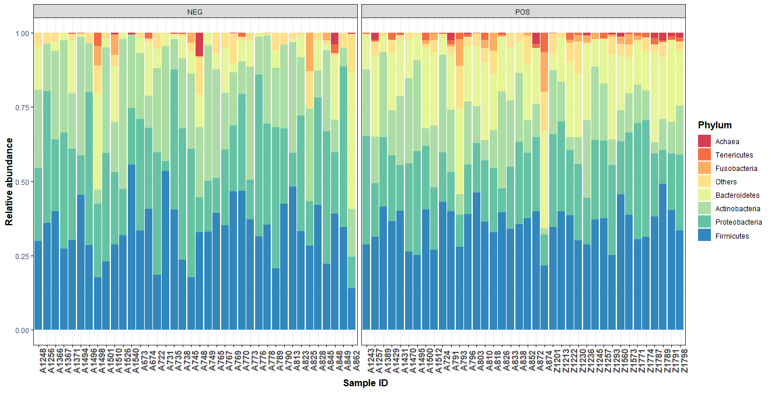
B)
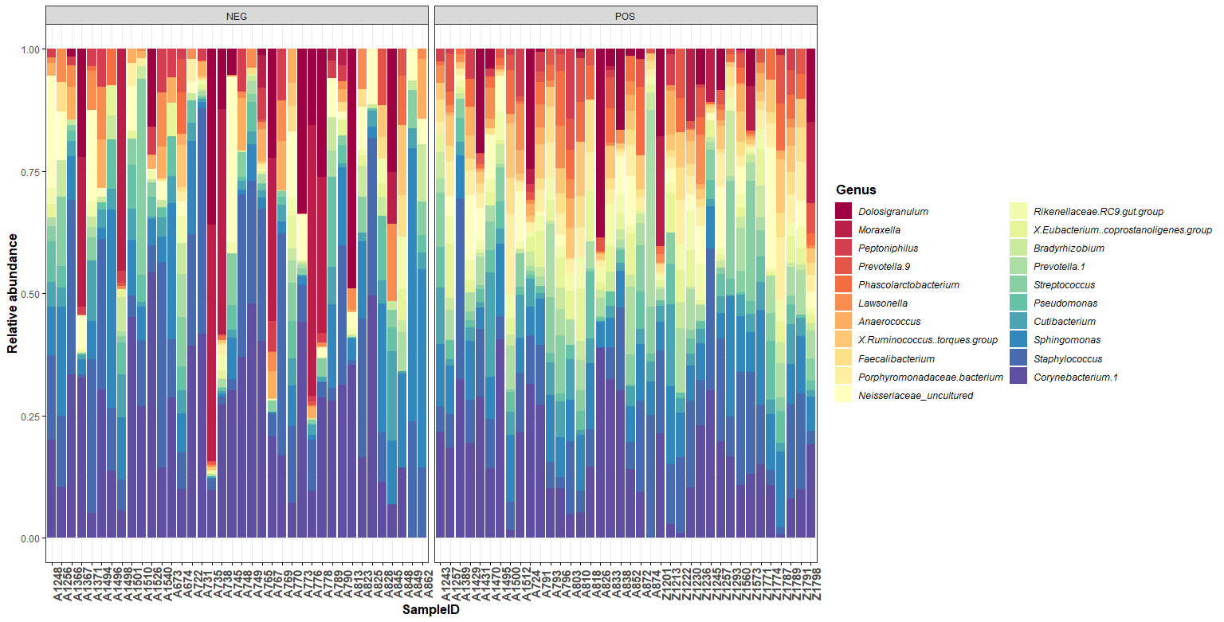
Figure S1. Description of nasopharyngeal microbiota at phylum (A) and genus level (B) from the studied population classified according their result for SARS-CoV-2 infection. At phylum level, those phyla with a relative abundance lower than 0.5% and Cyanobacteria were grouped as “Others”. Only those genera with a relative abundance higher than 0.1% are shown in figure. POS: Positive SARS-CoV-2 infection, NEG: Negative SARS-CoV-2 infection.

A)
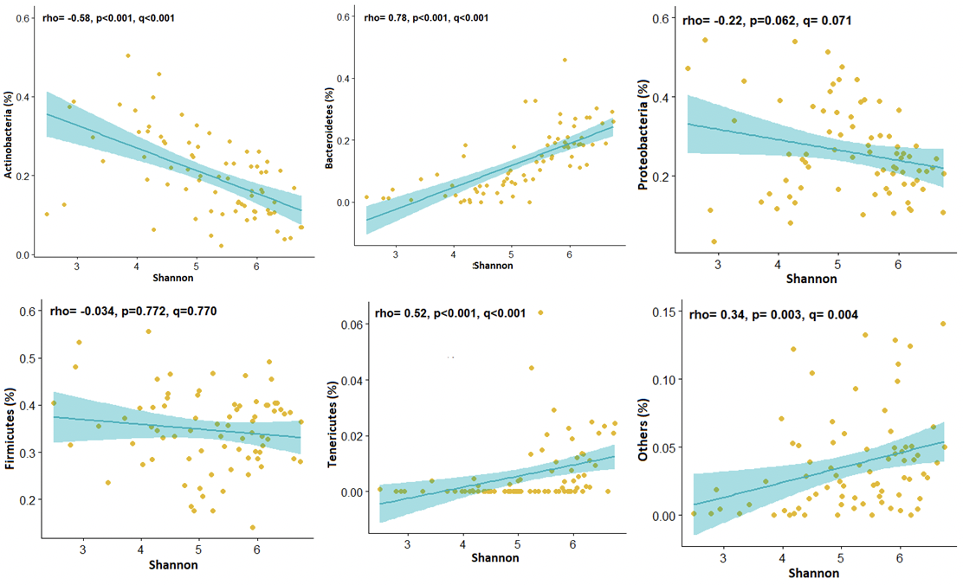
B)
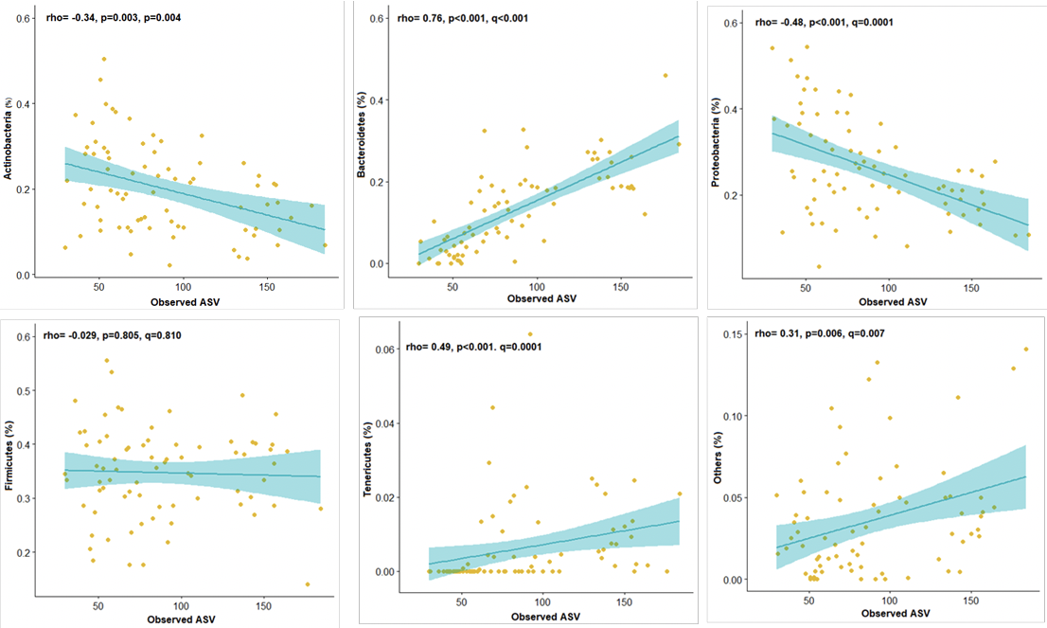
Figure S2. Scatter plots of the Spearman correlations between the relative abundance of the nasopharingeal microbial phyla and both alpha-diversity index, Shannon index (A) and Observed ASV (B). One outlayer point was removed for ploting (Observed ASV) after testing that the significant correlations were not affected by this individual.
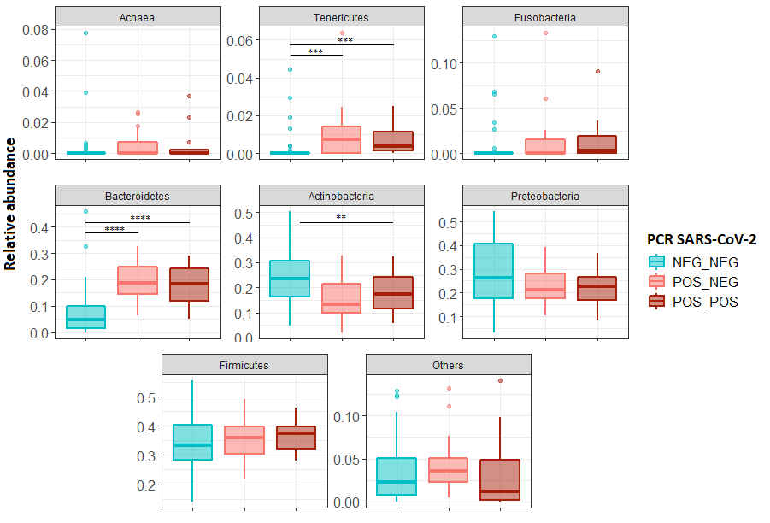
Figure S3. Differences in nasopharyngeal microbial phyla between those mothers with positive and negative (positive by serological determination) result for SARS-CoV-2 infection. At phylum level, those phyla with a relative abundance lower tan 0.5 and Cyanobacteria were grouped as “Others” but considered individually for all statistical analysis. POS_POS: Positive result for the serological determination and also for RT-PCR of SARS-CoV-2 (active infection); POS_NEG: Positive result in the serological determination and negative for for RT-PCR of SARS-CoV-2 (past infection); NEG-NEG: Negative result for serological determination and also for RT-PCR of SARS-CoV-2. Significance of the differences between groups were assessed by Kruskal-Wallis test followed by a post-hoc Conover's Test of multiple comparisons. *p<0.05, ** p<0.01, ***p<0.001, **** p<0.0001
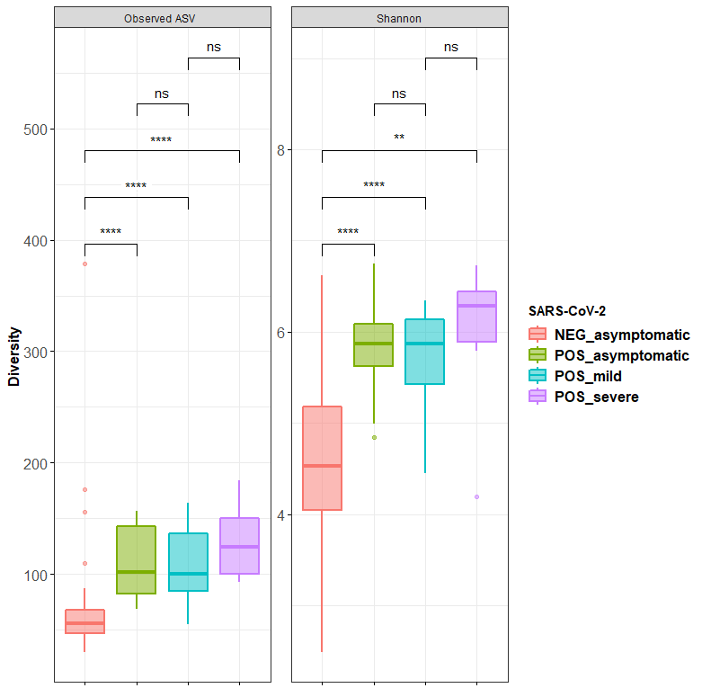
Figure S4. Nasopharyngeal microbiota alpha diversity measured as Observed ASV (richness) and Shannon (diversity) index according to the severity of the SARS-CoV-2 infection symptomatology. Significance of the differences between groups were assessed by Kruskal- Wallis test followed by a post-hoc Conover's Test of multiple comparisons. *p<0.05, ** p<0.01, ***p<0.001, **** p<0.0001.

