Supplementary Information
Attosecond Optical Switching

Author list
Dandan Hui^{1†}, Husain Alqattan^{1†}, Simin Zhang², Vladimir Pervak³, Enam Chowdhury², Mohammed Th. Hassan*¹.

Affiliations
¹ Department of Physics, University of Arizona, Tucson, AZ 85721, USA.
² Department of Material Science and Engineering, The Ohio State University, Columbus, OH 43210, USA.
³ Ludwig-Maximilians-Universität München, Am Coulombwall 1, 85748, Garching, Germany.

*Correspondence to: mohammedhassan@arizona.edu
†These authors contributed equally to this work.
The pump pulse utilized to induce the attosecond optical switching in dielectric fused silica

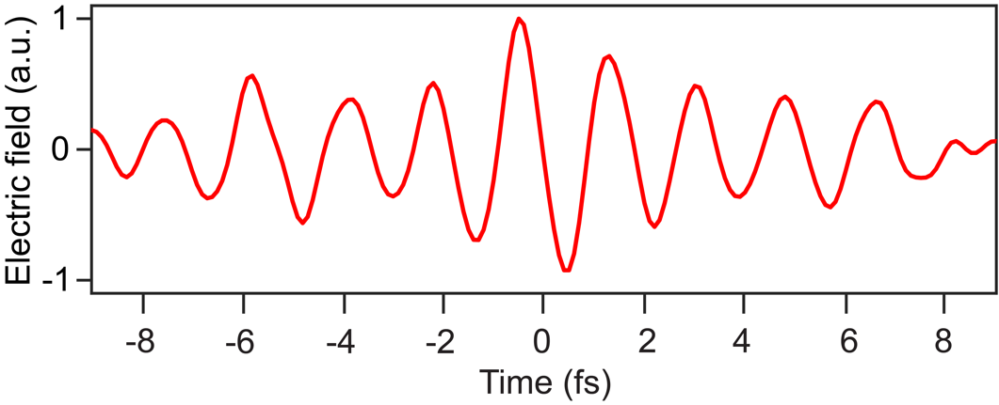
We utilized the measured spectrogram in Fig. 2a to retrieve the electric field of the pump pulse from the TRM depreciated in Fig. 2c as we previously demonstrated in Ref 9 in the main text.
Fig. S1. The retrieved driver electric field from the TRM trace (shown in Fig. 2c in main text) used to induces the phase transition and the reflectivity modulation shown in Fig. 2a in main text. This field has been also used in the simulation presented in Fig. 3c&d.

The simple model to calculate the fused silica reflectivity modulation in strong field.
Seven resonators are used in Eqs. 9 and 10 for each to model the multiple-resonance effect and temporal oscillation in Fig. 3a. The modeling parameters are listed in Table 1 and Table 2 for $χ_{2}'$ and $χ_{1}'$, respectively.
Table 1. Parameter for calculation of $χ_{2}'$ (C=0.9)
Resonance | 1 | 2 | 3 | 4 | 5 | 6 | 7
Photon energy (eV) | 3.49 | 3.02 | 2.50 | 2.18 | 1.94 | 1.64 | 1.38
Photon number | 3 | 4 | 4 | 5 | 5 | 6 | 7
MPI energy (eV) | 10.47 | 12.08 | 10.00 | 10.90 | 9.70 | 9.84 | 9.66
f_{j} | 0.0227 | 0.0102 | 0.0079 | 0.0027 | 0.0023 | 0.0034 | 0.0018
Γ_{i} ($×$10¹⁴ s⁻¹) | 4.0 | 4.0 | 2.5 | 2.0 | 2.0 | 2.0 | 2.0

Table 2. Parameter for calculation of $χ_{1}'$
Resonance | 1 | 2 | 3 | 4 | 5 | 6 | 7
Photon energy (eV) | 3.49 | 2.88 | 2.50 | 2.18 | 1.94 | 1.64 | 1.38
Photon number | 3 | 4 | 4 | 5 | 5 | 6 | 7
MPI energy (eV) | 10.47 | 11.52 | 10.00 | 10.90 | 9.70 | 9.84 | 9.66
f_{k} ($×$10⁻⁴) | 5.48 | 3.99 | 3.99 | 2.49 | 1.99 | 1.99 | 1.20
Γ_{k} ($×$10¹⁴ s⁻¹) | 4.0 | 4.0 | 2.5 | 2.0 | 2.0 | 2.0 | 2.0

Fig. 3a suggests that the asymmetry in reflectivity oscillation across the spectrum very likely originates from the phase drift of each frequency component of the pump pulse. This is because Eq. 10 is the only term in Eq. 9 that can introduce an oscillation to the reflectivity, and Eq. 10 is associated with the phase of each monochromatic wave that comprises the ultrashort pump pulse.
The calculate spectrogram based on the multiple resonances shows the main reflectivity modulation. Although, the asymmetry features are not captured. These features may attribute due to the relative phases between photons with different frequencies in the pump pulse which represents the spectral phase of this pump pulse.
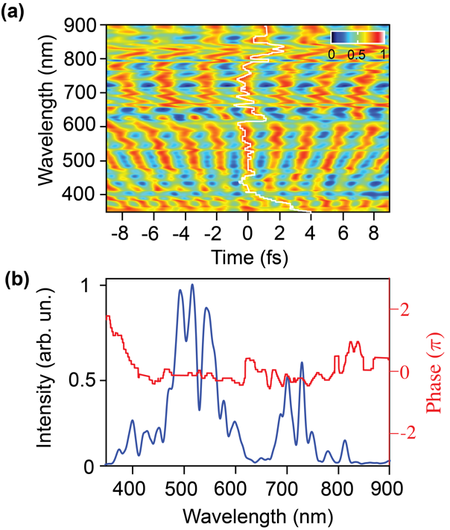
Fig. S2 (a) Normalized measured spectrogram shown in Fig. 3 in the main text. The white line trace shows the spectral phase effect on the reflectivity modulation (b) The measured spectra (solid blue curve) and the retrieved spectral phase from (a) is plotted in redline.
Accordingly, we extracted the spectral phase (white trace white line) from the normalized measured spectrogram (Fig. 3a) which is shown in Fig. S2a. The extracted spectral phase is shown in Fig. S2b in contrast with the pump pulse spectrum. The fitting calculated spectrogram considering the effect of the pump spectral phase (as shown in Fig. 3c, d) capture all the reflectivity modulation and in a good a agreement with the measured spectrogram in Fig. 2a, b.
Ultrafast optical information encoding application
The potential scheme for ultrafast data encoding is shown in Fig. S3. The input data in the binary form (0 &1) will be sent to the light field synthesizer or the pulse shaper (encoder unit) device to tailor the field accordingly and encode the input data on the light field. The laser beam travels from the coder to the decoder unit. The data will be decoded based on measuring the reflectivity modulation of the dielectric.
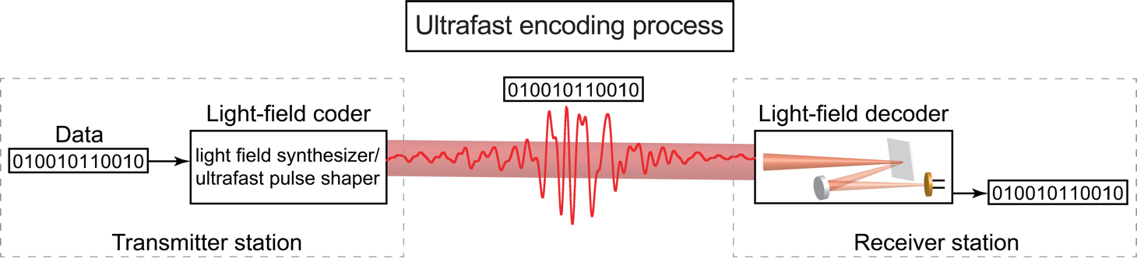
Fig. S3. Schematic of potential ultrafast light field encoding process exploiting the demonstrated optical switch with synthesized waveforms.

References:

1. A. B. Djurišić and E. H. Li, "Modeling the index of refraction of insulating solids with a modified lorentz oscillator model," Appl. Opt. 37(22), 5291 (1998).

