Raw data of blots May 24, 2020
BMC Developmental Biology
Dynamic Conversion of Cell Sorting Patterns in Aggregates of Embryonic Stem Cells with Differential Adhesive Affinity
Jeffrey D. Tse, Robert Moore, Yue Meng, Wensi Tao, Elizabeth R. Smith, and Xiang-Xi Xu⁺

Both figures were composed of blots using the same respective cell culture experiment. Lane/well loadings were kept constant throughout the blots.

Figure 1A: cell culture monolayer
E-cadherin/Actin (same lane setup/actin loading throughout Fig1A)
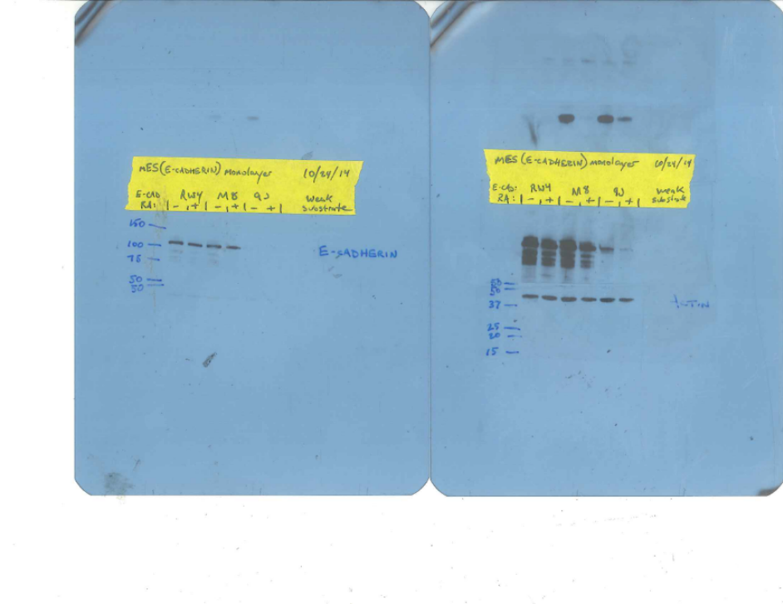

N-cadherin/Oct3/4
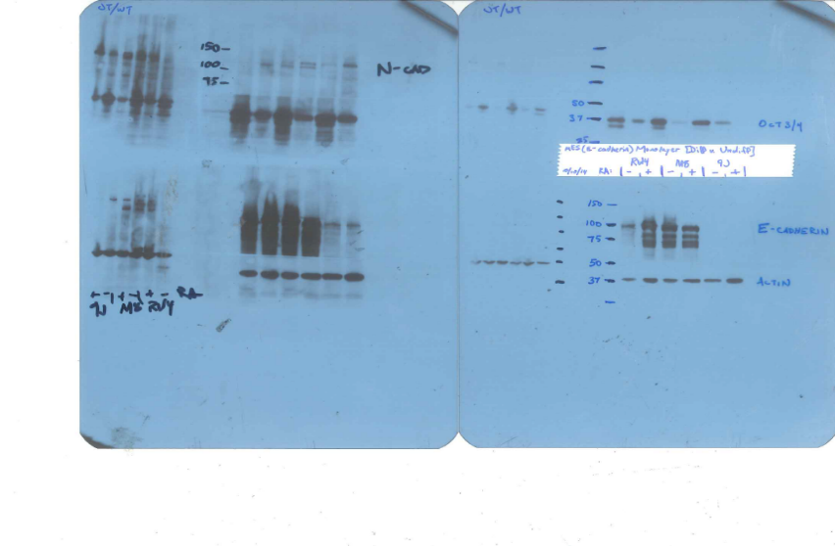

Dab2
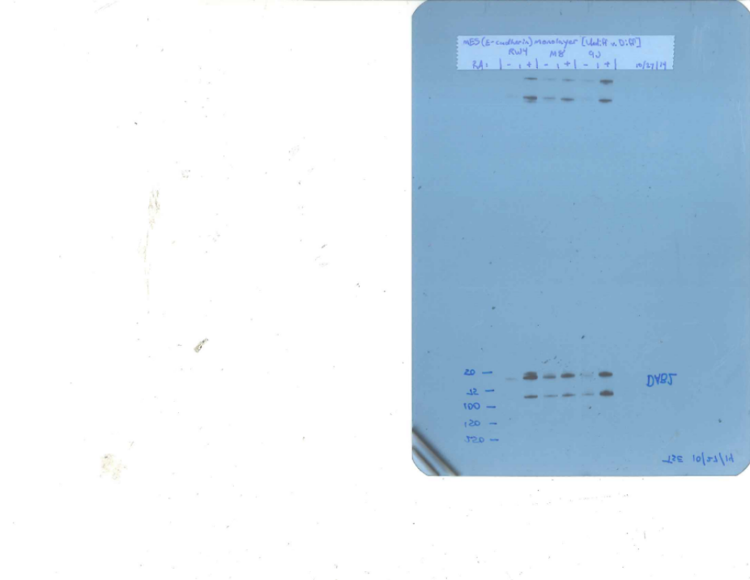
Figure 1D: cell aggregate
E-cadherin/Actin/Oct3/4 (Same lane setup/actin loading throughout Fig 1D)
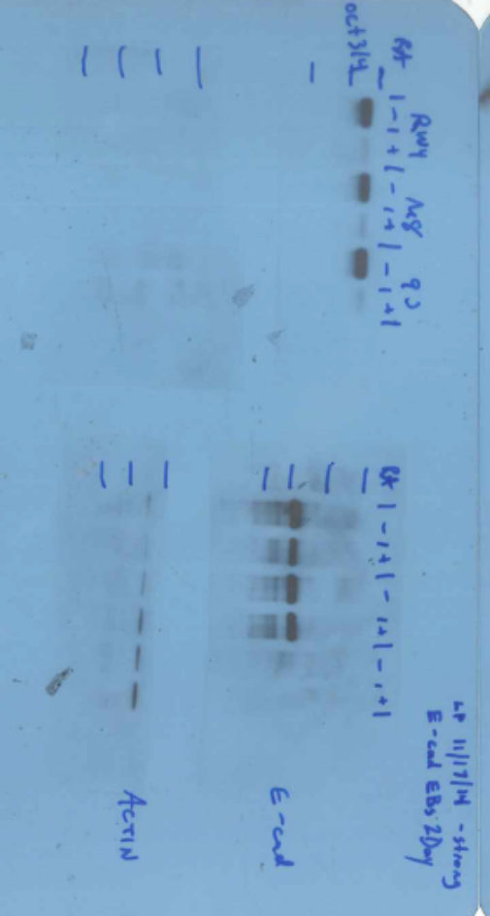

Dab2/N-cad
