Supplemental Figure 1. DASS-21 depression sub-scale item information function under the Graded Response Model.
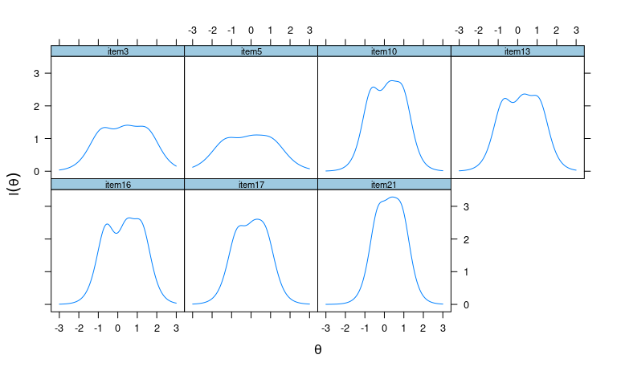

Supplemental Figure 2. DASS-21 depression sub-scale Categorical Response under the Graded Response Model.
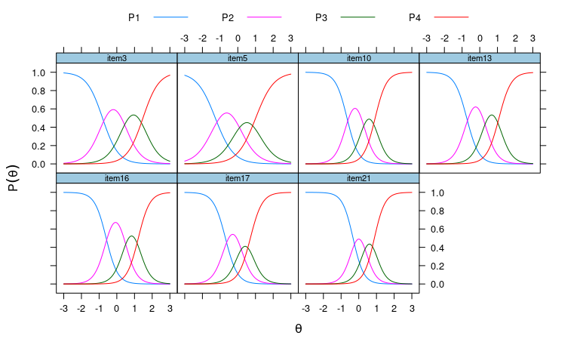

Supplemental Figure 3. DASS-21 depression sub-scale Operation Characteristic Curves under the Graded Response Model.
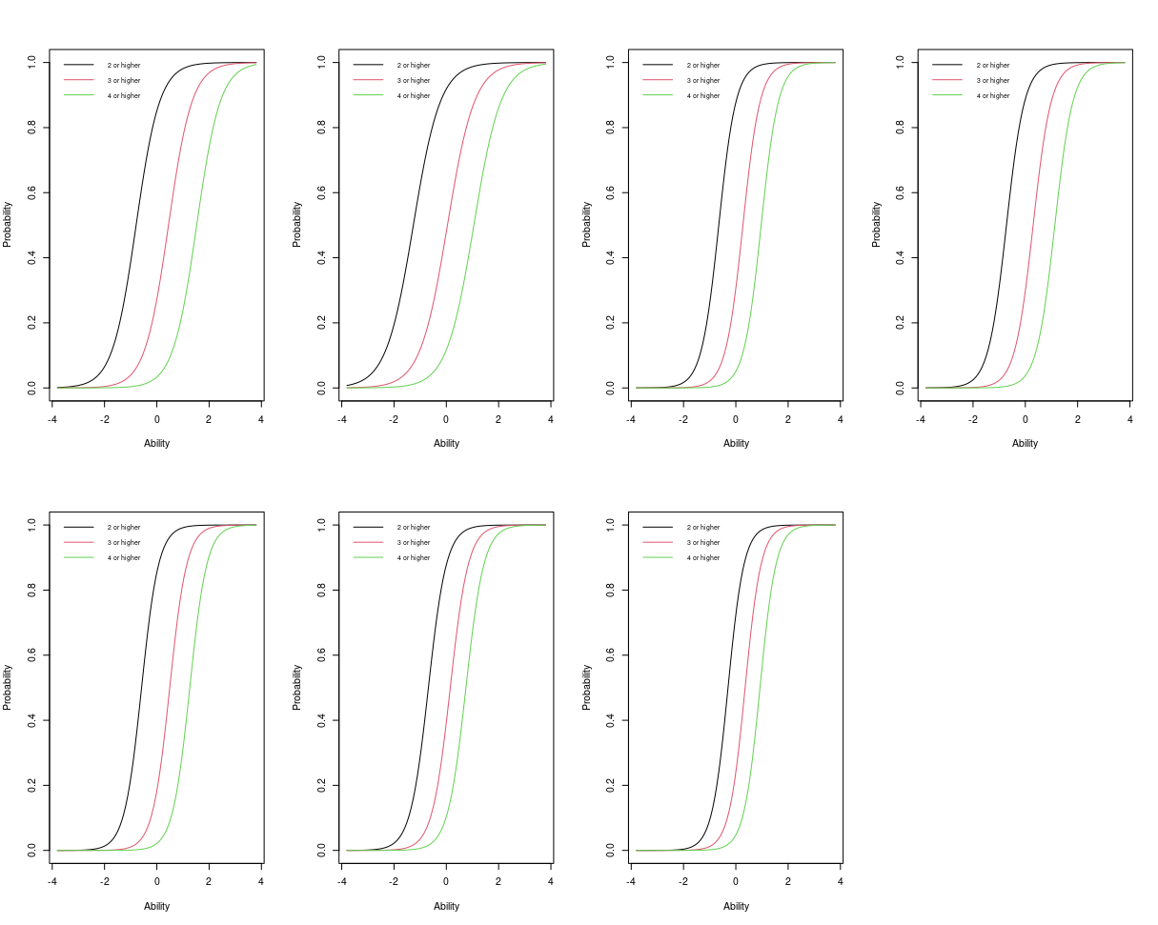

Supplemental Figure 4. DASS-21 anxiety sub-scale item information function under the Graded Response Model. 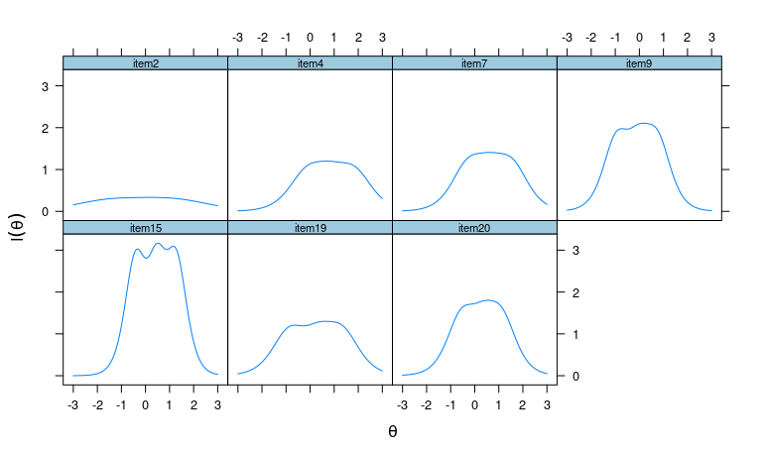

Supplemental Figure 5. DASS-21 anxiety sub-scale Categorical Response under the Graded Response Model.
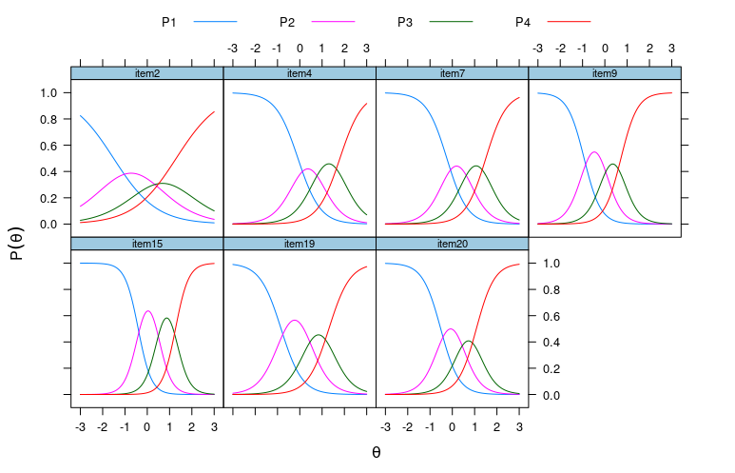

Supplemental Figure 6. DASS-21 anxiety sub-scale Operation Characteristic Curves under the Graded Response Model.
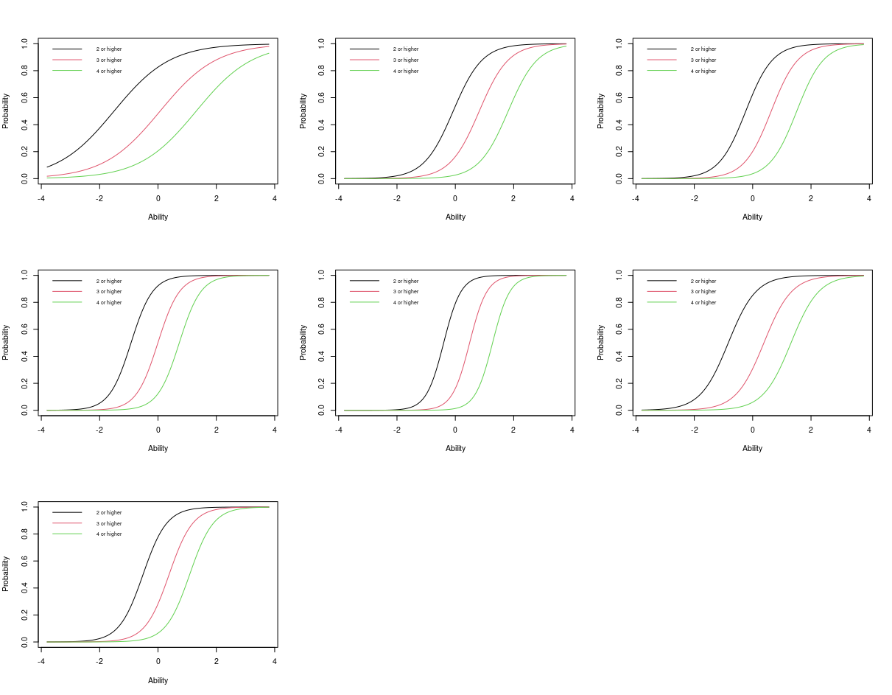

Supplemental Figure 7. DASS-21 stress sub-scale item information function under the Graded Response Model.
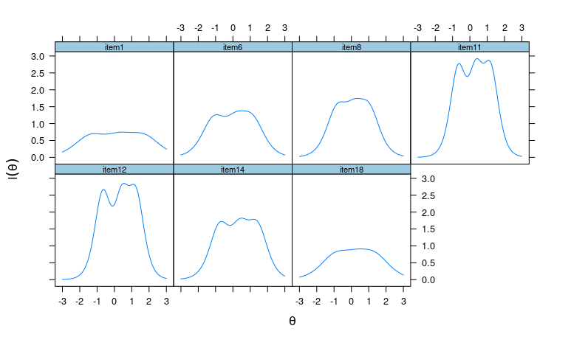

Supplemental Figure 8. DASS-21 stress sub-scale Categorical Response under the Graded Response Model.
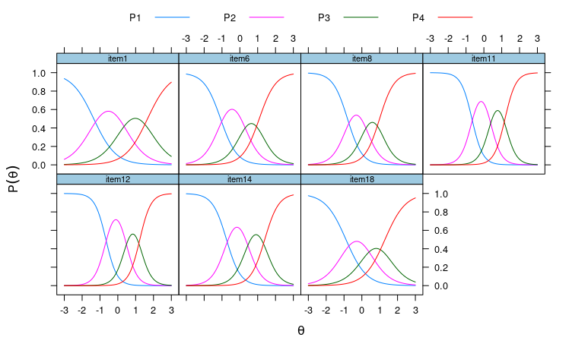

Supplemental Figure 9. DASS-21 stress sub-scale Operation Characteristic Curves under the Graded Response Model.
