Outcomes of hepatic epithelioid hemangioendothelioma with different managements: Retrospective investigation of 50 patients

Running title: Outcomes of HEHE with different managements

Xiaolei Liu, Zhiying Yang
Department of General Surgery, China-Japan Friendship Hospital, Beijing, China

Correspondence to: Zhiying Yang, Department of General Surgery, China-Japan Friendship Hospital, 2 Yinghua Dongjie, Hepingli, Beijing 100029, China
(e-mail: yangzhy@aliyun.com)

Brief profiles of radiological comparison for HEHE patients with treatment of interferon-α and thalidomide (Patients’ number was consistent with Table 3)

Patient 1# Male, 31 years old, interferon-α for 15 months, partial response
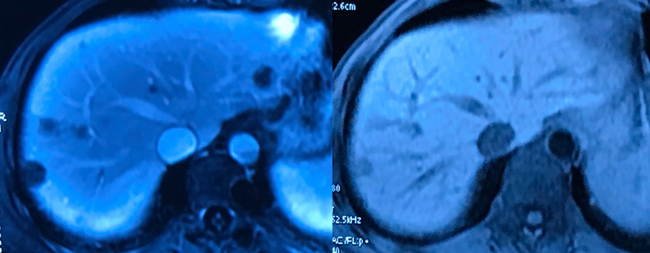

Patient 2# Male, 22 years old, interferon-α for 12 months, partial response
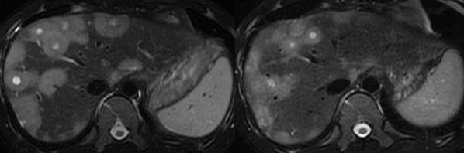

Patient 3# Female, 27 years old, interferon-α for 16 months, stable disease
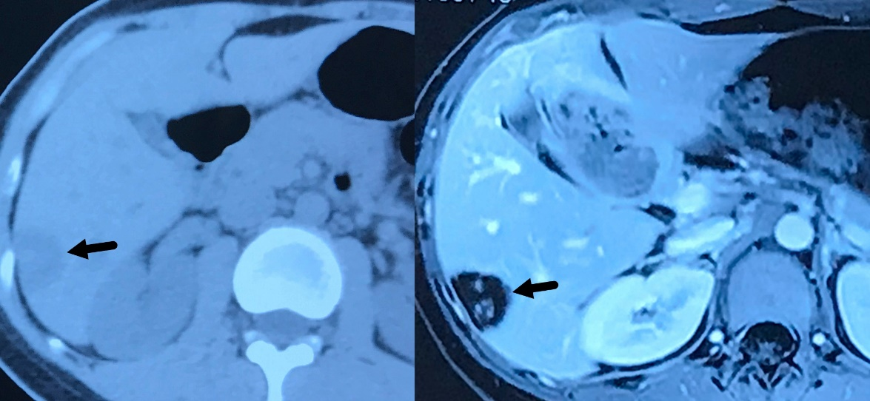
Patient 4# Female, 36 years old, interferon-α for 18 months, complete response
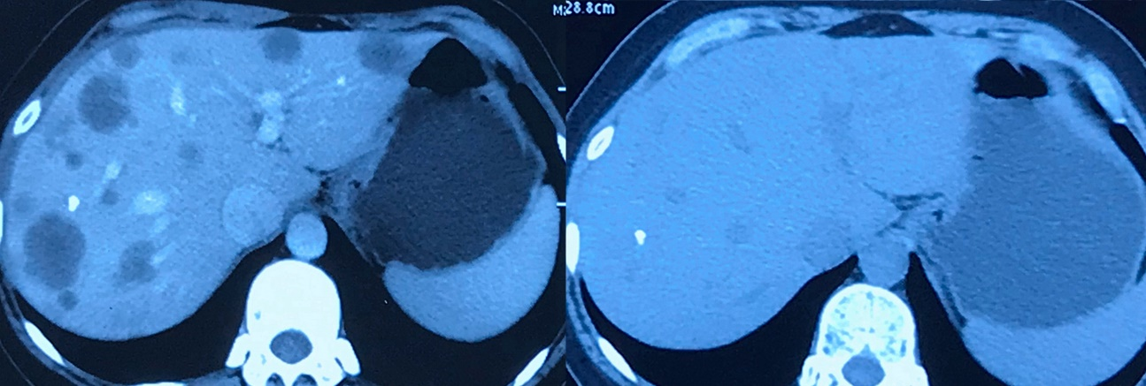

Patient 5# Male, 24 years old, interferon-α for 24 months, partial response
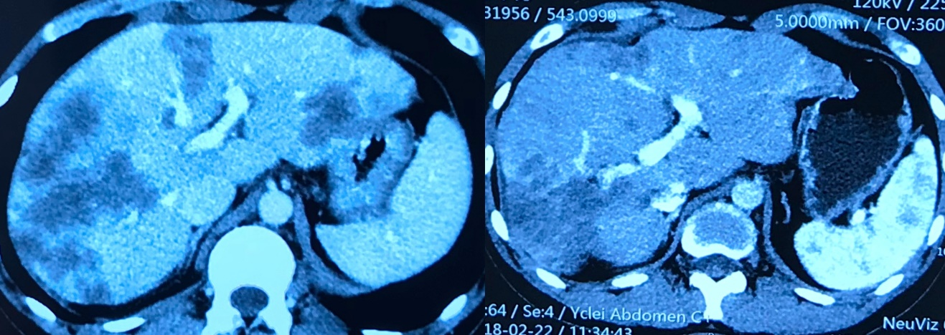

Patient 6# Male, 36 years old, interferon-α for 18 months, partial response
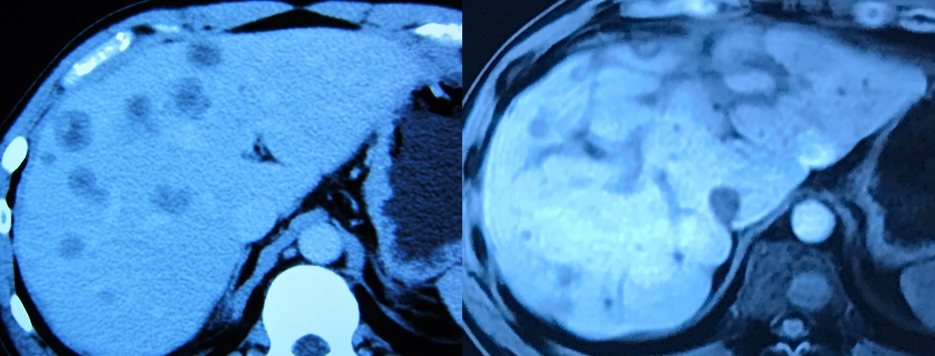

Patient 7# Female, 41 years old, thalidomide for 12 months, progressive disease
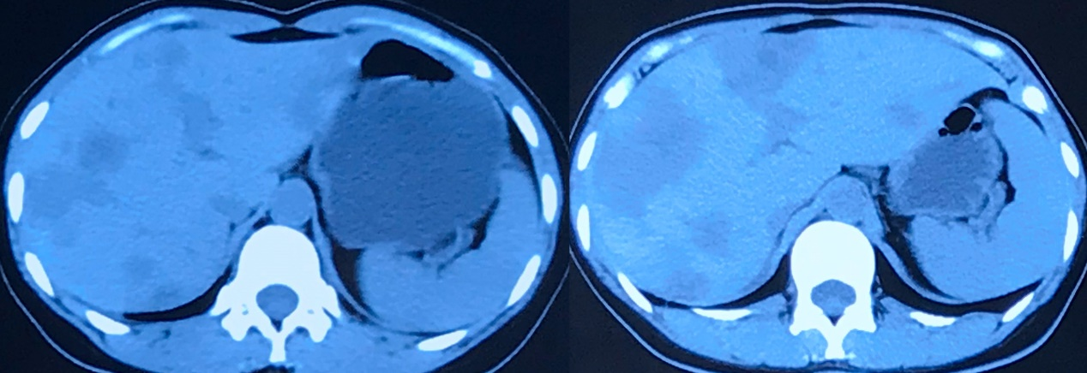

Patient 8# Male, 48 years old, thalidomide for 12 months, progressive disease
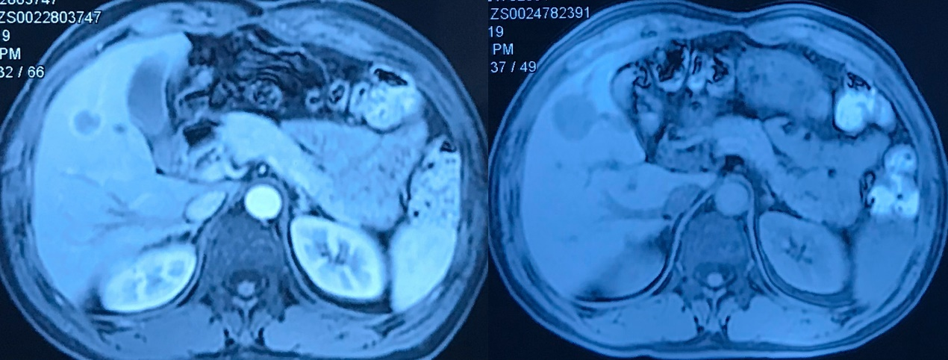

Patient 9# Male, 61 years old, thalidomide for 23 months, stable disease
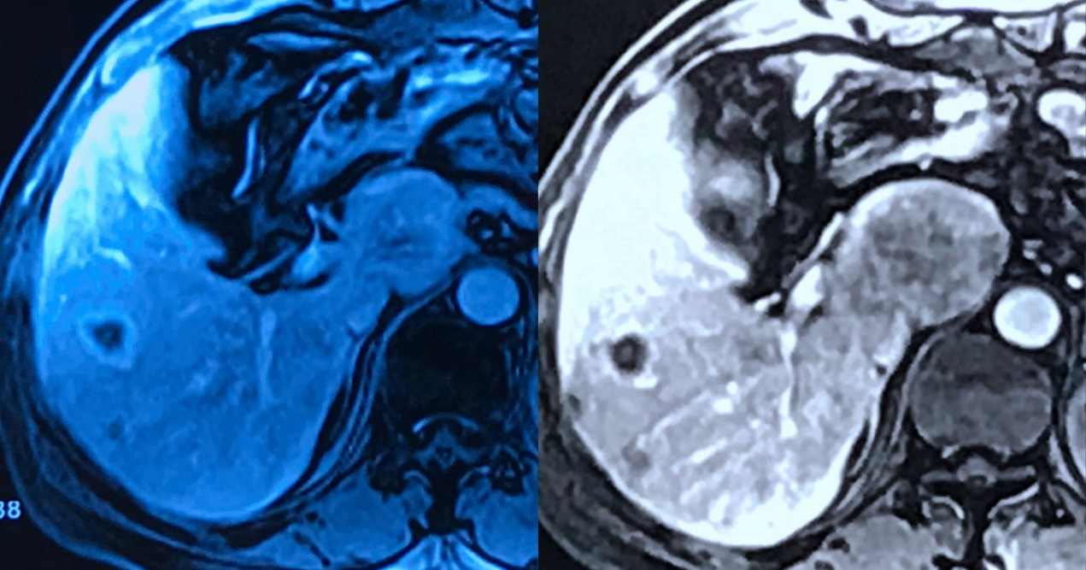

Patient 10# Male, 32 years old, thalidomide for 18 months, progressive disease
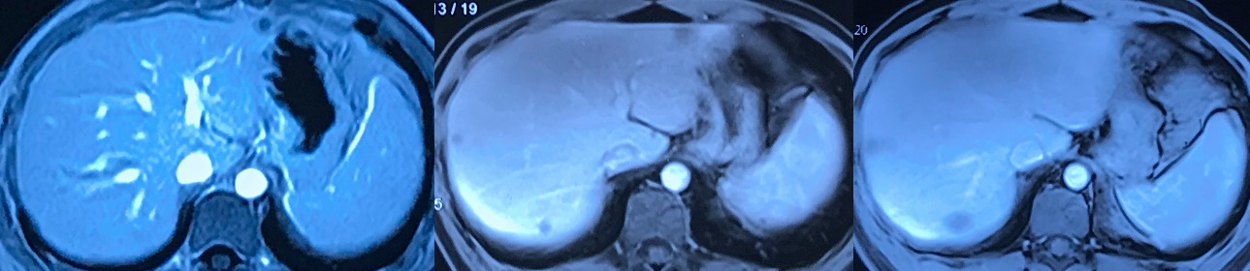

Patient 11# Female, 41 years old, thalidomide for 48 months, progressive disease
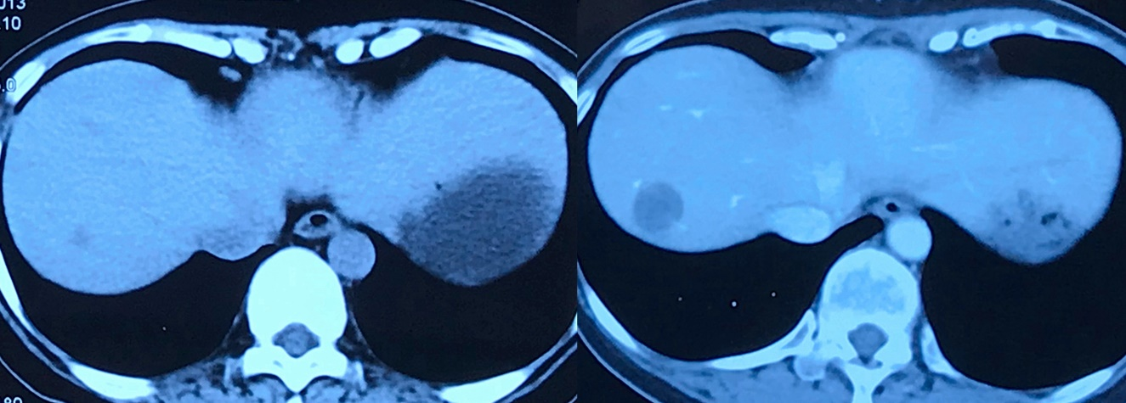

Patient 12# Male, 46 years old, thalidomide for 10 months, stable disease
