Outcomes of hepatic epithelioid hemangioendothelioma with different managements: Retrospective investigation of 50 patients

Running title: Outcomes of HEHE with different managements

Xiaolei Liu, Zhiying Yang
Department of General Surgery, China-Japan Friendship Hospital, Beijing, China

Correspondence to: Zhiying Yang, Department of General Surgery, China-Japan Friendship Hospital, 2 Yinghua Dongjie, Hepingli, Beijing 100029, China
(e-mail: yangzhy@aliyun.com)

Brief profiles of radiological comparison for HEHE patients with treatment of chemotherapy and targeted therapy (Patients’ number was consistent with Table 4)

Patient 1# Female, 34 years old, 3 cycles of Folfox, stable disease
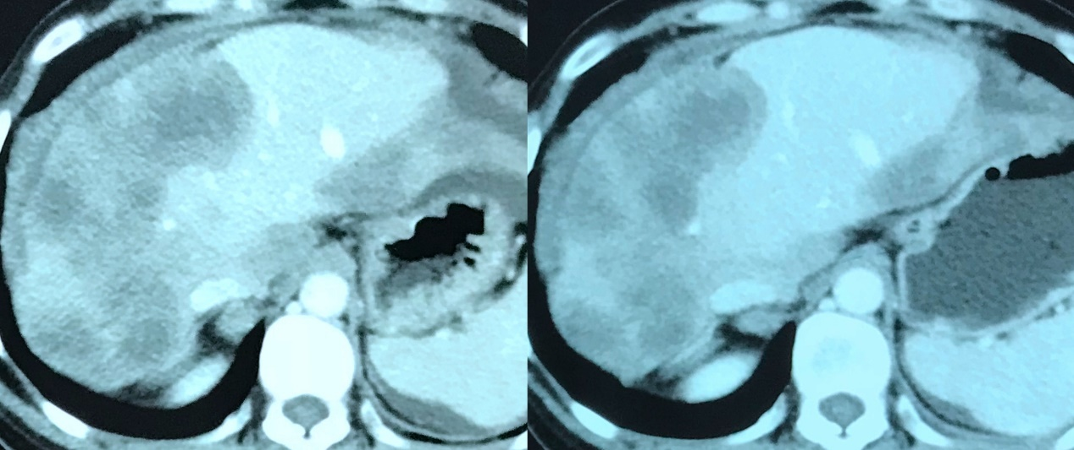

Patient 2# Male, 22 years old, 2 cycles of Folfox + gemcitabine, progressive disease
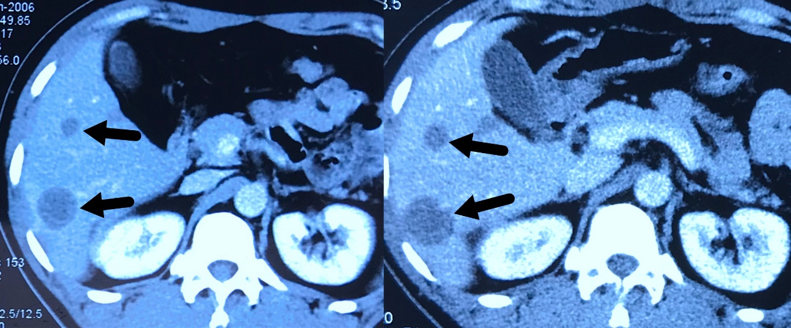

Patient 3# Female, 28 years old, 7 cycles of paclitaxel + endostatin, progressive disease
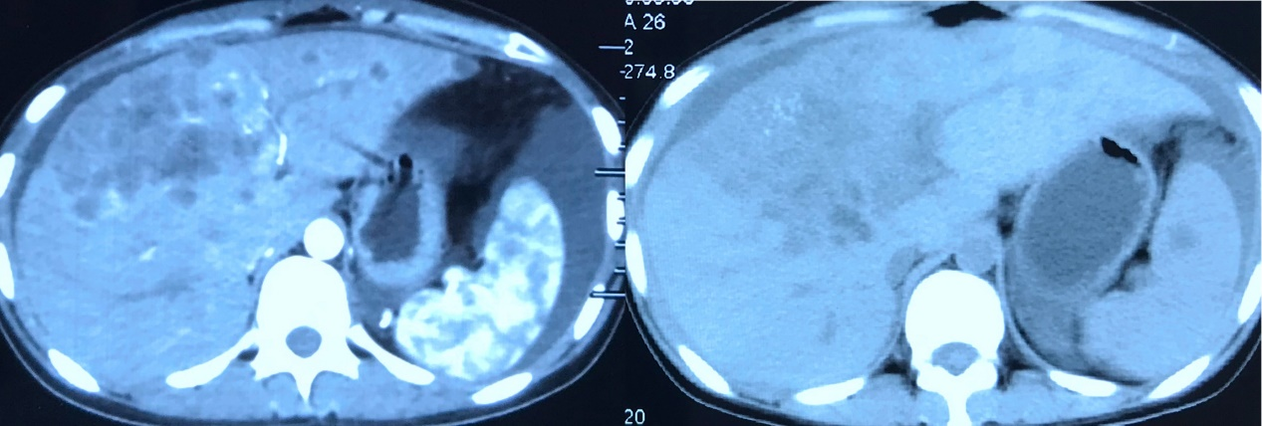
Patient 4# Female, 29 years old, 4 cycles of bevacizumab+docetaxel+cisplatin, progressive disease
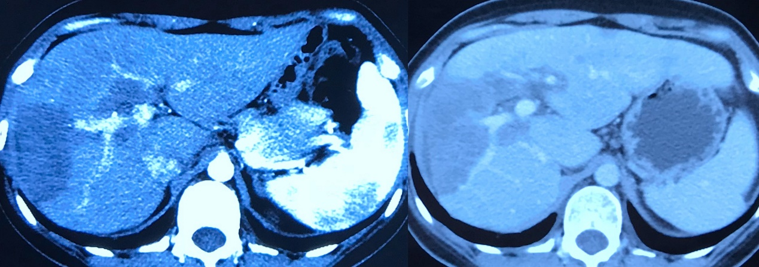
Apatinib for 22 months, partial response
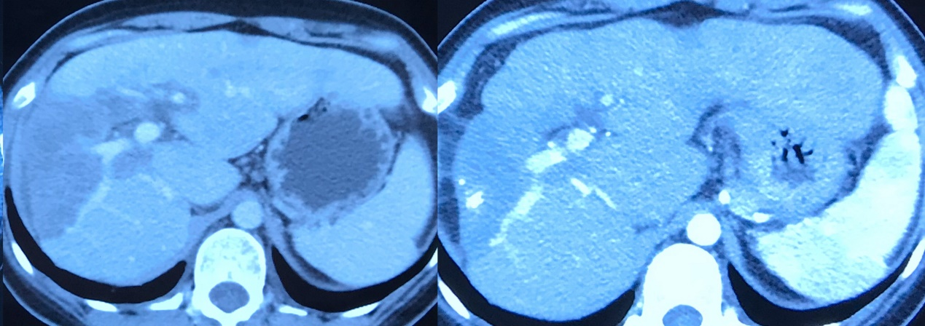

Patient 5# Male, 30 years old, apatinib for 5 months, progressive disease
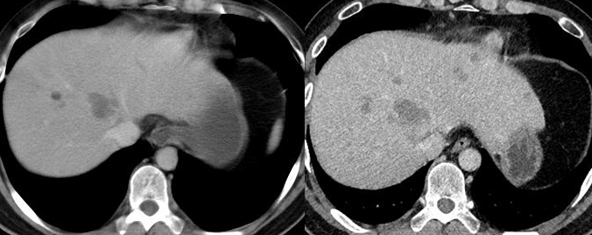

Patient 6# Female, 38 years old, apatinib for 14 months, partial response
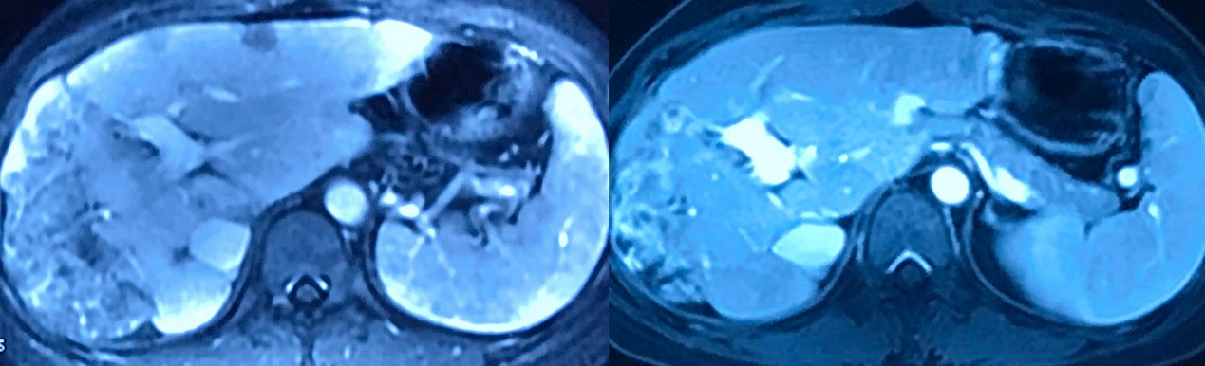

Patient 7# Male, 22 years old, sunitinib for 9 months, stable disease
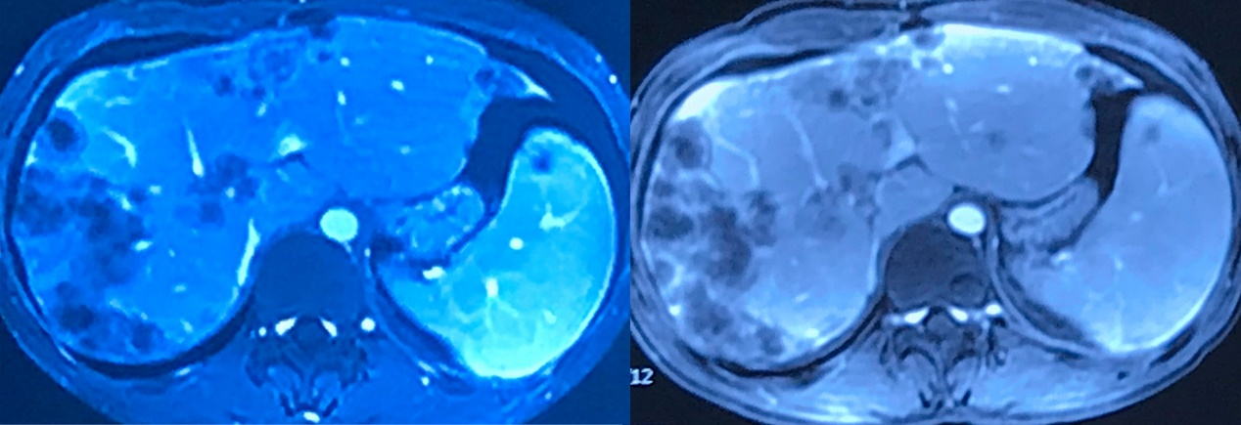

Patient 8# Male, 38 years old, 8 cycles of pembrolizumab and 8 cycles of pembrolizumab + bevacizumab + lenvatinib, progressive disease
