Supplementary Information
Unwrapping the surprisingly high risk of dying from cardiovascular disease at Christmas: the HUNT prospective population-based cohort study in Norway
Authors
Trine Moholdt, PhD ^{a,b}
Clifford Afoakwah, PhD ^{c}
Paul Scuffham, PhD ^{c,d}
Christine F McDonald, PhD ^{e}
Louise M Burrell, PhD ^{f}
Simon Stewart, PhD ^{g,h}
Authors Affiliations
Department of Circulation and Medical Imaging, Norwegian University of Science and Technology, Trondheim, Norway ª
The Women’s Clinic, St.Olav Hospital, Trondheim, Norway ^{b}
Centre for Applied Health Economics, Griffith University, Nathan, Queensland, Australia ^{c}
Menzies Health Institute Queensland, Griffith University, Southport, Queensland, Australia ^{d}
Department of Respiratory and Sleep Medicine, Austin Health, Institute for Breathing and Sleep, University of Melbourne, Melbourne, Australia ^{e}
Department of Medicine, Austin Health, University of Melbourne, Melbourne, Australia ^{f}
Torrens University Australia, Adelaide, South Australia, Australia ^{g}
University of Glasgow, Glasgow, Scotland, United Kingdom ^{h}
Corresponding Author
Professor Simon Stewart FESC FHFA
NHMRC Senior Principal Research Fellow
Torrens University Australia
Wakefield Campus, Adelaide, SA, 5000, Australia
Email: simon.stewart@laureate.edu.au
https://orcid.org/0000-0001-9032-8998

Figure S1 Monthly Pattern of All-Cause & Cardiovascular-related Deaths
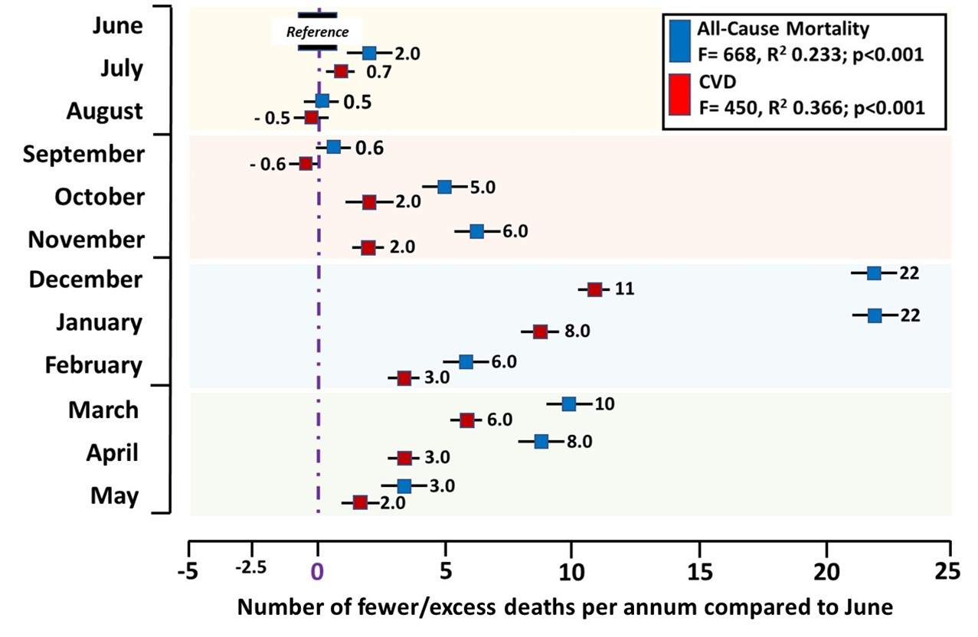
Legend: The number of deaths occurring in each month of the year above and below the reference month of June are shown for all-cause and cardiovascular-related mortality.

Figure S2 Monthly Pattern of Cancer, Respiratory and Other Causes of Death
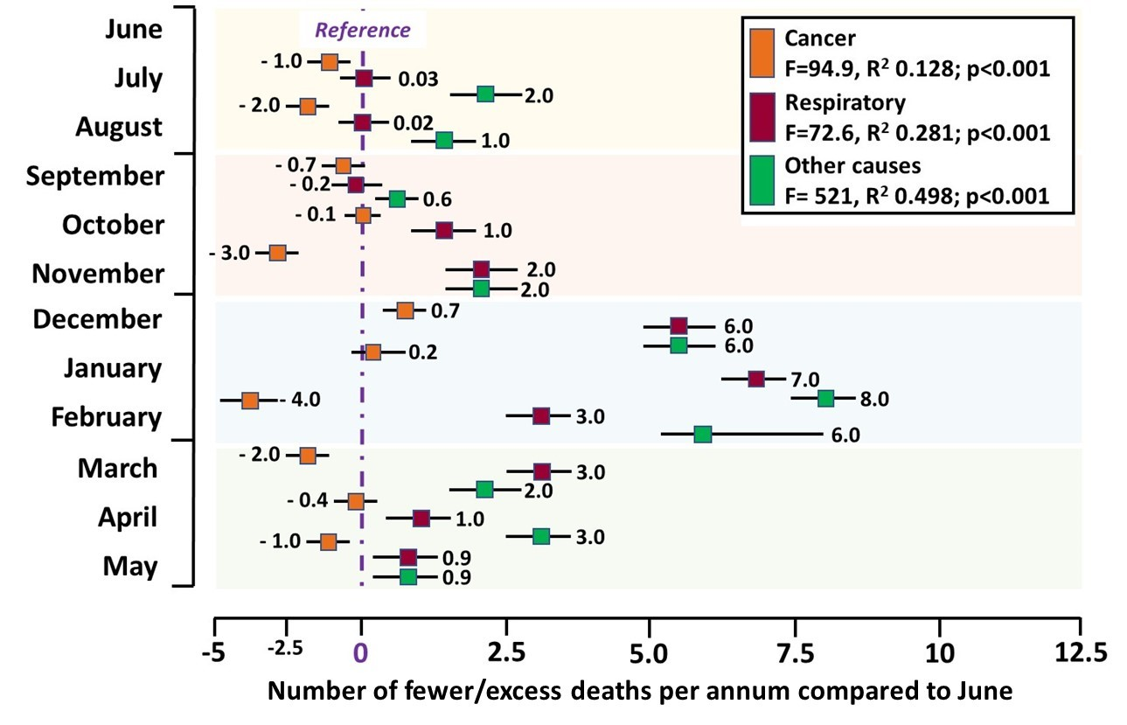
Legend: The number of deaths occurring in each month of the year above and below the reference month of June are shown for cancer-, respiratory disease-related and other causes of mortality.

Figure S3 21-day Pattern of Mortality – Pre-Christmas versus Summer Low and Christmas Holiday Period
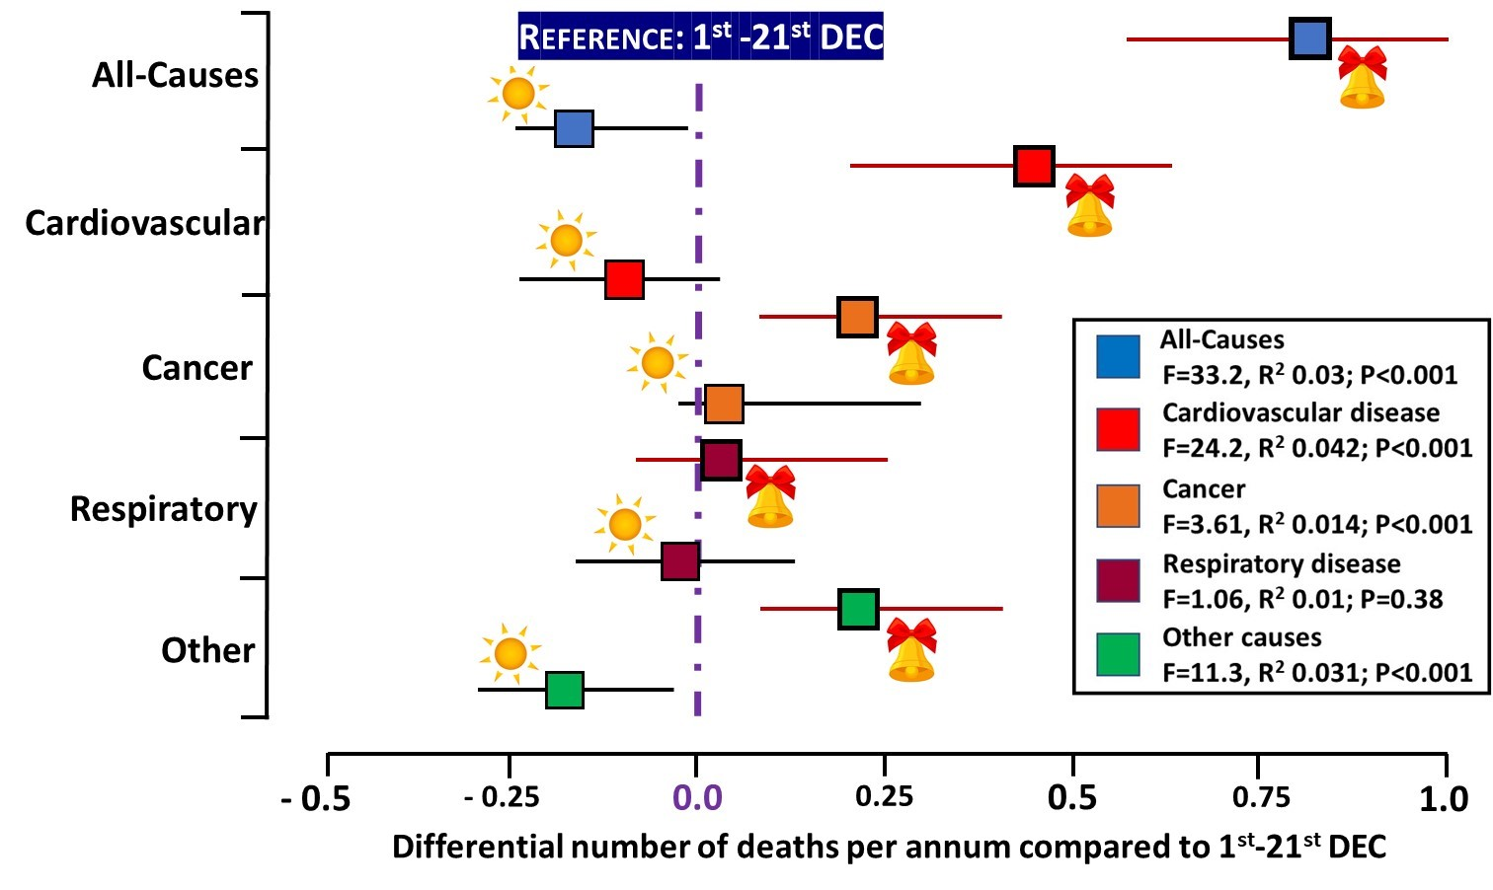
Legend: The number of deaths occurring during May 17th – June 6th (sun symbol) and 22nd December to 11th January (Christmas symbols) each year above and below the reference 21-day period 1st – 21st December are shown for all-cause and cause-specific mortality.

Figure S4 Sex-Specific Risk of Mortality – Pre-Christmas versus Summer Low Period
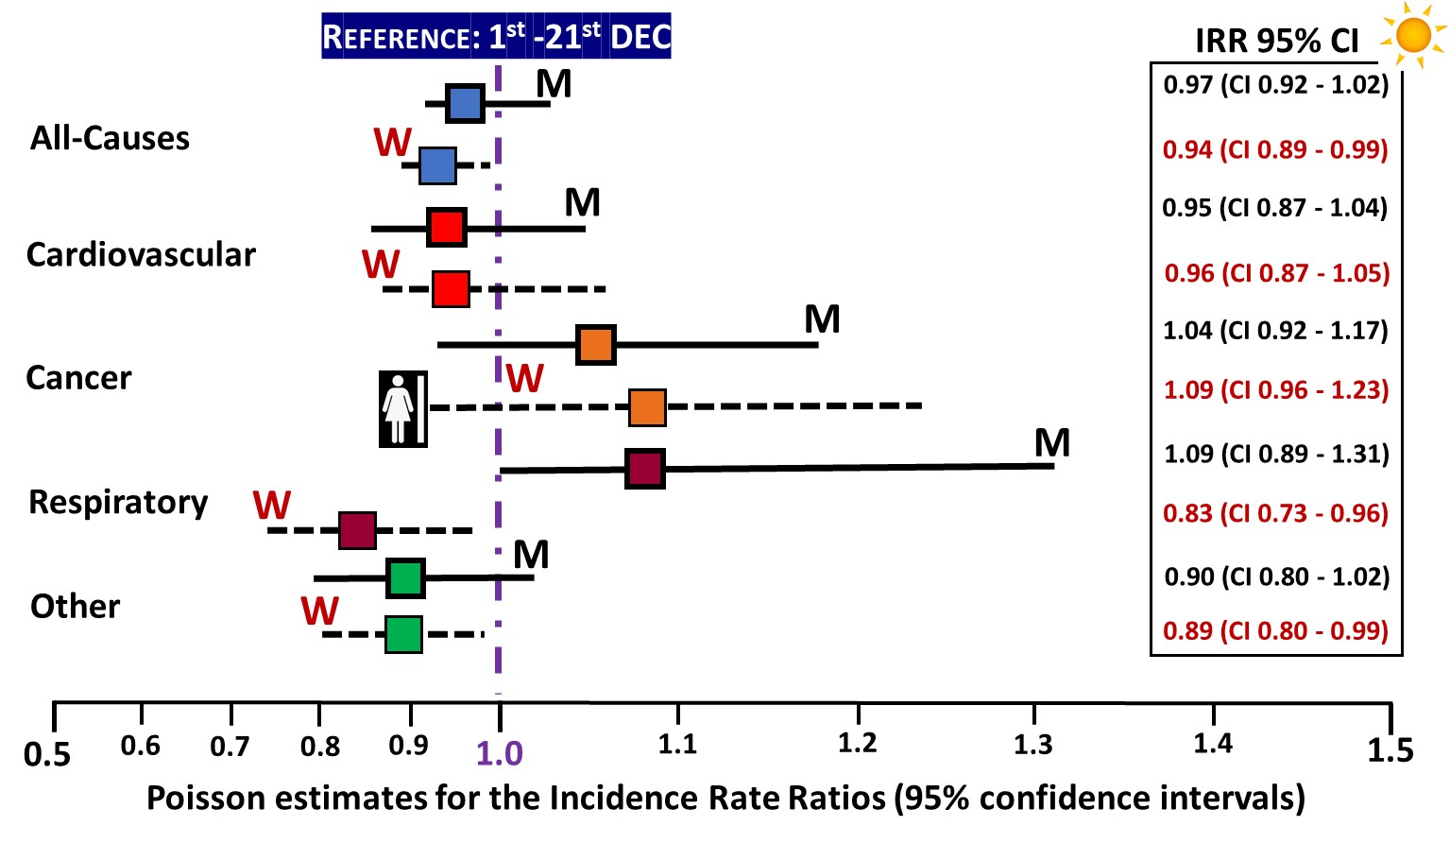
Legend: Sex-specific differences (blue figure men and pink figure women) in the incidence of daily mortality (all-cause and cause-specific) during May 17th – June 6th compared to the reference 21-day period 1st – 21st December. M=men (IRR and 95% CI in black) and W=women (IRR and 95% CI in red).

Figure S5 Sex-Specific Risk of Mortality – Pre-Christmas versus Christmas Holiday Period
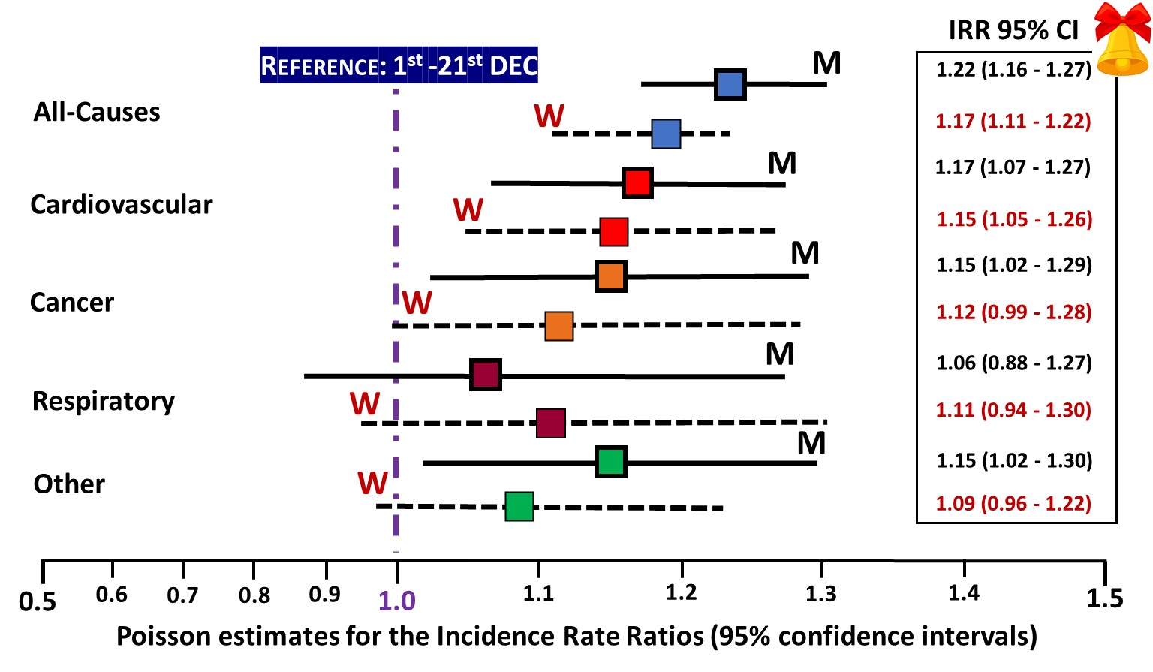

Legend: Sex-specific differences in the incidence of daily mortality (all-cause and cause-specific) during December 22nd – January 11th compared to the reference 21-day period 1st – 21st December. M=men (IRR and 95% CI in black) and W=women (IRR and 95% CI in red).

Table S1 | Sensitivity analyses
 | All-cause  mortality | P  value | Cardiovascular  mortality | P  value | Cancer  mortality | P  value | Respiratory  mortality | P  value | Other  causes | P  value
Model 1 | 0.30  (0.04 – 0.53) | 0.020 | 0.40  (0.11 - 0.62) | 0.005 | 0.07  (-0.19 - 0.33) | 0.586 | -0.03  (-0.23 - 0.16) | 0.740 | 0.06  (-0.19 - 0.31) | 0.648
Model 2 | 1.47  (1.27 – 1.66) | 0.000 | 0.95  (0.73 - 1.16) | 0.000 | 0.26  (0.04 - 0.47) | 0.020 | 0.09  (-0.07 - 0.24) | 0.267 | 0.26  (0.05 - 0.48) | 0.017
Model 3 | 0.43  (0.20 – 0.65) | 0.000 | 0.36  (0.12 - 0.59) | 0.003 | 0.23  (-0.003 - 0.472) | 0.053 | -0.16  (-0.36 - 0.04) | 0.118 | 0.05  (-0.20 - 0.29) | 0.708
Model 4 | 1.30  (0.99 – 1.61) | 0.000 | 0.87  (.57 – 1.16) | 0.000 | 0.13  (-0.17 - 0.42) | 0.395 | 0.02  (-0.24 - 028) | 0.870 | -0.28  (-0.61 - 0.04) | 0.088

Legend: In the first model, we used 3-days before Christmas (22nd-24th December) and 3-days after Christmas (28th-30th December) as the comparator. This model showed that daily all-cause and cardiovascular-related mortality during Christmas was significantly greater than the daily deaths recorded in any 3-days before or after Christmas. In model 2, we changed the comparator to any day in the calendar year except the Christmas period. Consistently, deaths during the 3-day Christmas window significantly exceeded deaths in any other day of the year. Model 3 compared Christmas deaths to death in any day of December except the Christmas window (comparator 1st-24th and 28th-31st December). Finally, we considered those baseline characteristics that could potentially influence the timing of death in our models to ascertain the impact of omitted variable bias on our estimates. The inclusion of these variables did not affect either the magnitude and statistical significance of estimated excess daily Christmas-related mortality for all-cause and cardiovascular-related mortality. Note: 95% confidence intervals are in parenthesis.

